PGRR Number | XXX | PGRR Title | Controllable Load Resource Planning Ahead of NPRR1188 Implementation

Date | September 18, 2025

Submitter’s Information
Name | Joint Commenters
E-mail Address
Company
Phone Number
Cell Number
Market Segment | Not applicable

Comments
Comments in Support of Proposed PGGR re: Controllable Load Resource Planning Ahead of NPRR1188 Implementation

NPRR1188 is an Essential Solution for ERCOT Operation of Large Loads
Nodal Protocol Revision Request (NPRR) 1188, approved by the Texas PUC in November 2024 with an 12-24 month implementation window, changes the dispatch and pricing of Controllable Load Resources (CLRs) in response to items in Phase 1 of Public Utility Commission of Texas’ (PUCT’s) market design blueprint related to demand response and increasing the “...utilization of load resources for grid reliability”. It is focused on the market modifications and technical measures that improve transparency of price signals for load resources. In the final approved version, the description section of NPRR1188 states that the outcome of this policy change is that resources can be dispatched “using their locational nodal shift factor” which “is essential for efficient congestion management.” NPRR1188 is a successful policy change that moves away from pricing what can and will be gigawatt-sized ERCOT loads from a prior zonal construct which used an inefficient, and generally problematic approach of apply zonal shift factors and zonal pricing to loads in SCED. Those attributes did not correctly price incentives in the market for withdrawal levels of a CLR and zonal dispatch factors misrepresented the impact of the withdrawal levels of these Resources on transmission constraints. In the case of very large loads, the impact of zonal shift factors and pricing would be egregious for the system:distorting the correct allocation of congestion costs and system operations which could be effectuated by small movements in these large loads’ consumption behavior at individual pricing nodes on the system. As stated in the PUC Texas Report for NPRR1188, it has been discussed at LFLTF that “[s]ome of these loads have shown interest in registering with ERCOT as CLRs. Because the individual MW sizes of these loads are significant, nodal Dispatch and Settlement is crucial for reliable operation of the grid.” Therefore, NPRR1188 changes the market participation model for CLRs (that are not ALRs) such that they are dispatched at a nodal shift factor and settled for their energy consumption at a nodal price.
NPRR1188 effectuates critical operations changes that ERCOT must fully implement in advance of operating large loads which elect to establish voluntary participation in ERCOT SCED, managing obligations as a CLR through their Qualified Scheduling Entity’s compliance with ERCOT Resource requirements. Interconnecting large load entities (ILLEs) which choose this status must be assigned a Resource Node Settlement Point and must comply with SCED instructions such that OUTL status can only be telemetered to ERCOT if the CLR “is truly outaged and is consuming zero MWh.”
Now that ERCOT has created an incentive for more loads to contribute to the system’s reliability management, the incentive for loads to participate as CLRs must come full circle to afford the market to capitalize on the benefits of this solution for congestion management, system operations transparency, reliability management, and by necessity to effectuate these outcomes, large load energization studies.

Under the current Planning Guide, ERCOT and Transmission Service Providers (TSPs) today cannot formally incorporate into Large Load Interconnection Study process the future expected dispatchability of Nodal Controllable Load Resources (CLRs) enabled under NPRR1188 – even on sites that are fully capable of investing in dispatchability solutions behind the large load site control or otherwise managing load participation in SCED through its QSE. This limits both the interconnecting utility and ERCOT’s ability to evaluate dispatch-based solutions to transmission constraints when reviewing the firm upgrade request of a Large Load, and blocks utilization of dispatchability in steady state models as a solution to speed up load energization.
Given the freeze in interconnection studies that all loads are experienced in Texas TSP areas with multiple N-1 constraints, it is critical to incorporate the same mechanisms that will benefit ERCOT operations into system studies. Doing so will recognize in interconnection studies, the benefits that sites running as ERCOT NPRR1188-compliant CLRs will already accrue to the system (including being capable of being dispatched and re-dispatched to solve a series of constraints) and further, may choose if provided the option for earlier energization as a CLR, to invest faster in private solutions that make sites more grid-friendly and customer-friendly, and speed up the interconnection queues for all loads in queue. Private solutions may include, but are not limited to, onsite gas turbines, various forms of energy storage, geothermal power, dispatachable IT and balance-of-plant infrastructure, compute workload, and software-enabled load-shifting protocols. By its nature, the proposed solution contemplates a technology-neutral approach inviting CLRs to voluntarily participate in grid-supportive energization solutions. Importantly, the approach is not about compelling loads themselves to participate as non-firm: rather, the solution creates private firming incentives which can be reflected in technology stacks, co-location PPAs, and innovative structure in QSE portfolios to privatize firming risk in exchange for earlier load energization and resolution of TSP queue constraints which are a detriment to all loads (of any size) seeking firm interconnection. In this approach, the dispatachability of the load itself behind a CLR election remains a “dispatch of last resort.”
About the PGGR
This PGRR aligns interconnection study treatment with explicitly allowing for loads that elect CLR status to be modeled as nodal, dispatchable Resources in TSP and applicable ERCOTstudies while keeping transmission planning for firm delivery unchanged. This solution enables loads electing CLR treatment to energizefaster ahead of those loads’ Load Commissioning Plan.
The Load Commissioning Plan (LCP), enabled by ERCOT-approved NPRR1234, continues to govern energization to firm service via identified upgrades. The PGRR simply provides that along with the LCP, an ILLE with a firm-service upgrade request may also submit a CLR election and attestation to its TSP; the TSP treats that election as a study input of the site and network area to verify N-0 is satisfied and whether N-1 can be mitigated by dispatch of the CLR to its LSL, which may equal zero. The effect of this change is described as follows:
- Election and data. Loads that intend to register as CLRs under NPRR1188 elect CLR treatment in the LLIS. These loads submit HSL and a dispatchable floor (which may equal zero) in the Load Commissioning Plan (LCP).
- Study method. In N-0, the case must pass at the proposed output. In N-1, the planner redispatches the electing CLR to its submitted floor. If all binding N-1s clear at or above the floor, the site is “advanceable” for non-firm early energization.
- Outcome. ERCOT and the TSP may energize that CLR as non-firm, with automated curtailment to the floor whenever the named N-1 binds, while firm upgrades proceed for the cluster.

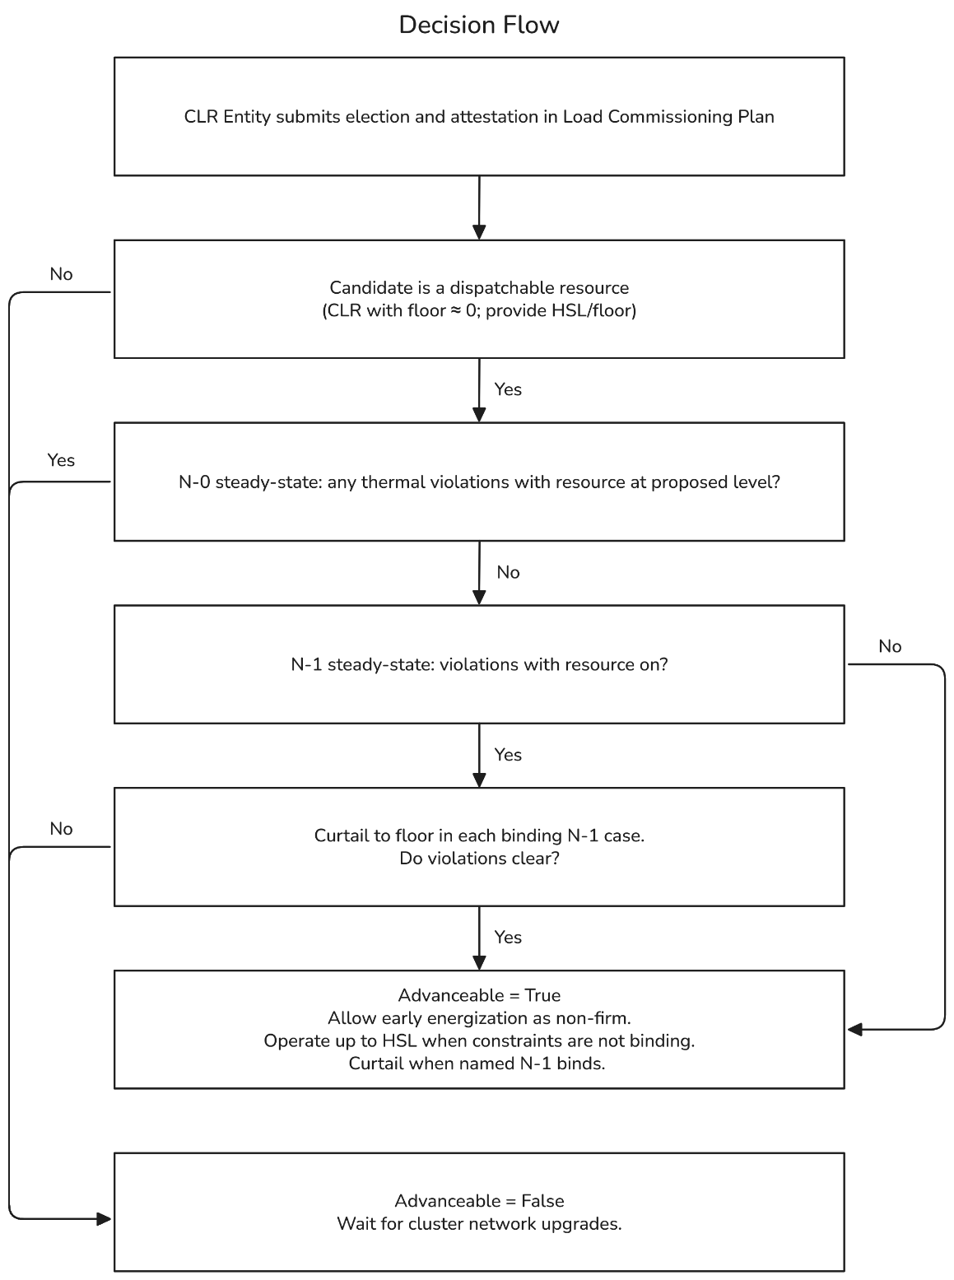

Given their individual size, ERCOT and stakeholders quickly recognized in the NPRR1188 proceeding that nodal Dispatch and Settlement given the overwhelming number of large loads coming into market ops is crucial for reliable grid operation. Likewise, given the enormous benefit that any of these sites which choose to participate at CLRs could have in resolving N-1 constraints which bind in load studies, it is crucial to effectuate this fix on an urgent basis and provide an investment signal to the market to perform to these parameters in planning and operations alike.

Discussion FAQ Topics
NERC TPL Requirements
- NERC TPL Compliance. The method studies P0 with the load on and meets TPL P1-P7 by a defined manual/system adjustment: curtailing a registered, telemetered CLR to its floor. It keeps firm-planning obligations intact, which aligns with TPL’s requirement to plan a reliable system, not to grant evergreen non-firm delivery.

NPRR1284 v. Proposed PGRR:
In its original from NPRR1284 intended to address thermal/voltage violations specifically arising from transmission maintenance scenarios under section 4.1.1.8, rather than standard n-1 thermal violations. NPRR1284 focuses on maintenance-driven, often temporary, system conditions rather than the broader, more structural n-1 issues which this PGRR proposal targets. The PGRR/N-1 Solution is a less operationally burdensome solution, aimed at resolving N-1 violations for large load interconnections. The PGRR approach leverages the controllable load resource (CLR) mechanism to allow certain loads to come online ahead of firm network upgrades, with the expectation that these loads will be nodally dispatched and subject to SCED, post-NPRR1188 implementation. The PGRR is described as providing meaningful impact for processing interconnection queues by resolving n-1 violations, rather than the n-2/n-1-1 scenarios envisioned by NPRR1284. NPRR1284 proposes to resolve maintenance-driven thermal/voltage issues, whereas this PGRR enables interim CLR operation while firm upgrades are planned for N-1 deliverability under the participating load’s LCP.
What this solves
- Brings planning treatment for dispatchable Loads into parity with how SCED already runs the system.
- Creates a safe “relief valve” for TSPs: serve what can be served now, curtail when the studied N-1 binds, keep building to firm.
- Unclogs schedules for non-CLR commercial and industrial load by removing upgrade triggers that a willing CLR can solve by redispatch.
- Preserves fairness: no preferential queueing or firm rights are granted.
Other Key Features
Economic Upgrade Studies (RTP/LTSA)
Note that congestion-driven upgrades are still evaluated per existing processes. The CLR’s behavior and curtailment history can be included as inputs, but the PGRR does not shield upgrades that are economic.
CLRs - No Opt-Out
Under NPRR1188, a nodal CLR must follow SCED dispatch and telemetering out means the CLR capacity is consuming 0MW.
Impact on Firm Load Queue Processing
It’s important to highlight that allowing CLR elected loads to advance to energization ahead of their LCP does not create adverse impacts to other loads in the firm interconnection queue (or impede the electing CLR’s own ability to receive firm service as part of the interconnection queue as reflected in its LCP).
All system delivery capacity which is available before violating N-1 constraints continues to be allocated consistent with load interconnection practices today. CLRs are only utilizing system capacity, which would otherwise go unutilized by any load, by privately assuming the risk of curtailment via SCED dispatch. In this sense, the CLRs are only advancing because they agree to be curtailed (or re-dispatched) by SCED through their QSEs when triggering conditions occur. As firm load is added to the system, the burden of dispatch by CLRs may increase as available transmission capacity is utilized and n-1 transmission constraints become more frequent and/or longer in duration. CLRs remain in the traditional load interconnection process, receiving firm service consistent with their LCP. Once firm service is delivered, resources may retire their resource node and continue consumption as a traditional retail load, or continue operations as a CLR for economic reasons, but nodal dispatch of the CLR resources would no longer manage the burden of delivery constraints.
Privately Managed Delivery Risk
Loads which elect CLR status to advance energization ahead of their Load Commissioning Plan assume all risk associated with assessing how frequently, and for how long, load may be curtailed via nodal SCED dispatch.
Technology Agnostic
So long as the load which elects for CLR treatment in planning can demonstrate its ability to operate as a CLR during the Resource registration process, there is no prescribed method by which loads must comply with this requirement. Ability to perform as a CLR is privately assumed risk and failure to comply with associated requirements in real time operations carry the applicable compliance penalties and risks which all ERCOT Resources manage via their QSE per the ERCOT NP, OG, and SMOG.

Specifically CLRs that are not Aggregated Load Resources, the latter being a unique category of very small (each under 1 MW) load assets which shall be aggregated to a minimum size of 100 kW to be eligible to be registered as an ERCOT ALR-CLR and receive SCED instruction consistent with other CLRs to dispatch load consumption with zonal pricing and zonal shift factors. A core distinction for CLRs subject to NPRR1188 from ALRs is that ALRs are aggregations of very small loads which are typically sited at retail meters on distribution feeders/circuits, consuming pricing from ERCOT via retail settlement or boundary retail metering at zonal prices – resale of load response from these assets is also zonal for consistency in the settlement of these assets.

