**TDTMS**

**August 19, 2024, 9:30 AM**

**WebEx**

|  |  |  |  |  |  |  |
| --- | --- | --- | --- | --- | --- | --- |
| Attendee | Company | Attendee | Company | | Attendee | Company |
| Jesse Macias | AEP | Bill Snyder | | AEP | Monica Jones | CNP |
| Rob Bevill | TNMP | Dave Michelson | | ERCOT | Eric Lotter | GridMonitor |
| Sheri Wiegand | Vistra | Mick Hanna | | ERCOT | Kathy Scott | CNP |
| Jim Wade | CES | Steven Pliler | | Vistra | Tammy Stewart | ERCOT |
| J Brooks | ESG | Sam Pak | | Oncor | Nick Reedy | CimView |
| William Butler | LP&L | Jordan Troublefield | | ERCOT | Michael Boyle | Shell |
| Yvette Perez | Octopus | M Suryanarayanan | | Shell | Moises Elias | Just Energy |
| Livia Scarassati | Just Energy | Tomas Fernandez | | NRG | Kyle Patrick | NRG |

Sam Pak opened the meeting, read the Antitrust Admonition, and introduced attendees.

Meeting minutes from the June 20th meeting were reviewed and approved.

**TAC Structural Review - TXSET / PWG merger**

Sam Pak and Kyle Patrick briefly discussed the impending TXSET / PWG merger highlighting the direction received from RMS leadership including expectations and timeline to execute. To summarize, the merger will become effective at the start of 2026 with new leadership, a scope/procedures will be proposed for review by RMS before the end of 2025, and working groups will conduct a combined meeting by the end of 2025. Further discussions will occur at upcoming TXSET and PWG meetings.

**TDTMS Scope / Working Group Procedures**

Proposed draft scope was reviewed (Schatz bullet version) was initially approved, however further discussion on the working group procedures document occurred where a scope was also outlined. ACTION: Jordan will research if the information on the main meeting page is indeed the WG scope or a high-level summary and the working group procedures document is designed to provide additional detail and full scope. Also to determine if there is an update to the general procedures document to use as a baseline. ACTION: Sheri will draft a condensed paragraph for a high-level summary of responsibilities for review at next meeting.

**ERCOT System Instances & MarkeTrak Monthly Performance Review -**

* Market SLA targets were met for July.
* Extended release on 7/26 -7/27 completed without issue reported from TDSPs (processing of safety nets from 2PM – 7 PM)

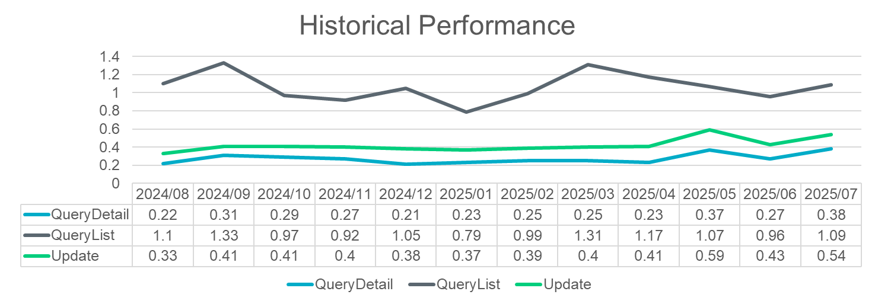

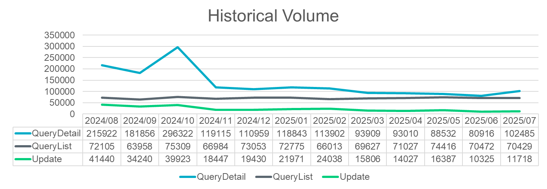

* MT performance looks good. ERCOT continues to watch performance since changes were made internally. As more MT APIs join, ERCOT will monitor performance. Thus far, no uptick due to # of users.
* Peak of MT concurrent users was achieved on 7/30 at 216. Adjustment to concurrent licenses was made. With the reset, no issues experienced on 8/4. ERCOT asks if ‘concurrent error’ message occurs, please issue a service ticket.
* SERVICE NOW TICKETS: Tomas discussed his experience with issuing the requested ticket for ‘concurrent license error’ message. The log in was clunky and the ask is: ACTION: Mick Hanna to update the instructions on issuing a Service Now ticket and outlining the expected response. Dave Michelson also expressed when the ticket is created, an email may also be sent to the Service Desk copying Dave for visibility.
* 2026 Retail Release Calendar: ERCOT presented the 2026 release calendar to be presented at RMS for approval. ERCOT indicated they modified some original dates to avoid ‘end of the month’ releases to minimize interruptions during higher transaction traffic days. TDTMS did not have any objections to the calendar dates.

**ERCOT Projects** – in general, Dave indicated most ERCOT resources are tied up with RTC+B projects and as soon as these conclude, he expects of flood of movement on the retail impacting projects noted below:

* **MIS API** – still early stages of development; consolidation of operations - APIs; consistent “look and feel” with ERCOT platforms; retail API and MT API will be impacted; expected development by EOY; SOAP will be retired and replaced with EWS
* **NAESB upgrade –** a change to internal systems yet ERCOT will be contacting service providers and trading partners requesting 1 ‘dummy’ file and 1 large file (IDR) to be sent as a test to ensure market partners can send/receive, encrypt/decrypt. Functionality is not in RMTE yet, however, will be new for Flight 1025. Nothing has been communicated via Technology Working Group (TWG) . TDTMS leadership committed to attending TWG and communicating materials also through TDTMS.
* **Enhancement list:** 
  + Adding ‘key dates’ back to Find Transactions which may be viewed as a heavier lift an unable to run through agile process
  + Reject code list in MIS as previously available pre TXSET v5.0
  + MarkeTrak – addition of ESI within automated subject line of escalation email (low effort per ERCOT and might be able to include in upcoming release)
  + MarkeTrak – allowing REPs to utilize same Switch Hold removal codes within MTs – today unexecutable reasons were developed for TDSPs

ACTION: Sheri will develop enhancement list to be updated and posted on main TDTMS meeting page – issues can be submitted similar to TXSET Change Controls for tracking purposes.

**MarkeTrak Information Page**

The assignments were reviewed and the following was reported:

* *MarkeTrak Bulk Insert Tips and Tricks* - Monica Jones indicated current document is accurate and suggested some additional content may be added. ACTION: Monica will provide revisions at the next meeting.
* *Background Report – Output Column Headings* – Tomas Fernandez also reported the existing document is valid yet thought additional content would make the document more valuable. ACTION: Tomas will provide suggested edits that will be reviewed at the next meeting.
* *MarkeTrak SubTypes Quick Reference* – Sheri Wiegand presented the changes and additions to the document and desktop edits were made. ACTION: Market participants are encouraged to have MT teams review for any additional edits. The document will be finalized at the next meeting.
* *MarkeTrak User’s Guide suggested revisions* – ACTION: Sheri will forward Tomas’ earlier inquiry to Tammy Stewart requesting the following User’s Guide changes:
  + Remove the reference to “waiting 5 days to submit” in section 4.3 Usage & Billing – Dispute
  + Add the reference to “waiting 5 days to submit” in section 4.2 Usage & Billing – Missing

**MarkeTrak Subtype Analysis**

MT volumes through mid-year 2025 were presented. The following observations were made:

* Overall volumes decreased for first half of 2025
* Events drive spikes in subtype volumes such as new market participant, new system, weather events
* Switch Hold volumes remain seasonal – higher second half of the year
* Possible additional validations put in place with SCR817 is a likely driver for reduced volumes

Sheri explained the next meeting we will review more common subtypes and activity of market participants revealing efficiency opportunities and successes.



**Meeting adjourned at 12:00 PM.**

**NEXT MEETING:** September 16th @ 1:30 PM WebEx only. TXSET will be held in the morning at 9:30 AM also WebEx only.

**DRAFT AGENDA**

* TSTMS Scope & Working Group Procedures
* ERCOT Reports
  + System Instances & MT Performance
  + Listserv
  + Service Now ticket tutorial
  + Projects
    - MIS – Retail API & UI
    - NAESB upgrade
    - MT & Siebel upgrade
    - Enhancements list
    - MarkeTrak User’s Guide suggested revisions
* MarkeTrak Information Page review
  + Follow up on Action Items:
    - Bulk Insert Tips and Tricks - additions
    - Background Reporting Column Headings – additions
    - Subytpe Quick Reference Guide – final review
  + Review of MarkeTrak Tips & Tricks 4.0 – assign review
* MarkeTrak Subtype Volumes – further deep dive on Other Subtypes