

System Planning

**Monthly Status Report**

Report Highlights

* ERCOT is currently reviewing proposed transmission improvements with a total estimated cost of $13.781 billion as of July 31, 2025.
* Transmission Projects endorsed in 2025 total $2.389 billion as of July 31, 2025.
* All projects (in engineering, routing, licensing, and construction) total approximately $16.866 billion[1] as of February 1, 2025.
* Transmission Projects energized in 2025 total approximately $1.354 billion (as of June 1, 2025).
* Transmission Projects planned to energize during the remainder of 2025 total approximately $2.970 billion (as of June 1, 2025).

Regional Planning Group Reviews

RPG Projects under Review:

* Oncor has submitted the Connell 345/138-kV Switch and Connell to Rockhound 345-kV Double-Circuit Line Project (RPG Project ID: 24RPG020). This is a Tier 1 project that is estimated to cost $110.62 million. This project is currently under ERCOT’s independent review.
* CNP has submitted the Baytown Area Load Addition Project (RPG Project ID: 24RPG028). This is a Tier 1 project that is estimated to cost $141.65 million. This project is currently under ERCOT’s independent review.
* TNMP has submitted the Galveston Region Project (RPG Project ID: 24RPG039). This is a Tier 1 project that is estimated to cost $133.73 million. This project is currently under ERCOT’s independent review.
* BTU has submitted the Texas A&M University System RELLIS Campus Reliability Project (RPG Project ID: 25RPG001). This is a Tier 1 project that is estimated to cost $271.50 million. This project is currently under ERCOT’s independent review.
* BEC has submitted the Hamilton County Conversion Project (RPG Project ID: 25RPG003). This is a Tier 2 project that is estimated to cost $90.00 million. This project is currently under ERCOT’s independent review.
* Oncor has submitted the Southern DFW Load Interconnection and General Grid Strengthening Project (RPG Project ID: 25RPG004). This is a Tier 1 project that is estimated to cost $1,219 million. This project is currently under ERCOT’s independent review.
* Oncor and LCRA TSC have submitted the Muscovy and Voss Lake 345/138-kV Project (RPG Project ID: 25RPG009). This is a Tier 1 project that is estimated to cost $381.83 million. This project is currently under ERCOT’s independent review.
* STEC has submitted the Ammonia Plant Load Project (RPG Project ID: 25RPG012). This is a Tier 2 project that is estimated to cost $65.47 million. This project is currently under ERCOT’s independent review.
* CPS Energy has submitted the Reactive Power Planning Project (RPG Project ID: 25RPG013). This is a Tier 1 project that is estimated to cost $116.50 million. This project is currently under ERCOT’s independent review.
* STEC has submitted the Nueces Green Ammonia Load Interconnection Project (RPG Project ID: 25RPG016). This is a Tier 2 project that is estimated to cost $74.00 million. This project is currently under ERCOT’s independent review.
* CPS Energy has submitted the Helotes 345/138-kV Switching Station and Autotransformer Addition at Eastside Switching Station Project (RPG Project ID: 25RPG017). This is a Tier 1 project that is estimated to cost $110.00 million. This project is currently under ERCOT’s independent review.
* AEPSC has submitted the Childress Area Transmission Improvement Project (RPG Project ID: 25RPG018). This is a Tier 2 project that is estimated to cost $53.00 million. This project is currently under ERCOT’s independent review.
* Oncor has submitted the Lamesa Switch to Willow Valley Switch 138-kV Line Rebuild Project (RPG Project ID: 25RPG019). This is a Tier 3 project that is estimated to cost $74.50 million. The RPG review of this project was completed on July 9, and ERCOT has issued an acceptance letter.
* CPS Energy has submitted the Large Load Additions Project (RPG Project ID: 25RPG020). This is a Tier 1 project that is estimated to cost $333.70 million. This project is currently in the RPG comment period.
* AEPSC has submitted the Victoria to Warburton 138-kV Line Rebuild Project (RPG Project ID: 25RPG021). This is a Tier 3 project that is estimated to cost $35.50 million. The RPG review of this project was completed on July 22, and ERCOT has issued an acceptance letter.
* Oncor and AEPSC have submitted the Drill Hole to Sand Lake to Solstice 765-kV Line Project (RPG Project ID: 25RPG022). This is a Tier 1 project that is estimated to cost $742.20 million. This project is currently in the RPG study mode.
* Oncor has submitted the Dunham 345/138-kV Switch Project (RPG Project ID: 25RPG023). This is a Tier 3 project that is estimated to cost $21.30 million. This project is currently in the RPG comment period.
* AEPSC has submitted the Blessing Area Improvements Project (RPG Project ID: 25RPG024). This is a Tier 1 project that is estimated to cost $256.00 million. This project is currently in the RPG comment period.
* AEP Texas, CPS Energy, Oncor and CNP have submitted the Texas 765-kV-STEP Eastern Backbone Project (RPG Project ID: 25RPG025). This is a Tier 1 project that is estimated to cost $9,384 million. This project is currently in the RPG comment period.
* Oncor has submitted the Paris Switch to Monticello Switch 345-kV Line Rebuild Project (RPG Project ID: 25RPG026). This is a Tier 1 project that is estimated to cost $231.75 million. This project is currently in the RPG comment period.
* Oncor has submitted the Royse Switch to Edgewood 69-kV Line Conversion to 138-kV Project (RPG Project ID: 25RPG027). This is a Tier 3 project that is estimated to cost $44.72 million. This project is currently in the RPG comment period.

RPG Project Reviews Completed in 2025:

|  |  |  |  |  |  |
| --- | --- | --- | --- | --- | --- |
| RPG Project ID | RPG Project Name | Submitted Entity | Tier | Estimated Cost  ($ Millions) | Review Completion Month |
| 24RPG037 | Partial Rebuild of 138-kV Ckt.63 West Galveston to Moody Project | CNP | Reclassified from Tier 3 to Tier 4 per Protocol | 26.20 | January |
| 24RPG038 | Bergheim Substation Upgrade Project | LCRA TSC & PEC | Tier 3 | 66.35 | January |
| 24RPG041 | Buck Canyon and Binturong 345-kV Synchronous Condenser Stations Project | WETT | Tier 3 | 98.61 | January |
| 24RPG017 | Venus Switch to Sam Switch 345-kV Line Project | Oncor | Tier 1 | 118.90 | February |
| 24RPG021 | Forney 345/138-kV Switch Rebuild Project | Oncor | Tier 1 | 100.40 | February |
| 24RPG022 | Wilmer 345/138-kV Switch Project | Oncor | Tier 1 | 158.20 | February |
| 25RPG002 | East Munday 138-kV Station Rebuild Project | AEPSC | Reclassified from Tier 3 to Tier 4 per Protocol | 28.30 | February |
| 25RPG005 | Pitchfork 345-kV Substation Addition Project | WETT | Tier 3 | 57.57 | March |
| 25RPG006 | Resubmission for Salado Switch to Hutto Switch 138-kV Line Project | Oncor | Tier 3 | 87.60 | March |
| 24RPG031 | Central Texas 345-kV Transmission Project | LST | Tier 1 (Withdrawn) | 342.00 | April |
| 24RPG032 | Southwest Houston 345-kV Reliability Project | CNP | Tier 1 (Not Recommend or Endorsed) | 569.32 | April |
| 25RPG007 | Salt Flat Road to Barr Ranch to Reiter 138-kV Second Circuit Project | Oncor | Tier 3 | 63.88 | April |
| 25RPG008 | Wolf Switch to Reiter Switch 138-kV Line Project | Oncor | Tier 3 | 52.65 | April |
| 25RPG010 | 138-kV Flewellen to Fort Bend Upgrades Project | CNP | Tier 3 | 72.86 | April |
| 24RPG024 | Hartring to Upland 138-kV Line and Benedum Autotransformer Addition Project | Oncor & LCRA TSC | Tier 2 | 97.70 | May |
| 24RPG035 | Aransas Pass to Rincon 69-kV Line Rebuild Project | AEPSC | Tier 2 | 34.00 | May |
| 24RPG040 | Roscoe Area Upgrades Project | Oncor | Tier 2 | 84.30 | May |
| 25RPG011 | 138-kV West Columbia to Needville Upgrades Project | CNP | Tier 3 | 95.11 | May |
| 24RPG015 | Delaware Basin State 5 Project | Oncor | Tier 1 | 855.30 | June |
| 24RPG029 | Tredway 138-kV Switch and Expanse to Tredway 138-kV 2nd Circuit Project | Oncor | Tier 1 | 119.03 | June |
| 25RPG014 | Cedar Bayou Autotransformer Upgrades Project | CNP | Tier 3 | 26.30 | June |
| 25RPG015 | Buchanan to Burnet Transmission Line Overhaul Project | LCRA TSC | Tier 3 | 36.20 | June |
| 25RPG019 | Lamesa Switch to Willow Valley Switch 138-kV Line Rebuild Project | Oncor | Tier 3 | 74.50 | July |
| 25RPG021 | Victoria to Warburton 138-kV Line Rebuild Project | AEPSC | Tier 3 | 35.50 | July |

More information on current and past RPG projects can be found on the ERCOT MIS Secure (digital certificate required): https://mis.ercot.com/secure/data-products/grid/regional-planning

Past email communication on RPG projects can be found on the ERCOT listserv by signing up for the REGPLANGROUP list: <http://lists.ercot.com/scripts/wa-ERCOT.exe?A0=REGPLANGROUP>

Planning Model Activities

The short-term calendar of major planning model events is as follows:

* By October 15, 2025 25SSWG_U1 Cases and TPIT will be posted
* By October 31, 2025 25SSWG_U1 Contingency and Planning Data Dictionary will be posted

The following table shows interconnection projects that met Planning Guide section 6.9(1) and 6.9(2) and were modeled in the SSWG cases as a full model or as a simple model in accordance with Planning Guide section 6.9.



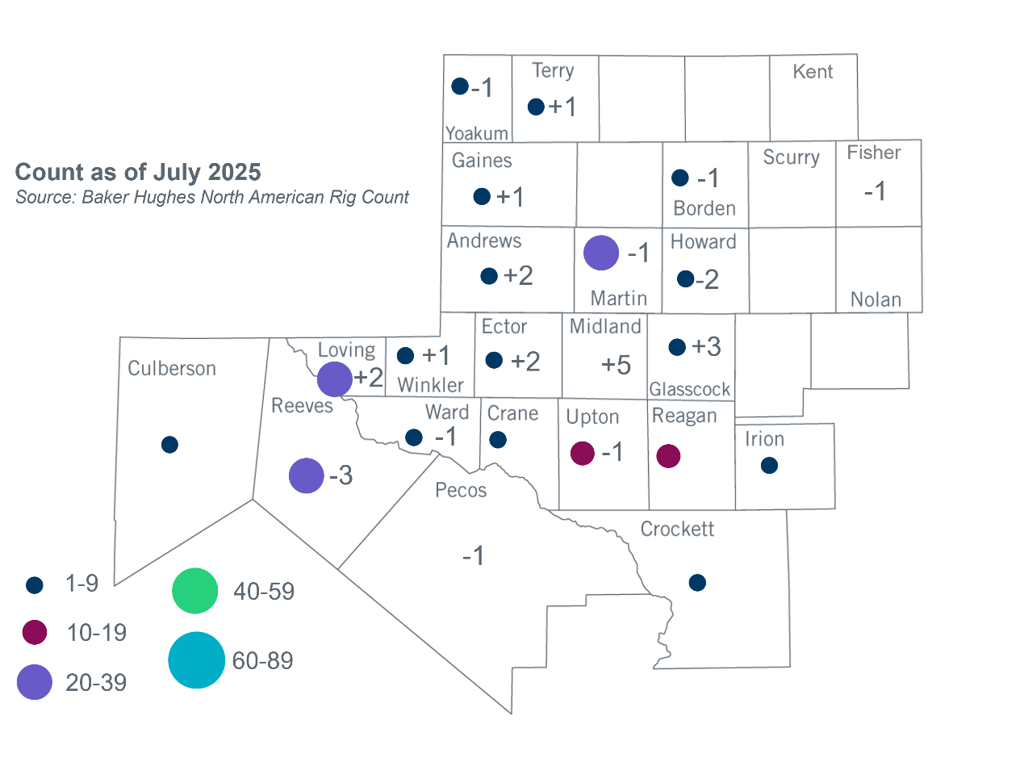Permian Basin Oil Rig Count[2]

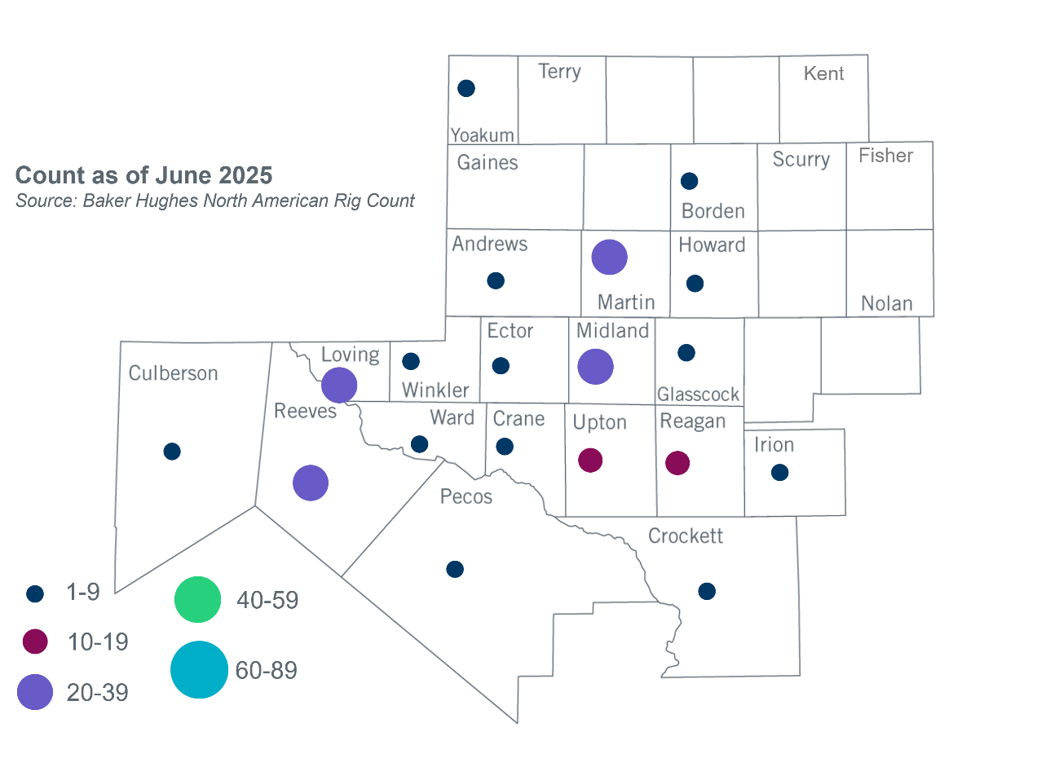

Other Notable Activities

* ERCOT presented the stability interface limits update for the 2025 Regional Transmission Plan (RTP) economic study at the July 2025 RPG meeting.

1. Based on the Total Project Estimated Cost for all future projects listed in the Transmission Project Information and Tracking (TPIT) report. TPIT is updated three times each year based on information TSPs provide in Model on Demand (MOD) as specified in the ERCOT Steady State Working Group Procedure Manual. The latest TPIT is available at https://www.ercot.com/gridinfo/planning.
2. +/- symbol indicates the increase or decrease from the previous month in oil rigs present in each county. There are 177 rigs, including a decrease of 5 oil rigs, in the Permian Basin from June to July.