RMTTF Meeting

Thursday, June 26, 2025

9:30 AM

This meeting is being held WebEx and in person.

Oncor

1616 Woodall Rodgers Fwy

Dallas, TX

Tomas Fernandez chaired the meeting.

Tomas welcomed everyone and proceeded with reading the antitrust statement and those listed on the WebEx. Those in the room introduced themselves.

**Attendees**

* Kathy Scott Centerpoint
* Amy Sue Stirland LP&L
* Debbie McKeever Oncor
* Melinda Earnest AEP
* Sheri Wiegand Vistra
* Monica Jones Centerpoint
* Art Deller ERCOT
* Eric Lotter GridMonitor
* Tomas Fernandez NRG
* Devon Hopper Oncor

**Meeting Agenda**

Tomas read the agenda. No questions were asked. No changes were made.

**Meeting Notes**

Meeting notes from the last meeting were reviewed.

None of the leadership received requests for other changes.

Meeting notes for our last meeting are considered final.

**LMS Stats**

ERCOT Learning Management System (LMS) counts for Web Based training modules are below.

Art noted that the stats are as of this morning.

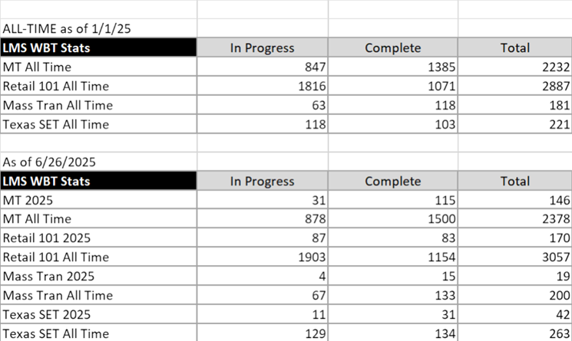

Tomas reviewed the LMS stats and survey feedback from the TXSET Survey held at VISTRA.

Overall feedback was positive, and each comment was reviewed in detail.

exas SET enrollment for 4/30/25 - 2/50 Art Deller Manager, Market Training 2705 West Lake Drive, Taylor, TX 76574 O: 512-248-6505 | M: 512-657-9775 ‍ ‍ ‍ ‍ ‍ ‍ ‍ ‍ ‍ ‍ ‍ ‍ ‍ ‍ ‍ ‍ ‍ ‍ ‍ ‍ ‍ ‍ ‍ ‍ ‍ ‍ ‍ ‍ ‍ ‍ ‍ ‍ ‍ ‍ ‍ ‍ ‍ ‍ ‍ ‍ ‍ ‍ ‍ ‍ ‍ ‍ ‍ ‍ ‍ ‍ ‍ ‍ ‍ ‍ ‍ ‍ ‍ ‍ ‍ ‍ ‍ ‍ ‍ ‍ ‍ ‍ ‍ ‍ ‍ ‍ ‍ ‍ ‍ ‍ ‍ ‍ ‍ ‍ ‍ ‍ ‍ ‍ ‍ ‍ ‍ ‍ ‍ ‍ ‍ ‍

**TX SET 5.0 Training held June 26th at Centerpoint.**

Tomas led the discussion. The instructors were Tomas, Monica, Sheri, Melinda, Kathy, Debbie and AmySue.

AmySue noted that corrections will be made to slide 98.

Tomas and Sheri emphasized the need to update and refine the presentation in August for the upcoming WebEx training on October 29th.

**TX SET 5.0 Training Surveys**

14 took the survey.

All positive comments.

Future action item:

Kathy suggested brining back Jeopardy for the TXSET training.

**Dates for 2025 Retail Training and Meetings**

Originally planned for August 7th, the meeting has been moved to August 5th at 1:30 PM after RMS – all were in favor. Melinda would send notice to ERCOT to advise of change for meeting.

Location of the October 28th RMTTF meeting – will be held at AEP time; 1:30 PM.

Below includes the updated schedule. We will review at each meeting.

* Designates WebEx only.

** Designates In person only

*** Designates In person and WebEx – as applicable to some RMTTF meetings only

Green highlighted text indicates past meeting or training prior to today’s meeting.

|  |  |  |  |
| --- | --- | --- | --- |
| Date | Time | Meeting or training | Comments |
|  |  |  |  |
| **FEBRUARY** |  |  |  |
| Tuesday, February 25 | 8:30 AM | MarkeTrak Part 1 * | 7:45 AM, Instructors arrive at ERCOT |
| Tuesday, February 25 | 1:30 PM | RMTTF meeting *** | WebEx and in person in at ERCOT |
| Wednesday, February 26 | 8:30 AM | MarkeTrak Part 2 * | 7:45 AM, Instructors arrive at ERCOT |
|  |  |  |  |
| **MARCH** |  |  |  |
| Thursday, March 20 | 9:30 AM | RMTTF meeting *** | WebEx and in person - Dallas at Oncor |
|  |  |  |  |
| **APRIL** |  | No meeting |  |
| Tuesday, April 29 | TBD | Training Set up | Instructors arrive late afternoon to Set up |
| Wednesday, April 30 | 8:30 AM | TX SET training** | 7:45 AM: Instructors arrive at CNP |
|  |  |  |  |
| **MAY** |  |  |  |
| Thursday, May 1st | 9:30 AM | RMTTF meeting*** | WebEx and In person at CNP |
|  |  |  |  |
| **JUNE** |  |  |  |
| June 18 | 8:30 AM | Retail 101 | WebEx only |
| Wednesday, June 25 | 8:30 AM | TX SET Training ** | In person only – Irving at Vistra |
| Thursday, June 26 | 9:30 AM | RMTTF meeting*** | WebEx and in person in Dallas at Oncor |
|  |  |  |  |
| **JULY** |  | NO MEETING |  |
|  |  |  |  |
| **AUGUST** |  |  |  |
| Thursday, August 5 | 1:30 AM | RMTTF meeting*** | In person WebEx only - Austin |
|  |  |  |  |
| **SEPTEMBER** |  |  |  |
| Wednesday, September 24 | 8:30 AM | MarkeTrak Part 1* | 7:45 AM: Instructors arrive at Oncor |
| Wednesday, September 24 | 1:30 PM | RMTTF meeting*** | WebEx and In person in Dallas at Oncor |
| Thursday, September 25 | 8:30 AM | MarkeTrak Part 2 * | 7:45 AM: Instructors arrive at Oncor |
|  |  |  |  |
| **OCTOBER** |  |  |  |
| Tuesday, October 28 | 1:30 PM | RMTTF Meeting*** | WebEx and In person at Corpus Christi |
| Wednesday, October 29 | 8:30 AM | TX SET Training * | 7:45 AM: Instructors arrive at AEP |
|  |  |  |  |
| **NOVEMBER** |  | NO MEETING |  |
| **DECEMBER** |  |  |  |
|  |  |  |  |
| Thursday, December 4 | 9:30 AM | RMTTF meeting * | WebEx only |

**Next Meeting**

August 5th.

**Other Business**

No other business was noted.

**Adjourn**

Tomas thanked everyone for attending.

Tomas adjourned the meeting.