**PWG Meeting Notes** – June 18, 2025

ERCOT MET Center & Via WebEx 9:30 AM

Attendees:

|  |  |  |  |
| --- | --- | --- | --- |
| Richard Beasley - CNP | Amar Khalifeh - ERCOT | Steve Pliler - Vistra | Sheri Wiegand - Vistra |
| Robert Bevill - TNMP | Eric Lotter – Grid Monitor | Nick Reedy - CimView |  |
| William Butler LP&L | Krista Ortiz – LP&L | Bill Snyder - AEP |  |
| Laura Gomez – LP&L | Sam Pak - Oncor | Jordan Troublefield - ERCOT |  |
| Monica Jones - CNP | Kyle Patrick - NRG | Viviana Valdez – LP&L |  |

* **Admonition**
  + Sam Pak advised the attendees of the Antitrust Admonition**.**
* **Introductions, Agenda Overview**
  + Sam confirmed the meeting participants and reviewed the agenda.
* **Review of May 21st Meeting Notes**
  + Sam said the attendee list on the 5/21 meeting notes may be incomplete and he invited any needed corrections. He asked the REPs for feedback on the AV slides presented. Sheri said there are no action items, although further discussion of “flip-flops” among the BUS load factors is needed. He also said the current process examines load on an hourly basis; resulting in average load being compared against temperature and washing out the variance. Amar said the difficulty will be implementing the changes through code updates. Rob asked why residential is not included in the discussion. Sheri and Sam recounted that the residential enhancement discussion landed on examining the heating and cooling degree day aspect, and the accompanying six data points. Sheri summarized the approach as looking at hourly data instead of averages.
  + Amar said there are 3.6 million RESLOWR ESIs in the ERCOT market, and there 3.5 million RESHIWR ESIs in the market. Residential ESIs account for 7.3 million of the total 8.3 million ESIs in ERCOT. Sheri questioned if the LO/HI default assignments are still accurate. Amar said examination of January and February is useful in determining premises using electric heat. Sheri and Amar calculated the approach provides 600+ sample points, which Amar said should be satisfactory. Amar added if a Uri-like event happened, data points may be missing, in which another year would be substituted in. Rob asked if a RES load averages HI, would that simply indicate a large house? Amar said load size is not reviewed, instead the relationship between load and weather is the determining factor.
* **Update BUSIDRRQ & LRG Profile Market Counts**
  + Rob advised the TNMP count is unchanged, and that TNMP will soon issue a market notice advising REPs may request lists of their ESIs to be converted from BUSIDRRQ. The goal was to perform the transition during the July meter cycles.

* **2025 RES and BUS Annual Validation Update**
* Amar asked Sheri about an email he had received from her. Sheri advised that previously a REP could request a list of ESIs that had changed in AV designation. She said the market notice reminding of the option was sent in March. Sheri recommended distributing the market notice via the RMS List Serv.
* Amar reviewed the Profile Validation Status. He observed there is substantial progress among the top three in completion percentage, although the work is ongoing.
* Amar spoke to the slide titled “Impact of Tweaking Profile Change Criteria for BUS.”
* 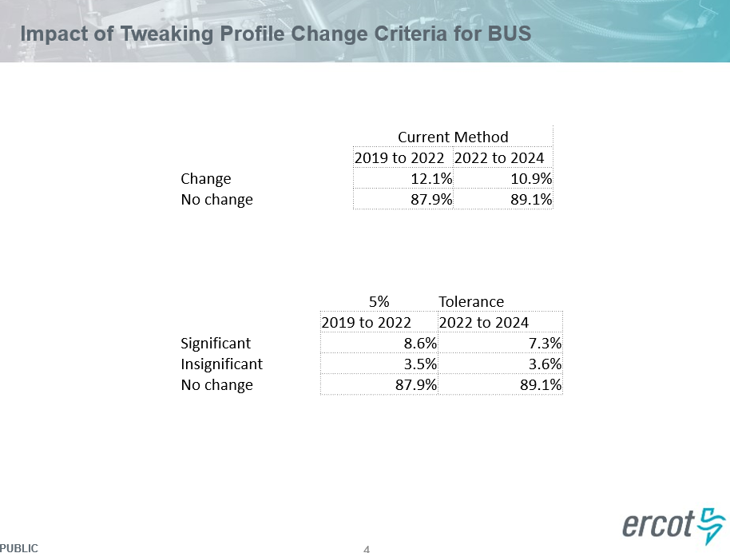
* He said if the change is based on 5% of the load factor, the current method has a profile change of 12.1% while the new method has an 8.6% rate. The result of the new method is 10,000 fewer ESIs changing. Amar added that a 10% load factor criteria would result in 20,000 fewer ESIs changing. Amar opined that 10% may be too much. He suggested reviewing anything below 38% and above 42% as a basis on whether a profile changes, given the threshold for BUSLO to BUSMED is 40% Sheri summarized the current enhancement discussion as settling on **calculating the load factor for the year; and if the load factor should remain unchanged if the value falls within 38-42%. In other words, if a current BUSLO profiled ESI came in with a 42% load factor during the valuation process, the profile would remain on BUSLO. The 5% method addresses the flip-flops and weather variance.** Sheri also said astute customers who are always on the cusp of LO can contact the REP to request the TDU make the change to LO. [ACTION ITEM] Sam asked Amar if the numbers could be processed using this approach to evaluate its effectiveness for the next meeting, to which Amar agreed.
* **TAC Assessment**
* Sam asked the attendees if an ad hoc discussion regarding the TAC assessment could be placed on the meeting agenda, with no dissent offered.
* In completing the assessment form, PWG answers included:
  + The frequency of PWG meetings is typically monthly with a duration of three hours.
  + Typical attendance is fifteen.
  + PWG has pivoted to a meeting format of 60% Webex and 40% In-person/Webex hybrid.
  + The Review of Scope discussion confirmed there is no redundancy among the working groups under RMS.

* **Review Draft LPGRR Conversion of the Profile Decision Tree from Excel to Word format**
* Sam reminded that in the 5/21 meeting it was agreed to convert the definitions section to a table form. It was decided this editing session should focus on high-level document arrangement rather than verbiage edits. Although discussion of the FAQs did include revising verbiage. The FAQ editing session led to agreement that many of the FAQs are self-evident and can be removed. The instructive questions will be moved to their respective sections within the Decision Tree.
* Other discussion points included:
  + Confirmation that 20.1.1 should include attributes of each load profile.
  + The DG Template, list of Valid Profile IDs, and Zip to Zone tabs should be moved to the Appendix where the Appendix D will convert to Word format.
* [ACTION ITEM] Sam took the action item of concatenation of the Load Profiles document.
  + Profile Type = Profile Group + Profile Segment
  + Profile Groups include Non-Metered, RES, BUS
  + Profile Segments are different for each profile group:
    - NM – Light and Flat
    - RES – HI and LO with possible extensions PV, WD, DG
    - BUS – HI, MED, and LO, NODEM, O&G with possible extensions PV, WD, DG
  + There are total of 1672 valid load profiles
* **Future Meeting Date**: Sam confirmed 7/23 as the next PWG meeting date (subsequently updated to 8/13).
* The meeting adjourned at 2:04 pm.
* **Draft agenda points for 8/13 meeting**
  + Agenda will follow up on many carryover items:
    - TNMP BUSLRG conversion update
    - 2025 RES/BUS AV update and progress
    - AV Enhancements for BUS bandwidth LO/MED load factor (~38%-42% data analysis)
    - Review Draft LPGRR Conversion of the Profile Decision Tree from Excel to Word format