The Electric Reliability Council of Texas

Operations Training Working Group

**June 13th, 2024**



Operations Training Working Group (OTWG)

# Minutes

June 13th, 2024

WebEx

0900-1100

Meeting Roster:Completed during the meeting

ATTENDANCE:

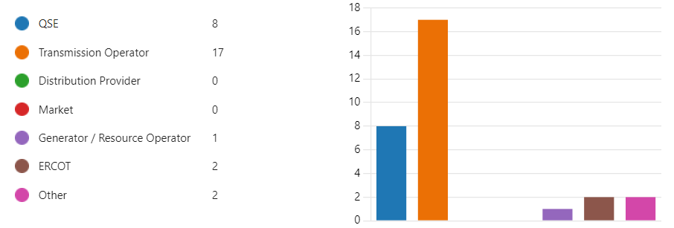

### Anti-trust Admonition:

To avoid raising concerns about antitrust liability, participants in ERCOT activities should refrain from proposing any action or measure that would exceed ERCOT’s authority under federal or state law. For additional information, stakeholders should consult the Statement of Position on Antitrust Issues for Members of ERCOT Committees, Subcommittees, and Working Groups, which is posted on the ERCOT website.

### Disclaimer:

All presentations and materials submitted by Market Participants or any other Entity to ERCOT staff for this meeting are received and posted with the acknowledgement that the information will be considered public in accordance with the ERCOT Websites Content Management Operating Procedure.

# Open Session

Chair/Vice-Chair will only recognize those that use the ‘raise hand” feature in WebEx

|  |  |  |
| --- | --- | --- |
| Previous meeting minutes | Made Motion | James Webb |
|  | 2nd Motion | Kevin Griffin |

## CURRENT/UPCOMING EVENTS - 2024 Training Schedule

### Load Shed Workshops.

* + - Winter – Thursday December 5, 2024, 09-12

## OPERATIONS NOTICES, NOGRRs and NPRRs

NOGRR 247 concerning UFLS. Review the notice and the dates of these UFLS to be in effect.



## ITEMS FOR DISCUSSION

Chair: [Manuel.Sanchez@oncor.com](mailto:Manuel.Sanchez@oncor.com)

Vice-Chair: [Benjamin.Ray@austinenergy.com](mailto:Benjamin.Ray@austinenergy.com)

## TASK FORCES & TRAINING EVENTS

* Interest in serving on Task Forces should be emailed to Leadership (above)
* An NDA on file with ERCOT is required to join OTWG Task Forces and participate in CLOSED sessions (one document covers all TFs Forces - NO renewal required)

Email to [NDA@ercot.com](mailto:NDA@ercot.com)

### ERCOT Operator Certification Task Force (EOCTF) – Updates

**Chair Steve Rainwater, Vice-Chair Dante' Jackson**

**Members – James Wallace**

**Requesting additional members – seeking member(s) from a QSE**

* If there are problems with registration to the exam, contact and coordinate with PSI.
* Use the Contact # PSI Candidate support at 855-746-8173 for any problems.
* ERCOT reviewed the question bank and failure rates to complete an item analysis and evaluate the passing rates to be above 65%.
* From past weeks, updates to the test question banks have been made to bring clarity and more consistency with the intended ERCOT Operator Certification objectives.

### Human Performance Improvement Topics – No Updates

* Ideas for HPI topics:
  + Access to NERC data for Human Error events and David Penny can share some of this data to the group for reference and analysis. No information related to Human or Performance Metrics at the moment.



* + Potentially have a workshop or session to discuss ideas, resources and data collection to performance metrics or Human Error events data.

### ERCOT Black Start Restoration Training Task Force (BSTTF) – Updates

**Chair John Jarmon, Vice-Chair N. Perio**

**Members –, S. Aragon, A. Ballew, D. Penny, Jonathan Love**

2024 Black Start Training

* New features are being developed in GridGeo
  + On Track to use Grid Geo for Black Start Training Simulation Exercises during Cycle 5.
  + A new Grid Geo release will be tested starting the week of 5/13 – 5/17 in preparations to the training
  + Losing islands due to generation issues – user awareness for hitting minimum excitation limiter
  + TO alarm identification – will only see their own alarms/equipment
* 2024 and beyond will be held on-site (Taylor ERCOT T4) and typically 2.5 days of simulation and CBTs for additional CE hours.
* Market notice to be sent no later than first week of September. Market participants recommended to send that notification earlier than September for planning attendance.
* Dates for the weeks of October 14th - November 21st, 2024 are confirmed.
* Pilot session most likely not be available at this time. The plan is to have the regular six sessions for the training.
* Grid Geo training prior to the training will be available and details will follow closer to the training cycle.
* Training will be provided to become familiar with the new Grid Geo tool. Some internal discussion will evaluate the approach.
  + Proposed a couple of WebEx sessions
  + No CEHS
  + Potentially use LMS to have the material before formal training.
* The Black Start Seminar will include:
  + A CBT portion that is in development.
  + CBT will award CEHs and will be a pre-requisite before participating to the in-person simulation. This can be completed through ERCOT LMS site.
  + One ILA divided in three segments, one segment per day and each segment will award hours. In order to receive hours, participants must attend the entire session.
  + The plan for the in-person session is two and a half days (Tuesday afternoon, all day Wednesday, and all day Thursday).

### ERCOT Region Operator Training Seminar Task Force (OTSTF) – Updates

**Chair Manuel Sanchez, Vice-Chair Aaron Ballew**

**Member – M. Cruz-Montes, Jonathan Love**

**Requesting additional members**

Topics for 2025 Operations Training Seminar (OTS)

* ERCOT will plan to include some additional topics related to QSEs.
* ERCOT is planning to host next year’s OTS on March-April timeframe (cycle 2).
* No plans to have simulation exercises at next year’s OTS.
* ERCOT is accepting requests for training in specific topics. Please reach out to OTWG members or send your recommendations via email.

### ERCOT Severe Weather Drill Task Force (SWDTF) – Updates

**Chair Nate Perio, Vice-Chair John Jarmon**

**Member –Jonathan Love**

**Requesting additional members**

* During cycle 4 2024
  + Facilitation Window Thursday 8/29/2024.
  + This session will be related to emergency notifications and communications with the expectation of market participants to respond to these emergency notifications.
  + Additional details will be available at a later time.

## Trainers sharing with Trainers

Training with Mixed Media – TBD

* TBD

June’s Presentation by: _TBD_

## OLD Business

* + Include joint ERCOT-TSP IROL training as required by NERC PER either as part of black start, seminar or stand alone. This will be discussed in more details as needed.
* Future OTWG Meeting dates:

Jul 08, 2024 - OTWG Meeting - Webex Only

Aug 08, 2024 - OTWG Meeting

Sep 12, 2024 - OTWG Meeting - Webex Only

Oct 10, 2024 - OTWG Meeting

Nov 14, 2024 - OTWG Meeting - Webex Only

Dec 12, 2024 - OTWG Meeting - Webex Only

## NEW Business

None at this time.

# Closed Session

|  |  |  |
| --- | --- | --- |
| No need for closed session | Motion Made | James Ballard |
|  | 2nd Motion | Jeff Branch |

# Adjourn

Time: Adjourned on June 13th 2024 at 0937.