The Electric Reliability Council of Texas

Operations Training Working Group

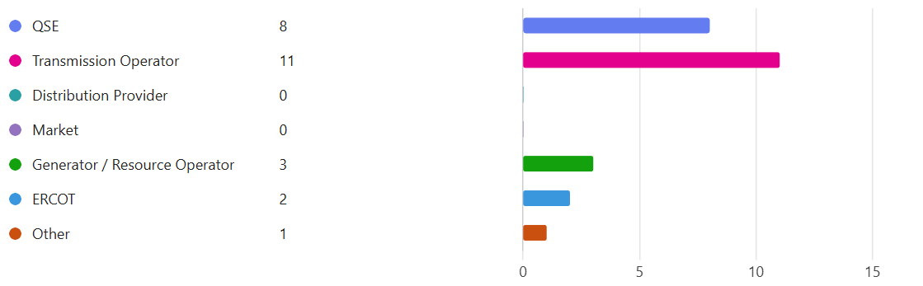

**February 13th, 2025**



Operations Training Working Group (OTWG)

# Minutes

February 13th, 2025

WebEx

0900-1100

Meeting Roster:insert Results

### Anti-trust Admonition:

To avoid raising concerns about antitrust liability, participants in ERCOT activities should refrain from proposing any action or measure that would exceed ERCOT’s authority under federal or state law. For additional information, stakeholders should consult the Statement of Position on Antitrust Issues for Members of ERCOT Committees, Subcommittees, and Working Groups, which is posted on the ERCOT website.

### Disclaimer:

All presentations and materials submitted by Market Participants or any other Entity to ERCOT staff for this meeting are received and posted with the acknowledgement that the information will be considered public in accordance with the ERCOT Websites Content Management Operating Procedure.

# Open Session

Chair/Vice-Chair will only recognize those that use the “raise hand” feature in WebEx

|  |  |  |
| --- | --- | --- |
| Previous meeting minutes | Made Motion | Rosemary H. |
|  | 2nd Motion | Michael G. |

## CURRENT/UPCOMING EVENTS - 2025 Training Schedule

None

## OPERATIONS NOTICES, NOGRRs and NPRRs

NOGRR 247 concerning UFLS. Review the notice and the dates of these UFLS to be in effect.

Market Notification Link: <https://www.ercot.com/services/comm/mkt_notices/M-A022924-01>



NOGRR 245 just passed. See status and documentation related to this NOGRR. <https://www.ercot.com/mktrules/issues/NOGRR245#summary>

Location of all NOGRR - <https://www.ercot.com/mktrules/issues/reports/nogrr>

## ITEMS FOR DISCUSSION

Chair: [Manuel.Sanchez@oncor.com](mailto:Manuel.Sanchez@oncor.com)

Vice-Chair: [Benjamin.Ray@austinenergy.com](mailto:Benjamin.Ray@austinenergy.com)

## TASK FORCES & TRAINING EVENTS

* Interest in serving on Task Forces should be emailed to Leadership (above)
* An NDA on file with ERCOT is required to join OTWG Task Forces and participate in CLOSED sessions (one document covers all TFs Forces - NO renewal required)

Email to [NDA@ercot.com](mailto:NDA@ercot.com)

### ERCOT Operator Certification Task Force (EOCTF)

**Chair Steve Rainwater, Vice-Chair Dante' Jackson**

**Members – James Wallace**

**Requesting additional members – seeking member(s) from a QSE**

* ERCOT has closing agreements with a new vendor.
* ERCOT will finalize transition and data conversion for the exam and new testing platform.
* New vendor will complete training with ERCOT personnel using the new platform.
  + The ERCOT Certification test will be remote using a local proctor to help manage and validate that the testing location is secured.
  + The proctor will need to lock web browser configurations to avoid invalidating the test.
* ERCOT will begin testing on site at Taylor starting February 4th. Use the link below for more details:

<https://web.cvent.com/event/1b1ffc4d-f78a-4e4b-b36b-2894e2835863/summary>

* There will be a waiting list for the first two sessions to allocate candidates who want to take the exam.
* ERCOT will open test every two weeks throughout the year. Cost will be $50 via credit card using CVENT to complete registration.
* Waiting period will be 21 days before retest.
* PLEASE USE THE CVENT SITE FOR ALL QUESTIONS. A FAQ document will be added to the site for more details.
* No testing center will be available at this time. There are a few logistics to work out before using external proctors other than ERCOT’s site.



### Human Performance Improvement Topics

* Ideas for HPI topics:
  + Identify topics for Human Performance Metrics for Real-Time operations.
  + Visit NERC Event reports for additional resources at <https://www.nerc.com/pa/rrm/ea/Pages/Major-Event-Reports.aspx>
  + Visit NERC lessons learned site for additional reference at <https://www.nerc.com/pa/rrm/ea/Pages/Lessons-Learned.aspx>
  + Visit the <https://www.natf.net/> portal for HPI resources, discussion boards and initiatives, other companies are doing related to Human Performance Improvement.
  + There will be a Human Performance in Action Conference March 17th – 19th, 2025 in Westin River Walk San Antonio, TX. Please see registration link at: [HPAC Registration 2025](https://isolate.menlosecurity.com/1/3735928009/https:/linkprotect.cudasvc.com/url?a=http%3a%2f%2fwww.humanperformanceinaction.com%2f&c=E,1,y2oDnQd-x0hrtSDJbHWzNNQgq3bKwtE6RvPrvrP4LG7UlO77l1tZ7nZSr0wW4L-xwQC6EGffhICUIf_aFafmVQ9qyfn4z9V_S_kXYRbP&typo=1)
    - See details in the link: <https://www.humanperformanceinaction.com/>

### ERCOT Black Start Restoration Training Task Force (BSTTF)

**Chair Mark Spinner, Vice-Chair Nate Perio**

**Members –, S. Aragon, A. Ballew, D. Penny, Jonathan Love**

BSTTF Chair Nominations: Mark Spinner

Mark Spinner was selected as the Chair for ERCOT Black Start Restoration Training Task Force

2025 Black Start Training

* This Task force will need a new chair for 2025.
* Onsite training during Weeks of October-November 2025.
* Traditionally will be 20 hrs of simulation plus the EOP standard portion (~7 CEHs).

### ERCOT Region Operator Training Seminar Task Force (OTSTF)

**Chair Manuel Sanchez, Vice-Chair Aaron Ballew**

**Member – M. Cruz-Montes, Jonathan Love**

**Requesting additional members**

Topics for 2025 Operations Training Seminar

* ERCOT will plan to include some additional topics related to QSEs.
  + ERCOT included additional speakers from market participants. Enough material for 1.5 days of training with total CEHs of about 12 hrs.
  + Topics locked in and confirmed to be available for each week of training
    - 1.5 Hour – RTC Project (ERCOT - Matt Mereness Sr Director Strategic Mkt Design Programs and Delivery)
    - 1 Hour - System Restoration requirement (ERCOT - Bobby Gray)
    - 1 Hour Summer Weather Outlook (Chris Coleman)
    - 2 Hrs MPs, TOAPS, RAPS, PCAPS - which are automatic and which is manual. This would need to be high level due to confidentiality (Steve Rainwater team).
    - 1 Hr TRE Topic
    - 1.5 Hr Oncor Load shed process
    - 0.5 Hr System Restoration
* Planning for next year’s OTS on March-April timeframe.
  + 2025 Training weeks:
    - No Pilot – Week of March 10 or Week of March 17 (only for the presenters, no market participants expected)
    - Week 1     3/25-3/26
    - Week 2     4/1-4/2
    - Week 3     4/8-4/9
    - Week 4     4/15-4/16
    - Week 5     4/22-4/23
    - Week 6     4/29-4/30
* No EEA or emergency training with the seminar. No virtual options for the seminar at this time.
* Registration link will not work until 2/19/25.
* ERCOT requests to pay attention on last day to cancel or modify registrations. Use the details from the market notice.
* Market notice will be sent out the week of February 10th.



### ERCOT Severe Weather Drill Task Force (SWDTF)

**Chair Nate Perio, Vice-Chair**

**Member –Jonathan Love**

**Requesting additional members**

* Planning for the month of June cycle training (6/6/25, Hurricane Drill).
* This session will be a communication drill.
* More details will be released later.

## OLD Business

* The discussion of the South Texas IROL training has been taken off the table. This decision was made due to confidentiality and complexity of the topic for market participants.

## NEW Business

* None

## Upcoming OTWG Meetings

* OTWG Meeting dates:

March 13th, 2025 – OTWG Meeting

April 10th, 2025 – OTWG Meeting – Consider this meeting in person.

May 8th, 2025 – OTWG Meeting

June 12th, 2025 – OTWG Meeting

July 17th, 2025 – OTWG Meeting

August 14th, 2025 – OTWG Meeting

September 18th, 2025 – OTWG Meeting

October 9th, 2025 – OTWG Meeting

November 13th, 2025 – OTWG Meeting – Potential Cancellation due to ERCOT Black Start

December 11th, 2025 – OTWG Meeting

# Closed Session

|  |  |  |
| --- | --- | --- |
| No need for closed session | Motion Made | Kevin G. |
|  | 2nd Motion | Steve R. |

# Adjourn

Time: Adjourn on February 13th, 2025 at 0927.