The Electric Reliability Council of Texas

Operations Training Working Group

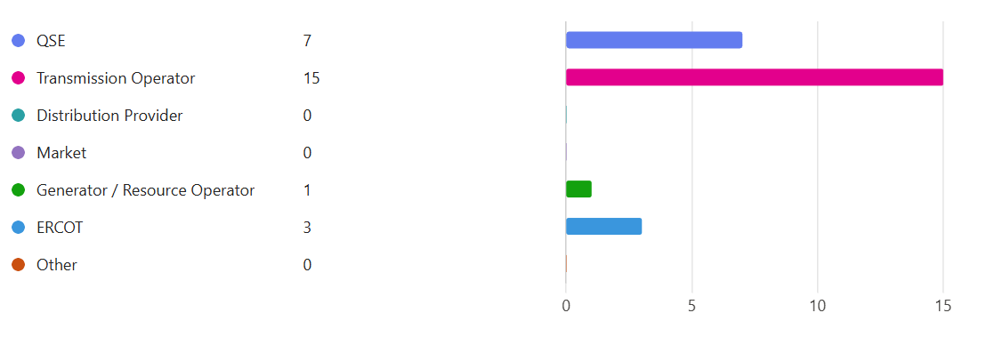

**December 12th, 2024**



Operations Training Working Group (OTWG)

# Agenda

December 12th, 2024

WebEx

0900-1100

Meeting Roster:[link](https://isolate.menlosecurity.com/1/3735928009/https:/forms.office.com/g/9eC8LNhFfB) disabled after meeting.

Completed during the meeting

### Anti-trust Admonition:

To avoid raising concerns about antitrust liability, participants in ERCOT activities should refrain from proposing any action or measure that would exceed ERCOT’s authority under federal or state law. For additional information, stakeholders should consult the Statement of Position on Antitrust Issues for Members of ERCOT Committees, Subcommittees, and Working Groups, which is posted on the ERCOT website.

### Disclaimer:

All presentations and materials submitted by Market Participants or any other Entity to ERCOT staff for this meeting are received and posted with the acknowledgement that the information will be considered public in accordance with the ERCOT Websites Content Management Operating Procedure.

# Open Session

Chair/Vice-Chair will only recognize those that use the “raise hand” feature in WebEx

|  |  |  |
| --- | --- | --- |
| Previous meeting minutes | Made Motion | Kevin Griffin |
|  | 2nd Motion | Michael Goulding |

## CURRENT/UPCOMING EVENTS - 2024 Training Schedule

None

## OPERATIONS NOTICES, NOGRRs and NPRRs

NOGRR 247 concerning UFLS. Review the notice and the dates of these UFLS to be in effect.

Market Notification Link: <https://www.ercot.com/services/comm/mkt_notices/M-A022924-01>



## ITEMS FOR DISCUSSION

Chair: [Manuel.Sanchez@oncor.com](mailto:Manuel.Sanchez@oncor.com)

Vice-Chair: [Benjamin.Ray@austinenergy.com](mailto:Benjamin.Ray@austinenergy.com)

## TASK FORCES & TRAINING EVENTS

* Interest in serving on Task Forces should be emailed to Leadership (above)
* An NDA on file with ERCOT is required to join OTWG Task Forces and participate in CLOSED sessions (one document covers all TFs Forces - NO renewal required)

Email to [NDA@ercot.com](mailto:NDA@ercot.com)

### ERCOT Operator Certification Task Force (EOCTF)

**Chair Steve Rainwater, Vice-Chair Dante' Jackson**

**Members – James Wallace**

**Requesting additional members – seeking member(s) from a QSE**

* The ERCOT Operator Certification exam has been temporarily suspended due to coordination issues with testing center. ERCOT is looking into options to resolve this issue.
* ERCOT notification sent to all market participants on September 9th indicating the ERCOT Operator Certification exam has been temporarily suspended. See note below:



* ERCOT has closing agreements with a new vendor.
* ERCOT will finalize transition and data conversion for the exam and new testing platform.
* New vendor will complete training with ERCOT personnel using the new platform.
  + The ERCOT Certification test will be remote using a local proctor to help manage and validate that the testing location is secured.
  + The proctor will need to lock web browser configurations to avoid invalidating the test.

### Human Performance Improvement Topics

* Ideas for HPI topics:
  + Access to NERC data for Human Error events, see David Penny’s shared information for reference and analysis. No information related to Human or Performance Metrics at the moment.



* + Identify topics for Human Performance Metrics for Real-Time operations.
  + Visit NERC Event reports for additional resources at <https://www.nerc.com/pa/rrm/ea/Pages/Major-Event-Reports.aspx>
  + Visit NERC lessons learned site for additional reference at <https://www.nerc.com/pa/rrm/ea/Pages/Lessons-Learned.aspx>
  + Visit the <https://www.natf.net/> portal for HPI resources, discussion boards and initiatives, other companies are doing related to Human Performance Improvement.
  + There will be a Human Performance in Action Conference March 17th – 19th, 2025 in Westin River Walk San Antonio, TX. Please see registration link at: [HPAC Registration 2025](https://isolate.menlosecurity.com/1/3735928009/https:/linkprotect.cudasvc.com/url?a=http%3a%2f%2fwww.humanperformanceinaction.com%2f&c=E,1,y2oDnQd-x0hrtSDJbHWzNNQgq3bKwtE6RvPrvrP4LG7UlO77l1tZ7nZSr0wW4L-xwQC6EGffhICUIf_aFafmVQ9qyfn4z9V_S_kXYRbP&typo=1)
    - See details in the link: <https://www.humanperformanceinaction.com/>

### ERCOT Black Start Restoration Training Task Force (BSTTF)

**Chair VACANT, Vice-Chair N. Perio**

**Members –, S. Aragon, A. Ballew, D. Penny, Jonathan Love**

2025 Black Start Training

* This Task force will need a new chair for 2025.
* December 31st is the last day to complete the CBT of 2024 Black Start.
* CBT hours from September and October are currently awarded, if CBT is complete in December, hours will be awarded in January 2025.
* If there are any problems with access to CBT or your hours have not been rewarded, contact Sarah Janak from ERCOT.
* Visit the [2024 ERCOT Black Start CVENT](https://web.cvent.com/event/a928275a-1e08-4922-865f-b3ac980cb101/websitePage:05606f8c-1a81-40cb-8869-146cccab7436) details for additional information.

### ERCOT Region Operator Training Seminar Task Force (OTSTF)

**Chair Manuel Sanchez, Vice-Chair Aaron Ballew**

**Member – M. Cruz-Montes, Jonathan Love**

**Requesting additional members**

Topics for 2025 Operations Training Seminar

* ERCOT will plan to include some additional topics related to QSEs.
  + ERCOT will include additional speakers from market participants as needed.
  + Topics locked in and confirmed to be available for each week of training
    - 1 Hour – RTC Project (ERCOT - Matt Mereness Sr Director Strategic Mkt Design Programs and Delivery)
    - 1 Hour - System Restoration requirement (ERCOT - Bobby Gray)
    - 1-4 Hour Topic on Ukraine Cyber attack (Tim Conway)
    - 1 Hour Summer Weather Outlook (Chris Coleman, Mark Witte backup)
    - 2 Hrs MPs, TOAPS, RAPS, PCAPS - which are automatic and which is manual. This would need to be high level due to confidentiality (Steve Rainwater team).
    - 1 Hr VAR Standard (placeholder)
    - 1 Hr TRE Topic
    - 1.5 Hr (Oncor) Load shed process
    - Market Participant Topic(s)
* Planning for next year’s OTS on March-April timeframe.
  + Planning for after spring break week.
  + Proposed weeks:
    - Pilot – Week of March 10 or Week of March 17 (only for the presenters, no market participants expected)
    - Week 1     3/25-3/27
    - Week 2     4/1-4/3
    - Week 3     4/8-4/10
    - Week 4     4/15-4/17
    - Week 5     4/22-4/24
    - Week 6     4/29-5/1
* No EEA or emergency training with the seminar.
* If there are any additional topics for future OTS, please reach out to OTWG members or send your recommendations via email.

### ERCOT Severe Weather Drill Task Force (SWDTF) –No Updates

**Chair Nate Perio, Vice-Chair**

**Member –Jonathan Love**

**Requesting additional members**

* No updates

## Trainers sharing with Trainers

Training with Mixed Media – TBD

* TBD

July’s Presentation by: _TBD_

## OLD Business

**None**

## NEW Business

* Future OTWG Meeting dates:
* Second Thursdays of the month: (Recommended dates below)

January 9th, 2025 – OTWG Meeting

February 13th, 2025 – OTWG Meeting

March 13th, 2025 – OTWG Meeting

April 10th, 2025 – OTWG Meeting – Potential Cancellation

May 8th, 2025 – OTWG Meeting

June 12th, 2025 – OTWG Meeting

July 10th, 2025 – OTWG Meeting

August 14th, 2025 – OTWG Meeting

September 11th, 2025 – OTWG Meeting

October 9th, 2025 – OTWG Meeting

November 13th, 2025 – OTWG Meeting

December 11th, 2025 – OTWG Meeting

# Closed Session

|  |  |  |
| --- | --- | --- |
| No need for closed session | Motion Made | James Ballard |
|  | 2nd Motion | Jeff Branch |

# Adjourn

Time: Adjourn on Thursday December 12th, 2024 at 0920.