|  |  |  |  |
| --- | --- | --- | --- |
| NPRR Number | [1282](https://www.ercot.com/mktrules/issues/NPRR1282) | NPRR Title | Ancillary Service Duration under Real-Time Co-optimization |
|  | |  | |
| Date | | June 18, 2025 | |
|  | |  | |
| Submitter’s Information | | | |
| Name | | Nitika Mago | |
| E-mail Address | | [Nitika.mago@ercot.com](mailto:Nitika.mago@ercot.com) | |
| Company | | ERCOT | |
| Phone Number | | 512-248-6601 | |
| Cell Number | |  | |
| Market Segment | | Not applicable | |

|  |
| --- |
| Comments |

ERCOT appreciates the robust discussion on Nodal Protocol Revision Request (NPRR) 1282 and supports the Technical Advisory Committee’s (TAC’s) recommendation. To help support discussion by the Board of Directors (Board), ERCOT provides a summary of why the changes are needed, additional details and context, and a final recommendation.

**Summary of changes:**

NPRR1282 specifies the duration requirements of Ancillary Services (“AS”) that are procured in the Real-Time Market (RTM) based on reliability needs for energy sufficiency to respond to typical events that may be experienced on the ERCOT System. The version of NPRR1282 that was approved by TAC would address the duration for each AS as follows:

1. Increase Regulation Service and Response Reserve (RRS) duration from 15 minutes to 30 minutes for both qualification and procurement. Why?
   * Under Real-Time Co-optimization Plus Batteries (RTC+B), when Security-Constrained Economic Dispatch (SCED) systems fail but Load Frequency Control (LFC) is functioning, RRS’s Primary Frequency Response (PFR) and Regulation Service will be the “first line of defense” to maintain frequency.
   * There were 80 planned and unplanned events between November 2013 and September 2024 when SCED failed but LFC was functioning. 90% of those events lasted for 30 minutes or less.
   * North American Electric Reliability Corporation’s (NERC’s) BAL-001 Reliability Standard requires that ERCOT’s average Area Control Error (ACE) not exceed the Balancing Authority ACE Limit (BAAL) for more than 30 minutes, including during an Energy Emergency Alert (EEA) condition.
   * Based on ERCOT’s analysis, an increase in duration for Regulation Service and RRS is essential to reduce the risk of violating ERCOT’s NERC BAL-001 obligation in the event that SCED is not available due to unplanned events. It is further worth noting that this change should not preclude the qualification of most Energy Storage Resources (ESRs) that are currently operating, since most ESRs have a duration capability that exceeds 30 minutes.
2. Decrease ERCOT Contingency Reserve Service (ECRS) duration from two hours to one hour for both qualification and procurement. Why?
   * On days when intra-hour forecasts are consistently under-forecasting the Net Load, ECRS may be needed until a Resource providing Off-Line Non-Spinning Reserve (Non-Spin) can be brought On-Line. Off-Line Non-Spin units are required to be On-Line and capable of operating at the awarded Non-Spin level within 30 minutes upon deployment.
   * In ERCOT’s experience, most extreme under-forecast events of 30-minute-ahead Net Load forecast have lasted between 30 minutes and 60 minutes. Further, all but one (November 10, 2024) ECRS deployments that were related to ramping have lasted between 30 minutes and 60 minutes.
   * Based on the above observations, a one-hour duration is anticipated to be sufficient to cover reliability needs during events with sustained under-forecast error in the intra-hour Net Load forecast.
3. Retain the four-hour duration for Non-Spin for both qualification and procurement. Why?
   * On days when hourly forecasts are consistently under-forecasting the Net Load, Non-Spin may be needed until the next off-line unit can be brought on. Analysis has shown that 50% of the time the next unit that the Control Room has committed using the Reliability Unit Commitment (RUC) process to solve for capacity issues is approximately six hours away.
   * In ERCOT’s experience, several extreme under-forecast events of six-hour-ahead Net Load forecast have lasted more than four hours. Further, 61 out of 65 Non-Spin deployments that were related to under-forecast in Net Load or Forced Outages on non-scarcity days[1] have lasted up to four hours. The remaining four Non-Spin deployments lasted between four and ten hours.
   * Based on the above observations, four-hour duration is essential to cover the reliability needs during events with sustained under-forecast error in the hourly Net Load forecast and/or Forced Outages.
4. Match the duration requirement to *qualify* to provide any AS type with duration requirements that will be used by RTM to *procure* the same AS. Why?
   * A higher duration requirement for qualification purposes than is required for procurement purposes has the effect of distributing the awards across more Resources but does little to effectively position the full fleet of Resources in Real-Time to provide a sustained energy response necessary to manage a prolonged event.
   * The current discrepancy between duration requirements for qualification versus procurement for Non-Spin under the post RTC+B version of Protocols was inadvertent and is appropriate to rectify.

**Additional Details:**

On the topic of AS duration, the following are additional important considerations that ERCOT wants to emphasize:

* AS are an important mechanism for maintaining the reliability of the ERCOT System. The importance of AS has grown and continues to grow as variability and uncertainty of both supply resources and demands on the grid continue to increase.
* The duration requirement in each AS type’s definition reflects the energy that should be available in the procured reserves to react to events when they occur in Real-Time to maintain reliability.
* Under RTC+B, AS duration will play a critical role in ensuring that Resources with sufficient energy, be it in terms of stored or contracted fuel or stored energy, are available in Real-Time for RTC+B-SCED to dispatch or assign reserves to respond to prolonged events triggered by under-forecast error or Forced Outages when ESRs may start running out of stored energy.
* The duration requirements specified in NPRR1282 will apply when RTC+B is implemented and will apply to all Resources and Resource types that are qualified to provide AS. Also, with approval of NPRR1270, Additional Revisions Required for Implementation of RTC, Section 6.5.5.2, Operational Data Requirements, now allows ERCOT the ability to validate every Resource’s physical capability offered to provide AS in the RTM to meet the AS criteria, including the duration specified in Section 8.1.1.3, Ancillary Service Capacity Compliance Criteria.
* The argument that the AS durations for procurement under RTC+B should be lowered because RTC+B is able to redistribute AS awards every five minutes is based on a flawed assumption that there will always be some other Resource available with sufficient energy in Real-Time to “catch” an AS award for future events. Further, the argument that RUC can be relied on to line up Resources when an energy deficiency is forecasted misses the point that AS is procured to react to events that by nature cannot be forecasted ahead of time. The ability of RUC to ensure energy sufficiency for future hours is dependent on the accuracy of the data input to the RUC process, specifically forecasts (of Demand and Intermittent Renewable Resource (IRR) production). Because forecast uncertainty is a given, one of the defining attributes for each AS, apart from the speed of response, is the energy requirement (i.e., the sustained MW-level response). Absent the duration requirements proposed in this NPRR, ERCOT may need to consider changing the energy requirement for the single interval RTM (i.e., SCED) to a value greater than five minutes to address energy sufficiency in the presence of uncertainties.
* The RTM under RTC+B has a single-interval clearing setup wherein the Base Points that RTC+B-SCED will issue will be based on the system’s needs (Load, wind, and solar) in the next five minutes only. Hence, absent the duration requirements for AS proposed by ERCOT in NPRR1282, RTC+B-SCED could dispatch Resources in a manner that does not maintain sufficient stored energy to mitigate a longer-duration forecast-error event. With NPRR1282 duration requirements in place, SCED will only do so when prices rise to the point where it is more optimal to dispatch for energy and not procure the full quantity of Non-Spin, thereby appropriately pricing the stored energy shortage in the RTM.
* The argument that the proposed duration for AS exposes ESRs to AS imbalance charges due to possible difference between Day-Ahead Market (DAM) AS MW awards and Real-Time AS MW awards misses the point that under RTC+B every up AS MW awarded will have a corresponding energy requirement with it and Qualified Scheduling Entities (QSEs) are expected to take this into account when offering to provide AS in DAM.
* NPRR1096, Require Sustained Two-Hour Capability for ECRS and Four-Hour Capability for Non-Spin, established the two-hour duration requirement for ECRS and four-hour duration requirement for Non-Spin for both pre- and post-RTC+B systems. ERCOT submitted NPRR1186, Improvements Prior to the RTC+B Project for Better ESR State of Charge Awareness, Accounting, and Monitoring, to include considerations for AS duration and State of Charge (SOC) in pre-RTC+B systems and submitted NPRR1204, Considerations of State of Charge with Real-Time Co-Optimization Implementation, for post-RTC+B systems, respectively. Specifically, NPRR1186 added system changes that would “hide” SOC from the pre-RTC+B version of SCED in order to preserve that SOC for future events. NPRR1186 was designed with minimal system changes to the pre RTC+B version of SCED to avoid impacting RTC+B development schedules. Under the NPRR1186 approach, it was recognized that enforcing the two-hour and four-hour duration for ECRS and Non-Spin respectively could result in stranding energy. The “times one and slope to zero” compromise for SOC included in the pre-RTC+B version of SCED avoided “stranding” stored energy from SCED and provided QSEs maximum flexibility in assigning their DAM AS awards to Resources that have the best ability to fulfil that obligation based on Real-Time operations.
* Under RTC+B, because AS and energy dispatch are co-optimized in Real-Time, the need for NPRR1186 type approach is obviated. Hence there is inherently no stranding of energy. Capacity (and stored energy) of all Resources will be fully available to RTC+B-SCED to either dispatch to serve Load or to procure AS reserves to be available to react to events that may occur. This is a point that was exemplified even in the analysis that the Independent Market Monitor (IMM) shared at TAC during the discussion on NPRR1282. In this setup, NPRR1204 coupled with the duration requirements specified in NPRR1282, help ensure that RTC-SCED awards AS to Resources in a manner that attempts to meet the capacity and duration/energy requirement of the AS plan for that interval. RTC+B stranding stored energy Therefore, it is not correct to say that NPRR1282 is incongruent with the policy direction laid out by the Public Utility Commission of Texas (PUCT) in NPRR1186 as that was a pre-RTC+B direction with the full recognition that system changes would allow a different approach post-RTC+B.
* Another point that was raised in the IMM’s analysis is the potential that RTC+B-SCED may award energy over longer-duration AS to ESRs, effectively using ESR energy early in an event. In addition to duration requirements , it is important to bear in mind that operating system conditions, the volume of AS being procured, and energy offers that the market submits also play a role in determining when SCED may see it as more optimal to dispatch ESRs for energy as opposed to preserving their SOC for AS reserves. This is not a reliability issue.
  + During scarcity conditions, it is appropriate for SCED to value energy over reserves and it is expected to go short on procuring reserves. Further, if scarcity/higher prices were to occur earlier than the typical net peak hours (i.e., sunset), ESRs have the ability to change their energy offers and preserve and/or recover SOC for the later hours.
  + This outcome is essentially a function of the difference between an energy duration of five minutes and an AS duration which is much greater than five minutes. A four-hour duration for Non-Spin just makes the possibility of this tradeoff occurring more probable than a one-hour duration. This does not mean the reliability need for Non-Spin should be ignored. The real question is whether the RTM under RTC+B appropriately values longer-duration reserves. ERCOT has not identified this as a problem currently but agrees that this behavior is something that should be monitored after RTC+B implementation.
* Lastly there is an argument being raised that the ERCOT-proposed duration requirements will potentially limit the amount of frequency responsive “foot room” available to respond during high-frequency events triggered by large load trips presumably because ESRs are fully charged, or close to fully charged, and holding a large volume of up reserves.
  + While it is correct that a fully charged ESR sitting idle cannot provide up response during a high-frequency event, to say that RTC+B-SCED will tend to dispatch Resources such that ESRs stay fully charged all the time so that they can provide up AS is contradictory to the previous point which asserted that RTC+B-SCED may prefer to award energy to ESRs during tight operating conditions. The SOC of ESRs will change throughout the course of a day.
  + Furthermore, per Section 8.5.1.1, Governor in Service, all Resources must have a Governor in service when On-Line, including ESRs. Accordingly, IRRs and thermal Resources, when operating above their Low Sustained Limit (LSL), will also have “foot room” to respond during high-frequency events. The graph below shows the average trend in “foot room” during Operating Days in spring 2025. This demonstrates that the lowest “foot room” to respond to high-frequency events tends to occur during times when Load is low, wind is high, and a portion of the thermal fleet is dispatched to its LSL. During these periods, system-wide SOC also tends to be such that not all ESRs are fully charged, so there will be “foot room” in some ESRs to provide PFR. To continue the thought, when ESRs are fully charged, typically prior to peak Net Load hours, other Resources are typically also dispatched above LSL and hence have “foot room”.

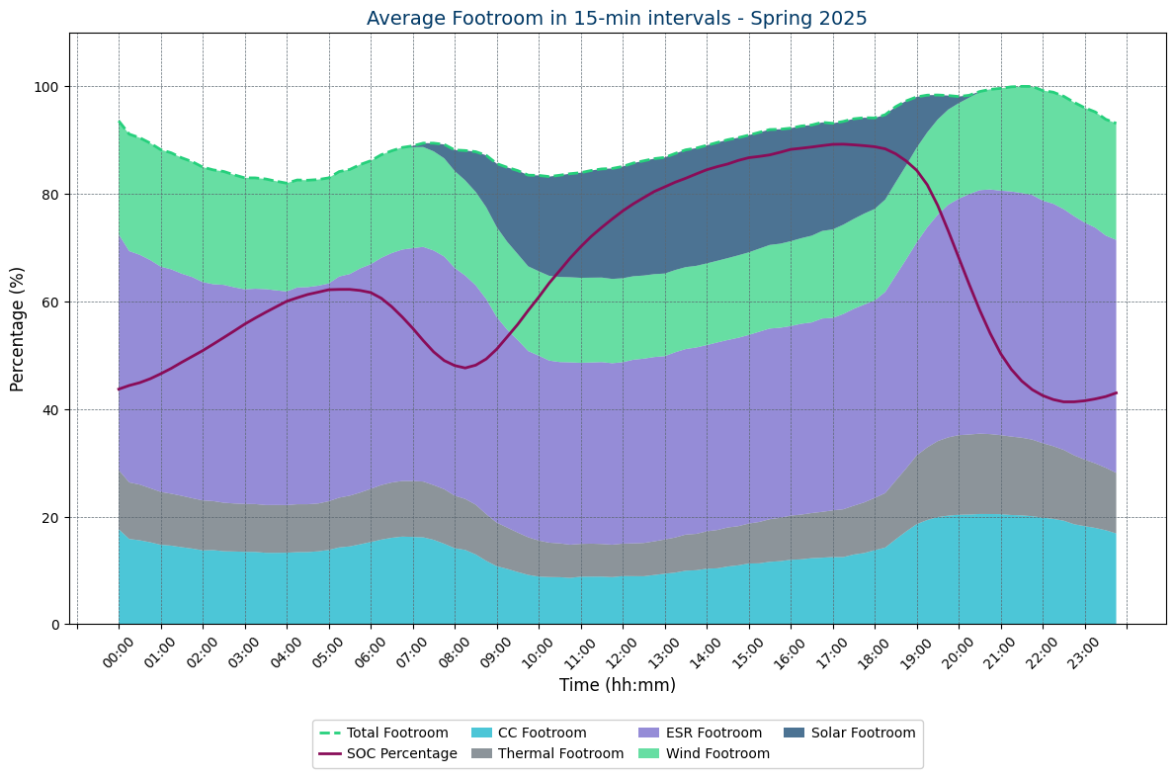

* + RTC+B-SCED will procure Regulation Down Service (Reg-Down) and 80 to 90% of Reg-Down provided between January 1 and May 31, 2025 was provided by ESRs by reserving charging room. This paradigm will continue to exist under RTC+B.
  + The issues related to Large Loads that were raised by ERCOT are a separate issue, mitigative actions for which should continue to be vetted.
* Except for California ISO (CAISO), other ISOs in North America all have set 60 minutes as the duration requirement for AS procured in Real-Time (CAISO uses a 30-minute duration requirement for AS procured in Real-Time). Further it is worth noting that all of these ISOs also have a capacity market or similar resource adequacy constructs. Eligibility requirements for ESRs to participate in those capacity market and/or resource adequacy constructs require a four-hour duration at least. Lastly, these ISOs are also part of the larger Eastern and/or Western interconnections and can rely on their neighbors during reliability events. In contrast, ERCOT is an electrical island as its own interconnection and therefore is solely reliant on its own Resources to maintain reliability and does not have a capacity market or Resource adequacy construct that provide additional streams of revenue to economically justify building longer-duration storage Resources.

**ERCOT Recommendation:**

ERCOT appreciates the support TAC provided.

1. ERCOT understands that some stakeholders support of the duration requirements recommended by TAC came with the expectation that ERCOT will revisit the underlying analysis after RTC+B implementation based on actual experience.
   * ERCOT reiterates its commitment that ERCOT will revisit the underlying analysis after RTC+B Go Live both as a part of work it is conducting in response to the PUCT’s AS Study and when Dispatchable Reliability Reserve Service (DRRS) is implemented.
2. ERCOT recognizes some stakeholders would like to see a substantially lower duration requirement for Real-Time AS procurement and have proposed ideas in comments to NPRR1282.
   * ERCOT agrees that with the expected continued growth of ESR installed capacity additional system changes will be needed to better manage SOC requirements for future hours. ERCOT will continue working on identifying these changes and will share its findings with TAC and the appropriate stakeholder groups.

ERCOT requests that the Board recommend approval of NPRR1282 as recommended by TAC in the 5/28/25 TAC Report.

|  |
| --- |
| Revised Cover Page Language |

None

|  |
| --- |
| Revised Proposed Protocol Language |

None

1. Analysis focused on non-scarcity days as these would be days when off-line capacity was available but due to the nature of the event could not be committed in a timely manner.