|  |  |  |  |
| --- | --- | --- | --- |
| NPRR Number | [1282](https://www.ercot.com/mktrules/issues/NPRR1282) | NPRR Title | Ancillary Service Duration Under Real-time Co-optimization |
|  | |  | |
| Date | | June 18, 2025 | |
|  | |  | |
| Submitter’s Information | | | |
| Name | | Caitlin Smith | |
| E-mail Address | | [Caitlin.Smith@JupiterPower.io](mailto:Caitlin.Smith@JupiterPower.io) | |
| Company | | Jupiter Power LLC | |
| Phone Number | |  | |
| Cell Number | | (832) 326-1238 | |
| Market Segment | | Independent Generator | |

|  |
| --- |
| Comments |

Jupiter Power LLC (“Jupiter Power” or “Jupiter”) respectfully submits these comments to Nodal Protocol Revision Request (“NPRR”) 1282 for consideration at the June ERCOT Board of Directors’ meeting.

Jupiter Power appreciates the effort over the last several years by stakeholders, ERCOT staff, the Public Utility Commissioners of Texas (PUCT), PUCT Staff and the Texas State Legislature to implement Real-Time Co-optimization (RTC) and “single model”[1] storage by the end of this year. We do not intend to propose to delay timely implementation of RTC, rather, we believe it is necessary to comment at the Board of Directors’ meeting to ensure thorough and effective deliberation of this technical issue, which will impact both reliability and market pricing outcomes. NPRR1282 was filed on April 29, 2025, less than two months before its consideration at ERCOT Board. In the interim time, three distinct compromise proposals were filed into the record by Market Participants and the Independent Market Monitor (IMM)[2] as well as comments from ERCOT laying out two paths of considering NPRR1282:

1. Consider NPRR1282 through the May Protocol Revision Subcommittee (PRS), May Technical Advisory Committee (TAC), and June 24 Board meeting. Comments can continue to be considered and language potentially changed as part of what goes to the Board for consideration and approval.
2. Alternative proposals can go into a separate NPRR(s) with a stakeholder path of the September 23, 2025 Board meeting. [3]

However, to date no edits have been proposed or agreed to by ERCOT to address the compromise proposals. Although the proposal from “Joint Commenters,” including Jupiter Power, earned a 38% vote in favor at the May Technical Advisory Committee, across four different segments of stakeholders, representing significant cross-interest support, ERCOT continued to support accelerated passage of the Technical Advisory Committee (TAC) passed version in front of the Board today is the NPRR “as submitted.”

As proposed, NPRR1282 makes significant changes to the duration requirements for Energy Storage Resources (ESRs) providing Ancillary Services under RTC.[4] ERCOT explains in its “Justification of Reason for Revision and Market Impacts”:

In preparation for the new market paradigm to be implemented with RTC+B, ERCOT revisited the analysis that was conducted under NPRR1096, Require Sustained Two (2)-Hour Capability for ECRS and Four-Hour Capability for Non-Spin, and conducted additional analysist to determine appropriate duration requirements for Ancillary Service.[5]

However, NPRR1282 conflates two distinct concepts of “duration”: **(1)** the **duration qualification standard** or how long an energy storage resource (ESR) must be able to sustain output in order to qualify to provide a given Ancillary Service (as addressed in NPRR1096, Ancillary Service Duration under Real-Time Co-Optimization[6]); and **(2)** the Real-Time **State of Charge (SOC) requirement** under RTC- Security-Constrained Economic Dispatch (SCED)—how much energy must be held in Real-Time for a five-minute award. To suggest that NPRR1282 merely “revisits” duration requirements set in NPRR1096, is misleading and ignores the hard-earned policy implications that are parallel to state of charge under the current market, implemented through NPRR1186. NPRR1282 does not simply update qualification standards—it restricts how ESRs will be awarded Ancillary Services under RTC and fundamentally alters how ESRs will offer Ancillary Services in both the Day-Ahead and Real-Time markets under RTC.

Although there is no direct corollary from the Settlement of Ancillary Services today to that under Real-Time Co-Optimization, NPRR1282’s proposed policy of required State of Charge for Real-Time operations conflicts with the policy which was recently adjudicated under NPRR1186, in which the Commission explicitly rejected inflexible SOC thresholds in favor of an approach aligned with Real-Time operational needs, and that matches the obligation to deliver energy from an ESR to the same timeline that the ESR has committed to make its capacity available.

ERCOT has stated that the key attributes of Real-Time Co-Optimization + Batteries (RTC+B)[7] are: efficiency (efficiently optimizes energy, congestion, and Ancillary Services in Real-Time); flexibility (increases by shifting to lower cost resources to rapidly adjust to changing conditions); competition (inclusive of new technologies [i.e., batteries] to help drive down costs).[8] NPRR1282 seeks to counteract these key attributes. For example, NPRR1282 introduces a four-hour state of charge requirement necessary for an ESR to be awarded Non-Spin Reserve Service for a five-minute award in Real-Time under RTC. Thus, where RTC should be efficiently optimizing between energy and Ancillary Services in Real-Time based upon available energy in the system, NPRR1282 imposes a four-hour Non-Spin energy requirement in Real-Time for a product that was sold by the hour in the Day-Ahead market. This means that a multiple of four times its $/MW energy price would be needed for RTC-SCED to see an ESR as indifferent between providing Non-Spin capacity or energy, degrading the ability of the RTC+B design to efficiently optimize between energy and Ancillary Services. The flexibility that should be realized through the ability to adjust awards every five-minutes would be negated by requiring that the ESR have four-hours state of charge for a five-minute interval – a multiple of 48 times the length of the interval – this ignores the fact that a feature of RTC is the ability to reshuffle optimal resources to provide an Ancillary Service throughout the deployment of that Ancillary Service. Finally, the limits on ESR capacity that can be offered into Ancillary Services will drive up Ancillary Service costs to consumers where they should be realizing the benefits of competition.

The transition to the RTC+B framework already provides for significant changes in the operation of ESRs and SOC management, both for ERCOT and ESR operators. Forcing passage of another major design change as contemplated in NPRR1282 prior to implementation of the RTC+B system changes is premature at best and irresponsible at worst as ESR stakeholders most encounter further market uncertainty in the midst of preparing for the transition to RTC+B, which is now less than six months away, with NPRR1282 having been filed less than eight months before RTC go-live, without showing a change in market or reliability need that warrants diverging from the SOC policy today.

NPRR1282’s attempt to restate SOC parameters for Ancillary Service participation also needlessly adds an additional level of complexity into other ongoing Ancillary Services design discussions, namely the Ancillary Services Requirements Methodology which included significant changes since the PUCT’s Ancillary Service study was completed, implications of the system wide offer cap under RTC, development of Dispatchable Reliability Reserve Service (DRRS), an discussions of new Ancillary Services to provide “foot-room” in the Large Load Working Group. It is not unreasonable to assume that SOC management policy might be subject to review over time, however it is inopportune to make such changes now before RTC+B practices have been successfully established and implemented, and before other Ancillary Service review initiatives have been completed, particularly since the topic of SOC management for Ancillary Services was so recently adjudicated by the Board.

**NPRR1282 conflates “Duration” with “State of Charge,” which is a misapplication of fundamental ESR concepts and results in a drastic departure from current ERCOT standards regarding duration and state of charge.**

**Duration** refers to the amount of time an ESR can continuously discharge at its rated power output before depleting its usable energy capacity—i.e., the battery’s energy capacity (MWh) divided by its power rating (MW), assuming a constant discharge rate.[9]

**SOC** or **SOC percentage** represents the amount of an ESR’s usable energy capacity that is currently stored—i.e., the battery’s usable stored energy divided by its maximum usable energy capacity, multiplied by 100.

***Example:***

* **Duration**
  + An ESR has a maximum usable energy capacity of 400 MWh and a rated power output of 100 MW.
    - 400 MWh ÷ 100 MW = 4 hours
    - The battery has a duration of 4 hours.
* **SOC**
  + The ESR is currently storing 200 MWh of usable energy.
    - 200 MWh ÷ 400 MWh × 100 = 50%
    - The battery’s SOC is 50% full; 50% of the battery’s usable energy capacity available.

A key feature of RTC+B is the shift to a “Single Model” representation of ESRs, giving RTC SCED full Real-Time visibility into each ESR’s Real-Time operating capabilities. This enhanced transparency—developed collaboratively with stakeholders through the Battery Energy Storage Task Force (BESTF) in 2020 and SOC provisions approved under NPRR1186—provides SCED with the information needed to assess the actual availability of ESRs for each SCED interval. In order for SCED to award a Real-Time five-minute Ancillary Service commitment to an ESR under RTC, NPRR1282 requires the Real-Time SOC energy in the ESR to match the Ancillary Service duration qualification for that Ancillary Service (e.g. four-hours of capacity under the Non-Spin duration qualification requirements).

Today, separate values for duration qualification and Real-Time SOC requirements are used, a solution which stemmed from direction from the ERCOT Board at their August 31, 2023, meeting to address the issue of “stranded energy” associated with proposed State of Charge requirements in NPRR1186, Improvements Prior to the RTC+B Project for Better ESR State of Charge Awareness, Accounting, and Monitoring, as proposed at that time[10]. At that time, ERCOT proposed for “the minimum SOC requirements for ECRS and Non-Spin to slope from the full hourly Ancillary Service Resource Responsibility at the start of each hour to 0 MWh at the end of the hour in each hour where the Resource is carrying that Responsibility…. This change will eliminate the need for Energy Storage Resources (ESRs) to hold any more SOC than the amount needed for a full deployment across a single hour and will enable this energy to be made available to the grid in all conditions, including scarcity.” Again, while a direct corollary cannot be made, NPRR1186 constitutes ERCOT’s measures to ensure that state of charge could meet operational needs, pre-RTC. As the current length of an Ancillary Service award is one hour, most Ancillary Services carry an expectation of SOC that begins at one hour and slopes down so that the required SOC can reasonably deplete as the time in the hour diminishes (forming a “triangle”). In other words, under today’s operations the Ancillary Service commitment awarded for each operating hour must be matched by an available store of energy to cover the capacity obligation through the hour.

See duration and SOC requirements as of passage of NPRR1186 below.

|  |  |  |
| --- | --- | --- |
| **Pre-RTC** | | |
| Ancillary Service | Qualification Requirement | SOC Expectation |
| Non-Spin Reserve Service | 4 hours | 1 hour, sloping down across the hour |
| ECRS | 2 hours | 1 hour, sloping down across the hour |
| Regulation Service | 1 hour | 1 hour, sloping down across the hour |
| RRS | 1 hour | 1 hour, sloping down across the hour |

The current expectation of SOC that an ESR must hold across the hour if it was awarded an Ancillary Service in the hourly Day-Ahead market can be equated to the amount of SOC that RTC SCED will require in order to award an ESR a physical responsibility for an Ancillary Service in Real-Time, under RTC. See proposed values, as in NPRR1282 as passed by TAC, below.

|  |  |  |
| --- | --- | --- |
| **RTC** | | |
| Ancillary Service | Qualification Requirement | RTC-SCED |
| Non-Spin Reserve Service | 4 hours | 4 hours |
| ECRS | 1 hour | 1 hours |
| Regulation Service | 30 minutes | 30 minutes |
| RRS | 30 minutes | 30 minutes |

Under RTC, Resources will receive a new physical Ancillary Service award every five minutes. Therefore, as an example, if the requirement for RTC-SCED for ECRS is one hour, then in order to receive a five minute award for ECRS, a resource would need one full hour’s worth of SOC, and then in order to receive the next five minute award for ECRS, a resource would again need one full hour’s worth of SOC, and then in order to receive a third five minute award for ECRS, the resource would for a third time, need one full hour’s worth of SOC, and so on. Designing Ancillary Service requirements this way counteracts the very flexibility that RTC should capitalize on and will lead to much higher prices of ancillaries, in particular across the sunset hours where the requirement to hold rolling future SOC levels will significantly restrict available Ancillary Service capacity for Real-Time dispatch.

As noted above, duration and SOC are distinct metrics, one used for qualification of resources and one used for measurement in Real-Time operations, and ERCOT has historically established separate requirements for each. Duration requirements were most recently addressed in NPRR1096, Require Sustained Two-Hour Capability for ECRS and Four-Hour Capability for Non-Spin, which set the current minimum capability standards—two hours for ECRS and four hours for Non-Spin***.***

In 2024, as part of the Commission’s review of Ancillary Services required by the 87th Legislature’s Senate Bill (SB) 3, the IMM explicitly recommended revisiting duration requirements for Non-Spin and ECRS. Commission Staff agreed that there was “some merit” reopening these discussions—but only after RTC+B has reached a steady state, which is consistent with ERCOT’s phased approach outlined in NPRR1096.[11]

Not only does NPRR1282 as passed by TAC change the durations set in NPRR1096, but it changes the hard-earned policy on state of charge, which this Board helped form, last year and with the full knowledge of the pending RTC+B. NPRR1282 revises the duration policy established in NPRR1096 and imposes a new, rigid SOC requirement that was never contemplated in that proceeding. Importantly, it also conflicts directly with the Commission’s policy decision in NPRR1186—rejecting similar blanket SOC requirements in favor of a risk-based, performance-driven approach that enables ERCOT to assess and deploy storage based on actual system needs and capabilities.

**Joint Commenters’ approach to NPRR1282 would create superior market outcomes.**

As stated in our May 7, 2025, comments, “Jupiter Power asserts that the requirements for qualification and for operating requirements should remain decoupled and that the values should be different, in order to realize the benefit of operating flexibility that is intended to be inherent to Real-Time Co-optimization, while preserving the reliability under the existing market design.”

Under RTC, Day-Ahead Ancillary Service responsibilities (Non-Spin in this example) do not hold physical requirement to deliver energy continuously over four hours but are awarded on a one-hour basis and carry financial responsibilities, paid through imbalance settlement, if not met. under the TAC-approved version of NPRR1282, not only would ESRs be required to have four hours of duration just to qualify for a one-hour Non-Spin award in the Day-Ahead, but they would also have to carry four hours of SOC to receive a five-minute award in Real-Time. This creates an economically and operationally inefficient barrier that unfairly disadvantages ESRs, even though ERCOT already has full visibility into SOC and dispatch duration through RTC systems.

Jupiter Power agrees with the IMM’s commentary on NPRR1282:

“SCED will recognize less available supply for these products, resulting in higher AS (Ancillary Service) and energy prices. The higher energy prices will tend to lead to more energy awards for ESRs sooner into a reliability event”[12]

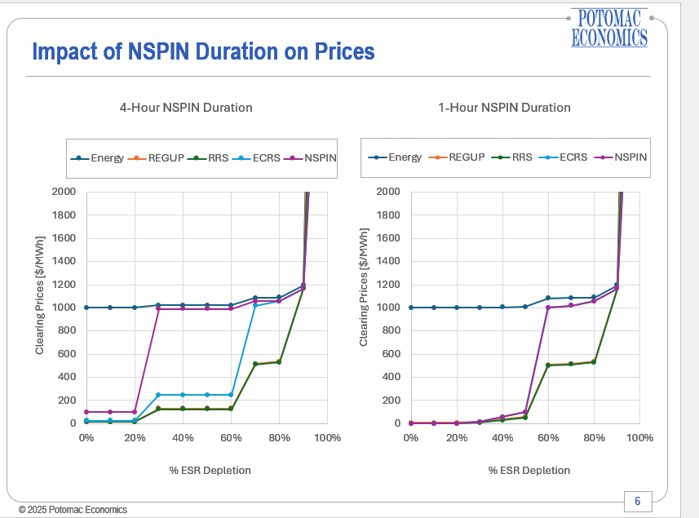[13]

In contrast, thermal Resources are eligible to provide Non-Spin if they can respond within 30 minutes, meaning they only need to be available for half the product length. This creates a significant asymmetry that is both inequitable and inefficient, disadvantaging storage Resources and inflating the cost of reserves by excluding flexible, fast-ramping assets that are otherwise capable of reliably responding.

The Joint Commenter proposal made by Jupiter Power LLC and Engie North America seeks to remedy the asymmetric pricing outcomes by decoupling the values for qualification duration requirement and Real-Time State of Charge operating requirements.

Joint Commenters proposed the below values in May 12, 2025, comments.

|  |  |  |
| --- | --- | --- |
| **RTC** | | |
| Ancillary Service | Qualification Requirement | RTC-SCED/SOC Enforcement Requirement |
| Non-Spin Reserve Service | 4 hours | 1 hours |
| ECRS | 1 hour | 15 minutes |
| Regulation Service | 30 minutes | 15 minutes |
| RRS | 30 minutes | 15 minutes |

In the one-month time period between the NPRR being filed by ERCOT (on April 29th) and its consideration at TAC, four compromise proposals were made. Those proposals were made by TSSA in May 4th comments, by Jupiter Power in May 7th comments, by Joint Comments Jupiter Power and Engie NA in May 12th comments, and by the IMM in May 13th comments, and included a variety of solutions, including a threshold for state of charge standards at a certain level of PRC, keeping duration and SOC requirements decoupled in RTC, and lowering Non-Spin duration requirements.

At its May 28 meeting, TAC took a first vote on the proposal made by Joint Comments. Notably, the Joint Commenters' proposal received 38% support at TAC — including affirmative votes from the Consumers, Independent Power Marketer, Municipally Owned Utility, and Generator segments—demonstrating meaningful cross-sector alignment in favor of a more flexible and balanced approach. Jupiter believes that this warrants further consideration and compromise with ERCOT.

This proposal reflects the substantial consideration and willingness to collaborate across the stakeholder community to find a workable, reliability-focused solution. The Joint Commenters’ framework preserves ERCOT’s ability to model duration conservatively for qualification (four hours for Non-Spin) while ensuring that Real-Time dispatch obligations are grounded in actual system needs, matching energy requirements to awarded commitments. This balance promotes operational flexibility, broadens ESR participation, and improves reliability and affordability across the grid. In its January 23, 2025, presentation to the RTCBTF, the IMM further reinforced this position, stating that “separate duration requirements for qualification vs. RTC-SCED is a reasonable short-term approach.”[14] The IMM explained that while ERCOT could continue to use the current 2- and four (4)-hour thresholds to qualify ESRs, but that in RTC-SCED, the Real-Time deployment requirements should be capped at no more than one (1) hour for each service. This distinction, the IMM noted, helps avoid the worst reliability and market outcomes by preventing unnecessary disqualification of storage while still enabling ERCOT to aggregate reserves across multiple ESRs.[15]

**NPRR1282 as passed by TAC will limit participation of Energy Storage Resources in Ancillary Services, posing reliability concerns.**

On May 14, 2025, the North American Electric Reliability Corporation (NERC) released its 2025 Summer Reliability Assessment, which evaluates each region’s risk of electricity supply shortfalls for the upcoming summer by analyzing planning reserve margins, probabilistic risk scenarios, and operational conditions—assessing whether operating reserves will be sufficient not only under typical conditions but also during extreme stress events. NERC’s report finds that ERCOT is well-positioned to maintain adequate reserves under normal summer peak conditions. NERC identified that ERCOT’s evening EEA risk is considerably decreased from last summer (i.e., 18% for 2024; 3% for 2025) and referenced ESRs as main driver in reducing ERCOT’s EEA probability for 2025 during solar ramp down hours.

* "**Lower risk is attributed to** a nearly **doubling** **of battery energy storage capacity** and improved **energy availability from new battery storage** and operational rules.”[16]
* “The **large decrease in EEA probabilities** is **due to** the addition of 7,414 MW of **BESS capacity**.”[17]
* “**New** solar generation, **battery resources**, and some thermal generation additions since Summer 2023 boosted electricity supplies, **enabling operators to meet demand records** without demand-side management.”[18]

There are also serious reliability reasons for not requiring a whole asset-class ESRs to hold their SOC high at all times to meet future responsibilities. A topic of concern from ERCOT at the recent Large Load Working Group (LLWG) meetings is the lack of “foot-room” or ability for load to ramp up (i.e. charge an ESR) in the event of a trip of a Large Load. ERCOT has introduced a problem statement regarding Large Load voltage ride-through that “under worst-case inertia and foot-room conditions, it could cause system-wide frequency instability if not mitigated.” ERCOT has gone further to suggest that a solution could be to “establish new Ancillary Service to preserve frequency responsive foot-room on resources.”[19] Requiring batteries to hold arbitrarily high SOC exacerbates the problem that an Ancillary Service requiring foot-room would seek to mitigate, prolonging a reliability problem, and forcing consumers to pay for a solution that they are also paying to create by limiting foot-room on ESRs.

In its presentation to the May 21, RTC+B task force meeting, the IMM noted that the expressed intention of the higher duration constraint for Non-Spin is to ensure that reserves are able to last longer through a reliability event such as prolonged forecast error, but that in practice, this constraint will lead to more (energy) base points being awarded to ESRs, which will then exhaust their SOC and make them unavailable to provide either energy or reserves as the event persists.[20] For example on a summer afternoon, where prices may rise, but the sunset hours may still be the highest risk time, RTC-SCED will prefer ESRs to provide energy earlier, rather than as reserves later, which may exacerbate potential emergencies during the sunset hours.

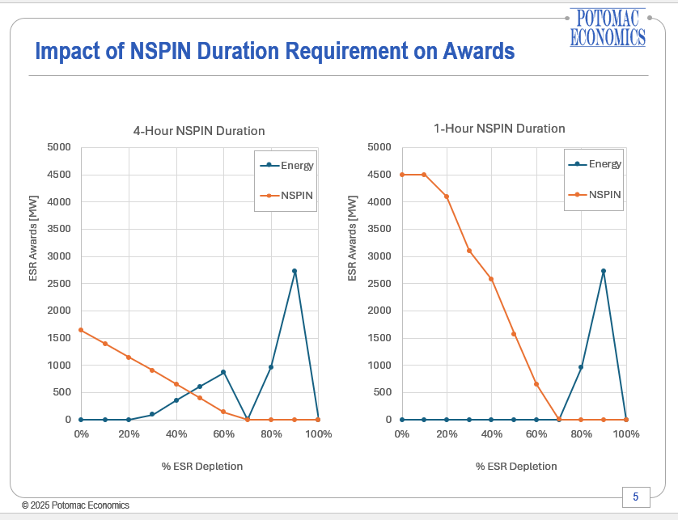[21]

Winter Storms Elliott (December 2022) and Heather (January 2024) brought sustained freezing temperatures, record-high electricity demand, and strained generation conditions across Texas—testing the resilience of the ERCOT grid under extreme and prolonged weather events. In both events, ERCOT relied heavily on ESRs to maintain system stability—batteries provided over half of RRS and nearly 90% of Reg-Up during Elliott, and delivered up to 1,200 MW of fast-ramping capacity during Heather—demonstrating that ESRs are proven, high-performing assets that have repeatedly delivered critical flexibility, frequency response, and Real-Time support during peak demand and extreme conditions, helping ERCOT avoid more severe emergency actions.

ESR’s has also greatly contributed to reliability in recent summers. At the January 18, 2024, PUCT Open Meeting, Commissioner Cobos, in response to operational challenges with solar ramp-down on hot days:

ERCOT so far has been able to maintain reliability. In the September 6 EEA event, we had 2,000 MW of storage on the system that helped us avoid load shed, so from this perspective, we are dealing with an operational challenge [that is] going to get more pronounced in the future, and so how do we fill in those gaps? We have to fill them with fast flexible dispatchable generation, and that includes both thermal generation and battery storage. And while we have [new thermal projects] being announced—and that is fantastic—it takes three to four years to get those in place. In the meantime, we have to take advantage of every megawatt that we can get on the system to help with this operational challenge.[22]past

In conclusion, Jupiter Power appreciates the time and consideration given to this issue by the ERCOT Board and respectfully requests that more consideration be given to a compromise proposal regarding Real-Time SOC requirements. The TAC-passed version of NPRR1282 includes requirements that greatly diverge from SOC policy that was recently considered by this Board, without showing that, since NPRR1186’s passage in April of 2024, a reliability benefit would be gained from such a change in policy. Rather, RTC should allow for the benefit of more flexibility and competition of Resources, while the TAC-passed version of NPRR1282 will stifle those flexibility benefits of RTC, at an increased costs to consumers.

|  |
| --- |
| Revised Cover Page Language |

None

|  |
| --- |
| Revised Proposed Protocol Language |

None

1. “Single Model” refers to the primary effort of the Battery Energy Storage Task Force (“BESTF”), created in 2019, to move from the “combination” model whereby Energy Storage Resources are modeled as a Controllable Load Resource when charging and as generation when discharging, to one “single model” resource.
2. (1) 1282NPRR-03 TSSA Comments 050425; (2) 1282NPRR-04 Jupiter Power Comments 050725 and 1282NPRR-06 Joint Commenters Comments 051225; (3) 1282NPRR-07 IMM Comments 051325  
   
3. 1282NPRR-05 ERCOT Comments 051225
4. NPRR1282, Ancillary Service Duration under Real-Time Co-Optimization, TAC Report (Jun. 2, 2025) at <https://www.ercot.com/files/docs/2025/06/02/1282NPRR-13-TAC-Report-052825v2.docx>.
5. *Id.*
6. *See* NPRR1096,Require Sustained Two (2)-Hour Capability for ECRS and Four-Hour Capability for Non-Spin (May 12, 2022) at <https://www.ercot.com/mktrules/issues/NPRR1096#keydocs>.
7. Real-Time Co-optimization (“RTC”) and Real-Time Co-Optimization + Batteries (“RTC+B”) used interchangeably
8. “Market Design Framework – Workshop” Presentation to Technical Advisory Committee, April 23, 2025
9. *See* International Electrotechnical Commission (IEC) Standard 62933-2-1:2017, Section 4.4, implying that output duration is energy capacity divided by rated output power (“The energy capacity shall be defined as the product of the rated output power and the output duration time at this rated power.”); National Renewable Energy Laboratory (NREL) (“Storage duration is the amount of time storage can discharge at its power capacity before depleting its energy capacity. For example, a battery with 1 MW of power capacity and 4 MWh of usable energy capacity will have a storage duration of four hours.”) at <https://docs.nrel.gov/docs/fy19osti/74426.pdf>; U.S. Department of Energy (DOE), Office of Energy Efficiency & Renewable Energy, (“Long-duration energy storage (LDES) is defined as systems that can store energy and discharge it over a period of 10 hours or more”—i.e., presuming that “duration” is a measure of continuous discharge at rated output.) at <https://www.energy.gov/oe/long-duration-storage-shot-summit>.
10. 1186NPRR-27 ERCOT Comments 091923
11. “Review of Ancillary Services in the ERCOT Market,” Public Utility Commission of Texas, Project No. 55845, Staff Recommendations, November 15, 2024
12. IMM presentation Jan 23 RTCBTF
13. “Impact of Duration Constraints for NSPIN on SCED Awards,” Presented to: RTCBTF, Andrew Reimers, Ph.D., Potomac Economics, May 21, 2025
14. IMM Presentation, RTCBTF (Jan. 23, 2025).
15. *Id.*
16. NERC 2025 Summer Reliability Assessment, Key Findings: Texas RE-ERCOT, p.6 (May 2025) at <https://www.nerc.com/pa/RAPA/ra/Reliability%20Assessments%20DL/NERC_SRA_2025.pdf> (emphasis added).
17. *Id.* at pg. 13.
18. *Id.* at pg. 51 (summarizing ERCOT’s 2024 capacity and energy performance).
19. “Large Electronic Load (LEL) Voltage Ride-Through Overview, Large Load Workshop, June 13, 2025
20. IMM 5-21 presentation
21. “Impact of Duration Constraints for NSPIN on SCED Awards,” Presented to: RTCBTF, Andrew Reimers, Ph.D., Potomac Economics, May 21, 2025
22. PUCT Open Meeting, Item No. 37 (Jan. 18, 2024) at

    <https://texasadmin.com/tx/puct/open_meeting/20240118/>.