**PWG Meeting Notes** – April 28, 2025

Via WebEx 1:00 PM

Attendees:

|  |  |  |  |
| --- | --- | --- | --- |
| Steve Pliler - Vistra | Greg Graham - CimView | Eric Lotter – Grid Monitor | Kathy Scott - CNP |
| Robert Bevill - TNMP | Viviana Valdez – LP&L | Sam Pak - Oncor | Jordan Troublefield - ERCOT |
| William Butler LP&L | Amar Khalifeh - ERCOT | Kyle Patrick - NRG | Sheri Wiegand - Vistra |
| Laura Gomez – LP&L | Bill Snyder - AEP |  |  |

* **Admonition**
  + Steve Pliler advised the attendees of the Antitrust Admonition**.**
* **Introductions, Agenda Overview**
  + Steve confirmed the meeting participants and reviewed the agenda.
* **Review of February 13th Meeting Notes**
  + There were no questions regarding the February 13, 2025, meeting notes.
* **Update BUSIDRRQ & LRG Profile Market Counts**
  + Rob provided an update that TNMP’s conversion would complete by June 30th. Sheri asked for market notification when the TNMP conversions begin. Steve reiterated that there is little change to the profile counts of the other TDSP’s and will be a slow transition to full conversion.

* **2025 Annual Validation (RES & BUS) Kickoff Update/Progress Report**
  + Amar provided an AV Progress Report and Task List timeline of events that will take place between March and October. Unfortunately, due dates on the presented Progress Report and Task List did not align with the Load Profiling Guide, Section 11.2.1. Sam will be providing Amar with corrections and revisions to the provided presentation.
    - On March 4th, ERCOT submitted MarkeTraks of the ESI ID’s subject to Annual Validation to the TDSP’s. Due to some confusion on the AV timelines, not all TDSP’s have submitted their exception ESI’s and finalized list of ESI’s subject to an AV change which resulted in a delay of an ERCOT Market Notice to Rep of Record CR’s. The next steps will be for ERCOT to release a market notice announcing that lists are available to Competitive Retailers of record and that TDSP’s can begin submitting 814_20 transactions.
  + Sam pointed out that the AV BUS Status Update page was not calculating the remaining accounts to update. Sam also suggested adding a footnote that indicates 99% complete is considered complete per the Load Profiling Guide, sec 11.2.1 (2).
  + Discussion began around Residential AV change comparison. Sam noted that FWest and Coast weather zones are defaulted to RESLOWR. Sheri asked if there was a way to determine how many of these ESI ID’s were brand new and assigned the default RESLOWR.

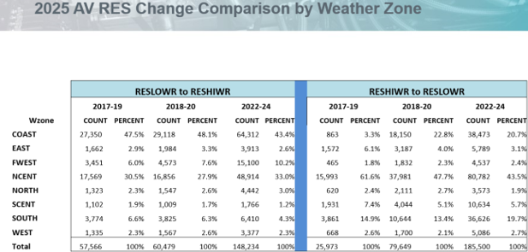

* + The group discussed the Business AV Change History. Kathy opined that over the years these were customers that were on the border between LO-MED and MED-HI and created a situation where the same ESI ID’s were just flip flopping every year. Sheri agreed and asked if ERCOT could run a program that shows a “scattergram” of accounts usage. Rather than taking percentages of the total population and assigning a profile, ERCOT could extract usage demarcation lines where LOW ends and MED begins and MED ends and HI begins. Amar indicated the AV SAS Program does produce multiple dataset outputs for annual load factor (ALF) percentages. PWG requested to have some analysis (eg. frequency table, scattergram, histogram, etc) of the ALF data to determine possible demarcation lines to review at our next meeting.
* **Other Business**
  + Sam brought up the 6 strategic objectives that RMS spelled out for the working groups. PWG agreed and were in alignment with the addition of SET’s redline addition.

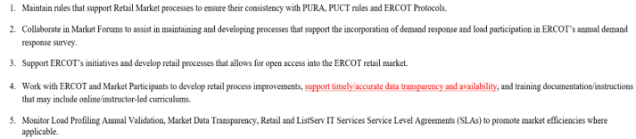

**Future Meeting Dates –** 5/13/25 at 9:30 a.m. The group is looking to reschedule for in-person on 5/21/25 (Following Texas SET).

* **The meeting adjourned at 3:05 p.m.**