**TDTMS**

**April 22nd, 2024, 1:30 PM**

**WebEx only**

|  |  |  |  |  |  |  |
| --- | --- | --- | --- | --- | --- | --- |
| Attendee | Company | Attendee | Company | | Attendee | Company |
| Jordan Troublefield | ERCOT | Bill Snyder | | AEP | Monica Jones | CNP |
| Dave Michelson | ERCOT | Kyle Patrick | | NRG | Eric Lotter | GridMonitor |
| Sheri Wiegand | Vistra | Mick Hanna | | ERCOT | Kathy Scott | CNP |
| Jesse Macias | AEP | Steven Pliler | | Vistra | Rob Bevill | TNMP |
| Zachary Dollar | PUCT | Sam Pak | | Oncor | Tammy Stewart | ERCOT |
| Cindy Juarez | AEP | Yvette Perez | | Octopus | Stephen Wilson | Vistra |
|  |  |  | |  |  |  |

Sheri Wiegand opened the meeting, read the Antitrust Admonition, and introduced attendees.

Meeting minutes from the February 19th meeting were reviewed (including ACTION items) and approved. All ACTION items were completed: screenshots of ‘log out’ vs ‘x’ feature in MarkeTrak, moving ‘867 Vs Sum of LSE’ subtype to Service/Transaction grouping in Rolodex, and collaboration with RMTTF on rejects of BDMVI ‘IA’ or ‘CR’ coded transactions.

One change to the agenda was the review of RMS’ strategic objectives. Information discussed at the morning’s TXSET meeting was reviewed with no additions/corrections and will be presented to RMS leadership.

**ERCOT System Instances & MarkeTrak Monthly Performance Review -**

* Market SLA targets were met for March.

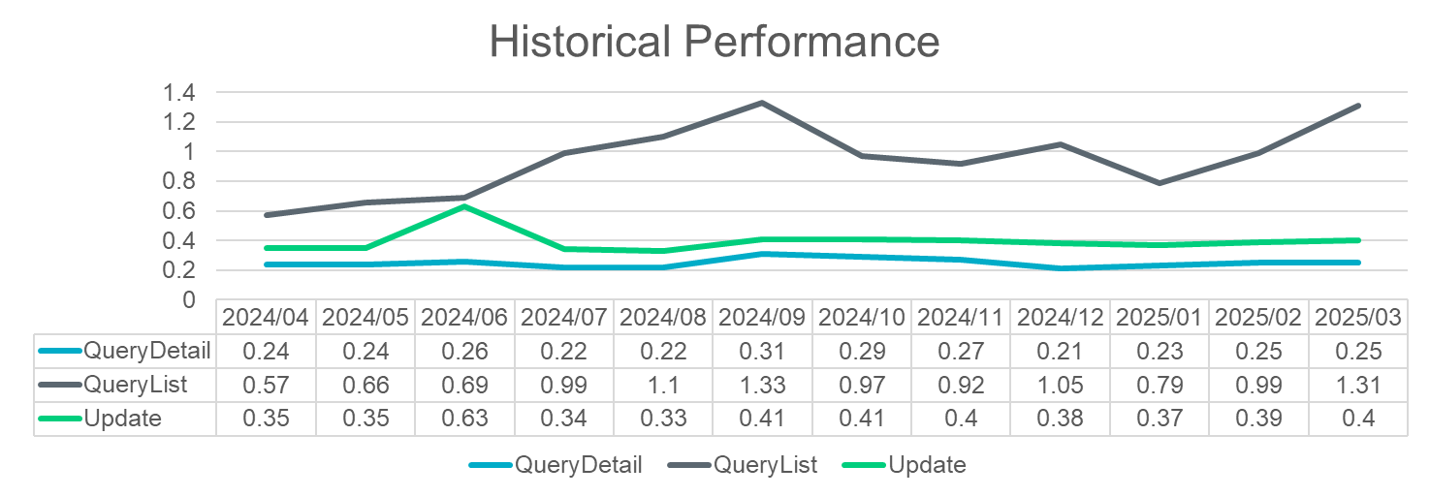

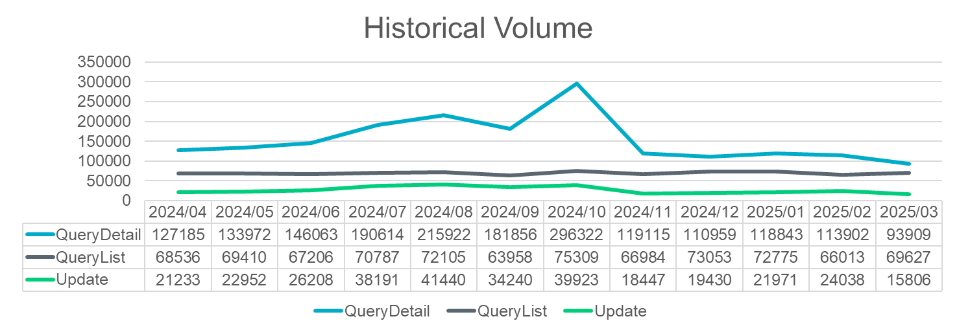

* February MarkeTrak incidents were discussed at length at the last TDTMS meeting. Mick clarified steps taken to remediate concurrent licensing:
  + Inquired with vendor on shortening ‘time out’
  + Recommending users log out vs. ‘x’ out
  + Pooling of licenses with RMTE
  + With next MT upgrade will attempt to pool licenses with FlighTrak
* Prior to February, users could experience concurrent licensing error message. There have not been reports of error since pooling has occurred.

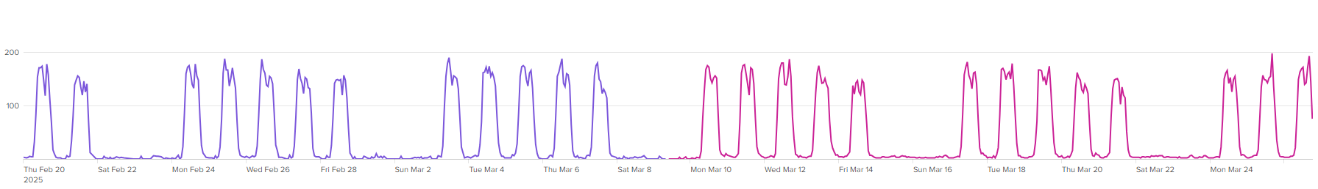

* ERCOT still has a threshold of 200 licenses and will continue to monitor as new companies/users are onboarded. ERCOT continues to recommend any issues are reported via a ‘ticket’ or emailing [servicedesk@ercot.com](mailto:servicedesk@ercot.com) . ACTION: Mick will generate a one-pager for use at RMTTF trainings on how to report any issues with MarkeTrak or TXSET.
* 3/8 – 3/9 site failover
* First retail release is scheduled April 28th which will utilize the 4:30 – 5:30 window thus impacting MT availability. Market notice was sent out April 15th.

**ERCOT Projects**

**MIS Re-Write**

* Dave announced that in 2025 ERCOT will be performing an architectural refresh of the retail API and UI for MIS as part of ERCOT’s ‘technical health’ efforts. The project will not be required to follow the governance process; however, updates will be offered at RMS or TWG. TDTMS will also keep an open agenda item for updates and offer a forum for any additional suggested revisions to the “look and feel” of the UI. Dave reminded any new data requests would be beyond the scope of the refresh and would require an SCR. Implementation is expected at the end of 2025. The following two “defects” were noted:
  + Spacing on the data returned for Find ESI and Find Transactions
  + ‘Key dates’ provided on Find Transactions summary should reflect dates of specific transactions and not revised to the last executable date

**NAESB Project**

* Expected for late 2025
* ERCOT will reach out to trading partners to ensure the exchange of data

**API Upgrade**

* Dave will provide any updates at TDTMS and TWG (for technology teams)
* Project will run parallel for MT API switchover
* A cutover date will exist at some point whereby SOAP technology will be decommissioned as ERCOT works toward current architecture in web services
* A roadmap for SOAP utilized in MT API will be provided
* Proposed changes will impact common public reports on API. A list of impacted reports will be provided

**SMT Upgrade**

* SMT will be upgrading from FTP to SFTP with the decommissioning of FTP tentatively on 8/22.

**Quarterly Review of Inadvertent Gain Reporting**

Sheri reviewed the highlights of the monthly IAG report posted to the respective RMS meeting page noting the following:

* Volume of IAGs from REPs with > 1% of enrollments resulting in IAGs has grown significantly higher over the years from those REPs with < 1% indicating same REPs continue to contribute to the overall volumes
* Improvement in January on the ‘days to resolution’ moving from double digit # of days to single digits supporting the IAG process improvements of TXSET v5.0 and SCR817. The efficiencies gained were:
  + No “stopping point” for agents once agreement between CRs is reached
  + No longer preparation of TDSP systems to accept a BDMVI

**MarkeTrak Subtype Volume Analysis – IAL**

The data from 2023 and 2024(1) for Inadvertent Loss subtype was reviewed and summarized by the smaller working group. Sheri thanked Sam Pak for his hard work on dissecting the data and Kyle Patrick and Monica Jones for their participation and input during the working sessions.

The following information was presented:

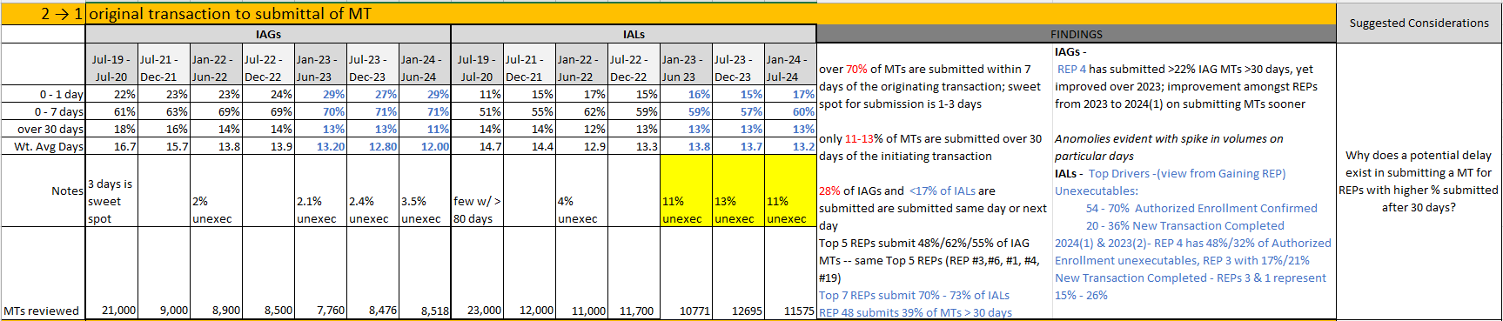

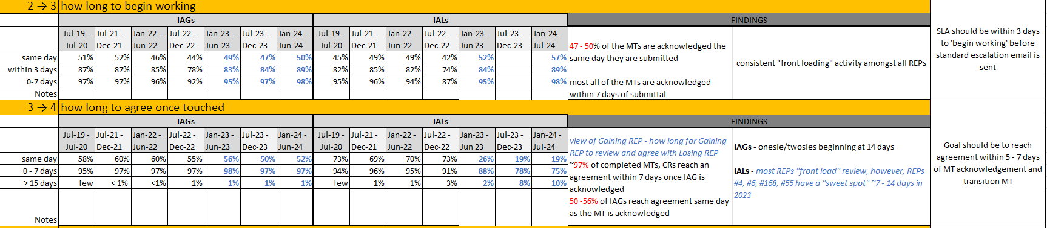

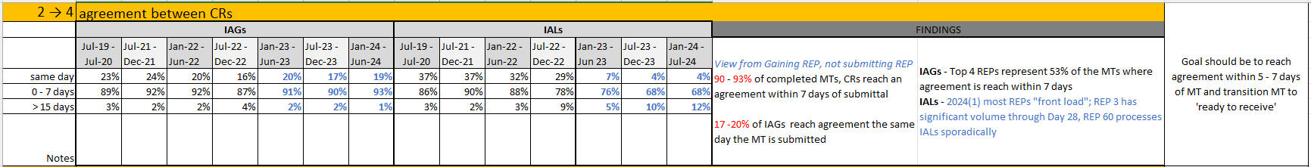

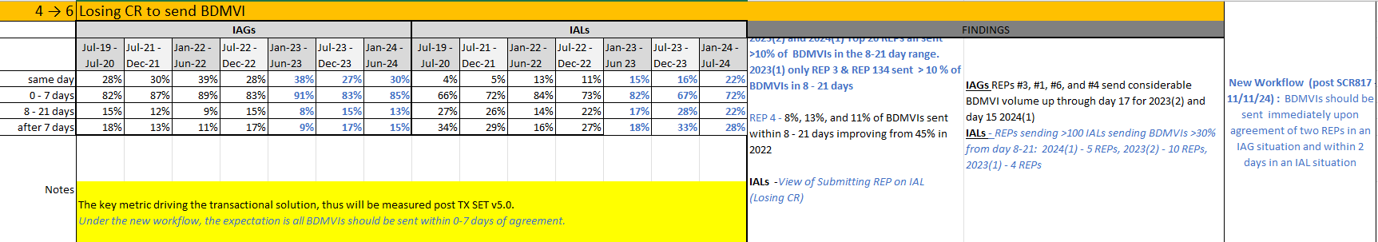

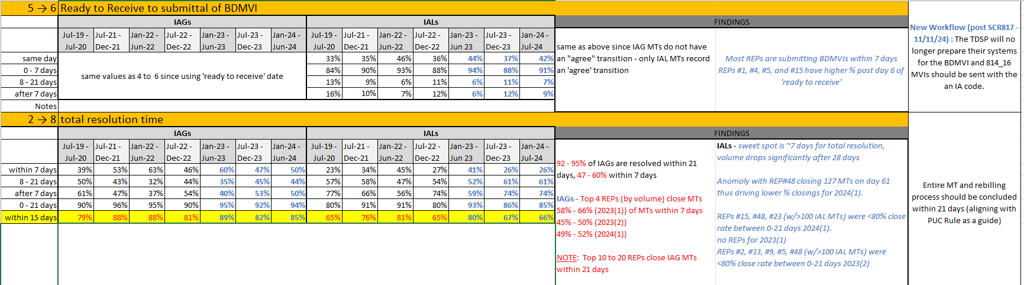

ACTION: Sam will “clean up” the workbooks and post the IAG and IAL analysis on the main TDTMS meeting page.

**MarkeTrak Information Page** will be taken up at the next TDTMS meeting.

**NEXT MEETING:** tentatively **May 21st @ 9:30 AM** - in person @ ERCOT. **TXSET** has scheduled an in person meeting on Tuesday, May 20th. Sheri also acknowledged **PWG** may want to leverage the in-person time on the 21st, thus TDTMS may move its meeting date to WebEx only in May. More to come…

**NEXT MEETING:**

**DRAFT AGENDA**

* Follow up on Action Items
  + Posting of MT analysis data on main TDTMS page – IAG, IAL, Other
* ERCOT Reports
  + System Instances & MT Performance
  + Listserv
  + MIS – Retail API & UI
* MT Subtypes Overall Volume Analysis – results 2024(2)
* MarkeTrak Information Page