

**RTC+B Market Trials Handbook 6.0**

**RTC Day-Ahead Market Testing**

**Initial draft version: April 18, 2025**

As described in the RTC+B Market Trials Planning Document, there are six major areas of Market Trial and Transition Activity. Each of these activities will have:

1. Defined Objective(s) for each Activity
2. Entry Criteria (for both ERCOT and QSEs) prior to starting activity
3. Defined Key activities during trial for ERCOT and QSE
4. Exit Criteria

This Handbook will focus specifically on RTC QSE Submission Testing (see below).

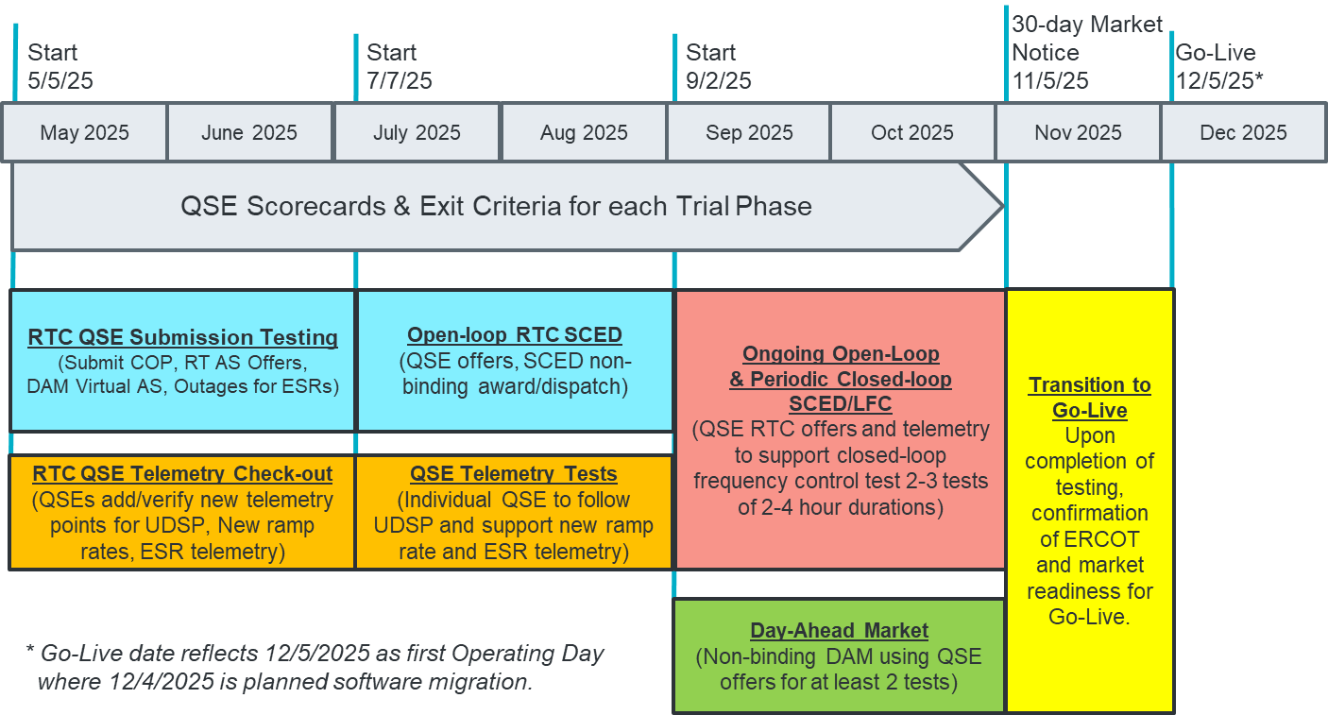

**6.0 DAY-AHEAD MARKET (Testing strongly encouraged, but not required for all QSEs)**

**1. Defined Objectives:**

* *ERCOT will deploy Day-Ahead Market into a market facing environment*
  + *RTC-DAM, MMS-UI, MMS-API*
    - *MMS-UI and MMS-API will support publishing awards to QSEs*
  + *# CDR Reports: DAM AS Obligations, DAM AS Demand Curves, DAM Awards, DAM LMPs, DAM AS prices, etc.*
* *QSEs will test their market submissions for defined transactions (Energy Bid/Offer Curves, AS Self-Arrangement, DAM AS Only Offers, and normal DAM submissions)*
* *ERCOT will execute and publish at least two Day-Ahead Markets*
* *DAM participation is strongly encouraged, but will not be required in Readiness metrics. The reasoning is that with RTC procuring AS in Real-Time, DAM is still an important market but is essentially voluntary. Additionally, participation includes much broader QSE population (traders and load-only QSEs).*

**2. Entry Criteria:**

* **2.1 ERCOT Entry Criteria**
  + **Publish Business Process flows summary of changes** for context of technical change (at least 8 months prior to market trial- may be met by Market Submission Whitepaper)
    - **ERCOT provided Market Submissions walkthrough at RTCBTF August 14, 2024 meeting, and memorialized the material on the RTCBTF training page.**
      * [**Presentation at RTCBTF on Aug 14, 2024**](https://www.ercot.com/files/docs/2024/08/07/Issue%209-%20RTC%20B%20Market%20Submissions%20Changes%20slides.pptx)
      * Training Page link <https://www.ercot.com/committees/tac/rtcbtf/training>
        + Select New Modified Market Submissions
  + **Publish “Trials Handbook”** with details of specific functionality and testing (at least 3 months prior)
    - Scope of functional testing (and for clarity, out of scope items, e.g. reports)
    - Duration of activity
    - Details of access to environment
    - **This document is the Handbook**
  + **Systems Testing and Readiness**
    - FAT testing and initial iTest Testing of MMS-API, MMS-UI, DAM
    - Deployed into Market Trials environment
* **2.2 QSE Entry Criteria**
  + **QSE Systems ready** to connect to ERCOT systems and submit defined transactions
  + **QSE has assigned staff** for attending weekly market trials meetings and submitting data to ERCOT per the applicable Handbook
    - Will be met on or before September 2, 2025

**3. Key Activities during Market Trial:**

* QSEs participate in weekly WebEx meetings (September 2 – October 31)
  + Every Monday 10am-10:30 am CPT (ahead of the first meeting, ERCOT will send reminders and post meetings on the ERCOT calendar)
  + Meeting agenda:
    - Expectations of QSEs for the week
    - Communicate any known issues with on-going trials
    - Provide snapshot of cumulative QSE scorecards
    - Support any technical and/or business questions
* ERCOT is responsive in supporting QSE questions and issues
* During the period of September 2 – October 31, all QSEs can perform the following activities to ensure the company is prepared for new Day-Ahead Market functionality:

**Pre-DAM**

* + QSEs participating in the DAM can download and review the DAM ASDCs.
  + QSEs representing Load Serving Entities (LSE) can download/review their Advisory AS Obligations and ensure they observe/handle values with up to 5 significant digits after the decimal.
  + QSEs with AS Obligations can submit all or a portion of their Advisory AS Obligation via AS self-arrangement for a single AS product and delivery hour (note, no self-arrangement will be allowed over their Advisory AS Obligation).
  + QSEs can submit DAM offers (should not exceed the DAM SWCAP).
  + QSEs with Energy Storage Resources can submit the following transactions that are new or have been modified:
    - COP – submit negative LSL/HSL for ESR; submit values for AS Capability within the existing AS fields
    - TPO (EB/OC) – submit TPO (EOC only) that includes negative MW quantity to reflect ESR Energy Bid/Offer Curve; note Startup-Up or Minimum Energy costs are not allowed as ESRs are considered self-committed Resources.
    - Resource-Specific AS Offers – submit AS offers (note Offline reserves, RRSUFR, and ECRSMD are not allowed).
  + QSEs participating in DAM AS market can submit a Resource-Specific AS Offer and an AS only Offer.
    - Resource-Specific AS Offer – submit offer between $0 /MW and DAM SWCAP (note, FRRSUP and FRRSDN offers will not be allowed).
    - AS only offer – submit AS only offers between $0 /MW and DAM SWCAP for REGUP, REGDN, RRSPFR, Online NSPIN, and Online ECRS; others will not be allowed; multi-hour and fixed blocks are not allowed.

**ERCOT Executes and Publishes DAM**

**Post-DAM**

* + - QSEs with Advisory AS Obligations and AS awards can download/review their Final AS Obligations and ensure they observe/handle values with up to 5 significant digits after the decimal.
    - QSEs can confirm AS-only awards, ESR Resource-Specific AS awards, and Energy Bid/Offer Curve awards are received.

**Adjustment Period**

* + - QSEs can update/submit offers for the Real-Time Market to not exceed the RTM SWCAP.
    - QSEs with DAM AS self-arrangement that will be covered by AS trade can submit an AS trade, where quantity does not exceed the AS self-arrangement quantity, by the end of the Adjustment Period.
    - QSEs with Load Resources (NCLR) and DAM awards/self-arrangement can test self-providing in the RT market.
* No QSE scorecard for this activity

**4. Exit Criteria**

* ERCOT executes and publishes a successful Day-Ahead Market based on the submissions received. As described above, participation by QSEs will be strongly encouraged but not required.