|  |  |  |  |
| --- | --- | --- | --- |
| NPRR Number | [1180](https://www.ercot.com/mktrules/issues/NPRR1247) | NPRR Title | Inclusion of Forecasted Load in Planning Analyses |
|  | |  | |
| Date | | October 16, 2024 | |
|  | |  | |
| Submitter’s Information | | | |
| Name | | Ping Yan, Robert Golen, Sun Wook Kang, Sam Morris | |
| E-mail Address | | [Ping.Yan@ercot.com](mailto:Ping.Yan@ercot.com), [Robert.Golen@ercot.com](mailto:Robert.Golen@ercot.com), [Sunwook.Kang@ercot.com](mailto:Sunwook.Kang@ercot.com), Sam.Morris@ercot.com | |
| Company | | ERCOT | |
| Phone Number | | 512-248-4153 (Ping) / 512-248-6702 (Robert) / 512-248-4159 (Sun Wook), 512-248-4147 (Sam) | |
| Cell Number | |  | |
| Market Segment | | Not applicable | |

|  |
| --- |
| Comments |

ERCOT provides these comments to Nodal Protocol Revision Request (NPRR) 1180 with additional details to support the Impact Analysis.

NPRR1180 incorporates the requirement in P.U.C. Subst. R.25.101(b)(3)(A)(ii)(II) for any reliability-driven transmission project review conducted by ERCOT to incorporate the historical Load, forecasted Load growth, and additional Load seeking interconnection (*As amended by SB1281 passed in 2021*). HB 5066 passed in 2023, now requires the PUC to consider including load for which the electric utility has yet to sign an interconnection agreement, as determined by the electric utility with the responsibility for serving the load. To facilitate the PUC’s consideration of projects that may be needed to serve this load, NPRR1180 proposes to incorporate this additional load into ERCOT’s planning processes. HB 5066 was enacted in June 2023 and therefore was not considered in the development of the 2024-2025 ERCOT budget.

NPRR1180 defines “Substantiated Load” as follows:

Load submitted by a TDSP for planning purposes that is substantiated by any of the following:

(a) An executed interconnection or other agreement;

(b) An independent third-party load forecast that has been deemed credible by ERCOT and that may include load for which a TDSP has yet to sign an interconnection agreement; or

(c) A letter from a TDSP officer attesting to such load, which may include load for which a TDSP has yet to sign an interconnection agreement.

ERCOT’s 2024 RTP incorporated Substantiated Load, as defined in NPRR1180, and NPRR1180 would require that the evaluation of Regional Planning Group (RPG) submissions would include Substantiated Load.

The Impact Analysis produced by ERCOT is to address the additional FTE needs that were not included in the 2024-2025 budget—specifically, the impact of the inclusion of Substantiated Load category (c).

In the 2024 RTP, the inclusion of the Substantiated Load category (c) introduced a significant amount of large load additions (more than 40 GW) to the RTP cases. The chart below provides a comparison of the amount of large load included in the past three RTPs.

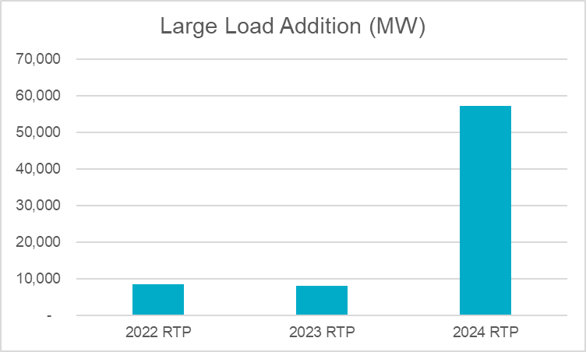

The significant increase in large load in the 2024 RTP cases resulted in a significant increase in reliability violations identified and thus will also significantly increase the need for new transmission projects. The charts below provided a comparison of the number of projects identified in ERCOT’s RTP from 2018 to 2024. Since the 2024 RTP is still underway, the 2024 projects are for N-1 contingency analysis only. To provide some context, the number of N-1 projects in 2023 RTP is about only a half of the number of 2024 RTP N-1 projects.

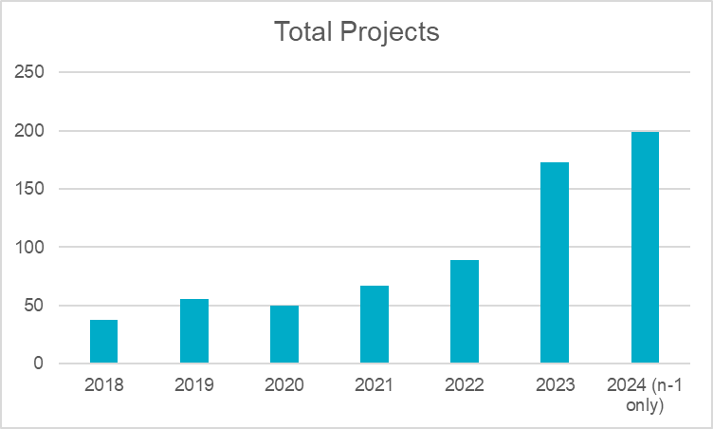

The additional large load not only requires more transmission projects, it also requires more projects at the 345-kV level. The chart below provides a comparison of 345-kV line rebuild/upgrade/addition in the 2023 RTP and the 2024 RTP N-1 analysis. Again, the 2024 figures do not include additional projects that will be identified in the RTP using something other than an N-1 analysis.

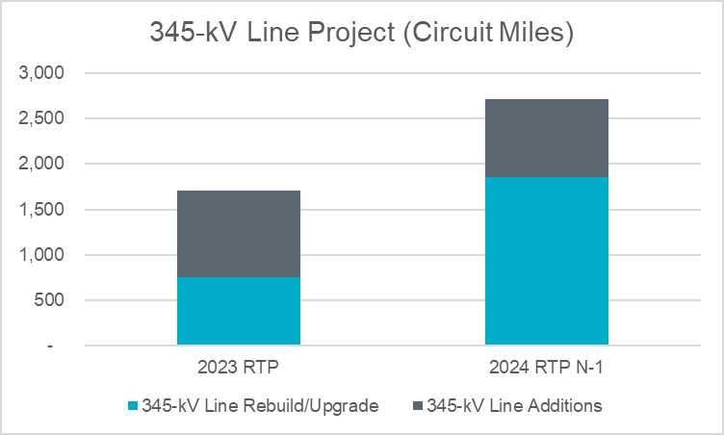

While the 2024 RTP is still underway, it is anticipated that a similar impact will continue for the analysis with prior outage conditions (including maintenance outage conditions).

It is also anticipated that other studies under NERC Reliability Standard TPL-001-5.1, such as P2, P4, P5 and extreme events analysis (multiple-element analysis), will also be significantly impacted. The chart below shows the increase in the reportable multiple-element analysis events from 2018 and 2023. Reportable events include those that may lead to cascading or instability, or that require load-shedding of 300 MW or more.

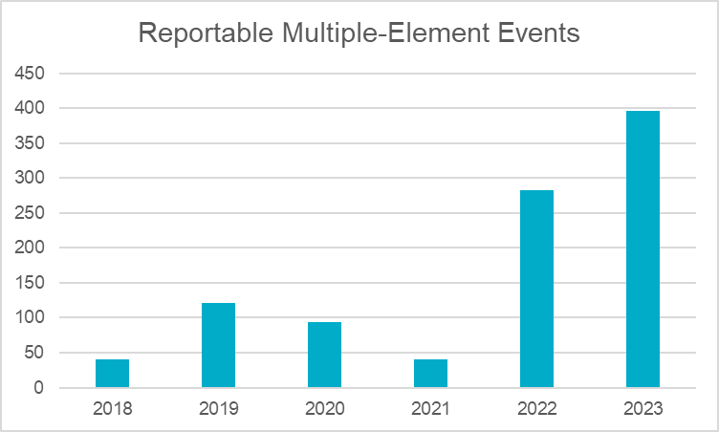

With the significant increase in reliability violations and transmission projects observed thus far in the 2024 RTP, it is expected that more RPG submittals especially Tier 1 and Tier 2 RPG submittals will come in to facilitate the interconnection of those load loads. ERCOT has already seen a significant increase in the number of Tier 1 RPG submittals since 2020 and expects this number to increase in 2025. As of August 31, 2024, ERCOT has endorsed four (4) Tier 1 and three (3) Tier 2 projects and is currently evaluating seven (7) Tier 1 and two (2) Tier 2 projects.

ERCOT is expecting an additional increase in the number of annual RPG submissions based on the inclusion of Substantiated Load category (c). ERCOT estimates five (5) additional Tier 1, Tier 2 and Tier 3 project submissions will need to be evaluated each year for the next five (5) years to address the current number of Substantiated Load category (c) submissions received.

ERCOT also anticipates that it will need additional engineering staff to conduct dynamic stability studies. The regulatory changes will expand the current workload of this group due to a significant increase in load expected in the ERCOT planning cases developed by ERCOT Steady-State Working Group (SSWG) and Dynamic Working Group (DWG). The increase in load in the planning cases will also create additional challenges (e.g., DWG flat start case development and dynamic load modeling) and potentially additional reliability issues in the annual stability assessment, and could also result in an increase in transmission projects and RPG submissions requiring dynamic stability studies.

For long-term load forecasting, an additional analyst is needed for requesting information from TDSPs, updating contracts, reviewing officer letters, and identifying additional loads to be studied. This position will also have the objective of researching loads, generating profiles, and integrating this data into the forecast waterfalls in the Long-Term Load Forecast.

|  |
| --- |
| Revised Cover Page Language |

None

|  |
| --- |
| Revised Proposed Protocol Language |

None