

August 2024 ERCOT Monthly Operations Report

Reliability and Operations Subcommittee Meeting

October 03, 2024

Table of Contents

1. Report Highlights 2

2. Frequency Control 3

2.1. Frequency Events 3

2.2. ERCOT Contingency Reserve Events 4

2.3. Responsive Reserve Events 4

2.4. Load Resource Events 4

3. Reliability Unit Commitment 5

4. IRR, Wind, and Solar Generation as a Percent of Load 6

5. Largest Net-Load Ramps 8

6. Congestion Analysis 9

6.1. Notable Constraints 9

6.2. Generic Transmission Constraint Congestion 17

6.3. Manual Overrides 18

6.4. Congestion Costs for Calendar Year 2024 18

7. System Events 20

7.1. ERCOT Peak Load 20

7.2. Load Shed Events 20

7.3. Stability Events 20

7.4. Notable PMU Events 20

7.5. DC Tie Curtailment 20

7.6. TRE/DOE Reportable Events 20

7.7. New/Updated Constraint Management Plans 20

7.8. New/Modified/Removed RAS 21

7.9. New Procedures/Forms/Operating Bulletins 21

8. Emergency Conditions 21

8.1. OCNs 21

8.2. Advisories 21

8.3. Watches 21

8.4. Emergency Notices 21

9. Application Performance 22

9.1. TSAT/VSAT Performance Issues 22

9.2. Communication Issues 22

9.3. Market System Issues 22

10. Model Updates 22

Appendix A: Real-Time Constraints 24

# Report Highlights

* The unofficial ERCOT peak demand was 85,199 MW for the month of August on 8/20/2024 HE 18:00; this is 309 MW less than the August 2023 peak demand of 85,508 MW on 8/10/2023 HE 18:00.
* A Solar Generation Record of 20,836 MW was set on 8/19/2024 at interval ending 14:30.
* There were 3 frequency events.
* There was 0 ERCOT Contingency Reserve Service (ECRS) events.
* There were no Responsive Reserve Service (RRS) events.
* There were 34 HRUC commitments.
* There were 2 OCNs issued due to extreme hot weather.
* There were 3 Advisories issued for Geomagnetic disturbance of [K-7] or Higher.
* The following GTCs saw congestion in August:

|  |  |
| --- | --- |
| GTC | Days Congestion |
| E_PASP | 19 |
| Zapata Starr | 19 |
| North Edinburg to Lobo | 16 |
| E_PATA | 12 |
| West Texas Export | 6 |
| Nelson Sharpe to Rio Hondo | 6 |
| Panhandle GTC | 5 |
| North to Houston | 1 |

# Frequency Control

## Frequency Events

The ERCOT Interconnection experienced 3 frequency events, which resulted from units tripping. The average event duration was 00:02:54.

A summary of the frequency events is provided below. The reported frequency events meet one of the following criteria: Delta Frequency is 60 mHz or greater; the MW loss is 350 MW or greater; resource trip event triggered ECRS deployment. Frequency events that have been identified as Frequency Measurable Events (FME) for purposes of BAL-001-TRE-2 analysis are highlighted in blue. When analyzing frequency events, ERCOT evaluates PMU data according to industry standards. Events with an oscillating frequency of less than 1 Hz are inter-area, while higher frequencies indicate local events. Industry standards specify that damping ratio for inter-area oscillations should be 3.0% or greater. For the frequency events listed below, the ERCOT system met these standards and transitioned well after each disturbance. In the case of negative delta frequency, the MW Loss column could refer to load loss.

|  |  |  |  |  |  |  |  |  |  |
| --- | --- | --- | --- | --- | --- | --- | --- | --- | --- |
| **Date and Time** | **Delta Frequency** | **Max/Min Frequency** | **Duration of Event** | **PMU Data** | | **MW Loss** | **Load** | **IRR** | **Inertia** |
| **(Hz)** | **(Hz)** | **Oscillation Mode (Hz)** | **Damping Ratio** | **(MW)** | **%** | **(MW-s)** |
| 8/7/2024 17:55:44 | 0.079 | 59.938 | 00:04:29 | 0.64 | 15% | 622 | 83,620 | 25% | 379,895 |
| 8/10/2024 2:56:27 | 0.073 | 59.911 | 00:03:55 | 0.56 | 8% | 655 | 53,096 | 13% | 329,572 |
| 8/26/2024 14:38:25 | 0.080 | 59.940 | 00:00:19 | 0.77 | 5% | 774 | 74,060 | 27% | 328,824 |

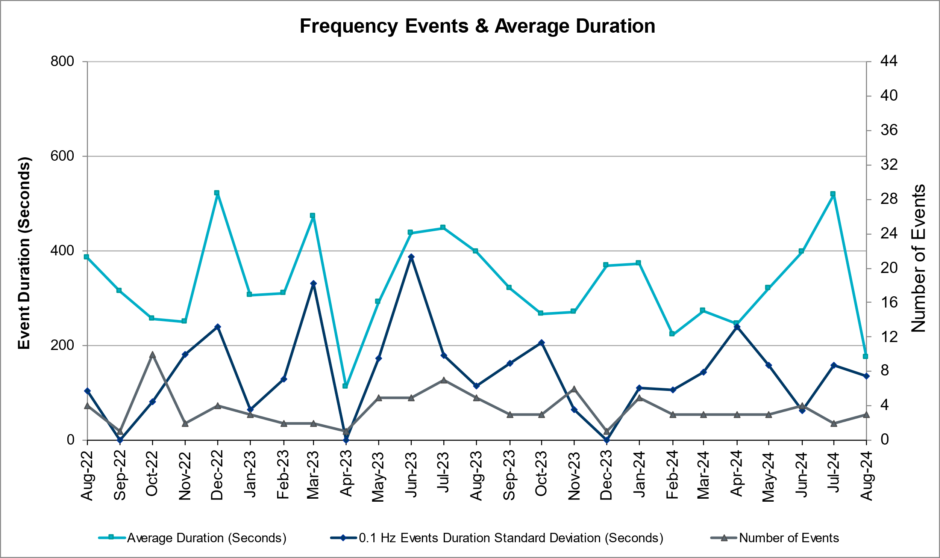

(Note: All data on this graph encompasses frequency event analysis based on BAL-001-TRE-2.)

## ERCOT Contingency Reserve Events

There were 0 events where ERCOT Contingency Reserve MWs were released to SCED. The events highlighted in blue were related to frequency events reported in Section 2.1 above.

|  |  |  |  |  |
| --- | --- | --- | --- | --- |
| Date and Time Released to SCED | Date and Time Recalled | Duration of Event | Maximum MWs Released | Comments |
| N/A | N/A | N/A | N/A | N/A |

## Responsive Reserve Events

There were 0 events where Responsive Reserve MWs were released to SCED.

|  |  |  |  |  |
| --- | --- | --- | --- | --- |
| **Date and Time Released to SCED** | **Date and Time Recalled** | **Duration of Event** | **Maximum MWs Released** | **Comments** |
| N/A | N/A | N/A | N/A | N/A |

## Load Resource Events

There were no events where Load Resource MWs were released to SCED.

|  |  |  |  |  |
| --- | --- | --- | --- | --- |
| **Date and Time Released to SCED** | **Date and Time Recalled** | **Duration of Event** | **Maximum MWs Released** | **Comments** |
| N/A | N/A | N/A | N/A | N/A |

# Reliability Unit Commitment

ERCOT reports on Reliability Unit Commitments (RUC) monthly. Commitments are reported grouped by operating day and weather zone. The total number of hours committed is the sum of the hours for all the units in the specified region. Additional information on RUC commitments can be found on the MIS secure site at Grid 🡪 Generation 🡪 Reliability Unit Commitment.

There were no DRUC commitments.

There were 34 HRUC commitments.

|  |  |  |  |  |  |
| --- | --- | --- | --- | --- | --- |
| **Resource Location** | **# of Resources** | **Operating Day** | **Total # of Hours Committed** | **Total MWhs** | **Reason for Commitment** |
| NORTH_CENTRAL | 6 | August 5, 2024 | 33 | 1,739.0 | System Capacity |
| NORTH_CENTRAL | 1 | August 6, 2024 | 1 | 107.0 | meet min run time |
| SOUTH_CENTRAL | 1 | August 14, 2024 | 6 | 1,302.0 | E_PASP |
| NORTH_CENTRAL | 1 | August 15, 2024 | 4 | 72.0 | System Capacity |
| NORTH_CENTRAL | 1 | August 17, 2024 | 4 | 72.0 | System Capacity |
| NORTH_CENTRAL, SOUTH_CENTRAL | 2 | August 18, 2024 | 9 | 2,016.0 | System Capacity |
| NORTH_CENTRAL | 4 | August 21, 2024 | 29 | 1,423.0 | System Capacity |
| NORTH_CENTRAL | 3 | August 25, 2024 | 22 | 3,066.0 | E_PASP, System Capacity |
| NORTH_CENTRAL | 4 | August 26, 2024 | 16 | 3,177.0 | System Capacity |
| NORTH_CENTRAL | 2 | August 27, 2024 | 11 | 1,900.0 | E_PASP, System Capacity |
| EAST, NORTH_CENTRAL, SOUTH_CENTRAL | 3 | August 30, 2024 | 16 | 3,050.0 | System Capacity |
| COAST, EAST, NORTH_CENTRAL, SOUTH_CENTRAL | 6 | August 31, 2024 | 33 | 5,225.0 | System Capacity |

# IRR, Wind, and Solar Generation as a Percent of Load

The graph below shows the maximum, minimum and average aggregate solar, wind and IRR output as a percentage of total ERCOT load when evaluated as 10-minute averaged intervals, over the past 13 months. Current wind and solar generation and penetration records are listed in the footnote below[1]. Maximum IRR penetration for the month was 51.22% on 08/11/2024 interval ending 09:30 and minimum IRR penetration for the month was 4.26% on 08/27/2024 interval ending 07:10.

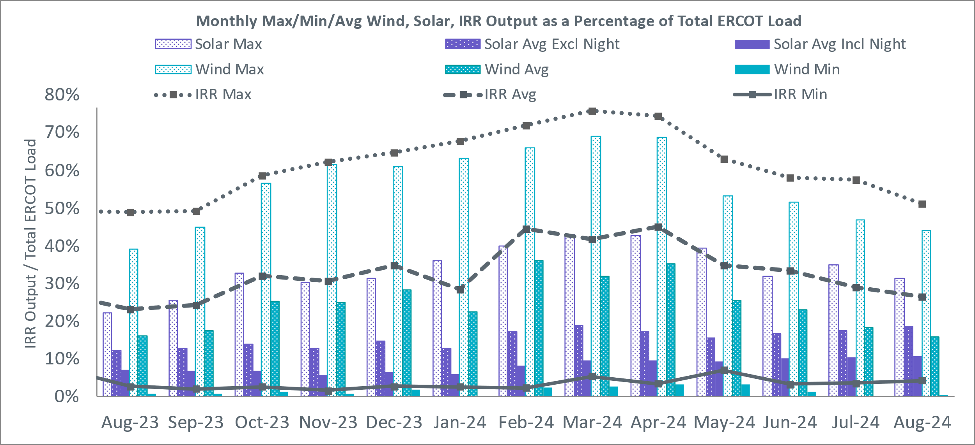

During the hour of peak load for the month, hourly integrated wind generation was 6286 MW and solar generation was 17,568 MW. The graph below shows the wind and solar penetration percentage during the hour of the peak load in the last 13 months.

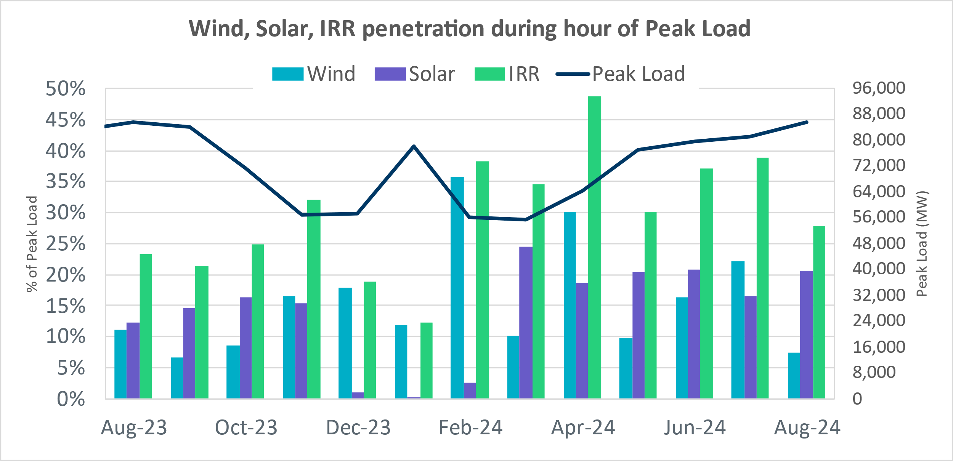

Lastly, the graph below shows the minimum wind, solar, and IRR output during the peak load hour as a percentage of the daily peak load for every day in the month.

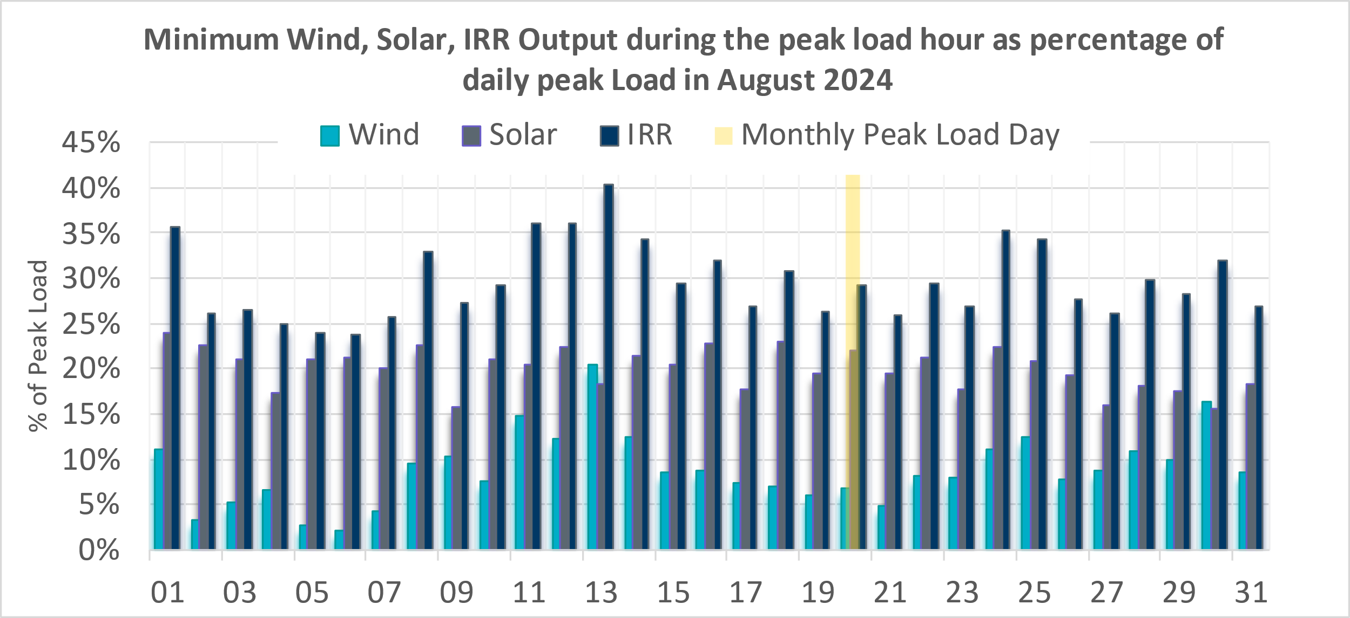

# Largest Net-Load Ramps

The net-load ramp is defined as the change in net-load (load minus wind and PVGR generation) during the defined time horizon. Such a variation in net-load needs to be accommodated in grid operations to ensure that the reliability of the grid is satisfactorily maintained. The largest net-load ramp during 5-min, 10-min, 15-min, 30-min, and 60-min in August 2024 was 1,128 MW, 2,011 MW, 2,837 MW, 4,671 MW, and 7,772 MW, respectively. The comparison with respect to the historical values is given in the table below.

|  |  |  |  |  |  |
| --- | --- | --- | --- | --- | --- |
| **Month and Year** | **5 min** | **10 min** | **15 min** | **30 min** | **60 min** |
| August 2014 | 674 MW | 1,169 MW | 1,589 MW | 2,854 MW | 5,201 MW |
| August 2015 | 776 MW | 1,231 MW | 1,754 MW | 3,303 MW | 6,260 MW |
| August 2016 | 834 MW | 1,350 MW | 1,881 MW | 3,230 MW | 6,319 MW |
| August 2017 | 797 MW | 1,421 MW | 1,953 MW | 3,167 MW | 5,798 MW |
| August 2018 | 1,333 MW | 1,854 MW | 2,780 MW | 3,205 MW | 6,604 MW |
| August 2019 | 830 MW | 1,460 MW | 2,084 MW | 3,795 MW | 7,375 MW |
| August 2020 | 954 MW | 1,536 MW | 2,221 MW | 4,101 MW | 7,690 MW |
| August 2021 | 1,323 MW | 1,596 MW | 2,081 MW | 3,614 MW | 6,761 MW |
| August 2022 | 977 MW | 1,837 MW | 2,664 MW | 4,529 MW | 7,716 MW |
| August 2023 | 1,230 MW | 1,793 MW | 2,519 MW | 4,733 MW | 8,650 MW |
| August 2024 | 1128 MW | 2011 MW | 2837 MW | 4671 MW | 7772 MW |
| 08/18/2024 | 08/18/2024 | 08/18/2024 | 08/18/2024 | 08/18/2024 |
| (IE 18:47) | (IE 18:50) | (IE 18:53) | (IE 18:52) | (IE 19:19) |
| All Months in 2014-2024 | | 1,978 MW | 3,107 MW | 4,588 MW | 8,901 MW | 16,522 MW |
| 6/1/2024 | 1/29/2024 | 1/29/2024 | 1/29/2024 | 1/29/2024 |
| (IE 10:07) | (IE 17:05) | (IE 17:10) | (IE 17:11) | (IE 17:17) |

# Congestion Analysis

## Notable Constraints

Nodal protocol section 3.20 specifies that ERCOT shall identify transmission constraints that are binding in Real-Time three or more Operating Days within a calendar month. As part of this process, ERCOT reports congestion that meets this criterion to ROS. In addition, ERCOT also highlights notable constraints that have an estimated congestion rent exceeding $1,000,000 for a calendar month. These constraints are detailed in the table below, including approved transmission upgrades from TPIT that may provide some congestion relief based on ERCOT’s engineering judgement. Rows highlighted in blue indicate the congestion was affected by one or more outages. For a list of all constraints activated in SCED, please see Appendix A at the end of this report.

|  |  |  |  |  |  |  |
| --- | --- | --- | --- | --- | --- | --- |
| **Contingency Name** | **Overloaded Element** | **Contingency Name** | **Overloaded Element** | **# of Days Constraint Binding** | **Congestion Rent** | **Transmission Project** |
|
| DMGSCON5 | 6471__C | MGSES-LNGSW_and_MGSES-CONSW_345_DBLCKT | Morgan Creek Ses - Navigation Sub 138kV | 16 | $20,223,209.03 | Oncor_FW_5436 Morgan Creek_McDonald Rd 138 kV Line(23RPG011, MOD 5436) |
| SDAFAUS8 | CKT_1027_1 | AUSTROP to DAFFIN GIN LIN 1 | Decker Power Plant - Aen Dunlap 138kV | 6 | $16,287,390.38 |  |
| DSALHUT5 | 1710__C | SALSW - HUTTO 345KV | Bell County - Salado Switch 138kV | 12 | $15,351,208.01 |  |
| DCONLNG5 | 6471__C | CONSW-MGSES_and_CONSW-LNGSW_345kV_DBLCKT | Morgan Creek Ses - Navigation Sub 138kV | 25 | $12,359,123.35 | Oncor_FW_5436 Morgan Creek_McDonald Rd 138 kV Line(23RPG011, MOD 5436) |
| SWALNAA8 | COLLE_JUPIT_1 | NAAMAN to NAAMAN LIN 1 | College - Jupiter 138kV | 8 | $11,704,777.80 |  |
| DWLFMOS5 | 6520__E | WLFSW-MOSSW 345&WLFSW-ODEHV 345____TRPLCKT-1of3 | Odessa Ehv Switch - Yarbrough Sub 138kV | 15 | $7,638,142.48 |  |
| SW_LVLT5 | 15060__B | wett_long_draw to Volta LIN 1 | Koch Tap - Vealmoor 138kV | 12 | $4,906,982.83 |  |
| SSHIMC28 | CNT_MCCR_1 | MCCREE to MCCREE LIN 1 | Centerville - Mccree 138kV | 7 | $4,028,112.75 |  |
| SBWDDBM5 | LPLMK_LPLNE_1 | BLACKWATER DRAW SWITCH to DOUBLE MOUNTAIN SWITCH LIN 1 | Mackenzie Substation - Northeast Substation 115kV | 14 | $3,977,431.33 |  |
| MLOBFOR5 | LARDVN_LASCRU1_1 | manual double Lobo to fowlerton 1&2 345 | Laredo Vft North - Las Cruces 138kV | 20 | $3,798,543.00 | AEP_TCC_Las Cruces - Milo Rebuild (76076), AEP_TCC_Milo - Mines Road Rebuild (76078), AEP_TCC_Mines Road - North Laredo SW Rebuild (76080) |
| DHILLAS8 | G2_M3_1 | Hillctry-Lasierra&Helotes 138kV | Hamwolf - Med_Ctr 138kV | 3 | $3,623,352.02 |  |
| DROUCHI8 | 1680__A | RNDRK-CHIEBR & SPANOA 138kV | Georgetown South - Round Rock Westinghouse 138kV | 4 | $2,989,921.73 |  |
| BASE CASE | E_PASP | Basecase | E_PASP GTC | 15 | $2,878,849.21 |  |
| DBIGKEN5 | FORTMA_YELWJC1_1 | Bighil-Kendal 345kV | Yellow Jacket - Fort Mason 138kV | 10 | $2,767,858.32 |  |
| SBWDDBM5 | LPLNW_LPLMD_1 | BLACKWATER DRAW SWITCH to DOUBLE MOUNTAIN SWITCH LIN 1 | Northwest Substation - Mcdonald Substation 115kV | 5 | $2,762,149.06 |  |
| DDILCOT8 | DILLEYSW_69A1 | Dilleysw-Sanmgsw&Cotulas 138kV | Dilley Switch Aep 138kV | 28 | $2,116,628.88 |  |
| SHCKRNK5 | 106__A | HICKS SWITCH to HICKS SWITCH LIN _A | Hicks Switch - Alliance 345kV | 4 | $2,074,504.25 | Oncor_MW_RoanokeAreaProjects(21RPG008, MOD 70900) |
| DVLSPAC5 | 389__A | VLSES-PACSW 345&PRSSW-VLYSO 345 DBLCKT | Monticello Ses - Woodard Switch 345kV | 24 | $2,052,126.70 |  |
| SOBWAP5 | OB_WAP98_A | WA PARISH to OBRIEN LIN A | Wa Parish - Obrien 345kV | 11 | $1,925,904.36 |  |
| DBIGSCH5 | PALOUS_WOLFCA1_1 | Big Hill - Schneeman Draw & Big Hill - Schneeman Draw 2 | Palouse - Wolfcamp 138kV | 8 | $1,823,019.21 |  |
| MLARMIL8 | DEL_MA_LAREDO1_1 | Manual MILO - LAREDO VFT NORTH | Del Mar - Laredo Plant 138kV | 4 | $1,608,466.75 |  |
| XPEA89 | DILLEYSW_69A1 | PEARSALL SWITCHING STATION TRX 69_4 138/69 | Dilley Switch Aep 138kV | 15 | $1,398,488.73 |  |
| SBWDDBM5 | LPLYH_T4P | BLACKWATER DRAW SWITCH to DOUBLE MOUNTAIN SWITCH LIN 1 | Yellow House Canyon Substation 345kV | 4 | $1,258,665.00 |  |
| SCRMSAR8 | ORNT_REDCRE1_1 | SAN ANGELO RED CREEK to Weiss LIN 1 | Orient - San Angelo Red Creek 138kV | 6 | $1,127,192.52 |  |
| XVIC89 | MAGRUD_VICTOR2_1 | VICTORIA TRX 69A2 138/69 | Magruder - Victoria 138kV | 8 | $1,040,445.29 |  |
| DWO5_EU8 | HY_WZ_24_A | TWR (345/138) EU-SF09 & WO-JN72 | Hayes - Westchase 138kV | 7 | $964,222.24 |  |
| SSTILOM8 | SCARBI_STILLM1_1 | STILLMAN to LOMA ALTA SUBSTATION LIN 1 | South Carbide - Stillman 138kV | 3 | $924,080.73 |  |
| SRRDLCS5 | 235__B | Rattlesnake Rd Switch to LAKE CREEK SES LIN _A | Bale Switch - Jewett 345kV | 9 | $725,523.24 |  |
| DMTSCOS5 | 6437__F | DMTSW TO SCOSW 345 DBLCKT | Knapp - Scurry Chevron 138kV | 9 | $712,537.01 |  |
| SCO2EUL8 | COLETO_ROSATA1_1 | COLETO CREEK to Euler LIN 1 | Coleto Creek - Rosata Tap 138kV | 7 | $564,603.71 |  |
| SPLSFAS9 | POT_PEAR_1 | Tordillo 138_69 to McCoy LIN 1 | Poteet Sub - Pearsall Switching Station 69kV | 5 | $543,488.52 |  |
| DWAP_JN5 | BI_WAP50_A | TWR (345) JN-WAP64 & JN-WAP72 | Bellaire - Wa Parish 345kV | 10 | $508,773.63 |  |
| MLOBFOR5 | ASHERT_CATARI1_1 | manual double Lobo to fowlerton 1&2 345 | Asherton - Catarina 138kV | 13 | $492,052.41 | AEP_TCC_AshertontoPiloncillo138kVLine_rebuild (73100) |
| BASE CASE | PNHNDL | Basecase | PNHNDL GTC | 5 | $469,153.81 |  |
| BASE CASE | WESTEX | Basecase | WESTEX GTC | 5 | $467,468.69 |  |
| DWLFMOS5 | 6485__A | WLFSW-MOSSW 345&WLFSW-ODEHV 345____TRPLCKT-1of3 | Wolf Switching Station - Penwell Pod 138kV | 8 | $459,579.35 |  |
| DCMNCMN8 | 660__B | CMNSW TO BRNWD 138 AND CMNSW TO SWTNVL 138 DBLCKT | Zephyr Bepc - Mercers Gap Sw 138kV | 4 | $384,972.07 |  |
| XCAG158 | CAGNON_MR4H | CAGNON TRX CAGNON_3_3 345/138 | Cagnon 345kV | 3 | $380,043.88 |  |
| SBVFB8 | FB_FL_60_A | BRAZOS VALLEY to BRAZOS VALLEY LIN A | Fort Bend - Flewellen 138kV | 8 | $376,198.95 |  |
| BASE CASE | E_PATA | Basecase | E_PATA GTC | 6 | $342,219.54 |  |
| DWPWFWP5 | STPWAP39_1 | TWR(345) WAP-WLF64 & WAP-WLY72 | South Texas Project - Wa Parish 345kV | 7 | $324,468.53 |  |
| XJK_58 | GRE_GIBC_1 | BTU_JACK_CREEK TRX JK_CK_3_1 345/138 | Gibbons Creek - Btu_Greens_Prairie 138kV | 3 | $266,513.73 |  |
| MHARNED5 | BURNS_RIOHONDO_1 | Manual dbl ckt for NEDIN-BONILLA 345kV & RIOH-PRIM138kV | Burns Sub - Rio Hondo 138kV | 8 | $265,615.02 | STEC_71930_RioHondo_Burns_Upgrade (71930), STEC_71926_Burns_Heidelberg_Upgrade (71926), STEC_71928_Heidelberg_AEPWeslaco_Upgrade (71928) |
| DCONLNG5 | 6046__A | CONSW-MGSES_and_CONSW-LNGSW_345kV_DBLCKT | Falcon Seaboard - Morgan Creek Ses 345kV | 3 | $262,396.99 |  |
| DBAKCED5 | HARGRO_TWINBU1_1 | BAKESW-CEDACA 345kV & BAKESW-CEDACA 345kV | Hargrove - Twin Buttes 138kV | 4 | $260,301.55 |  |
| XDIL89 | DILLEYSW_69A1 | DILLEY SWITCH AEP TRX 69_1 138/69 | Dilley Switch Aep 138kV | 8 | $243,271.14 |  |
| SBAKCED5 | HARGRO_TWINBU1_1 | BAKERSFIELD SWITCHYARD to CEDAR CANYON LIN 1 | Hargrove - Twin Buttes 138kV | 4 | $231,641.60 |  |
| DBIGSCH5 | CROSSO_NORTMC1_1 | Big Hill - Schneeman Draw & Big Hill - Schneeman Draw 2 | North Mccamey - Crossover 138kV | 3 | $216,467.36 |  |
| SOBWA2P5 | OB_WAP99_A | WA PARISH to OBRIEN LIN A | Wa Parish - Obrien 345kV | 3 | $200,709.82 |  |
| SPETSNU8 | AE_STR26_A | PETSON to Snug LIN A | Angleton - Stratt 138kV | 4 | $163,074.33 |  |
| SMADSAP8 | MADDUX_SAPOWE2_1 | MADDUX to SAN ANGELO POWER STATION LIN 1 | Maddux - San Angelo Power Station 138kV | 9 | $149,565.26 |  |
| BASE CASE | ZAPSTR | Basecase | ZAPSTR GTC | 19 | $148,552.95 |  |
| BASE CASE | NELRIO | Basecase | NELRIO GTC | 5 | $118,108.35 | The Lower Rio Grande Valley (LRGV) System Enhancement Project (21RPG017) will cause there to be no stability constraint for NelsonSharpe_RioHondoGTC under normal conditions. |
| DCONLNG5 | 14040__A | CONSW-MGSES_and_CONSW-LNGSW_345kV_DBLCKT | Polecat Creek Switch - Dewey Lake Tap 138kV | 5 | $114,612.13 | Oncor_FW_45640_Spraberry - Polecat Creek 138 kV Line(23RPG009, MOD 45640) |
| BASE CASE | NE_LOB | Basecase | NE_LOB GTC | 9 | $92,438.10 | The Lower Rio Grande Valley (LRGV) System Enhancement Project (21RPG017) will improve the NorthEd_LoboGTC to support up to 80% of total wind and solar generation capacity in the LRGV area. |
| DVLSPAC5 | 1561__A | VLSES-PACSW 345&PRSSW-VLYSO 345 DBLCKT | Rivercrest Ses - Deport Rea 138kV | 5 | $92,342.02 |  |
| DODEMOS5 | 6513__A | ODEHV-MOSSW 345&ODEHV-WLFSW 345_DBLCKT | Odessa North - Odessa 138kV | 4 | $72,843.96 |  |
| SBTPBNT8 | MYRA_VAL_1 | BENNETT ROAD SWITCH to WISE COUNTY LIN _B | Myra - Valley View Bepc 138kV | 5 | $71,414.56 | BEPC_TPIT4645_MYRA_SPRING (4645) |
| DBIGKEN5 | HAMILT_MAXWEL1_1 | Bighil-Kendal 345kV | Hamilton Road - Maxwell 138kV | 7 | $69,195.54 | Hamilton Road to Maxwell 138 kV Line Rebuild Project (20RPG022) |
| SKBBI8 | HOCKB_90_A | BELLAIRE to BELLAIRE LIN A | H O Clarke - Kirby 138kV | 4 | $59,066.87 |  |
| SBRAPIN8 | HAMILT_MAVERI1_1 | BRACKETTVILLE to BRACKETTVILLE LIN 1 | Hamilton Road - Maverick 138kV | 9 | $57,789.45 | Escondido to Hamilton Road 138 kV Line Rebuild Project (22RPG044) |
| SRRDLCS5 | 245__A | Rattlesnake Rd Switch to LAKE CREEK SES LIN _A | St Johns Switch - Bale Switch 345kV | 4 | $51,642.76 |  |
| DPRSHWK8 | 1535__B | PRSSW-HWKSW 138 DBLCKT | Tenaska (Txu) - Toco Switch 138kV | 10 | $35,249.98 |  |
| DCAGCO58 | 583T583_1 | Cagnon-Kendal 345 & Cico-Comfor 138 | Mason Creek - Bandera 138kV | 3 | $22,919.71 |  |
| SHAYZO25 | 6T227_1 | HAYS ENERGY to ZORN LIN 1 | Zorn - Hays Energy 345kV | 4 | $21,539.92 |  |
| SPEBTRU8 | 940__A | GAMMA to GAMMA LIN _D | Ennis West Switch - Templeton 138kV | 5 | $12,953.56 |  |
| SSTAPYO8 | 138_IH2_COT_1 | PYOTE TNP to PYOTE TNP LIN 1 | Ih 20 Tnp - Collie Field Tap Tnp 138kV | 8 | $7,277.38 |  |
| SSTAWIC8 | 138_IH2_COT_1 | STAGHORN TNP to WICKETT TNP LIN 1 | Ih 20 Tnp - Collie Field Tap Tnp 138kV | 6 | $3,468.11 |  |
| DBIGKEN5 | FORTMA_YELWJC1_1 | Bighil-Kendal 345kV | Yellow Jacket - Fort Mason 138kV | 10 | $1,293.41 |  |
| SBROALP9 | FTST_69T1 | Bronco to ALPINE LIN 1 | Fort Stockton Plant 138kV | 3 | $240.72 |  |
| DELMSAN5 | PAWNEE_SPRUCE_1 | Elmcreek-Sanmigl 345kV | Pawnee Switching Station - Calaveras 345kV | 25 | $16,769,635.34 |  |
| BASE CASE | NE_LOB | Basecase | NE_LOB GTC | 26 | $10,077,970.46 | The Lower Rio Grande Valley (LRGV) System Enhancement Project (21RPG017) will improve the NorthEd_LoboGTC to support up to 80% of total wind and solar generation capacity in the LRGV area. |
| MXFL1C58 | 6462__C | MAN-TRX_MDLNE_AXFMR1_345/138 | #N/A | 13 | $8,650,276.69 |  |
| DCDHMCS8 | 3160__A | MCSES TO CDHSW 138 DBLCKT | Cedar Crest Switch - Oak Cliff South 138kV | 2 | $5,327,104.25 |  |
| DWPWFWP5 | STPWAP39_1 | TWR(345) WAP-WLF64 & WAP-WLY72 | South Texas Project - Wa Parish 345kV | 6 | $5,235,049.44 |  |
| BASE CASE | WESTEX | Basecase | WESTEX GTC | 2 | $4,033,498.41 |  |
| BASE CASE | NELRIO | Basecase | NELRIO GTC | 17 | $3,009,360.97 | The Lower Rio Grande Valley (LRGV) System Enhancement Project (21RPG017) will cause there to be no stability constraint for NelsonSharpe_RioHondoGTC under normal conditions. |
| SLOBSA25 | LARDVN_LASCRU1_1 | FOWLERTON to FOWLERTON LIN 1 | Laredo Vft North - Las Cruces 138kV | 18 | $2,851,101.01 | AEP_TCC_Las Cruces - Milo Rebuild (76076), AEP_TCC_Milo - Mines Road Rebuild (76078), AEP_TCC_Mines Road - North Laredo SW Rebuild (76080) |
| DWAP_JN5 | OB_WAP99_A | TWR (345) JN-WAP64 & JN-WAP72 | Wa Parish - Obrien 345kV | 6 | $2,676,269.99 |  |
| MHARNED5 | BURNS_RIOHONDO_1 | Manual dbl ckt for NEDIN-BONILLA 345kV & RIOH-PRIM138kV | Burns Sub - Rio Hondo 138kV | 11 | $2,497,867.85 | STEC_71930_RioHondo_Burns_Upgrade (71930), STEC_71926_Burns_Heidelberg_Upgrade (71926), STEC_71928_Heidelberg_AEPWeslaco_Upgrade (71928) |
| DWAP_JN5 | OB_WAP98_A | TWR (345) JN-WAP64 & JN-WAP72 | Wa Parish - Obrien 345kV | 5 | $2,072,441.04 |  |
| SOBWAP5 | OB_WAP98_A | WA PARISH to OBRIEN LIN A | Wa Parish - Obrien 345kV | 5 | $1,585,725.10 |  |
| SCMNCPS5 | 651__B | COMANCHE SWITCH (Oncor) to COMANCHE PEAK SES LIN _A | Comanche Tap - Comanche Switch (Oncor) 138kV | 3 | $1,429,796.10 |  |
| SOXYIN28 | I_DUPP_I_DUPS1_1 | INGLESIDE COGEN SWITCH to OXYCHEM INGLESIDE LIN 1 | Dupont Pp1 - Ingleside - Dupont Switch - Ingleside 138kV | 5 | $1,384,940.35 |  |
| DCAGCO58 | BERGHE_AT1H | Cagnon-Kendal 345 & Cico-Comfor 138 | Bergheim 345kV | 3 | $1,287,560.37 |  |
| DLYTTUR8 | CKT_943_1 | Lytton - Slaughtr & Turner 138 kV | Lytton Springs - Pilot Knob 138kV | 3 | $1,076,477.18 |  |
| SNATBEA8 | 6144__A | BEALS CREEK SUB to BEALS CREEK SUB LIN _A | Big Spring West - Stanton East 138kV | 14 | $1,045,683.33 |  |

## Generic Transmission Constraint Congestion

|  |  |
| --- | --- |
| GTC | Days Congestion |
| E_PASP | 19 |
| Zapata Starr | 19 |
| North Edinburg to Lobo | 16 |
| E_PATA | 12 |
| West Texas Export | 6 |
| Nelson Sharpe to Rio Hondo | 6 |
| Panhandle GTC | 5 |
| North to Houston | 1 |

There was no activity on the remaining GTCs during the month.

Note: This is how many times a constraint has been activated to avoid exceeding a GTC limit, it does not imply an exceedance of the GTC occurred or that the GTC was binding.

## Manual Overrides

None

## Congestion Costs for Calendar Year 2024

The following table represents the top twenty active constraints for the calendar year based on the estimated congestion rent attributed to the congestion. ERCOT updates this list on a monthly basis.

|  |  |  |  |
| --- | --- | --- | --- |
| **Contingency** | **Overloaded Element** | **# of 5-min SCED** | **Estimated Congestion Rent (2024)** |
| Basecase | WESTEX GTC | 18,108 | $93,635,628.69 |
| MGSES TO CCRSW 345 AND BTRCK TO MGSES 345 DBLCKT | Tonkawa Switch - Morgan Creek Ses 345kV | 7,456 | $87,576,954.87 |
| MGSES-LNGSW_and_MGSES-CONSW_345_DBLCKT | Morgan Creek Ses - Navigation Sub 138kV | 8,093 | $66,524,840.59 |
| SALSW - HUTTO 345KV | Bell County - Salado Switch 138kV | 8,358 | $47,376,861.83 |
| BAKERSFIELD SWITCHYARD to CEDAR CANYON LIN 1 | Hargrove - Twin Buttes 138kV | 6,420 | $40,760,686.90 |
| Basecase | NE_LOB GTC | 23,329 | $32,446,522.40 |
| Manual dbl ckt for NEDIN-BONILLA 345kV & RIOH-PRIM138kV | Burns Sub - Rio Hondo 138kV | 14,318 | $31,845,620.36 |
| CONSW-MGSES_and_CONSW-LNGSW_345kV_DBLCKT | Morgan Creek Ses - Navigation Sub 138kV | 9,326 | $29,655,574.18 |
| BLACKWATER DRAW SWITCH to DOUBLE MOUNTAIN SWITCH LIN 1 | Northwest Substation - Mcdonald Substation 115kV | 4,834 | $26,523,546.74 |
| Basecase | PNHNDL GTC | 20,498 | $25,132,545.97 |
| NAAMAN to NAAMAN LIN 1 | College - Jupiter 138kV | 2,485 | $19,241,454.25 |
| AUSTROP to DAFFIN GIN LIN 1 | Decker Power Plant - Aen Dunlap 138kV | 1,135 | $16,382,680.09 |
| manual double NEDIN to PALMITO 345 & NEDIN to STEWART 345 | Burns Sub - Rio Hondo 138kV | 1,833 | $15,606,001.64 |
| WLFSW-MOSSW 345&WLFSW-ODEHV 345____TRPLCKT-1of3 | Odessa Ehv Switch - Yarbrough Sub 138kV | 9,025 | $14,758,432.19 |
| Basecase | I_KALO GTC | 1,399 | $14,548,366.61 |
| FOWLERTON TRX FOWLRTON_AUTO1 345/138 | Laredo Vft North - Las Cruces 138kV | 6,265 | $13,110,290.05 |
| CONSW-MGSES_and_CONSW-LNGSW_345kV_DBLCKT | Falcon Seaboard - Morgan Creek Ses 345kV | 6,909 | $13,058,620.04 |
| HICKS SWITCH to HICKS SWITCH LIN _A | Hicks Switch - Alliance 345kV | 2,933 | $12,969,619.39 |
| BLACKWATER DRAW SWITCH to DOUBLE MOUNTAIN SWITCH LIN 1 | Mackenzie Substation - Northeast Substation 115kV | 4,574 | $12,761,242.52 |
| SALSW TO KLNSW 345 DBLCKT | Harker Heights South - Killeen Switch 138kV | 5,004 | $11,899,287.91 |

# System Events

## ERCOT Peak Load

The unofficial ERCOT peak load for the month was 85,199 MW and occurred on 08/20/2024, during hour ending 18:00. Instantaneous peak was 85,934 MW. Actual peak for the same month last year was 85,508 MW.

## Load Shed Events

None.

## Stability Events

None.

## Notable PMU Events

ERCOT analyzes PMU data for any significant system disturbances that do not fall into the Frequency Events category reported in section 2.1. The results are summarized in this section once the analysis has been completed.

There were no PMU events outside of those reported in section 2.1.

## DC Tie Curtailment

None.

## TRE/DOE Reportable Events

BPUB Submitted a DOE-417 for 08/06/2024 - Suspicious activity to its Facility.

ONCOR Submitted an EOP-004-4 for 08/16/2024 - Damage or destruction of a Facility.

ONCOR Submitted a DOE-417 for 08/16/2024 - Damage or destruction of a Facility.

ONCOR Submitted an EOP-004-4 for 08/28/2024 - Damage or destruction of a Facility.

ONCOR Submitted a DOE-417 for 08/28/2024 - Damage or destruction of a Facility.

ONCOR Submitted an EOP-004-4 for 08/29/2024 - Damage or destruction of a Facility.

ONCOR Submitted a DOE-417 for 08/29/2024 - Damage or destruction of a Facility.

## New/Updated Constraint Management Plans

Updated MPs:

* MP_2011_08 REV33

## New/Modified/Removed RAS

None.

## New Procedures/Forms/Operating Bulletins

|  |  |  |
| --- | --- | --- |
| **Date** | **Subject** | **Bulletin No.** |
| 8/29/2024 | Transmission and Security Desk V1 Rev 113 | 1150 |
| 8/29/2024 | Real Time Desk V1 Rev 98 | 1149 |

# Emergency Conditions

## OCNs

|  |  |
| --- | --- |
| **Date and Time** | **Message** |
| Aug 6, 2024 13:05 CST | ERCOT is issuing an OCN for the extreme hot weather with forecasted temperatures to be above 103°F in the North Central and South Central weather zones from Wednesday, August 7, 2024 through Thursday, August 8, 2024. |
| Aug 16, 2024 10:00 CST | ERCOT is issuing an OCN for the extreme hot weather with forecasted temperatures to be at or above 103°F in the North-Central and South-Central weather zones from Sunday, August 18, 2024 through Tuesday, August 20, 2024. |

## Advisories

|  |  |
| --- | --- |
| **Date and Time** | **Message** |
| Aug 04, 2024 10:13 CST | The Space Weather Prediction Center has issued a GMD Alert of K-7 or greater until August 4, 2024 0700-1000. |
| Aug 12, 2024 12:26 CST | The Space Weather Prediction Center has issued a GMD Warning of G7 until August 12, 2024 beginning 00:00 Central time till 04:00 Central time. |
| Aug 17, 2024 13:24 CST | The Space Weather Prediction Center has issued the GMD Alert of K7 at 13:00, August 17, 2024. |

## Watches

None.

## Emergency Notices

None.

# Application Performance

## TSAT/VSAT Performance Issues

None

## Communication Issues

None.

## Market System Issues

None.

# Model Updates

The Downstream Production Change (DPC) process allows ERCOT to make changes in the one-line Network Operations Model without loading a completely new model. The purpose of this process is to allow for reliable grid operations as system conditions change between designated Network Operations Model database loads. The DPC process is limited in scope to just those items listed below, with equipment ratings updates being the most common. ERCOT has seen a rise in the use of the DPC process to make on-line updates to the Network Operations Model in recent years, instead of through the standard Network Operations Model Change Request process.

* Static Line ratings (Interim Update)
* Dynamic Line ratings (non-Interim Update)
* Autotransformer ratings (non-Interim Update)
* Breaker and Switch Normal status (Interim Update)
* Contingency Definitions (Interim Update)
* RAP and RAS changes or additions (Interim Update)
* Net Dependable and Reactive Capability (NDCRC) values (Interim Update)
* Impedance Updates (non-Interim)

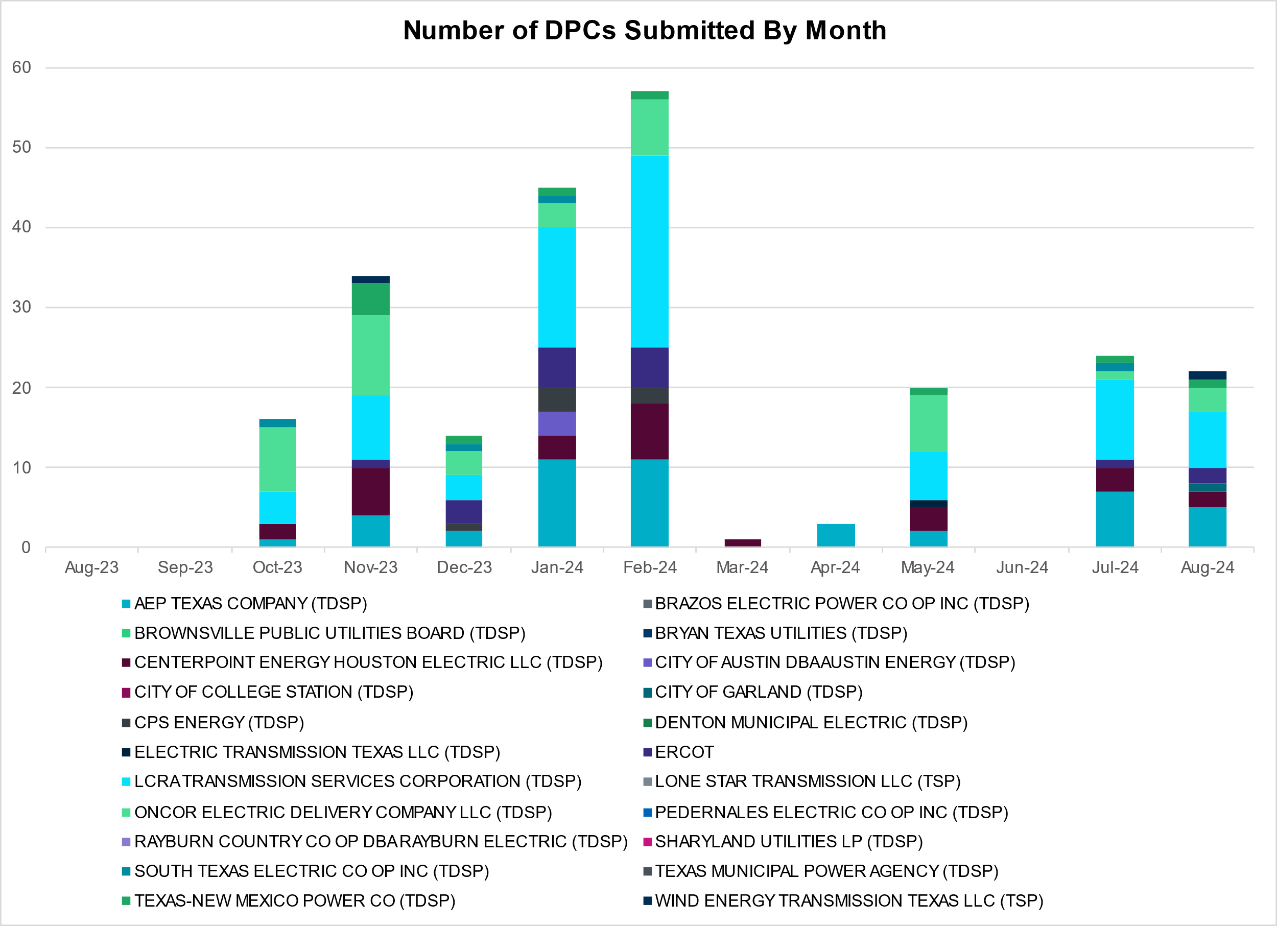

|  |  |
| --- | --- |
| **Transmission Operator** | **Number of DPCs** |
| AEP TEXAS COMPANY (TDSP) | 5 |
| BRAZOS ELECTRIC POWER CO OP INC (TDSP) | 0 |
| BROWNSVILLE PUBLIC UTILITIES BOARD (TDSP) | 0 |
| BRYAN TEXAS UTILITIES (TDSP) | 0 |
| CENTERPOINT ENERGY HOUSTON ELECTRIC LLC (TDSP) | 2 |
| CITY OF AUSTIN DBA AUSTIN ENERGY (TDSP) | 0 |
| CITY OF COLLEGE STATION (TDSP) | 0 |
| CITY OF GARLAND (TDSP) | 1 |
| CPS ENERGY (TDSP) | 0 |
| DENTON MUNICIPAL ELECTRIC (TDSP) | 0 |
| ELECTRIC TRANSMISSION TEXAS LLC (TDSP) | 0 |
| ERCOT | 2 |
| LCRA TRANSMISSION SERVICES CORPORATION (TDSP) | 7 |
| LONE STAR TRANSMISSION LLC (TSP) | 0 |
| ONCOR ELECTRIC DELIVERY COMPANY LLC (TDSP) | 3 |
| PEDERNALES ELECTRIC CO OP INC (TDSP) | 0 |
| RAYBURN COUNTRY CO OP DBA RAYBURN ELECTRIC (TDSP) | 0 |
| SHARYLAND UTILITIES LP (TDSP) | 0 |
| SOUTH TEXAS ELECTRIC CO OP INC (TDSP) | 0 |
| TEXAS MUNICIPAL POWER AGENCY (TDSP) | 0 |
| TEXAS-NEW MEXICO POWER CO (TDSP) | 1 |
| WIND ENERGY TRANSMISSION TEXAS LLC (TSP) | 1 |

# Appendix A: Real-Time Constraints

The following is a complete list of constraints activated in SCED. Full contingency descriptions can be found in the Standard Contingencies List located on the MIS secure site at Grid 🡪 Generation 🡪 Reliability Unit Commitment.

|  |  |  |  |  |  |  |
| --- | --- | --- | --- | --- | --- | --- |
| Year | Month | Contingency Name | Overloaded Element | From Station | To Station | Count of Days |
| 2024 | August | DCONLNG5 | 6471__C | MGSES | NAVIG | 30 |
| 2024 | August | DDILCOT8 | DILLEYSW_69A1 | DILLEYSW | DILLEYSW | 28 |
| 2024 | August | DVLSPAC5 | 389__A | WDDSW | MNSES | 25 |
| 2024 | August | DMGSCON5 | 6471__C | MGSES | NAVIG | 23 |
| 2024 | August | MLOBFOR5 | LARDVN_LASCRU1_1 | LARDVNTH | LASCRUCE | 20 |
| 2024 | August | BASE CASE | E_PASP | n/a | n/a | 19 |
| 2024 | August | BASE CASE | ZAPSTR | n/a | n/a | 19 |
| 2024 | August | SBWDDBM5 | LPLMK_LPLNE_1 | LPLMK | LPLNE | 17 |
| 2024 | August | DWLFMOS5 | 6520__E | ODEHV | YARBR | 17 |
| 2024 | August | SW_LVLT5 | 15060__B | VEALMOOR | KOCHTAP | 17 |
| 2024 | August | XPEA89 | DILLEYSW_69A1 | DILLEYSW | DILLEYSW | 16 |
| 2024 | August | BASE CASE | NE_LOB | n/a | n/a | 16 |
| 2024 | August | MLOBFOR5 | ASHERT_CATARI1_1 | ASHERTON | CATARINA | 14 |
| 2024 | August | DSALHUT5 | 1710__C | BELCNTY | SALSW | 14 |
| 2024 | August | SMADSAP8 | MADDUX_SAPOWE2_1 | MADDUX | SAPOWER | 12 |
| 2024 | August | DWAP_JN5 | BI_WAP50_A | WAP | BI | 12 |
| 2024 | August | DCONLNG5 | 14040__A | PCTSW | DEWTP | 12 |
| 2024 | August | DMTSCOS5 | 6437__F | SCRCV | KNAPP | 12 |
| 2024 | August | SBENS_M8 | BENTS_FRTER_1B_1 | FRONTERA | S_MISSIN | 12 |
| 2024 | August | SDAFAUS8 | CKT_1027_1 | DUNLAP | DECKER | 12 |
| 2024 | August | BASE CASE | E_PATA | n/a | n/a | 12 |
| 2024 | August | DPRSHWK8 | 1535__B | TNSKA | TCOSW | 11 |
| 2024 | August | SOBWAP5 | OB_WAP98_A | WAP | OB | 11 |
| 2024 | August | DBIGKEN5 | FORTMA_YELWJC1_1 | YELWJCKT | FORTMA | 11 |
| 2024 | August | SOBWA2P5 | OB_WAP99_A | WAP | OB | 11 |
| 2024 | August | DBIGKEN5 | FORTMA_YELWJC1_1 | FORTMA | YELWJCKT | 11 |
| 2024 | August | SBVFB8 | FB_FL_60_A | FB | FL | 11 |
| 2024 | August | SBTPBNT8 | MYRA_VAL_1 | MYRA | VALYVIEW | 11 |
| 2024 | August | SCO2EUL8 | COLETO_ROSATA1_1 | COLETO | ROSATA | 10 |
| 2024 | August | SSTAPYO8 | 138_IH2_COT_1 | IH20 | TNCOLIET | 10 |
| 2024 | August | SRRDLCS5 | 235__B | BALSW | JEWET | 10 |
| 2024 | August | DBIGSCH5 | PALOUS_WOLFCA1_1 | PALOUSE | WOLFCAMP | 9 |
| 2024 | August | SBRAPIN8 | HAMILT_MAVERI1_1 | HAMILTON | MAVERICK | 9 |
| 2024 | August | DWPWFWP5 | STPWAP39_1 | STP | WAP | 9 |
| 2024 | August | SSTAWIC8 | 138_IH2_COT_1 | IH20 | TNCOLIET | 9 |
| 2024 | August | DKENBA89 | COLETO_ROSATA1_1 | COLETO | ROSATA | 9 |
| 2024 | August | DBIGKEN5 | HAMILT_MAXWEL1_1 | MAXWELL | HAMILTON | 9 |
| 2024 | August | XDIL89 | DILLEYSW_69A1 | DILLEYSW | DILLEYSW | 9 |
| 2024 | August | DWLFMOS5 | 6485__A | PWPOD | WLFSW | 8 |
| 2024 | August | SBWDDBM5 | LPLNW_LPLMD_1 | LPLNW | LPLMD | 8 |
| 2024 | August | XVIC89 | MAGRUD_VICTOR2_1 | VICTORIA | MAGRUDER | 8 |
| 2024 | August | SWALNAA8 | COLLE_JUPIT_1 | COLLEGE | JUPITER | 8 |
| 2024 | August | MHARNED5 | BURNS_RIOHONDO_1 | RIOHONDO | MV_BURNS | 8 |
| 2024 | August | DVLSPAC5 | 1561__A | DPREA | RCSES | 8 |
| 2024 | August | DWO5_EU8 | HY_WZ_24_A | WZ | HY | 8 |
| 2024 | August | XEIN58 | 6471__C | MGSES | NAVIG | 8 |
| 2024 | August | SBROALP9 | FTST_69T1 | FTST | FTST | 8 |
| 2024 | August | SSHIMC28 | CNT_MCCR_1 | MCCREE | CENTRVIL | 7 |
| 2024 | August | SPEBTRU8 | 940__A | ENWSW | TMPTN | 7 |
| 2024 | August | DHILLAS8 | G2_M3_1 | M3 | G2 | 7 |
| 2024 | August | XCAG158 | CAGNON_MR4H | CAGNON | CAGNON | 7 |
| 2024 | August | SCRMSAR8 | ORNT_REDCRE1_1 | REDCREEK | ORNT | 7 |
| 2024 | August | XFTS89 | ALPINE_BRONCO1_1 | ALPINE | BRONCO | 7 |
| 2024 | August | XFTS89 | ALPINE_BRONCO1_1 | BRONCO | ALPINE | 7 |
| 2024 | August | DCONLNG5 | 6095__G | JPPOI | ALKLK | 7 |
| 2024 | August | SHAYZO25 | 6T227_1 | HAYSEN | ZORN | 6 |
| 2024 | August | DODEMOS5 | 6513__A | ODESA | ODNTH | 6 |
| 2024 | August | SBAKCED5 | HARGRO_TWINBU1_1 | TWINBU | HARGROVE | 6 |
| 2024 | August | DELMSAN5 | PAWNEE_SPRUCE_1 | PAWNEE | CALAVERS | 6 |
| 2024 | August | BASE CASE | NELRIO | n/a | n/a | 6 |
| 2024 | August | SHCKRNK5 | 106__A | HCKSW | ALLNC | 6 |
| 2024 | August | BASE CASE | WESTEX | n/a | n/a | 6 |
| 2024 | August | SRRDLCS5 | 245__A | SJNSW | BALSW | 5 |
| 2024 | August | SBWDDBM5 | LPLNE_LPLDB_1 | LPLDB | LPLNE | 5 |
| 2024 | August | SBWDDBM5 | LPLNE_LPLDB_1 | LPLNE | LPLDB | 5 |
| 2024 | August | DCDHTVW5 | 310__A | LIGSW | NORSW | 5 |
| 2024 | August | SHONMOO8 | BIG_FO_PLEASA1_1 | BIG_FOOT | PLEASANT | 5 |
| 2024 | August | DBAKCED5 | HARGRO_TWINBU1_1 | TWINBU | HARGROVE | 5 |
| 2024 | August | SPAWCAL5 | MAGRUD_VICTOR2_1 | VICTORIA | MAGRUDER | 5 |
| 2024 | August | BASE CASE | PNHNDL | n/a | n/a | 5 |
| 2024 | August | SPLSFAS9 | POT_PEAR_1 | PEARSALL | POTEETS | 5 |
| 2024 | August | DCMNCMN8 | 660__B | MGPSW | ZEPHYR | 4 |
| 2024 | August | DROUCHI8 | 1680__A | RRWES | GEORSO | 4 |
| 2024 | August | SHUDMU8 | AE_STR26_A | AE | STR | 4 |
| 2024 | August | XJK_58 | GRE_GIBC_1 | GIBCRK | GREENS_P | 4 |
| 2024 | August | DELMSAN5 | MAGRUD_VICTOR2_1 | VICTORIA | MAGRUDER | 4 |
| 2024 | August | DCAGCO58 | 583T583_1 | BANDER | MASOCR | 4 |
| 2024 | August | SPETSNU8 | AE_STR26_A | AE | STR | 4 |
| 2024 | August | MLARMIL8 | DEL_MA_LAREDO1_1 | LAREDO | DEL_MAR | 4 |
| 2024 | August | SBWDDBM5 | LPLYH_T4P | LPLYH | LPLYH | 4 |
| 2024 | August | DCONLNG5 | RKYROAD_STILES_1 | RCKYROAD | STILES | 4 |
| 2024 | August | DCAGCI58 | 255T279_1 | PIPECR | MEDILA | 4 |
| 2024 | August | XEI258 | 6471__C | MGSES | NAVIG | 4 |
| 2024 | August | SKBBI8 | HOCKB_90_A | HOC | KB | 4 |
| 2024 | August | SBRAPIN8 | ESCOND_GANSO1_1 | GANSO | ESCONDID | 3 |
| 2024 | August | SOLNRIC8 | 6840__B | NVKSW | ANARN | 3 |
| 2024 | August | SSTILOM8 | SCARBI_STILLM1_1 | STILLMAN | SCARBIDE | 3 |
| 2024 | August | DBAKCED5 | 6056__A | LNGSW | CONSW | 3 |
| 2024 | August | DYELME89 | HEXT_YELWJC1_1 | YELWJCKT | HEXT | 3 |
| 2024 | August | DNUEGIL8 | MCKENZ_WESTSI1_1 | WESTSIDE | MCKENZIE | 3 |
| 2024 | August | SCOLPAW5 | COLETO_ROSATA1_1 | COLETO | ROSATA | 3 |
| 2024 | August | SMDOOAS5 | GN_PZ_08_A | GN | PZ | 3 |
| 2024 | August | DCONLNG5 | 6046__A | MGSES | FLCNS | 3 |
| 2024 | August | SLAQLOB8 | BRUNI_69_1 | BRUNI | BRUNI | 3 |
| 2024 | August | MLOBFOR5 | CATARI_PILONC1_1 | CATARINA | PILONCIL | 3 |
| 2024 | August | SCOCBAR9 | ALPINE_BRONCO1_1 | BRONCO | ALPINE | 3 |
| 2024 | August | DBIGSCH5 | CROSSO_NORTMC1_1 | NORTMC | CROSSOVE | 3 |
| 2024 | August | SEBHUG8 | DA_WC_89_A | WC | DA | 3 |
| 2024 | August | XRIN89 | WHITE_PT_69A1 | WHITE_PT | WHITE_PT | 3 |
| 2024 | August | DCDHMCS8 | 3160__A | CDCSW | OKCLS | 3 |
| 2024 | August | DHILMAR5 | 361T361_1 | SCHERT | PARKWA | 3 |
| 2024 | August | MLOBFOR5 | CATARI_PILONC1_1 | PILONCIL | CATARINA | 3 |
| 2024 | August | DRNS_TB5 | THWZEN71_A | ZEN | THW | 3 |
| 2024 | August | SALLHCK5 | 107__A | HCKSW | RNKSW | 2 |
| 2024 | August | SCOLPAW5 | MAGRUD_VICTOR2_1 | VICTORIA | MAGRUDER | 2 |
| 2024 | August | DTRIASH8 | 1661__B | HUTTO | RRNES | 2 |
| 2024 | August | SRRNHU48 | 1680__A | RRWES | GEORSO | 2 |
| 2024 | August | SMCCRAT8 | 230T230_1 | STRAHAT1 | SANMAR | 2 |
| 2024 | August | SMYRSPR8 | 595__A | BNTSW | DCATR | 2 |
| 2024 | August | SBONNED5 | BURNS_RIOHONDO_1 | RIOHONDO | MV_BURNS | 2 |
| 2024 | August | SBRAHAM8 | HAMILT_MAVERI1_1 | MAVERICK | HAMILTON | 2 |
| 2024 | August | DWPWFCK5 | STPWAP39_1 | STP | WAP | 2 |
| 2024 | August | SGIDLIN8 | 215T215_1 | HIGH36 | BRENNO | 2 |
| 2024 | August | SBAKCED5 | 6056__A | LNGSW | CONSW | 2 |
| 2024 | August | DNOESGT5 | HARGRO_TWINBU1_1 | TWINBU | HARGROVE | 2 |
| 2024 | August | DVLSPAC5 | 390__A | PRSSW | WDDSW | 2 |
| 2024 | August | DKURTRI8 | GRE_GIBC_1 | GIBCRK | GREENS_P | 2 |
| 2024 | August | SHOLWES8 | HOLLY4_SOUTH_1_1 | HOLLY4 | SOUTH_SI | 2 |
| 2024 | August | SN_SAJO5 | LASPUL_RAYMND1_1 | LASPULGA | RAYMND2 | 2 |
| 2024 | August | SENSENW8 | 943__B | ENWSW | SHKSW | 2 |
| 2024 | August | DVICDUP8 | BIGTRE_V_DUPS1_1 | V_DUPSW | BIGTRE | 2 |
| 2024 | August | DLYTTUR8 | CKT_943_1 | LYTTON_S | PILOT | 2 |
| 2024 | August | DNOECED5 | HARGRO_TWINBU1_1 | TWINBU | HARGROVE | 2 |
| 2024 | August | DHILPAN8 | P3_P1TAP_1 | SKYLINE | P1 | 2 |
| 2024 | August | SMVRLA_8 | STEWAR_VERTRE1_1 | STEWART | VERTREES | 2 |
| 2024 | August | MWHPLON5 | WHITE_PT_69A1 | WHITE_PT | WHITE_PT | 2 |
| 2024 | August | DCDHTVW5 | 3180__A | FCRSW | CDHSW | 2 |
| 2024 | August | DCMNCMN8 | 660__A | ZEPHYR | BRNSW | 2 |
| 2024 | August | SFBFL8 | BV_FL_09_A | BV | FL | 2 |
| 2024 | August | SRAYRI38 | HAINE__LA_PAL1_1 | LA_PALMA | HAINE_DR | 2 |
| 2024 | August | SJUNYEL9 | HEXT_MASONS1_1 | HEXT | MASONSW | 2 |
| 2024 | August | DHJWFCK5 | STPWAP39_1 | STP | WAP | 2 |
| 2024 | August | DVENLIG5 | 6300__C | BOWEN | VGCRK | 2 |
| 2024 | August | SCMNCPS5 | 651__B | CMNSW | CMNTP | 2 |
| 2024 | August | DWEBLMU8 | AE_STR26_A | AE | STR | 2 |
| 2024 | August | DWAP_JN5 | BI_SMR98_A | SMITHERS | BI | 2 |
| 2024 | August | DSWELNC5 | BLUF_C_MULBER1_1 | BLUF_CRK | MULBERRY | 2 |
| 2024 | August | SLOLFOR8 | BROOKT_JOSLIN1_1 | JOSLIN | BROOKTAP | 2 |
| 2024 | August | XUVA189 | CHAPAR_TURTLC1_1 | TURTLCRK | CHAPARRO | 2 |
| 2024 | August | DGARHIC8 | CKT_1027_1 | DUNLAP | DECKER | 2 |
| 2024 | August | DFRIILL8 | HAMILT_MAXWEL1_1 | MAXWELL | HAMILTON | 2 |
| 2024 | August | DYELME89 | HEXT_MASONS1_1 | HEXT | MASONSW | 2 |
| 2024 | August | SBLSJAC8 | MYRA_VAL_1 | MYRA | VALYVIEW | 2 |
| 2024 | August | DMTSCOS5 | 6240__C | SACRC | DPCRK | 2 |
| 2024 | August | SENSENW8 | 940__A | ENWSW | TMPTN | 2 |
| 2024 | August | DZORHAY5 | BERGHE_AT1L | BERGHE | BERGHE | 2 |
| 2024 | August | DCC1DUKE | BURNS_RIOHONDO_1 | RIOHONDO | MV_BURNS | 2 |
| 2024 | August | DWHICOT5 | FARMLAND_LONGD_1 | FARMLAND | W_LD_345 | 2 |
| 2024 | August | SDELLAR8 | LARDVN_LASCRU1_1 | LARDVNTH | LASCRUCE | 2 |
| 2024 | August | DSLKSOL5 | 138_FLT_FXT_1 | TNFXTAIL | FLAT_TOP | 2 |
| 2024 | August | DHUTGEA8 | 1710__C | BELCNTY | SALSW | 2 |
| 2024 | August | DHCKRNK5 | 595__A | BNTSW | DCATR | 2 |
| 2024 | August | MPEAMOO8 | DILLEYSW_69A1 | DILLEYSW | DILLEYSW | 2 |
| 2024 | August | MLOBFOR5 | LASCRU_MILO1_1 | LASCRUCE | MILO | 2 |
| 2024 | August | DCONLNG5 | 14040__E | DEWTP | MDPOD | 2 |
| 2024 | August | SFMRRYS5 | 400__A | FMRVL | RYSSW | 1 |
| 2024 | August | SBCESND5 | 421__A | BCESW | SNDSW | 1 |
| 2024 | August | SHUDMU8 | BFPCAV82_A | CAV | BFP | 1 |
| 2024 | August | SPOTPAN9 | GUS_HAS_1 | GUSTINE | HAS | 1 |
| 2024 | August | SILLFTL8 | HAMILT_MAXWEL1_1 | MAXWELL | HAMILTON | 1 |
| 2024 | August | DRAZSA89 | READIN_UVALDE1_1 | UVALDE | READING | 1 |
| 2024 | August | SVEROK28 | SANDRO_VERS1_1 | VERS | SANDROAD | 1 |
| 2024 | August | SHCKRNK5 | 106__B | ALLNC | RNKSW | 1 |
| 2024 | August | DCAGCI58 | 243T278_1 | CICO | PIPECR | 1 |
| 2024 | August | DSNDBCE5 | 36040__A | KNBSW | SALSW | 1 |
| 2024 | August | SKNBSAL5 | 431__A | BCESW | SNDSW | 1 |
| 2024 | August | SFTLMES8 | CROSSO_NORTMC1_1 | NORTMC | CROSSOVE | 1 |
| 2024 | August | SSPUASP8 | GIRA_T_SPUR1_1 | SPUR | GIRA_TAP | 1 |
| 2024 | August | DSGTSCH5 | HARGRO_TWINBU1_1 | TWINBU | HARGROVE | 1 |
| 2024 | August | SAILAB48 | OILMIT_SAWGRA1_1 | SAWGRASS | OILMITAP | 1 |
| 2024 | August | SSTAWIC8 | 138_HRT_BPT_1 | BRDSPRYT | HARPOONT | 1 |
| 2024 | August | DKENCA58 | 243T278_1 | CICO | PIPECR | 1 |
| 2024 | August | DTVWJON5 | 6017__B | MBDSW | CMBSW | 1 |
| 2024 | August | DCAGCO58 | 656T656_1 | KENDAL | BERGHE | 1 |
| 2024 | August | XPEA89 | BIG_FO_PLEASA1_1 | BIG_FOOT | PLEASANT | 1 |
| 2024 | August | SFTWW_D8 | LOCUST_NODE_1 | LOCUST_D | DMENODE | 1 |
| 2024 | August | MWHI58 | NUECES_WHITE_2_1 | NUECES_B | WHITE_PT | 1 |
| 2024 | August | BASE CASE | N_TO_H | n/a | n/a | 1 |
| 2024 | August | DBIGKEN5 | TREADW_YELWJC1_1 | TREADWEL | YELWJCKT | 1 |
| 2024 | August | SVENFTS5 | 35055__A | SAMSW | VENSW | 1 |
| 2024 | August | DNOECED5 | 6056__A | LNGSW | CONSW | 1 |
| 2024 | August | DCAGCI58 | 656T656_1 | KENDAL | BERGHE | 1 |
| 2024 | August | DCMNCMN8 | 663__A | CMNSW | MGPSW | 1 |
| 2024 | August | DVLSPAC5 | 874__A | CRSSW | COMSW | 1 |
| 2024 | August | XALM689 | ALMC_T2 | ALMC | ALMC | 1 |
| 2024 | August | DELMSAN5 | POT_OAKS_1 | POTEETS | OAKS9 | 1 |
| 2024 | August | Unknown | Unknown | HYDR_ESS | BAKESW | 1 |
| 2024 | August | DMCCHIL8 | 106T200_1 | REDWOO | SANMAR | 1 |
| 2024 | August | DKENCA58 | 255T279_1 | PIPECR | MEDILA | 1 |
| 2024 | August | SBUZLME8 | 6217__A | WLVSW | GAILS | 1 |
| 2024 | August | SENPCRS8 | 874__A | CRSSW | COMSW | 1 |
| 2024 | August | DZORHAY5 | BERGHE_AT1H | BERGHE | BERGHE | 1 |
| 2024 | August | SPAWCAL5 | COLETO_ROSATA1_1 | COLETO | ROSATA | 1 |
| 2024 | August | SNLAGAT8 | DEL_MA_LAREDO1_1 | LAREDO | DEL_MAR | 1 |
| 2024 | August | SBRAHAM8 | ESCOND_GANSO1_1 | ESCONDID | GANSO | 1 |
| 2024 | August | SMDOPHR5 | G138_10B_1 | SEMINOLE | MAGNO_TN | 1 |
| 2024 | August | DJK_KUR8 | GRE_GIBC_1 | GIBCRK | GREENS_P | 1 |
| 2024 | August | SJUNYEL9 | HEXT_YELWJC1_1 | YELWJCKT | HEXT | 1 |
| 2024 | August | DWO5_EU8 | MIDPK_90_A | MID | PK | 1 |
| 2024 | August | DBWN_AM5 | ORNT_REDCRE1_1 | REDCREEK | ORNT | 1 |
| 2024 | August | DRAZSA89 | 2585_1 | DOWNIES | MOORE | 1 |
| 2024 | August | DSALTM58 | 431__A | BCESW | SNDSW | 1 |
| 2024 | August | SRICGRS8 | 6840__A | ANARN | CRDSW | 1 |
| 2024 | August | DTRIASH8 | CKT_1027_1 | DUNLAP | DECKER | 1 |
| 2024 | August | SEULTUL8 | COLETO_ROSATA1_1 | COLETO | ROSATA | 1 |
| 2024 | August | SSANFER8 | CORONA_AT4 | CORONA | CORONA | 1 |
| 2024 | August | SFTPFTP8 | OILMIT_SAWGRA1_1 | SAWGRASS | OILMITAP | 1 |
| 2024 | August | BASE CASE | RZ_WML26_A | RZ | WML | 1 |
| 2024 | August | Unknown | Unknown | BAKESW | HYDR_ESS | 1 |
| 2024 | August | SWORBRD8 | 138_WIC_STG_1 | WICKETT | STAGHORN | 1 |
| 2024 | August | DWIRSTA8 | 231T323_1 | PALEPE | MARSFO | 1 |
| 2024 | August | DFOWSMG5 | ASHERT_CATARI1_1 | ASHERTON | CATARINA | 1 |
| 2024 | August | MANGWHP5 | BLESSI_LOLITA1_1 | LOLITA | BLESSING | 1 |
| 2024 | August | SJOSBRO8 | FORMOS_JOSLIN1_1 | JOSLIN | FORMOSA | 1 |
| 2024 | August | SJOSBRO8 | FORMOS_LOLITA1_1 | FORMOSA | LOLITA | 1 |
| 2024 | August | SRAYRI28 | HAINE__LA_PAL1_1 | LA_PALMA | HAINE_DR | 1 |
| 2024 | August | SMULFLA8 | MAGRUD_VICTOR2_1 | VICTORIA | MAGRUDER | 1 |
| 2024 | August | SCOMHA38 | MAXWEL_WHITIN1_1 | MAXWELL | WHITING | 1 |
| 2024 | August | DSALTM58 | SEA_AAT1 | SEA | SEA | 1 |
| 2024 | August | BASE CASE | W_LD_138_LDXF | W_LD_138 | W_LD_138 | 1 |
| 2024 | August | DSALHUT5 | 431__A | BCESW | SNDSW | 1 |
| 2024 | August | SSPRVAL8 | 595__A | BNTSW | DCATR | 1 |
| 2024 | August | DGRSPKR5 | 6375__A | GRSES | GRMES | 1 |
| 2024 | August | DCONLNG5 | 6470__E | PCTSW | FRSTP | 1 |
| 2024 | August | SENWSHK8 | 941__F | ENNIS | SHKSW | 1 |
| 2024 | August | SBROALP9 | BELD_BRONCO1_1 | BELD | BRONCO | 1 |
| 2024 | August | SBONWF28 | BNMSW_FMR1 | BNMSW | BNMSW | 1 |
| 2024 | August | SFIRWY28 | COLLE_JUPIT_1 | COLLEGE | JUPITER | 1 |
| 2024 | August | DVICDUP8 | FORMOS_JOSLIN1_1 | JOSLIN | FORMOSA | 1 |
| 2024 | August | SBRAHAM8 | GANSO_MAVERI1_1 | GANSO | MAVERICK | 1 |
| 2024 | August | DCC1DUKE | HAINE__LA_PAL1_1 | LA_PALMA | HAINE_DR | 1 |
| 2024 | August | SBWDDBM5 | LPLYH_T3P | LPLYH | LPLYH | 1 |
| 2024 | August | XPEA89 | PALDRO_DILLEY_1 | PALODURO | DILLEYSW | 1 |
| 2024 | August | SBONWF28 | 1940__D | BNMSW | ECTOR | 1 |

1. Current Wind Generation Record: 27,881 MW on 06/17/2024 at 21:15 | Current Wind Penetration Record: 69.15% on 04/10/2022 at 01:43

   Current Solar Generation Record: 21,667 MW on 09/08/2024 at 14:03 | Current Solar Penetration Record: 42.98% 03/28/2024 at 11:27