**TDTMS**

**March 12th, 2024 @ 9:30 AM**

**WebEx only**

|  |  |  |  |  |  |  |
| --- | --- | --- | --- | --- | --- | --- |
| Attendee | Company | Attendee | Company | | Attendee | Company |
| Diana Rehfeldt | TNMP | Marty Allen | | Oncor | Kyle Patrick | NRG |
| Jordan Troublefield | ERCOT | Dee Lowerre | | NRG | Monica Jones | CNP |
| Tammy Stewart | ERCOT | Sam Pak | | Oncor | Eric Lotter | GridMonitor |
| Sheri Wiegand | Vistra | Chandria Porter | | Oncor | Kathy Scott | CNP |
| Mick Hanna | ERCOT | Debbie McKeever | | Oncor | Amy Sue Stirland | LP&L |
| Cindy Juarez | AEP | Kyle Patrick | | NRG | Dheena Chinnasamy | LP&L |
| Gary Walcott | TNMP | Angela Ghormley | | Calpine | Steven Pliler | Vistra |
| Nabaraj Pokharel | OPUC | Yenpo Ho | | NextEra |  |  |

Monica Jones opened the meeting with the Antitrust Admonition.

Attendance and introductions completed.

Meeting minutes from the February 13th meeting were reviewed and approved without additions or comments.

**ERCOT System Instances & MarkeTrak Monthly Performance Review**

* Mick presented **February performance reports** and noted all SLA targets for January were met. MarkeTrak response times are continuing to perform well – leveling off and trending downward.

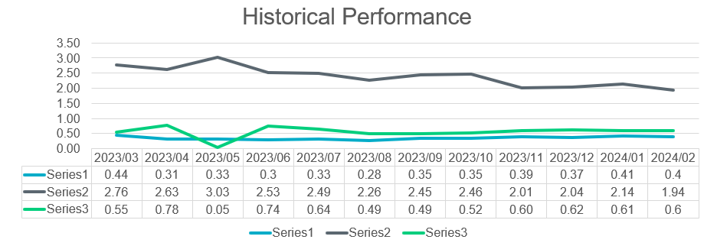

* + **Listserv activity** – No activities. Regular subscribes and unsubscribes.
  + **Retail incident experienced on 2/12** – ERCOT was unable to send transactions for a period of ~ 1 hour from 7:56 – 8:57AM. The network issue was triggered by a known “bug”. Reporting and outbound transactions were impacted. Two market notices were sent timely to the two listservs: [notice_extracts_retail@lists.ercot.com](mailto:notice_extracts_retail@lists.ercot.com) and [notice_operations_retail@lists.ercot.com](mailto:notice_operations_retail@lists.ercot.com) . In terms of preventative measures, the new data center will receive a tech refresh and storage refresh which should correct the issue. The transition is expected to complete in 3-4 weeks. **UPDATE**: New design in testing and expected to take a month or so. No expected impacts after re-design is moved to production which the release will likely be combined with a normally scheduled one.
  + **MIS API project update –** Release to correct the issue of the missing *key date* in the GUI for initiating transactions if viewer is not the submitter is tentatively scheduled for March 24.
  + **ERCOT Developer Portal –** Available now online with full release scheduled for March 28: [ERCOT Developer Portal](https://developer.ercot.com/). Portal offers technical support and is an open forum for all market participants to ask questions and search “how to”. ERCOT is also a moderator as well as cyber security enabled. Portal and all technology topics are discussed in [Technology Working Group](https://www.ercot.com/committees/other/twg) meetings. Market Notice announcing Portal: [M-B022824-01 ERCOT to launch Developer Portal](https://www.ercot.com/services/comm/mkt_notices/M-B022824-01)

**SCR 817 MarkeTrak Validations –**

* Tammy reviewed the edits to the IAG User’s Guide section with the WG. Tammy agreed to post the edits to the TDTMS meeting page, so that participants can review on their own and bring back questions/concerns to the April TDTMS meeting. Most edits pertain to the removal of TDSP step actions that will no longer be required after 5.0 release.
  + Reviewed “IA” and “CR” codes must be present in all back dated MVIs related to IAS. The “IA” code is optional in forward basis regaining MVIs; however, it is highly encourage all participants utilize “IA” in any IAS related MVI.
  + TDSPs will review to determine what reject codes may be present if a CR does not have “IA” in the backdated MVI after 5.0 release.
  + Rescissions must have the “CR” code and always be date of loss plus one day. Time to enter a rescission is decreasing from 25 calendar days to 15.
* Tammy discussed possible transition plans for IAS in process at 5.0 release because any MTs in process at the TDSP will follow the old path after 5.0 release. Any MTs pending with CRs will follow the new 5.0 path.
  + Maybe have CRs hold off on selecting button to send to TDSP for a day or so prior to release.
  + To be discussed further at future meetings.

**RMGRR177 – Switch Hold Removal Clarification – Update**

The revision will likely be on the PUCT OM in June and effective July 1.

**Data/Talking Points for Client Services on MT Analysis**

Sheri will set up a meeting with Ted Hailu, Client Services leadership, to review approach discussed and seek support regarding addressment of IAG Quarterly Report opportunities.

**MarkeTrak Subtypes Volume for 2023**

* Discussed the need to request all 2023 MT data from Dave Michelsen so that Rescissions, Cancel w/Approval, DEVs, and Service Orders can be further analyzed for opportunities as well as for all other MT subtype insights. Sheri to discuss with Dave what data is easily available and once a pull is ready, a smaller group will sort, group, review, etc. for discussion at a future TDTMS meeting for presentation to RMS.

**Review of ERCOT’s IAG Report – December 2023**

The WG performed their quarterly review of the latest ERCOT IAG report (December 2023). Observations:

1. The growing trend for IAGs with > 1% of enrollments make up the majority of the volume (2520 counts) as opposed to the REPs with < 1% of enrollments (945 counts). This number used to be divided ~ 50/50. This would be an indicator the same “offenders” have continued business practices that lead to a higher % of IAGs.
2. % of total enrollments has reduced overall (down to 1.04% as opposed to 1.2% as seen in the past
3. The number of REPs with ‘12’ representing the number of months with enrollments > 1% resulting in IAGs has declined over the years.
4. Fewer REPs with >1% of switches resulting in rescissions. Either this process is improving or REPs are not sending as many switch transactions
5. Sheri will provide graphical representation of trends as shown in MarkeTrak training for RMS viewing.

**NEXT MEETING** **Wednesday, April 10th @ 9:30 AM** **WebEx Only**

**DRAFT AGENDA**

* ERCOT Reports
  + System Instances & MT Performance
  + Listserv
  + MIS API review – update on key dates populating
* SCR817 Business Requirements discussion
  + Review of User’s Guide drafts
  + Any other clarifications
* MT Subtypes Volume Analysis – 2023 – progress update
* Data/Talking Points for Client Services on MT Analysis – update