# Q and A

1. 2021-832:  What situation(s) would the MVO reject code be used?  Is it only for IA or CR’s?

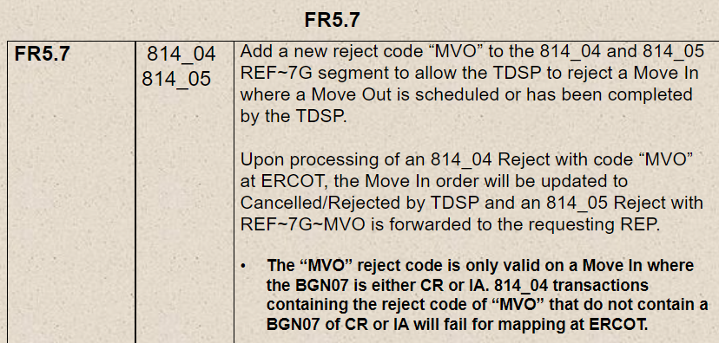

Answer – Yes, it would have to have the IA or CR code.

This reject would occur when a MVO has been submitted and scheduled prior to the Inadvertent.

1. 2021-830:
   1. FR6.5 and 6.13 – What is the difference between DCI and DIP?  Wouldn’t DCI only apply if it was a DIP?  Can we eliminate DCI and just use DIP as a reject code in both FR’s?

Answer – question no longer needed

* 1. FR6.12 – What situation would the TDPS use SOP as the reject code?    Transaction already worked?  TDSP already cancelled?  Other?

Answer –

SOP – unable to cancel due to order already cancelled or completed

Update SOP to – Subsequent Order Processed

Update Gray box for SOP – Rejected Due to Competing Transaction Already Pending, Scheduled or Completed

Question: what to use if the order that received the cancel is already cancelled?

Answer: A78

* 1. FR6.23 – How do TDSP’s treat a MVO to CSA when a new transaction is a MVI?  Do we reject MVO to CSA or the MVI?  Does one trump the other?

Answer – MVI trumps MVO

Example: 2 MVIs came in requesting the same day and both 814_03s were sent to the TDSP. TDSP schedules first MVI and rejects the second for NFI.

* 1. FR6.25 – What’s an example of reject code SCP (Schedule Conflict Pending)?

Answer – this is just removing MIMO and ERCOT/TDSP rules

1. Is 180 days still the furthest we can go back on tampering back billing?

Answer – It’s 150 days in the tariff.

1. TXSETCC 2021-836 – Punctuation marks in name fields (various transactions)

ERCOTwill only perform single punctuation validation.

**List of Punctuation Marks**

* Period **.**
* Comma **,**
* Semicolon **;**
* Colon **:**
* Exclamation Mark **!**
* Question Mark **?**
* Dash **–**
* Hyphen **-**
* Parentheses  **( or )**
* Brackets  **[ or ]**
* Curly Braces  **{ or }**
* Quotation Marks  **” or “**
* Apostrophe  **‘**
* Ellipses **…**

1. TXSETCC 2022-837 – NFI (Not First In) rejection code in the 814_25

This would be valid for an 814_25 inbound from the TDSP.

Example: 2 814_24s received by the TDSP, neither are scheduled at ERCOT. The TDSP would reject the second for NFI.

1. TXSETCC 2021-830 – use case for rejection codes on
   1. 814_04
      1. I2M – requesting to remove as the REF*1P*2MR is not in the 814_03.
      2. CCL – Oncor would not use this.
      3. A78 – previously being used as A13 for SW rejected due to pending MVI or MVO.
   2. 814_09
   3. 814_13
   4. 814_21
   5. 814_25
   6. 814_29
2. Use of IA and CR codes in transactions received from REPs. The understanding is that these codes should be used whether a forward dated or back dated transaction is submitted to resolve the IAG MarkeTrak.
   1. Will transactions be rejected for Backdated if IA code is not present – depends if it is on the safety net list?
      1. safety net, market cleanup or Inadvertent Gain codes (CR or IA) should be the only reason a TDSP should accept a backdated transaction.
   2. Support from user’s guide stating proposed regain date should match date on follow up transactions and codes should used when associated with a MT.
      1. TDSP will not do any verification of matching date to the MT. TDSP is expecting the CR to use the correct date.
   3. Will dates on transactions be “skootched” to next business day or rejected by TDSP if IA and CR codes are present?
      1. No plans of skootching the date. TDSP plans to work based on the requested date in the transaction containing the IA or CR.
3. IA code – is there any validation for current/future/past dated?
   1. No, there is no validation to prevent current or future dated to contain the IA code.
   2. If it should have been IA or CR and it is backdated request, TDSPs will be rejecting for backdating.
   3. “CR” and “IA” current dated and future dated MVIs will get the same scheduling criteria as any other MVI, since current or future dated MVIs could require a field meter reading to complete the “CR” or “IA” MVI.
      1. It is critical for CRs to manage this process by sending the correct regain date.
4. Can the TDSPs check the County upload after sending the MarkeTrak?
   1. No – TDSPs will need to wait for the TDSP ESIID extract after go-live
5. Are there any impacts to Reprocessing after Texas SET 5.0?
   1. ERCOT will not be able to reprocess 814_04s that were sent in prior to 5.0, since the 814_04 will require the County to be present.
   2. ERCOT will not be able to resend 814_20 maintains to the CR that contain the N4 Customer Service Address, since the County is now a required value.
   3. ERCOT will not be able to reprocess any 814_20s (Adds or Maintains) received prior to 5.0 that contain the N4 Customer Service Address, since the County is now a required value.
   4. ERCOT will not be able to reprocess any 814_18 Adds that were sent in prior to 5.0, since the CSA Start Date is a required field.