Transition to Competition_____________________________________________________________
Q: Does LP&L plan to transition customers / ESIs on meter cycle reads or a ‘flash cut’ date?
A: LP&L plans for an on-cycle transition. ESIs will transition commencing with March Meter Read Cycle 2 on 3/4/24 and conclude with April Meter Read Cycle 1 on 4/1/24.
Q: When will LP&L accept EDI transactions for transition to competition?
A: Transactions will be accepted August 2nd, which corresponds to 90 days prior to LP&L’s last meter read cycle in October. “LP&L anticipate that the FERC order will result in a delay of both the integration of the remaining load and LP&L’s transition to retail competition but are currently unable to provide a definitive estimate of the magnitude of the delay due to the uncertainty surrounding the timing of the settlement and hearing procedures at FERC.” A final FERC approval is still pending, however, a “March transition is more realistic” thus, if approved, the market would begin accepting transactions January 5th. FERC Commissioners have approved the settlement in docket ER23-1144. Procedurally, a 30 day period for rehearing is mandatory, however, the parties reached a unanimous agreement and further filings are unlikely. Given the FERC approval, LP&L is proceeding with the below timeline for the transition to competition.
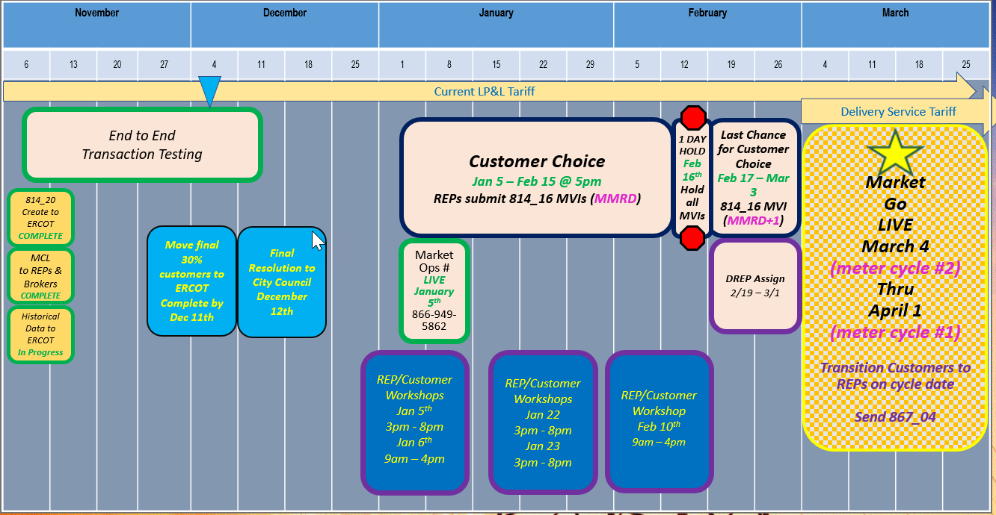
ERCOT/LP&L will begin accepting transactions 1/5/24 – 2/15/24 @ 5PM. On 1/5/24, transactions will be accepted at any time, however, LP&L will not begin processing transactions until after 5PM on 1/5/24. With the throttling of transactions to LP&L on 1/5 @ 5PM (by ESG), Not First In transactions (NFI) on 1/5 will be reviewed by LP&L and NFIs will be unexecuted if necessary with T025 codes “Competing Transaction Scheduled for the Same Date”.
IMPORTANT: LP&L has asked REPs to hold transactions from 2/15/24 @ 5PM until Saturday, 2/17 @ 7AM to allow time for LP&L to perform queries for DREP assignments and modify systems to no longer automate the MVI date for the appropriate meter read cycle.
DREP Assignment Period to commence 2/19/24 – 3/1/24
Transitioning of LP&L customers on March/early April meter read cycles (starting 3/4/24 – 4/1/24)
Q: Has LP&L selected Default Service REPs, POLR Voluntary REPs and a POLR REP?
A: Lubbock’s Electric Utility Board and City Council have approved the following REPs:
Default Service REPs: Reliant, Octopus, TXUE (Octopus will only serve residential customers)
POLR Voluntary REPs: Reliant, Octopus, TXUE
POLR REP: Reliant
Q: Does Lubbock have any requirements/regulations pertaining to door-to-door solicitations?
A: Below is a summary of the Peddler’s License requirements for any solicitations within the City of Lubbock. The Lubbock Police Department administers the licensing.
- All D2D solicitors will be required to register with the city.
- D2D registration licenses will remain active for six months (as opposed to the original 30 days)
- No registration is required if the REP makes an appointment with the customer.
- Town hall meetings will not require D2D registration as will be hosted by the City
- Pop-up sales sites at existing businesses will require registration as well as a letter from the business.
- REPs can contact the city to register at:
  - 806-775-2803
  - 806-775-2809
- Peddler’s permits will not be issued by the Lubbock Police Department until LP&L provides the list of certified/registered REPs on their website on October 25th post City Council approval.
- REPs granted Peddler’s permits will be noted on the LP&L website.
Q: Will LP&L customers have the option of dual billing?
A: No, HB2663 / SB1170 were approved by the Governor modifying PURA Section 40.057 to allow an opt-in MOU/EC the option of a single bill scenario through REPs as opposed to a customer’s choice of a dual billing scenario.
Q: Will LP&L require a Delivery Service Agreement/ Access Agreement from REPs wanting to participate in LP&L territory? What is the process to execute?
A: Yes, the Access Agreement found in the LP&L tariffs (Appendix A), posted to the LRITF main page, will be required for REP participation within LP&L territory. Successful flight testing is required. The executed agreement should be forwarded to MarketOps@mylubbock.us . Within 24 – 48 hours a reply will be forwarded with a REP Account Number that will be needed for REPs to utilize the REP hotline and a welcome packet will be provided with valuable market partner information. LP&L has asked REPs wanting to participate to provide Access Agreements by Friday, October 13th to be included in the initial listing of certified/registered REPs that will appear on the LP&L website on October 25th. Access Agreements from REPs received after 10/13 will be added to the posted list accordingly.
Q: Will a separate Access Agreement be required for each DUNS+4 wanting to participate in the LP&L territory?
A: Yes, an Access Agreement is required from each DUNs (including +4) entity.
Q: Is the DUNS or DUNS+4 required to be listed on the Access Agreement?
A: LP&L does not require the DUNS nor DUNS+4 to be included on the Access Agreement, however, REPs may add the DUNS if desired for clarity.
Q: What information will be found in the REP Welcome Kit upon approval of the submitted Access Agreement?
A: The following information is expected in the Welcome Kit and will be provided with a USB.
- Peddler’s license information - Email aliases
- Banking information - Left in Hot information
- EFT Authorization form - Business & Holiday Hours
- LP&L Organization Chart - QR codes for Distributed Generation forms
- SFTP Access information - Letter of Authorization for historical usage
- Energy Assistance contacts
Q: Will LP&L provide a Mass Customer List prior to transition? If so, when? And how?
A: YES, a Mass Customer List will be provided to registered REPs via their established SFTP site around mid October. A second MCL will be provided for their distributed generation (solar) customers as well via the same SFTP process.
Q: Will email addresses be provided in the Mass Customer List?
A: No, LP&L does not collect or store email addresses.
Q: Will registered brokers/aggregators have access to the Mass Customer List?
A: YES, LP&L has a parallel process for brokers/aggregators to obtain a copy of the MCL with an authorized agreement. Brokers/Aggregators should email marketops@mylubbock.us for additional information.
Q: Did LP&L send out a Mass Customer List opt-out letter to its current customers? If so, how many customers elected to opt out of having their customer information provided on the Mass Customer List?
A: LP&L sent a letter to customers in the August timeframe. ~ less than 100 customers opted out. No further opt out letters will be sent.
Q: Will additional updated Mass Customer Lists be provided to registered REPs/brokers?
A: NO, only one Mass Customer List will be provided
Q: Will LP&L post a list of registered REPs on their website?
A: YES, LP&L plans to post a list of registered REPs on their website on October 25th 2023 post approval by the City Council. The list will be updated accordingly as new REPs are approved.
Q: When does LP&L plan to cease disconnections for non-pay (DNP) prior to the transition?
A: LP&L will continue disconnections through the end of February regardless of the meter cycle. A customer will remain disconnected (unless payment is received) and will be energized with the MVI transition transaction on the March/early April meter read cycle.
Q: Will inspections be required for the transitioning MVI transactions?
A: Permits will not be required to ‘schedule’ the transitioning MVI transaction.
Q: Will existing LP&L customers with multiple ESI IDs be assigned to the same DREP if necessary?
A: YES, LP&L will attempt to group the same customer accounts to the same DREP.
Q: Will LP&L transition de-energized ESI IDs? If so, under what circumstances? How will the new REP be aware the premise is de-energized?
A: LP&L will transition only active accounts. If a premise does not have an active account, a DREP will not be assigned and the ESI ID will be energized only when an MVI is submitted post-transition. De-energized ESI IDs with active accounts (ESI ID is de-energized for a clearance request) will transition to a REP of Choice or a DREP. Upon transition, LP&L will send a 650_04 to the REP of Record notifying of the de-energized status.
Q: How will LP&L customers know they are assigned to a DREP? And to which DREP?
A: LP&L sent postcards to customers who had not chosen by 2/15 @ 5:00 informing them of their assigned DREP. DREPs will also be sending out Welcome Kits and letters.
Q: Will any special transition stacking logic apply during the transition phase commencing 3/4/24?
A: The transition stacking logic (MMRD+1 to trump MMRD MVIs and pushing first MVI to MMRD or MMRD+1 post DREP assignment) was removed on 3/6/24 to allow for the efficient execution of the true MVIs since LP&L was no longer accepting MVIs. Any requested dates would be accepted.
Q: Post 3/6/24, during the transition phase, will a defaulted customer be able to choose a provider prior to their scheduled cycle date (MMRD)?
A: Customers assigned to a DREP will still have the ability to select a provider of choice prior to their transitioning meter cycle. REPs of choice should submit a MVI with an MMRD+1 date. DREPs will be receiving daily reports from ERCOT listing the ESIs for which a choice transaction has been submitted after the DREP MVI. DREPs committed to cancelling their MVI to allow for choice to occur.
Q: Post 3/6/24, with removal of the transition logic, if a true MVI was processed prior to scheduled MMRD and MMRD+1 transactions, will the MMRD and MMRD+1 transactions also be processed? If rejected, what rejection code will be received for the unexecuted MMRD and MMRD+1 transactions?
A: No, LP&L will unexecute any MMRD and MMRD+1 MVIs if a true MVI is requested and executed prior to MMRD. REPs will receive 814_28 Unexecutables with T018 coded as “MVI prior to default”. REPs are encouraged to contact their customers confirming if another MVI should be resubmitted (primarily for “make ready” apartment units.
Q: How will LP&L handle ESIs with no assigned Rep Of Record?
A: LP&L has attempted to make contact with customers whose DREP enrollment was cancelled (and a new REP was not chosen) or situations where an enrollment was cancelled due to a customer failing to submit a required deposit. Calls are being made and door hangers applied notifying customer they must select a REP of Choice or power may be interrupted.
Customer Education___________________________________________________________________
Q: Will LP&L’s customer tax exemption certificates transfer to a customer’s REP of choice/DREP?
A: NO, customers will be responsible for providing their tax certificate to their new REP of choice/DREP upon transition to ensure taxes are not assessed.
Q: Will payment history information be available for LP&L customers?
A: LP&L customers may self-serve using their current customer portal to request a print of payment history form/utility letter of credit. A sample is posted on the main LRITF page.
Q: Does LP&L plan to return deposits previously collected to customers after the transition?
A: YES, deposits are collected for electricity accounts (not specifically for water or other utilities). LP&L plans to apply any deposits to customer’s final bills. Any additional funds will be refunded via check to the customer.
Q: Will Lubbock zip codes be integrated into PUCT’s Power to Choose website for customer shopping?
A: Lubbock zip codes have been entered into PUCT’s PTC website and is ready for REP offer postings.
Q: Does LP&L currently deploy a CSA process, and will LP&L adopt a CSA process as other TDSPs?
A: Yes, LP&L currently deploys a CSA process. With the approval of RMGRR171, upon transition, CSA activity will take the same path as the TDSP’s CSA process.
Q: Will Lubbock host Town Halls/Community Meetings informing Lubbock residents about the transition to competition?
A: Lubbock will be hosting “Shopping Fairs” where REPs may engage customers (no peddler’s license required). Registration, times, and additional information to follow. The Shopping Fairs will be held at the Civic Center on:
- January 5th, Friday, 3 PM – 8 PM
- January 6th , Saturday, 10 AM – 4 PM
- January 22nd , Monday, 3 PM – 8 PM
- January 23rd , Tuesday 3 PM – 8 PM
- February 10th , Saturday 10 AM – 4 PM
Interested REPs and brokers may contact marketops@mylubbock.us to register for any of the Shopping Fairs. An official invite/RSVP will be sent out via Market Ops team. Lubbock plans to advertise for the shopping fairs via website, billboards, TV ads, and static ads prior to the fairs. Lubbock has also partnered with local station KCBD for a live telecast during the first shopping fairs. Lubbock plans to distribute a ‘one-pager’ with “questions to ask your provider” at each fair to educate residents about the transition. Wifi will be available for REPs. REPs may request two booths (one for residential, one for commercial). Booths will be 10x12 in size and equipped with table and chairs. REPs are encouraged to bring a Spanish speaking representative. Set up and tear down times will be one hour before and one hour after each fair.
Q: Where can information be found on Lubbock’s communications to its residents about the transition?
A: Any materials used for community meetings and bill onserts is posted on the LP&L website as well as information about the transition.
PUCT Requirements____________________________________________________________________
Q: Will LP&L customers be included in the monthly low-income Solix lists provided ?
A: YES, LP&L customers will be included.
Q: Will Energy Assistance be available for Lubbock customers during the transition to competition?
A: At the time of transition, customers should appear on Solix list as REPs submit their scheduled monthly list of ESIs and Solix results will be received prior to Lubbock customers receiving their first bill from their REP.
Q: Will LP&L adopt a similar POLR process as utilized in competitive ERCOT?
A: Yes, HB2663 / SB1170 were approved by the Governor modifying PURA Section 40.057 to allow an MOU/EC the option for PUC POLR selection designation. LP&L intends to utilize the PUC POLR selection process upon transition.
Q: Have LP&Ls tariffs and Customer Protection Rules been approved? Where will the information be made available?
A: LP&L’s tariffs were approved by the Electric Utility Board and City Council, 7/18 and 7/25 respectively. The document is currently posted on the main LRITF page and will be permanently housed on the Lubbock website with a revision date.
Q: How will PUCT Complaints be handled?
A: As approved in LP&L’s Customer Protection Rules, there are no material changes for the REP’s existing complaint process: when a customer files a complaint about a REP, the customer will be directed to the PUCT. If the complaint is regarding the delivery service, LP&L will address and manage the complaint. The PUCT would remain as the enforcement agency regarding REPs as within other TDSP territories.
Q: Will the Winter Storm Uri securitizations apply to LP&L customers post-transition?
A: PUCT issued a declaratory order supporting LP&L’s position is that HB4492 and PUCT Dockets 52321 and 52322 (Securitizations M & N) excluded LP&L customers (post-transition) from securitization charges and REPs should not be charging customers for such charges. LP&L met with PUCT Staff and Executive Director to review. ERCOT agrees with LPL’s interpretation and intends to file two petitions (one for each subchapter of PURA 39.151 (j-1) addressing Securitizations M and N) for a clear written record of the PUCT’s interpretation of the above applicability. The goal of the procedural schedule is for the Commission to hear no later than the Feb 15th Open Meeting. Concurrently, ERCOT is working to operationalize excluding LP&L load from the calculations and expect the exclusions to be in place for the first initial settlement invoices (in March).
ERCOT Market Requirements_________________________________________________________
Q: When will flight testing occur for LP&L and REPs planning to operate in LP&L’s territory?
A: A special flight test has been approved for REPs to test with LP&L.
  - TX SET is planning a ‘round-robin’ approach for full testing selecting 5 different use cases and 5 REPs to test. All REPs participating in round robin have been notified.
  - Bank and connectivity testing will be required for all REPs seeking to operate in the LP&L territory
  - The special LPL0423 flight is reserved for established REPs only with a deadline for sign up on 3/8/23.
  - New REPs wanting to enter the LP&L territory, must test in the first flight for 2023 with a sign-up deadline on 1/18/23.
  - The special LPL0423 flight has concluded. REPs still interested in participating in the LP&L territory at market transition are encouraged to sign up for the 1023 flight (sign up deadline of 9/6/23) as LPL may not participate in the early flight of 2024 due to the transition.
  - Certified REPs with a change in banking or service providers will be required to test at least connectivity and penny testing to remain certified in the Lubbock territory.
  - LP&L has agreed to accept ‘round robin’ results of the other TDSPs and will perform penny and connectivity testing themselves in the 0224 Flight Test.
Q: In order to exchange banking information between LP&L and registered REPs, will the existing EFT Authorization be acceptable? If so, where should the form be submitted to complete the penny testing?
A: Yes, ERCOT’s existing EFT Authorization form is acceptable and should be submitted to LP&L at marketops@mylubbock.us
Q: What test scripts will be tested for full end to end testing by selected REPs? What scripts are required for all REPs entering LP&L’s territory?
A: The following test scripts will be tested for full end to end testing: CON01, CON02, IBANK01, STK01, SOR01, TDSP01, TDSP02. All REPs entering LP&L territory will be required to perform CON01 and CON02 (penny and connectivity testing).
Q: Does LP&L plan to utilize MarkeTrak for issue resolution?
A: YES, LP&L plans to use the MarkeTrak process.
Q: Does LP&L plan to provide interval data via LSE files to ERCOT for settlement purposes?
A: YES, LP&L plans to send daily LSE files for any AMS profiled meters to ERCOT.
Q: Will LP&L submit LSE files to Smart Meter Texas for customer and REP access?
A: An SMT Participation Agreement has been fully signed and executed between the SMT JDOA, TDSPs, and LP&L. It is expected LP&L will not integrate LSE files until at least Q2 of Q4 2024. SMT has completed the SMT3.0 update and the MOU functionality will be ready for LP&L. As a workaround, REPs are encouraged to utilize ERCOT’s AMS Settlement extract to obtain daily interval data files (which is available at OD+4). With the delay of the transition, LP&L is hopeful an agreement is reached with SMT and REPs will be able to retrieve daily LSE files in the same manner as other TDUs. LP&L will continue to provide updates for SMT utilization when REPs will be able to retrieve daily LSE files in the same manner as other TDUs.
Q: Has LP&L tested their daily LSE files with ERCOT for formatting and processing? What is LP&L’s level of confidence in the quality of the AMS data?
A: LP&L does plan to tested their LSE file processing with ERCOT in August 2023 and will provide test files for interested REPs once all the LP&L ESIs have been created thus around mid to late October. Regarding the quality of the AMS data, LP&L is confident in their system and are currently fine tuning the Validating, Editing, and Estimating (VEE) process. LP&L reminded the market they have been deployed and operational with AMS meters for ~3 years.
Q: Which load zone/congestion zone will apply to LP&L territory?
A: West
Q: Which weather zone will apply to LP&L territory?
A: North
Q: Will LP&L’s Membership ID be required for initiating transactions?
A: No
Q: Have LP&L’s substations been mapped in ERCOT?
A: YES, substation names all begin with “LP_” followed by the name. Document found at https://www.ercot.com/mp/data-products/data-product-details?id=NP4-160-SG
Q: Which SAC04 Codes do Lubbock plan to utilize for 810_02 invoices to REPs?
A: LP&L will use the following existing SAC04 codes to represent the cost recovery components of their delivery charges:
DIS001 – Delivery Service Charge (volumetric)
MSC029 – Transition Charge (volumetric)
BAS003 – Monthly DG Charge (fixed)
Keep in mind for demand-based rate classifications, the SAC04 of DIS001 will appear twice in an 810_02 (once for kW and once for kWh volumes).
Q: Will LP&L utilize a similar safety net process as TDSPs?
A: Yes, safety nets will be accepted by LP&L. Existing approved spreadsheets will need to be submitted via an SFTP site which will be monitored and processed automatically. SFTP site URL will be available to approved REPs once registration is complete. The Retail Market Guide will provide additional guidance on the submittal of safety nets (see DRAFT RMGRR).
Q: How will LP&L monitor safety-nets? Will LP&L accept safety nets on Saturdays?
A: LP&L’s SFTP site will be monitored Mon-Fri 8AM through 5PM. Safety nets files will be automatically run during these times. LP&L is also asking REPs to send an email (with the spreadsheet attached) to marketops@mylubbock.us notifying of the SN submission. The mailbox will be monitored Mon-Fri 7AM – 7PM and Saturdays 7AM-12PM (noon).
Q: What transaction stacking logic will be in place during the transition?
A: Below is summary of the phases of the transition and which transactions will be accepted during each phase. Please see the document posted to the main LRITF meeting page for additional information https://www.ercot.com/files/docs/2023/06/13/Solution-to-Transition-Stacking_final-final-notes_060623.docx
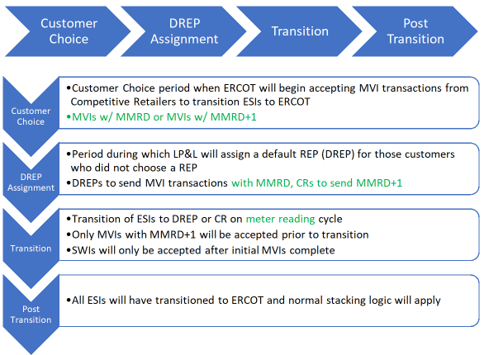 Additional notes on true MVIs:
- a customer may be at risk of not transitioning on the date wanted in a true MVI situation that may occur ahead of the scheduled MMRD if the previous customer fails to notify LP&L of an MVO and/or if a default transaction is not submitted.
- The first transaction for a transitioning ESI will be pushed to the MMRD.
- LP&L will accept date changes to move to the actual date wanted (for the true MVI).
- For a vacant de-energized premise (no activity w/in last 12 months), the requested MVI date will be honored.
- For MVIs received earlier than the expected cycle date, LP&L will monitor customer names. If requested name is different from existing LP&L customer, the requested date will be honored.
- See Q&A #s 21 – 23 for additional information on stacking logic applied post 3/4/24 during the Transition Phase.
Q: Which transaction will be sent by LP&L to cancel/unexecute a default MVI or a competitive MVI with an MMRD date as the requested date? When will the cancel/unexecutable transaction be sent?
A: The 814_28 with a reject code of T025 “Competing Transaction Scheduled for the Same Date” will be used during Customer Choice, DREP Assignment, and Transition phases. When multiple transactions are submitted with both MMRD and MMRD+1, the MMRD MVI will be cancelled the day prior to the MMRD.
Q: How will LP&L respond transactionally for same day requests submitted after operational hours? Will the order be unexecuted or “skootched” to the next operational day?
A: LP&L plans to “skootch” the key date on the response 814_04/05 transaction. For example if an order was submitted on Saturday at 5PM for Saturday, will the response be unexecuted for Invalid Backdated Order (IBO) or skootched to Monday. LP&L would respond to the order with a date of Monday.
Q: When will NAESB URL information be exchanged with registered REPs?
A: LP&L will work with ESG to coordinate connectivity with each registered REP.
TDSP Specific Activities_______________________________________________________________
Q: Will historical usage information be available for transitioning customers? Will an LOA process be available and when?
A: Monthly summary historical usage information will be available via the Mass Customer List (MCL) for entering REPs. Historical interval data will be available for REPs by emailing marketops@mylubbock.us with a signed copy of the approved LOA which is posted on the LP&L website. Brokers may also request monthly and interval data via the LOA process noted above. The LOA process may commence at the time the MCL is available for distribution (late April/early May). LOAs are required to be notarized. Out of state LOAs are accepted with a valid Commission ID. Modifications to the LOA will not be accepted. Upon effectuation of RMGRR176, the LOA found in Appendix B1/B2 may be utilized for LOA requests.
LP&L has agreed to provide the following information when responding to a valid LOA: DLF code, load profile, LP&L Rate Class, LP&L Meter Read Cycle, and address.
The data for the LOA responses are being pulled from existing systems prior to an ESI transitioning and will be found in the current format. Once an ESI transitions, the format of the data received will align with Section 9, Appendix B4.
Q: What is the LP&L DUNS?
A: 05-821-3893-4100 for retail competition
Q: What is the LP&L Prefix for ESI creation?
A: ESI prefix will be 1011292xxxxxxxx.
Q: What are the applicable LP&L zip codes?
A: A full list of zip codes has been provided to ERCOT and are also posted on the main LRITF page. Zip + 4s will not be available. https://www.ercot.com/files/docs/2024/01/17/Lubbock-Zip-Codes-2024-01.xlsx
Additional zip codes were added in December 2023.
Q: Will the meter read and holiday calendars be posted on LP&L’s website by October 31st each year?
A: YES, schedules will be posted on LP&L website and 2023/2024 schedules will be posted on LRITF main page. Meter Cycle # is listed as “Bill Cycle”; ALOP stands for ‘always open’ and is indicative of an internal LP&L process. The cycles show a “1” in front of the true meter read cycle, e.g. 121 is listed, however the cycle noted in ERCOT is 21.
Q: Will LP&L have an OGFLT load profiles?
A: LP&L systems will be set up for OGFLT load profiles, however, any OGFLT requests will need to be initiated by the customer.
Q: What are the Call Center support lines for LP&L customers to contact for outage reporting? Call Center? REP Hotline?
A: The following phone numbers should be utilized:
- LP&L outage line will remain the same as today 1-806-775-2509
- New REP hotline number established (for REPs only) 1-866-949-5862
- LP&L Call Center (for customers) 1-806-775-2509
LP&L has also developed a REP Contact list of resources which is posted on the main LRITF page. https://www.ercot.com/files/docs/2023/09/14/REP-Contact-Resources.docx
The new REP hotline opened mid January, This line is to used for REPs only (no customers) as REPs will be required to provide their REP account number upon contact.
Q: Will a fax number for LP&L be available?
A: No
Q: Will REPs be provided a different phone number for agents to contact LP&L regarding underground line locating, tampering hotlines, etc?
A: No, REPs should contact the REP hotline phone number.
Q: Will LP&L have any ESIs on a BUSIDRRQ load profile since most of meters are AMS meters?
A: LP&L has 3 ERCOT Polled Settlement (EPS) meters which will have BUSIDRRQ load profiles.
Q: What format should be expected on an 867_03 for an ESI with a BUSLRG load profile? IDR or summary?
A: LP&L will provide an 867_03IDR format where interval data will be received on the monthly 867_03 transaction.
Q: What is the aggregated number of ESIs by load profile?
A: Based on information as of mid-December, Lubbock as classified the following load profiles:

Q: Will service orders be accepted through LP&L’s Contact Center for those REPS not utilizing 650 transactions?
A: Yes, service orders such as meter tests will be accepted through the Contact Center. Meter re-reads are discouraged since AMS meters are in place. Meter tests will be accepted.
Q: Will AMSM meters have color coded meter tags representing a specific status of the service? If so , what do the various colors represent?
A: For AMSM meters requiring a field visit:
Red = DNPd
Yellow = MVO
Blue = Energized
All AMSR meters will not have a designated meter tag.
Q: Will LP&L service guard lights?
A: No, LP&L plans to either sell or remove all existing guard light services by market open and will not offer guard light services.
Q: Will LP&L service street lighting? If so, what operational practices will be adopted?
A: Yes, LP&L currently serve City of Lubbock and TXDOT for street lighting. 1 ESI ID will be created for each like wattage and lamp (same fixed costs and set kWh values). HOAs will not be considered street lighting accounts thus will be phased out by LP&L prior to transition.
Q: What are LP&L’s tampering practices when tampering is discovered at a premise?
A: LP&L’s tampering practices are and will be as follows:
- Disconnects are only performed if unsafe/hazardous conditions exist
- Once service order is complete and tampering is discovered:
    - DAY 1 - $200 tampering fee will be assessed on ESI and sent to ROR via 810_02; 814_20 to set tampering switch hold will be sent
    - DAY 3 – after investigation, any additional fees and cancel/rebilling will be sent to ROR via 810_02 (867_03s for cancel/rebills)
    - DAY 5 – evidence will be sent to ROR via email
  - Customer will be advised of tampering via door hanger left at the premise
Q: What are LP&L’s current disconnection for non-pay practices? What is the approximate volume of DNP notices sent out? What is the approximate volume of actual disconnects completed?
A: LP&L currently has a 14-day grace period for payment yet will be transitioning to a 9 day grace period.
- The day the bill is issued and due is 21 days.
- With a 9-day grace period, a customer will be disconnected on day 30.
- A 7-day disconnect notice is sent and if necessary disconnected on day 30.
- With LP&L “one utility bill” (water, electric, etc), non-payment results in electricity disconnection first followed by water should non-payment persist
- LP&L currently sends out ~29,000 disconnect notices per month, disconnecting 5500 – 8000 customers (80% electric)
Q: Will daily switch hold files be provided by Lubbock? Where will a REP access the files?
A: Yes, LP&L will provide daily switch hold files and will be available via an SFTP site. Format will be the same as TDSPs use today. SFTP site URL will be available to approved REPs once registration is complete.
Q: Will LP&L maintain its existing URL and website? Will any subsites be updated/revised such as outage mapping?
A: LP&L will maintain current website URLs including outage mapping information.
Q: What is LP&L’s temp to perm process for new installations? Will new ESIs be created or will a ‘swingover’ process occur?
A: The existing temporary meter will not require re-configuration and a new ESI will be created for the permanent service.
Q: What are the number of AMS opt-out customers within the fully deployed AMS Lubbock territory?
A: 32 opt out customers
Q: What are is the approximate number of solar customers in the Lubbock territory? How will these customers be billed for delivery charges? Will net metering continue for these customers?
A: LP&L currently has ~1200 solar (PV) customers and growing. Current LP&L solar customers receive true net metering where energy costs reflect consumption – generation values. Upon transition, LP&L will adopt current TDSP practices of non-bypassable consumption charges. Any generation “credits” may be received from a customer’s REP of choice depending upon their product. LP&L delivery charges will include a monthly fixed charge. LP&L Delivery Charges will be billed under the residential rate classification.
A list of all current Solar PV customers will be provided in the same format as the MCL.
The TDSP Solar Matrix has been updated to include the operational procedures of LP&L and is posted on the main LRITF meeting page. https://www.ercot.com/files/docs/2023/09/14/Draft-REP-Solar-Questions-TDSP-Matrix_LPL-09082023.xlsx
Q: Post-transition, how will REPs be notified if an existing customer has installed solar panels and received their Permission to Operate?
A: Once complete, LP&L will send an 814_20 transaction (received by the ROR) to update the load profile, meter configuration, and new rate classification upon the current meter cycle (as 814_20s effective date will always be back-dated).
Q: How will critical care customers be established upon transition and what process will be utilized for enrolling new critical care customers?
A: LP&L’s critical care process will mirror current TDSP practices. Upon transition, the CC flag will be passed onto the 814_05 response transaction and LP&L will follow up with an 814_20 transaction providing CC information and expiration. For new enrollments, the current PUC form will add LP&L as a drop-down option for submission. Critical care form (English) https://www.puc.texas.gov/industry/electric/forms/critical/ccform.pdf Critical care form (Spanish) https://www.puc.texas.gov/industry/electric/forms/critical/ccform_spanish.pdf
Q: What are LP&L’s Distribution Loss Factors?
A: Additional information is posted https://www.ercot.com/files/docs/2023/08/01/LPL-Distribution-Loss-Factor-and-Methodology.docx.
DLFs will be applied the same as other TDUs: DL ADJUSTED LOAD = UNADJUSTED LOAD * (1/(1-DLF))
LP&L Distribution Loss Factors were calculated based on 70% of the load in ERCOT with remaining 30% in SPP and acknowledging some inefficient 23kV circuits. LP&L plans to review DLFs in Q2-3 2024 timeframe to update.at the end of 2023 when the final 30% of Lubbock’s load has moved to ERCOT. The revised DLFs will include one value for secondary voltage, one for primary voltage, and one for transmission. New codes will be provided early January 2024. The new DLF codes are expected to be:
A – Primary voltage – F1 = 0.0322, F2 = 0.000302, F3 = 0.0254
B – Secondary voltage - F1 = 0.0361, F2 = 0.000926, F3 = 0.083277644
T – Transmission voltage (LP&L currently has no transmission level customers)
LP&L does not plan to review any efficiencies gained with moving to ERCOT for at least a couple of months.
Q: Will LP&L execute Weather Moratoriums? If so, under what criteria? How will moratoriums and updates be communicated?
A: Yes, weather moratoriums will be executed as described in LP&L’s approved tariffs and are executed under the same conditions as other TDUs (as described in 25.483). LP&L intends to communicate the notices/updates via the RMS and Weather Moratorium listservs.
Q: What are LP&L’s AMS Data Practices as outlined in the TDSP AMS Data Practices matrix?
A: LP&L’s AMS Data Practices have been added to the TDSP AMS Data Practices matrix and is currently found on the main LRITF meeting page. Once fully completed, the TDSP AMS Data Practices matrix can be found on the main TXSET meeting page.
Q: Does the monthly register read (scalar data) represent the midnight register read of the cycle end date or the day prior?
A: As with other TDSPs, the end register read on the 867 represents the midnight register read 11:59:59 of the day prior (i.e. the read at the start of the day).
Q: Will LP&L change the meter read cycles upon a customer’s request?
A: Per LP&L’s tariffs, LP&L will consider one meter read cycle per customer.
Q: Does LP&L utilize a ‘mesh network’ for their AMS infrastructure?
A: Yes, LP&L has deployed a mesh network with Itron meters.
Q: Post-transition, for new construction projects, when will an ESI be created?
A: LP&L will send 814_20 create transactions when the customer is ready for service. Exceptions will be made for the creation of large commercial premises for the purposes of REP quoting/pricing processes.
Q: Pre-transition, for new construction projects, when will an ESI be created?
A: Similar to above, once an inspection is received an ESI will automatically be created in a batch process overnight. Once the ESI is created, the REP can then send an MVI for the March/early April MMRD.
Q: What are Lubbock’s requirements for city inspections?
A: All new meter boxes require a standard inspection by one of the city’s inspectors – both residential and commercial premises. Green tags or red tags will be issued. If a customer is performing electrical work, an inspection may be required (residential customers are exempt). Typically, it is the customer’s electrician providing the notification an inspection is required.
Q: For clearance requests, how should the customer/customer’s electrician notify LP&L?
A: Typically, an Option 1 REP will notify LP&L of a clearance request by sending the appropriate transactions and informing customers of any associated costs. Option 3 REPs would allow customers/electricians to make the request directly with LP&L. With LP&L not charging for a clearance requests, having the customer contact LP&L directly to make the arrangements should be preferred.
Q: Will LP&L adhere to the same transaction timelines as the TDSPs as noted in Appendix D1 and D3 of the Retail Market Guide?
A: LP&L plans to follow the Transaction Timing Matrix as noted in Section 9, Appendix D1: Transaction Timing Matrix. A few notable differences of LP&L regarding Section 9, Appendix D3: Discretionary Services Timelines Matrix that shall be included in proposed revisions of the Retail Market Guide are as follows:
- Timing deadlines for MVIs and MVOs are shifting from 2PM and 5PM to 3PM and 7PM for LP&L
- No fees for Priority Move-Ins at this time
- No special pre-pay reconnects – will follow normal 2 hour timeline
Q: Does LP&L have any master metered apartments?
A: LP&L does not currently have any have 3 master metered apartments and 5 “all bills paid” complexes. If a REP needs to make arrangements for a DNP/RNP, REPs should email marketops@mylubbock.us to confirm and coordinate as noted in Chapter 8 of the RMG.
Q: What is the current timing for a Lubbock resident to receive their utility bill after their meter has been read?
A: Today, Lubbock residents typically receive their utility bills within 48 hours of their read date.
Q: Has LP&L created multiple ESI IDs at the same address (duplicate addresses)? If so, how are REPs able to align the appropriate ESI ID with the premise?
A: Yes, unfortunately, some ESI IDs were created under the same address without a differentiator such as barn, well, A/C, etc. LP&L has created an ESI look up tool to be used only by registered REPs /brokers which will align the meter number at the premise (found on customer’s current utility bill) with the assigned ESI ID. REPs may request the tool via marketops@mylubbock.us
Q: What are LP&L’s Priority Move In codes? Where will the information be found?
A: LP&L’s PMVI codes are similar to their Reconnect codes posted in the Retail Market Guides. PMVI codes are required to be posted to LP&L’s website:
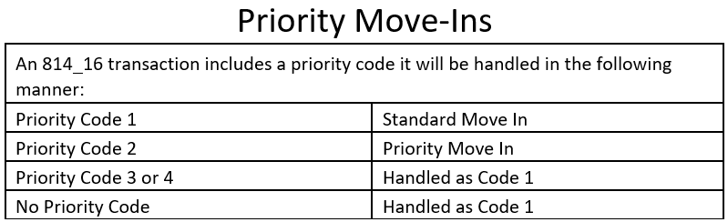

Q: Will LP&L accept 814_01, 814_16s, and/or 814_26s coded with HI vs HU (interval historical usage vs summary historical usage) to generate an 867_02?
A: LP&L is currently working on functionality to allow an HI code to generate summary historical usage if interval usage is not present.
LP&L Rates ______________________________________________________________________
Delivery Charge Component | YES | NO | Notes
Power Factor Adjustments |  | x | Customers expected to maintain at least 85% lagging power factor; must install corrective equipment
Street Lighting | x |  | Only City of Lubbock and TXDOT have accounts; 1 ESI ID per lamp & wattage type
Security Lighting |  | x | Lighting will be phased out prior to transition to competition; HOA is considered security lighting
Demand Ratchets |  | x | 15 min demands, yet load factor will not be <3% - kWh/21 hours
4CP Demands |  | x | 4CP demands will not apply
Transition Charges | x |  | Transition charges represent stranded costs with debt service over 20 years; will be a separate line item on the 810 invoice

- Rate classifications (secondary < and > 10 kW) will occur on an annual basis aligning with LP&L fiscal year Oct – Sep and will not necessarily occur when a customer’s peak demand exceeds 10 kW
- Finalized discretionary and non-discretionary rates will be included in Chapter 5
- Below is a summary of the approved non-discretionary rates:
- LP&L’s street lighting rate was inadvertently assigned as $0.27 per kWh and will be revised to $0.17 per kWh. Upon final approval, rate is expected to effective prior to transition.
- The following rate codes will be utilized by LP&L as noted on 810_02 and 814_05 transactions:
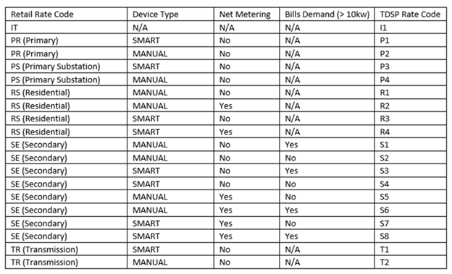

Q: What is the expected cadence of LP&L rate revisions? Will REPs be provided a 45 day notice of approved rates?
A: LP&L expect their rates to be reviewed once per year aligning with Lubbock’s fiscal calendar thus the expected effective date is 10/1. LP&L acknowledged REP’s expected 45 day notice of approved rates and intend to honor.
Q: What is considered a normal 30 day billing cycle?
A: Normal billing cycles range from 27 to 33 days.
Q: Will LP&L consider proration of demand charges for billing periods outside of normal 30 day billing cycle?
A: LP&L systems are not designed to adjust/prorate demand charges for billing periods outside of 30 days. For SWIs that result in the same customer receiving two split bills for one 30 day period, a REP(s) may submit a Usage & Billing – Dispute MarkeTrak to request demand charges be prorated for the shorter billing cycle.
Q: Can LP&L provide mapping of existing LP&L rate classes to the new rate classes post transition?
A:

Q: What are LP&L’s historical ‘all in’ rates?
A: The following ‘all in’ rates are posted on the main LRITF meeting page:
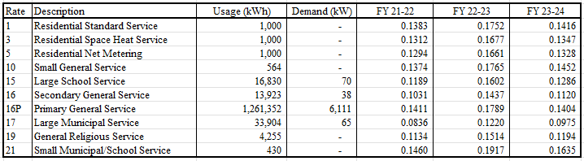
Q: Will LP&L have a discretionary Priority Move In Fee?
A: At this time, LP&L will not implement a PMVI, however, may consider its addition at their annual rate review (mid to late summer).

