**TDTMS**

**February 13th, 2024 1:30 PM**

**WebEx only**

|  |  |  |  |  |  |  |
| --- | --- | --- | --- | --- | --- | --- |
| Attendee | Company | Attendee | Company | | Attendee | Company |
| Diana Rehfeldt | TNMP | Dave Michelson | | ERCOT | Matt Arth | ERCOT |
| Jordan Troublefield | ERCOT | Dee Lowerre | | NRG | Monica Jones | CNP |
| Tammy Stewart | ERCOT | Sam Pak | | Oncor | Eric Lotter | GridMonitor |
| Sheri Wiegand | Vistra | Bill Snyder | | AEP | Kathy Scott | CNP |
| Mick Hanna | ERCOT | Marina Grady | | Oncor | Amy Sue Stirland | LP&L |
| Cindy Juarez | AEP | Jesse Macias | | AEP | Dheena Chinnasamy | LP&L |
| Melinda Earnest | AEP | Chandria Porter | | Oncor | Steven Pliler | Vistra |
| Mark Hensley | Oncor | Debbie McKeever | | Oncor | Dale Gibbs | Just Energy |

Dee Lowerre opened the meeting with the Antitrust Admonition.

Minutes from the January 17th meeting was reviewed and approved.

**ERCOT System Instances & MarkeTrak Monthly Performance Review**

* Mick presented **January performance reports** and noted all SLA targets for January were met. 1/27 longer release was moved to 2/25. MarkeTrak response times are continuing to perform well – leveling off and trending downward.

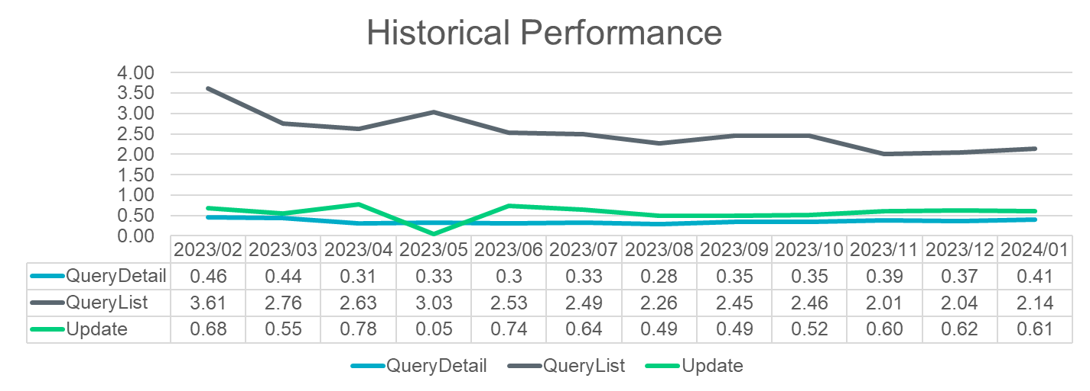

* + **Listserv activity** – 1/12 listserv experienced an issue uncovered by TXANS listserv. A throttle was in place and once removed performance was as expected. This was due to the growth in the TXNS listserv from 20,000 to 26,000 subscribers. TXANS is the public facing listserv utilized for conservation requests and media.
  + **Retail incident experienced on 2/12** – ERCOT was unable to send transactions for a period of ~ 1 hour from 7:56 – 8:57AM. The network issue was triggered by a known “bug”. The goal is to shift the design. Reporting and outbound transactions were impacted. Two market notices were sent timely to the two listservs: [notice_extracts_retail@lists.ercot.com](mailto:notice_extracts_retail@lists.ercot.com) and [notice_operations_retail@lists.ercot.com](mailto:notice_operations_retail@lists.ercot.com) . In terms of preventative measures, the new data center will receive a tech refresh and storage refresh which should correct the issue. The transition is expected to complete in 3-4 weeks.
  + **MIS API project update –** Retail API is reportedly functioning as expected. The issue of the missing *key date* in the GUI for initiating transactions if viewer is not the submitter is currently undergoing another round of testing. It was thought the fix was corrected, however, other impacts were discovered.

**SCR 817 MarkeTrak Validations –**

* Tammy reported testing is continuing to go well with no issues.
* The WG asked for additional comments on the User’s Guide drafts for the two new subtypes (AMS vs LSE and Meter Cycle Change requests). There is still time for review.
* Tammy is still working on the IAG User’s Guide section.
* Tammy did bring up a few impacts of IAGs in another section – Switch Hold Removal. If a REP inadvertently executes the “Time Limit Exceeded” button prematurely and the SH is removed from the ESI allowing the Gaining REP’s MVI to process, there are two sections in the RMG outlining corrective action:
  + Section 7.16.4.3.3 to reinstate a tampering SH…

* + Section 7.17.3.3.3 to reinstate a deferred payment plan SH…

* It was decided to preserve the RMG revisions until all SCR817 business requirements and user’s guides drafts have been reviewed and then only one RMGRR will be submitted with proposed changes.
* Questions were raised around when the technical documents would be available for market participants such as WDSL information for API users. Per Tammy, “as early as they can”. As a rough schedule, WSDLs are usually available a few weeks prior to functionality being placed in RMTE. Goal is for RMTE to be available for testing at the end of September /early October. With the TXSET flight for 5.0 flowing transactions on 9/23. The ask if the API information can be made available earlier.

**RMGRR177 – Switch Hold Removal Clarification – communication to PUCT Staff**

RMGRR was approved (with one abstention from OPUC) at RMS on 2/6. The question was asked during RMS if PUCT staff will be made aware of the changes. Per Dave Michelson, ERCOT meets regularly with PUCT staff and he indicated Staff was comfortable with the proposed language and no changes need to be made in the documentation.

**Data/Talking Points for Client Services on MT Analysis**

Sheri will set up a meeting with Ted Hailu, Client Services leadership, to review approach discussed earlier and seek support.

**MarkeTrak Subtypes Volume for 2023**



Further review will be discussed at next meeting to determine next steps.

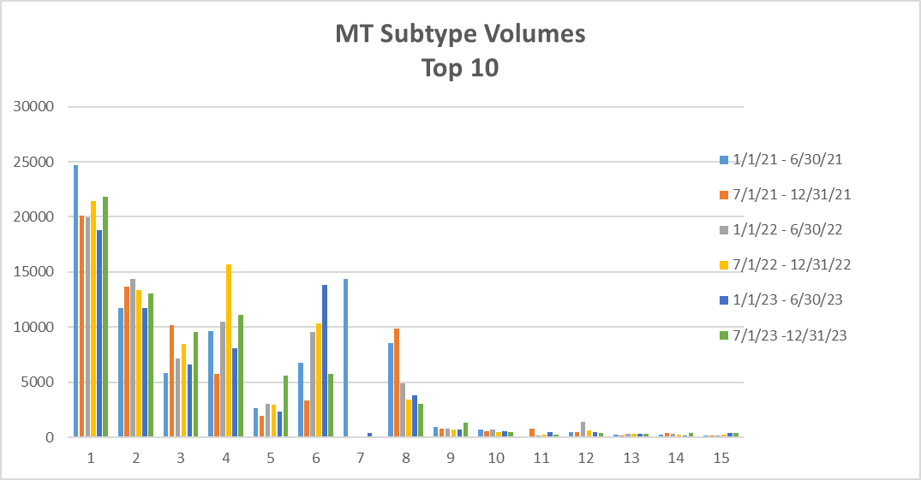

Observations:

* **IALs** continue to remain elevated
* **IAGs** levels appear to have seasonality and remain more consistent the latter halves of the years
* Growth in **Switch Hold removal** requests with higher volumes in the latter halves of the years likely due to heat related weather moratoriums
* **Rescissions** seeing spike in the latter half of 2023 – may want to review if growth is by REP
* **Cancel w/Approval MTs** – bump in latter half of 2023 – breaking down by REP to determine if REP specific and are REPs sending same day cancel requests
* **DEVs** and **Service Orders** have also seen growth

**NEXT MEETING** was rescheduled for **Tuesday, March 12th @ 9:30 AM** (sliding into TXSET’s spot who moved meeting to Monday, March 4th @1:30 PM)

**DRAFT AGENDA**

* ERCOT Reports
  + System Instances & MT Performance
  + Listserv
  + MIS API review – update on key dates populating
* RMGRR177 Switch Hold Removal Clarification – status of progress
* SCR817 Business Requirements discussion
  + Review of User’s Guide drafts
    - Inadvertent Gain
  + Any other clarifications
* MT Subtypes Volume Analysis – 2023 – further review?
* IAG Report – Quarterly Review
* Data/Talking Points for Client Services on MT Analysis – update