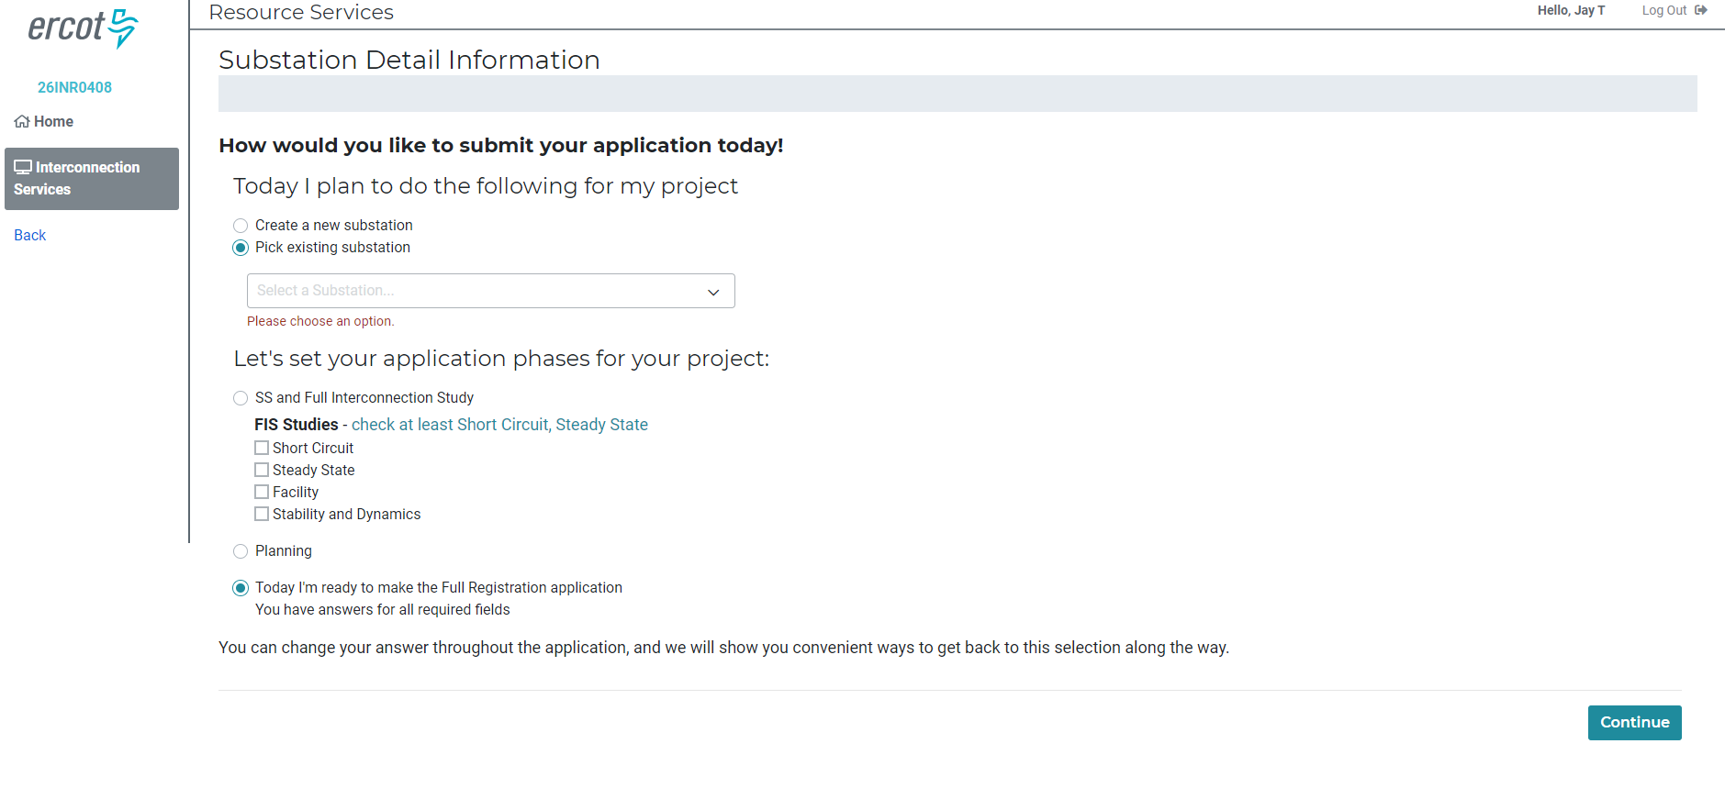
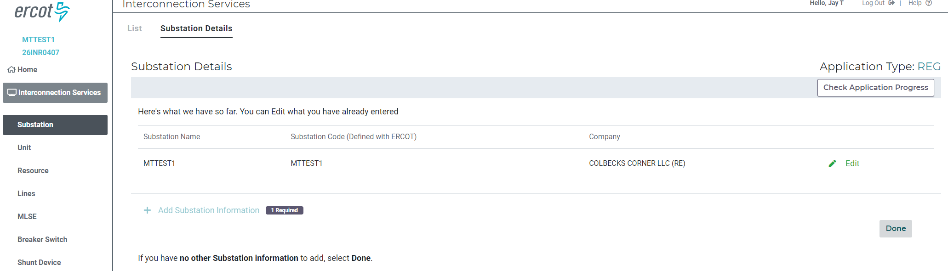
Figure 1- The Substation data entered for the first INR is visible for the second INR

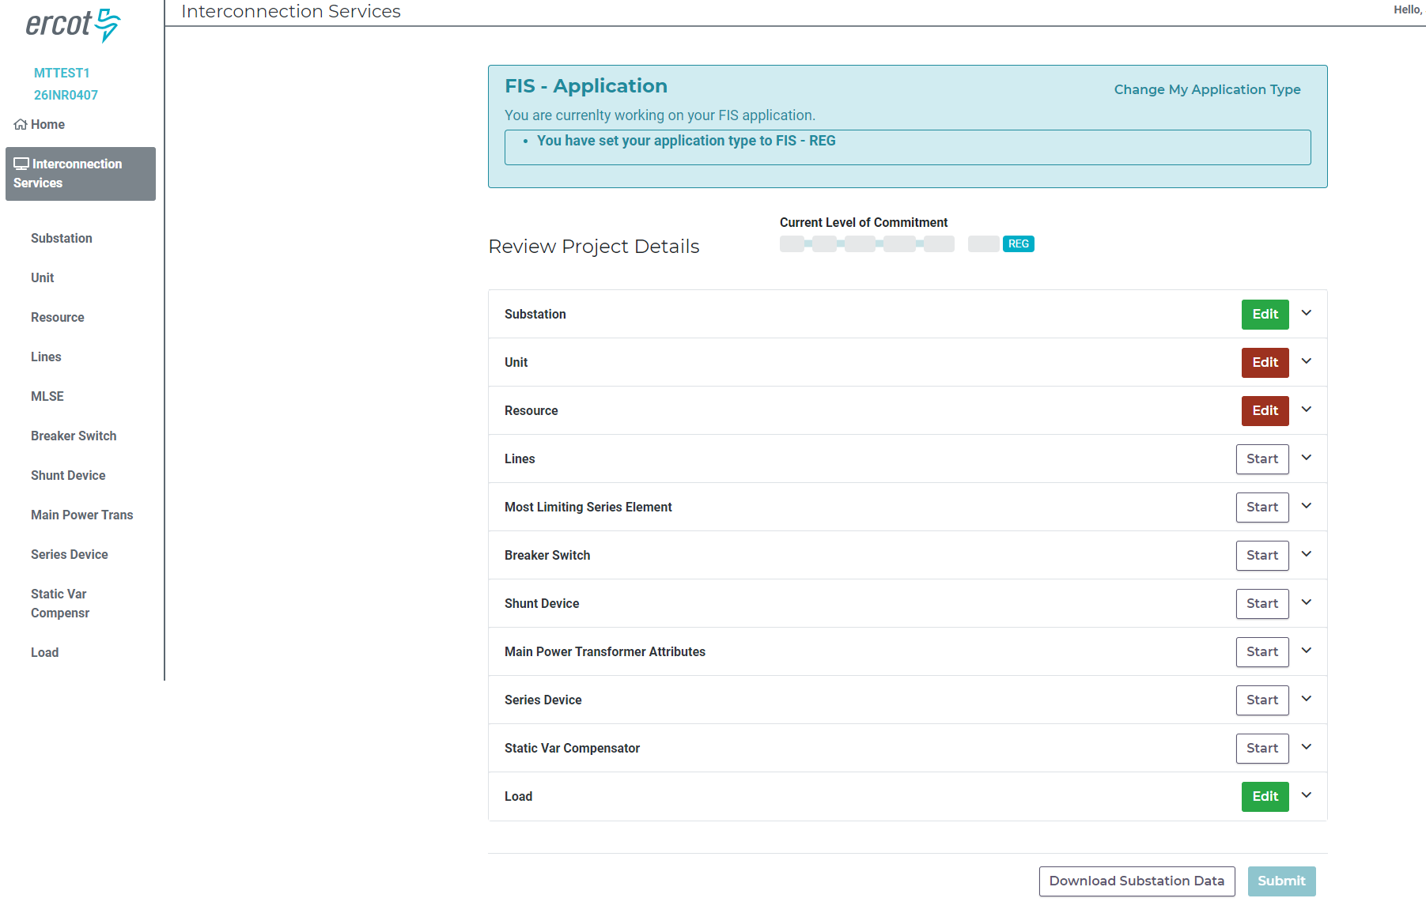
Figure 2- Check Application Progress shows that as a minimum, Unit and Resource data must be entered.

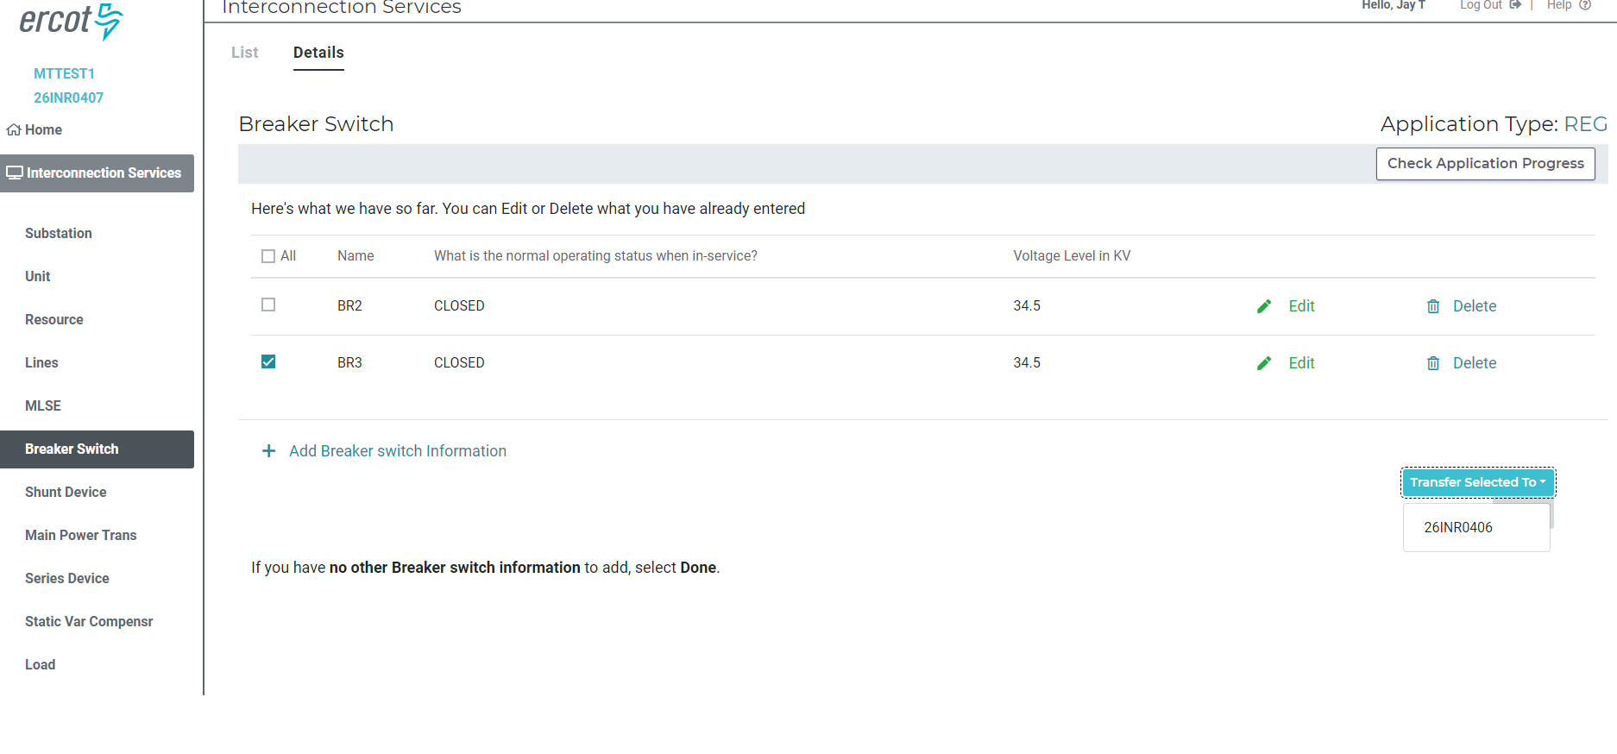
Figure 3- While in INR2(26INR0407) Substation Details, check the box next to BR3 and then select the "Transfer Selected To" dropbox to transfer BR3 to 26INR0406
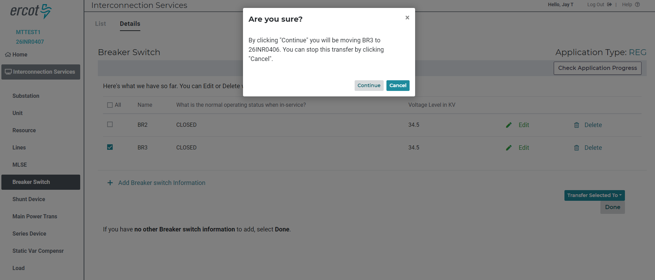
Figure 4- "Are you sure?" confirmation box appears, click Continue
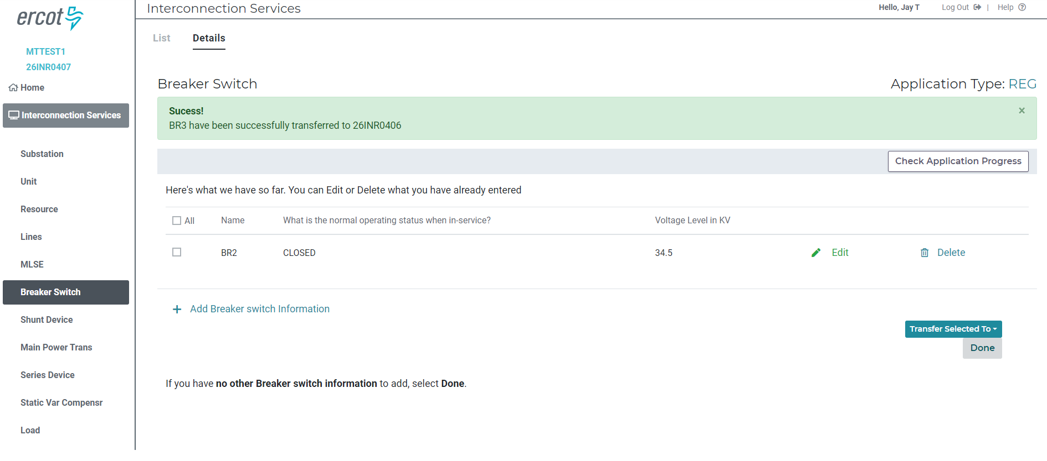
Figure 5- Success line appears confirming BR3 has been successfully transferred to 26INR0406. BR3 is no longer listed in Breaker Switch section of Substation Details.
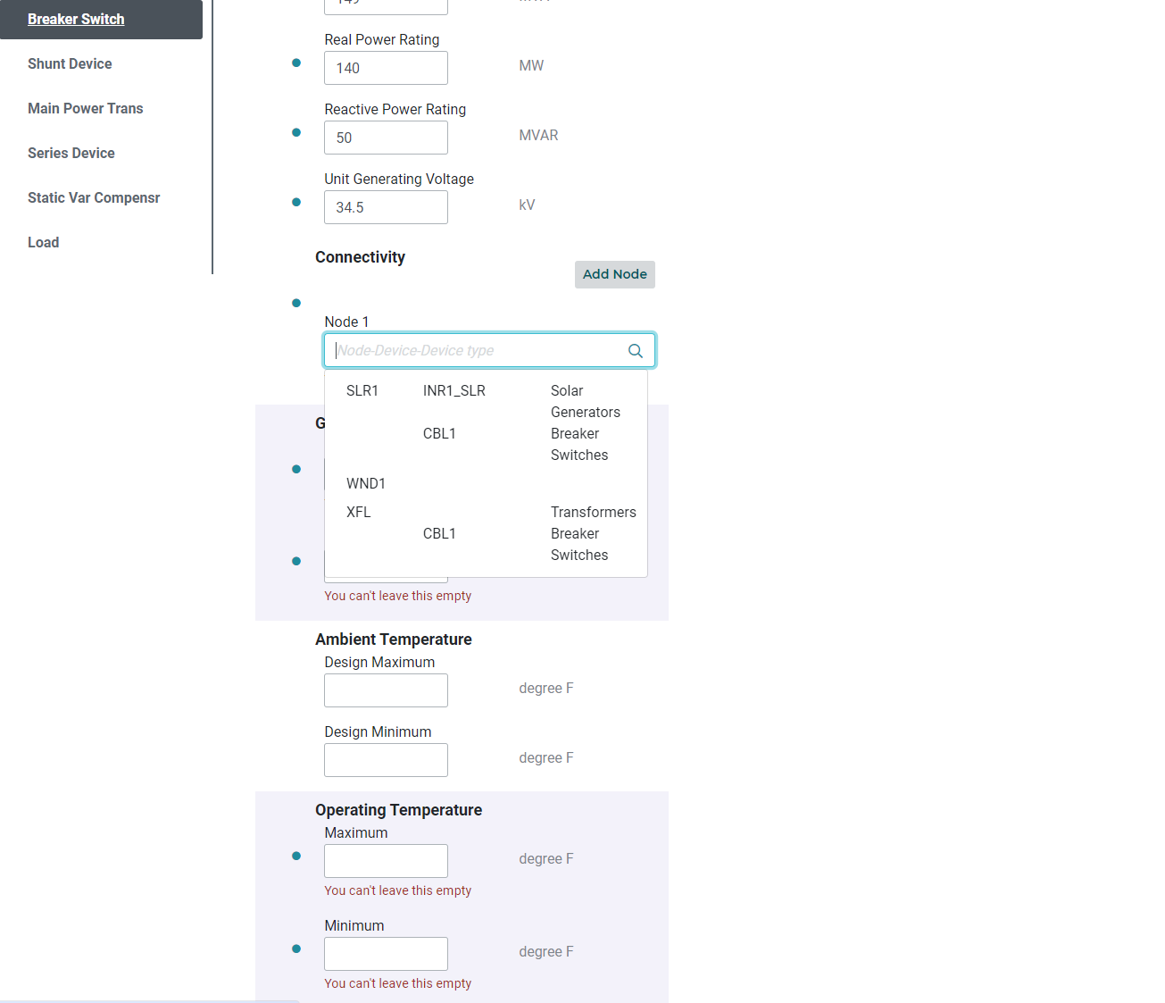
Figure 6- Nodes created in the 1st INR are visible in INR2. Here nodes SLR1 and XFL were created in the first INR.

