

System Planning

**Monthly Status Report**

Report Highlights

* ERCOT is currently reviewing proposed transmission improvements with a total estimated cost of $1.950 billion as of January 31, 2024.
* Transmission Projects endorsed in 2024 total $0.00 million as of January 31, 2024.
* All projects (in engineering, routing, licensing, and construction) total approximately $13.933 billion[1] as of February 1, 2024.
* Transmission Projects energized in 2024 total approximately $789.5 million[2] (as of February 1, 2024).

Regional Planning Group Reviews

RPG Projects under Review:

* TNMP has submitted the Silverleaf and Cowpen 345/138-kV Stations Project (RPG Project ID: 23RPG013). This is a Tier 1 project that is estimated to cost $299.00 million. ERCOT has completed the independent review on November 27, and the recommended project is estimated to cost $273.10 million. TAC voted unanimously to endorse the project on December 4, 2023. The ERCOT Board of Directors endorsed the project on December 19, 2023, and ERCOT has issued the ERCOT endorsement letter.
* TNMP has submitted the Pecos County Transmission Improvement Project (RPG Project ID: 23RPG023). This is a Tier 1 project that is estimated to cost $108.00 million. ERCOT has completed the independent review on January 18, and the recommended project is estimated to cost $114.80 million. TAC voted unanimously to endorse the project on January 24, 2024. ERCOT will present the recommendation for Board of Directors endorsement on February 27.
* WETT has submitted the Synchronous Condensers Project (RPG Project ID: 23RPG026). This is a Tier 1 project that is estimated to cost $468.00 million. ERCOT has completed the independent review on November 27, and the recommended project is estimated to cost $467.70 million. TAC voted unanimously to endorse the project on December 4, 2023. The ERCOT Board of Directors endorsed the project on December 19, 2023, and ERCOT has issued the ERCOT endorsement letter.
* LCRA TSC has submitted the Bakersfield Dynamic Reactive Substation Upgrade Project (RPG Project ID: 23RPG027). This is a Tier 1 project that is estimated to cost $145.00 million. ERCOT has completed the independent review on November 27, and the recommended project is estimated to cost $144.50 million. TAC voted unanimously to endorse the project on December 4, 2023. The ERCOT Board of Directors endorsed the project on December 19, 2023, and ERCOT has issued the ERCOT endorsement letter.
* STEC has submitted the Rio Medina Project (RPG Project ID: 23RPG028). This is a Tier 2 project that is estimated to cost $38.00 million. This project is currently under ERCOT’s independent review.
* Oncor has submitted the West Texas Synchronous Condenser Project (RPG Project ID: 23RPG029). This is a Tier 1 project that is estimated to cost $280.00 million. ERCOT has completed the independent review on November 27, and the recommended project is estimated to cost $280.00 million. TAC voted unanimously to endorse the project on December 4, 2023. The ERCOT Board of Directors endorsed the project on December 19, 2023, and ERCOT has issued the ERCOT endorsement letter.
* BEC has submitted the San Miguel to Marion 345-KV Project (RPG Project ID: 23RPG032). This is a Tier 1 project that is estimated to cost $258.50 million. This project is currently under ERCOT’s independent review.
* Oncor has submitted the West Texas 345-kV Infrastructure Rebuild Project (RPG Project ID: 23RPG034). This is a Tier 1 project that is estimated to cost $1.120 billion. This project is currently under ERCOT’s independent review.
* Oncor has submitted the Temple Area Project (RPG Project ID: 24RPG001). This is a Tier 1 project that is estimated to cost $120.70 million. This project is currently under ERCOT’s independent review.
* Oncor has submitted the Rockhound 345/138-kV Switch and Grey Well Draw to Buffalo 2nd 138-kV Circuit Project (RPG Project ID: 24RPG002). This is a Tier 3 project that is estimated to cost $97.00 million. This project is currently in the RPG comment period.
* CPS Energy has submitted the Eastside 345/138-kV Switching Station Project (RPG Project ID: 24RPG003). This is a Tier 1 project that is estimated to cost $158.00 million. This project is currently in the RPG comment period.
* CPS Energy has submitted the Omicron Reliability Project (RPG Project ID: 24RPG004). This is a Tier 2 project that is estimated to cost $42.50 million. This project is currently in the RPG comment period.

RPG Project Reviews Completed in 2024:

|  |  |  |  |  |  |
| --- | --- | --- | --- | --- | --- |
| RPG Project ID | RPG Project Name | Submitted Entity | Tier | Estimated Cost  ($ Millions) | Review Completion Month |

More information on current and past RPG projects can be found on the ERCOT MIS Secure (digital certificate required): https://mis.ercot.com/secure/data-products/grid/regional-planning

Past email communication on RPG projects can be found on the ERCOT listserv by signing up for the REGPLANGROUP list: <http://lists.ercot.com/scripts/wa-ERCOT.exe?A0=REGPLANGROUP>

Planning Model Activities

The short-term calendar of major planning model events is as follows:

* By May 31, 2024 24SSWG Cases and TPIT will be posted
* By June 7, 2024 24SSWG Contingencies and Data Dictionary will be posted

The following table shows interconnection projects that met Planning Guide section 6.9(1) and 6.9(2) and were modeled in the SSWG cases as a full model or as a simple model in accordance with Planning Guide section 6.9.





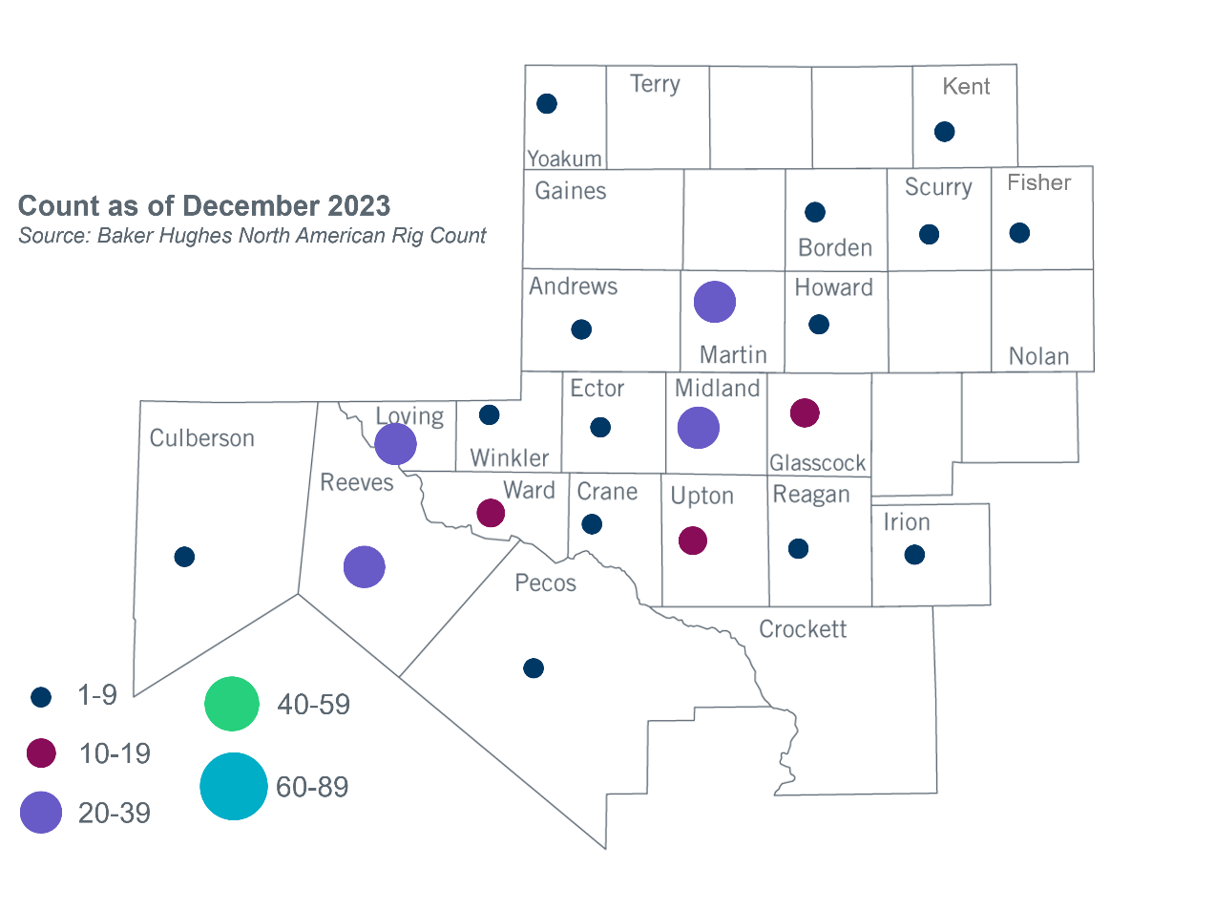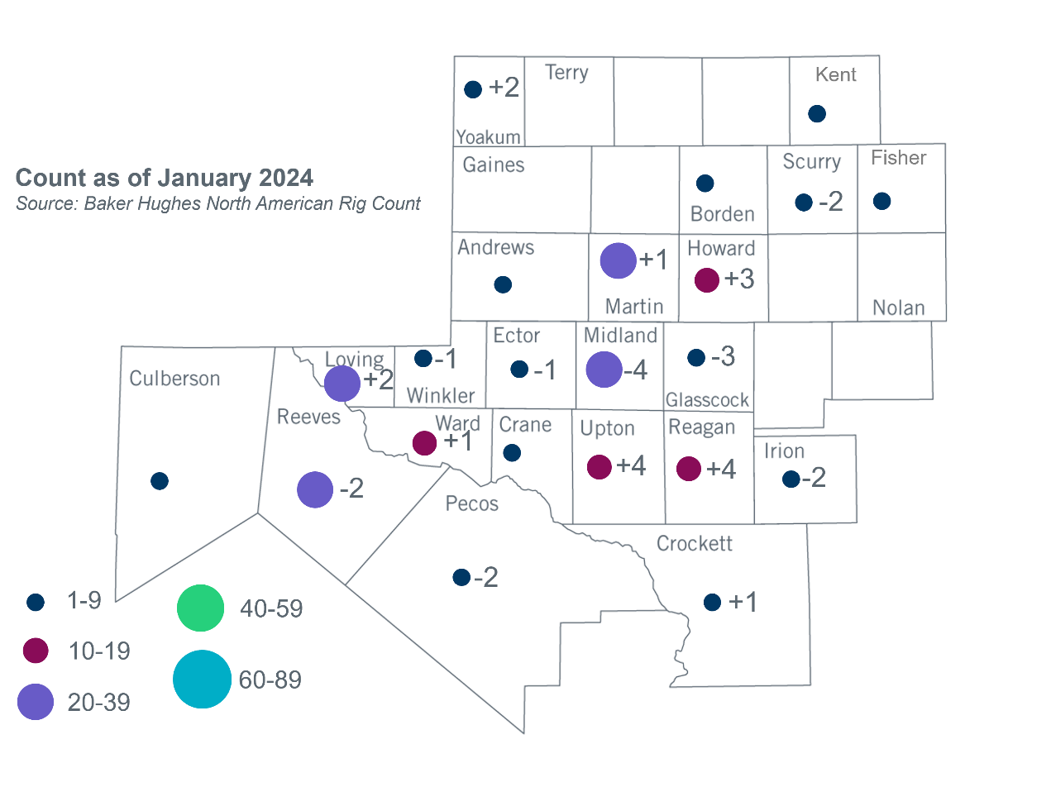Permian Basin Oil Rig Count[3]Other Notable Activities

* ERCOT is continuing to work with the TSPs to collect the Permian Basin Load data to initiate the Permian Basin reliability plan study in 2024 as directed by HB5066 and by the PUC.
* ERCOT presented the 2023 Regional Transmission Plan (RTP) final updates and economic analysis results at the January 2024 RPG meeting.
* ERCOT presented the 2024 RTP load review timeline and process at the January 2024 RPG meeting.

1. Based on the Total Project Estimated Cost for all future projects listed in the Transmission Project Information and Tracking (TPIT) report. TPIT is updated three times each year based on information TSPs provide in Model on Demand (MOD) as specified in the ERCOT Steady State Working Group Procedure Manual. The latest TPIT is available at https://www.ercot.com/gridinfo/planning.
2. Based on the Total Project Estimated Cost for all completed projects with Projected In-Service Dates in 2023 listed in the TPIT.
3. +/- symbol indicates the increase or decrease from the previous month in oil rigs present in each county. There are 211 rigs in the Permian Basin from December 2023 to January 2024.