1/22/2024
Meeting minutes
Presented by Tom McQuilken and Jon Beach (SEL)
Defining an elephant example
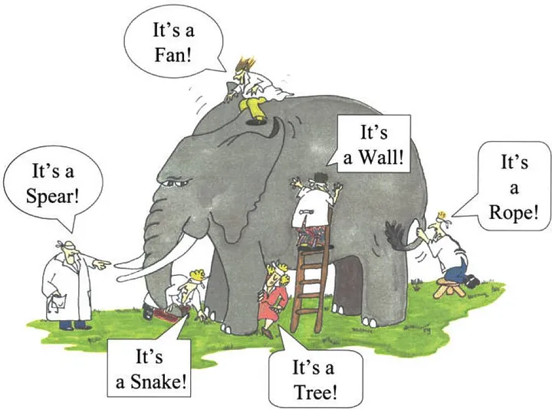

Elephant in this example is the power system and people in this example are measuring equipment on the power system. But to add a power system is much more complex than an elephant, because it’s dynamic and is changing in time and you cannot repeat an event that has already happened again on a real power system.
The aim of the presentation today is to talk about how SEL relays and SEL automation products are use to help fulfil the monitoring requirements.
Types of Disturbance Monitoring
Three different types:
- Fault recording of power system events that happened, where we use event recording capabilities of SEL relays to record what happened on the power system and particularly how the relays reacted to that event and why.
  - Analog and binary signals with high resolution and short duration (for faults the needs to record are short in duration but need to be high resolution)
- Sequence of events recording
  - State changes (binary signals) e.g. circuit breaker status from open to close, or relay when senses a signal. Important to capture sequence of what happened and to provide overall description of the state of the system prior to fault and then what happened during the fault.
- Dynamic Disturbance monitoring
  - Trying to solve a different kind of problem. May be we are not as interested in as high resolution compared to fault recording
  - Something like synchro phasors they are low resolution but continuously captured. – fantastic to use
  - More recently there is a lot of interest in high resolution streaming: continuously capturing high-resolution data (like continuous event report) and streaming.
Slide 3 showing the system like that (yet to be released but coming soon). Two things to note about it:
- There’s continual oscillography, continual grabbing “event-report-resolution-like” data, 14 kHz in this case. On the right-hand side, you see the automation equipment and software that grabs and stores this continual data capture.
- High resolution energy packet grabbing time-synchronized data with high resolution.
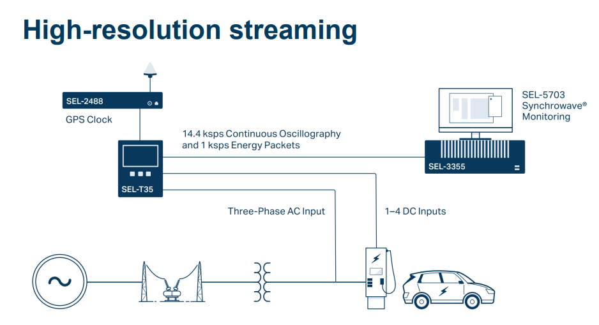
Next slide talks about what’s happening today and where relays are grabbing the signal from and what resolution they can record at. Example of 4XX series relay.
- Box number 1 is where physical voltage and current signals are coming in from a CT and VTs, there is also low-path filtering that happens. Selection of A/D converter is what dictates at what resolution data is captured. It is making discrete time data samples at a rate of 8 kHz
- In Box 2 - high resolution event recorder, will allow you to see with high resolution what is happening on the power system. There is minimum processing that happens, it’s just capturing discretized data.
- In Box 3 - Filter and down sample and corelate to GPS time synch to create synchrophasor data. The idea behind synchrophasors or phasor measurement units (which is used to describe the same thing) is to reports data (state of the power system) over narrow frequency band (centered around 60 Hz) and transmit it via communications to other devices. If generator comes offline you can see the exact response of other generators to rebalance from this data – for example
- In Box 4 – Filtered event report and the main difference between high resolution data and this one, is that there is a digital filter extracts only 60 Hz component (in most cases, there are some exceptions) for the purposes of sending this signal to automation and protection.
If you want to understand what’s happening at power systems signal looking at high resolution data is the way to do it, i.e. prior to this Box 4.
If you want to know what relay is seeing, then looking at the Filtered event report is the correct path.
- In Box 5 is sequence of events recorder. This is the report that keeps track of changes in binary status of everything within the relay and things that you feed into the relay, e.g. aux breaker status.
Next slide - Event reports. The things listed on the slide are points of the main consideration of the event report: format, content, length, storage, filtering and sample rate and triggering conditions.
Word of caution: event reports have always been there in SEL relays (40+ years), it will be impossible to put in all of the details of storage and light and formats etc. on slides. So will share some trends. He’ll point where to find details for each particular relay.
The ability to trigger relays is of most importance!
Next slide - Event report formats. As the ability to analyze events has improved so has the event report format. Originally was EVE format – human readable, before there was any event analysis software. There is some negative aspects it only provides subset of relay word bits. Data is available as filtered or unfiltered as he talked before. The word of caution, don’t grab EVE anymore. Use other formats.
For CEV event analyzes by software is possible, i.e. charts and reports, compressed version of event repot data. Compressed means smaller. Also available and unfiltered data.
EVE and CEV are SEL specific formats.
With the creation of COMTADE IEEE C37.111 this is a standardized way of packing power system data that is read by relays and relays respond to it. Any relay now can interpret it so that you can do event analysis.
Most of the time COMTRADE is unfiltered/raw data only but more recently started to pack both unfiltered and filtered data in COMTRADE event recording.
Show slide with event report: analog signals of currents and voltages, as well as binary signals that represent state of all different relays, protective elements, digital inputs, physical outputs of the relay. Specifically with SEL relays, you’ll also get Relay Settings as a part of the report. These can be very helpful not having to request these settings but have them available in the report. Event summary – summarizes what happened as an overview.
Next slide groups report content by relay family 3XX, 6XX and 7XX. The slide includes data that’s available from these relay series.
The next slide provides the same information about 4XX relay family. So many digitals in these relays that it’s impractical to provide them all in the report. By default, includes most important ones for filtered events. Same can be said about unfiltered events but also how additional bits can be included, but at the expense of storage. This is a very big difference from other families of relays.
Event report length is configurable in modern relays can chose from 15 cycles, 30 cycles or 60 cycles of report length. You set LER setting accordingly. More recent relays have more storage available to them. That storage is split into two parts: the overall event report length, and the amount of data prior to trigger happening, i.e. the memory buffer to keep before the event happening. So the moment the trigger happens it tells the relay how much of that buffer to store + event data is the rest of the data = the length of the event report .

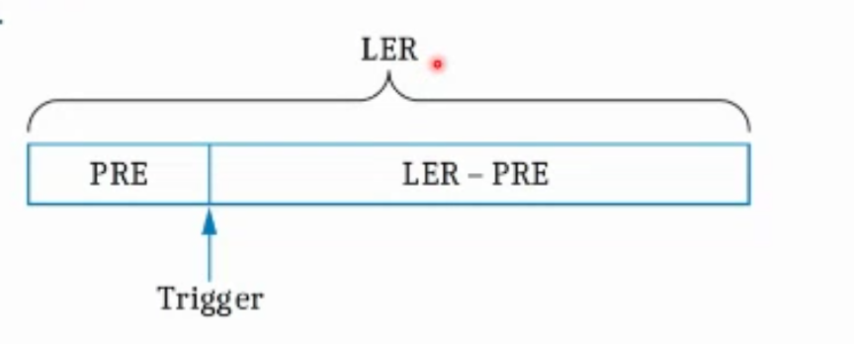
Maximum length varies by relay model but also by hardware version. All of this information is available, in particular relay instruction manual and he’ll be showing some examples.
Next slide - Sample rate and relay filtering.
Shows example: red signal is higher resolution 16 samples per cycle the green is 4 samples per cycle resolution, and it is filtered and that is what relay will be using for overcurrent triggering etc. And there is big difference between these two signals, and they are used for two different things. So you really need to distinguish between do you want data to understand what happened (unfiltered) or you need data to understand what relay saw and why it acted certain way (filtered). Recommended to download both.
The next slide shows that you need both to understand what happened and provides instructions on how to choose the right event report depending on the goal of the analysis.
Next slide shows event parameters by relay type.
Notes underneath show exceptions (for specific relay models within a family of relays) and these are many, accumulated over the years. Need to look at the specific instruction manuals. Total length of the events/data you can store depends on your ERDIG setting.
Next slide - Event report storage in relays
Provided data just for two relays as a sample. SEL-311C-2/3 typical of 3XX, 6XX and 7XX series, 6 and 7 hund. series are just a little bit better than 3. The 4XX series is way better than all of them but ERDIG setting set to S in the example, means can store much more, if it’s set to A then you can storage less, because recording more data. Need to find balance between your needs and storage availability.
The amount you can store depends on the length of the event report obviously. Very significantly by relay type but is not upgradable, you can’t just add more memory. That’s an important thing to note.
The “first in first out” principle is used when recording events, so will override earlier events first, if you run out of storage capacity.
Next slide - Event rereport triggering
Three main path that can trigger the report in SEL relay. Relay trip, Can manually trigger an event report with TRI or PUL commands, event report (ER) triggering equation = true. This is the path to fulfill NOGRR255 and to specify triggering rules for, i.e. when my voltage exceeds certain level etc.
Next slid - Setting up ER trigger
Identify criteria you wish to trigger for (e.g. NOGRR255 or some standard). Relay element to set up to operate the desired threshold that you wish. Then need to take the output of that protective element (called relay word bits) to the ER equation. If relay element is not available, you can still put digital output (called bits) together to do custom logic and create custom behavior. If you don’t have a particular relay element to create and event trigger you can look at feasibility to create a custom logic.
Next slide - Example where there’s no RoCoF element. You have SELogic but no analog comparisons as part of that SELogic (to compare to set RoCOF trigger). But are there other triggers that can substitute in case the signal you need that is not available, e.g. underfrequency. May or may not be sufficient for what you need.
In 4XX can use df/dt analog quantity specifying a threshold manually. In 6XX and 7XX series there is RoCoF element, with some exceptions.
What do if nothing is available? Is there another option? Is there another device in your signal path that is available, you can always do something. There are communication protocols for examples that you can set up to talk between devices as a means for triggering – but particular to the application you need.
Next slide - Sequential events recorder (SER) tracks binary data when the status change, which data it records depends on settings that you specify. The amount that you can store depends on relay type. That tells you how often you need to pull the data into the long term storage before it gets overwritten. When selecting word bits to track for SER you shouldn’t select word bits that constantly change, because the storage will quickly fill up and data will be overwritten. If overwrite too much the memory will fail eventually.
Next slide – Time synchronization – Jon Beach presenting
Stephen Solis: Everything that you were presenting here is related to taking advantage of multifunction protective relays for high speed data recording, correct? Are the other devices that are built to be DFRs and DDR?
Tom: Yes there are other dedicated recorders that what Jon is going to talk ab out now. It’s great to have this data recording functionality being built into relays themselves, but there are other pieces of equipment and other equipment that can provide unified data recording.
Sequence of Events Recording (SER) slide
You’ll notice the third column is time. Time is very important we want to make sure that the time is aligned between data-recording devices. That’s where SEL comes in with time synch devices.
Time Synchronization slide
Shows one of their clock devices on the slide with its technical specifications.
Next slide shows time protocol comparison, the worst accuracy is going to be 1 microsecond. The important thing is how this information is getting into the relays. Need really good networking equipment and the one the understands and speaks PTP.
Next slide SEL-2731 Ethernet Switch, which is PTP transparent device. PTP can move through the switch without any stops or concerns. Has the ability to upgrade to something called SDM switch, switch that has higher cyber security options that he is not going to cover today but can talk about offline.
Next slied on comprehensive disturbance monitoring and dynamic disturbance recording – RTAC. Able to pull back relay SERs and event reports. RTAC is pulling data in but first in first out manner, but its storage is dramatically bigger than multifunction relays that Tom was talking about. RTAC also has ability to look at multiple devices at the same time.
RTAC can act as phasor data concentrator - PDC. Able to support a lot of streams coming in and event recording with it he’ll talk about on the upcoming slides.
Next slide on Axion as a disturbance monitor. As Stephen was asking in his question, SED does have equipment that is specifically made for continuous disturbance monitoring and fault recoding – Axion (middle of the slide pic). It has a RTAC in the front and configurable IO on the back. On the right-hand side of the slide is disturbance monitoring system using Axion and an RTAC. RTAC will be the brains of the operation gathering all information from up to 60 different module in the field.
Next slide Fault Event requirement.
RTAC is capable of setting up an event report, much like what Tom mentioned. Pre-trigger length, length of the event report and sampling rate. 64 samples per cycle (4 kHz), capable of recording for up to 24 kHz capable of getting very accurate information and event reports. It’s easy to update the settings as needed.
What is going to trigger the event report: voltage, current and frequency,
Showing slides with examples of voltage triggers, overcurrent triggers and frequency trigger settings. On the latter example talks about RoCoF trigger and RTAC’s ability of resolution on df/dt and it’s able to see and potentially record this type of signals
Julia: RoCoF is based on certain signal and equation to calculate RoCoF, how do you aling what your devices is doing vs what system operator is seeing?
John: Not sure how the calculation is done but will follow up
Tom: Julia can you elaborate.
Julia: In IEEE2800 there is a requirement to ride through certain RoCoF with measuring window at least 100 ms but depending how you measuring/sampling and calculating RoCoF you can come out with different results. And so, if this sampling and calculation differs between IBR measurement and ISO measurement you may have different performance expectations.
Tom: Got you. Is there a standard on how RoCoF is calculated?
Julia: Seems like there is a standard in how relays do it but no standard industry way standard.
Tom: Is the concern with RoCoF ride-through for relays that are used for protection or triggering of event data off of RoCoF?
Julia: If you could follow up with your colleagues and able to share the methodology you are using it will be great to share.
Mohammad: RoCoF is used as a constraint for unit commitment optimization.
Stephen: Want to add, it really comes down of what do you use as denominator. IEEE2800 says at least 100 ms, but if we use 100 ms we get one RoCoF, if we use 500 ms window, we get different RoCoF. If we exclude fault times and go to pre-fault to some time after the fault it’s a different number. So it’s good to understand what the relays and protection devices and/or fault recording triggers are using so that ERCOT could synch up. On ERCOT side there is currently no synchronization, but there is a will to align with what equipment is using and measuring.
Julia comments in the chat that resolution comes into that concern and frequency itself is also a calculated quantity. Tom confirms in the chat that frequency estimation is a bit of an art itself and has direct impact on df/dt.
Tom & Joh: Understood and will follow up.
Next slide on continuous recording
The RTAC is also capable of doing continuous recording in addition to just event reports. So the continuous recording is using the PTCT module, it’s capable of 3 kHz resolution for continuous recording and it is the rolling storage unit. As you set it data retention duration it will not move beyond that point of storage. Storage capacity is a big deal. People don’t understand how much data is coming in at 3 kHz sampling rate. So the average channel: frequency, current, voltages that is a channel or a stream and each stream will take 700 MB of storage up per day. So 30 days’ worth is 30 GB of data if you pulling 5 devices it’s 150 GB of data.
Philip Andries: Is each phase a separate stream?
Jon: Stream is going to be alike a synchro phasor system. You specific PTCT module 4 voltages, frequency, change of frequency that’s going to be your stream of information
Tom: so it’s per module?
Jon: per PTCT, grouped together. So, V_0, V_1, V_2, I_A, I_B, I_C, frequency and change of frequency it’s going to be a singular data stream.
Next slide continuous recorder file retrieval. Easy to use interphase, especially web interphase. Can create COMTRADE reports as long as you like. Shows how event settings can be selected.
Next few slides around recorder file settings.
Next slide on synchrophasors. RTAC can be used as phasor data concentrator, if you have phasor information coming back as part of your compliance.
Next streaming requirements and standard IEEE C37.118. IEEE standards are backwards compatible, i.e. equipment that originally has older standard capabilities is still capable of delivering to the newer standard.
Next slide PMU server configuration and settings. It is adjustable to comply with newer standards if all devices are pulling at rate per the standard and same rate for all devices.
Next slide on local storage talks about NERC PRC standard and ERCOT NOGRR255 storage requirements specifying storage. RTAC has selectable SSD drive 32GB-2TB, 16 GB per month per device. Configurable after the fact, can upgrade with a new, bigger SSD that has an image of previous RTAC SSD on it.
Next slide Axion system as a whole. PTCT module running with 3 Hz sampling.
Q&A
Stephen Solis: Appreciate all the information! This rule change is potentially going to increase the demand for some of these products. And when a new version of NERC standard comes in, there’ll be an increase in demand nationwide. Do you have any constraints that you see causing excessive lee times? If the customer orders specific equipment what’s the lee time for them to get it at high level?
Tom: I looked at it right before the meeting just to get an idea. Covid times were unprecedented from a supply chain point of view, SEL was affected as well. On their end SEL did a lot with stocking parts and redesigning equipment to get rid of the pats that we were not able to procure to better manage their lee times. Fortunately things have recovered from that point of view and lee times for our relays today the longest this year is 11 work days for all of our relays. Sometimes when we build something and there’s standards process for finding defects, this process may stop production and delivery process and affect lee time. But otherwise, lee times are short and we are planning on keeping it that way
Bret Burford (AEP): Also member PRC-2/28 drafting team. Reviewed older and newer SEL relays at AEP to understand what we can live with vs new. So, I understand that the Axion is going to capture data at 3 kHz, i.e. 50 samples per second are the any plans to increase that to match say 4XX relay capability. 128 samples per cycle came out of IEEE2800 and couldn’t find any justification for this requirement. The IEEE2800 development team said it was something forward looking based on current state of the art capability of recording equipment. So, not what’s needed but what can be done. Do you actually need that? Haven’t gotten a good answer. So, presently we backed off to 64 which is still more than 50, however last week we had Tesla and others chime in with some. It’s highly probable that inverter monitoring question should it be 3 kHz and we need to scale back to 50 samples per seconds. Maybe it depends on how fast the inverter is making a decision? So it’s a tradeoff between setting a standard and understanding what’s actually is needed? I’d appreciate this working group working with the thought in mind what you really need?
Tom: If I can add one thing of clarification, that 3 kHz is the real time streaming and storing capability of the Axion, i.e. second umbrella of dynamic disturbance recording. For Fault recording capability of the Axion, you can be configured to far surpass 4XX series relay (with is up to 8 kHz), Axion is up to 24 kHz. So, the current limitation with the streaming doesn’t apply to fault recording. Jon also confirmed.
Stephen: It’s obvious you took a look at proposed rules in NOGRR255. In your all’s observations did you all see any issues that we should address, or some things we should take into consideration for adjustments?
Tom: I think there needs to be some consideration, of RoCoF triggering requirement and in case of 7xx series the unfiltered sampling rate requirement going up to 64, it won’t be able to meet. Not that you don’t have particular reason for considering higher sampling rate but think about the reason behind more is better and the consequence of that. Event length that you can get out of most relays is 1 second
Stephen some requirements go to 1 s while others are 2 s, in particular for IBR. This is to make sure we have sufficient resolution to do model validation and to determine very fast acting causes like overvoltage protection or overcurrent protection. Instantaneous overvoltage or overcurrent tripping could be just on a single sample and if you haven’t captured that you cannot do the assessment.
We were ready to back down from 128 samples because there was not capability on the ground currently available. So, we dropped it to 64, but if it’s still to high to accommodate that for one piece of equipment? Getting equipment capability into the pool is not our objective but we need to understand limitations of equipment and trade off against the value of capturing at this resolution.
Tom: Let’s continue this conversation. One note about protection aspect of things. Keep in mind that vast majority of protective relay is operating on that 4-8 sample per cycle filtered data, so not on instantaneous values. So these trips not actually on instantaneous value, unless you start talking about point on wave protection.
Stephen: I think you are right when it comes to SEL relay, but I think the IBRs are reacting differently. NERC disturbance reports indicate that inherent protective functions in IBRs are not using filtered data and not using time delays to trip. So, you are measuring it sometimes with a fault recorder on the high side of the transformer but inverter itself has a built in protection that trips off on instantaneous signal that we cannot see at the POI. So higher resolution data allows us to see those instances.
Tom: Curious if it’s standardized and how resolution and storage looks like at inverter leve.
Stephen: It’s high resolution but differs company to company.
From Steven Withrow to in the chat: will the T35 include some sort of harmonic element for reporting or processing?
Tom: What type of thing you are trying to solve with that harmonic element?
Stephen Withrow: at inverter level we are trying to focus on harmonics and filtering there to start THD and may be more.
Tom: Power quality-like metrics? More just fundamental frequency?
Stephen Withrow: To start fundamental but may be more potentially
Tom: Let’s take it offline.
Jon and Tom shared their contact information:
tom_mcquilken@selinc.com, 509-336-7179
jon_beach@selinc.com, 509-334-8873

