IBRWG Meeting Minutes – 01/12/2024
EMT Models for Legacy IBRs
Presentation by Andrew Isaacs (Electranix), and discussion supported by Deepak Ramasubramanian (EPRI)
- Large portion of IBRs where EMT model is not available OEMs are still in business.
- Often no good or satisfactory solution to this problem
- FERC ruling on EMT model collection point is shortsighted. It is important to start collecting EMT models at the interconnection stage regardless of if EMT studies are being done or not at the time.
- Ask yourself a question of how important it is to get EMT model for legacy equipment?
  - How impactful the device/IBR is for that specific study?
  - What are you worried about? SSO, VRT or voltage control or unknown issues?
  - This will determine how important EMT modeling assumptions for a device are
  - This will set the tone of how much work you are willing to do to get the models
- If you cannot get a model that you want. There are some options, but as soon as you are off from a good, fully qualified EMT model it will degrade the accuracy of your study immediately. If the model degraded too far and the IBR plant in question is important for your study, without a good model the study may become useless.
- Options:
- Get a model that meets all requirements – desired option!
- Find engineers involved from original OEM and ask/pay them to create a model using their best information – some degree of success;
- Proxy model approach: actual equipment models, i.e. real models from real OEM but not exactly representing this specific plant. The selection can be based on model vintage, protections, settings etc.
- Configure proxy model using similar vintage and type from a different OEM model, the advantage of it is that you are still using actual PLLs (phase lock loops) of actual equipment, but the downside is that you might be deviating from actual controls (damping VRT recovery may be different)
- Generic model approach, very good work being done by EPRI on generic models. Once you know a lot about the plant/model then you can go and develop a good generic model. But you need to learn as much as you can about actual equipment and settings to be able to do that.
- Off the shelf generic models.
Deepak Ramasubramanian (EPRI) asked to explain why option 5 is ok, but 6 is not?
Andrew (Electranix): number 1 is what we want and then everything is down from there. Use of 3 & 4 is better than generic model, because it picks up on settings/limiters of real equipment of that vintage.
Deepak (EPRI): the difference between 4 and 5&6 is that the model may still be more representative of actual hardware that is being modelled.
Andrew made a change to his slides that if you have the ability to test the hardware in a lab, then you may configure a detailed generic model to match the performance better.
Frank Berring (SMA): Seems like these proxy model approaches pose exponentially more risk and probably provide a false sense of security to the end-client. Would you agree or is that overstated in your opinion?
Andrew (Electranix): It’s true, you can potentially override voltage control and ride-through response. If you are worried about ride-through, then number 5 is definitely going to put you in a risky position and no better than off the shelf generic model.
Mohammad: Can you please summarize how all different models in options 1-5 compare to a generic model.
Andrew: Referring back to slide 3, it depends on how important the model is for the study.
Andrew: SMA has been a good actor in the modeling space, can you reflect on all these modeling options?
Frank (SMA): I think it’s sliding scale of risk. Same OEMs’ proxy is better than others’ (in this case you need to have some intimate knowledge of the hardware and controls of that OEM). To me they are all extremely high risk.
Stephen Solis (ERCOT): Thank you for presenting! We are in the situation where not just PSCAD but even PSS/E dynamic modelling issue. Where we had units trip, and models do not reflect that behavior, so even just getting these models accurate is challenging. Are the principles that Andrew presented generally apply to PSS/E models as well?
Andrew: probably the principles apply but the risk is much lower. The risks listed on slide 6 do not apply as these phenomena are approximated or not modelled in the PSS/E studies anyway.
You should be able to do better with generic or proxy models for transient stability, compared to EMT. For PSS/E models I would strike the last point that “if device is very important and you don’t have an accurate model of it, you shouldn’t even do the study, as it’s going to be a waste of time”. This is because for phasor-domain simulation, the generic models can be tuned pretty well, and you are not stuck in the same way as in EMT.
Stephen: Based on what Andrew just said, for PSS/E models, where OEM is out of business it should be possible to obtain generic model and tune it up to match the response.
Andrew: Yes, if you can’t get OEM’s support, take high quality generic model and have the specialist to tune behavior to match the equipment.
Deepak: Yes it’s doable, but have to be realistic about the effort involved. The way generic model is purposefully constructed is to have multiple control paths and multiple settings to choose from in the model. So, if there no information available at all about the plant in the field, it takes more time to figure out what control strategies are used at that plant to select the right controls in the generic model. You have to know which control path to use before tuning the gains etc..
Andrew: Yes and you might not be even be able to figure that out and then will have to match the performance of the IBR model to the best of your abilities.
Stephen: If the models don’t reflect the IBR performance limitations, then, when we have contingencies on the system, there is more impact than what was studied. This creates a problem with NERC compliance. If I can’t model accurately, should we be assuming the worst case scenarios to handle the risk of not having an accurate IBR models.
TSAT modeling update
Update presented by Yunzhi Cheng (ERCOT)
- Last 5% model left for TSAT, this could be higher or lower in the future depending on if plant owners decide to switch from generic model to UDM
- TSAT has generic models by default but for UDM there is special process. There is a list of models that are not accepted, it doesn’t mean that the model is bad but means that did not receive the model from the resource owner. The vendor may have good models, but we cannot directly use the model provided by the vendor. All the models need to be submitted to ERCOT from resource owners or interconnection entity.
- UDM Submittal Requirement guideline was recently updated to include additional UDM TSAT requirements. A common issue with TSAT models is, for example, where the plant is modeled as 3 units in operational load flow case but the dynamic model only has 2 units. The real time load flow case and the dynamic TSAT model need to match. This is what led to additional requirements from ERCOT’s side for UDM TSAT models.
- PowerTech released model quality testing (MQT) tool. The tool is free of charge and is similar to DMView, developed at ERCOT. ERCOT doesn’t have requirement that any specific tool is used for MQT though. Only a requirement of what MQT supposed to include.
- Last slide (slide 6) showing Status Update in more detail. Out of 16 existing GTCs, 7 don’t have acceptable TSAT models. The slide has details for those 7 and how much % of models are accepted so far.
Seth Cochran (DC Energy): Do you have more precise date for item 4 & 5 on slide 6.
Yunzhi: No, but we will provide an update in the future
Seth: Item 4 sounds like a whole lot of tests and will take a lot of time?
Yunzhi: We have 16 GTCs, but we won’t start with all at the same time, will start with the few GTCs.
Seth: New UDM requirement will it be onerous on further collection of the models or was the change not much burden to the IBRs.
Yunzhi: This change is applied to models that don’t work in the first place, so the new requirement will help to speed up model acceptance rather.
Fred: We are not putting a new requirement per se. The intent is to receive useful UDM model to start with. The changes are based on what we’ve learned through modeling issues, and the intent is to provide better guidance and therefore receive more usable models from the start. In terms of the challenge we are 95% good, but we do have some concerns for the models developed by third parties where we spent a lot of time iterating before they provide, what we need.
Seth summarizes: The new requirement is just to reduce back and forth between ERCOT and model developers?
Fred confirms.
Mohammad: Is there a priority of which GTCs will be implemented first.
Yunzhi: We’ll start with a few GTCs that we are comfortable with (in terms of models accepted and approved and TSAT results consistent with PSS/E and reasonable).
DWG and IBRWG collaboration,
Presented by Paul Koberlein (vice-chair of DWG)
- NOGRR245 how ERCOT is going to review test and verify compliance?
- Current answer on slide 2
- In the future forming a subgroup between DWG & IBRWG will help to form best practice for this.
- Still need to talk to Market Rules, if formal TF is needed or informal collaboration is acceptable.
- Scope of work for the subgroup (on slide 3) will also consider inputs from IEEE standards.
- Timeline on slide 4. Approximate timeline is 6 month but it doesn’t always go as planned.
- Can, potentially, use IBRWG or DWG meetings time, but the feeling is that a separate meeting time is necessary.
- A question was posed that DWG meetings are closed meetings, while most of IBRWG discussions are open. The response was that this subgroup meetings will be open as well.
Update on NOGRR245
Presented by Stephen Solis (ERCOT)
- On NOGRR245 ERCOT did submit additional comments on 1/8/24 with proposed additional modifications to the requirements that consider the technical feasibility of meeting the requirements as identified in RFI results and taking in the feedback from the stakeholders.
- Texas RE filed comments on1/11/24, which were supportive.
- ERCOT hopes for a positive vote at January TAC
- Slide 3 and 4 summarizes proposed changes as of 1/8/24, allowed for additional exceptions, considering those allowed by FERC Order 901, which says if you are going to allow exceptions then need to include these in you contingency analysis. Took project upgrade cost reported by generator owner into account, when developing criteria (item 1.2 on slide 3)
- Slide 5 summarized Reliability Impacts of ERCOT proposed exceptions.
David Azari (Invenergy): Trying to clarify ERCOT expectations. Second bullet on RoCoF and Phase Jump there is now differentiation between fault and non-fault disturbance, so if it’s non-fault disturbance what are ERCOT’s expectations?
Stephen: ERCOT took non-fault IEEE2800 specificity out as it’s not helpful for legacy IBRs.
David: Expectation for legacy plants to ride through any phase jump or RoCoF is more stringent than IEEE2800.2 according to new NOGRR245 language?
Stephen: As long as the voltage within ride-through envelope these IBRs are expected to stay connected.
Eric Goff (representing of Nextera): how is this expectation different than NOGR245 before specificity was taken out?
Stephen: Legacy IBRs (especially wind) are not monitoring these parameters, and to monitor and start testing, there is more uncertainty for them and no way for them to know, if these are the parameters that cause other things mechanically from showing up. So ERCOT’s thought was that just removing this specificity takes care of this concern. The approach was to take a step back, take specificity out, as it creates more barrier, so ERCOT hoping that it was viewed as a positive change.
David: To ask in a different way, for solar inverters that are measuring phase angle jump, is the expectation for non-disturbance within ride through zone, if say 30 deg phase jump happens, the disconnection is not allowed?
Stephen: Correct, as that is the current expectation even without NOGRR 245.
Kristin Cook (Southern Power) : Exception language clarification: reading Jan 8th ERCOT comments, IBR owner must submit evidence. The evidence needs to show that you don’t create the risk, but is that the IBR owner’s responsibility or ERCOT? Stephen said that ERCOT will probably need to be part of that determination.
David Anzari (Invenergy): On multiple excursion requirements: is that intended to cover the example of a DC chopper heat limitations?
Stephen: No, it in particular gives wind resources an exception because of resonance issues. The DC chopper heat limitations issue, we probably need more discussion to get the wording right. ERCOT is not opposed but this can be added with a separate NOGRR after NOGRR 245.
David asked about 20% replacement cost and
Stephen: This is trying to take the concept of creating a criteria for determining reasonable or unreasonable upgrades.
David: Can you clarify grandfathering requirements?
Stephen referenced our minimum requirement of the current ERCOT operating requirements.
David: Has ERCOT done a follow up summary about what has been done at Resource level after Odessa events?
Patrick Gravois (ERCOT): ERCOT has followed up with individual entities and sent out market notices. No report but ERCOT will discuss internally and may bring an update to the future IBRWG.
David confirmed that it will be of interest to this group.
Alex Mitasev (Avangrid): If adding capacity to a site, are you saying the full capacity has to meet the requirements? Or would the known limitations for existing turbines be applied?
Stephen: May need to follow up, but adding on to capacity and undergoing the GIM process would mean that new additions would need to meet updated requirements, as apply to new plants installed after June 2023.
Update on NOGRR 255
Presented by Stephen Solis (ERCOT) presented
- NOGRR 255 has been updated (Jan 4th ERCOT comments).
- Proposed changes are listed on the slides
- Steven raised a question from ROS, that at least one commenter at ROS asked if IBRWG had concerns with NOGRR255 and that they would like to see the position more formally documented. Does IBRWG endorse or not endorse? The group hasn’t provided any opposing responses but a more formal report may help provide the clarity.
Questions:
- Kristin Cook (Southern Power) – said she appreciates the work and they are pleased with the changes.

IBR plant model development and Developer/OEM/ERCOT interactions and gaps Topic
Siddharth Pant (GE Vernova) presented on GE Vernova solar and storage solutions (S&SS) products
- OEM/Developer/Consultant/Utility interactions, potential gaps, and considerations for improvements.
- General summary of interactions shown in the slide below.
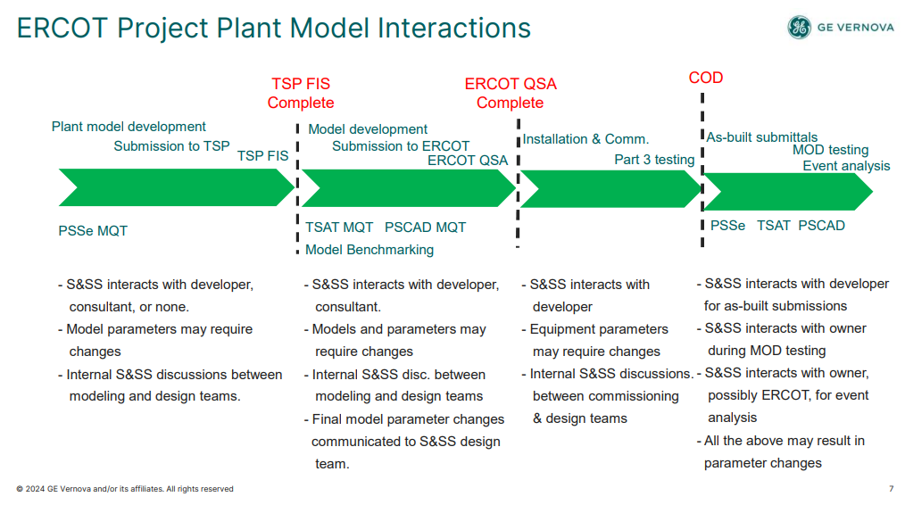

Dustin Howard (GE Vernova) presented primarily focusing on wind
- Product design process, IBR model development, project-specific model and study aspects, gaps in model development and studies, and suggested improvements.
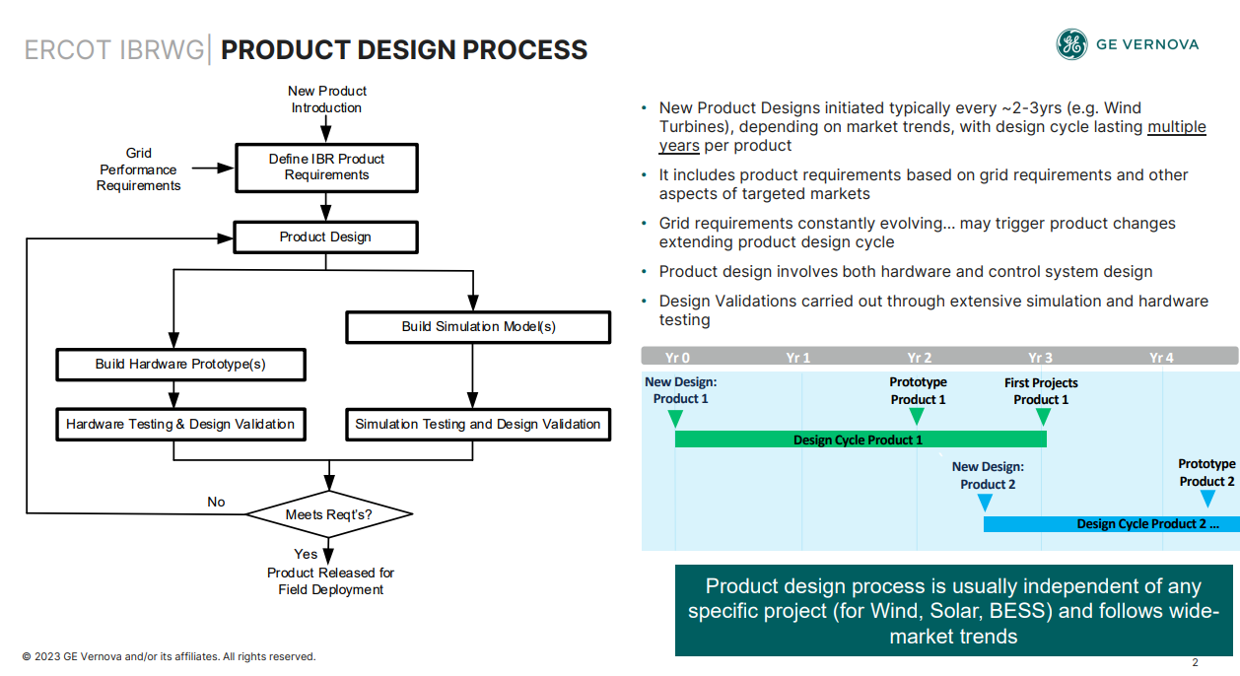

Stephen Solis (ERCOT): How often do you tune the initial model assumptions/parameters.
Dustin: We would expect early on more frequent changes, but less frequently for more established products. Some responses aren’t universal, but universal requirements would be updated according to product changes.

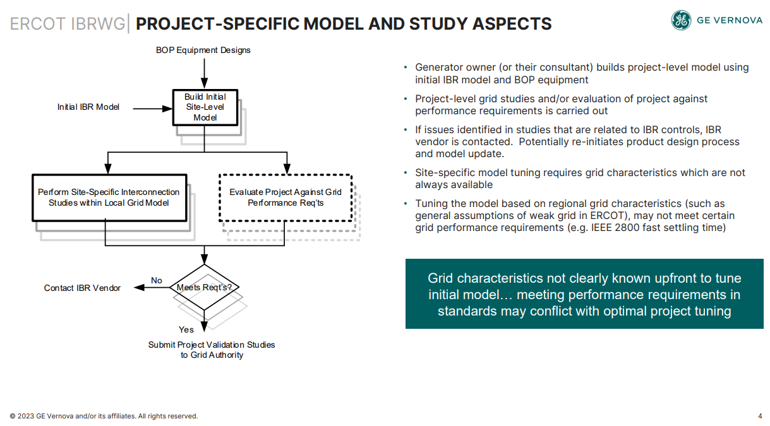
- Dustin discussed the potential improvements that could be made:
  - Have minimum of 2 stages for project model submission
  - Final model comes with vendor attestation
  - Develop standard grid performance tests
  - Use regional grid studies to update standard grid performance evaluation
Stephen Solis (ERCOT): Is there a verification process that the field settings actually match the model?
Dustin: Yes, the intention is to be able to do that.
Update on ERCOT’s GFM Performance Requirements
Fred Huang (ERCOT) provided a verbal update.
- ERCOT is working on identifying grid-forming performance and need.
- ERCOT issued an RFI last last year and selected a consultant. Project expected to be completed by summer.
- ERCOT will work with IBRWG for feedback/comments on how to adopt grid-forming in the ERCOT grid.
- ERCOT requested vendors to be engaged during this process and share models with ERCOT.
GFM BESS and BESS Augmentation
Presented by Prashant Kensal (Tesla), Askhat Tullegen (Tesla), Sarah Dodamead (Tesla)
- The presentation covered Tesla’s Hornsdale grid forming project experience, grid forming applications and modeling examples, synchronous condenser vs BESS, grid forming challenges, and energy augmentation.
- Hornsdale project in Australia proved that grid forming conversion (from grid following) is possible.
- System strength charge has been implemented in Australia, which makes grid forming IBRs potentially more economically attractive compared to grid following
- Two additional Tesla projects operational in Australia (Wallgrove- 50 MW, Riverina- 150 MW).
- Grid forming resource can be installed at same POI as an existing wind or PV to help stabilize.
- The UK is creating an inertia market.
- BESS grid forming impact: frequency nadir, damping, and voltage dip during fault improvement.
- BESS grid forming allows full control on tuning inertial and voltage support behavior separately.
- BESS grid forming can have limitations like PV/QV curve.
- Sarah Dodamead (Tesla) presented augmentation goals and proposals. Main point is that power augmentation (supplementing degraded battery modules with new ones over the course of the project life, to keep the same MWh) in a BESS is will be an ongoing/continuous process throughout lifetime of the project – it may be impractical and unnecessary to treat it as material modification and trigger restudies.
Seth Cochran (DC Energy): Were the batteries in Australia acting as resources or transmission assets?
Eric Goff (representing of Nextera): said that they were operating as wholesale assets providing grid services and energy.
Mohammad Albaijat: Are the specifications on slide 13 Tesla-specific or could they be applied to others. Prashant: It’s Tesla specific but most likely can apply to others.
Jun Li (CNP): How Tesla battery changes the P-V curve to increase the power transfer?
Prashant: says that it provides reactive power response to better support voltage.
Stephen Solis (ERCOT): ERCOT also cares about active current injection during faults
Deepak Ramasubramanian (EPRI) : From a system impact perspective, has Tesla looked at the impact of providing virtual inertia support to the system?
Prashant: Tesla doesn’t have access to that system level information.
Amro Quedan (ERCOT): What type of current limiting control is used and what is short-term overcurrent capability? Prashant said they will probably end up at 2.0 pu and they use total current limiting.
Stephen Solis (ERCOT): It would be good to bring the Tesla proposed validation to the DWG/IBRWG subgroup list of items to consider for testing changes to the ERCOT rules.
Prashant asked if DWG is open group? Paul Koberlein (LP&L) said that it is mostly closed meetings, but guests could be invited for certain topics. But the sub-group will be open.
Jose Villarreal (Acciona Energy): Most of conversation has been about software, but are there any hardware needed to provide the services and what is impact on battery?
Prashant: For conversion, there is no hardware requirement. During lifecycle, Tesla’s experience says it does not need more battery.
Eric Goff (representing NextEra): When AEMO wanted these services, they paid for it and might be a theme worth exploring in North America as well.
Siddharth Pant (GE Vernova): If a GFM plant is designed to provide rated current (current at capability of inverter), is any derating required for GFM? Prashant said not for Tesla.
Andrew Isaacs (Electranix): If you are maintaining capacity over time through augmentation adding inverters (rather than just adding DC capacity), would it be possible to leave the inverter capacity there and exploit the extra current rating?
Sarah said that it depends on balance of equipment on site. Technically a possibility, but outside of the scope of this discussion. (The main goal with this augmentation is to keep MWh capability of the plant constant, while not exceeding MW/MVA limit set out in SGIA).
Reminder next meeting on 1/22 focusing on data recoding
Stephen Solis (ERCOT) brought up that Tom McQuilken (SEL) will present information and answer questions concerning SEL DME equipment during the January 22nd IBRWG meeting.
Current topics of focus for meeting:
- Capabilities of different models
- Retention periods of PMUs
- Differences between some of the models
- File type exports
- Naming conventions
- Which elements can meet time synch requirements
- Lead times for equipment and upgrades

Meeting adjourned at 1:10 pm

The order only requires EMT models for a new IBR to be collected when EMT studies are being carried out during interconnection process.

