December 2023 ERCOT Monthly Operations Report Public
Reliability and Operations Subcommittee Meeting
February 08, 2024

Table of Contents
1. Report Highlights 2
2. Frequency Control 3
2.1. Frequency Events 3
2.2. ERCOT Contingency Reserve Events 4
2.3. Responsive Reserve Events 4
2.4. Load Resource Events 4
3. Reliability Unit Commitment 4
4. IRR, Wind, and Solar Generation as a Percent of Load 5
5. Largest Net-Load Ramps 6
6. Congestion Analysis 7
6.1. Notable Constraints 7
6.2. Generic Transmission Constraint Congestion 10
6.3. Manual Overrides 10
6.4. Congestion Costs for Calendar Year 2023 10
7. System Events 12
7.1. ERCOT Peak Load 12
7.2. Load Shed Events 12
7.3. Stability Events 12
7.4. Notable PMU Events 12
7.5. DC Tie Curtailment 12
7.6. TRE/DOE Reportable Events 12
7.7. New/Updated Constraint Management Plans 12
7.8. New/Modified/Removed RAS 13
7.9. New Procedures/Forms/Operating Bulletins 13
8. Emergency Conditions 13
8.1. OCNs 13
8.2. Advisories 13
8.3. Watches 13
8.4. Emergency Notices 13
9. Application Performance 14
9.1. TSAT/VSAT Performance Issues 14
9.2. Communication Issues 14
9.3. Market System Issues 14
10. Model Updates 14
Appendix A: Real-Time Constraints 17

Report Highlights
- The unofficial ERCOT peak demand was 56,976 MW for the month of December on 12/11/2023 HE 8:00; this was 17,549 MW less than the previous December record of 74,427 MW set on 12/23/2022 HE 8:00, and 28,488 MW less than the previous all-time record of 85,464 MW set on 8/10/2023 HE 18:00.
- There was 1 frequency event.
- There were no Watches for the month of December.
- There was 1 Advisory for geomagnetic disturbance K7.
- There were no Media Appeal’s through public news media.
- 1 OCN for the PANHANDLE IROL due to planned outage and topology change.
- There was 1 HRUC commitment.
- There were 18 days congestion on Valley Export GTC, 19 days on North Edinburg to Lobo GTC, 20 days on Panhandle GTC, 13 days on West Texas Export GTC, 8 days on Nelson Sharpe to Rio Hondo GTC, 1 day on Hamilton GTC, 5 days on East Texas GTC, 9 days on Zapata Starr GTC, 1 day on the McCamey GTC, and 1 day in the Redtap GTC. There was no activity on the remaining GTCs during the month.

Frequency Control

Frequency Events

The ERCOT Interconnection experienced 1 frequency event, which resulted from units tripping. The event duration was 00:06:09.

A summary of the frequency events is provided below. The reported frequency events meet one of the following criteria: Delta Frequency is 60 mHz or greater; the MW loss is 350 MW or greater; resource trip event triggered ECRS deployment. Frequency events that have been identified as Frequency Measurable Events (FME) for purposes of BAL-001-TRE-2 analysis are highlighted in blue. When analyzing frequency events, ERCOT evaluates PMU data according to industry standards. Events with an oscillating frequency of less than 1 Hz are inter-area, while higher frequencies indicate local events. Industry standards specify that damping ratio for inter-area oscillations should be 3.0% or greater. For the frequency events listed below, the ERCOT system met these standards and transitioned well after each disturbance. In the case of negative delta frequency, the MW Loss column could refer to load loss.

Date and Time | Delta Frequency | Max/Min Frequency | Duration of Event | PMU Data |  | MW Loss | Load | IRR | Inertia
 | (Hz) | (Hz) |  | Oscillation Mode (Hz) | Damping Ratio |  | (MW) | % | (GW-s)
12/14/2023 19:29:32 | 0.073 | 59.890 | 00:06:09 | 0.79 | 6% | 565 | 47,499 | 36% | 239,607
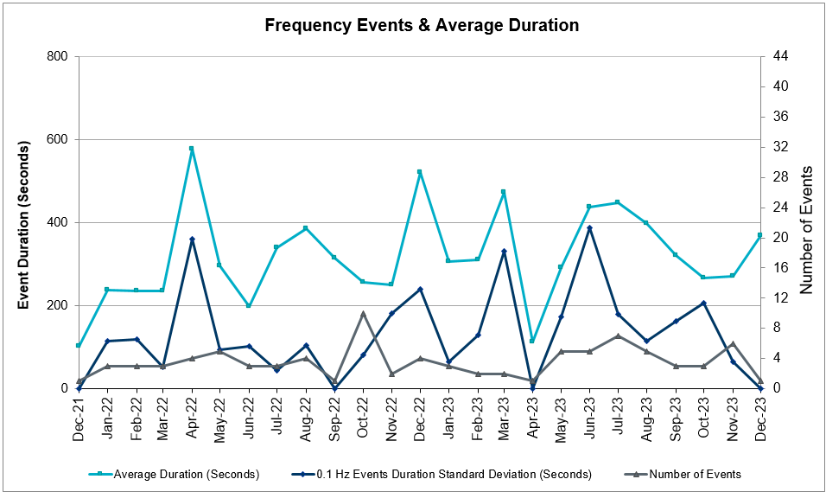
(Note: All data on this graph encompasses frequency event analysis based on BAL-001-TRE-2.)

ERCOT Contingency Reserve Events
There was 1 event where ERCOT Contingency Reserve MWs were released to SCED. The events highlighted in blue were related to frequency events reported in Section 2.1 above.

Date and Time Released to SCED | Date and Time Recalled | Duration of Event | Maximum MWs Released | Comments
12/14/2023 19:29 | 12/14/2023 19:36 | 0:06:56 | 805.4 | Unit Trip

Responsive Reserve Events
There were 0 events where Responsive Reserve MWs were released to SCED.

Date and Time Released to SCED | Date and Time Recalled | Duration of Event | Maximum MWs Released | Comments
N/A | N/A | N/A | N/A | N/A

Load Resource Events
None.

Reliability Unit Commitment
ERCOT reports on Reliability Unit Commitments (RUC) monthly. Commitments are reported grouped by operating day and weather zone. The total number of hours committed is the sum of the hours for all the units in the specified region. Additional information on RUC commitments can be found on the MIS secure site at Grid Generation Reliability Unit Commitment.

There were no DRUC commitments.

There was 1 HRUC commitments.

Resource Location | # of Resources | Operating Day | Total # of Hours Committed | Total MWhs | Reason for Commitment
FAR_WEST | 1 | 12/20/2023 | 7 | 2,386 | DCONLNG5

IRR, Wind, and Solar Generation as a Percent of Load
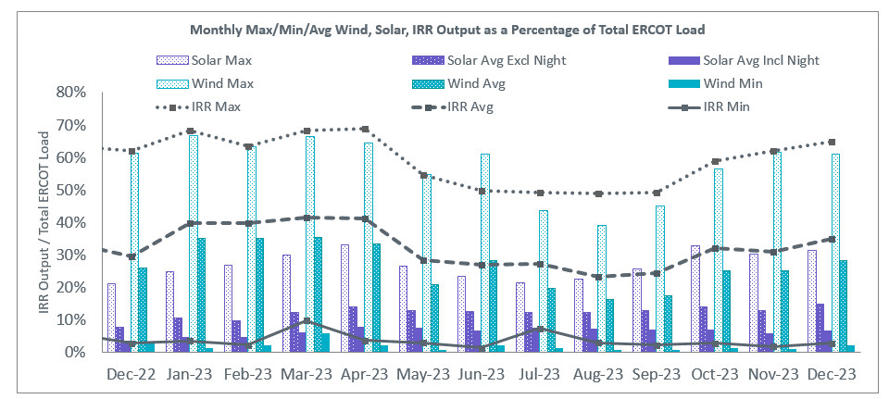
The graph below shows the maximum, minimum and average aggregate solar, wind and IRR output as a percentage of total ERCOT load when evaluated as 10-minute averaged intervals, over the past 13 months. Current wind and solar generation and penetration records are listed in the footnote below. Maximum IRR penetration for the month was 64.83% on 12/07/2023 interval ending 11:50 and minimum IRR penetration for the month was 2.76% on 12/25/2023 interval ending 20:10.

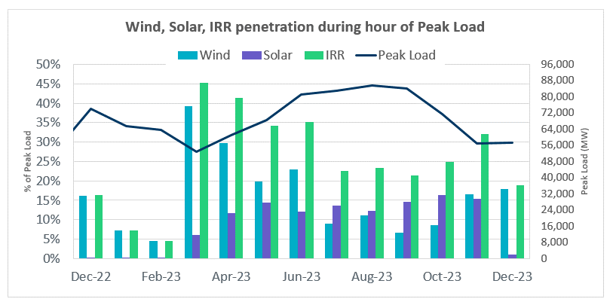
During the hour of peak load for the month, hourly integrated wind generation was 10,230 MW and solar generation was 602 MW. The graph below shows the wind and solar penetration percentage during the hour of the peak load in the last 13 months.
Lastly, the graph below shows the minimum wind, solar and IRR output during the peak load hour as a percentage of the daily peak load for every day in the month.
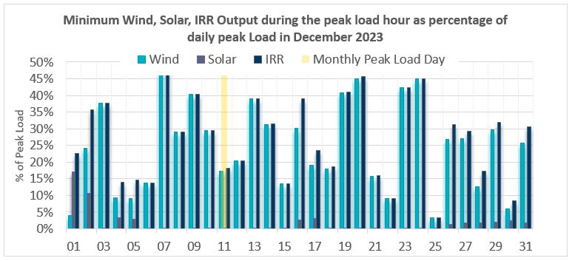

Largest Net-Load Ramps
The net-load ramp is defined as the change in net-load (load minus wind and PVGR generation) during the defined time horizon. Such a variation in net-load needs to be accommodated in grid operations to ensure that the reliability of the grid is satisfactorily maintained. The largest net-load ramp during 5-min, 10-min, 15-min, 30-min and 60-min in December 2023 is 1512 MW, 2841 MW, 3903 MW, 6762 MW, and 13703 MW, respectively. The comparison with respect to the historical values is given in the table below.

Month and Year | 5 min | 10 min | 15 min | 30 min | 60 min
December 2014 | 1,014 MW | 1,689 MW | 2,112 MW | 3,034 MW | 5,296 MW
December 2015 | 962 MW | 1,637 MW | 1,995 MW | 3,241 MW | 5,516 MW
December 2016 | 857 MW | 1,404 MW | 1,827 MW | 3,166 MW | 5,866 MW
December 2017 | 964 MW | 1,581 MW | 2,078 MW | 3,393 MW | 5,708 MW
December 2018 | 923 MW | 1,553 MW | 2,148 MW | 4,109 MW | 7,218 MW
December 2019 | 1,014 MW | 1,689 MW | 2,112 MW | 3,034 MW | 5,296 MW
December 2020 | 1,083 MW | 1,780 MW | 2,479 MW | 5,882 MW | 10,364 MW
December 2021 | 933 MW | 1,518 MW | 2,154 MW | 4,103 MW | 7,128 MW
December 2022 | 1,138 MW | 1,981 MW | 2,841 MW | 5,459 MW | 10,490 MW
December 2023 | 1,512 MW  12/29/23  (IE 17:02) | 2,841 MW  12/29/23  (IE 17:05) | 3,903 MW  12/29/23  (IE 17:10) | 6,762 MW  12/29/23  (IE 17:11) | 13,703 MW  12/29/23  (IE 17:17)
All months in 2014-2023 | 2,789 MW  10/16/23  (IE 11:56) | 3,018 MW  10/11/23  (IE 11:12) | 4,023 MW  10/11/23  (IE 11:17) | 7,209 MW  10/04/23  (IE 12:07) | 13,703 MW  12/29/23  (IE 17:17)

Congestion Analysis

Notable Constraints
Nodal protocol section 3.20 specifies that ERCOT shall identify transmission constraints that are binding in Real-Time three or more Operating Days within a calendar month. As part of this process, ERCOT reports congestion that meets this criterion to ROS. In addition, ERCOT also highlights notable constraints that have an estimated congestion rent exceeding $1,000,000 for a calendar month. These constraints are detailed in the table below, including approved transmission upgrades from TPIT that may provide some congestion relief based on ERCOT’s engineering judgement. Rows highlighted in blue indicate the congestion was affected by one or more outages. For a list of all constraints activated in SCED, please see Appendix A at the end of this report.

Contingency Name | Overloaded Element | # of Days Constraint Binding | Congestion Rent | Transmission Project
DMGSBTR5 | 6036__A | 18 | $27,074,749.37
BASE CASE | WESTEX | 10 | $13,083,047.32
DCONLNG5 | HARGRO_TWINBU1_1 | 5 | $12,493,924.49
DCONLNG5 | 6095__D | 10 | $12,154,368.33
SBAKCED5 | HARGRO_TWINBU1_1 | 14 | $10,736,020.90
DCONLNG5 | 6471__C | 7 | $8,901,180.76
DCONLNG5 | 15060__B | 4 | $3,468,125.96
BASE CASE | EASTEX | 4 | $3,077,200.44
XFOW58 | CATARI_PILONC1_1 | 9 | $2,490,366.32 | AEP_TCC_AshertontoPiloncillo138kVLine_rebuild (73100)
DCHBJO25 | CBY_AT3 | 2 | $2,246,747.71
SBWDDBM5 | LPLNW_LPLMD_1 | 3 | $2,213,413.63
DMGSBIT5 | 6036__A | 10 | $1,923,989.37
DSWECCR5 | 6036__A | 4 | $1,871,008.62
DFOWSMG5 | CATARI_PILONC1_1 | 11 | $1,585,156.00
SW_GODE5 | 15060__B | 5 | $1,433,721.39
BASE CASE | NE_LOB | 15 | $1,369,167.24 | The Lower Rio Grande Valley (LRGV) System Enhancement Project (21RPG017) will improve the NorthEd_LoboGTC to support up to 80% of total wind and solar generation capacity in the LRGV area.
DCONLNG5 | 14040__A | 7 | $1,364,835.37 | Oncor_FW_45640_Spraberry - Polecat Creek 138 kV Line (23RPG009, 45640)
SCARFRI8 | ATSO_SONR1_1 | 8 | $1,283,381.62
SCEDHI_5 | HARGRO_TWINBU1_1 | 8 | $1,167,450.28
MNOESGT5 | HARGRO_TWINBU1_1 | 3 | $1,127,930.19
MFOWLOB5 | CATARI_PILONC1_1 | 6 | $1,047,867.81 | AEP_TCC_AshertontoPiloncillo138kVLine_rebuild (73100)
BASE CASE | PNHNDL | 13 | $1,017,472.76
DBIGSCH5 | BAKRFLD_CEDCAN_1 | 3 | $808,066.62
SBWDDBM5 | LPLMK_LPLNE_1 | 4 | $771,421.33
SCRMSAR8 | CONCHO_VRBS1_1 | 6 | $564,883.89
MHARNED5 | BURNS_RIOHONDO_1 | 4 | $557,201.25 | STEC_71930_RioHondo_Burns_Upgrade (71930), STEC_71926_Burns_Heidelberg_Upgrade (71926), STEC_71928_Heidelberg_AEPWeslaco_Upgrade (71928)
DBIGKEN5 | CARVER_TINSLE1_1 | 4 | $465,479.64 | AEP_TCC_RebuildCarver-Maxwell (22RPG042, 52070)
SCOLBAL8 | CONAN_SANA1_1 | 3 | $431,914.48
DBIGKEN5 | HAMILT_MAXWEL1_1 | 10 | $423,102.22
DSALKLN5 | 630__B | 4 | $412,150.07
BASE CASE | VALEXP | 16 | $409,866.11 | The Lower Rio Grande Valley (LRGV) System Enhancement Project (21RPG017) will improve but not eliminate the need for this GTC.
DKOCNUE8 | MCKENZ_WESTSI1_1 | 7 | $387,155.45
SBRAUVA8 | HAMILT_MAVERI1_1 | 9 | $367,474.56
SNOECED5 | HARGRO_TWINBU1_1 | 4 | $346,329.43
SGRICOL5 | PAWNEE_TANGO1_1 | 3 | $333,481.17
DFOWSMG5 | LARDVN_LASCRU1_1 | 4 | $279,277.54
DCONLNG5 | 15060__A | 3 | $221,548.93
DSALHUT5 | 1710__C | 3 | $206,213.22
DMGSCON5 | 6471__C | 3 | $187,127.16
DBIGKEN5 | TREADW_YELWJC1_1 | 6 | $182,413.67
SKLNSAL5 | 271__A | 3 | $141,875.53
DBIGKEN5 | HAMILT_MAVERI1_1 | 4 | $86,762.09
SBRAUVA8 | ESCOND_GANSO1_1 | 4 | $85,012.63 | AEP_TCC_Escondido - Ganso 138 kV Line Rebuild (55624)
BASE CASE | NELRIO | 6 | $84,158.79 | The Lower Rio Grande Valley (LRGV) System Enhancement Project (21RPG017) will cause there to be no stability constraint for NelsonSharpe_RioHondoGTC under normal conditions.
BASE CASE | ZAPSTR | 5 | $30,273.48
SNICBLU8 | ABNTHW_CALLAH1_1 | 3 | $21,788.79
SNATBEA8 | 6144__A | 4 | $11,475.48
SMADSAP8 | MADDUX_SAPOWE2_1 | 4 | $6,179.34
MFOWLOB5 | LARDVN_LASCRU1_1 | 3 | $5,531.27
SWALWLN8 | SWI_OLIN_1 | 3 | $3,439.19

Generic Transmission Constraint Congestion
There were 18 days congestion on Valley Export GTC, 19 days on North Edinburg to Lobo GTC, 20 days on Panhandle GTC, 13 days on West Texas Export GTC, 8 days on Nelson Sharpe to Rio Hondo GTC, 1 day on Hamilton GTC, 5 days on East Texas GTC, 9 days on Zapata Starr GTC, 1 day on the McCamey GTC, and 1 day in the Redtap GTC. There was no activity on the remaining GTCs during the month.

Note: This is how many times a constraint has been activated to avoid exceeding a GTC limit, it does not imply an exceedance of the GTC occurred or that the GTC was binding.

Manual Overrides
There were no overrides for the month of December.

Congestion Costs for Calendar Year 2023
The following table represents the top twenty active constraints for the calendar year based on the estimated congestion rent attributed to the congestion. ERCOT updates this list on a monthly basis.

Contingency | Overloaded Element | # of 5-min SCED | Estimated Congestion Rent (2023)
Elmcreek-Sanmigl 345kV | Pawnee Switching Station - Calaveras 345kV | 10,212 | $165,191,719.27
MGSES TO CCRSW 345 AND BTRCK TO MGSES 345 DBLCKT | Tonkawa Switch - Morgan Creek Ses 345kV | 13,634 | $110,893,694.49
Basecase | WESTEX GTC | 21,274 | $92,006,191.94
TWR(345) WAP-WLF64 & WAP-WLY72 | South Texas Project - Wa Parish 345kV | 5,163 | $89,574,495.11
MAN_DBL_MDSSW-ODEHB_and_CONSW-QALSW_345kV_DBLCKT | Midessa South Sw 138kV | 11,605 | $79,014,288.16
Basecase | NE_LOB GTC | 41,396 | $71,097,931.44
BEVO to BEVO LIN 1 | Hamilton Road - Maverick 138kV | 7,602 | $52,011,887.52
Rattlesnake Rd Switch to LAKE CREEK SES LIN _A | St Johns Switch - Jewett 345kV | 4,881 | $45,754,231.09
SKYWEST to SKYWEST LIN 1 | Consavvy Switch - Cottonfield Sub 138kV | 2,909 | $45,341,291.63
CONSW-MGSES_and_CONSW-LNGSW_345kV_DBLCKT | Lamesa - Jim Payne Poi 138kV | 7,743 | $43,458,873.37
SKYWEST to SKYWEST LIN 1 | South Midland - Consavvy Switch 138kV | 10,282 | $41,928,489.30
HICKS SWITCH to HICKS SWITCH LIN _A | Hicks Switch - Alliance 345kV | 2,814 | $40,032,160.11
SALSW - HUTTO 345KV | Bell County - Salado Switch 138kV | 4,911 | $37,802,066.93
BLACKWATER DRAW SWITCH to DOUBLE MOUNTAIN SWITCH LIN 1 | Mackenzie Substation - Northeast Substation 115kV | 10,663 | $34,942,811.08
Basecase | PNHNDL GTC | 15,085 | $34,642,832.42
TWR(345) WAP-WLF64 & CCK-WLY72 | South Texas Project - Wa Parish 345kV | 4,025 | $34,465,421.37
Austro-Daffin&Dunlap-Decker 138kV | Sim Gideon - Bastrop City 138kV | 2,244 | $28,796,696.82
DMTSW TO SCOSW 345 DBLCKT | Knapp - Scurry Chevron 138kV | 10,898 | $28,124,431.10
Manual_SGL_CONSW-MDSSW_345kV_SglCkt | Quail Switch - Odessa Ehv Switch 345kV | 3,594 | $26,545,479.50
Manual dbl ckt for NEDIN-BONILLA 345kV & RIOH-PRIM138kV | Burns Sub - Rio Hondo 138kV | 11,577 | $25,185,694.52

System Events

ERCOT Peak Load
The unofficial ERCOT peak load for the month was 56,976 MW and occurred on 12/11/2023, during hour ending 08:00.

Load Shed Events
None.

Stability Events
None.

Notable PMU Events
ERCOT analyzes PMU data for any significant system disturbances that do not fall into the Frequency Events category reported in section 2.1. The results are summarized in this section once the analysis has been completed.

There were no PMU events outside of those reported in section 2.1.

DC Tie Curtailment
None.

TRE/DOE Reportable Events
- AEN Submitted a DOE-417 For 12/12/2023 System Report: Damage or destruction of a Facility
- Oncor Submitted a EOP-004-4 For 12/12/2023 Damage or destruction of its Facility
- Oncor Submitted a DOE-417 For 12/12/2023 Damage or destruction of its Facility
- LCRA Submitted a DOE-417 For 12/30/2023 System Report - Physical threat to its Facility

New/Updated Constraint Management Plans

None

New/Modified/Removed RAS
None.

New Procedures/Forms/Operating Bulletins
Date | Subject | Bulletin No.
12/28/2023 | DC Tie V1 Rev 75 | 1118
12/28/2023 | Real Time Desk V1 Rev 92 | 1119
12/28/2023 | Reliability Risk Desk Operating Procedure V1 Rev 34 | 1120
12/28/2023 | Reliability Unit Commitment V1 Rev 75 | 1121
12/28/2023 | Resource Desk V1 Rev 79 | 1122
12/28/2023 | Scripts V1 Rev 54 | 1123
12/28/2023 | Shift Supervisor Desk V1 Rev 93 | 1124
12/28/2023 | Transmission and Security Desk V1 Rev 105 | 1125

Emergency Conditions

OCNs
Date and Time | Message
Dec 06, 2023 09:37 CPT | ERCOT issued an OCN for PANHANDLE IROL due to planned outage and topology change.

Advisories
Date and Time | Message
Dec 01, 2023 05:43  CPT | ERCOT issued an Advisory for geomagnetic disturbance of K-7.

Watches
None.

Emergency Notices
None.

Application Performance

TSAT/VSAT Performance Issues
None

Communication Issues
None.

Market System Issues
None.

Model Updates
The Downstream Production Change (DPC) process allows ERCOT to make changes in the one-line Network Operations Model without loading a completely new model. The purpose of this process is to allow for reliable grid operations as system conditions change between designated Network Operations Model database loads. The DPC process is limited in scope to just those items listed below, with equipment ratings updates being the most common. ERCOT has seen a rise in the use of the DPC process to make on-line updates to the Network Operations Model in recent years, instead of through the standard Network Operations Model Change Request process.

- Static Line ratings (Interim Update)
- Dynamic Line ratings (non-Interim Update)
- Autotransformer ratings (non-Interim Update)
- Breaker and Switch Normal status (Interim Update)
- Contingency Definitions (Interim Update)
- RAP and RAS changes or additions (Interim Update)
- Net Dependable and Reactive Capability (NDCRC) values (Interim Update)
- Impedance Updates (non-Interim)

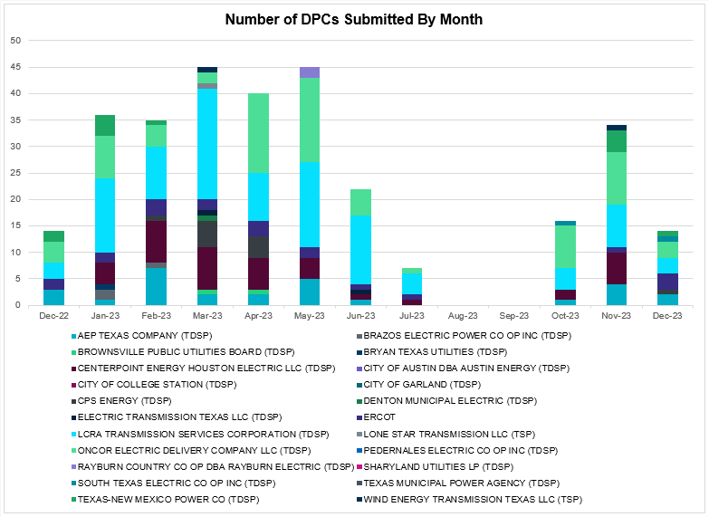

Transmission Operator | Number of DPCs
AEP TEXAS COMPANY (TDSP) | 2
BRAZOS ELECTRIC POWER CO OP INC (TDSP) | 0
BROWNSVILLE PUBLIC UTILITIES BOARD (TDSP) | 0
BRYAN TEXAS UTILITIES (TDSP) | 0
CENTERPOINT ENERGY HOUSTON ELECTRIC LLC (TDSP) | 0
CITY OF AUSTIN DBA AUSTIN ENERGY (TDSP) | 0
CITY OF COLLEGE STATION (TDSP) | 0
CITY OF GARLAND (TDSP) | 0
CPS ENERGY (TDSP) | 1
DENTON MUNICIPAL ELECTRIC (TDSP) | 0
ELECTRIC TRANSMISSION TEXAS LLC (TDSP) | 0
ERCOT | 3
LCRA TRANSMISSION SERVICES CORPORATION (TDSP) | 3
LONE STAR TRANSMISSION LLC (TSP) | 0
ONCOR ELECTRIC DELIVERY COMPANY LLC (TDSP) | 3
PEDERNALES ELECTRIC CO OP INC (TDSP) | 0
RAYBURN COUNTRY CO OP DBA RAYBURN ELECTRIC (TDSP) | 0
SHARYLAND UTILITIES LP (TDSP) | 0
SOUTH TEXAS ELECTRIC CO OP INC (TDSP) | 1
TEXAS MUNICIPAL POWER AGENCY (TDSP) | 0
TEXAS-NEW MEXICO POWER CO (TDSP) | 1
WIND ENERGY TRANSMISSION TEXAS LLC (TSP) | 0

Appendix A: Real-Time Constraints
The following is a complete list of constraints activated in SCED. Full contingency descriptions can be found in the Standard Contingencies List located on the MIS secure site at Grid Generation Reliability Unit Commitment.

Year | Month of the Year | Contingency Name | Overloaded Element | From Station | To Station | Count of Days
2023 | 12 | BASE CASE | PNHNDL | n/a | n/a | 20
2023 | 12 | DMGSBTR5 | 6036__A | TKWSW | MGSES | 20
2023 | 12 | DMGSBIT5 | 6036__A | TKWSW | MGSES | 19
2023 | 12 | BASE CASE | NE_LOB | n/a | n/a | 18
2023 | 12 | BASE CASE | VALEXP | n/a | n/a | 17
2023 | 12 | SBAKCED5 | HARGRO_TWINBU1_1 | TWINBU | HARGROVE | 15
2023 | 12 | DCONLNG5 | 6095__D | LMESA | JPPOI | 14
2023 | 12 | SW_GODE5 | 15060__B | VEALMOOR | KOCHTAP | 14
2023 | 12 | SCARFRI8 | ATSO_SONR1_1 | SONR | ATSO | 14
2023 | 12 | BASE CASE | WESTEX | n/a | n/a | 13
2023 | 12 | SCEDHI_5 | HARGRO_TWINBU1_1 | TWINBU | HARGROVE | 13
2023 | 12 | DCONLNG5 | 14040__A | PCTSW | DEWTP | 13
2023 | 12 | DSWECCR5 | 6036__A | TKWSW | MGSES | 12
2023 | 12 | DFOWSMG5 | CATARI_PILONC1_1 | CATARINA | PILONCIL | 12
2023 | 12 | DFOWSMG5 | CATARI_PILONC1_1 | PILONCIL | CATARINA | 12
2023 | 12 | DBIGKEN5 | HAMILT_MAXWEL1_1 | MAXWELL | HAMILTON | 11
2023 | 12 | XFOW58 | CATARI_PILONC1_1 | PILONCIL | CATARINA | 11
2023 | 12 | DCONLNG5 | 6471__C | MGSES | NAVIG | 10
2023 | 12 | SBRAUVA8 | HAMILT_MAVERI1_1 | HAMILTON | MAVERICK | 9
2023 | 12 | SNOECED5 | HARGRO_TWINBU1_1 | TWINBU | HARGROVE | 9
2023 | 12 | DMGSCON5 | 6471__C | MGSES | NAVIG | 9
2023 | 12 | DCONLNG5 | 15060__B | VEALMOOR | KOCHTAP | 8
2023 | 12 | SCRMSAR8 | CONCHO_VRBS1_1 | CONCHO | VRBS | 8
2023 | 12 | MNOESGT5 | HARGRO_TWINBU1_1 | TWINBU | HARGROVE | 8
2023 | 12 | BASE CASE | ZAPSTR | n/a | n/a | 8
2023 | 12 | DCONLNG5 | HARGRO_TWINBU1_1 | TWINBU | HARGROVE | 7
2023 | 12 | DKOCNUE8 | MCKENZ_WESTSI1_1 | WESTSIDE | MCKENZIE | 7
2023 | 12 | BASE CASE | NELRIO | n/a | n/a | 7
2023 | 12 | DNOECED5 | HARGRO_TWINBU1_1 | TWINBU | HARGROVE | 7
2023 | 12 | MFOWLOB5 | CATARI_PILONC1_1 | PILONCIL | CATARINA | 7
2023 | 12 | DSALKLN5 | 630__B | KLNSW | HHSTH | 7
2023 | 12 | DBIGKEN5 | TREADW_YELWJC1_1 | TREADWEL | YELWJCKT | 7
2023 | 12 | SNATBEA8 | 6144__A | BSPRW | STASW | 6
2023 | 12 | SMADSAP8 | MADDUX_SAPOWE2_1 | MADDUX | SAPOWER | 6
2023 | 12 | DFOWSMG5 | LARDVN_LASCRU1_1 | LARDVNTH | LASCRUCE | 6
2023 | 12 | SKEYWLV8 | 15060__B | VEALMOOR | KOCHTAP | 5
2023 | 12 | DCONLNG5 | 6046__A | MGSES | FLCNS | 5
2023 | 12 | DBIGKEN5 | HAMILT_MAVERI1_1 | MAVERICK | HAMILTON | 5
2023 | 12 | BASE CASE | EASTEX | n/a | n/a | 5
2023 | 12 | SBTPBNT8 | MYRA_VAL_1 | MYRA | VALYVIEW | 5
2023 | 12 | DBIGKEN5 | HAMILT_MAVERI1_1 | HAMILTON | MAVERICK | 5
2023 | 12 | SBWDDBM5 | LPLMK_LPLNE_1 | LPLMK | LPLNE | 5
2023 | 12 | DBIGKEN5 | CARVER_TINSLE1_1 | CARVER | TINSLEY | 4
2023 | 12 | DCONLNG5 | 15060__A | KOCHTAP | BUZSW | 4
2023 | 12 | SKLNSAL5 | 271__A | KLNSW | SALSW | 4
2023 | 12 | SGRICOL5 | PAWNEE_TANGO1_1 | TANGO | PAWNEE | 4
2023 | 12 | MHARNED5 | BURNS_RIOHONDO_1 | RIOHONDO | MV_BURNS | 4
2023 | 12 | BASE CASE | RANDAD_ZAPATA1_1 | RANDADO | ZAPATA | 4
2023 | 12 | SNICBLU8 | ABNTHW_CALLAH1_1 | CALLAHAN | ABNTHWST | 4
2023 | 12 | SILLFTL8 | HAMILT_MAXWEL1_1 | MAXWELL | HAMILTON | 4
2023 | 12 | SEL_ARR8 | BLESSI_PAVLOV1_1 | BLESSING | PAVLOV | 4
2023 | 12 | SBRAPIN8 | HAMILT_MAVERI1_1 | MAVERICK | HAMILTON | 4
2023 | 12 | XFOW58 | LARDVN_LASCRU1_1 | LARDVNTH | LASCRUCE | 4
2023 | 12 | DFOWSMG5 | ASHERT_CATARI1_1 | CATARINA | ASHERTON | 4
2023 | 12 | DCHBJO25 | CBY_AT3 | CBY | CBY | 4
2023 | 12 | SBRAUVA8 | ESCOND_GANSO1_1 | GANSO | ESCONDID | 4
2023 | 12 | SBRAPIN8 | HAMILT_MAVERI1_1 | HAMILTON | MAVERICK | 4
2023 | 12 | BASE CASE | RANDAD_ZAPATA1_1 | ZAPATA | RANDADO | 4
2023 | 12 | DBIGSCH5 | HARGRO_TWINBU1_1 | TWINBU | HARGROVE | 4
2023 | 12 | XBOM358 | 6558__B | FSHSW | WFALS | 3
2023 | 12 | DELMSAN5 | PAWNEE_SPRUCE_1 | PAWNEE | CALAVERS | 3
2023 | 12 | DBIGKEN5 | ESCOND_GANSO1_1 | ESCONDID | GANSO | 3
2023 | 12 | DBIGKEN5 | ESCOND_GANSO1_1 | GANSO | ESCONDID | 3
2023 | 12 | DBIGSCH5 | BAKRFLD_CEDCAN_1 | CEDACA | BAKESW | 3
2023 | 12 | SCOLBAL8 | CONAN_SANA1_1 | SANA_TAP | CONAN | 3
2023 | 12 | SRT2WC8 | G138_15_1 | WCOLLOCL | ANGLETON | 3
2023 | 12 | MSGTSCH5 | HARGRO_TWINBU1_1 | TWINBU | HARGROVE | 3
2023 | 12 | SWALWLN8 | SWI_OLIN_1 | OLINGR | SWINDELL | 3
2023 | 12 | DSALHUT5 | 1710__C | BELCNTY | SALSW | 3
2023 | 12 | MFOWLOB5 | LARDVN_LASCRU1_1 | LARDVNTH | LASCRUCE | 3
2023 | 12 | SBWDDBM5 | LPLNW_LPLMD_1 | LPLNW | LPLMD | 3
2023 | 12 | SW_GODE5 | 15060__A | KOCHTAP | BUZSW | 3
2023 | 12 | XFOW58 | ASHERT_CATARI1_1 | CATARINA | ASHERTON | 3
2023 | 12 | DCHBJO25 | CBY_AT3L | CBY | CBY | 3
2023 | 12 | DMTSCOS5 | 6437__F | SCRCV | KNAPP | 3
2023 | 12 | SBONNED5 | BURNS_RIOHONDO_1 | RIOHONDO | MV_BURNS | 3
2023 | 12 | XFOW58 | ASHERT_CATARI1_1 | ASHERTON | CATARINA | 3
2023 | 12 | SFORYEL8 | HEXT_YELWJC1_1 | YELWJCKT | HEXT | 3
2023 | 12 | DKOCNUE8 | CHAMPL_WEIL_T1_1 | WEIL_TRC | CHAMPLIN | 3
2023 | 12 | DSCOTKW5 | 15060__B | VEALMOOR | KOCHTAP | 2
2023 | 12 | SDC_RAI8 | VALEXP | n/a | n/a | 2
2023 | 12 | DCONLNG5 | 6095__G | JPPOI | ALKLK | 2
2023 | 12 | SCMNCPS5 | 651__B | CMNSW | CMNTP | 2
2023 | 12 | SBROALP9 | BELD_BRONCO1_1 | BELD | BRONCO | 2
2023 | 12 | SLAQLOB8 | FALFUR_PREMON1_1 | FALFUR | PREMONT | 2
2023 | 12 | DBIGKEN5 | YELWJCKT_PS_1 | YELWJCKT | YELWJCKT | 2
2023 | 12 | DSALKLN5 | 610__A | BLTON | TMSTH | 2
2023 | 12 | SVEAW_L5 | 6217__A | WLVSW | GAILS | 2
2023 | 12 | SHOLNLA8 | ASHERT_CATARI1_1 | ASHERTON | CATARINA | 2
2023 | 12 | XBAL89 | CONCHO_VRBS1_1 | CONCHO | VRBS | 2
2023 | 12 | SCARFRI8 | FDR_OZNC_1 | OZNC | FRIEND_R | 2
2023 | 12 | DBIGKEN5 | MADDUX_TREADW1_1 | MADDUX | TREADWEL | 2
2023 | 12 | DCONLNG5 | 6471__B | NAVIG | MCDLD | 2
2023 | 12 | SBROALP9 | BELD_BRONCO1_1 | BRONCO | BELD | 2
2023 | 12 | DBRNCMN8 | CONCHO_VRBS1_1 | CONCHO | VRBS | 2
2023 | 12 | DFRIILL8 | HAMILT_MAXWEL1_1 | MAXWELL | HAMILTON | 2
2023 | 12 | MRESMCM8 | RINCON_WHITE_2_1 | RINCON | WHITE_PT | 2
2023 | 12 | DMCOPHA8 | AZTECA_HEC1_1 | HEC | AZTECA | 2
2023 | 12 | DBIGKEN5 | CONCHO_VRBS1_1 | CONCHO | VRBS | 2
2023 | 12 | SBAKCED5 | HARGRO_PUMPJA1_1 | HARGROVE | PUMPJACK | 2
2023 | 12 | SLANARR8 | LAN_CT_PAVLOV1_1 | PAVLOV | LAN_CTY | 2
2023 | 12 | SBTPBNT8 | SPR_VALY_1 | VALYVIEW | SPR | 2
2023 | 12 | MFOWLOB5 | ASHERT_CATARI1_1 | CATARINA | ASHERTON | 2
2023 | 12 | SCARFRI8 | ATSO_OZNC1_1 | ATSO | OZNC | 2
2023 | 12 | SSANFER8 | CORONA_AT4 | CORONA | CORONA | 2
2023 | 12 | XFOW58 | LASCRU_MILO1_1 | LASCRUCE | MILO | 2
2023 | 12 | SKLELOY8 | LOYOLA_69_1 | LOYOLA | LOYOLA | 2
2023 | 12 | DCOLFA59 | PAWNEE_TANGO1_1 | TANGO | PAWNEE | 2
2023 | 12 | STMPTHS5 | 305__A | LCSES | BLFSW | 2
2023 | 12 | DBIGKEN5 | GANSO_MAVERI1_1 | GANSO | MAVERICK | 2
2023 | 12 | DNORCAS8 | LCRANE_RIOPEC1_1 | RIOPECOS | LCRANE | 2
2023 | 12 | BASE CASE | RIOHND_ERIOHND_1 | MV_RIOHO | RIOHONDO | 2
2023 | 12 | BASE CASE | WRANCH_TLINE_1 | WL_RANCH | BIGHIL | 2
2023 | 12 | DKG_NB_5 | BCVLY_03_A | BCV | LY | 2
2023 | 12 | SCHBJOR5 | CBY_AT3 | CBY | CBY | 2
2023 | 12 | SLARLAR8 | LARDVN_LASCRU1_1 | LARDVNTH | LASCRUCE | 2
2023 | 12 | SFTLMES8 | PALOUS_WOLFCA1_1 | PALOUSE | WOLFCAMP | 2
2023 | 12 | SILLFTL8 | CARVER_TINSLE1_1 | CARVER | TINSLEY | 2
2023 | 12 | SBRAHAM8 | GANSO_MAVERI1_1 | GANSO | MAVERICK | 2
2023 | 12 | DCONLNG5 | JERRY_PUMPJA1_1 | PUMPJACK | JERRY | 2
2023 | 12 | DTWIDIV5 | PALOUS_WOLFCA1_1 | PALOUSE | WOLFCAMP | 2
2023 | 12 | MDTMBEL5 | 1830__F | WATCO | COTONBLT | 2
2023 | 12 | DTVWVE85 | 160__B | CNTRY | SHRSW | 1
2023 | 12 | DCRLLSW5 | 589_C_1 | LWSVS | CRLNW | 1
2023 | 12 | SKATLON5 | ASHERT_CATARI1_1 | ASHERTON | CATARINA | 1
2023 | 12 | DCAGCO58 | BERGHE_AT1L | BERGHE | BERGHE | 1
2023 | 12 | DAUSDUN8 | CKT_1032_1 | TRIDGE | ASHWDS | 1
2023 | 12 | DFIRBA89 | CONCHO_VRBS1_1 | CONCHO | VRBS | 1
2023 | 12 | SBRAPIN8 | ESCOND_GANSO1_1 | ESCONDID | GANSO | 1
2023 | 12 | SBRAPIN8 | GANSO_MAVERI1_1 | GANSO | MAVERICK | 1
2023 | 12 | DFRIILL8 | PALOUS_WOLFCA1_1 | PALOUSE | WOLFCAMP | 1
2023 | 12 | BASE CASE | REDTAP | n/a | n/a | 1
2023 | 12 | SENSENW8 | 943__B | ENWSW | SHKSW | 1
2023 | 12 | SSANFOW5 | ASHERT_CATARI1_1 | ASHERTON | CATARINA | 1
2023 | 12 | DBRNCMN8 | ATBR_MILES1_1 | ATBR | MILES | 1
2023 | 12 | DELMSAN5 | BEEVIL_NORMAN1_1 | BEEVILLE | NORMANNA | 1
2023 | 12 | MPROPOM5 | CATARI_PILONC1_1 | PILONCIL | CATARINA | 1
2023 | 12 | DABPAB98 | ESTES_PECAN_1_1 | PECAN_BY | ESTES | 1
2023 | 12 | DBIGKEN5 | FORTMA_YELWJC1_1 | FORTMA | YELWJCKT | 1
2023 | 12 | SGRILON5 | NCARBI_SEADRF1_1 | NCARBIDE | SEADRFTC | 1
2023 | 12 | DELMSAN5 | NORMAN_PETTUS1_1 | NORMANNA | PETTUS | 1
2023 | 12 | DLONWAR5 | PAWNEE_TANGO1_1 | TANGO | PAWNEE | 1
2023 | 12 | SL_4RAY8 | RAYBURN_69_2 | RAYBURN | RAYBURN | 1
2023 | 12 | SDESRDO8 | TRU_UAT1 | TRU | TRU | 1
2023 | 12 | DCRLLSW5 | 589_E_1 | LWVTI | LWSVS | 1
2023 | 12 | SFLTLNG8 | 6635__G | MRVLY | ESTLD | 1
2023 | 12 | DCC1DUKE | ASHERT_CATARI1_1 | ASHERTON | CATARINA | 1
2023 | 12 | MRAPCEN5 | CATARI_PILONC1_1 | PILONCIL | CATARINA | 1
2023 | 12 | SKATLON5 | CATARI_PILONC1_1 | CATARINA | PILONCIL | 1
2023 | 12 | STORLOB5 | CATARI_PILONC1_1 | PILONCIL | CATARINA | 1
2023 | 12 | DGARHIC8 | CKT_1027_1 | DUNLAP | DECKER | 1
2023 | 12 | SVICCO28 | COLETO_VICTOR2_1 | COLETO | VICTORIA | 1
2023 | 12 | SBRAHAM8 | ESCOND_GANSO1_1 | GANSO | ESCONDID | 1
2023 | 12 | SDIMBEV8 | HAMILT_MAVERI1_1 | HAMILTON | MAVERICK | 1
2023 | 12 | MPROPOM5 | LARDVN_LASCRU1_1 | LARDVNTH | LASCRUCE | 1
2023 | 12 | BASE CASE | MCCAMY | n/a | n/a | 1
2023 | 12 | MWHILON5 | NCARBI_SEADRF1_1 | NCARBIDE | SEADRFTC | 1
2023 | 12 | DBIGSCH5 | PALOUS_WOLFCA1_1 | PALOUSE | WOLFCAMP | 1
2023 | 12 | XLOB258 | PAWNEE_TANGO1_1 | TANGO | PAWNEE | 1
2023 | 12 | DCAGCI58 | 255T279_1 | PIPECR | MEDILA | 1
2023 | 12 | DCONLNG5 | 6045__A | FLCNS | MDLNE | 1
2023 | 12 | SCOCBAR9 | ALPINE_BRONCO1_1 | BRONCO | ALPINE | 1
2023 | 12 | DBRNCMN8 | ATBR_BRONTE1_1 | BRONTE | ATBR | 1
2023 | 12 | DBIGKEN5 | BALLIN_PAINTR1_1 | BALLINGE | PAINTROC | 1
2023 | 12 | MHARNED5 | BURNS_HEIDLBRG_1 | MV_BURNS | MV_HBRG4 | 1
2023 | 12 | DCC1DUKE | BURNS_RIOHONDO_1 | RIOHONDO | MV_BURNS | 1
2023 | 12 | SBAKCED5 | JERRY_PUMPJA1_1 | PUMPJACK | JERRY | 1
2023 | 12 | DYELHE89 | KATEMC_MASN1_1 | MASN | KATEMCY | 1
2023 | 12 | DLCRKIN8 | LCRANE_RIOPEC1_1 | RIOPECOS | LCRANE | 1
2023 | 12 | SCISPUT8 | SOUTHA_VINSON1_1 | SOUTHABI | VINSON | 1
2023 | 12 | DCONLNG5 | 6144__A | BSPRW | STASW | 1
2023 | 12 | DCC3_NED | ASHERT_CATARI1_1 | ASHERTON | CATARINA | 1
2023 | 12 | MSTPANG5 | ASHERT_CATARI1_1 | ASHERTON | CATARINA | 1
2023 | 12 | MPOMPRO5 | CATARI_PILONC1_1 | PILONCIL | CATARINA | 1
2023 | 12 | MRAPDEL5 | CATARI_PILONC1_1 | PILONCIL | CATARINA | 1
2023 | 12 | DSTVSTN8 | CONAN_SANA1_1 | SANA_TAP | CONAN | 1
2023 | 12 | SBRAUVA8 | GANSO_MAVERI1_1 | GANSO | MAVERICK | 1
2023 | 12 | SBR2BRA8 | HAMILT_MAVERI1_1 | HAMILTON | MAVERICK | 1
2023 | 12 | DBIGKEN5 | HARI_VRBS1_1 | VRBS | HARI | 1
2023 | 12 | DELMSAN5 | OAKS9_69_1 | OAKS9 | OAKS9 | 1
2023 | 12 | SCOLBAL8 | SANA_FMR1 | SANA | SANA | 1
2023 | 12 | SCEDHI_5 | 6095__D | LMESA | JPPOI | 1
2023 | 12 | DBYRRIL5 | 6380__D | PAINTCRE | MURRAY | 1
2023 | 12 | DWLFMOS5 | 6485__B | RLKSW | PWPOD | 1
2023 | 12 | MSTPANG5 | CATARI_PILONC1_1 | CATARINA | PILONCIL | 1
2023 | 12 | XCMN58 | CONCHO_VRBS1_1 | CONCHO | VRBS | 1
2023 | 12 | SCISPUT8 | ESTES_PECAN_1_1 | PECAN_BY | ESTES | 1
2023 | 12 | SECLBRA8 | GANSO_MAVERI1_1 | GANSO | MAVERICK | 1
2023 | 12 | DCONLNG5 | HARGRO_PUMPJA1_1 | HARGROVE | PUMPJACK | 1
2023 | 12 | BASE CASE | HMLTN | n/a | n/a | 1
2023 | 12 | SFORYEL8 | MASNPH_MASN1_1 | MASN | MASNPHT | 1
2023 | 12 | STANPAW5 | MELONC_SEADRF1_1 | MELONCRE | SEADRFTC | 1
2023 | 12 | SN_SLON5 | N_SHARPE_XF1 | N_SHARPE | N_SHARPE | 1
2023 | 12 | SSAMTH35 | 505__B | FBRSW | THSES | 1
2023 | 12 | SGODTAN5 | ASHERT_CATARI1_1 | ASHERTON | CATARINA | 1
2023 | 12 | SDIMBEV8 | BRACKE_ESCOND1_1 | BRACKETT | ESCONDID | 1
2023 | 12 | MCE_LO58 | CATARI_PILONC1_1 | PILONCIL | CATARINA | 1
2023 | 12 | DBIGKEN5 | CTHR_TINSLE1_1 | TINSLEY | CTHR | 1
2023 | 12 | SCOMHA38 | HAMILT_MAXWEL1_1 | MAXWELL | HAMILTON | 1
2023 | 12 | MRAPDEL5 | LARDVN_LASCRU1_1 | LARDVNTH | LASCRUCE | 1
2023 | 12 | DHUTHUT5 | 1661__A | RRNES | RNDRK | 1
2023 | 12 | XTRS258 | 1920__B | ATHNS | TRNDD | 1
2023 | 12 | SW_GW_L5 | 6051__A | QALSW | ODEHV | 1
2023 | 12 | DCAGCO58 | 656T656_1 | KENDAL | BERGHE | 1
2023 | 12 | STANPAW5 | ASHERT_CATARI1_1 | ASHERTON | CATARINA | 1
2023 | 12 | SBROALP9 | BELD_COCS1_1 | BELD | COCS | 1
2023 | 12 | MCE_RI58 | CATARI_PILONC1_1 | PILONCIL | CATARINA | 1
2023 | 12 | MNEDPOM5 | CATARI_PILONC1_1 | PILONCIL | CATARINA | 1
2023 | 12 | SHOLNLA8 | CATARI_PILONC1_1 | PILONCIL | CATARINA | 1
2023 | 12 | STANPAW5 | CATARI_PILONC1_1 | CATARINA | PILONCIL | 1
2023 | 12 | DELMSAN5 | COLETO_ROSATA1_1 | COLETO | ROSATA | 1
2023 | 12 | DBWN_AM5 | CONCHO_VRBS1_1 | CONCHO | VRBS | 1
2023 | 12 | SMDOPHR5 | G138_10B_1 | SEMINOLE | MAGNO_TN | 1
2023 | 12 | SBRAHAM8 | HAMILT_MAVERI1_1 | HAMILTON | MAVERICK | 1
2023 | 12 | SPAWSAN5 | LOOP_VICTORIA_1 | VICTORIA | L_463S | 1
2023 | 12 | DCOLFA59 | NCARBI_SEADRF1_1 | NCARBIDE | SEADRFTC | 1

Current Wind Generation Record: 27,044 MW on 05/29/2022 at 22:36 | Current Wind Penetration Record: 69.15% on 04/10/2022 at 01:43 Current Solar Generation Record: 13,735 MW on 08/16/2023 at 12:28 | Current Solar Penetration Record: 32.93% on 04/30/2023 at 09:24

