PWG Meeting Notes – December 8th, 2023
Via WebEx 9:30 AM
Attendees:
Austin Board – LP&L | Sam Pak - Oncor | Sam Senanayake - PGR
William Butler – LP&L | Steve Pliler - Vistra | Martiza Torres – LP&L
Angela Ghormley - Calpine | Diana Rehfeldt - TNMP | Jordan Troublefield - ERCOT
Eric Lotter – Grid Monitor | Randy Roberts - ERCOT | Richard Beasley - CNP
Eduardo Martinez - GC | Kathy Scott - CNP

- Admonition
  - Jordan advised the attendees of the Antitrust Admonition.

- Introductions, Agenda Review
  - Sam Pak noted the attendees and reviewed the meeting agenda.

- Meeting notes for October 13th
  - Sam provided a verbal summary of the PWG meeting notes from 10/13/23. Sam observed the topic of Annual Validation and Load Profile was the most prominent agenda item; and there was consensus that the market can improve upon utilizing AMS data. There was also discussion about the hurdles in using Smart Meter Texas and AMS data, such as customer authorization. Kathy provided documentation on the ERCOT/TDU cost of AV/LP. Sam noted the topic will be pursued in TAC by Eric Goff and that Debbie McKeever requested justification bullet points. Sam suggested a discussion around the cadence of BUSLRG updates.

- Annual Validation and Load Profiles Purposes and Needs
  - Sam advised that RMS leadership requested that PWG provide an Annual Validation and Load Profiles Purposes and Needs document. The document should be one page in length, utilize bullet points, and be housed on the PWG home page
  - Sam’s initial draft of the Purpose and Needs document was reviewed. Sam said he composed the introductory paragraph and the remaining points were taken from the documents that Debbie summarized for TAC. The group revised the opening paragraph to replace “all market participants” with “non-REP of ROR”.
  - There was discussion of the availability of SMT data to REPs. SMT will provide interval data to a non-ROR, although Angela pointed out the practical difficulties of the process such as the need for the meter number and customer legwork. A sentence was added to reference TDU/ERCOT costs associated with AV/LP, along with other minor edits.
  - Sam asked the meeting to take the revised Purpose and Needs document to their respective shops and collect feedback. Kathy asked if ERCOT had been approached about the exclusion of ZIP codes in 2024. Sam advised he had spoken with Sam Cannon at ERCOT about the possibility. Sam said that the TDUs should meet to discuss expectations of decoupling that work and then follow up with ERCOT.

- IDR/AMS BUSLRG Updates from TDSPs

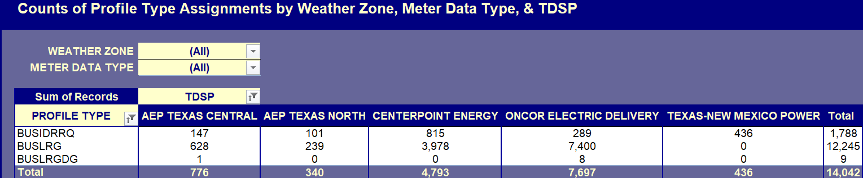

  - The TDU updates included TNMP advising that PWG will be notified when BUSLRG work begins. Sam observed that the BUSLRG updates have been static in the past few meetings. He suggested revising the BUSLRG update cadence to quarterly from monthly. There was attendee agreement with no dissent to move to quarterly BUSLRG updates.
  - Sam updated the meeting of a discussion stemming from market entry planning for Lubbock Power and Light. Displaying the Profile Type Counts report, Sam said that LP&L requested a profile type count for LP&L service territory. Randy advised that the LP&L counts should be added to the report when LP&L formally enters the market, possibly when the ESI IDs are assigned. Sam said he would follow up with Sam Cannon to specify when LP&L will be included in the Profile Type Counts Report.

- Administrative LPGRR: LRG & LRGDG definitions in alignment with LPGRR069
  - Sam informed the meeting that LP&L discussions included LPGRR069 and the Load Profiling Guide decision tree. Sam noted there was movement away from including the term “4CP” in the Segment Assignment tab, Section 3. Sam suggested a better option would be “or if 4CP is applicable”. Kathy, Randy, and the group concurred. Jordan performed the document edit.

- Parking Lot Items

- Conversion of Profile Decision Tree from Excel to Word – Jordan said the Word document conversion is proceeding with a focus on ensuring that wording is unchanged. Sam confirmed that document two sections will retain Excel formatting.

- Other Business
  - The next PWG was confirmed for 1/23/24. Sam said the next meeting would include finalization of the Purpose and Needs document and PWG leadership elections. Those interested in PWG leadership should contact Jordan.

- DRAFT Agenda for January 23rd meeting:
  - Leadership Elections
  - AV/LP Purpose & Needs document
  - AV Process Enhancements
  - 2023 Accomplishments & 2024 Goals

