Client Services Talking Points
REP Collaboration
MarkeTrak Data

Texas Data Transport and MarkeTrak Systems (TDTMS) Work Group, under the Retail Market Subcommittee (RMS) has performed analyses on MarkeTrak volumes and data submitted over the past couple of years. Such analyses offer insight into market processes, identifying market issues, and offering opportunities for efficiencies both at the market level and market participant level.

Whiles analysis results are presented at the Retail Market Subcommittee, TDTMS is collaborating with Client Services in further REP outreach. The multiple reports listed below are available to REPs and TDSPs to determine their specific market performance as it relates to MarkeTraks for resolving issues.

The initial goals of the analysis were as follows:
- Establish baseline Inadvertent Gain performance and trends before (and after) the implementation of TXSET5.0 / MT improvements to validate the proposed changes
- Allow for individual REP performance based on MarkeTrak volumes submitted for process opportunities (e.g. if a REP submits 10x the volume of a particular subtype, is this indicative of a possible business process improvement)
- Perform a timing analysis on processing of MarkeTrak subtypes to potentially reveal updated acceptable SLAs

STEP ONE: Determine the anonymous REP#/TDSP# assigned to the respective DUNS. REP#s/TSDP#s are used in all the ERCOT reports below and remain unchanged.

Reports Available for REP/TDSP Review

- ERCOT Monthly Inadvertent Stats – performed monthly by ERCOT (posted to the RMS meeting page), and based on the volume of Inadvertent Gains as a percentage of REP enrollments. REP percentages are reviewed on a three-month lag to allow for Inadvertent Gain MTs to be completed.
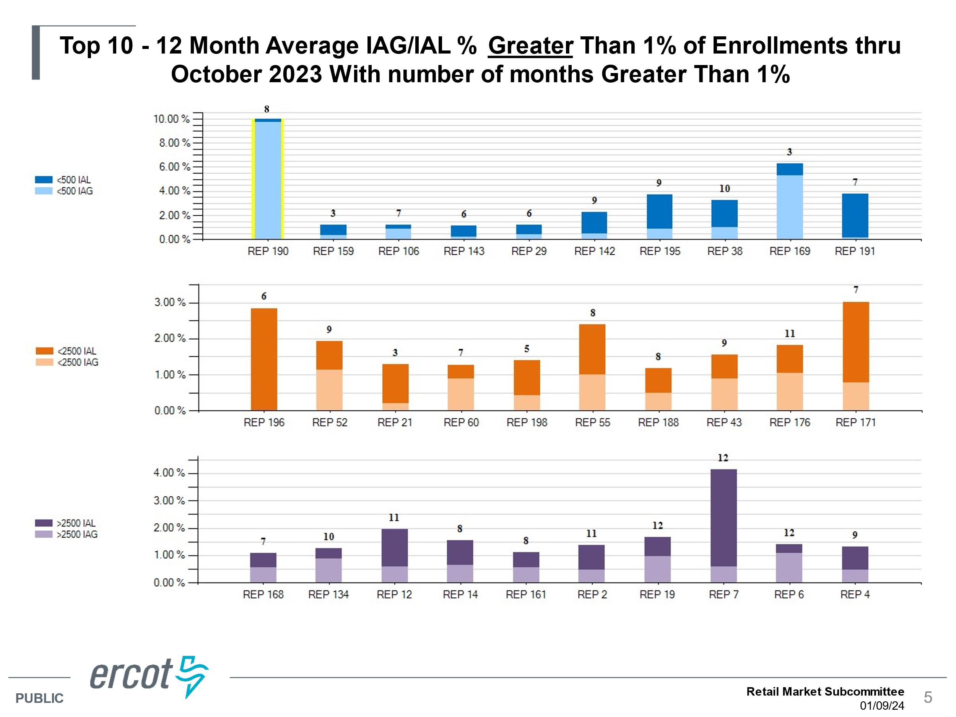

- Inadvertent Gain Analyses – reports detailing REP performance during each step of an IAG. The report offers suggested actions for efficiencies and allows a REP to compare performance amongst peers and year over year.
  - originating transaction -> submittal of MT
  - MT submittal -> Begin Working
  - MT submittal -> Agreement
  - Agreement -> Ready to Receive
  - Ready to Receive -> BDMVI submittal
  - Submittal of MT -> Completion
Four reports available and posted to the main TDTMS pages https://www.ercot.com/committees/rms/tdtms
- July 2019 – July 2020 data
  - July 2021 – Dec 2021 data
  - Jan 2022 – Jun 2022 data
  - July 2022 – Dec 2022 data

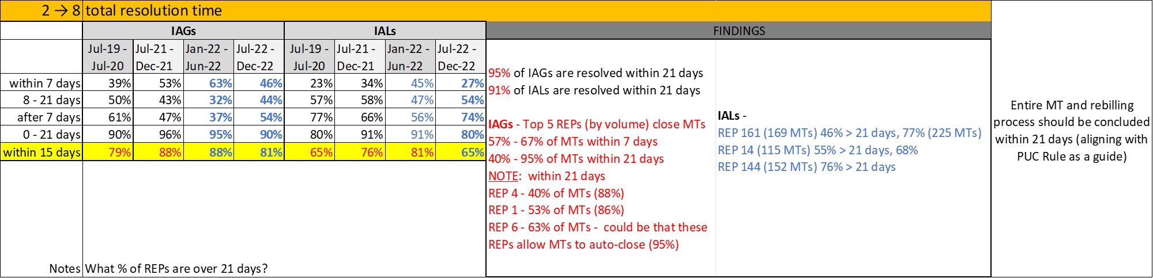

- Other MarkeTrak Subtype Volumes and Timing Analysis – this report reviewed the more common subtypes submitted, identifying REPs submitting higher volumes, reviewing timing for closure, common unexecutable reasons, and offered suggested tips for improvement opportunities. Comparison available for July 2021 – December 2021, January 2022 – June 2022, and July 2022 – December 2022 time periods. https://www.ercot.com/files/docs/2023/11/03/06-tdtms_update11_07_2023.pptx

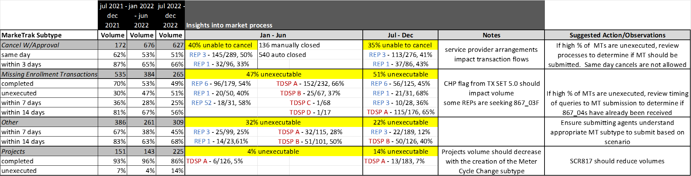

TDTMS encourages participation in monthly meetings. If there are any questions or concerns regarding the content of the reports, those may be directed to TDTMS leadership listed here:
https://www.ercot.com/committees/rms/tdtms

