IBRWG Report To ROS
January 08, 2024
Chair: Mohammad Albaijat, Vice-Chair: Julia Matevosyan

IBRWG met on December 8th, 2023 (Webex, Open Meeting)

Leadership Discussion
- Mohammad Albaijat has served as a chair since the inception of IBRTF and would like to step down
- Nominated Julia Matevosyan (current vice-chair) for the chair position, nomination supported by Freddy Garcia (ERCOT) and Stephen Solis (ERCOT). No other nominations for the chair position have been voiced.
- Freddy Garcia (ERCOT) nominated Miguel Angel Cova Acosta (Vestas) for the vice-chair position. No other nominations for the vice-chair position have been voiced.
- Freddy Garcia will inform Chase Smooth (ROS chair) about these proposed changes in IBRWG leadership.

TSAT Modeling Update
Ken Donahoo (representing APA) raised the following questions asking for feedback from ERCOT’s staff:
Validation Improvement:
- What type of simulation is ERCOT working on for model validation and/or the definition of specifications for model and performance requirements?
- What are the roadblocks regarding IBR projects achieving model validation?
- How can APA and IBRs help ERCOT in advancing the validation process more expeditiously?
Status:
- The last status update presentation that stakeholders received was the April 2023 Report. Could ERCOT please provide an update like this report? Here is the link to the April 2023 Report: https://www.ercot.com/files/docs/2023/05/02/05-tsat_update_ros_05042023.pdf.
- What is the status of the projects that are not compliant? Could ERCOT please provide details regarding reasons for non-compliance?
- What percentage of capacity compliance is needed for ERCOT to move forward with TSAT? Is it 100%, 95% or 90%? Where are we at this time regarding meeting this threshold?
Timeline:
- Glad to hear that the EMS is fully implemented, what is the timeline for expected implementation of TSAT? We are specifically interested in knowing the TSAT implementation timeline for Panhandle, South and West GTCs?
- Is there any bridge proposal that could be implemented prior to TSAT go-live? For example, is ERCOT considering calculating GTCs during different times of day or the year to reflect solar generating hours more accurately?
Operations:
How will TSAT be implemented in operations and application of the resulting limits? How will TSAT limits and calculated GTC limits be applied in operations? What is the decision process when selecting the limit for operations?

GFM BESS Activities Update
Fred Huang (ERCOT)
3 key points
- Related to GFM activities, as reported previously to ROS, ERCOT is engaging with industrial consultant/expert to help ERCOT develop performance requirements for grid forming (GFM) that would suit ERCOT system need. The schedule for the performance requirements to be completed is Q2-Q3 of 2024. Sequentially or in parallel with this work, the requirements will need to be added to the relevant sections of ERCOT’s protocols. Next step, regardless of adoption/incentivizing path, a GFM resource will need to have these capabilities as defined in the requirements.
- ERCOT sees the benefit of GFM BESS in certain areas with active GTCs. Potentially, GFM Resources can improve stability performance in areas behind GTCs and, potentially, improve GTL. Currently there are no projects developing in ERCOT footprint with grid forming capabilities, but, on the other hand, there is no restrictions from ERCOT’s side for such development.
So, if IE / RE is interested to improve GTC/GTL, look into building a grid forming ERS instead of grid following or modify the existing one to be GFM capable. ERCOT can work with the developers to look into these benefits during interconnection process.
For now ERCOT may use recently published NERC whitepaper recommending functional specifications and simulation tests for grid forming BESS https://www.nerc.com/comm/RSTC_Reliability_Guidelines/White_Paper_GFM_Functional_Specification.pdf tests. ERCOT has reviewed the paper internally and planning to use these tests in interim as the consult is working on the ERCOT-specific requirements.
- When working on GFM study the question was how ERCOT is going to implement the requirement for grid forming. For now it is TBD, expect to have some discussion in this area in 2024.

IBR plant model development and Developer/OEM/ERCOT interactions and gaps
Billy Yancey (EPE)
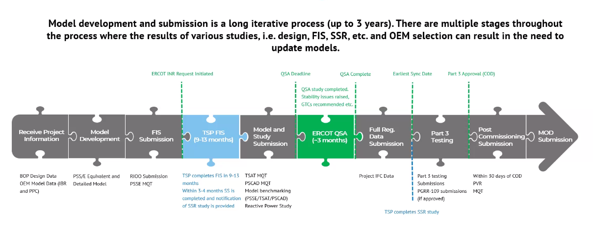
Challenges summarized on the next slide (below). This is the observation from EPE specifically and others may see different challenges.
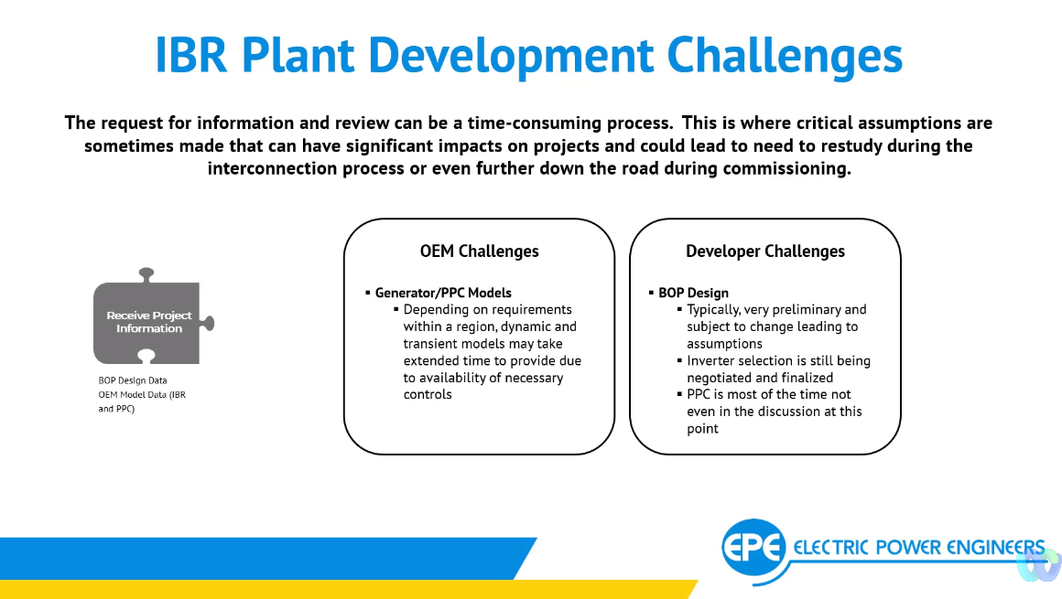

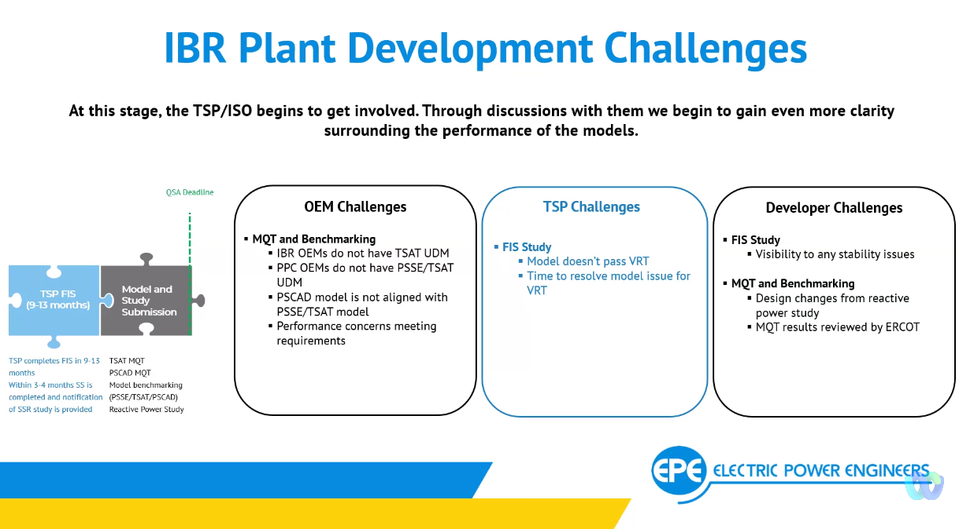
Update on NOGRR245
Stephen, presented summary of recent FERC Oder 901 directing NERC to develop IBR standards to mitigate issues seen in the recent disturbance events. Reiterating that ERCOT is already on the path very well aligned with the direction of FERC Order and NERC.

Update on NOGRR255
Again Stephen reflected on FERC Order 901 directing NERC to develop standards for disturbance monitoring equipment and saying it aligns well with NOGRR255 and PRC-002 and PRC-028 changes that NERC Standard Drafting Team is currently working on.

FERC Order 901 and NERC Level 2 Alert Update
David Penny presented NERC Alert Key findings. These are very concerning and well aligned with what we are seeing in ERCOT. The NERC Alert Report is calling for mitigations that NOGRR245 and 255 are trying to address.
Key takeaways are on the slide below, more details in the slide deck.
