November 2023 ERCOT Monthly Operations Report
Reliability and Operations Subcommittee Meeting
January 08, 2024

Table of Contents
1. Report Highlights 2
2. Frequency Control 3
2.1. Frequency Events 3
2.2. ERCOT Contingency Reserve Events 4
2.3. Responsive Reserve Events 4
2.4. Load Resource Events 4
3. Reliability Unit Commitment 5
4. IRR, Wind, and Solar Generation as a Percent of Load 6
5. Largest Net-Load Ramps 8
6. Congestion Analysis 9
6.1. Notable Constraints 9
6.2. Generic Transmission Constraint Congestion 13
6.3. Manual Overrides 13
6.4. Congestion Costs for Calendar Year 2023 13
7. System Events 14
7.1. ERCOT Peak Load 14
7.2. Load Shed Events 14
7.3. Stability Events 15
7.4. Notable PMU Events 15
7.5. DC Tie Curtailment 15
7.6. TRE/DOE Reportable Events 15
7.7. New/Updated Constraint Management Plans 15
7.8. New/Modified/Removed RAS 15
7.9. New Procedures/Forms/Operating Bulletins 15
8. Emergency Conditions 16
8.1. OCNs 16
8.2. Advisories 16
8.3. Watches 16
8.4. Emergency Notices 16
9. Application Performance 17
9.1. TSAT/VSAT Performance Issues 17
9.2. Communication Issues 17
9.3. Market System Issues 17
10. Model Updates 17
Appendix A: Real-Time Constraints 19

Report Highlights
- The unofficial ERCOT peak demand was 56,515 MW for the month of November on 11/08/2023 HE 16:00; this was 69 MW more than the previous November record of 56,446 MW set on 11/12/2019 HE 08:00, and 28,993 MW less than the previous all-time record of 85,508 MW set on 8/10/2023 HE 18:00.
- There were 6 frequency events.
- There were no Watches for the month of November.
- There was 1 Advisory for geomagnetic disturbance G7.
- 3 OCN’s for PNHNDL IROL due to planned outage and topology change.
- 1 OCN for WESTEX IROL due to planned outage and topology change.
- 1 AANs due to conditions changing and possible future emergency condition of reserve capacity deficiency.
- There was 24 HRUC commitments.
- There were 25 days congestion on Valley Export GTC, 21 days on North Edinburg to Lobo GTC, 18 days on Panhandle GTC, 16 days on West Texas Export GTC, 8 days on Treadwell GTC, 5 days on Nelson Sharpe to Rio Hondo GTC, 5 days on Hamilton GTC, 4 days on East Texas GTC, 3 days on Wharton County GTC, 1 days on Zapata Starr GTC, and 1 days on North to Houston GTC, There was no activity on the remaining GTCs during the month.

Frequency Control

Frequency Events
The ERCOT Interconnection experienced 6 frequency events, which resulted from units tripping. The shortest event duration was 00:03:29 and the longest was 00:05:59.

A summary of the frequency events is provided below. The reported frequency events meet one of the following criteria: Delta Frequency is 60 mHz or greater; the MW loss is 350 MW or greater; resource trip event triggered ECRS deployment. Frequency events that have been identified as Frequency Measurable Events (FME) for purposes of BAL-001-TRE-2 analysis are highlighted in blue. When analyzing frequency events, ERCOT evaluates PMU data according to industry standards. Events with an oscillating frequency of less than 1 Hz are inter-area, while higher frequencies indicate local events. Industry standards specify that damping ratio for inter-area oscillations should be 3.0% or greater. For the frequency events listed below, the ERCOT system met these standards and transitioned well after each disturbance. In the case of negative delta frequency, the MW Loss column could refer to load loss.

Date and Time | Delta Frequency | Max/Min Frequency | Duration of Event | PMU Data |  | MW Loss | Load | IRR | Inertia
 | (Hz) | (Hz) |  | Oscillation Mode (Hz) | Damping Ratio |  | (MW) | % | (GW-s)
11/7/2023 10:03:04 | 0.067 | 59.914 | 00:04:29 | 0.91 | 14% | 423 | 47,341 | 50% | 190,593
11/9/2023 12:37:36 | 0.096 | 59.918 | 00:03:29 | 0.51 | 7% | 512 | 49,597 | 35% | 225,369
11/13/2023 6:21:41 | 0.077 | 59.905 | 00:03:38 | 1.26 | 11% | 611 | 42,163 | 15% | 217,179
11/13/2023 7:10:44 | -0.071 | 60.103 | 00:05:59 | 0.74 | 16% | -648 | 42,792 | 12% | 218,902
11/13/2023 10:28:23 | 0.126 | 59.883 | 00:05:39 | 1.47 | 6% | 748 | 44,710 | 19% | 223,619
11/20/2023 23:39:17 | 0.080 | 59.904 | 00:03:47 | 0.72 | 5% | 554 | 41,045 | 60% | 162,615

(Note: All data on this graph encompasses frequency event analysis based on BAL-001-TRE-2.)

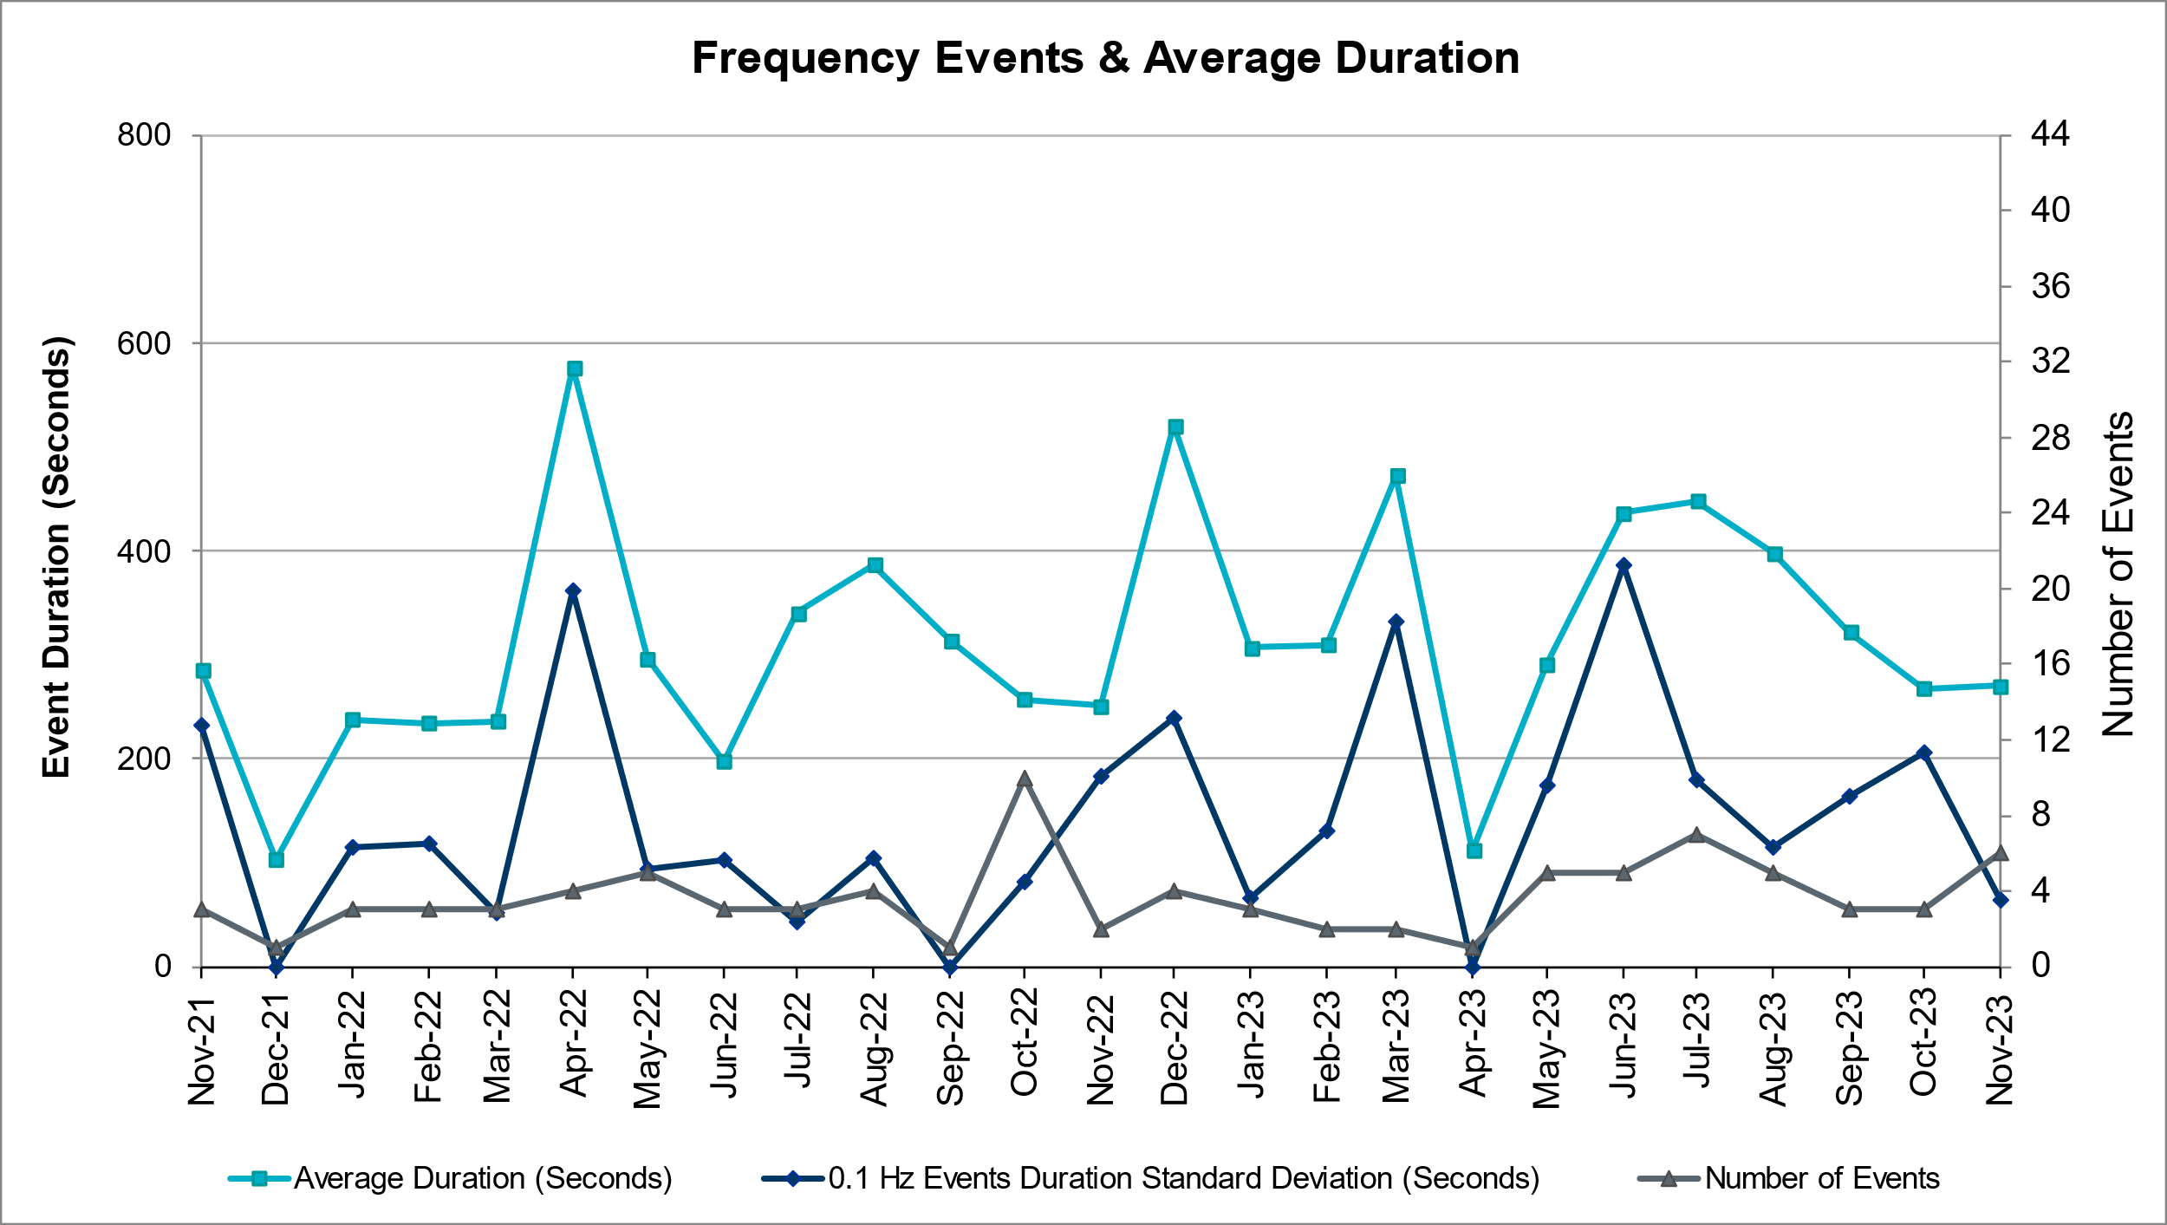

ERCOT Contingency Reserve Events
There were 2 events where ERCOT Contingency Reserve MWs were released to SCED. The events highlighted in blue were related to frequency events reported in Section 2.1 above.

Date and Time Released to SCED | Date and Time Recalled | Duration of Event | Maximum MWs Released | Comments
11/13/2023 6:21 | 11/13/2023 6:25 | 0:03:32 | 148.7 | Unit Trip
11/13/2023 10:28 | 11/13/2023 10:33 | 0:04:52 | 546.1 | Unit Trip

Responsive Reserve Events
There were 0 events where Responsive Reserve MWs were released to SCED.

Date and Time Released to SCED | Date and Time Recalled | Duration of Event | Maximum MWs Released | Comments
N/A | N/A | N/A | N/A | N/A

Load Resource Events
None.

Reliability Unit Commitment

ERCOT reports on Reliability Unit Commitments (RUC) monthly. Commitments are reported grouped by operating day and weather zone. The total number of hours committed is the sum of the hours for all the units in the specified region. Additional information on RUC commitments can be found on the MIS secure site at Grid Generation Reliability Unit Commitment.

There were no DRUC commitments.

There was 24 HRUC commitments.

Resource Location | # of Resources | Operating Day | Total # of Hours Committed | Total MWhs | Reason for Commitment
SOUTH_CENTRAL | 1 | 11/5/2023 | 5 | 1,585 | SYSTEM CAPACITY
NORTH_CENTRAL | 1 | 11/5/2023 | 6 | 4,375 | SYSTEM CAPACITY
NORTH_CENTRAL | 1 | 11/5/2023 | 4 | 1,700 | SYSTEM CAPACITY
NORTH_CENTRAL | 1 | 11/6/2023 | 1 | 239 | SYSTEM CAPACITY
COAST | 1 | 11/8/2023 | 6 | 1,483 | SYSTEM CAPACITY
NORTH_CENTRAL | 1 | 11/8/2023 | 6 | 1,914 | SYSTEM CAPACITY
COAST | 1 | 11/10/2023 | 5 | 780 | SYSTEM CAPACITY
SOUTH_CENTRAL | 1 | 11/10/2023 | 6 | 1,380 | SYSTEM CAPACITY
NORTH_CENTRAL | 1 | 11/11/2023 | 4 | 86 | SYSTEM CAPACITY
NORTH_CENTRAL | 1 | 11/10/2023 | 16 | 1,600 | SYSTEM CAPACITY
SOUTH_CENTRAL | 1 | 11/11/2023 | 6 | 1,380 | SYSTEM CAPACITY
EAST | 1 | 11/11/2023 | 4 | 680 | SYSTEM CAPACITY
NORTH_CENTRAL | 1 | 11/12/2023 | 8 | 1,168 | SYSTEM CAPACITY
SOUTH_CENTRAL | 1 | 11/12/2023 | 6 | 1,380 | SYSTEM CAPACITY
NORTH_CENTRAL | 1 | 11/12/2023 | 6 | 108 | SYSTEM CAPACITY
EAST | 1 | 11/12/2023 | 5 | 850 | SYSTEM CAPACITY
COAST | 1 | 11/12/2023 | 6 | 936 | SYSTEM CAPACITY
SOUTH_CENTRAL | 1 | 11/13/2023 | 15 | 3,450 | SYSTEM CAPACITY
COAST | 1 | 11/13/2023 | 4 | 608 | SYSTEM CAPACITY
NORTH_CENTRAL | 1 | 11/13/2023 | 8 | 1,160 | SYSTEM CAPACITY
EAST | 1 | 11/13/2023 | 5 | 850 | SYSTEM CAPACITY
COAST | 1 | 11/14/2023 | 4 | 608 | SYSTEM CAPACITY
COAST | 1 | 11/15/2023 | 6 | 1,476 | SYSTEM CAPACITY
NORTH_CENTRAL | 1 | 11/15/2023 | 2 | 784 | SYSTEM CAPACITY

IRR, Wind, and Solar Generation as a Percent of Load
The graph below shows the maximum, minimum and average aggregate solar, wind and IRR output as a percentage of total ERCOT load when evaluated as 10-minute averaged intervals, over the past 13 months. Current wind and solar generation and penetration records are listed in the footnote below. Maximum IRR penetration for the month was 62.11% on 11/21/2023 interval ending 13:10 and minimum IRR penetration for the month was 1.74% on 11/22/2023 interval ending 17:40.

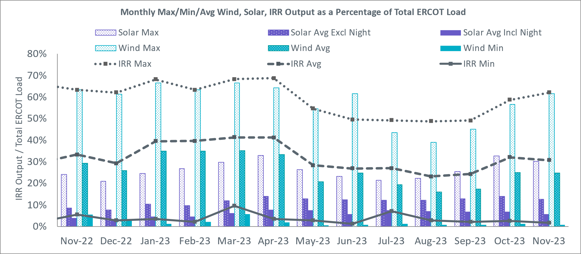

During the hour of peak load for the month, hourly integrated wind generation was 9,453 MW and solar generation was 8,739 MW. The graph below shows the wind and solar penetration percentage during the hour of the peak load in the last 13 months.

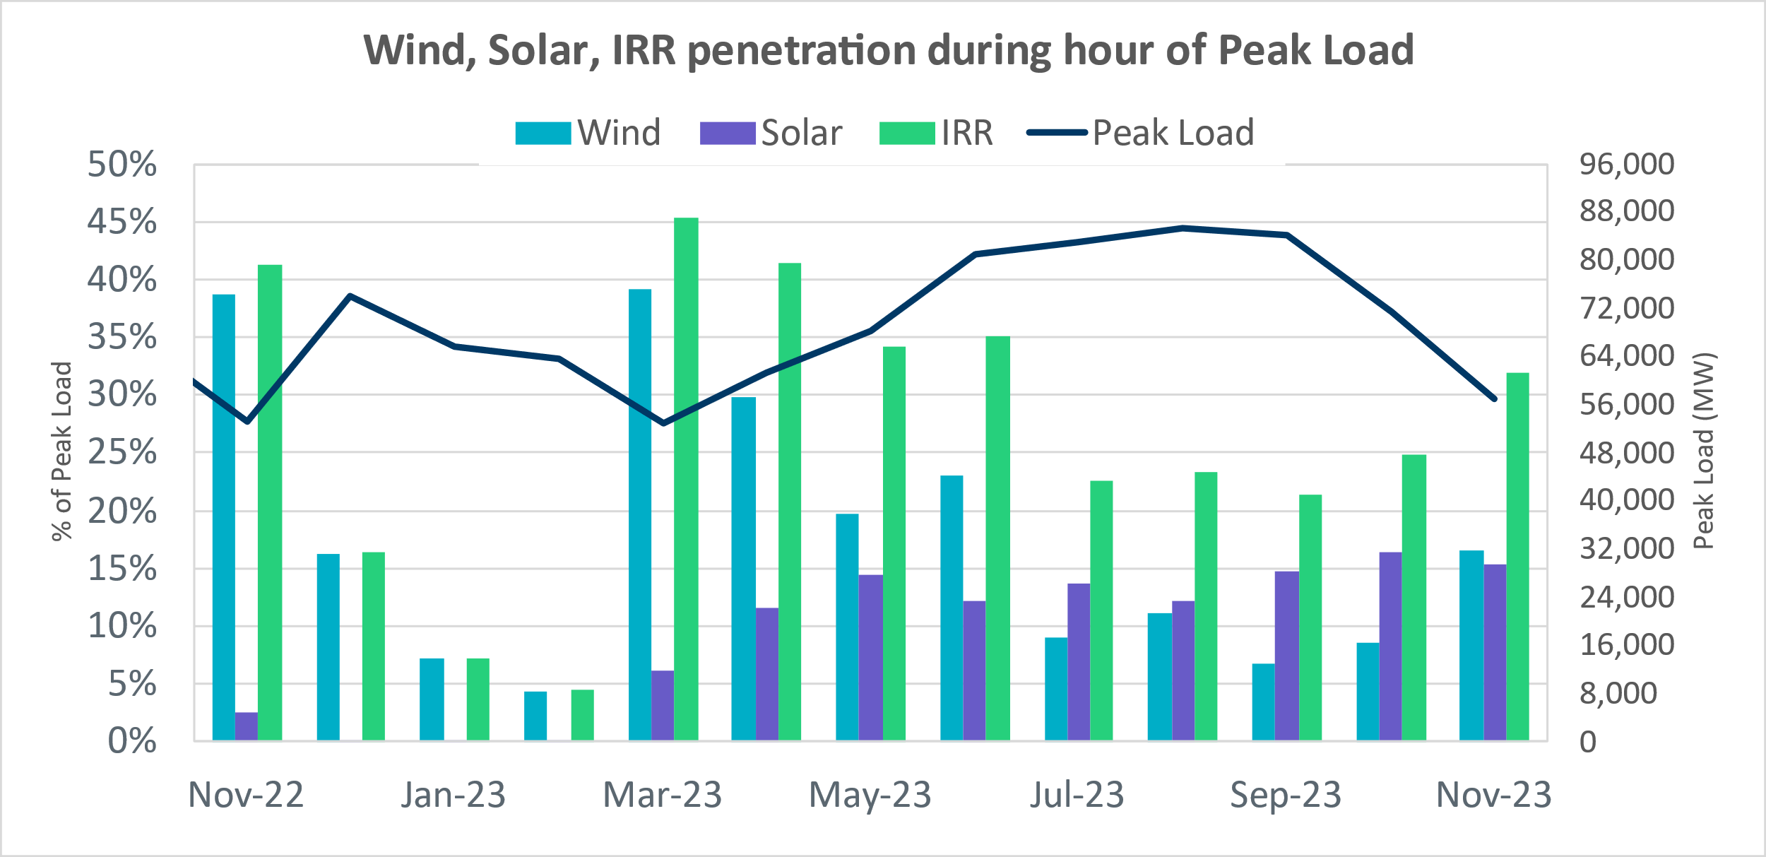

Lastly, the graph below shows the minimum wind, solar and IRR output during the peak load hour as a percentage of the daily peak load for every day in the month.
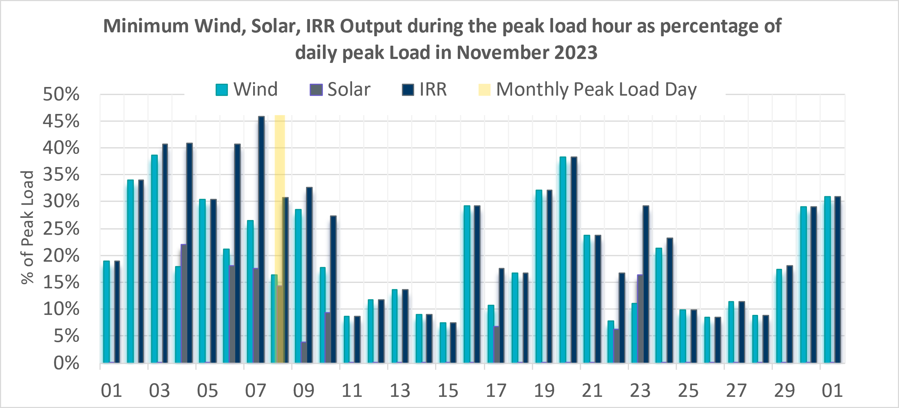

Largest Net-Load Ramps
The net-load ramp is defined as the change in net-load (load minus wind and PVGR generation) during the defined time horizon. Such a variation in net-load needs to be accommodated in grid operations to ensure that the reliability of the grid is satisfactorily maintained. The largest net-load ramp during 5-min, 10-min, 15-min, 30-min and 60-min in November 2023 is 1426 MW, 2810 MW, 3991 MW, 6762 MW, and 10976 MW, respectively. The comparison with respect to the historical values is given in the table below.

Month and Year | 5 min | 10 min | 15 min | 30 min | 60 min
November 2014 | 991 MW | 1,689 MW | 2,112 MW | 3,289 MW | 5,392 MW
November 2015 | 915 MW | 1,637 MW | 1,995 MW | 3,241 MW | 5,516 MW
November 2016 | 821 MW | 1,404 MW | 1,827 MW | 3,166 MW | 5,866 MW
November 2017 | 877 MW | 1,581 MW | 2,078 MW | 3,393 MW | 5,708 MW
November 2018 | 814 MW | 1,553 MW | 2,148 MW | 4,109 MW | 7,218 MW
November 2019 | 940 MW | 1,606 MW | 2,269 MW | 3,934 MW | 6,317 MW
November 2020 | 971 MW | 1,264 MW | 1,655 MW | 3,061 MW | 5,751 MW
November 2021 | 1,311 MW | 1,639 MW | 2,281 MW | 3,781 MW | 6,587 MW
November 2022 | 1,107 MW | 1,907 MW | 2,764 MW | 5,166 MW | 9,218 MW
November 2023 | 1,426 MW | 2,810 MW | 3,991 MW | 6,762 MW | 10,976 MW
All months in 2014-2023 | 2,789 MW | 3,018 MW | 4,023 MW | 7,209 MW | 10,976 MW

Congestion Analysis

Notable Constraints
Nodal protocol section 3.20 specifies that ERCOT shall identify transmission constraints that are binding in Real-Time three or more Operating Days within a calendar month. As part of this process, ERCOT reports congestion that meets this criterion to ROS. In addition, ERCOT also highlights notable constraints that have an estimated congestion rent exceeding $1,000,000 for a calendar month. These constraints are detailed in the table below, including approved transmission upgrades from TPIT that may provide some congestion relief based on ERCOT’s engineering judgement. Rows highlighted in blue indicate the congestion was affected by one or more outages. For a list of all constraints activated in SCED, please see Appendix A at the end of this report.

Contingency Name | Overloaded Element | # of Days Constraint Binding | Congestion Rent | Transmission Project
DMGSBTR5 | 6036__A | 16 | $20,032,855.17
BASE CASE | WESTEX | 12 | $17,170,417.89
DCONLNG5 | 6095__D | 15 | $15,260,811.45
BASE CASE | NE_LOB | 19 | $4,986,578.58 | The Lower Rio Grande Valley (LRGV) System Enhancement Project (21RPG017) will improve the NorthEd_LoboGTC to support up to 80% of total wind and solar generation capacity in the LRGV area.
SN_SLON5 | N_SHARPE_XF1 | 12 | $3,496,027.28
SMCEABS8 | CAPELL_MERK1_1 | 4 | $3,152,192.20
DCONLNG5 | 6471__C | 3 | $2,707,662.72
SDBMFID5 | LPLSL_LPLSE_1 | 5 | $2,424,860.46
BASE CASE | PNHNDL | 13 | $2,104,239.53
SNATBEA8 | 6144__A | 3 | $2,052,828.84
BASE CASE | VALEXP | 22 | $2,034,647.08 | The Lower Rio Grande Valley (LRGV) System Enhancement Project (21RPG017) will improve but not eliminate the need for this GTC.
SBWDDBM5 | LPLMK_LPLNE_1 | 6 | $1,852,049.80
SBAKCED5 | HARGRO_TWINBU1_1 | 6 | $1,761,482.56
SMCEABS8 | ESKSW_TRNT1_1 | 3 | $1,756,521.27
DSWECCR5 | 6036__A | 8 | $1,630,078.23
DMGSBIT5 | 6036__A | 8 | $1,336,032.36
DLHSPRC8 | 3671__A | 1 | $1,323,049.51
SVEAW_L5 | CEDRHI_SILT1_1 | 4 | $1,206,167.88 | AEP_TNC_Cedar_Hill_Relay_Upgrade (72213)
DCHBJO25 | CBY_AT3 | 1 | $1,173,178.50
DSALKLN5 | 630__B | 3 | $994,422.15
DCONLNG5 | 14040__A | 13 | $885,885.98 | Oncor_FW_45640_Spraberry - Polecat Creek 138 kV Line (23RPG009, MOD 45640)
SMGIENW8 | TRU_UAT1 | 9 | $750,529.73
SGRICOL5 | PAWNEE_TANGO1_1 | 5 | $709,086.31
DBIGKEN5 | HAMILT_MAXWEL1_1 | 10 | $660,319.64 | AEP_TCC_HamiltonRoad-Maxwell(20RPG022, MOD 61396)
DWAP_JN5 | BI_WAP50_A | 3 | $599,941.22
SBAKCED5 | CEDRHI_SILT1_1 | 3 | $576,192.87 | AEP_TNC_Cedar_Hill_Relay_Upgrade (72213)
MFOWLOB5 | LARDVN_LASCRU1_1 | 9 | $535,240.62 | AEP_TCC_Laredo VFT North - Las Cruces 138 kV Line Rebuild (58008), AEP_TCC_Las Cruces - Milo Rebuild (76076), AEP_TCC_Milo - Mines Road Rebuild (76078), AEP_TCC_Mines Road - North Laredo SW Rebuild (76080)
DMTSCOS5 | 6437__F | 5 | $478,148.89
SBAKCED5 | CONCHO_SANW0_1 | 3 | $467,536.27
DCONLNG5 | CEDRHI_SILT1_1 | 3 | $461,549.93
SMV_PAR8 | RIOHND_ERIOHND_1 | 11 | $457,791.58 | STEC_6687_RebuildRioHondo-ERioHondo (6687)
DSCOTKW5 | 15060__B | 3 | $455,880.24
DBIGKEN5 | REDCRE_WEISS1_1 | 3 | $420,192.09
DMGSCON5 | 6471__C | 3 | $377,474.26
XFOW58 | CATARI_PILONC1_1 | 4 | $356,469.75
SCROSAN8 | PEARSALL_69_4 | 9 | $299,712.93 | STEC_76790_upgradePearsallAuto (76790)
SBAKNOR5 | CEDRHI_SILT1_1 | 3 | $291,679.99 | AEP_TNC_Cedar_Hill_Relay_Upgrade (72213)
SCOLBAL8 | CONAN_SANA1_1 | 3 | $284,430.48
SCEDHI_5 | HARGRO_TWINBU1_1 | 4 | $254,136.72
DBIGKEN5 | TREADW_YELWJC1_1 | 5 | $236,596.99
BASE CASE | EASTEX | 3 | $200,367.70
BASE CASE | TRDWEL | 8 | $175,554.90
SMCEESK8 | ESKSW_TRNT1_1 | 4 | $151,351.94
SW_GODE5 | 15060__B | 6 | $145,268.34
SBTPBNT8 | MYRA_VAL_1 | 3 | $131,729.23 | BEPC_TPIT4645_MYRA_SPRING (4645)
SCRMSAR8 | CONAN_SANA1_1 | 3 | $122,839.08
SBRAUVA8 | HAMILT_MAVERI1_1 | 6 | $119,248.29
DBRNGOL8 | HLD_FMR1 | 3 | $99,554.07
MFOWLOB5 | CATARI_PILONC1_1 | 4 | $94,446.38
SKLELOY8 | LOYOLA_69_1 | 6 | $87,046.47
DABPAB98 | ESTES_PECAN_1_1 | 4 | $85,424.66
XFOW58 | FALFUR_PREMON1_1 | 4 | $80,739.06
SPOTPAN9 | HAS_HAS2 | 3 | $37,578.66
SBOSWHT8 | LKW_WHT_1 | 5 | $28,308.01
SSTLEIN8 | CRTVLE_EINSTEN_1 | 4 | $24,264.04
SMADSAP8 | MADDUX_SAPOWE2_1 | 3 | $23,641.92
BASE CASE | HMLTN | 5 | $22,153.15
XFOW58 | ASHERT_CATARI1_1 | 4 | $20,639.53 | AEP_TCC_AshertontoPiloncillo138kVLine_rebuild (73100)

Generic Transmission Constraint Congestion
There were 25 days congestion on Valley Export GTC, 21 days on North Edinburg to Lobo GTC, 18 days on Panhandle GTC, 16 days on West Texas Export GTC, 8 days on Treadwell GTC, 5 days on Nelson Sharpe to Rio Hondo GTC, 5 days on Hamilton GTC, 4 days on East Texas GTC, 3 days on Wharton County GTC, 1 days on Zapata Starr GTC, and 1 days on North to Houston GTC, There was no activity on the remaining GTCs during the month.

Note: This is how many times a constraint has been activated to avoid exceeding a GTC limit, it does not imply an exceedance of the GTC occurred or that the GTC was binding.

Manual Overrides
There were no overrides for the month of November.

Congestion Costs for Calendar Year 2023
The following table represents the top twenty active constraints for the calendar year based on the estimated congestion rent attributed to the congestion. ERCOT updates this list on a monthly basis.

Contingency | Overloaded Element | # of 5-min SCED | Estimated Congestion Rent (2023)
Elmcreek-Sanmigl 345kV | Pawnee Switching Station - Calaveras 345kV | 10033 | $165,032,523.72
TWR(345) WAP-WLF64 & WAP-WLY72 | South Texas Project - Wa Parish 345kV | 5163 | $89,574,495.11
MGSES TO CCRSW 345 AND BTRCK TO MGSES 345 DBLCKT | Tonkawa Switch - Morgan Creek Ses 345kV | 11860 | $83,818,945.12
MAN_DBL_MDSSW-ODEHB_and_CONSW-QALSW_345kV_DBLCKT | Midessa South Sw 138kV | 11605 | $79,014,288.16
Basecase | WESTEX GTC | 19225 | $78,885,901.14
Basecase | NE_LOB GTC | 39655 | $69,728,764.19
BEVO to BEVO LIN 1 | Hamilton Road - Maverick 138kV | 7549 | $52,011,887.52
Rattlesnake Rd Switch to LAKE CREEK SES LIN _A | St Johns Switch - Jewett 345kV | 4881 | $45,754,231.09
SKYWEST to SKYWEST LIN 1 | #N/A | 2909 | $45,341,291.63
Basecase | PNHNDL GTC | 12769 | $42,425,611.94
SKYWEST to SKYWEST LIN 1 | #N/A | 10282 | $41,928,489.30
HICKS SWITCH to HICKS SWITCH LIN _A | Hicks Switch - Alliance 345kV | 2814 | $40,032,160.11
SALSW - HUTTO 345KV | Bell County - Salado Switch 138kV | 4538 | $37,595,853.70
TWR(345) WAP-WLF64 & CCK-WLY72 | South Texas Project - Wa Parish 345kV | 4025 | $34,465,421.37
BLACKWATER DRAW SWITCH to DOUBLE MOUNTAIN SWITCH LIN 1 | Mackenzie Substation - Northeast Substation 115kV | 10272 | $34,171,389.75
CONSW-MGSES_and_CONSW-LNGSW_345kV_DBLCKT | Lamesa - Jim Payne Poi 138kV | 5819 | $30,683,272.75
Austro-Daffin&Dunlap-Decker 138kV | Sim Gideon - Bastrop City 138kV | 2244 | $28,796,696.82
DMTSW TO SCOSW 345 DBLCKT | Knapp - Scurry Chevron 138kV | 10780 | $27,789,207.41
Manual_SGL_CONSW-MDSSW_345kV_SglCkt | Quail Switch - Odessa Ehv Switch 345kV | 3594 | $26,545,479.50
Manual dbl ckt for NEDIN-BONILLA 345kV & RIOH-PRIM138kV | Burns Sub - Rio Hondo 138kV | 10987 | $24,598,380.90

System Events

ERCOT Peak Load
The unofficial ERCOT peak load for the month was 56,515 MW and occurred on 11/08/2023, during hour ending 16:00.

Load Shed Events
None.

Stability Events
None.

Notable PMU Events
ERCOT analyzes PMU data for any significant system disturbances that do not fall into the Frequency Events category reported in section 2.1. The results are summarized in this section once the analysis has been completed.

There were no PMU events outside of those reported in section 2.1.

DC Tie Curtailment
None.

TRE/DOE Reportable Events
- BPUB Submitted a DOE-417 on 11/17/2023 for Damage or destruction to its Facility

New/Updated Constraint Management Plans
There were 2 CMP modifications: MP_2023_06, MP_2023_07

New/Modified/Removed RAS
None.

New Procedures/Forms/Operating Bulletins
Date | Subject | Bulletin No.
11/06/2023 | Real Time Desk V1 Rev 90 | 1110
11/06/2023 | Shift Supervisor Desk V1 Rev 92 | 1111
11/06/2023 | Transmission and Security Desk V1 Rev 103 | 1112
11/09/2023 | Resource Desk V1 Rev 78 | 1113
11/30/2023 | Real Time Desk V1 Rev 91 | 1114
11/30/2023 | Reliability Unit Commitment V1 Rev 74 | 1115
11/30/2023 | Scripts V1 Rev 53 | 1116
11/30/2023 | Transmission and Security Desk V1 Rev 104 | 1117

Emergency Conditions

OCNs
Date and Time | Message
Nov 05, 2023 10:00 CPT | ERCOT issued an Advanced Action Notice (AAN) due to possible future emergency condition of reserve capacity deficiency beginning November 8, 2023 HE 1600 – HE2000. ERCOT may delay/withdraw accepted Resource Outages. ERCOT may seek up to 5,700 MW from an OAE and them make the OSA. On November 6, 2023 at 10:00 ERCOT will execute an OAE if deemed necessary.
Nov 06, 2023 10:00 CPT | ERCOT has updated an Advanced Action Notice (AAN) due to conditions changing and possible future emergency condition of reserve capacity deficiency beginning November 8, 2023 HE 1600 – HE2000. ERCOT may delay/withdraw accepted Resource Outages. ERCOT may seek up to 5,565 MW from an OAE and them make the OSA. On November 6, 2023 at 16:00 ERCOT will execute an OAE if deemed necessary.
Nov 06, 2023 16:00 CPT | ERCOT has updated an Advanced Action Notice (AAN) due to conditions changing and possible future emergency condition of reserve capacity deficiency beginning November 8, 2023 HE 1600 – HE2000. QSEs have updated their Resource COPs and the Outage Scheduler. At this time, ERCOT still shows potentially 6,089 MW deficient, although no additional capacity is available and will not be issuing an OSA. ERCOT has posted an updated AAN planning Assessment for reference.
Nov 12, 2023 15:35 CPT | ERCOT Issued an OCN for PANHANDLE IROL due to planned outage and topology change.
Nov 14, 2023 7:08 CPT | ERCOT Issued an OCN for PANHANDLE IROL due to planned outage and topology change.
Nov 15, 2023 5:53 CPT | ERCOT issued an OCN for WESTTEX IROL due to planned outage and topology change.
Nov 27, 2023 20:08 CPT | ERCOT Issued an OCN for PANHANDLE IROL due to planned outage and topology change.

Advisories
Date and Time | Message
Nov 05, 2023 12:14  CPT | ERCOT issued an Advisory for geomagnetic disturbance G7.

Watches
None.

Emergency Notices
None.

Application Performance

TSAT/VSAT Performance Issues
None

Communication Issues
None.

Market System Issues
None.

Model Updates
The Downstream Production Change (DPC) process allows ERCOT to make changes in the on-line Network Operations Model without loading a completely new model. The purpose of this process is to allow for reliable grid operations as system conditions change between designated Network Operations Model database loads. The DPC process is limited in scope to just those items listed below, with equipment ratings updates being the most common. ERCOT has seen a rise in the use of the DPC process to make on-line updates to the Network Operations Model in recent years, instead of through the standard Network Operations Model Change Request process.

- Static Line ratings (Interim Update)
- Dynamic Line ratings (non-Interim Update)
- Autotransformer ratings (non-Interim Update)
- Breaker and Switch Normal status (Interim Update)
- Contingency Definitions (Interim Update)
- RAP and RAS changes or additions (Interim Update)
- Net Dependable and Reactive Capability (NDCRC) values (Interim Update)
- Impedance Updates (non-Interim)

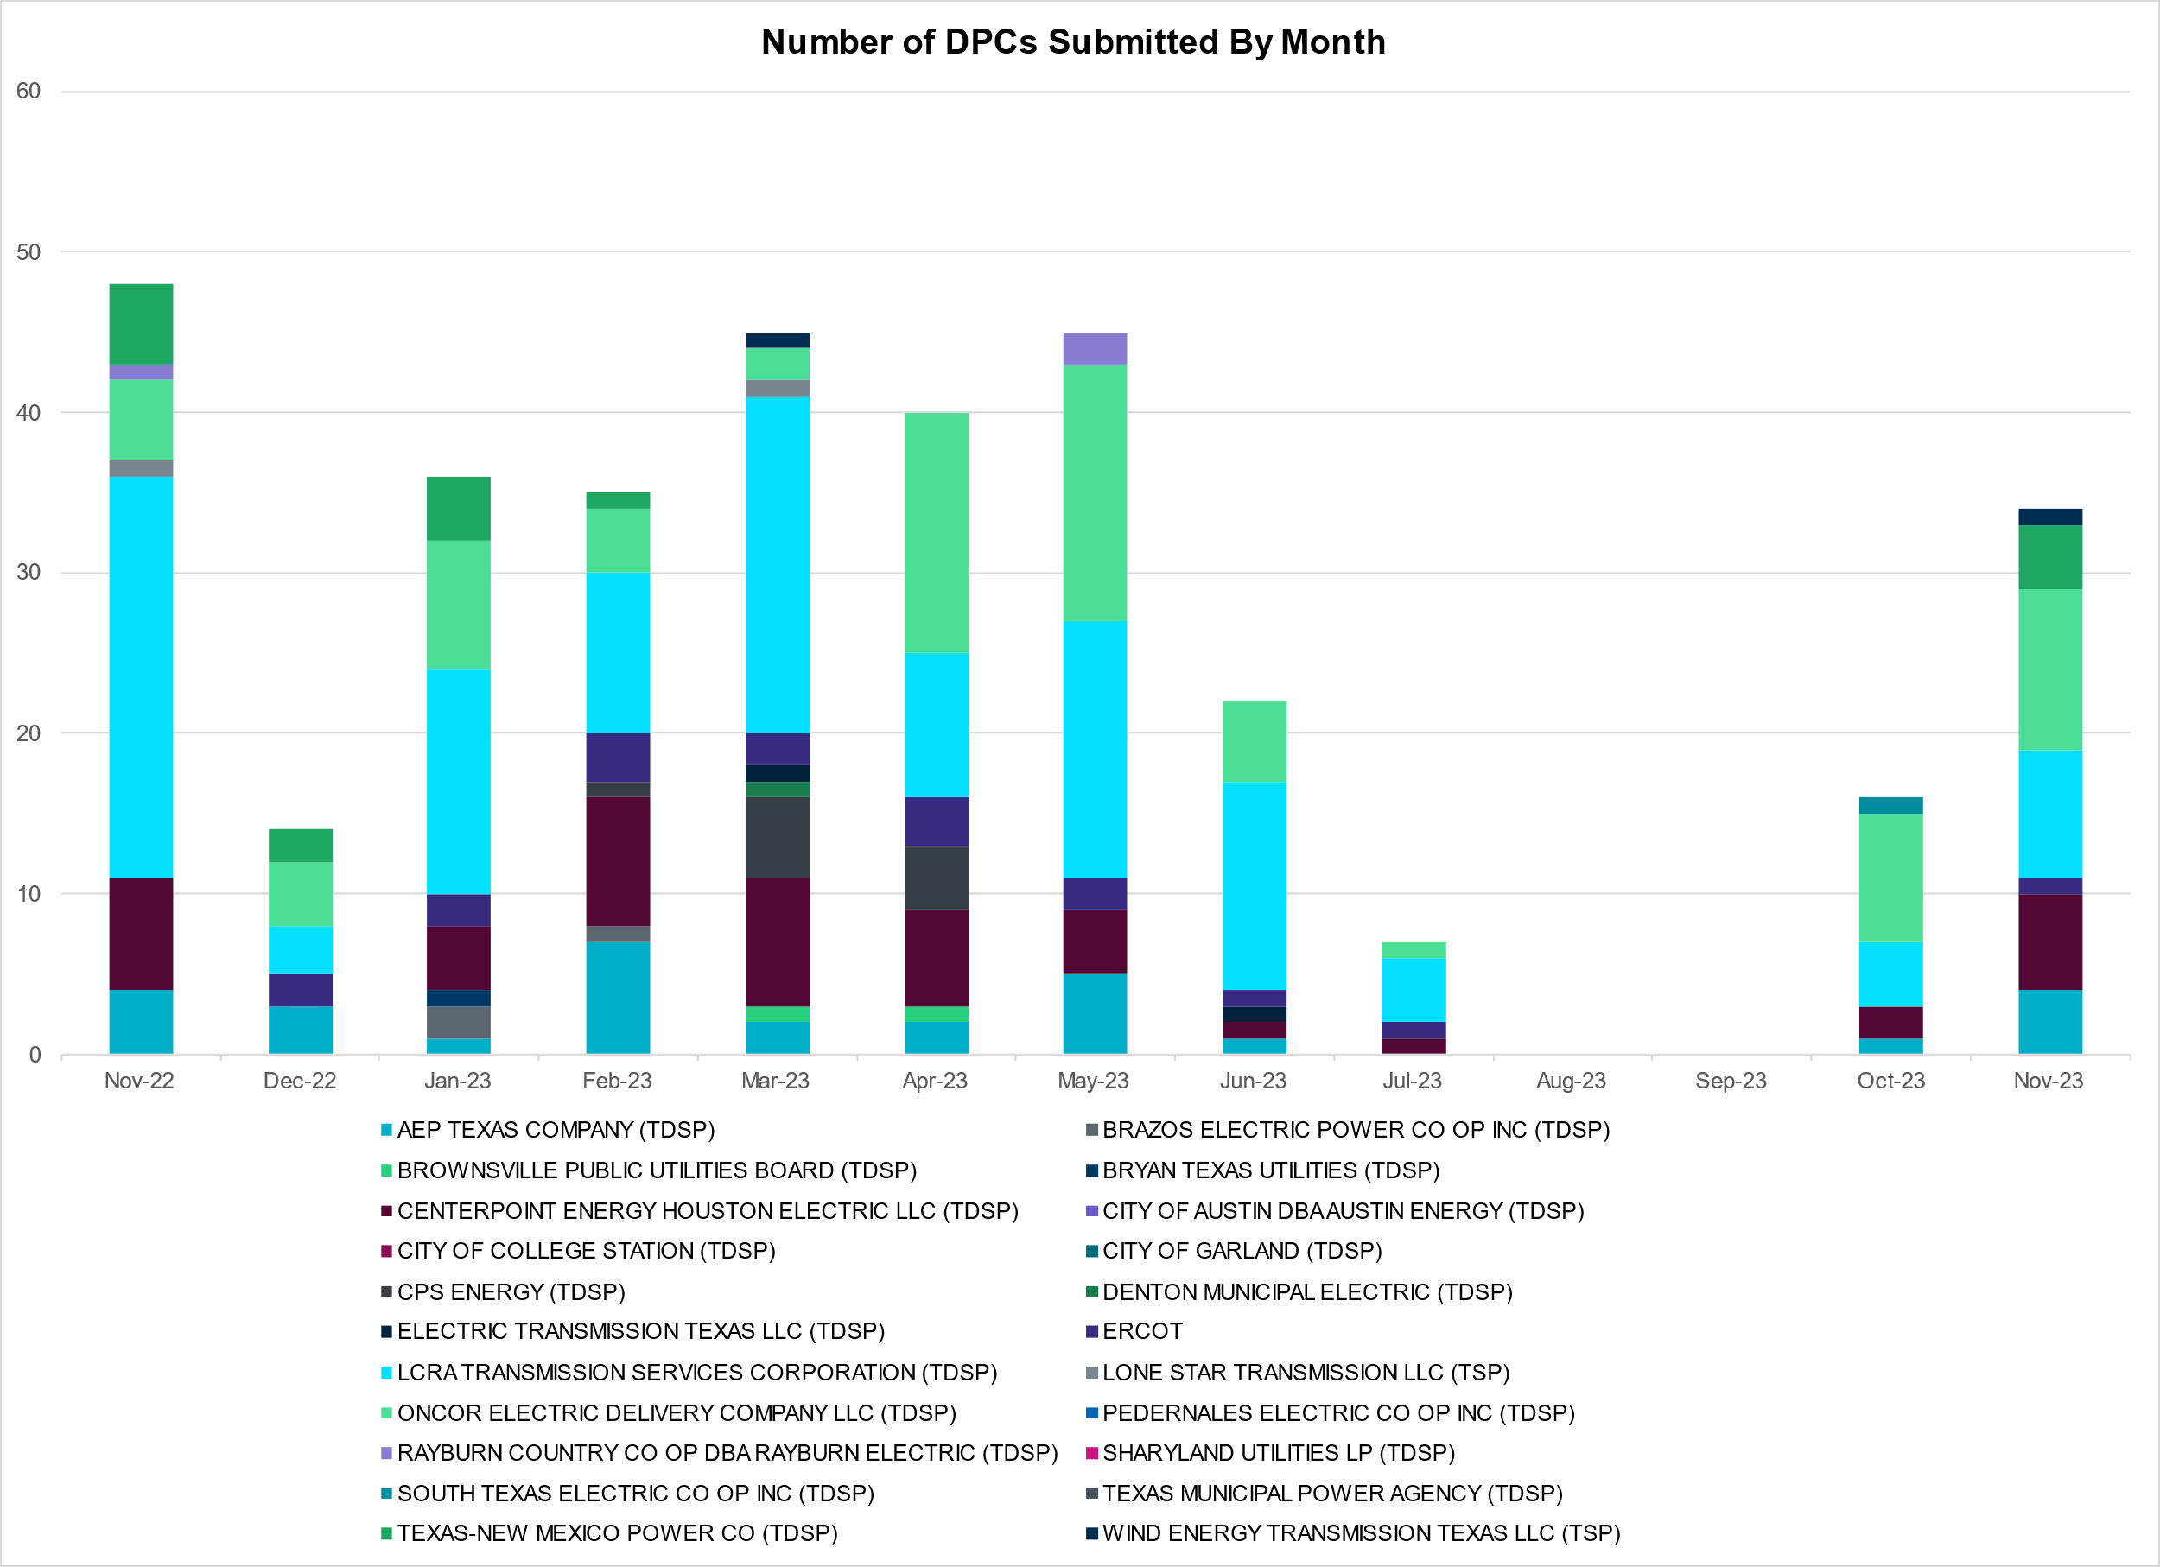

Transmission Operator | Number of DPCs
AEP TEXAS COMPANY (TDSP) | 4
BRAZOS ELECTRIC POWER CO OP INC (TDSP) | 0
BROWNSVILLE PUBLIC UTILITIES BOARD (TDSP) | 0
BRYAN TEXAS UTILITIES (TDSP) | 0
CENTERPOINT ENERGY HOUSTON ELECTRIC LLC (TDSP) | 6
CITY OF AUSTIN DBA AUSTIN ENERGY (TDSP) | 0
CITY OF COLLEGE STATION (TDSP) | 0
CITY OF GARLAND (TDSP) | 0
CPS ENERGY (TDSP) | 0
DENTON MUNICIPAL ELECTRIC (TDSP) | 0
ELECTRIC TRANSMISSION TEXAS LLC (TDSP) | 0
ERCOT | 1
LCRA TRANSMISSION SERVICES CORPORATION (TDSP) | 8
LONE STAR TRANSMISSION LLC (TSP) | 0
ONCOR ELECTRIC DELIVERY COMPANY LLC (TDSP) | 10
PEDERNALES ELECTRIC CO OP INC (TDSP) | 0
RAYBURN COUNTRY CO OP DBA RAYBURN ELECTRIC (TDSP) | 0
SHARYLAND UTILITIES LP (TDSP) | 0
SOUTH TEXAS ELECTRIC CO OP INC (TDSP) | 0
TEXAS MUNICIPAL POWER AGENCY (TDSP) | 0
TEXAS-NEW MEXICO POWER CO (TDSP) | 4
WIND ENERGY TRANSMISSION TEXAS LLC (TSP) | 1

Appendix A: Real-Time Constraints
The following is a complete list of constraints activated in SCED. Full contingency descriptions can be found in the Standard Contingencies List located on the MIS secure site at Grid Generation Reliability Unit Commitment.

Year | Month of the Year | Contingency Name | Overloaded Element | From Station | To Station | Count of Days
2023 | 11 | BASE CASE | VALEXP | n/a | n/a | 24
2023 | 11 | BASE CASE | NE_LOB | n/a | n/a | 21
2023 | 11 | DMGSBIT5 | 6036__A | TKWSW | MGSES | 19
2023 | 11 | DMGSBTR5 | 6036__A | TKWSW | MGSES | 19
2023 | 11 | DCONLNG5 | 6095__D | LMESA | JPPOI | 19
2023 | 11 | BASE CASE | PNHNDL | n/a | n/a | 17
2023 | 11 | BASE CASE | WESTEX | n/a | n/a | 15
2023 | 11 | DSWECCR5 | 6036__A | TKWSW | MGSES | 15
2023 | 11 | DCONLNG5 | 14040__A | PCTSW | DEWTP | 13
2023 | 11 | SN_SLON5 | N_SHARPE_XF1 | N_SHARPE | N_SHARPE | 12
2023 | 11 | MFOWLOB5 | LARDVN_LASCRU1_1 | LARDVNTH | LASCRUCE | 12
2023 | 11 | XFOW58 | ASHERT_CATARI1_1 | ASHERTON | CATARINA | 11
2023 | 11 | SMV_PAR8 | RIOHND_ERIOHND_1 | MV_RIOHO | RIOHONDO | 11
2023 | 11 | DMGSCON5 | 6471__C | MGSES | NAVIG | 11
2023 | 11 | XFOW58 | ASHERT_CATARI1_1 | CATARINA | ASHERTON | 11
2023 | 11 | DBIGKEN5 | HAMILT_MAXWEL1_1 | MAXWELL | HAMILTON | 10
2023 | 11 | SBWDDBM5 | LPLMK_LPLNE_1 | LPLMK | LPLNE | 10
2023 | 11 | SCROSAN8 | PEARSALL_69_4 | PEARSALL | PEARSALL | 9
2023 | 11 | SMGIENW8 | TRU_UAT1 | TRU | TRU | 9
2023 | 11 | SSPJFS8 | JFSSC_06_A | SC | JFS | 8
2023 | 11 | SSPJFS8 | JFSSC_06_A | JFS | SC | 8
2023 | 11 | BASE CASE | TRDWEL | n/a | n/a | 8
2023 | 11 | DCONLNG5 | 6471__C | MGSES | NAVIG | 8
2023 | 11 | XFOW58 | FALFUR_PREMON1_1 | FALFUR | PREMONT | 8
2023 | 11 | SW_GODE5 | 15060__B | VEALMOOR | KOCHTAP | 8
2023 | 11 | DMTSCOS5 | 6437__F | SCRCV | KNAPP | 7
2023 | 11 | SNATBEA8 | 6144__A | BSPRW | STASW | 7
2023 | 11 | SKLELOY8 | LOYOLA_69_1 | LOYOLA | LOYOLA | 7
2023 | 11 | XFOW58 | CATARI_PILONC1_1 | PILONCIL | CATARINA | 7
2023 | 11 | DFOWSMG5 | FALFUR_PREMON1_1 | FALFUR | PREMONT | 7
2023 | 11 | XFOW58 | CATARI_PILONC1_1 | CATARINA | PILONCIL | 7
2023 | 11 | SGRICOL5 | PAWNEE_TANGO1_1 | TANGO | PAWNEE | 7
2023 | 11 | SBRAUVA8 | HAMILT_MAVERI1_1 | HAMILTON | MAVERICK | 6
2023 | 11 | SBOSWHT8 | LKW_WHT_1 | LKWHITNY | WHTNY | 6
2023 | 11 | DCONLNG5 | 15060__B | VEALMOOR | KOCHTAP | 6
2023 | 11 | SN_SAJO5 | LASPUL_RAYMND1_1 | LASPULGA | RAYMND2 | 6
2023 | 11 | SSTLEIN8 | CRTVLE_EINSTEN_1 | EINSTEIN | CRTRVLLE | 6
2023 | 11 | DBIGKEN5 | TREADW_YELWJC1_1 | TREADWEL | YELWJCKT | 6
2023 | 11 | SBAKCED5 | HARGRO_TWINBU1_1 | TWINBU | HARGROVE | 6
2023 | 11 | SCOLBAL8 | CONAN_SANA1_1 | CONAN | SANA_TAP | 5
2023 | 11 | SCEDHI_5 | HARGRO_TWINBU1_1 | TWINBU | HARGROVE | 5
2023 | 11 | SMADSAP8 | MADDUX_SAPOWE2_1 | SAPOWER | MADDUX | 5
2023 | 11 | SBAKCED5 | CONCHO_SANW0_1 | CONCHO | SANW | 5
2023 | 11 | MFOWLOB5 | FALFUR_PREMON1_1 | FALFUR | PREMONT | 5
2023 | 11 | BASE CASE | HMLTN | n/a | n/a | 5
2023 | 11 | SCOLBAL8 | CONAN_SANA1_1 | SANA_TAP | CONAN | 5
2023 | 11 | DABPAB98 | ESTES_PECAN_1_1 | PECAN_BY | ESTES | 5
2023 | 11 | SDBMFID5 | LPLSL_LPLSE_1 | LPLSL | LPLSE | 5
2023 | 11 | SMCEABS8 | CAPELL_MERK1_1 | CAPELLA | MERK | 5
2023 | 11 | MFOWLOB5 | CATARI_PILONC1_1 | PILONCIL | CATARINA | 5
2023 | 11 | SMCEABS8 | CAPELL_MERK1_1 | MERK | CAPELLA | 5
2023 | 11 | SMADSAP8 | MADDUX_SAPOWE2_1 | MADDUX | SAPOWER | 5
2023 | 11 | SVEAW_L5 | CEDRHI_SILT1_1 | CEDRHILL | SILT | 4
2023 | 11 | DBRNGOL8 | HLD_FMR1 | HLD | HLD | 4
2023 | 11 | SBTPBNT8 | MYRA_VAL_1 | MYRA | VALYVIEW | 4
2023 | 11 | SBAKCED5 | CEDRHI_SILT1_1 | CEDRHILL | SILT | 4
2023 | 11 | MARRLAN8 | BLESSI_PAVLOV1_1 | BLESSING | PAVLOV | 4
2023 | 11 | SCRMSAR8 | CONCHO_VRBS1_1 | VRBS | CONCHO | 4
2023 | 11 | SMCEABS8 | ESKSW_TRNT1_1 | ESKSW | TRNT | 4
2023 | 11 | SMCEESK8 | ESKSW_TRNT1_1 | TRNT | ESKSW | 4
2023 | 11 | BASE CASE | NELRIO | n/a | n/a | 4
2023 | 11 | DSCOTKW5 | 15060__B | VEALMOOR | KOCHTAP | 4
2023 | 11 | DFOWSMG5 | ASHERT_CATARI1_1 | ASHERTON | CATARINA | 4
2023 | 11 | DCONLNG5 | CEDRHI_SILT1_1 | CEDRHILL | SILT | 4
2023 | 11 | SVICCO28 | COLETO_VICTOR2_1 | COLETO | VICTORIA | 4
2023 | 11 | DSTPRED5 | BLESSI_PAVLOV1_1 | BLESSING | PAVLOV | 4
2023 | 11 | SCRMSAR8 | CONCHO_VRBS1_1 | CONCHO | VRBS | 4
2023 | 11 | SMCEABS8 | ESKSW_TRNT1_1 | TRNT | ESKSW | 4
2023 | 11 | SMCEESK8 | ESKSW_TRNT1_1 | ESKSW | TRNT | 4
2023 | 11 | DFOWSMG5 | ASHERT_CATARI1_1 | CATARINA | ASHERTON | 4
2023 | 11 | DSALKLN5 | 630__B | KLNSW | HHSTH | 3
2023 | 11 | DENWSTE8 | TRU_UAT1 | TRU | TRU | 3
2023 | 11 | SCRMSAR8 | CONAN_SANA1_1 | CONAN | SANA_TAP | 3
2023 | 11 | MARREL_8 | BLESSI_PAVLOV1_1 | BLESSING | PAVLOV | 3
2023 | 11 | SLAQLOB8 | BRUNI_69_1 | BRUNI | BRUNI | 3
2023 | 11 | DWAP_JN5 | BI_WAP50_A | WAP | BI | 3
2023 | 11 | DCOLFA59 | PAWNEE_TANGO1_1 | TANGO | PAWNEE | 3
2023 | 11 | SBGLTWI8 | CONCHO_SANW0_1 | CONCHO | SANW | 3
2023 | 11 | DNOECED5 | HARGRO_TWINBU1_1 | TWINBU | HARGROVE | 3
2023 | 11 | SSANFOW5 | ASHERT_CATARI1_1 | ASHERTON | CATARINA | 3
2023 | 11 | SPOTPAN9 | HAS_HAS2 | HAS | HAS | 3
2023 | 11 | XWHI58 | PAWNEE_TANGO1_1 | TANGO | PAWNEE | 3
2023 | 11 | DBIGKEN5 | REDCRE_WEISS1_1 | REDCREEK | WEISS | 3
2023 | 11 | BASE CASE | WHARTN | n/a | n/a | 3
2023 | 11 | SCARFRI8 | ATSO_SONR1_1 | SONR | ATSO | 3
2023 | 11 | DFOWSMG5 | CATARI_PILONC1_1 | PILONCIL | CATARINA | 3
2023 | 11 | SBAKNOR5 | CEDRHI_SILT1_1 | CEDRHILL | SILT | 3
2023 | 11 | BASE CASE | EASTEX | n/a | n/a | 3
2023 | 11 | DABPAB98 | SOUTHA_VINSON1_1 | SOUTHABI | VINSON | 3
2023 | 11 | DELMSAN5 | UVALDE_W_BATE1_1 | W_BATESV | UVALDE | 3
2023 | 11 | SSTLEST8 | CRTVLE_EINSTEN_1 | EINSTEIN | CRTRVLLE | 3
2023 | 11 | SCROSAN8 | POT_PEAR_1 | PEARSALL | POTEETS | 3
2023 | 11 | DFOWSMG5 | CATARI_PILONC1_1 | CATARINA | PILONCIL | 3
2023 | 11 | DODEMOS5 | 6095__D | LMESA | JPPOI | 2
2023 | 11 | SNICBLU8 | ABNTHW_CALLAH1_1 | CALLAHAN | ABNTHWST | 2
2023 | 11 | DCONLNG5 | CONCHO_SANW0_1 | CONCHO | SANW | 2
2023 | 11 | SDI2DIL9 | DILLEYSW_69A1 | DILLEYSW | DILLEYSW | 2
2023 | 11 | SMIDLO28 | FALFUR_PREMON1_1 | FALFUR | PREMONT | 2
2023 | 11 | DKG_NB_5 | JFSSC_06_A | JFS | SC | 2
2023 | 11 | DBIGKEN5 | MADDUX_TREADW1_1 | MADDUX | TREADWEL | 2
2023 | 11 | DWLDSCO5 | 15060__B | VEALMOOR | KOCHTAP | 2
2023 | 11 | MHARNED5 | BURNS_RIOHONDO_1 | RIOHONDO | MV_BURNS | 2
2023 | 11 | DFRIILL8 | CARVER_TINSLE1_1 | CARVER | TINSLEY | 2
2023 | 11 | SLAQLOB8 | FALFUR_PREMON1_1 | FALFUR | PREMONT | 2
2023 | 11 | MANGWHI5 | PAWNEE_TANGO1_1 | TANGO | PAWNEE | 2
2023 | 11 | MWHI58 | PAWNEE_TANGO1_1 | TANGO | PAWNEE | 2
2023 | 11 | XPRS58 | 1561__A | DPREA | RCSES | 2
2023 | 11 | DBUCRGP5 | 300__B | BLFSW | TMPSW | 2
2023 | 11 | SRUSBIG8 | CONCHO_SANW0_1 | CONCHO | SANW | 2
2023 | 11 | DELMSAN5 | PAWNEE_SPRUCE_1 | PAWNEE | CALAVERS | 2
2023 | 11 | XFOW58 | UVALDE_W_BATE1_1 | W_BATESV | UVALDE | 2
2023 | 11 | DWLDSCO5 | 15060__A | KOCHTAP | BUZSW | 2
2023 | 11 | MFOWLOB5 | BRUNI_69_1 | BRUNI | BRUNI | 2
2023 | 11 | SNOECED5 | CEDRHI_SILT1_1 | CEDRHILL | SILT | 2
2023 | 11 | DKOCNUE8 | MCKENZ_WESTSI1_1 | WESTSIDE | MCKENZIE | 2
2023 | 11 | SW_GW_L5 | 15060__B | VEALMOOR | KOCHTAP | 2
2023 | 11 | STMPTHS5 | 305__A | LCSES | BLFSW | 2
2023 | 11 | SKINFAL8 | FALFUR_PREMON1_1 | FALFUR | PREMONT | 2
2023 | 11 | STANPAW5 | LON_HI_ORNGRO1_1 | LON_HILL | ORNGROV | 2
2023 | 11 | MWHILON5 | PAWNEE_TANGO1_1 | TANGO | PAWNEE | 2
2023 | 11 | SL_4RAY8 | RAYBURN_69_2 | RAYBURN | RAYBURN | 2
2023 | 11 | XCED289 | ATBR_MILES1_1 | MILES | ATBR | 2
2023 | 11 | DBIGKEN5 | CARVER_TINSLE1_1 | CARVER | TINSLEY | 2
2023 | 11 | SKOCBUZ8 | CEDRHI_SILT1_1 | CEDRHILL | SILT | 2
2023 | 11 | SBTPBNT8 | SPR_VALY_1 | VALYVIEW | SPR | 2
2023 | 11 | DUVASA89 | 2585_1 | DOWNIES | MOORE | 2
2023 | 11 | SKLNSAL5 | 271__A | KLNSW | SALSW | 2
2023 | 11 | DBUCRGP5 | 305__A | LCSES | BLFSW | 2
2023 | 11 | DFRIILL8 | HAMILT_MAXWEL1_1 | MAXWELL | HAMILTON | 2
2023 | 11 | SFORYEL8 | HEXT_YELWJC1_1 | YELWJCKT | HEXT | 2
2023 | 11 | DFOWSMG5 | LARDVN_LASCRU1_1 | LARDVNTH | LASCRUCE | 2
2023 | 11 | SCOLPAW5 | PAWNEE_TANGO1_1 | TANGO | PAWNEE | 2
2023 | 11 | DCONLNG5 | 15060__A | KOCHTAP | BUZSW | 2
2023 | 11 | SKEYWLV8 | 15060__B | VEALMOOR | KOCHTAP | 2
2023 | 11 | SCOLBAL8 | BALLIN_HUMBLT1_1 | BALLINGE | HUMBLTAP | 2
2023 | 11 | SILLFTL8 | CARVER_TINSLE1_1 | CARVER | TINSLEY | 2
2023 | 11 | SL_4VIC8 | RAYBURN_69_2 | RAYBURN | RAYBURN | 2
2023 | 11 | DPUTAB98 | ESTES_PECAN_1_1 | PECAN_BY | ESTES | 1
2023 | 11 | DCONLNG5 | HARGRO_TWINBU1_1 | TWINBU | HARGROVE | 1
2023 | 11 | SNOECED5 | HARGRO_TWINBU1_1 | TWINBU | HARGROVE | 1
2023 | 11 | BASE CASE | RIOHND_ERIOHND_1 | MV_RIOHO | RIOHONDO | 1
2023 | 11 | SCISPUT8 | SOUTHA_VINSON1_1 | SOUTHABI | VINSON | 1
2023 | 11 | SVEAW_L5 | 6217__A | WLVSW | GAILS | 1
2023 | 11 | SDAFAUS8 | CKT_1027_1 | DUNLAP | DECKER | 1
2023 | 11 | SCO2EUL8 | COLETO_ROSATA1_1 | COLETO | ROSATA | 1
2023 | 11 | DWHICOT5 | FARMLAND_LONGD_1 | FARMLAND | W_LD_345 | 1
2023 | 11 | SSCHNOE5 | HARGRO_TWINBU1_1 | TWINBU | HARGROVE | 1
2023 | 11 | SBATPEA8 | PEARSALL_69_4 | PEARSALL | PEARSALL | 1
2023 | 11 | SGLNDES8 | TRU_UAT1 | TRU | TRU | 1
2023 | 11 | DFOWSMG5 | UVALDE_W_BATE1_1 | W_BATESV | UVALDE | 1
2023 | 11 | SW_GODE5 | 15060__A | KOCHTAP | BUZSW | 1
2023 | 11 | SCMNCPS5 | 651__B | CMNSW | CMNTP | 1
2023 | 11 | MCE_RI58 | ASHERT_CATARI1_1 | ASHERTON | CATARINA | 1
2023 | 11 | DAUSDUN8 | CKT_962_1 | GARFIELD | STONEY_R | 1
2023 | 11 | DWPWFWP5 | DOWJCK27_A | JCK | DOW | 1
2023 | 11 | SCISPUT8 | ESTES_PECAN_1_1 | PECAN_BY | ESTES | 1
2023 | 11 | SCOLBAL8 | HUMBLT_NOVICT1_1 | HUMBLTAP | NOVICTAP | 1
2023 | 11 | DLC_SAN8 | LANCTY_LAN_CT1_1 | LAN_CTY | LANCTYPM | 1
2023 | 11 | SBWDDBM5 | LPLNE_LPLDB_1 | LPLNE | LPLDB | 1
2023 | 11 | STI2WES8 | PALOUS_WOLFCA1_1 | PALOUSE | WOLFCAMP | 1
2023 | 11 | DCONLNG5 | SAMATH_SANW1_1 | SANW | SAMATHIS | 1
2023 | 11 | SRUSBIG8 | SAMATH_SANW1_1 | SANW | SAMATHIS | 1
2023 | 11 | SSANFOW5 | UVALDE_W_BATE1_1 | W_BATESV | UVALDE | 1
2023 | 11 | MDTPBEL5 | 1295__A | TMPCR | TMPSW | 1
2023 | 11 | DKLNRGP5 | 300__B | BLFSW | TMPSW | 1
2023 | 11 | XBOM358 | 6558__B | FSHSW | WFALS | 1
2023 | 11 | SMCEESK8 | CAPELL_MERK1_1 | MERK | CAPELLA | 1
2023 | 11 | DCHBJO25 | CBY_AT3 | CBY | CBY | 1
2023 | 11 | DWPWFWP5 | DOWOAS18_A | DOW | OAS | 1
2023 | 11 | DCONLNG5 | JERRY_RUSSEK1_1 | JERRY | RUSSEKST | 1
2023 | 11 | SWCSAN8 | LANCTY_LAN_CT1_1 | LAN_CTY | LANCTYPM | 1
2023 | 11 | MFOWLOB5 | LASCRU_MILO1_1 | LASCRUCE | MILO | 1
2023 | 11 | MSTPANS5 | NCARBI_SEADRF1_1 | NCARBIDE | SEADRFTC | 1
2023 | 11 | SFTLMES8 | PALOUS_WOLFCA1_1 | PALOUSE | WOLFCAMP | 1
2023 | 11 | SRRNHU48 | 457T457_1 | GABRIE | RIVERY | 1
2023 | 11 | DSCOTKW5 | 6215__A | BCKSW | CGRSW | 1
2023 | 11 | DCAGCO58 | 656T656_1 | KENDAL | BERGHE | 1
2023 | 11 | DBLUBUF8 | ABNTHW_CALLAH1_1 | CALLAHAN | ABNTHWST | 1
2023 | 11 | DDILCOT8 | ASHERT_CATARI1_1 | ASHERTON | CATARINA | 1
2023 | 11 | SCRMSAR8 | ATBR_MILES1_1 | ATBR | MILES | 1
2023 | 11 | SSANFOW5 | CATARI_PILONC1_1 | CATARINA | PILONCIL | 1
2023 | 11 | DCONLNG5 | JERRY_PUMPJA1_1 | PUMPJACK | JERRY | 1
2023 | 11 | SNEWGLF8 | LANCTY_LAN_CT1_1 | LAN_CTY | LANCTYPM | 1
2023 | 11 | DNORCAS8 | LCRANE_RIOPEC1_1 | RIOPECOS | LCRANE | 1
2023 | 11 | BASE CASE | N_TO_H | n/a | n/a | 1
2023 | 11 | DTWIBGL8 | SAMATH_SANW1_1 | SANW | SAMATHIS | 1
2023 | 11 | SBGLTWI8 | SAMATH_SANW1_1 | SANW | SAMATHIS | 1
2023 | 11 | XBLE58 | SAR_FRAN_1 | FRANKC | SARGNTS | 1
2023 | 11 | MFOWLOB5 | ASHERT_CATARI1_1 | ASHERTON | CATARINA | 1
2023 | 11 | DGARHIC8 | CKT_1027_1 | DUNLAP | DECKER | 1
2023 | 11 | DBIGKEN5 | CONCHO_VRBS1_1 | CONCHO | VRBS | 1
2023 | 11 | SFTLMES8 | CROSSO_NORTMC1_1 | NORTMC | CROSSOVE | 1
2023 | 11 | SN_SLON5 | MCKENZ_WESTSI1_1 | WESTSIDE | MCKENZIE | 1
2023 | 11 | SDESRDO8 | TRU_UAT1 | TRU | TRU | 1
2023 | 11 | SELMTH25 | 1020__A | ELMOT | MCTYE | 1
2023 | 11 | SWDDMNS5 | 1561__A | DPREA | RCSES | 1
2023 | 11 | DHUTHUT5 | 457T457_1 | GABRIE | RIVERY | 1
2023 | 11 | DGRSPKR5 | 6377__A | BRTSW | ORANS | 1
2023 | 11 | DMCEBUT8 | 6940__C | SWTWR | PLOWB | 1
2023 | 11 | DCENRI25 | ASHERT_CATARI1_1 | ASHERTON | CATARINA | 1
2023 | 11 | DBIGKEN5 | BALLIN_WEISS1_1 | WEISS | BALLINGE | 1
2023 | 11 | DSWECBF5 | BLUF_C_MULBER1_1 | MULBERRY | BLUF_CRK | 1
2023 | 11 | BASE CASE | BLUF_HRSE_1A_1 | H_HOLLOW | BLUF_CRK | 1
2023 | 11 | SCARLVO8 | CONCHO_SANW0_1 | CONCHO | SANW | 1
2023 | 11 | DBIGKEN5 | FORTMA_YELWJC1_1 | YELWJCKT | FORTMA | 1
2023 | 11 | SMCEABS8 | MERK_MKLT1_1 | MKLT | MERK | 1
2023 | 11 | DDILPE89 | POT_PEAR_1 | PEARSALL | POTEETS | 1
2023 | 11 | SOAKNIC8 | REDCRE_WEISS1_1 | REDCREEK | WEISS | 1
2023 | 11 | MLONOR58 | SND_ORAN_1 | SNDIEGS | ORNGROV | 1
2023 | 11 | DPUTAB98 | SOUTHA_VINSON1_1 | SOUTHABI | VINSON | 1
2023 | 11 | DCALBEC8 | U2_X3_1 | BRAUNIG | X3 | 1
2023 | 11 | DUVASA89 | UVALDE_W_BATE1_1 | UVALDE | W_BATESV | 1
2023 | 11 | SPAWCAL5 | UVALDE_W_BATE1_1 | W_BATESV | UVALDE | 1
2023 | 11 | SWLALCS8 | WEAST_XF1H | WEAST | WEAST | 1
2023 | 11 | DBBSRCH5 | 1240__J | POKSW | FFD | 1
2023 | 11 | XPRS58 | 1650__D | TALTP | MNTTP | 1
2023 | 11 | STMPTHS5 | 300__B | BLFSW | TMPSW | 1
2023 | 11 | DLHSPRC8 | 3671__A | LHSES | CNRSW | 1
2023 | 11 | DSCOFAR5 | 6437__F | SCRCV | KNAPP | 1
2023 | 11 | DMGSCON5 | 6471__B | NAVIG | MCDLD | 1
2023 | 11 | DCENRI35 | ASHERT_CATARI1_1 | ASHERTON | CATARINA | 1
2023 | 11 | MSTPANS5 | BLESSI_LOLITA1_1 | BLESSING | LOLITA | 1
2023 | 11 | DSPRDAF8 | CKT_1027_1 | DUNLAP | DECKER | 1
2023 | 11 | SLGDSAP8 | CONCHO_SANW0_1 | CONCHO | SANW | 1
2023 | 11 | SILLFTL8 | HAMILT_MAXWEL1_1 | MAXWELL | HAMILTON | 1
2023 | 11 | DCONLNG5 | HARGRO_PUMPJA1_1 | HARGROVE | PUMPJACK | 1
2023 | 11 | DCONLNG5 | RKYROAD_STILES_1 | RCKYROAD | STILES | 1
2023 | 11 | XCED289 | STMBOA_WINT1_1 | STMBOAT | WINT | 1
2023 | 11 | MFOWLOB5 | UVALDE_W_BATE1_1 | W_BATESV | UVALDE | 1
2023 | 11 | SELMTH25 | WEAST_XF1H | WEAST | WEAST | 1
2023 | 11 | SOLSBOS8 | WNTSP_FMR2 | WNTSP | WNTSP | 1
2023 | 11 | DPRCSCY8 | 3671__A | LHSES | CNRSW | 1
2023 | 11 | DSTVSTN8 | 6635__G | MRVLY | ESTLD | 1
2023 | 11 | SABSBLU8 | ABNTHW_CALLAH1_1 | CALLAHAN | ABNTHWST | 1
2023 | 11 | DBIGKEN5 | BONDRO_SONR1_1 | SONR | BONDROAD | 1
2023 | 11 | SODLBRA8 | CAMPWO_NEWBAR1_1 | CAMPWOOD | NEWBARKS | 1
2023 | 11 | SSCHNOE5 | CEDRHI_SILT1_1 | CEDRHILL | SILT | 1
2023 | 11 | XBAL89 | COLJ_SANA1_1 | SANA | COLJ | 1

Current Wind Generation Record: 27,044 MW on 05/29/2022 at 22:36 | Current Wind Penetration Record: 69.15% on 04/10/2022 at 01:43 Current Solar Generation Record: 13,735 MW on 08/16/2023 at 12:28 | Current Solar Penetration Record: 32.93% on 04/30/2023 at 09:24

