RMTTF Meeting

Friday, October 6th, 2023

9:30 AM

WebEx only

**RMTTF MEETING NOTES**

Debbie opened the meeting, welcomed everyone, and proceeded with reading the Antitrust Admonition.

**Introductions:**

* Debbie McKeever ONCOR
* Diana Rehfeldt TNMP
* Art Deller ERCOT
* Kathy Scott CenterPoint
* Monica Jones CenterPoint
* Tomas Fernandez NRG
* Melinda Earnest AEP Texas
* Sheri Wiegand Vistra
* Eric Lotter GridMonitor
* Edelmira Pena Revolution Energy
* Bill Snyder AEP Texas

**Agenda Review**

Debbie reviewed the agenda.

**Meeting Minutes**

Meeting notes from the last meeting were presented for comment. No comments/corrections, therefore, were approved.

**Update of action items**

TX SET training went very well. Debbie mentioned that next TX SET training will be at ONCOR. Art provided list of attendees to Kathy. Kathy mentioned that someone asked for more group activities. Tomas agreed that we can have more group activities. Sheri and Monica believe that sometime after lunch we can more activities. We all agreed they like group engagement. Tomas will evaluate to see if we can fit into schedule.

**ERCOT Learning Management System (LMS) Statistics**

The numbers were provided today by Art Deller, Manager of Training for ERCOT that were up to date 10/6/23. Art went over LMS stats.

**LMS STATS AS OF 10/6/23**

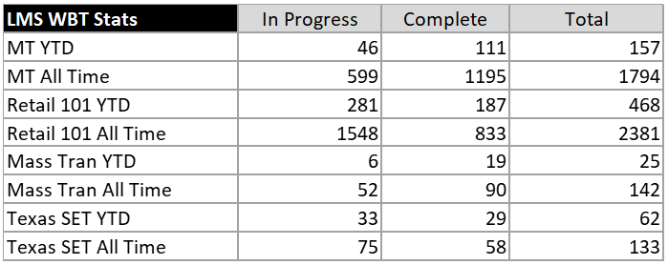

Tomas mentioned that web-based training will and may jump, since this is offered to new employees. Monica was asked about IAG/MT training in person. Tomas states maybe we consider in the future. Melinda asked about 5.0 training. Kathy mentioned Tammy is still working on slides.

Kathy asked Art if there was a problem with registration. Art apologized and explained issue was with the with default issue.

**TX SET Instructor Led class**

Art advised that there were 34 completed surveys. Tomas went over survey comments.

Below are a few comments from survey:

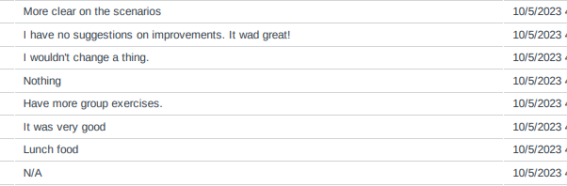

Debbie went over survey:

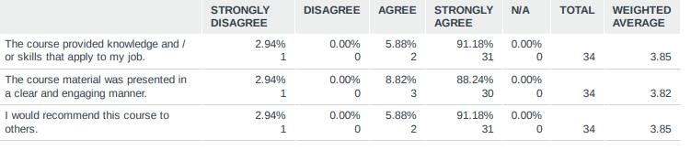

Amy Sue mentioned that its hard to read slides on notebook. Kathy says she can put 2 slides per page. Tomas says they can print on their own for future reference.

What can we improve for TX SET suggestions from survey:

* Sugar free snacks
* Class could start later
* Provide the link
* More group exercises
* More time for questions
* Larger slides

Tomas and Melinda mentioned that we started at 9 a.m. instead of 8:30 a.m.

Eric Broach (GEXA) says to provide parking instructions.

**November RMTTF meeting**

Debbie mentioned the RMTTF meeting for November. Melinda advised that November meeting should be cancelled and just have meeting in December.

**Training changes needed to support TX SET 5.0 and MarkeTrak**

Kathy mentioned that a presentation for TX SET training will be at MCT. Rough slides have been drafted and will get with Tammy.

Tomas asked Art who will be take care of slides for TX SET training WEB based.

Tammy will be updating MT.

Will discuss further in December.

**2024 Training dates**

Retail 101 – November 1

Debbie asked Art Retail 101 dates. Retail 101 dates will be discussed in December.

Art mentioned Retail 101 will be WebEx only and will provide update in December.

Debbie says ONCOR will host TX SET training in February and to plan to have RMTTF next day. We need to limit number of people to attend. Debbie will check with her building facilities people to see how many people can attend. She will provide an update in December.

Kathy mentioned that RMS is February 6th, so practice on Wednesday, TX SET February 8th and RMTTF February 9th. Sheri says VISTRA can be backup if ONCOR is not available.

MT/IAG training sometime 1st quarter – tentative March 6th and 7th and RMTTF mtg afternoon of March 6th.

RMTTF will stary with meeting on Thursdays.

Kathy will check with May 9th and May 10th for TX SET in Houston.

* May 9 TX SET
* May 10
* Alternates dates will be May 2 and May 3

MarkeTrak/IAG training will be March 6th and March 7th.

**Other Business:**

2024 dates will be discussed in December.

Meeting adjourned at 10:30 a.m.

RMTTF will not meet in November, next meeting will be December 7th.