RIOO-IS November 2023 Major Changes

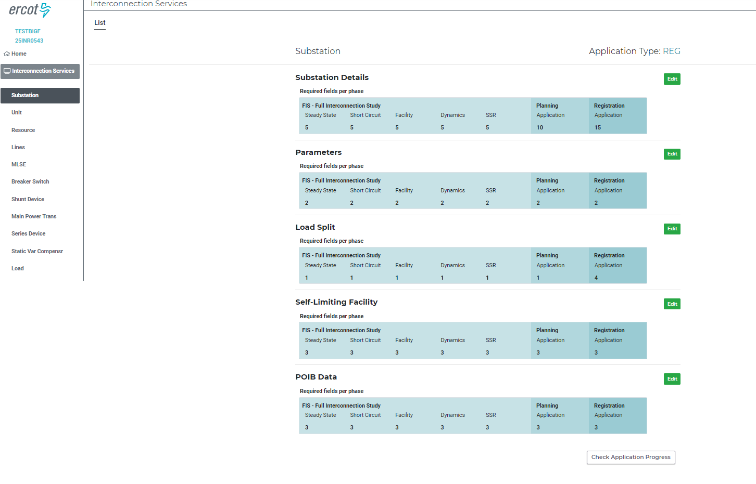
Figure 1 These two sections are new to RIOO-IS in the December 2023 update.
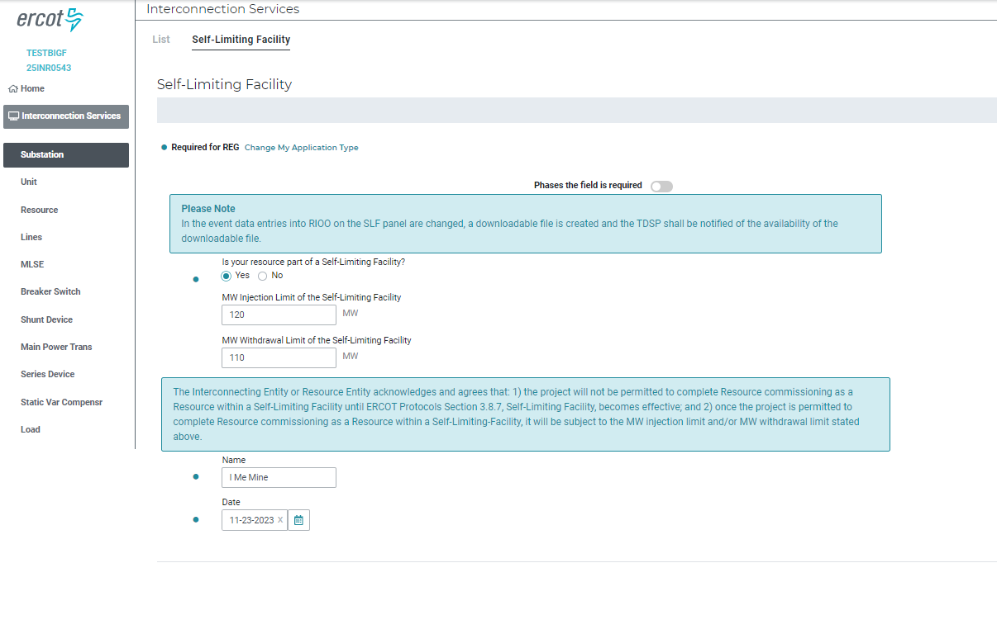
Figure 2 The SLF entries were moved from the Unit Details section to this section since SLF applies to the entire facility. Different Injection and Withdrawal limits are now available for entry. This panel needs an attestation from one of the contacts on the project with a date for the attestation. An email should be sent to the TSP for this project and to ERCOT if the Yes/No or Injection/Withdrawal limits are changed.
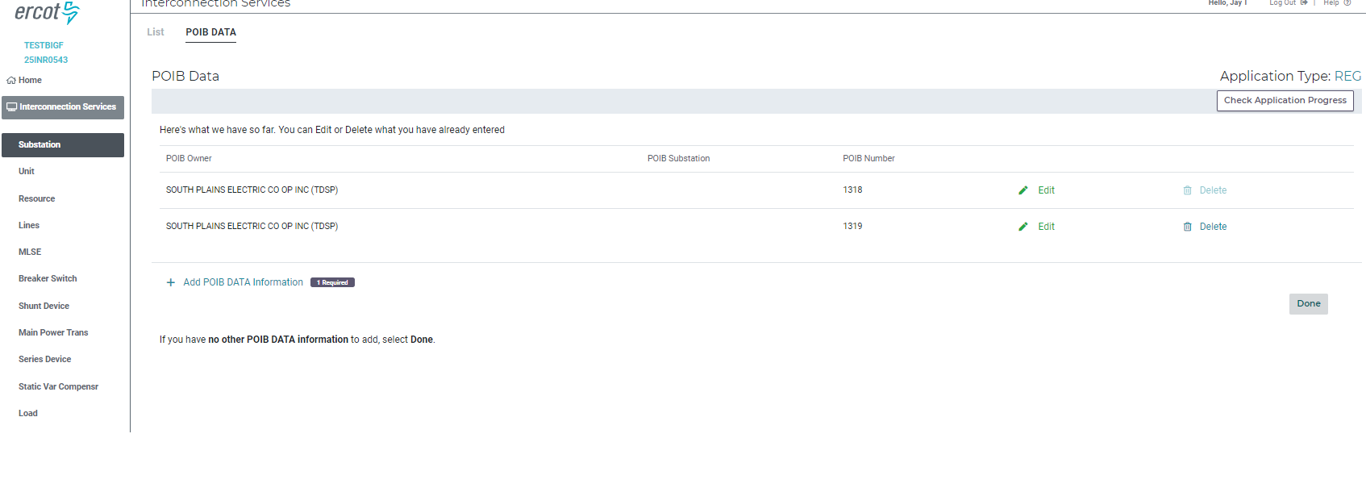
Figure 3 POIB data was moved from the Unit Details panel into the POIB panel under substation. The purpose was for the RE to be able to enter more than one POIB if necessary. An example of when this may be necessary is when there are two or more units in the RE substation that are not connected and each unit has a unique POIB. The RE would then enter each POIB as shown above by clicking the “+ Add POIB DATA Information” link. Most projects will have only one POIB.
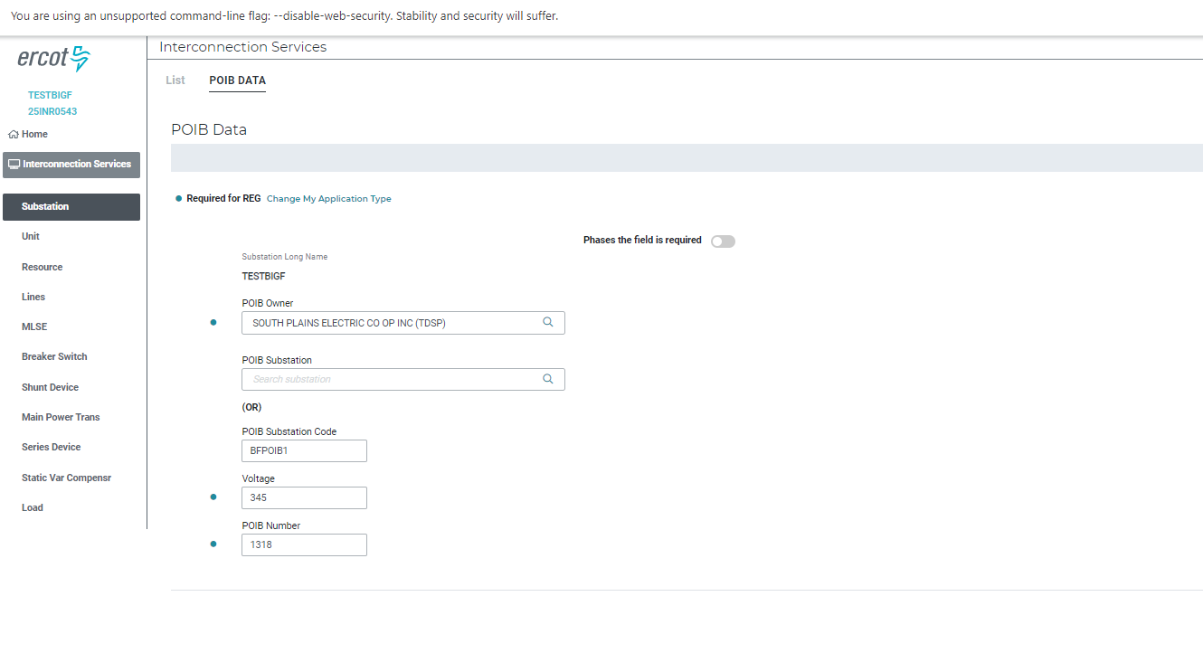
Figure 4 The data required for the POIB section has been expanded to include the substation code and POIB owner. If the POIB substation is an existing substation, then start typing the POIB Substation code in the upper box labeled “POIB Substation” and the station code will autofill if found. If the POIB Substation is a new station, then enter the new station code in the lower box labeled “POIB Substation Code”. Note that this is 8 character substation code and not the substation name.

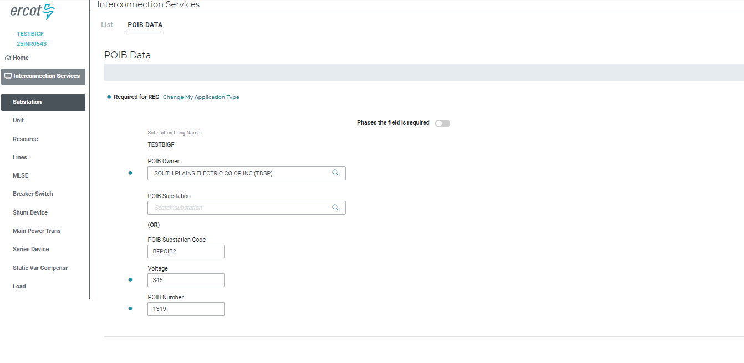
Figure 5 Same as the above figure but for the second POIB. Notice that the POIB Substation Code (BFPOIB2) and PIOB Number (1319) are different from the figure above.
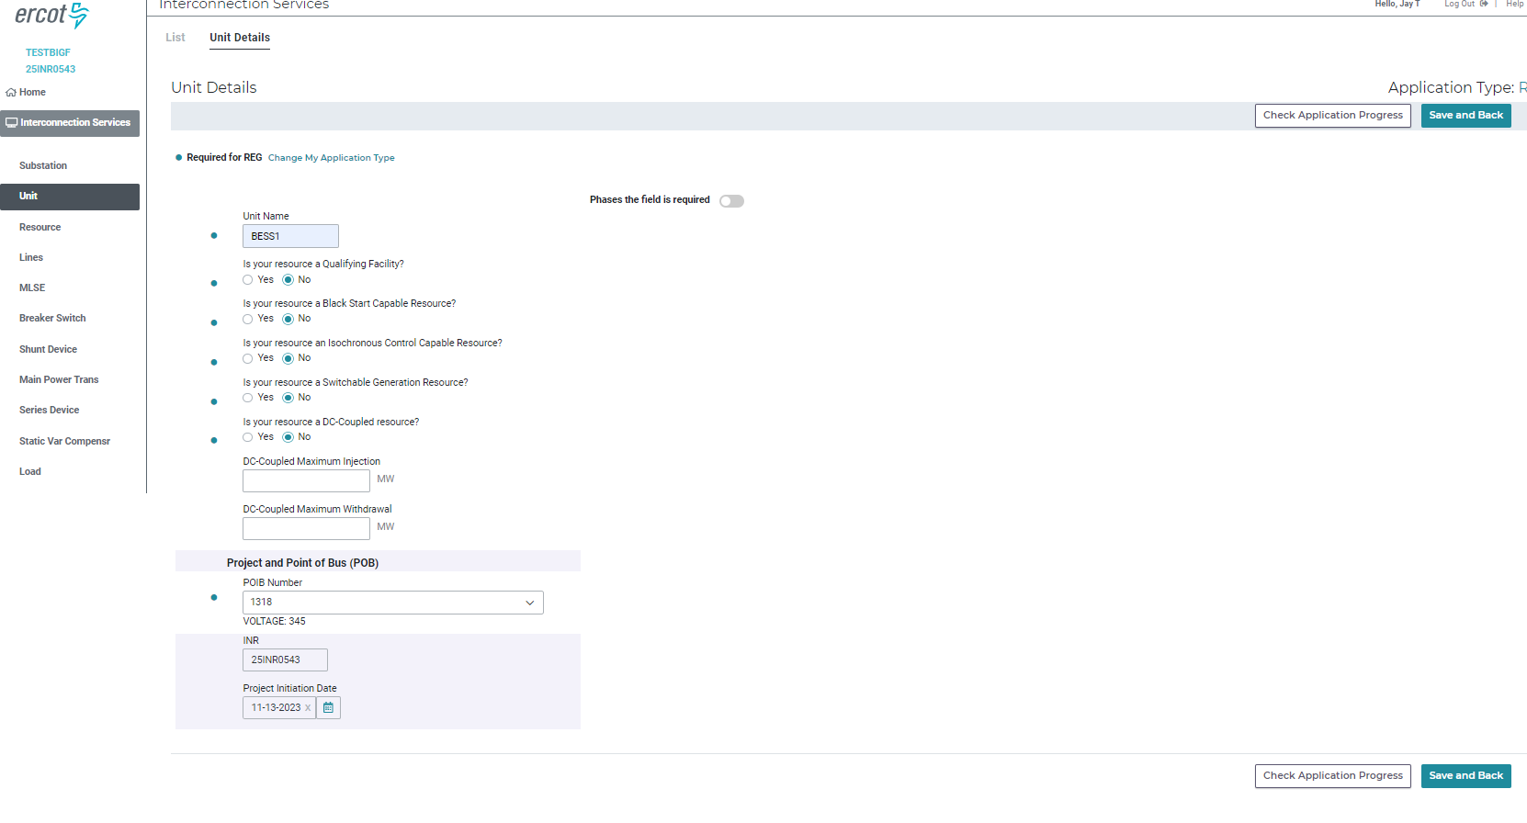
Figure 6 The Unit Details panel now has a drop down that contains the POIB Number(s) that were entered in Figures 4 or 5 above.

