September 2023 ERCOT Monthly Operations Report
Reliability and Operations Subcommittee Meeting
November 02, 2023

Table of Contents
1. Report Highlights 2
2. Frequency Control 3
2.1. Frequency Events 3
2.2. ERCOT Contingency Reserve Events 4
2.3. Responsive Reserve Events 5
2.4. Load Resource Events 5
3. Reliability Unit Commitment 5
4. IRR, Wind, and Solar Generation as a Percent of Load 6
5. Largest Net-Load Ramps 8
6. Congestion Analysis 8
6.1. Notable Constraints 8
6.2. Generic Transmission Constraint Congestion 16
6.3. Manual Overrides 16
6.4. Congestion Costs for Calendar Year 2023 17
7. System Events 18
7.1. ERCOT Peak Load 18
7.2. Load Shed Events 18
7.3. Stability Events 18
7.4. Notable PMU Events 19
7.5. DC Tie Curtailment 19
7.6. TRE/DOE Reportable Events 19
7.7. New/Updated Constraint Management Plans 19
7.8. New/Modified/Removed RAS 19
7.9. New Procedures/Forms/Operating Bulletins 19
8. Emergency Conditions 20
8.1. OCNs 20
8.2. Advisories 20
8.3. Watches 20
8.4. Emergency Notices 21
9. Application Performance 21
9.1. TSAT/VSAT Performance Issues 21
9.2. Communication Issues 21
9.3. Market System Issues 21
10. Model Updates 21
Appendix A: Real-Time Constraints 24

Report Highlights
- The unofficial ERCOT peak demand was 84,346 MW for the month of September on 9/08/2023 HE 17:00; this was 13,271 MW more than the previous September record of 71,075 MW set on 09/20/2022 HE 17:00, and 1,118 MW less than the previous all-time record of 85,464 MW set on 8/10/2023 HE 18:00.
- There were 3 frequency events.
- 1 Energy Emergency Alert Level 2 (Load Resources were deployed)
- There were 2 Watch’s due to projected reserve capacity shortage with no market solution.
- There were 2 Transmission Watch’s due to post-contingency overload South of San Antonio.
- There was 1 Advisory due to PRC falling below 3000 MW’s. (ERS Deployed)
- There was 1 instance where Distribution voltage reduction was requested.
- There was 1 Advisory due to Geomagnetic Disturbance K-7 of higher.
- There were 2 Media Appeal’s through public news media.
- There were 7 instances where ERCOT Contingency Reserve Service was released.
- 3 OCN’s due to ERCOT modifying the PNHNDL Generic Transmission Constraint due to the current transmission outage topology
- There were 17 HRUC commitments.
- There were 25 days congestion on the North Edinburg to Lobo GTC, 9 days on the Valley Export GTC, 8 days on the West Texas Export GTC, 7 days on the Nelson Sharpe to Rio Hondo GTC, 4 days on the North to Houston GTC, 4 days on the Panhandle GTC, 3 days on the East Texas GTC, 1 day on the Williamson to Burnet GTC, and 1 day on the McCamey GTC. There was no activity on the remaining GTCs during the month.

Frequency Control

Frequency Events
The ERCOT Interconnection experienced 3 frequency events, which resulted from units tripping. The shortest event duration was 03:29 and the longest was 08:29.

A summary of the frequency events is provided below. The reported frequency events meet one of the following criteria: Delta Frequency is 60 mHz or greater; the MW loss is 350 MW or greater; resource trip event triggered ECRS deployment. Frequency events that have been identified as Frequency Measurable Events (FME) for purposes of BAL-001-TRE-2 analysis are highlighted in blue. When analyzing frequency events, ERCOT evaluates PMU data according to industry standards. Events with an oscillating frequency of less than 1 Hz are inter-area, while higher frequencies indicate local events. Industry standards specify that damping ratio for inter-area oscillations should be 3.0% or greater. For the frequency events listed below, the ERCOT system met these standards and transitioned well after each disturbance. In the case of negative delta frequency, the MW Loss column could refer to load loss.

Date and Time | Delta Frequency | Max/Min Frequency | Duration of Event | PMU Data |  | MW Loss | Load | IRR | Inertia
 | (Hz) | (Hz) |  | Oscillation Mode (Hz) | Damping Ratio |  | (MW) | % | (GW-s)
9/8/2023 22:05:10 | 0.080 | 59.901 | 00:08:29 | 0.6 | 10% | 820 | 60,786 | 18% | 345,430
9/10/2023 5:52:38 | 0.085 | 59.925 | 00:04:07 | 0.63 | 8% | 536 | 45,862 | 22% | 308,998
9/22/2023 10:09:16 | 0.075 | 59.897 | 00:03:29 | 0.63 | 11% | 694 | 59,751 | 45% | 295,144

(Note: All data on this graph encompasses frequency event analysis based on BAL-001-TRE-2.)

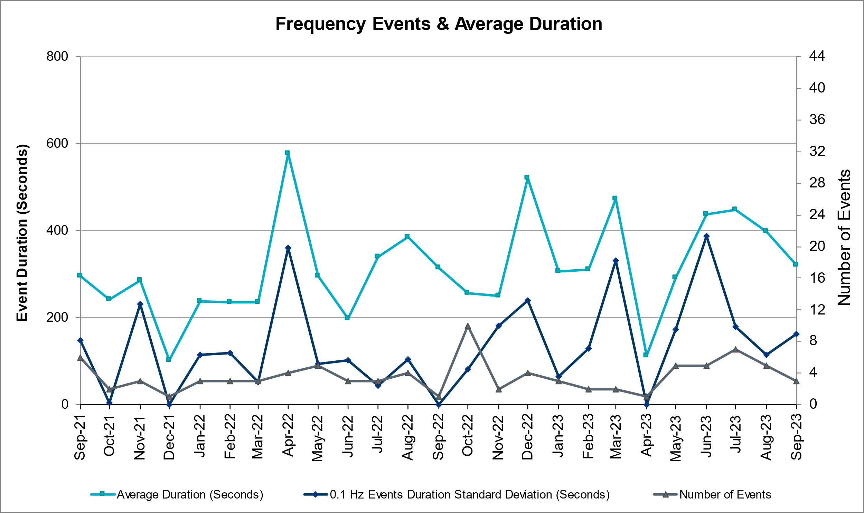

ERCOT Contingency Reserve Events
There were 7 events where ERCOT Contingency Reserve MWs were released to SCED. The events highlighted in blue were related to frequency events reported in Section 2.1 above.

Date and Time Released to SCED | Date and Time Recalled | Duration of Event |  | Maximum MWs Released |  | Comments
9/5/2023 19:20 | 9/5/2023 20:02 | 0:42:04 |  | 500 |  | Insufficient capability for forecasted 10min Ahead Net Load
9/6/2023 14:57 | 9/6/2023 20:55 | 5:58:40 |  | 2600 |  | Insufficient capability for forecasted 10min Ahead Net Load
9/7/2023 18:34 | 9/7/2023 20:03 | 1:28:56 |  | 1964 |  | Insufficient capability for forecasted 10min Ahead Net Load
9/8/2023 16:06 | 9/8/2023 17:43 | 1:37:08 |  | 1000 |  | Insufficient capability for forecasted 10min Ahead Net Load
9/8/2023 18:56 | 9/8/2023 19:32 | 0:36:00 |  | 750 |  | Insufficient capability for forecasted 10min Ahead Net Load
9/17/2023 18:56 | 9/17/2023 19:27 | 0:30:56 |  | 500 |  | Insufficient capability for forecasted 10min Ahead Net Load
9/22/2023 10:09 | 9/22/2023 10:13 | 0:03:56 | 232 |  | Unit Trip

Responsive Reserve Events
There was 1 event where Responsive Reserve MWs were released to SCED.

Date and Time Released to SCED | Date and Time Recalled | Duration of Event | Maximum MWs Released | Comments
9/6/2023 18:59 | 9/6/2023 19:55 | 0:55:52 | 1100 | Released for Capacity

Load Resource Events
A manual deployment of ECRS and RRS that was being supplied by Load Resources controlled by high-set UFRs (NCLRs) was deployed 9/6/2023. 1593 MW of NCLRs were deployed via an XML deployment on 9/6/2023 at 17:26:52. At about the same time, a notice was issued that EEA 2 was occurring. The LRs were automatically redeployed at 20:00:12 and then the ERCOT Operators started a manual recall operation at 20:04:19 by recalling Groups 3 and 4 of RRS and redeploying a portion that was still carrying ECRS and RRS. All remaining NCLRs carrying RRS and ECRS were recalled via XML instructions at 20:14:47.

Reliability Unit Commitment
ERCOT reports on Reliability Unit Commitments (RUC) monthly. Commitments are reported grouped by operating day and weather zone. The total number of hours committed is the sum of the hours for all the units in the specified region. Additional information on RUC commitments can be found on the MIS secure site at Grid Generation Reliability Unit Commitment.

There were no DRUC commitments.

There were 17 HRUC commitments.

Resource Location | # of Resources | Operating Day | Total # of Hours Committed | Total MWhs | Reason for Commitment
NORTH_CENTRAL, SOUTH_CENTRAL, SOUTHERN | 5 | 09/05/2023 | 42 | 5,820.0 | SYSTEM CAPACITY
SOUTH_CENTRAL | 1 | 09/06/2023 | 3 | 630.0 | SYSTEM CAPACITY
SOUTH_CENTRAL | 1 | 09/07/2023 | 2 | 420.0 | SYSTEM CAPACITY
SOUTH_CENTRAL | 1 | 09/12/2023 | 6 | 1,260.0 | SYSTEM CAPACITY
NORTH_CENTRAL, SOUTH_CENTRAL | 4 | 09/16/2023 | 33 | 12,590.0 | SYSTEM CAPACITY
NORTH_CENTRAL | 2 | 09/17/2023 | 22 | 12,036.0 | SYSTEM CAPACITY
SOUTHERN | 1 | 09/20/2023 | 8 | 2,320.0 | SYSTEM CAPACITY
SOUTHERN | 1 | 09/21/2023 | 4 | 1,000.0 | MIN RUN TIME
SOUTH_CENTRAL | 1 | 09/23/2023 | 6 | 1,260.0 | SYSTEM CAPACITY

IRR, Wind, and Solar Generation as a Percent of Load
The graph below shows the maximum, minimum and average aggregate solar, wind and IRR output as a percentage of total ERCOT load when evaluated as 10-minute averaged intervals, over the past 13 months. Current wind and solar generation and penetration records are listed in the footnote below. Maximum IRR penetration for the month was 49.10% on 09/04/2023 interval ending 09:40 and minimum IRR penetration for the month was 2.08% on 09/17/2023 interval ending 05:00.

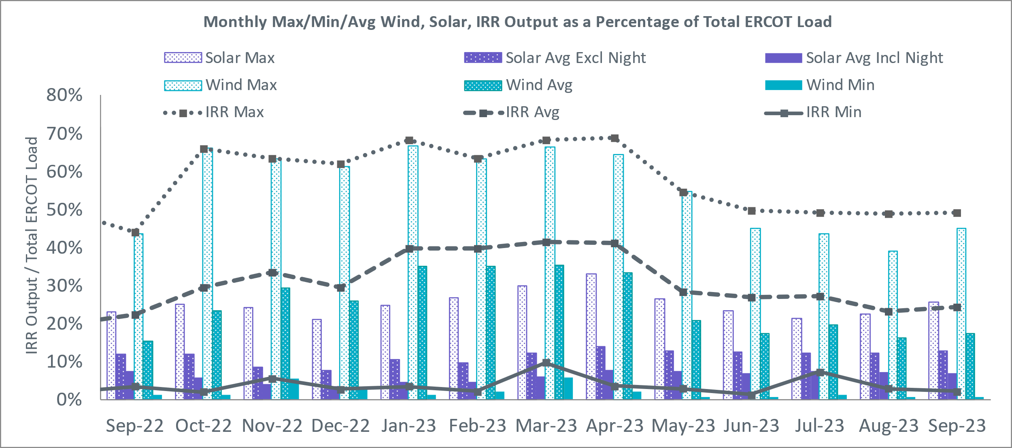

During the hour of peak load for the month, hourly integrated wind generation was 5,667 MW and solar generation was 12,380 MW. The graph below shows the wind and solar penetration percentage during the hour of the peak load in the last 13 months.

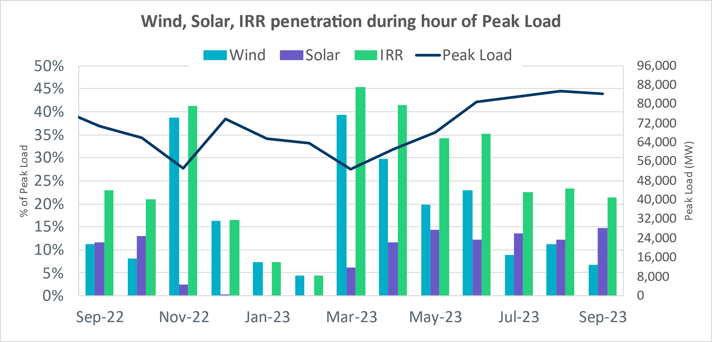

Lastly, the graph below shows the minimum wind, solar and IRR output during the peak load hour as a percentage of the daily peak load for every day in the month.

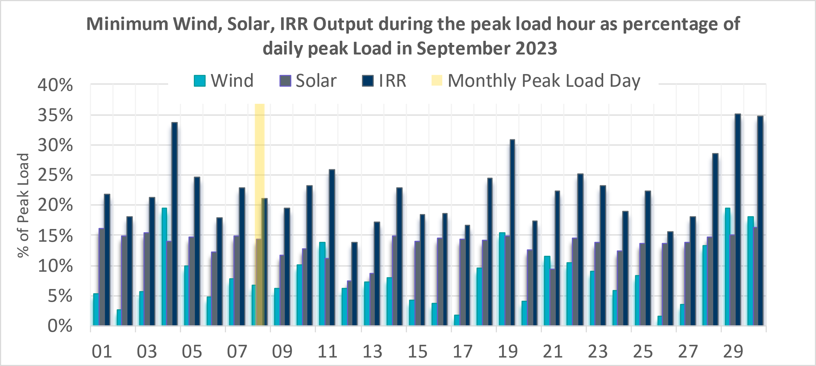

Largest Net-Load Ramps
The net-load ramp is defined as the change in net-load (load minus wind and PVGR generation) during the defined time horizon. Such a variation in net-load needs to be accommodated in grid operations to ensure that the reliability of the grid is satisfactorily maintained. The largest net-load ramp during 5-min, 10-min, 15-min, 30-min and 60-min in September 2023 is 1018 MW, 1642 MW, 2416 MW, 4129 MW, and 7947 MW, respectively. The comparison with respect to the historical values is given in the table below.

Month and Year | 5 min | 10 min | 15 min | 30 min | 60 min
September 2014 | 1,054 MW | 1,531 MW | 1,695 MW | 2,628 MW | 4,898 MW
September 2015 | 993 MW | 1,457 MW | 1,779 MW | 2,952 MW | 5,659 MW
September 2016 | 827 MW | 1,260 MW | 1,688 MW | 2,880 MW | 5,464 MW
September 2017 | 730 MW | 1,251 MW | 1,758 MW | 3,298 MW | 5,716 MW
September 2018 | 1,129 MW | 1,991 MW | 2,372 MW | 3,391 MW | 6,015 MW
September 2019 | 867 MW | 1,207 MW | 1,643 MW | 3,134 MW | 5,716 MW
September 2020 | 776 MW | 1,285 MW | 1,763 MW | 2,728 MW | 5,087 MW
September 2021 | 1,251 MW | 1,655 MW | 1,972 MW | 3,519 MW | 6,629 MW
September 2022 | 887 MW | 1,391 MW | 1,818 MW | 3,099 MW | 5,351 MW
September 2023 | 1,018 MW | 1,642 MW | 2,416 MW | 4,129 MW | 7,947 MW
All months in 2014-2023 | 1,647 MW | 2,157 MW | 3,015 MW | 5,882 MW | 10,750 MW

Congestion Analysis

Notable Constraints
Nodal protocol section 3.20 specifies that ERCOT shall identify transmission constraints that are binding in Real-Time three or more Operating Days within a calendar month. As part of this process, ERCOT reports congestion that meets this criterion to ROS. In addition, ERCOT also highlights notable constraints that have an estimated congestion rent exceeding $1,000,000 for a calendar month. These constraints are detailed in the table below, including approved transmission upgrades from TPIT that may provide some congestion relief based on ERCOT’s engineering judgement. Rows highlighted in blue indicate the congestion was affected by one or more outages. For a list of all constraints activated in SCED, please see Appendix A at the end of this report.

Contingency Name | Overloaded Element | # of Days Constraint Binding | Congestion Rent | Transmission Project
Elmcreek-Sanmigl 345kV | Pawnee Switching Station - Calaveras 345kV | 8 | $22,235,693.84 | South San Antonio RPG Project
BURLESON AEN to BURLESON AEN LIN 1 | Magnesium Plant - Northland 138kV | 6 | $15,949,272.79 | AEN_14TPIT0038_PMCR_NL_MP_Recond_3000A (2443)
HICKS SWITCH to HICKS SWITCH LIN _A | Hicks Switch - Alliance 345kV | 3 | $15,314,248.55 | Oncor_MW_RoanokeAreaProjects(21RPG008)
AUSTROP to DAFFIN GIN LIN 1 | Decker Power Plant - Aen Dunlap 138kV | 1 | $14,940,839.69 | AEN_24TPIT67091_PMCR_CKT1034_DUNLAP_DECKER_138 KV (67091)
Austro-Daffin&Dunlap-Decker 138kV | Sim Gideon - Bastrop City 138kV | 5 | $10,927,120.55
MGSES TO CCRSW 345 AND BTRCK TO MGSES 345 DBLCKT | Tonkawa Switch - Morgan Creek Ses 345kV | 17 | $10,246,163.95
SALSW - HUTTO 345KV | Bell County - Salado Switch 138kV | 13 | $8,772,628.98
Basecase | Pawnee Switching Station - Calaveras 345kV | 2 | $7,967,319.91
HUTTO TO RNDRK 138 AND HUTTO TO GEORSO 138 DBLCKT | Wells Branch - Howard Lane 138kV | 3 | $7,572,105.43
COLETO CREEK to Euler LIN 1 | Coleto Creek - Rosata Tap 138kV | 12 | $6,648,007.74 | AEP_TCC_UpgradeColetoCreek-Rosata(20RPG014)
DOUBLE MOUNTAIN SWITCH to DOUBLE MOUNTAIN SWITCH LIN 1 | Holly Substation - Dunbar Substation 115kV | 10 | $6,133,418.23
TRIDGE-ASHWDSnHWRDLN 138 KV | Hutto Switch - Round Rock Northeast 138kV | 2 | $5,986,504.59
CENTERVILLE to MCCREE LIN 1 | Shiloh - Mccree 138kV | 10 | $5,044,818.35
CAGNON - RAFTER & RAFTER - TX_RSRCH | Hondo Creek Switching Station - Moore Switching Station 138kV | 4 | $4,953,979.75
Calavers-Kirby&Beck_Rd 138kV | Braunig - Streich 138kV | 7 | $4,631,621.84
DMTSW TO SCOSW 345 DBLCKT | Knapp - Scurry Chevron 138kV | 9 | $4,236,419.40
WESLACO SWITCH to NORTH MERCEDES LIN 1 | Burns Sub - Rio Hondo 138kV | 2 | $4,023,712.71 | STEC_71930_RioHondo_Burns_Upgrade (71930), STEC_71926_Burns_Heidelberg_Upgrade (71926), STEC_71928_Heidelberg_AEPWeslaco_Upgrade (71928)
Manual dbl ckt for NEDIN-BONILLA 345kV & RIOH-PRIM138kV | Burns Sub - Rio Hondo 138kV | 9 | $3,900,908.56 | STEC_71930_RioHondo_Burns_Upgrade (71930), STEC_71926_Burns_Heidelberg_Upgrade (71926), STEC_71928_Heidelberg_AEPWeslaco_Upgrade (71928)
Basecase | NE_LOB GTC | 21 | $3,895,933.69 | The Lower Rio Grande Valley (LRGV) System Enhancement Project (21RPG017) will improve the NorthEd_LoboGTC to support up to 80% of total wind and solar generation capacity in the LRGV area.
Decker-Ed_Blues & Walnut 138kV | Kingsbery - Bergstrom 138kV | 1 | $3,789,304.16
CCRSW TO SWESW 345 AND BTRCK TO MGSES 345 DBLCKT | Tonkawa Switch - Morgan Creek Ses 345kV | 10 | $3,607,636.53
BOWMAN SWITCH TRX BOMSW_3_2 345/138 | Fisher Road Switch - Wichita Falls 138kV | 4 | $3,480,702.07
Basecase | WESTEX GTC | 8 | $3,164,896.59
RNDRK-CHIEBR & SPANOA 138kV | Round Rock Northeast - Hutto Switch 138kV | 2 | $3,088,683.25
South Texas # 1 & # 2 | Blessing - Lolita 138kV | 2 | $2,594,117.05
PALODURO SUB to PEARSALL SWITCHING STATION LIN 1 | Pearsall Switching Station 138kV | 23 | $2,304,612.43 | STEC_76790_upgradePearsallAuto (76790)
DUPONT SWITCH - INGLESIDE to DUPONT SWITCH - INGLESIDE LIN 1 | Dupont Switch - Ingleside - Lge 138kV | 13 | $2,225,802.62
AE-STR26&RIC82 138kV | Monsan Cogen - Petson 138kV | 2 | $2,207,583.30
BEALS CREEK SUB to BEALS CREEK SUB LIN _A | Big Spring West - Stanton East 138kV | 11 | $2,137,348.74
Loss of NEDIN train | Burns Sub - Rio Hondo 138kV | 4 | $2,132,901.81 | STEC_71930_RioHondo_Burns_Upgrade (71930), STEC_71926_Burns_Heidelberg_Upgrade (71926), STEC_71928_Heidelberg_AEPWeslaco_Upgrade (71928)
FOWLERTON to FOWLERTON LIN 1 | Laredo Vft North - Las Cruces 138kV | 5 | $2,047,706.10
MIDKIFF SWITCH to SKYWEST LIN 1 | Driver - Skywest 138kV | 2 | $1,986,872.99
Elmcreek-Sanmigl 345kV | Magruder - Victoria 138kV | 2 | $1,972,285.06
NUECES BAY - LON HILL 138 & GILA - TORTUGA 138 | Champlin - Weil Tract 138kV | 3 | $1,965,114.41 | ETT_TCC_Champlin-WeilTractRebuild (57912)
FALFURRIAS to FALFURRIAS LIN 1 | Burns Sub - Rio Hondo 138kV | 2 | $1,885,813.65 | STEC_71930_RioHondo_Burns_Upgrade (71930), STEC_71926_Burns_Heidelberg_Upgrade (71926), STEC_71928_Heidelberg_AEPWeslaco_Upgrade (71928)
CALAVERAS to CALAVERAS LIN 1 | Coleto Creek - Rosata Tap 138kV | 4 | $1,786,137.51 | AEP_TCC_UpgradeColetoCreek-Rosata(20RPG014)
VICTORIA TRX 69A2 138/69 | Magruder - Victoria 138kV | 1 | $1,660,370.02
BLACKWATER DRAW SWITCH to DOUBLE MOUNTAIN SWITCH LIN 1 | Mackenzie Substation - Northeast Substation 115kV | 9 | $1,552,529.79
Hutto-Zorn & Gillcr 345kV | Hutto Switch 345kV | 2 | $1,444,543.06
WHITE OAK TRX WO_AT1 345/138 | Campbell - Addicks 138kV | 2 | $1,428,942.76
Basecase | VALEXP GTC | 8 | $1,424,782.00 | The Lower Rio Grande Valley (LRGV) System Enhancement Project (21RPG017) will improve but not eliminate the need for this GTC.
BEVO to BEVO LIN 1 | Hamilton Road - Maverick 138kV | 10 | $1,342,755.69 | Escondido to Hamilton Road 138 kV Line Rebuild Project (22RPG044)
COMAL to HENNE LIN 1 | Mccarty Lane - Zorn 138kV | 1 | $1,222,669.13
MCSES TO CDHSW 138 DBLCKT | Cedar Crest Switch - Oak Cliff South 138kV | 3 | $1,202,182.53
TWR (345) JN-WAP64 & JN-WAP72 | Wa Parish - Obrien 345kV | 4 | $1,151,039.14
NORTH EDINBURG to NORTH EDINBURG LIN 1 | Burns Sub - Rio Hondo 138kV | 1 | $1,140,830.19 | STEC_71930_RioHondo_Burns_Upgrade (71930), STEC_71926_Burns_Heidelberg_Upgrade (71926), STEC_71928_Heidelberg_AEPWeslaco_Upgrade (71928)
CENTERVILLE to CENTERVILLE LIN 1 | Mesquite Forney Road - Buckner Home 138kV | 2 | $1,099,807.22
LON HILL to NELSON SHARPE LIN 1 | Nelson Sharpe 345kV | 7 | $1,073,672.71
Cagnon-Kendal 345 & Cico-Comfor 138 | Bergheim - Kendall 345kV | 5 | $1,031,609.00
Manual White Point to Angstrom & Lon Hill 345KV DOUBLE | Blessing - Lolita 138kV | 2 | $1,014,169.84
BAKERSFIELD SWITCHYARD to CEDAR CANYON LIN 1 | Rocky Road - Stiles 138kV | 5 | $988,067.02
Rattlesnake Rd Switch to LAKE CREEK SES LIN _A | St Johns Switch - Jewett 345kV | 3 | $882,539.25
BBSES TO RCHBR 345 DBLCKT | Pin Oak Switch - Fairfield Bepc 138kV | 9 | $857,899.12 | Oncor_SE_62327_Fairfield West - Big Brown Tap 138 kV Line (62327)
Elmcreek-Sanmigl 345kV | Coleto Creek - Rosata Tap 138kV | 4 | $719,996.28 | AEP_TCC_UpgradeColetoCreek-Rosata(20RPG014)
Carver to Carver LIN 1 | Atlantic Sonora - Sonora 69kV | 12 | $703,653.27
DESOTO SWITCH to RED OAK LIN _A | Trumbull 138kV | 5 | $638,616.04
Jn-Fd & Ro 138kV | Brays - H O Clarke 138kV | 3 | $628,476.62
SWESW TO BTRCK AND SWESW TO CCRSW 345 DBLCKT | Tonkawa Switch - Morgan Creek Ses 345kV | 3 | $602,900.27
FOWLERTON to FOWLERTON LIN 1 | Catarina - Piloncillo 138kV | 12 | $600,592.11 | AEP_TCC_AshertontoPiloncillo138kVLine_rebuild (73100)
wett_long_draw to VEALMOOR - Sharyland Utilities LIN 1 | Willow Valley Switch - Gail Sub 138kV | 4 | $569,967.21
ENNIS SOUTH to ENNIS SOUTH LIN _C | Shankle Switch - Ennis West Switch 138kV | 6 | $500,092.62
Basecase | Hamilton Road - Maverick 138kV | 5 | $473,985.84
CROSS to CROSS LIN 1 | Pearsall Switching Station 138kV | 9 | $433,073.19 | STEC_76790_upgradePearsallAuto (76790)
STNVL TO CPSES 138 AND STNVL TO WHTNY 138 DBLCKT | Stephenville (Oncor) - Stephenville Bepc 138kV | 3 | $420,268.86
SALSW TO KLNSW 345 DBLCKT | Harker Heights South - Killeen Switch 138kV | 3 | $410,995.39
MANUAL PRSSW-HWKSW 138 DBLCKT | Rivercrest Ses - Deport Rea 138kV | 4 | $391,938.71
Cagnon-Kendal 345 &Cico-Mengcr 138 | Medina Lake - Pipe Creek 138kV | 7 | $345,692.17
ZORN - HAYSEN 345KV | Bergheim 138kV | 3 | $288,276.25
MAN_DBL_'CONSW-MGSES_and_CONSW-LNGSW_345kV_DBLCKT | Morgan Creek Ses - Navigation Sub 138kV | 6 | $276,218.28
BAKERSFIELD SWITCHYARD to CEDAR CANYON LIN 1 | San Angelo Concho - San Angelo Lake Nasworthy 69kV | 5 | $242,869.52
TWIN BUTTES to HARGROVE LIN 1 | San Angelo Concho - San Angelo Lake Nasworthy 69kV | 5 | $236,794.79
ODESSA EHV SWITCH to ODESSA EHV SWITCH LIN 1 | Koch Tap - Vealmoor 138kV | 5 | $226,767.35
MAN_DBL_'CONSW-MGSES_and_CONSW-LNGSW_345kV_DBLCKT | Rocky Road - Stiles 138kV | 3 | $217,387.77
LAQUINTA to LOBO LIN 1 | Bruni Sub 138kV | 13 | $211,345.60
FORT LANCASTER to FORT LANCASTER LIN 1 | Palouse - Wolfcamp 138kV | 5 | $161,543.85
YELWJCKT - FORTMA (138) & HEXT (69) | Katemcy - Mason Aep 69kV | 3 | $132,842.75
ST. LAWRENCE to EINSTEIN LIN 1 | Carterville - Einstein 138kV | 6 | $123,020.29
MEADOW to OASIS LIN A | Monsan Cogen - Petson 138kV | 3 | $111,433.17
ODLAW SWITCH to ASPHALT MINES LIN 1 | Hamilton Road - Maverick 138kV | 4 | $103,805.94 | Escondido to Hamilton Road 138 kV Line Rebuild Project (22RPG044)
Bighil-Kendal 345kV | Hamilton Road - Maxwell 138kV | 3 | $101,403.96 | AEP_TCC_HamiltonRoad-Maxwell(20RPG022)
AJO to AJO LIN 1 | Las Pulgas - Raymondville 2 138kV | 4 | $79,853.93
Basecase | NELRIO GTC | 4 | $76,313.63 | The Lower Rio Grande Valley (LRGV) System Enhancement Project (21RPG017) will cause there to be no stability constraint for NelsonSharpe_RioHondoGTC under normal conditions.
CARTERVILLE to EINSTEIN LIN 1 | Rocky Road - Stiles 138kV | 4 | $74,481.74
Manual STP to HLJ & Anstrom345 KV DOUBLE | Sea Drift Coke - North Carbide 138kV | 4 | $71,052.60
LISTON to BATES LIN 1 | Roma - Roma Switch 138kV | 5 | $69,357.40
MADDUX to SAN ANGELO POWER STATION LIN 1 | Maddux - San Angelo Power Station 138kV | 9 | $69,041.63
FOWLERTON to FOWLERTON LIN 1 | Asherton - Catarina 138kV | 6 | $67,029.33 | AEP_TCC_AshertontoPiloncillo138kVLine_rebuild (73100)
FORT LANCASTER to FORT LANCASTER LIN 1 | Hamilton Road - Maxwell 138kV | 5 | $59,750.73 | AEP_TCC_HamiltonRoad-Maxwell(20RPG022)
LAQUINTA to LOBO LIN 1 | Falfurrias - Premont 69kV | 5 | $59,439.81
Bighil-Kendal 345kV | Yellow Jacket - Treadwell 138kV | 4 | $32,188.88
Carver to Carver LIN 1 | Maddux - San Angelo Power Station 138kV | 3 | $23,861.06
FOWLERTON to FOWLERTON LIN 1 | Asherton - Catarina 138kV | 4 | $15,677.71 | AEP_TCC_AshertontoPiloncillo138kVLine_rebuild (73100)
Manual for I_DUPS - RESNIK & MCCAMPBE 2 138KV | Whitepoint - Rincon 138kV | 4 | $15,418.14

Generic Transmission Constraint Congestion
There were 25 days congestion on the North Edinburg to Lobo GTC, 9 days on the Valley Export GTC, 8 days on the West Texas Export GTC, 7 days on the Nelson Sharpe to Rio Hondo GTC, 4 days on the North to Houston GTC, 4 days on the Panhandle GTC, 3 days on the East Texas GTC, 1 day on the Williamson to Burnet GTC, and 1 day on the McCamey GTC. There was no activity on the remaining GTCs during the month.

Note: This is how many times a constraint has been activated to avoid exceeding a GTC limit, it does not imply an exceedance of the GTC occurred or that the GTC was binding.

Manual Overrides
On 9/6/2023 18:40, ERCOT issued manual HDL override for congestion management and the override
was removed on 9/6/2023 20:30.

On 9/7/2023 19:05, ERCOT issued manual HDL override for congestion management and the override was removed on 9/7/2023 20:15.

Congestion Costs for Calendar Year 2023
The following table represents the top twenty active constraints for the calendar year based on the estimated congestion rent attributed to the congestion. ERCOT updates this list on a monthly basis.

Contingency | Overloaded Element | # of 5-min SCED | Estimated Congestion Rent (2023)
MAN_DBL_MDSSW-ODEHB_and_CONSW-QALSW_345kV_DBLCKT | Midessa South Sw 138kV | 11605 | $79,014,288.16
Basecase | NE_LOB GTC | 32794 | $58,113,523.89
Basecase | WESTEX GTC | 15670 | $54,679,822.10
BEVO to BEVO LIN 1 | Hamilton Road - Maverick 138kV | 7549 | $52,011,887.52
Rattlesnake Rd Switch to LAKE CREEK SES LIN _A | St Johns Switch - Jewett 345kV | 4796 | $45,745,832.64
SKYWEST to SKYWEST LIN 1 | Consavvy Switch - Cottonfield Sub 138kV | 2909 | $45,341,291.63
MGSES TO CCRSW 345 AND BTRCK TO MGSES 345 DBLCKT | Tonkawa Switch - Morgan Creek Ses 345kV | 7345 | $42,441,144.03
SKYWEST to SKYWEST LIN 1 | South Midland - Consavvy Switch 138kV | 10282 | $41,928,489.30
HICKS SWITCH to HICKS SWITCH LIN _A | Hicks Switch - Alliance 345kV | 2814 | $40,032,160.11
SALSW - HUTTO 345KV | Bell County - Salado Switch 138kV | 4538 | $37,595,853.70
TWR(345) WAP-WLF64 & CCK-WLY72 | South Texas Project - Wa Parish 345kV | 4025 | $34,465,421.37
BLACKWATER DRAW SWITCH to DOUBLE MOUNTAIN SWITCH LIN 1 | Mackenzie Substation - Northeast Substation 115kV | 9120 | $31,289,045.51
Austro-Daffin&Dunlap-Decker 138kV | Sim Gideon - Bastrop City 138kV | 2244 | $28,796,696.82
DMTSW TO SCOSW 345 DBLCKT | Knapp - Scurry Chevron 138kV | 9728 | $26,549,405.83
Manual_SGL_CONSW-MDSSW_345kV_SglCkt | Quail Switch - Odessa Ehv Switch 345kV | 3594 | $26,545,479.50
Basecase | PNHNDL GTC | 8252 | $24,636,322.43
COLETO CREEK to Euler LIN 1 | Coleto Creek - Rosata Tap 138kV | 7241 | $23,965,165.46
Manual dbl ckt for NEDIN-BONILLA 345kV & RIOH-PRIM138kV | Burns Sub - Rio Hondo 138kV | 10039 | $23,876,652.58
MAN_DBL_MDSSW-ODEHB_and_CONSW-QALSW_345kV_DBLCKT | Midessa South Sw 138kV | 11605 | $79,014,288.16
Basecase | NE_LOB GTC | 32794 | $58,113,523.89

System Events

ERCOT Peak Load
The unofficial ERCOT peak load for the month was 84,343 MW and occurred on 9/08/2023, during hour ending 17:00.

Load Shed Events
None.

Stability Events
None.

Notable PMU Events
ERCOT analyzes PMU data for any significant system disturbances that do not fall into the Frequency Events category reported in section 2.1. The results are summarized in this section once the analysis has been completed.

There were no PMU events outside of those reported in section 2.1.

DC Tie Curtailment
Date | DC Tie | Curtailing Period | # of Tags Curtailed | Initiating Event | Curtailment Reason,
9/6/2023 | DC_L | 19:56 – 20:34 | 10 | Actual or Anticipated Emergency | Actual or Anticipated Emergency in its Control Area. EEA2 Status.

TRE/DOE Reportable Events

- ERCOT Submitted a DOE-417 on 09/06/2023 for Emergency Event-Media Appeal
- ERCOT Submitted a DOE-417 on 09/07/2023 for Emergency Event-Media Appeal
- Oncor Submitted a DOE-417 on 09/08/2023 for Loss of 50,000 customers
- BPUB Submitted a DOE-417 on 09/18/2023 for Physical threat to its facility
- Oncor Submitted a DOE-417 on 09/24/2023 for Loss of 50,000 customers
- LCRA Submitted a DOE-417 on 07/21/2023 (Received Late) for Loss of 3 or more BES Elements

New/Updated Constraint Management Plans

There were 3 CMP modifications: MP_2021_02, MP_2023_11, and MP_2023_12

New/Modified/Removed RAS
None.

New Procedures/Forms/Operating Bulletins
None.

Emergency Conditions

OCNs
Date and Time | Message
Sept 5, 2023 10:30  CPT | ERCOT issued an OCN for the extreme hot weather with forecasted temperatures to be above 103°F in the North Central and South Central weather zones, from Thursday, September 07, 2023 until Saturday, September 09, 2023.
Sept 18, 2023 10:09  CPT | ERCOT issued an OCN due to ERCOT modifying the PNHNDL Generic Transmission Constraint due to the current transmission outage topology, effective at 10:09.
Sept 19, 2023 09:25  CPT | ERCOT issued an OCN due to ERCOT modifying the PNHNDL Generic Transmission Constraint due to the current transmission outage topology.
Sept 25, 2023 07:46  CPT | ERCOT issued an OCN due to ERCOT modifying the PNHNDL Generic Transmission Constraint due to the current transmission outage topology.

Advisories
Date and Time | Message
Sept 06, 2023 19:15  CPT | ERCOT issued an Advisory due to Physical Responsive Capability being below 3000 MW.
Sept 06, 2023 19:15  CPT | During the Advisory on 9/6/23, ERCOT requested Transmission Operators to implement distribution voltage reduction measures if available from 19:15 to 20:44.
Sept 19, 2023 01:26  CPT | Advisory issued for a geomagnetic disturbance of K7 until 09/19/2023 at 04:00.

Watches
Date and Time | Message
Sept 06, 2023 09:30  CPT | ERCOT issued a Watch for a projected reserve capacity shortage with no market solution available for Wednesday, September 06, 2023, HE 19:00 – 20:00, which causes a risk for an EEA event.
Sept 06, 2023 18:34  CPT | ERCOT issued a Transmission Watch for post-contingency overload South of San Antonio and manual actions are being performed to reduce post contingency overloads.
Sept 07, 2023 10:00  CPT | ERCOT issued a Watch for a projected reserve capacity shortage with no market solution available for Wednesday, September 06, 2023, HE 19:00 – 20:00, which causes a risk for an EEA event.
Sept 07, 2023 18:55  CPT | ERCOT issued a Transmission Watch for post-contingency overload South of San Antonio and manual actions are being performed to reduce post contingency overloads.

Emergency Notices
Date and Time | Message
Sept 6, 2023 19:25  CPT | ERCOT declared Energy Emergency Alert 2. Reserves below 1,750 MW. Load Resources being deployed. No controlled outages at this time. Please conserve energy.
Sept 6, 2023 20:27  CPT | ERCOT moved from Energy Emergency Alert 2 to Energy Emergency Alert 1.
Sept 6, 2023 20:37  CPT | ERCOT ended EEA1 and returned to normal operations.

Application Performance

TSAT/VSAT Performance Issues
None

Communication Issues
None.

Market System Issues
None.

Model Updates
The Downstream Production Change (DPC) process allows ERCOT to make changes in the on-line Network Operations Model without loading a completely new model. The purpose of this process is to allow for reliable grid operations as system conditions change between designated Network Operations Model database loads. The DPC process is limited in scope to just those items listed below, with equipment ratings updates being the most common. ERCOT has seen a rise in the use of the DPC process to make on-line updates to the Network Operations Model in recent years, instead of through the standard Network Operations Model Change Request process.

- Static Line ratings (Interim Update)
- Dynamic Line ratings (non-Interim Update)
- Autotransformer ratings (non-Interim Update)
- Breaker and Switch Normal status (Interim Update)
- Contingency Definitions (Interim Update)
- RAP and RAS changes or additions (Interim Update)
- Net Dependable and Reactive Capability (NDCRC) values (Interim Update)
- Impedance Updates (non-Interim)

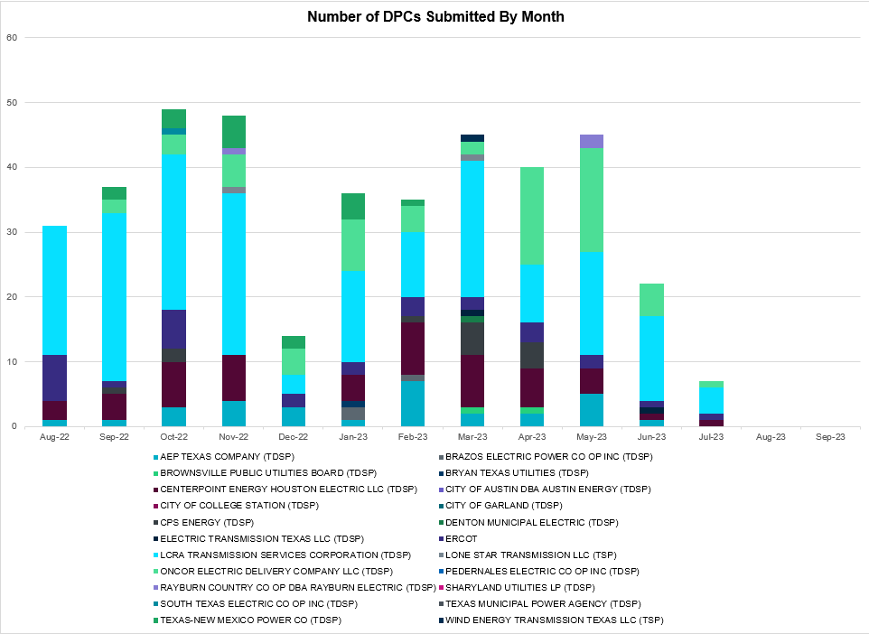

Transmission Operator | Number of DPCs
AEP TEXAS COMPANY (TDSP) | 0
BRAZOS ELECTRIC POWER CO OP INC (TDSP) | 0
BROWNSVILLE PUBLIC UTILITIES BOARD (TDSP) | 0
BRYAN TEXAS UTILITIES (TDSP) | 0
CENTERPOINT ENERGY HOUSTON ELECTRIC LLC (TDSP) | 0
CITY OF AUSTIN DBA AUSTIN ENERGY (TDSP) | 0
CITY OF COLLEGE STATION (TDSP) | 0
CITY OF GARLAND (TDSP) | 0
CPS ENERGY (TDSP) | 0
DENTON MUNICIPAL ELECTRIC (TDSP) | 0
ELECTRIC TRANSMISSION TEXAS LLC (TDSP) | 0
ERCOT | 0
LCRA TRANSMISSION SERVICES CORPORATION (TDSP) | 0
LONE STAR TRANSMISSION LLC (TSP) | 0
ONCOR ELECTRIC DELIVERY COMPANY LLC (TDSP) | 0
PEDERNALES ELECTRIC CO OP INC (TDSP) | 0
RAYBURN COUNTRY CO OP DBA RAYBURN ELECTRIC (TDSP) | 0
SHARYLAND UTILITIES LP (TDSP) | 0
SOUTH TEXAS ELECTRIC CO OP INC (TDSP) | 0
TEXAS MUNICIPAL POWER AGENCY (TDSP) | 0
TEXAS-NEW MEXICO POWER CO (TDSP) | 0
WIND ENERGY TRANSMISSION TEXAS LLC (TSP) | 0

Appendix A: Real-Time Constraints
The following is a complete list of constraints activated in SCED. Full contingency descriptions can be found in the Standard Contingencies List located on the MIS secure site at Grid Generation Reliability Unit Commitment.
Year | Month of the Year | Contingency Name | Overloaded Element | From Station | To Station | Count of Days
2023 | 9 | BASE CASE | NE_LOB | n/a | n/a | 25
2023 | 9 | SBATPEA8 | PEARSALL_69_4 | PEARSALL | PEARSALL | 25
2023 | 9 | DMGSBIT5 | 6036__A | TKWSW | MGSES | 20
2023 | 9 | DMGSBTR5 | 6036__A | TKWSW | MGSES | 20
2023 | 9 | SVEAW_L5 | 6217__A | WLVSW | GAILS | 18
2023 | 9 | SLOBSA25 | CATARI_PILONC1_1 | PILONCIL | CATARINA | 15
2023 | 9 | SLOBSA25 | CATARI_PILONC1_1 | CATARINA | PILONCIL | 15
2023 | 9 | SLAQLOB8 | BRUNI_69_1 | BRUNI | BRUNI | 14
2023 | 9 | SCO2EUL8 | COLETO_ROSATA1_1 | COLETO | ROSATA | 14
2023 | 9 | SLGEI_D8 | I_DUPS_LGE1_1 | LGE | I_DUPSW | 14
2023 | 9 | DMTSCOS5 | 6437__F | SCRCV | KNAPP | 14
2023 | 9 | DSALHUT5 | 1710__C | BELCNTY | SALSW | 13
2023 | 9 | SDIMBEV8 | HAMILT_MAVERI1_1 | HAMILTON | MAVERICK | 13
2023 | 9 | SGARBAT8 | RKYROAD_STILES_1 | RCKYROAD | STILES | 13
2023 | 9 | SLOBSA25 | ASHERT_CATARI1_1 | ASHERTON | CATARINA | 12
2023 | 9 | SLOBSA25 | ASHERT_CATARI1_1 | CATARINA | ASHERTON | 12
2023 | 9 | SNATBEA8 | 6144__A | BSPRW | STASW | 12
2023 | 9 | SCARFRI8 | ATSO_SONR1_1 | SONR | ATSO | 12
2023 | 9 | SCENMCC8 | SHIL_MCC_1 | MCCREE | SHILOH | 11
2023 | 9 | DBBSRCH5 | 1240__J | POKSW | FFD | 11
2023 | 9 | SW_GODE5 | 15060__B | VEALMOOR | KOCHTAP | 11
2023 | 9 | SBAKCED5 | CONCHO_SANW0_1 | CONCHO | SANW | 11
2023 | 9 | DELMSAN5 | PAWNEE_SPRUCE_1 | CALAVERS | PAWNEE | 11
2023 | 9 | DELMSAN5 | PAWNEE_SPRUCE_1 | PAWNEE | CALAVERS | 11
2023 | 9 | SDBMFID5 | LPLHY_LPLDB_1 | LPLDB | LPLHY | 11
2023 | 9 | SLOBSA25 | LARDVN_LASCRU1_1 | LARDVNTH | LASCRUCE | 10
2023 | 9 | SMADSAP8 | MADDUX_SAPOWE2_1 | MADDUX | SAPOWER | 10
2023 | 9 | SCROSAN8 | PEARSALL_69_4 | PEARSALL | PEARSALL | 10
2023 | 9 | SBENS_M8 | BENTS_FRTER_1C_1 | RAILROAD | S_MISSIN | 10
2023 | 9 | MCONLNG5 | 6471__C | MGSES | NAVIG | 10
2023 | 9 | SBENS_M8 | BENTS_FRTER_1C_1 | S_MISSIN | RAILROAD | 10
2023 | 9 | DSWECCR5 | 6036__A | TKWSW | MGSES | 10
2023 | 9 | BASE CASE | VALEXP | n/a | n/a | 9
2023 | 9 | MHARNED5 | BURNS_RIOHONDO_1 | RIOHONDO | MV_BURNS | 9
2023 | 9 | SSTLEIN8 | CRTVLE_EINSTEN_1 | EINSTEIN | CRTRVLLE | 9
2023 | 9 | SBWDDBM5 | LPLMK_LPLNE_1 | LPLMK | LPLNE | 9
2023 | 9 | DCAGCI58 | 255T279_1 | PIPECR | MEDILA | 9
2023 | 9 | SBGLTWI8 | CONCHO_SANW0_1 | CONCHO | SANW | 8
2023 | 9 | BASE CASE | WESTEX | n/a | n/a | 8
2023 | 9 | BASE CASE | HAMILT_MAVERI1_1 | HAMILTON | MAVERICK | 7
2023 | 9 | SCARBU28 | CKT_979_1 | MAGPLANT | NORTHLAN | 7
2023 | 9 | SDESRDO8 | TRU_UAT1 | TRU | TRU | 7
2023 | 9 | SLAQLOB8 | FALFUR_PREMON1_1 | FALFUR | PREMONT | 7
2023 | 9 | BASE CASE | NELRIO | n/a | n/a | 7
2023 | 9 | DCAGCO58 | 656T656_1 | KENDAL | BERGHE | 7
2023 | 9 | BASE CASE | HAMILT_MAVERI1_1 | MAVERICK | HAMILTON | 7
2023 | 9 | SN_SLON5 | N_SHARPE_XF1 | N_SHARPE | N_SHARPE | 7
2023 | 9 | DCALBEC8 | U2_X3_1 | BRAUNIG | X3 | 7
2023 | 9 | DSALKLN5 | 630__B | KLNSW | HHSTH | 6
2023 | 9 | DBIGKEN5 | TREADW_YELWJC1_1 | TREADWEL | YELWJCKT | 6
2023 | 9 | SCOLPAW5 | COLETO_ROSATA1_1 | COLETO | ROSATA | 6
2023 | 9 | SBAKCED5 | RKYROAD_STILES_1 | RCKYROAD | STILES | 6
2023 | 9 | MRESMCM8 | RINCON_WHITE_2_1 | RINCON | WHITE_PT | 6
2023 | 9 | SBAKCED5 | CROSSO_PALOUS1_1 | PALOUSE | CROSSOVE | 6
2023 | 9 | SENSENW8 | 943__B | ENWSW | SHKSW | 6
2023 | 9 | SLISBAT8 | RGCIT_ROMAS_1C_1 | ROMA_SW | ROMA | 5
2023 | 9 | MPRSHWK8 | 1561__A | DPREA | RCSES | 5
2023 | 9 | MSTPANS5 | NCARBI_SEADRF1_1 | NCARBIDE | SEADRFTC | 5
2023 | 9 | DWAP_JN5 | OB_WAP99_A | WAP | OB | 5
2023 | 9 | SILLFTL8 | HAMILT_MAXWEL1_1 | MAXWELL | HAMILTON | 5
2023 | 9 | SW_GODE5 | 15060__A | KOCHTAP | BUZSW | 5
2023 | 9 | DAUSDUN8 | 608T608_1 | GIDEON | BASTCI | 5
2023 | 9 | SN_SAJO5 | LASPUL_RAYMND1_1 | LASPULGA | RAYMND2 | 5
2023 | 9 | SMDOOAS5 | MSNPET04_A | PET | MSN | 5
2023 | 9 | SHCKRNK5 | 106__A | HCKSW | ALLNC | 5
2023 | 9 | SPAWCAL5 | COLETO_ROSATA1_1 | COLETO | ROSATA | 5
2023 | 9 | SFTLMES8 | PALOUS_WOLFCA1_1 | PALOUSE | WOLFCAMP | 5
2023 | 9 | DELMSAN5 | COLETO_ROSATA1_1 | COLETO | ROSATA | 5
2023 | 9 | SLOBSA25 | NLARSW_PILONC1_1 | NLARSW | PILONCIL | 4
2023 | 9 | SCEDHI_5 | RKYROAD_STILES_1 | RCKYROAD | STILES | 4
2023 | 9 | MCONLNG5 | 6095__D | LMESA | JPPOI | 4
2023 | 9 | DCAGCI58 | 656T656_1 | KENDAL | BERGHE | 4
2023 | 9 | DZORHAY5 | BERGHE_AT1L | BERGHE | BERGHE | 4
2023 | 9 | DCC3_NED | BURNS_RIOHONDO_1 | RIOHONDO | MV_BURNS | 4
2023 | 9 | SBIGSCH5 | PALOUS_WOLFCA1_1 | PALOUSE | WOLFCAMP | 4
2023 | 9 | SDAFAUS8 | CKT_1027_1 | DUNLAP | DECKER | 4
2023 | 9 | BASE CASE | N_TO_H | n/a | n/a | 4
2023 | 9 | DCAGCO58 | 583T583_1 | BANDER | MASOCR | 4
2023 | 9 | SKEYWLV8 | 15060__B | VEALMOOR | KOCHTAP | 4
2023 | 9 | SBRAUVA8 | HAMILT_MAVERI1_1 | HAMILTON | MAVERICK | 4
2023 | 9 | SI_DWH38 | I_DUPS_RESNIK2_2 | I_DUPSW | RESNIK | 4
2023 | 9 | DCAGTX_8 | MHONDOCR_1 | MOORE | HONDOCK | 4
2023 | 9 | BASE CASE | PNHNDL | n/a | n/a | 4
2023 | 9 | SBRAWCO8 | 138_RTR_ANG_1 | RT | ANGLETON | 4
2023 | 9 | DHUTGEA8 | 378T387_1 | HWRDTP | WELLBR | 4
2023 | 9 | MMGSCON5 | 6471__C | MGSES | NAVIG | 4
2023 | 9 | XBOM358 | 6558__B | FSHSW | WFALS | 4
2023 | 9 | SRICGRS8 | 6840__B | NVKSW | ANARN | 4
2023 | 9 | MCONLNG5 | RKYROAD_STILES_1 | RCKYROAD | STILES | 4
2023 | 9 | SRRDLCS5 | 235__A | SJNSW | JEWET | 4
2023 | 9 | SHOLWES8 | HOLLY4_SOUTH_1_1 | HOLLY4 | SOUTH_SI | 3
2023 | 9 | DYELHE89 | KATEMC_MASN1_1 | MASN | KATEMCY | 3
2023 | 9 | XVE2N58 | 945__A | DESSW | GLNHT | 3
2023 | 9 | SGRICOL5 | PAWNEE_TANGO1_1 | TANGO | PAWNEE | 3
2023 | 9 | SALLHCK5 | 107__A | HCKSW | RNKSW | 3
2023 | 9 | SILLFTL8 | CARVER_TINSLE1_1 | CARVER | TINSLEY | 3
2023 | 9 | DBIGKEN5 | HAMILT_MAXWEL1_1 | MAXWELL | HAMILTON | 3
2023 | 9 | SFORYEL8 | HEXT_MASONS1_1 | MASONSW | HEXT | 3
2023 | 9 | SCARLVO8 | MADDUX_SAPOWE1_1 | MADDUX | SAPOWER | 3
2023 | 9 | SBTPBNT8 | MYRA_VAL_1 | MYRA | VALYVIEW | 3
2023 | 9 | SNOECED5 | RKYROAD_STILES_1 | RCKYROAD | STILES | 3
2023 | 9 | DROUCHI8 | 1660__C | HUTTO | RRNES | 3
2023 | 9 | DSTEXP12 | BLESSI_LOLITA1_1 | LOLITA | BLESSING | 3
2023 | 9 | SFORGIL8 | FRPHIL_GILLES1_1 | GILLES | FRPHILLT | 3
2023 | 9 | DTRSMAN8 | 1263__B | SGVSW | CRAND | 3
2023 | 9 | DSTNCPS8 | 1785__A | STV | STNVL | 3
2023 | 9 | XWO58 | ADKCB_21_A | ADK | CB | 3
2023 | 9 | DMCOPHA8 | AZTECA_HEC1_1 | HEC | AZTECA | 3
2023 | 9 | DJN_RO28 | BR_HOC09_A | BR | HOC | 3
2023 | 9 | SMDKSBY8 | DRIVER_SKYWEST_1 | SKYWES | DRIVER | 3
2023 | 9 | SKOCBUZ8 | 6217__A | WLVSW | GAILS | 3
2023 | 9 | SKLELOY8 | LOYOLA_69_1 | LOYOLA | LOYOLA | 3
2023 | 9 | DELMSAN5 | MAGRUD_VICTOR2_1 | VICTORIA | MAGRUDER | 3
2023 | 9 | DCDHMCS8 | 3160__A | CDCSW | OKCLS | 3
2023 | 9 | DNUEGIL8 | CHAMPL_WEIL_T1_1 | WEIL_TRC | CHAMPLIN | 3
2023 | 9 | BASE CASE | EASTEX | n/a | n/a | 3
2023 | 9 | SHOLWES8 | HOLLY4_SOUTH_1_1 | SOUTH_SI | HOLLY4 | 3
2023 | 9 | SHAYZOR5 | 388T388_1 | HAYSEN | ZORN | 2
2023 | 9 | SSWDMGS8 | 6940__D | CLCTY | PLOWB | 2
2023 | 9 | DDAVGB25 | GBYLYD70_A | LYD | GBY | 2
2023 | 9 | SBRAHAM8 | HAMILT_MAVERI1_1 | HAMILTON | MAVERICK | 2
2023 | 9 | SKBBI8 | HOCKB_90_A | HOC | KB | 2
2023 | 9 | SPALFRO8 | MAYBER_SHARYL1_1 | MAYBERRY | SHARYLND | 2
2023 | 9 | DCENRI35 | PAWNEE_TANGO1_1 | TANGO | PAWNEE | 2
2023 | 9 | MCONLNG5 | 6046__A | MGSES | FLCNS | 2
2023 | 9 | SSCLWF18 | 6840__B | NVKSW | ANARN | 2
2023 | 9 | SHAYZO25 | 6T227_1 | HAYSEN | ZORN | 2
2023 | 9 | BASE CASE | BURNS_RIOHONDO_1 | RIOHONDO | MV_BURNS | 2
2023 | 9 | SBONNED5 | BURNS_RIOHONDO_1 | RIOHONDO | MV_BURNS | 2
2023 | 9 | SPOTPAN9 | GUS_HAS_1 | GUSTINE | HAS | 2
2023 | 9 | SLP2LPL9 | LPLER_LPLMK_1 | LPLMK | LPLER | 2
2023 | 9 | DYELME89 | MADDUX_SAPOWE1_1 | MADDUX | SAPOWER | 2
2023 | 9 | DRNS_TB5 | THWZEN71_A | ZEN | THW | 2
2023 | 9 | MPEAMOO8 | UVALDE_W_BATE1_1 | W_BATESV | UVALDE | 2
2023 | 9 | SFDJN8 | BR_HOC09_A | BR | HOC | 2
2023 | 9 | SBL_FAL8 | CNT_MCCR_1 | MCCREE | CENTRVIL | 2
2023 | 9 | SW_SDIV5 | CRTVLE_EINSTEN_1 | EINSTEIN | CRTRVLLE | 2
2023 | 9 | SPOTPAN9 | GUS_HAS_1 | HAS | GUSTINE | 2
2023 | 9 | SDBLBN28 | MIL_PALPNTO_1 | MIL | PLPTP | 2
2023 | 9 | DCENREV5 | PAWNEE_TANGO1_1 | TANGO | PAWNEE | 2
2023 | 9 | SFORRAY8 | RAYBURN_69_2 | RAYBURN | RAYBURN | 2
2023 | 9 | BASE CASE | 138_RTR_ANG_1 | RT | ANGLETON | 2
2023 | 9 | SSCLWCO8 | 138_RTR_ANG_1 | RT | ANGLETON | 2
2023 | 9 | XFL2C58 | 6095__D | LMESA | JPPOI | 2
2023 | 9 | DCENRO58 | 904T485_1 | FRONTERA | GOODWIN | 2
2023 | 9 | SNWEWES8 | BURNS_RIOHONDO_1 | RIOHONDO | MV_BURNS | 2
2023 | 9 | SN_MN_M8 | FRONTE_MAYBER1_1 | FRONTERA | MAYBERRY | 2
2023 | 9 | SODLBRA8 | HAMILT_MAVERI1_1 | HAMILTON | MAVERICK | 2
2023 | 9 | SSTVMIL8 | MIL_PALPNTO_1 | MIL | PLPTP | 2
2023 | 9 | SCMNCMN8 | PAN-JON_1 | JNESBORO | PCAKETNP | 2
2023 | 9 | DCOLFA59 | PAWNEE_TANGO1_1 | TANGO | PAWNEE | 2
2023 | 9 | XBGL88 | PHBL_T_STRS1_1 | STRS | PHBL_TAP | 2
2023 | 9 | DKENCA58 | 255T279_1 | PIPECR | MEDILA | 2
2023 | 9 | SCEDHI_5 | 6095__D | LMESA | JPPOI | 2
2023 | 9 | XEI258 | 6471__C | MGSES | NAVIG | 2
2023 | 9 | SOWLBIG8 | BIGLAK_PHBL_T1_1 | PHBL_TAP | BIGLAKE | 2
2023 | 9 | SPALFRO8 | FRONTE_MAYBER1_1 | FRONTERA | MAYBERRY | 2
2023 | 9 | SGILHUT5 | HUTTO_MR2H | HUTTO | HUTTO | 2
2023 | 9 | BASE CASE | MAGRUD_VICTOR2_1 | VICTORIA | MAGRUDER | 2
2023 | 9 | BASE CASE | NEDIN_REDTAP1_1 | REDTAP | NEDIN | 2
2023 | 9 | BASE CASE | PAWNEE_SPRUCE_1 | PAWNEE | CALAVERS | 2
2023 | 9 | MLNGCON5 | RKYROAD_STILES_1 | RCKYROAD | STILES | 2
2023 | 9 | DPRSVLS5 | 1561__A | DPREA | RCSES | 2
2023 | 9 | DAUSLOS5 | 190T152_1 | WINCHES | GIDEON | 2
2023 | 9 | DFLCMGS5 | 6095__D | LMESA | JPPOI | 2
2023 | 9 | DMGSFLC5 | 6095__D | LMESA | JPPOI | 2
2023 | 9 | SOWLBIG8 | BISON_STRS1_1 | BISON | STRS | 2
2023 | 9 | SOWLBIG8 | BISON_STRS1_1 | STRS | BISON | 2
2023 | 9 | MWHILON5 | BLESSI_LOLITA1_1 | LOLITA | BLESSING | 2
2023 | 9 | SLOBSA25 | BRUNI_69_1 | BRUNI | BRUNI | 2
2023 | 9 | DLYTTUR8 | CKT_943_1 | LYTTON_S | PILOT | 2
2023 | 9 | DHOCGV89 | HOCKB_90_A | HOC | KB | 2
2023 | 9 | SRAYRAY8 | LOOP_VICTORIA_1 | VICTORIA | L_463S | 2
2023 | 9 | SPAWCAL5 | MAGRUD_VICTOR2_1 | VICTORIA | MAGRUDER | 2
2023 | 9 | DFLCMGS5 | MGSES_MR1H | MGSES | MGSES | 2
2023 | 9 | DAE_AE_8 | MSNPET04_A | PET | MSN | 2
2023 | 9 | DCALBEC8 | N4_X3_1 | X3 | CALAVERS | 2
2023 | 9 | BASE CASE | 138_RTR_ANG_1 | ANGLETON | RT | 2
2023 | 9 | SRICGRS8 | 6840__A | ANARN | CRDSW | 2
2023 | 9 | SMDOOAS5 | BI_KB_37_A | BI | KB | 2
2023 | 9 | SSTLEST8 | CRTVLE_EINSTEN_1 | EINSTEIN | CRTRVLLE | 2
2023 | 9 | DGT_HOC8 | GN_PZ_08_A | PZ | GN | 2
2023 | 9 | SCEDHI_5 | HARGRO_TWINBU1_1 | TWINBU | HARGROVE | 2
2023 | 9 | BASE CASE | HOCKB_90_A | HOC | KB | 2
2023 | 9 | DHUTHUT5 | HUTTO_MR2H | HUTTO | HUTTO | 2
2023 | 9 | STANPAW5 | LON_HI_ORNGRO1_1 | LON_HILL | ORNGROV | 2
2023 | 9 | SFORYEL8 | MASNPH_MASN1_1 | MASN | MASNPHT | 2
2023 | 9 | MMGSCON5 | RKYROAD_STILES_1 | RCKYROAD | STILES | 2
2023 | 9 | SCENOAT8 | 1390__F | MESFR | BCKHM | 2
2023 | 9 | DTMPBE58 | 1660__C | HUTTO | RRNES | 2
2023 | 9 | DAUSDUN8 | 211T147_1 | GILLCR | MCNEIL_ | 2
2023 | 9 | SSANFOW5 | ASHERT_CATARI1_1 | ASHERTON | CATARINA | 2
2023 | 9 | SCOLBAL8 | BALLIN_HUMBLT1_1 | BALLINGE | HUMBLTAP | 2
2023 | 9 | SRACNED8 | BURNS_RIOHONDO_1 | RIOHONDO | MV_BURNS | 2
2023 | 9 | SBRBI8 | JN_WW_25_A | JN | WW | 2
2023 | 9 | SSCLWF18 | NVKSW_FMR1 | NVKSW | NVKSW | 2
2023 | 9 | DRNS_TB5 | THWZEN98_A | ZEN | THW | 2
2023 | 9 | DTRIASH8 | 1661__B | HUTTO | RRNES | 2
2023 | 9 | DRILKRW5 | 106__A | HCKSW | ALLNC | 1
2023 | 9 | SWMMLCS8 | 1890__A | WEAST | BAYTP | 1
2023 | 9 | SBAKCED5 | 6056__A | LNGSW | CONSW | 1
2023 | 9 | DCMNCMN8 | 660__B | MGPSW | ZEPHYR | 1
2023 | 9 | DGRMGRS8 | 6830__B | CRDSW | OLNEY | 1
2023 | 9 | SENSENW8 | 940__C | ENWSW | WXHCH | 1
2023 | 9 | DWESNUE8 | CHAMPL_WEIL_T1_1 | WEIL_TRC | CHAMPLIN | 1
2023 | 9 | MWBAUVA8 | DOWNIE_READIN1_1 | DOWNIES | READING | 1
2023 | 9 | SBE2ASH8 | HAMILT_MAVERI1_1 | HAMILTON | MAVERICK | 1
2023 | 9 | DGBY_GS8 | HOCKB_90_A | HOC | KB | 1
2023 | 9 | DHUTHUT5 | HUTTO_MR2L | HUTTO | HUTTO | 1
2023 | 9 | DBIGKEN5 | MADDUX_TREADW1_1 | TREADWEL | MADDUX | 1
2023 | 9 | DLONWAR5 | NCARBI_SEADRF1_1 | NCARBIDE | SEADRFTC | 1
2023 | 9 | SOWLBIG8 | PHBL_T_STRS1_1 | STRS | PHBL_TAP | 1
2023 | 9 | SDESRDO8 | ROC_ROCK_1 | ROCKETT | ROCKETSW | 1
2023 | 9 | XDAN89 | TAB_DANS_1 | DANSBY | TABOR | 1
2023 | 9 | BASE CASE | WILBRN | n/a | n/a | 1
2023 | 9 | SWCOW2C8 | 138_RTR_ANG_1 | RT | ANGLETON | 1
2023 | 9 | MCONLNG5 | 14040__A | PCTSW | DEWTP | 1
2023 | 9 | DGIBSNG5 | 240__A | JEWET | SNG | 1
2023 | 9 | DSALHUT5 | 270__A | KNBSW | TMPSW | 1
2023 | 9 | SBCESND5 | 421__A | BCESW | SNDSW | 1
2023 | 9 | DCAGCI58 | 583T583_1 | BANDER | MASOCR | 1
2023 | 9 | DVENLIG5 | 6300__C | BOWEN | VGCRK | 1
2023 | 9 | SZEPCMN8 | 650__A | CMNSW | PNKNY | 1
2023 | 9 | DCC1DUKE | BURNS_RIOHONDO_1 | RIOHONDO | MV_BURNS | 1
2023 | 9 | DBIGKEN5 | CARVER_TINSLE1_1 | CARVER | TINSLEY | 1
2023 | 9 | MCONLNG5 | CONCHO_SANW0_1 | CONCHO | SANW | 1
2023 | 9 | DW_CNVA5 | FARMLAND_LONGD_1 | FARMLAND | W_LD_345 | 1
2023 | 9 | DVICDUP8 | FORMOS_JOSLIN1_1 | FORMOSA | JOSLIN | 1
2023 | 9 | BASE CASE | HAMILT_MAXWEL1_1 | MAXWELL | HAMILTON | 1
2023 | 9 | DFRIILL8 | HAMILT_MAXWEL1_1 | MAXWELL | HAMILTON | 1
2023 | 9 | SN_SLON5 | LOYOLA_69_1 | LOYOLA | LOYOLA | 1
2023 | 9 | SCARFRI8 | MADDUX_SAPOWE1_1 | MADDUX | SAPOWER | 1
2023 | 9 | SCOLPAW5 | MAGRUD_VICTOR2_1 | VICTORIA | MAGRUDER | 1
2023 | 9 | DHILMAR5 | MARN_ELMCRK1_1 | MARION | ELMCREEK | 1
2023 | 9 | DKRACMV8 | MSNPET04_A | PET | MSN | 1
2023 | 9 | DBIGSCH5 | PALOUS_WOLFCA1_1 | PALOUSE | WOLFCAMP | 1
2023 | 9 | DLONWAR5 | PAWNEE_TANGO1_1 | TANGO | PAWNEE | 1
2023 | 9 | BASE CASE | THOMASTN_PS1 | THOMASTN | THOMASTN | 1
2023 | 9 | SDOWMOO8 | UVALDE_W_BATE1_1 | W_BATESV | UVALDE | 1
2023 | 9 | SMV_ALB8 | VAL_VERD_WSLCO_1 | MV_VALV4 | WESLACO | 1
2023 | 9 | SKRWBDG5 | 106__A | HCKSW | ALLNC | 1
2023 | 9 | SKLNSAL5 | 271__A | KLNSW | SALSW | 1
2023 | 9 | DCDHTVW5 | 310__A | LIGSW | NORSW | 1
2023 | 9 | SFIRWY28 | APO_JUPI_1 | JUPITER | APOLLO | 1
2023 | 9 | DWAP_JN5 | BI_WAP50_A | WAP | BI | 1
2023 | 9 | DDECWAC8 | CKT_1021_1 | BERGSTRO | KINGSBER | 1
2023 | 9 | MCONLNG5 | CROSSO_PALOUS1_1 | PALOUSE | CROSSOVE | 1
2023 | 9 | SALIKIN8 | FALFUR_PREMON1_1 | FALFUR | PREMONT | 1
2023 | 9 | SKINFAL8 | FALFUR_PREMON1_1 | FALFUR | PREMONT | 1
2023 | 9 | DBI_GT_8 | HR_NS_91_A | HR | NS | 1
2023 | 9 | BASE CASE | MADDUX_SAPOWE1_1 | MADDUX | SAPOWER | 1
2023 | 9 | BASE CASE | PAWNEE_TANGO1_1 | TANGO | PAWNEE | 1
2023 | 9 | DMOLLO58 | PAWNEE_TANGO1_1 | TANGO | PAWNEE | 1
2023 | 9 | XFL1C58 | 6056__A | LNGSW | CONSW | 1
2023 | 9 | SKOCBUZ8 | 6217__B | GAILS | KEYSB | 1
2023 | 9 | SMCDBSP8 | 6471__C | MGSES | NAVIG | 1
2023 | 9 | DKENCA58 | 656T656_1 | KENDAL | BERGHE | 1
2023 | 9 | DCAGCI58 | 6T227_1 | HAYSEN | ZORN | 1
2023 | 9 | SLOLFOR8 | BIGTRE_V_DUPS1_1 | V_DUPSW | BIGTRE | 1
2023 | 9 | MSTPANS5 | BLESSI_LOLITA1_1 | BLESSING | LOLITA | 1
2023 | 9 | SGANVIC8 | BLESSI_LOLITA1_1 | LOLITA | BLESSING | 1
2023 | 9 | DSALHUT5 | CKT_1027_1 | DUNLAP | DECKER | 1
2023 | 9 | SCEDHI_5 | CROSSO_PALOUS1_1 | PALOUSE | CROSSOVE | 1
2023 | 9 | SWRDYN8 | DA_WC_89_A | WC | DA | 1
2023 | 9 | SGSES8 | DT_PK_91_A | DT | PK | 1
2023 | 9 | DHCKRNK5 | EMSES_MR1H | EMSES | EMSES | 1
2023 | 9 | MCONLNG5 | HARGRO_TWINBU1_1 | TWINBU | HARGROVE | 1
2023 | 9 | SFORYEL8 | HEXT_YELWJC1_1 | HEXT | YELWJCKT | 1
2023 | 9 | SCOLBAL8 | HUMBLT_NOVICT1_1 | HUMBLTAP | NOVICTAP | 1
2023 | 9 | SSPJFS8 | JFSSC_06_A | JFS | SC | 1
2023 | 9 | SCO2EUL8 | KENEDS_ROSATA1_1 | ROSATA | KENEDSW | 1
2023 | 9 | SJAYHAN8 | MIL_PALPNTO_1 | MIL | PLPTP | 1
2023 | 9 | MWHILON5 | NCARBI_SEADRF1_1 | NCARBIDE | SEADRFTC | 1
2023 | 9 | SKATLON5 | NCARBI_SEADRF1_1 | NCARBIDE | SEADRFTC | 1
2023 | 9 | MANGWHI5 | PAWNEE_TANGO1_1 | TANGO | PAWNEE | 1
2023 | 9 | DHECWHI8 | RINCON_WHITE_2_1 | WHITE_PT | RINCON | 1
2023 | 9 | DELMSAN5 | UVALDE_W_BATE1_1 | W_BATESV | UVALDE | 1
2023 | 9 | SREAUVA8 | UVALDE_W_BATE1_1 | W_BATESV | UVALDE | 1
2023 | 9 | SWCOWCO8 | 138_RTR_ANG_1 | RT | ANGLETON | 1
2023 | 9 | SENWSHK8 | 941__F | SHKSW | ENNIS | 1
2023 | 9 | SFAYFRE8 | BELLSO_AT2 | BELLSO | BELLSO | 1
2023 | 9 | MSTPANG5 | BLESSI_LOLITA1_1 | LOLITA | BLESSING | 1
2023 | 9 | SNEDSTE5 | BURNS_RIOHONDO_1 | RIOHONDO | MV_BURNS | 1
2023 | 9 | DLONEQU8 | CHAMPL_WEIL_T1_1 | WEIL_TRC | CHAMPLIN | 1
2023 | 9 | SCEDHI_5 | CONCHO_SANW0_1 | CONCHO | SANW | 1
2023 | 9 | DBIGKEN5 | CONCHO_VRBS1_1 | CONCHO | VRBS | 1
2023 | 9 | SCARFRI8 | FDR_OZNC_1 | OZNC | FRIEND_R | 1
2023 | 9 | SBATPEA8 | FRI_PEAR_1 | PEARSALL | FRIOTOS | 1
2023 | 9 | DBI_GT_8 | GN_PZ_08_A | PZ | GN | 1
2023 | 9 | MHARNED5 | HAINE__LA_PAL1_1 | LA_PALMA | HAINE_DR | 1
2023 | 9 | SGTKB8 | HOCKB_90_A | HOC | KB | 1
2023 | 9 | SN_SLON5 | HOLLY4_SOUTH_1_1 | HOLLY4 | SOUTH_SI | 1
2023 | 9 | D_JN_BI5 | JN_AT3L | JN | JN | 1
2023 | 9 | XVIC89 | MAGRUD_VICTOR2_1 | VICTORIA | MAGRUDER | 1
2023 | 9 | MSTPANS5 | MELONC_SEADRF1_1 | SEADRFTC | MELONCRE | 1
2023 | 9 | SLONLON8 | N_SHARPE_XF1 | N_SHARPE | N_SHARPE | 1
2023 | 9 | SCOLPAW5 | PAWNEE_TANGO1_1 | TANGO | PAWNEE | 1
2023 | 9 | DWPWFCK5 | STPWAP39_1 | STP | WAP | 1
2023 | 9 | SCOMCYP8 | 122T122_1 | COMFOR | RAYBAR | 1
2023 | 9 | DCPSST58 | 1785__A | STV | STNVL | 1
2023 | 9 | DTOKJK_5 | 240__A | JEWET | SNG | 1
2023 | 9 | SRUTBUD8 | 259T328_1 | BUDA | MANCHA | 1
2023 | 9 | DGRSPKR5 | 6377__A | BRTSW | ORANS | 1
2023 | 9 | SELBBUL8 | 6471__C | MGSES | NAVIG | 1
2023 | 9 | DCAGCO58 | 6T227_1 | HAYSEN | ZORN | 1
2023 | 9 | SENWSHK8 | 941__C | ENWSW | ENSSO | 1
2023 | 9 | XBGL88 | BIGLAK_PHBL_T1_1 | PHBL_TAP | BIGLAKE | 1
2023 | 9 | DELMSAN5 | BLESSI_LOLITA1_1 | LOLITA | BLESSING | 1
2023 | 9 | DLONWEI8 | CHAMPL_WEIL_T1_1 | WEIL_TRC | CHAMPLIN | 1
2023 | 9 | SNICORN8 | CONCHO_VRBS1_1 | CONCHO | VRBS | 1
2023 | 9 | XBAL89 | CONCHO_VRBS1_1 | CONCHO | VRBS | 1
2023 | 9 | DVICDUP8 | GREENL_WEAVER1_1 | WEAVERRD | GREENLK | 1
2023 | 9 | DCAGTA58 | H3_K0_1 | K0 | H3 | 1
2023 | 9 | SMDOOAS5 | HR_NS_91_A | HR | NS | 1
2023 | 9 | DCAGTX_8 | KARNES_KENEDS1_1 | KENEDSW | KARNESCI | 1
2023 | 9 | BASE CASE | MCCAMY | n/a | n/a | 1
2023 | 9 | DALNRYS5 | NAAMA_WALNU_1 | WALNUT1 | NAAMAN | 1
2023 | 9 | SWALWNT9 | OLS_JNES_1 | OLSEN | JNESBORO | 1
2023 | 9 | SCENLOB5 | PAWNEE_TANGO1_1 | TANGO | PAWNEE | 1
2023 | 9 | DKRWLWS5 | 106__A | HCKSW | ALLNC | 1
2023 | 9 | DELKMLS5 | 1255__B | SCSES | STCKY | 1
2023 | 9 | DTRSEUS8 | 1263__B | SGVSW | CRAND | 1
2023 | 9 | MPRSHWK8 | 1650__D | TALTP | MNTTP | 1
2023 | 9 | DHILMAR5 | 361T361_1 | SCHERT | PARKWA | 1
2023 | 9 | SVEAW_L5 | 6217__B | GAILS | KEYSB | 1
2023 | 9 | MEINW_B5 | 6471__C | MGSES | NAVIG | 1
2023 | 9 | SW_BW_25 | 6471__C | MGSES | NAVIG | 1
2023 | 9 | XBOM58 | 6558__B | FSHSW | WFALS | 1
2023 | 9 | SOLNRIC8 | 6840__B | NVKSW | ANARN | 1
2023 | 9 | SENWSHK8 | 941__C | ENSSO | ENWSW | 1
2023 | 9 | DCC3_NED | ASHERT_CATARI1_1 | ASHERTON | CATARINA | 1
2023 | 9 | DTRIASH8 | CKT_1027_1 | DUNLAP | DECKER | 1
2023 | 9 | DHICEMS5 | EMSES_MR1H | EMSES | EMSES | 1
2023 | 9 | DWHICOT5 | FARMLAND_LONGD_1 | FARMLAND | W_LD_345 | 1
2023 | 9 | DCENRI35 | GODDAR_KATOEN1_1 | KATOEN | GODDARD | 1
2023 | 9 | DGS_CF_8 | HR_NS_91_A | HR | NS | 1
2023 | 9 | DWO5_EU8 | JN_AT3L | JN | JN | 1
2023 | 9 | SLGDSAP8 | MADDUX_SAPOWE1_1 | MADDUX | SAPOWER | 1
2023 | 9 | DVICDUP8 | NCARBI_PV_TAP1_1 | NCARBIDE | PV_TAP | 1
2023 | 9 | DWPWFWP5 | STPWAP39_1 | STP | WAP | 1
2023 | 9 | SPHAWES8 | VAL_VERD_WSLCO_1 | MV_VALV4 | WESLACO | 1
2023 | 9 | DSCOTKW5 | 15060__B | VEALMOOR | KOCHTAP | 1
2023 | 9 | MPRSHWK8 | 1650__G | RCSES | TALTP | 1
2023 | 9 | DSALHUT5 | 431__A | BCESW | SNDSW | 1
2023 | 9 | MLNGCON5 | 6046__A | MGSES | FLCNS | 1
2023 | 9 | SCEDHI_5 | 6056__A | LNGSW | CONSW | 1
2023 | 9 | SELBBUL8 | 6470__D | MCDLD | GLSCN | 1
2023 | 9 | SHENCO28 | 97T205_1 | ZORN | MCCALA | 1
2023 | 9 | SBENRAI8 | BENTS_FRTER_1C_1 | S_MISSIN | RAILROAD | 1
2023 | 9 | XFER85 | CARVER_TINSLE1_1 | CARVER | TINSLEY | 1
2023 | 9 | DKOCNUE8 | CHAMPL_WEIL_T1_1 | WEIL_TRC | CHAMPLIN | 1
2023 | 9 | SN_SLON5 | CHAMPL_WEIL_T1_1 | WEIL_TRC | CHAMPLIN | 1
2023 | 9 | SCARLVO8 | ELDO_LVOK1_1 | LVOK | ELDO | 1
2023 | 9 | DCHBJO25 | HOPWRN84_A | HOP | WRN | 1
2023 | 9 | SI_DI_48 | I_DUPP_I_DUPS2_1 | I_DUPP1 | I_DUPSW | 1
2023 | 9 | MWHILON5 | PAWNEE_TANGO1_1 | TANGO | PAWNEE | 1

Current Wind Generation Record: 27,044 MW on 05/29/2022 at 22:36 | Current Wind Penetration Record: 69.15% on 04/10/2022 at 01:43 Current Solar Generation Record: 13,735 MW on 08/16/2023 at 12:28 | Current Solar Penetration Record: 32.93% on 04/30/2023 at 09:24
All DC Tie Curtailments are posted publicly on the ERCOT Market Information System. See that posting for additional details for the event(s) in question.
See DC Tie Operating Procedure (http://www.ercot.com/mktrules/guides/procedures) for more details.

