SCR Number | 827 | SCR Title | Grid Conditions Graph Addition for Operating Reserve Demand Curve (ORDC) Level
Date of Decision |  | October 12, 2023
Action |  | Tabled
Timeline |  | Normal
Proposed Effective Date |  | To be determined
Priority and Rank Assigned |  | To be determined
Supporting Protocol or Guide Sections/Related Documents |  | Other Binding Document Revision Request (OBDRR) 048, Implementation of Operating Reserve Demand Curve (ORDC) Multi-Step Price Floor
System Change Description |  | This System Change Request (SCR) adds a third selection to the “Grid Conditions” dashboard on the ERCOT.com website. The three selections would be “Operating Reserves/Daily PRC/Current ORDC Level.”
Reason for Revision |  | Strategic Plan Objective 1 – Be an industry leader for grid reliability and resilience  Strategic Plan Objective 2 - Enhance the ERCOT region’s economic competitiveness with respect to trends in wholesale power rates and retail electricity prices to consumers  Strategic Plan Objective 3 - Advance ERCOT, Inc. as an independent leading industry expert and an employer of choice by fostering innovation, investing in our people, and emphasizing the importance of our mission  General system and/or process improvement(s)  Regulatory requirements  ERCOT Board/PUCT Directive  (please select ONLY ONE – if more than one apply, please select the ONE that is most relevant)
Justification of Reason for Revision and Market Impacts |  | The addition of two price floors to the Operating Reserve Demand Curve (ORDC) via OBDRR048 requires transparency regarding the “trigger reserve levels” of 7,000 MW and 6,500 MW. Because the Real-Time value is already available on the “System Ancillary Service Capacity Monitor” page (see below), capturing the value from the “Real-Time On-Line reserve capacity” under the heading “Real-Time Operating Reserve Demand Curve Capacity (MW)” should provide the most current data needed for the graph.
PRS Decision |  | On 10/12/23, PRS voted unanimously to table SCR827. All Market Segments participated in the vote.
Summary of PRS Discussion |  | On 10/12/23, participants reviewed the 10/9/23 ERCOT comments and discussed the need for timely and substantive stakeholder feedback on public-facing dashboards, whether or not the requests are ultimately made via SCRs. Participants agreed to table SCR827 for continued discussions with ERCOT Staff on a path forward.

Opinions
Credit Review | Not applicable
Independent Market Monitor Opinion | To be determined
ERCOT Opinion | To be determined
ERCOT Market Impact Statement | To be determined

Sponsor
Name | Roy True
E-mail Address | royt@acespower.com
Company | ACES
Phone Number | 317.344.7203
Cell Number | 317.695.4146
Market Segment | Not applicable

Market Rules Staff Contact
Name | Cory Phillips
E-Mail Address | cory.phillips@ercot.com
Phone Number | 512-248-6464

Comments Received
Comment Author | Comment Summary
ERCOT 100923 | Opposed SCR827 and provided alternate methods to provide feedback on dashboards
ACES 101023 | Disagreed with the 10/9/23 ERCOT comments

Market Rules Notes
None
Proposed System Change
Issue:
Currently there are two options within the “Grid Conditions” dashboard – one for “Operating Reserves” and one for “Daily PRC”, however, with the introduction of multi-step price floors within ORDC, additional market transparency is needed.
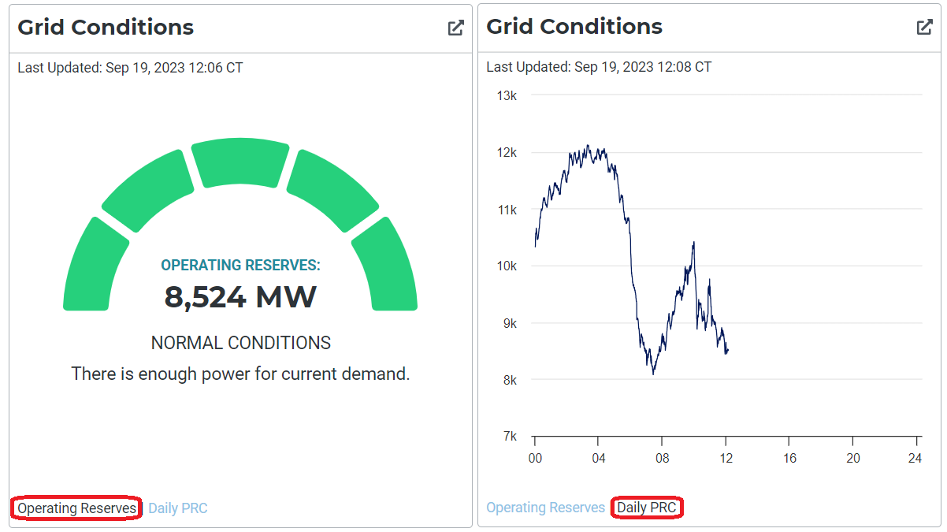
Resolution:
Add an additional selection to the “Grid Conditions” dashboard, titled “Current ORDC Level”.
The data needed to populate this graph is already available under the Ancillary Service Capacity Monitor under “Real-Time On-Line reserve capacity”, as highlighted below:
