PWG Meeting Notes – August 9th, 2023
Via WebEx 9:30 AM
Attendees:
Richard Beasley - CNP | Eric Lotter – Grid Monitor | Steve Pliler - TXU | Bill Snyder - AEP
Sam Cannon - ERCOT | Jim Lee - CNP | Diana Rehfeldt - TNMP | Sheri Wiegand - TXU
Angela Ghormley - Calpine | Debbie McKeever - Oncor | Randy Roberts - ERCOT
Amar Khalifeh – ERCOT | Sam Pak - Oncor | Kathy Scott - CNP

- Meeting notes for May 12th were reviewed and approved with no revisions.
  - Sheri followed up on load profile questions that were discussed at the 5/12/23 meeting. She asked that if a RID profile was assigned to a BUSLRGDG profile, would the profile remain BUSLRG? Randy advised yes and said that ERCOT anticipated that BUSLRGDG would be used in this scenario, adding that a registered DG is not assigned a DG profile. An SODG would be needed for a BUSLRGDG profile to obtain usage data.

- 2023 Annual Validation Update
  - Sam Pak noted that Annual Validation Updates are due on September 30th and that AV updates should be provided at RMS and/or PWG meetings.
  - Sam Cannon. advised that CenterPoint, Oncor, and TNMP had completed their validations. AEP is four individual validations away from completion.
  - Sam Pak said that he had advised Nueces of their ESIIDs to be validated. Sam observed that even with the four pending AEP validations, the ERCOT standard of 99% completion has been met. Bill advised that AEP intends to complete the last four validations.
  - Sam confirmed to Amar that Annual Validations will not be performed in 2024 (both residential and business). Sam also said that residential and business validations will be performed in 2025, and that only business profiles will be validated in 2026. Amar noted that ERCOT will have to apply code updates due to the cessation of BUSLRG validations.
  - Sam observed that there was little change on the AV TDU change history slide. Amar confirmed that the numbers did not reflect CNP’s recent migration effort. Sam will monitor for an update from Nueces and track the four incomplete validations for AEP.

- Annual Validation Purpose and Needs
  - Sam said that the TAC meeting on 7/25/23 included comments questioning the purpose of Annual Validations. Debbie said there were also questions about the cost of AV and the need to discontinue practices performed out of habit. Debbie updated the meeting that Sam has already provided slides to her that were used in 2018 when similar questions arose in TAC. Debbie said that the slides should be updated to include recent information that supports the need for AV in the ERCOT market. She will then reaffirm the need for AV to TAC members.
  - Sheri observed that the recent one-year suspension of AV by PWG is evidence that unneeded tasks are avoided by PWG. Sheri said that AV is accuracy maintenance of the load profiles; that accuracy is crucial for REP load procurement and pricing. Without AV, there is no neutral party that determines load profile values.
  - Randy asked if ERCOT processes use AV, and Amar advised that long-term solar forecasting requires load profiles. The attendees agreed to create a new slide that emphasizes accurate load profiles are dependent on validations. The ensuing verbiage discussion included these observations:
    - Jim said that the response to TAC should anticipate questions about REP use of AMS data for load procurement and pricing.
    - Sheri noted that AV provides consistent information for the price quotation process. Because AV provides more information, there is a more accurate pricing process that leads to more efficiency in the market. Angela agreed, saying there are difficulties in obtaining AMS data and that AV makes is easier to obtain pricing data via load profiles. Sheri and Angela pointed out that AV supports apples-to-apples pricing, which benefits customers. AV facilitates a neutral baseline for pricing that mitigates bad actors offering unrealistic pricing.
    - Randy observed that the BUSLRG profile was recently added, which should aid accurate pricing. Angela said that Smart Meter Texas usage data is available only to the REP of record and not to other REPs. Randy suggested creating a slide that addresses the issues in obtaining SMT data.
    - Randy questioned if AV is mostly a benefit to business premises; Sheri replied that AV also benefits residential customers as AV is a quick way to build rates and allows for pricing aggregation.
    - Sheri said that prior to AMS flag activation (which can take up to 30 days) for a new meter, the meter is settled according to the load profile. This is an example of AV being used in other market processes.
    - The discussion included many remarks and contributions from attendees on verbiage choices. Debbie will work with PWG to produce slides for presentation to TAC that detail the uses and need for Annual Validation.

- IDR/AMS BUSLRG Updates from TDSPs
  - Oncor - Sam observed that the individual TDU counts are mostly unchanged. Oncor is chipping away at a list of ESIIDs that mostly have access issues or are EPS.
  - AEP – Bill said that AEP is in the much same position as Oncor in dealing with one-offs and EPS situations.
  - CenterPoint – The TDU shows the most activity due to CNP’s recent BUSLRG transition, which Kathy described as smooth. She said that CenterPoint has not identified any profiles that are BUSLRGDG and that approximately 800 profiles will remain as BUSIDRRQ.
  - TNMP – Status quo, TNMP will advise when transition efforts begin.

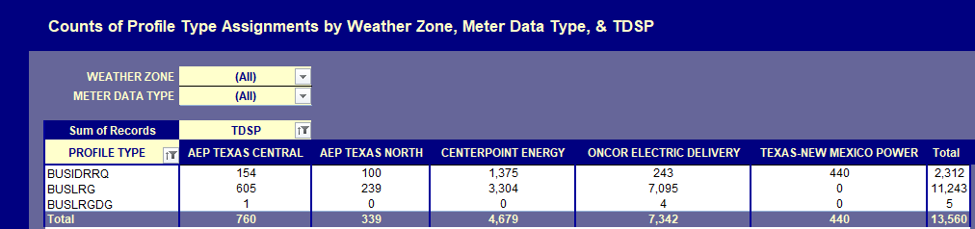

- Other Updates
- LPGRR 070 / NPRR1163 Discontinuation of IDR Meter Weather Sensitivity Process – Sam advised that approval should be forthcoming at the next PUC Open Meeting, which would be prior to kickoff of the next annual cycle.
- Conversion of Profile Decision Tree from Excel to Word – No update available.

- Future Meeting Dates
Sam confirmed that the next PWG meeting is scheduled for 9/13/23. Kathy advised that meeting may conflict with a PUC OPEN meeting that is scheduled for 9/14. Sam noted the tight scheduling and said that a reschedule of the 9/13 meeting may be needed. It was also observed that the November PWG meeting conflicts with the AEP workshop. With that in mind, it was decided to keep the October PWG meeting on the calendar.

- DRAFT Agenda for September 13th meeting:
  - 2023 Annual Validation
  - IDR/AMS BUSLRG Updates from TDSPs
  - Annual Validation Suspension via LPGRR 070
  - LPGRR 070 Update (regarding RMS 6/6 meeting
  - LPGRR 068 Update
  - Conversion of the Profile Decision Tree from Excel to Word format (LPGRR)

