IBRWG Meeting Minutes.

1. Case Studies of the Stability Benefit of Grid Forming Inverters on Energy Storage Facilities, presented by Nishantha C Ekneligoda, AEP

* Overview of Grid-Forming (GFM) vs Grid-Following (GFL)
* Summary of EPRI positive sequence generic GFM model
* Available control modes in EPRI GFM model
* Positive sequence simulation case studies:
  + Case 1: 230 kV station in Oklahoma
  + Case 2: 345/138 kV station in ERCOT
  + Case 3: 138 kV GTC area in ERCOT
* Conclusion and future directions

A battery inverter equipped with GFM control is effective in stabilizing GFL wind and solar IBRs under various post-contingency “weak” grid conditions. Different forms of instability can be addressed partial voltage collapse, poorly damped oscillations, and rapid unstable GFL IBR mode shifting can all be resolved. GFM battery drives systems to stable operating points by short-term dynamic active and reactive power injection (either without continuing power injection or with minimal continuing reactive contribution). Determination of optimal GFM sizing as well as the appropriate number and placement of GFMs are some other possible future directions. GFM device control tuning is also important, and one shouldn’t expect a particular GFM inverter control tuning to always function effectively in all scenarios.

Q&A:

* Mohammad (IBRWG chair) asked about the size of the battery and any benefits of GFM batteries. – Nishantha answered that the optimal size as well as optimal placement of the battery are the topics for future work, while the benefits of the GFM battery have already been shown in the presentation.
* Julia (ESIG) asked if all studies were conducted with positive sequence dynamic models – Nishantha confirmed and added that EMT modeling/study is the topic for future work.
* Yunzhi (ERCOT) asked about overcurrent capability for GFM battery that was modelled – Nishanta says used default value (1.5 pu[1]) provided by EPRI and AEP hasn’t modified/tested different values.
* In Case 1 it seems like the problem is deficiency is reactive power, have you tried solving it with other devices like SVC or STATCOM – Nishantha says there is STATCOM near that station, but they haven’t tried adding another one. Rob O’Keefe (AEP) adds the STATCOM is not nearly big enough to help, but it is possible that another STATCOM or SVC could also help to stabilize the Case.
* Yenpo Ho (Oncor) asking, GFM output is 0 MW, so all grid forming capacity is used for supporting the grid (on slide 21) – Yes because AEP tries to maximize reactive current capability. GFM battery fully used for stabilizing the grid. The question is how to decide GFM capacity to insert at a given bus. AEP says this is the question of further study alongside location. Generally, as IBRs are connected to a certain bus the voltage at the bus reduces. The buses with the worst voltage reduction are the best candidates for GFM application. Rob, added that AEP is not proposing to install GFM battery for just stability problems, there are plenty of battery in the queue already proposed for these locations, we can use these batteries to stabilize the system, while the battery is charging and discharging based on the market dispatch. So, in the study the size was not selected to stabilize but rather based on planned batteries in the study area. Currently simulated these cases with 0 initial power level but certainly can run these cases with non-zero active power.
* Another question from Ho, is the model public? – Deepak (EPRI) says it is available from EPRI, and provided his email for further inquiries dramasubramanian@epri.com

1. FPL GFM and IEEE2800 activities, presented by Andrew Arana, Florida Power and Light

Andrew provided some background on FPL system. Previously, FPL developed facility interconnection requirements in response to system studies and NERC recommendations. FPL adopted IEEE 2800, excluding the last 2 chapters – monitoring and testing (waiting on IEEE2800). Many vendors are familiar with IEEE 2800 and have started testing their equipment. The requirements are applicable to newly interconnecting IBR; with IBR capacity is currently making up less than 19% of peak load and FPL is a part of large Eastern Interconnection it was not necessary or prudent to require wholesale retroactive upgrades. For existing IBRs focusing on tripping/active power reduction issues reported in previous NERC events, working with IBR owners to understand what it takes to fix.

FPL is seeing a week grid challenge in FPL system at the end of long transmission line where several IBRs are connected. It is possible to address it by adding new transmission, SynCons or Synchronous compensation (though in this case SSR might be a concern). Currently focusing on GFM BESS as a potential solution. Similarly, to AEP, the reason why FPL focuses on battery is because these are already being planned in the area and FPL wants to avoid installing additional transmission assets exclusively for stability. While currently the focus is on GFM BESS, the plan is to look at GFM capabilities of solar as well as explore black start capabilities with GFM technology. Similarly to AEP optimal sizing and locations of GFM BESS are subject of future studies. FPL needs to establish performance specifications very soon.

**Q&A**

Julia asked how many IBR plants FPL has? – 5000 MW of IBR capacity across about 50 plants.

Julia also asked what fixes have been implemented retroactively? – momentary cessation, PLL loss of synch protection setting.

1. ERCOT provided a quick update on their activities related to Grid Forming. Following the results of preliminary benefits assessment that was presented at 8/9 meeting ERCOT issued and RFI looking for support developing interconnection requirement for grid forming batteries. RFI is posted on ERCOT website under this link <https://www.ercot.com/files/rfps/2023/08/28/Consulting-Services-for-Grid-Forming-Inverter-Based-Resources-in-ERCOT%20Region_Public.pdf>
2. Stephen (ERCOT) presented NOGRR 245 update. The first slide of his presentation lists all the latest changes that were made to NOGRR 245. Stephen said based on ERCOT’s understanding FRT requirements should be feasible with the tailored exclusion in NOGRR 245 for some Type 3 WGRs. Stephen also presented the chart about how different requirements apply based on the request from ROS meeting on 9/7/2023. Reiterated that today, in the absence of specificity there still requirement to ride through disturbances for **all** of the parameters specified in NOGRR 245 if the voltage is withinVRT envelope as per current protocols. So, NOGRR 245 is, in fact, lowering the bar by adding specificity but not applying it to all IBRs equally.

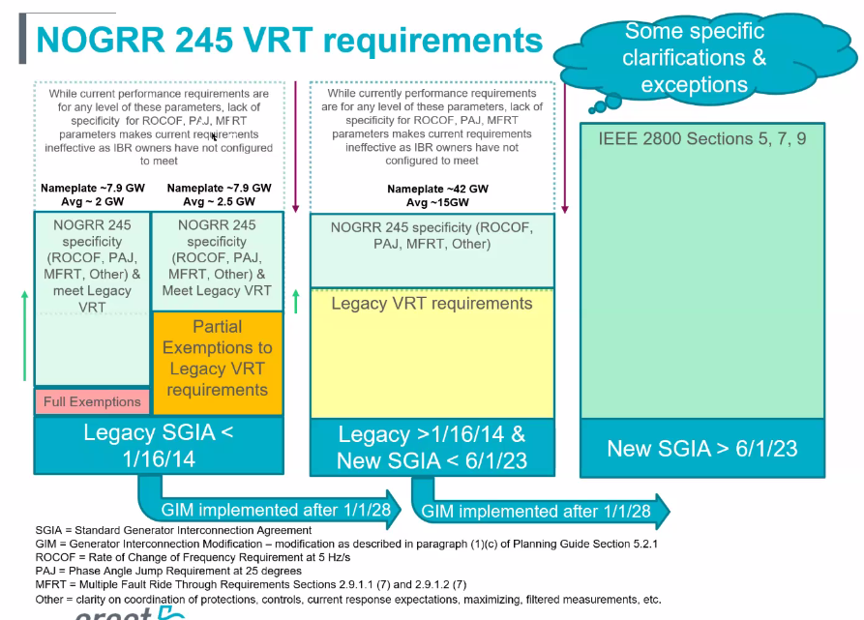

Stephen stated even within these charts there are specific exceptions allowed based on OEM’s specific limitations after all retrofits and changes can be applied. Legacy IBRs SGIA before 2014 will be most challenged managing the requirements applied with NOGRR 245, not impossible but challenging. For the second bucket on the chart, the challenge may be RoCoF and phase jump and multiple fault ride through (MFRT), with generators and OEMs, if they have never paid attention to the parameters before.

Stephen highlighted again since there was confusion at ROS that legacy IBRs that implement changes after 2028, is when they progress to bucket 3 (which is currently only applicable to new IBRs with SGIA 6/1/23). Also, if existing IBRs in bucket 1 and 2 undergo updates/upgrades, the 3rd bucket will apply after the upgrades.

The new VRT requirements in green area only apply to new (third bucket) but because applying only to new IBRs it needs to be better aligned with IEEE2800 requirements (be more stringent). Partial exemption will have to meet blue section of VRT curve.

ERCOT allowed even more compromise with Type 3 that may not quite meet IEEE2800 but substantially meet and could argue the very small exclusion did not create significant reliability risk. ERCOT is working with them on exceptions to accommodate the limitations. This may provide additional flexibility for these even after 2028.

A special ROS meeting scheduled for next Thursday. More details on Stephen’s slide.

**Q&A**

* David Azari (GE) commented that some of the requirements are more challenging than others. The OEMs (including one major wind OEM) saying that they don’t know the capability of their equipment yet and need to investigate capability first and then see what it takes to meet the requirements. So, this process involves multiple steps. Specifically, David focused on multiple ride-through and phase jump requirements. Stephen comments that other vendor (for Type 3 wind) said they are not monitoring these and think they’ll be able to comply, but still OEM need to confirm to get higher level of confidence. Phase jump, they said, may turn into mechanical vibration issue and for ride through it’s about heat dissipation, but Stephen reiterated that today’s VRT requirement applies to any phase jump and any number of ride through events. It’s just that the industry was not paying attention to these details. David reiterates that difference may be by make, model, and technology. He says that currently ERCOT is silent on those details, and GE doesn’t believe it’s the case that any requirement (for phase jump and multiple ride through) apply today, and that requiring specificity (slide 3 and 6) is additional requirement, which currently doesn’t exist, so this is not lowering the bar, as Stephen stated.
* David asked if the specificity added by NOGRR 245 is from IEEE2800. Stephen said yes. But if all GOs/OEMs came back and said for all these units we can do 4 Hz/s and for others 5 Hz/s, ERCOT would be respective of this. But to say we cannot do **anything at all** around RoCoF is just unacceptable. ERCOT hopes to identify very specific things that are not feasible, and those specifics may be exempted but not addressing NOGRR 245 requirements at all is not acceptable. David clarified their position and said that in the perfect world they would be able to say precisely what they can and cannot do, but as they have seen ERCOT started with very stringent IEEE2800 requirements and OEMs don’t know yet what the capabilities of their equipment are with regard to those. Proposals by Southern and NextEra do not propose not to have any additional requirements but to have flexibility for issues that are more challenging. As soon as OEM can identify that it is technically possibly and commercially doable then the generator owner will go and implement the changes to adhere to the requirements. That is a critical point here that we are characterizing inappropriately.
* Stephen: ERCOT reviewed the proposal and the fact that **the generator owners** propose to determine what’s commercially “reasonable” and “commercially feasible”, which is problematic for ERCOT as it does not consider or prioritize reliability. He further clarified that ERCOT sets the requirements as the bar for reliability, then a GO should determine what it takes for them to meet the bar. ERCOT then would like the GOs to tell what they can and cannot do with all available changes, retrofits, etc. ERCOT needs specific concerns raised, not a blanket assessment that perhaps a small exception is need on a portion of a requirement or an extension on one particular requirement is needed vs a blanket statement of overall incapability to comply and that this warrants retainment of a complete exemption.
* David says SC and NextEras proposals are closer to what ERCOT is looking for than it sounds. The proposals have annual certification requirements (similar to weatherization requirements). We all take reliability seriously, even if we don’t agree on details, it doesn’t mean that the GOs will be saying every year there is nothing we can do. OEMs have financial incentives to develop these solutions and sell their products so he doesn’t believe that GOs will continue every year that they cannot do anything.
* David continued that there is no strictly speaking technical way to meet these requirements, but ERCOT will want to disconnect these resources that operated for 15 years without issues. There is another bucket where fixing things would be commercially unreasonable forcing generators to retire, so, again, ERCOT is forcing to retire projects that have been operating without issues. This is not just the matter of “we don’t want to do it”.
* Stephen asks: if there is a particular unit of specific model, where specific requirement that cannot be met fully is met partially, ERCOT is ready to discuss about those. But if the unit is such that the only way to comply is to change everything out and ERCOT is seeing there is no commercial way to update everything, the unit then continue tripping off event after event, what does ERCOT supposed to do in this case.
* David says study is necessary to show that there’s a reliability concern with such regular tripping. The generators **are** tripping every now and again, and we need a study to show the degree of NOGR245 implementation and where generators repeatedly tripping is a reliability issue. ERCOT says it is a problem because these constant tripping will make the events worse, and it has already been demonstrated in multiple events.
* OGR 208 ERCOT was doing the study and applying VRT only and the thought then may have been new resources solved the problem there, so, it was decided that it is ok to exempt legacy resources. However, this was before ERCOT was seeing, multiple and very large events on the system and to allow resources to trip on regular basis is not acceptable anymore. These are normal system disturbances with normal parameters and ability to ride through is a part of being reliable.
* David says this is hypothetical example doesn’t match the reality there are no resources out there today that are repeatedly tripping on trivial events. ERCOT hasn’t shown proof of that. In Odessa some of the examples in the report, indicated some artificial protection settings that could be relatively easily. That is different for a generator from 2007, where it will take time to figure out what that resource’s phase jump withstand capability even is, let alone how to bring it to ERCOT’s requirement. So, it’s different. David says he understands Stephen’s concerns about the incentives that GOs and OEMs have (about SC and NextEra proposal) and he’ll work with them to try to clarify.
* Alex Miller: Appreciate the visual that Stephen has provided but trying to match up the discussions and the wording in the presentation vs what it seems to be saying in the specific NORGG245 language about GIM implemented after 2028. A small improvement to the site can trigger move to a different requirement bucket and may disincentivize GO to do any upgrades to their plant, which is not desirable for reliability may be?
* Stephen: as technology changes we want it to comply with new more resilient requirements. Reiterated that if there are some small, detailed improvements that can be made but not quite before 2028 ERCOT may be receptive to this and grant exceptions for those specific things. Stakeholders should recommend specific language to this effect for the stakeholders to evaluate. There is a broader language that ERCOT has proposed to allow discretion to allow limited exceptions even if modifications/upgrades to the plant were made after 2028. Hopefully that language addresses Alex’s concern. Alex says it makes sense. But her concern is that the language in NOGR245 says **any** modification, which means that GIM that might not be full repower will hit the same bar as GIM that is full repower. So, it may discourage GO from making any incremental improvements. Section 5.2.1, paragraph 1c should address what will go through GIM or not, but it needs to be assessed and ERCOT would be open to evaluating what part of exclusions would be needed for each specific GIM. Stephen that he was given an example co-located load trigger GIM and causing IEEE 2800 to come into consideration. Stephen reiterated that NOGRR 245 was not targeting co located loads but as technology improves retrofits and repowers should improve and utilize new technologies available. He also stated that co located loads creates challenges for ERCOT, e.g., for forecasting the load for look ahead studies. It can put additional loading for some lines, additional reactive requirement for the full plant may not be met, presenting all sort of challenges to ERCOT. ERCOT needs to be considering these changes in detailed way and cannot put overarching language in the NOGRR245.
* Shawn (Enel): GE’s point from ROS discussion yesterday is very valid. Even for new plants IBRs won’t be able to meet some of the NOGRR245 requirements, how are we going to address this concern.
* Stephen: Stephen stated he appreciated the concern, and similar consideration applies here. If IBR cannot meet all of the requirements at the interconnection phase and need more time for specific portions to meet IEEE 2800, they would be open to considering a temporary exception, within reason to allow time for a retrofit to occur to allow faster synchronization time so long as they met current VRT requirements and did not have a performance failure. Shawn comments that this consideration needs to be embedded in the NOGR245 language. Stephen suggested that Enel adds such language in their comments.
* Ryan (NERC) agrees that specificity in NOGRR 245 is actually degrading the existing requirement. Have you thought about enforcing requirements that you currently have and addressing specificity through some sort of guide rather than requirements. Stephen responded that he could not comment on compliance issues/consequences with PUC after Odessa events, but also from ERCOT’s perspective, as presented at ROS the timeline of all NERC disturbance events, NERC alerts, guidelines, etc, all demonstrate that the guidelines are not effective and mandatory requirements are needed.
* Eric Geoff (on behalf of NextEra) asked David to repeat his concern around commercial reasonableness qualifier. Stephen added that ERCOT’s concern is that proposal retains exemptions by default (i.e., for the entire set of requirements) with NextEra’s and SC’s proposal and then tries to incrementally add from that exemption. But ERCOT says here is the reliability bar, and if you can argue that you cannot meet the reliability bar for a specific reason (that doesn’t lower reliability bar too low) then ERCOT is willing to work with on case-by-case basis for a very specific exemption or extension if reliability risk can still be addressed. These specific carve outs (along with the risk of operational restrictions) keeps the things moving in the right direction. Eric reiterates that the existing rules that were there for 15 years got deleted and there are facilities that were built based on these rules but says that **every** facility that will go through annual review to see what it takes to get to the requirements of NOGRR245. Concerned with restrictions that are placed on resources and hopes there is a way to compromise. ERCOT for many years only apply new requirements looking forward but now ERCOT is changing that approach and GOs/developers are willing to work with that and think that commercial reasonableness may be provides the compromise?
* Dennis (AEP), my understanding phase angle jump and multiple rides through **is the requirement now** (i.e., absence of specificity means that for every event that is within voltage envelope the resource should ride through) and it doesn’t come through on the slide and doesn’t coincide with what Eric just said. Dennis asked Stephen to please clarify that these are existing requirements today. Stephen will try to capture that on the next iteration of the graphic.

1. Presentation is from Ryan (NERC), on Utah disturbance. Nothing new in this event, it’s just the repetition of the previous ones that’s why the report is short this time. Unless NERC sees new findings, this will be the approach of NERC going forward. It is great to hear that on the regional level there are things happening to address the issues.

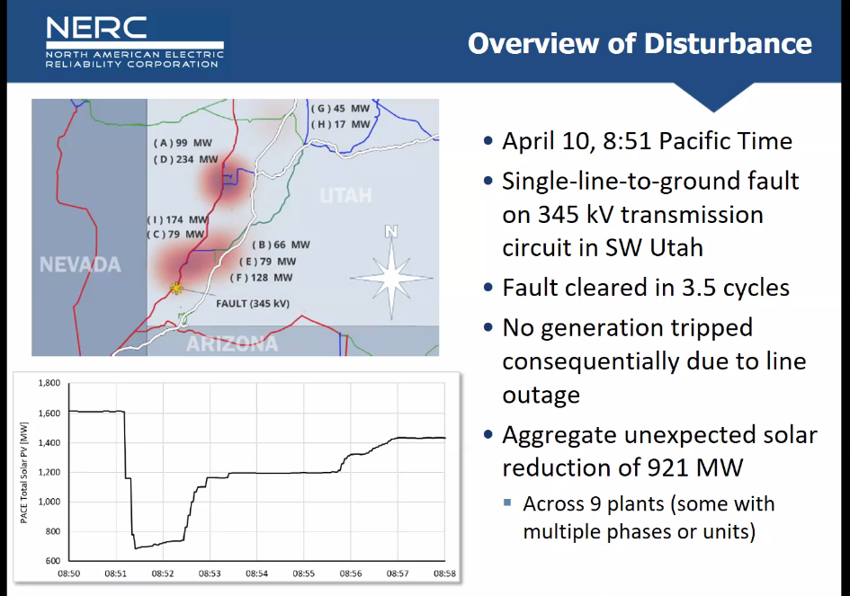

* Most facilities that tripped are bulk electric system facilities and majority are “legacy” facilities (meaning installed even before Blue Cut fire) and so the issues that have been reported many times by now still not have been addressed. All causes of reduction previously identified in past reports. GOs aware of past disturbance reports; no proactive action being taken to address performance deficiencies. OEMs also aware of performance issues but fixes not being deployed unless asked by GO (due to the way maintenance contracts are written). Need for comprehensive ride-through standard.
* There are similarities and differences with Odessa disturbances. Findings of NERC event reports are applicable to all Regions across North America. People saying, we are not CAISO we are not ERCOT, so we don’t need to be doing anything on the events that happened there but see even in smaller area it’s still created this large event with exactly same findings as from those other areas.
* Accurate modeling and studies are critically important, and appears to be poor presently. **Establishing detailed interconnection requirements is absolutely essential**, should be taken very seriously across North America. Lack of industry action reinforcing need for NERC Standards efforts. Some ongoing improvement efforts include:
* NERC Project 2023-02 to ensure proactive risk mitigation.
* NERC Project 2020-02 to ensure comprehensive ride-through performance standard.
* Ryan also reiterated on the need for Level 2 NERC Alert regarding inverter-based resource performance issues.
* Except for phase-jump protection, none of the tripping reasons seen in the recent events can be captured in positive sequence models. Can’t stress the need for accurate EMT models enough.
* Ryan concluded with the list of ongoing activities at NERC, NERC IRPS and NERC EMTTF.
* New disturbance report is coming out on BESS disturbance event in California. The findings from NERC Level 2 alert identifies a lot of issues, where performance issues have not been, reported to FERC and have to do something.

**Q&A**

* Julia (ESIG) asked if areas seeing NERC disturbance events undertaking efforts similar to ERCOT? – Not seeing sufficient action to fix their interconnection requirements form the areas affected in the events, NERC is looking to improve their standards with additional specificity.
* Mohammad asked about how IEEE2800 is different from NERC standards? – IEEE2800 is a great detailed standard. IEEE2800 used the NERC IRPS guidelines as starting point, however IEEE2800 is not enforceable. NERC has a range of open-ended high-level standards basically saying each area shall have requirements and do studies. But these requirements need to ensure reliability of the grid. Another end of the spectrum is where there are very detailed standards. This area useful because they provide specificity to manufacturers. Other NERC standards fall in the middle but starting to see need for more specificity. NERC, however, doesn’t develop standards the industry is. Standard development process starts with a SAR and there is currently no SAR to adopt IEEE 2800. We need ride through standard that ensures reliability. PRC-024-3 offers some improvements but still is protection standard not performance standard.
* Chase (SC) comments: we have an example of a plant in other area that was involved in a disturbance event and SC have followed up with the plant that got involved. And looked into changes that are needed, it’s been an iterative process with OEM. OEM recommends the changes; they implement the changes, but they don’t have a way to test the solution, and the next event happens and there may be other (unexpected) issues that happen at the plant. The current fleet was designed to existing standards at the time.
* Julia (ESIG) had a follow up question to Chase (SC): If an event happens and a plant in your fleet trips are you following up with plants in your fleet that are same make and model as the plant that tripped and making same changes to those. – Chase said that he can speak for Southern Power and that this is current practice.
* The comment from Julia (ESIG) to Chase (SC) and may be Ryan can comment as well? The modifications to made to plants in response to previous events cannot be fully tested and when the next event happens. I appreciate that physical tests cannot be done for large disturbance events but isn’t it possible to “hit” the plant model (updated with recent modifications) with the same event that happened and analyze its performance, shouldn’t this be a routine step of post-event follow up? - Ryan says that it should be possible, still there may be things that are not accurately represented in the model but ideally that should be the process.
* Shawn (Enel) asked about California BESS event that Ryan said NERC is about to release the disturbance report for, if it’s new or recent? Ryan says these are 2022 events, but NERC is having challenges analyzing the events and it’s taken longer than expected to finalize the report. Shawn asked if these are specifically storage events. Rayn says yes either BESS or hybrids, but the challenge was that NERC couldn’t even tell the difference in the analysis which component the issues were coming from. However then there was another event during nighttime, where NERC is able to tell that difference and link the issues to specific components of the hybrid plants.
* Sawn (Enel) also commented that he is a chair of NERC Project 2020 – 02 Modifications to PRC-024 (Generator Ride-through). The original scope was to revise PRC-024-3. The project kicked off mid this year, but the standard drafting team realized that current PRC-24-3 is protection standard, and still currently more applicable to synchronous generators even through still provides value. So, currently, drafting team is considering revising PRC-024 to only apply to synchronous generators and SynCons and additionally develop a new performance-based ride-through standard for IBRs. Ryan said that this is deviating from original SAR and both from NERC and FERC perspective it is concerning. Ryan will follow up with Shawn offline.
* Stephen comments that NERC with event analysis helped a lot to ERCOT to identify issues and be pro-active in fixing these reliability concerns. Ryan comments that the urgency doesn’t match the action we are seeing in the industry. The credit should be given to some GOs for being proactive, but others are not following up.
* Stephen goes on to comment that ERCOT does agree with Chase’s interpretation that the current NERC standard only applies to protection settings. Need to find right balance for specificity to present needed parameters and define what normal disturbance are and performance through to makes sure that developers are proactively asking for those things. Requirements need to be proactive not reactive.
* Final comment to Chase, Stephen said he was happy to hear about the program Chase says that they look across the fleet we need to bring these lessons learned to IBRWG, so that other can learn.

1. Clarification from Deepak Ramasubramanian (EPRI) was provided after the meeting stating that such a high overcurrent capability is set default as a default in the model because areas such as HECO are specifically looking for higher overcurrent. Having 1.5 pu overcurrent capability in an inverter will require additional hardware costs.