NOGRR Number | 245 | NOGRR Title | Inverter-Based Resource (IBR) Ride-Through Requirements

Date | September 22, 2023

Submitter’s Information
Name | Samir Dahal (Onshore), Christian Beckmann (Services)
E-mail Address | Samir.Dahal@siemensgamesa.com, christian.beckmann@siemensgamesa.com
Company | Siemens Gamesa Renewable Energy (SGRE)
Phone Number
Cell Number
Market Segment | Not Applicable

Comments

SGRE appreciates ERCOT’s clarification/modification on the latest proposed requirements (“245NOGRR-35 ERCOT Comments 081823_1”). The present draft does address some of the known areas of highest uncertainty by phasing-out deadlines and providing the items with most complexity with the longest allowable exemptions (phase angle and multiple fault ride through up to Dec 2028). This at first sight may seem a reasonable approach, however, SGRE has yet to start investigation on possibilities to comply with phase angle, multiple fault ride through, and ROCOF requirements and thus, does not currently know if compliance can be made possible and, if yes, how long SGRE will need to be compliant.

Based on the latest language and considerations, SGRE’s latest (but still preliminary) analysis is certain on being able to meet FRT and VRT* requirements at WTG terminals on most of the fleet. Nevertheless, SGRE objects to retroactive implementation of new standard requirements, especially the requirements whose major testing specification component is yet to be finalized.
*Note that SGRE cannot speculate about VRT compliance at the plant POIB.

As mentioned in previous comments on this subject, SGRE has approximately 7 GW of installation in ERCOT with a variety of configurations and ages (high level breakdown has been shared in the prior published letter 245NOGRR - SGRE Comments r20230605). As such, without any guidance from ERCOT on prioritization, SGRE has only been able to perform preliminary and high-level assessment to cover most of the platforms (refer to the summary table for legacy operational fleet).

The conclusion so far are as follows:

- SGRE’s current offerings meet most of the NOGRR requirements. Please note that the multiple-ride through requirement test-specifications as per the (pending) IEEE P2800-2 might differ from multiple-ride through test-specifications from presently active standards.
- SGRE’s new products, which are currently in a design phase, are anticipated to meet all the IEEE 2800 requirements and test specifications.
- The majority of SGRE’s TYPE III and Type IV operational fleets can be made compliant to VRT and FRT requirements through existing software and/or hardware upgrades. However, given the large number of the turbines and absence of guidance from ERCOT on wind farm prioritization, implementing these changes across the fleet within the proposed timeframe (December 2025) could result unviable given that the resources involved in coordinating could be the same group of people, the manufacturing lead times, etc.
  - It is SGRE’s assumption that Table 13 in IEEE 2800-2022 won’t be retroactively applied to the existing fleet and would only be applicable for new units.
- The majority of SGRE’s Type III and Type IV operational fleets have no certainty on being able to meet the Multiple Fault Ride Through, Phase Angle, and ROCOF requirements as they currently stand.
- SGRE's Older WTGs (Type II) have the highest uncertainty given a more detailed verification of present component, variances, obsolescence. etc. is needed

Topology

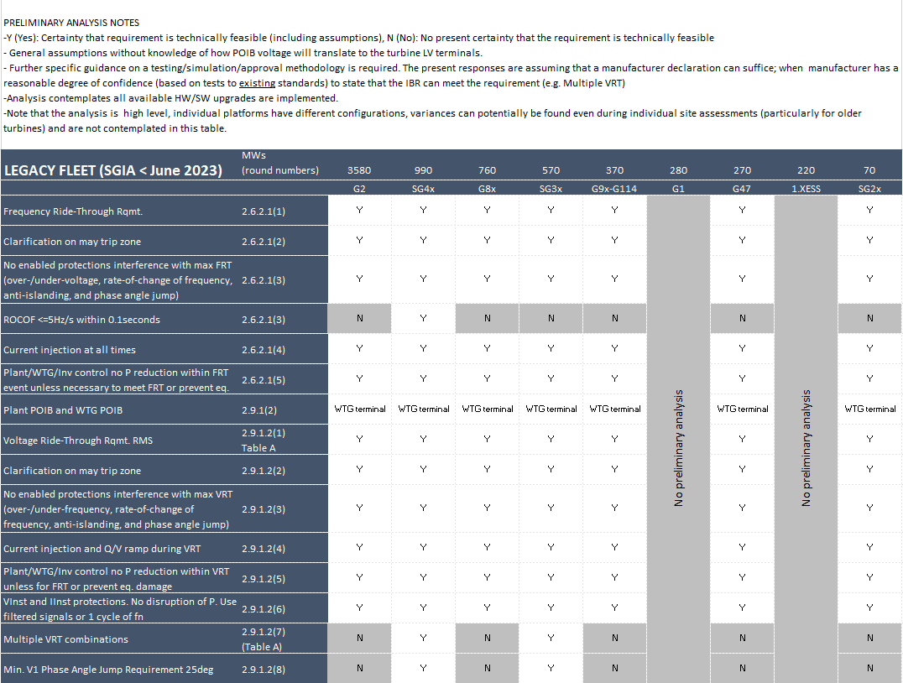
Table 1: Preliminary Assessment of SGRE’s Legacy Turbines on meeting the proposed performance requirement as listed in the latest draft of NOGRR 245

As such, SGRE humbly recommends the following:

- ERCOT to provide a strategic prioritization schedule that could bring about more effective implementation (e.g., focusing on the specific technologies/platforms that predominate the most, or the already identified populations that bring about vulnerabilities) based on operational experience. This would allow the industry to focus the efforts on resolving the most severe issues first.
- Remove the retroactive adoption for items with uncertainty and/or without test specifications (e.g., Multiple Dip, Phase angle, and ROCOF).
  - Request OEMs to provide detailed capabilities of turbines regarding Multiple Dip, Phase angle, and ROCOF. The majority of SGRE fleet already offer these to some extent.
- Clarification on test conditions and deliverables for different requested features (e.g., attestations, simulation report, plant or turbine level simulation, etc.)
- Provide enough time for OEMs to implement the new requirements in their products after the completion of IEEE P2800-2.
- Additionally, SGRE suggests giving consideration for treatment on the “re-powering” projects depending on the type of repower (replacement of electrical components vs only mechanical components). SGRE currently offers repowering of the older Type IV turbines, where only mechanical components (rotors, gearboxes, etc.) are changed while keeping the electrical converter intact.

