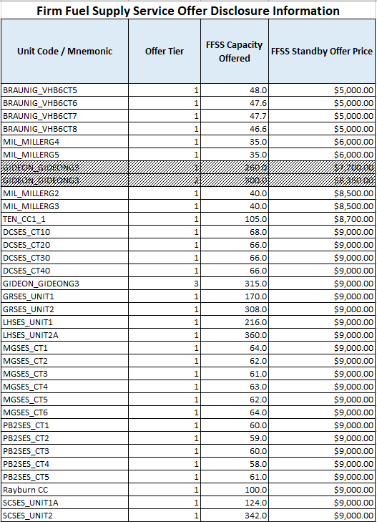

Note: The shaded offers are from a Generation Resource which submitted multiple offers for FFSS in which only one of the offers was awarded (Tier 3). This is being included for informational purposes only.

