SCR Number | 827 | SCR Title | Grid Conditions Graph Addition for Operating Reserve Demand Curve (ORDC) Level
Date Posted |  | September 20, 2023
Requested Resolution |  | Normal
Supporting Protocol or Guide Sections/Related Documents |  | Other Binding Document Revision Request (OBDRR) 048, Implementation of Operating Reserve Demand Curve (ORDC) Multi-Step Price Floor
System Change Description |  | This System Change Request (SCR) adds a third selection to the “Grid Conditions” dashboard on the ERCOT.com website. The three selections would be “Operating Reserves/Daily PRC/Current ORDC Level.”
Reason for Revision |  | Addresses current operational issues.  Meets Strategic goals (tied to the ERCOT Strategic Plan or directed by the ERCOT Board).  Market efficiencies or enhancements  Administrative  Regulatory requirements  Other: (explain)  (please select all that apply)
Business Case |  | The addition of two price floors to the ORDC via OBDRR048 requires transparency regarding the “trigger reserve levels” of 7,000 MW and 6,500 MW. Because the Real-Time value is already available on the “System Ancillary Service Capacity Monitor” page (see below), capturing the value from the “Real-Time On-Line reserve capacity” under the heading “Real-Time Operating Reserve Demand Curve Capacity (MW)” should provide the most current data needed for the graph.

Sponsor
Name | Roy True
E-mail Address | royt@acespower.com
Company | ACES
Phone Number | 317.344.7203
Cell Number | 317.695.4146
Market Segment | Not applicable

Market Rules Staff Contact
Name | Cory Phillips
E-Mail Address | cory.phillips@ercot.com
Phone Number | 512-248-6464

Proposed System Change
Issue:
Currently there are two options within the “Grid Conditions” dashboard – one for “Operating Reserves” and one for “Daily PRC”, however, with the introduction of multi-step price floors within ORDC, additional market transparency is needed.
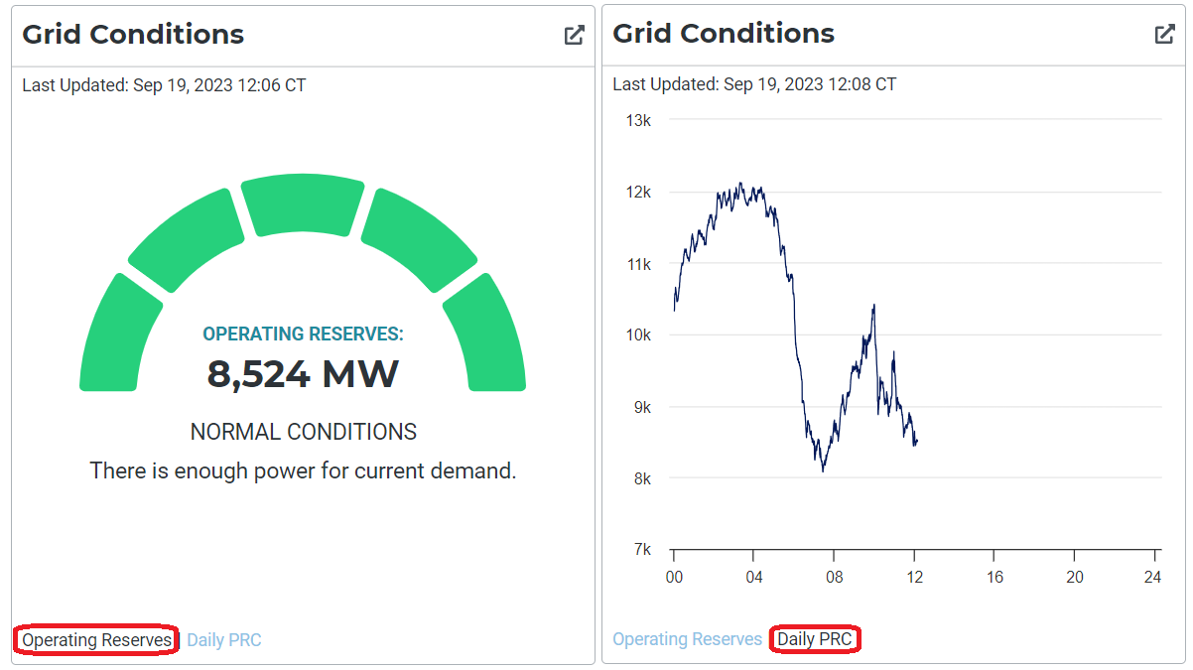
Resolution:
Add an additional selection to the “Grid Conditions” dashboard, titled “Current ORDC Level”.
The data needed to populate this graph is already available under the Ancillary Service Capacity Monitor under “Real-Time On-Line reserve capacity”, as highlighted below:
