TDTMS
August 17th, 2023
WebEx only
Attendee | Company | Attendee | Company | Attendee | Company
Diana Rehfeldt | TNMP | Dave Michelson | ERCOT | Kyle Patrick | NRG
Tammy Stewart | ERCOT | Dee Lowerre | NRG | Monica Jones | CNP
Jordan Troublefield | ERCOT | Sam Pak | Oncor | Eric Lotter | GridMonitor
Sheri Wiegand | Vistra | Brittney Albreit | ERCOT | Kathy Scott | CNP
Mick Hanna | ERCOT | Mansoor Khanmohamed | BP Energy Retail | Stephen Wilson | Vistra

Sheri opened the meeting with the Antitrust Admonition and announced attendees.
Minutes from the July 18th meeting were amended by Tammy Stewart and will be reposted to today’s meeting.

ERCOT System Instances & MarkeTrak Monthly Performance Review
- Dave presented July performance reports and noted all SLA targets for July were met along with MarkeTrak response times continuing to perform well
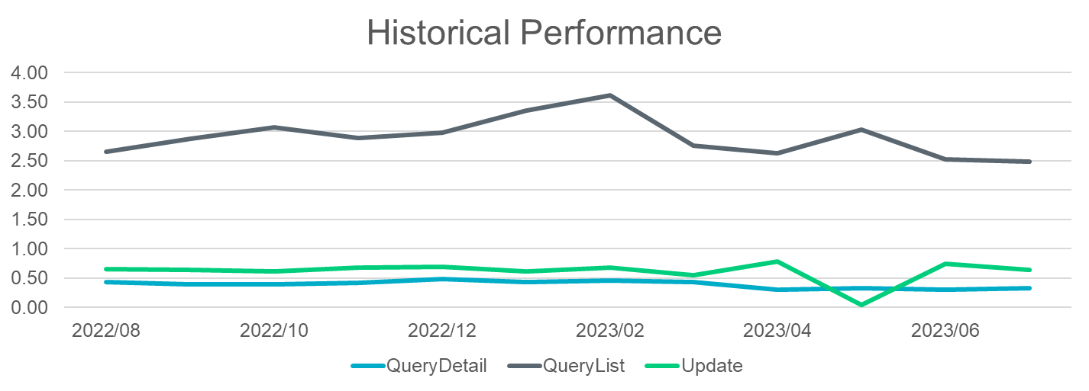

- Three incidents were reported for July – 7/16 (Weather Moratorium notices impacted), 7/22, and 7/30
- Listserv activity –
    - ~500,000 recipients and over 1000 posts for July
    - Weather Moratorium discussion (from RMS) was reviewed again noting during the incident ERCOT was not receiving the notices, thus they could not be archived. As a back-up, Weather Moratorium notices are posted on Oncor, CNP, and AEP CRIP sites. TNMP also saves notices.

- MIS API project update – Technology Working Group will be meeting 8/24 from 2:00 – 4:00 PM to review the technical changes for the Retail MIS API with the lead architects. As noted again, the Retail MIS API will be moving from MIME to SOAP exchanges. MarkeTrak API will not be changing as it is already using SOAP exchanges. At TWG, ERCOT hopes to have examples of the changes. GO LIVE is still planned for December with a testing window a week or so prior to go live. New digital certificates will be required for test environment since RMTE does not have the infrastructure for MIS.

- ERCOT Digital Certificate reduction– ERCOT will be reaching out to market participants with elevated growth in their volume of DCs. TDTMS no longer needs to review this item.

- October extended retail release – does not look like the extended release will be required for October. ERCOT will present the retail release calendar next month and notes they will be proposing ~ 10 smaller releases for the year, nearly one per month utilizing maintenance windows. For 2024, will extended releases be required in March and November for the pending Lubbock transition and TXSET 5.0 implementation? Discussions will take place at MCT and TXSET.

- TDTMS EDM Implementation Guide update – a big thank you to Kathy Scott and the ERCOT team for the administrative ‘clean up’ of the document. There are many deletions and added references pointing to other documents. This will allow for efficient maintenance of the material. TDTMS recommended approval of the revisions and will forward to TDTMS for final approval. Jordan will submit to RMS.

- Market Data Transparency Terms of Use – Mick Hanna noted the links in the document have been updated (only three). The document is more of a User’s Guide and will likely not need full stakeholder approval.

SCR 817 MarkeTrak Validations –
Tammy reported testing is going well for the changes. For testing the 867_04 validation for Missing Enrollment Transactions, there were three scenarios where a hard stop or warning would occur:
- Global ID or initiating transaction has cancelled – hard stop
- If 867_04 is already in ERCOT’s system – hard stop
- In comparing the SMRD to the submit date, the question was if the > 5 days requirement was looking backward and forward. The WG responded YES, the calendar should be a look back and forward.
Tammy will draft the User’s Guide revisions for the new MarkeTrak subtypes created. These documents can be used to support the training modules and training materials for TXSET v5.0 and MarkeTrak changes. Plan is to commence no later than Q1 2024.

MarkeTrak Volume Subtype Analysis & Inadvertent Gain Data Analysis – has been postponed to allow for the smaller group to sort through the data and draft the results. The smaller working group will meet prior to next TDTMS meeting (Sam, Monica, Kyle and Sheri). Sheri will set up the meeting.

Kathy asked about the goal of providing this data. The following comments were presented:
- Baseline IAG performance and trends before (and after) 5.0/MT to validate the changes
- Individual REP performance/volumes on MT subtypes submitted – leveraging data for Client Services for awareness on REP’s process opportunities
- Timing analysis may reveal updated acceptable SLAs – waiting on results of data

NEXT MEETING scheduled – September 21st Thursday @ 9:30 AM WebEx only
- ERCOT Updates
  - System Instances & MT Performance
  - Listserv
  - MIS API review
  - Upcoming retail releases – 2024 retail release calendar
- SCR817 Business Requirements discussion, if needed
- MarkeTrak Subtype Analysis – timing
- Inadvertent Gain Data Analysis – additional data points
  - % of invalid enrollments by Gaining and Losing CRs
  - Unexecutables - % & timing
  - Rescissions

