PGRR Number | 105 | PGRR Title | Deliverability Criteria for DC Tie Imports

Date | September 1, 2023

Submitter’s Information
Name | Mark Bruce
E-mail Address | mark.bruce@cratyl.us
Company | Cratylus Advisors, on behalf of Southern Spirit Transmission LLC
Phone Number
Cell Number | 512-810-1516
Market Segment | N/A

Comments

Southern Spirit Transmission LLC (“SST” or “Southern Spirit” formerly Southern Cross Transmission LLC) appreciates the opportunity to submit these comments regarding Planning Guide Revision Request (PGRR) 105, Deliverability Criteria for DC Tie Imports.

1. Response to ERCOT Comments
In comments filed Aug. 29, 2023, ERCOT requested PGRR105 “be rejected or tabled indefinitely.” At the outset, Southern Spirit notes that tabling a Revision Request “indefinitely” is untenable. PGRR105 proposes a reasonable policy change in response to lessons learned from Winter Storm Uri. It was developed through extensive analysis and discussion in the Planning Working Group (PLWG) and has already been overwhelmingly endorsed by the Reliability and Operations Subcommittee (ROS). The author of PGRR105 deserves a vote on the measure, not perpetual limbo, which will only leave important policy decisions unmade and, by extension, the ERCOT System unsure of its ability to accept emergency energy during a crisis – even if such energy is readily available from a nearby Bulk Electric System (BES). Stakeholders should reject ERCOT’s request to “table indefinitely.”

Additionally, ERCOT opines that, “the appropriate forum for addressing this policy issue at this stage is the Public Utility Commission of Texas (PUCT), not ERCOT.” In response, SST observes that the most straightforward way for this policy issue to appear before the PUCT to deliver the policy guidance ERCOT seeks is for PGRR105 to be endorsed by the stakeholders and approved by the ERCOT Board, thereby forwarding the PGRR to the PUCT for final approval, rejection, or remand to ERCOT with instructions.

Further, Southern Spirit disagrees with ERCOT’s characterization that PGRR105 is “at odds” with ERCOT’s determination regarding Directive 6 from PUCT Project No. 46304. PGRR105 merely proposes a change in policy to an older (pre-Winter Storm Uri) policy upon which ERCOT relied in making that determination, hence the procedural title, “Revision Request.” The fact that Directive 6 is final and approved by the Commission should not mean that no change to the underlying policy can be recommended, ever, if the PUCT has approved the previous policy. The Commission often looks to ERCOT for advice and recommendations and ERCOT should provide such while recognizing that the PUCT has ultimate authority whether to adopt them.

ERCOT’s logic ignores the fact that every single Revision Request adopted by the ERCOT Board and forwarded to the PUCT for final approval is a recommendation to change a policy previously adopted by the PUCT in a formal agency order. In that regard, PGRR105 is no different than the 31 Revision Requests pending before the ERCOT Board at the time of this writing or the 59 Revision Requests approved by the ERCOT Board and the PUCT since the September 30, 2022 PUCT Order ERCOT cites as the reason stakeholders should reject PGRR105.

ERCOT clearly states its comments, “are not intended to express a position on whether additional transmission capacity should be built to accommodate DC Tie imports.” It is puzzling that the organization charged with maintaining the reliability of the Texas grid should have no opinion on this policy proposal, which is born of direct analysis of DC Tie performance during the most catastrophic event in ERCOT’s history.

2. PGRR105 will enhance ERCOT System reliability and resiliency
Although the existing DC Ties are few in number and small in capacity, they deliver outsized benefits to the ERCOT market and Texas consumers because they are active on the extreme ends of the market. When prices are unsustainably low, DC Tie exports are a relief valve for excess renewable energy production – creating room in the offer stack for dispatchable Resources to remain online. Conversely, when energy prices are unsustainably high, DC Tie imports can answer the scarcity signal and temper the price.

Similarly, the outsized reliability benefits of DC Ties connected to neighboring power regions were on full display during Winter Storm Uri when the sustained maximum imports over all the ties during the onset of the storm were essential to preserving ERCOT System security as illustrated in Figure 1.

Fig. 1 Energy imports to ERCOT during the critical early hours of Winter Storm Uri
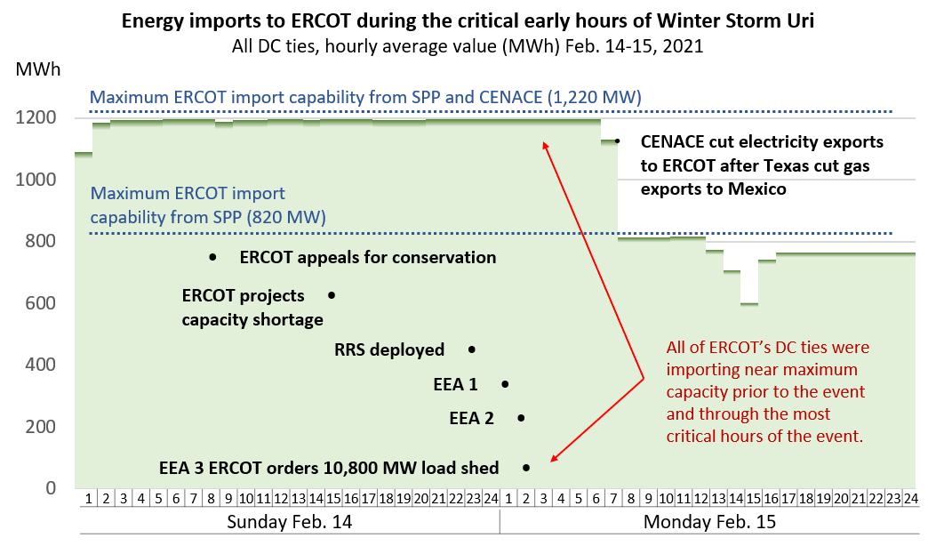

Additionally, as illustrated in Figure 2, imports to ERCOT throughout the weeklong crisis kept the power on for thousands of Texans. If the existing DC Ties interconnected to ERCOT have any shortcomings, it is in their small scale and short reach to only immediately adjacent Bulk Electric Systems.

Fig. 2 Energy imports to ERCOT during Winter Storm Uri
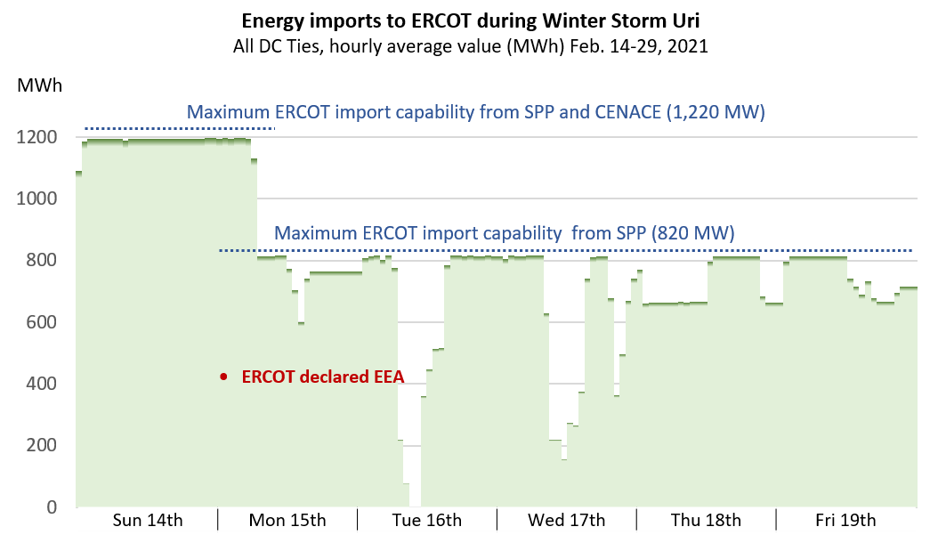

Revised Cover Page Language
None
Revised Proposed Guide Language
None

Formerly known as Southern Cross Transmission LLC, Southern Spirit changed its name in November 2022. Similarly, its proposed 400-mile High-Voltage Direct Current (HVDC) transmission line between Texas and the southeastern U.S., formerly known as the Southern Cross Transmission Project, is now known as the Southern Spirit Transmission Project.
See PLWG calendar pages and meeting materials for June 15, 2021; January 25, 2022; February 15, 2022; March 15, 2022; January 25, 2023; February 14, 2023; and March 22, 2023.
PGRR105, ROS Ballot, June 8, 2023. Motion to recommend approval of PGRR105 as submitted carried with 100% in favor, 0% opposed, and 1 abstention.

