NPRR Number | 1186 | NPRR Title | Improvements Prior to the RTC+B Project for Better ESR State of Charge Awareness, Accounting, and Monitoring
Date |  | August 28, 2023
Submitter’s Information
Name |  | Dan Woodfin; Chad V. Seely
E-mail Address |  | dan.woodfin@ercot.com; chad.seely@ercot.com
Company |  | ERCOT
Phone Number |  | 512-248-3115; 512-225-7035
Cell Number
Market Segment |  | Not applicable

Comments and Position Statement
ERCOT submits these comments to express its support for TAC’s recommendation to approve Nodal Protocol Revision Request (NPRR) 1186 and to express its general disagreement with Eolian LP’s TAC Recommendation Opposition. As further explained below, ERCOT agrees with Eolian in one limited respect and would therefore support a remand of this NPRR to TAC to consider revisions to address one narrow issue, as further detailed below. A limited scope of any such remand is necessary to ensure that the timeline for implementation of Real-Time Co-optimization (RTC) is not jeopardized. In the absence of such a limited remand, ERCOT would urge approval of this NPRR as recommended for approval by TAC.
Background
ERCOT submitted NPRR 1186 to address a critical reliability issue presented by the growing number of grid-scale batteries providing Ancillary Services in the ERCOT Region. Market-participating batteries—referred to in ERCOT Protocols as “Energy Storage Resources” (ESRs)—are an important emerging technology in the modern grid. They provide several unique benefits, including fast-ramping capability that can significantly reduce the magnitude of frequency excursions and dispatchability that can help offset the intermittency of renewable generation. ESRs also provide the ability to move excess energy from periods of abundance (e.g., summer mornings) to periods of relative scarcity (e.g., summer evenings), smoothing ERCOT’s system demand profile, and potentially reducing the need for other forms of dispatchable generating capacity to meet peak Load requirements.
However, ESRs also have one inherent disadvantage, which is that they cannot deploy indefinitely; at some point of deployment, an ESR will exhaust its supply of stored power and must be charged again before it can provide generation to the grid.

The Problem of State of Charge Insufficiency
ESRs’ duration-limited nature poses a unique problem in the context of Ancillary Services. Ancillary Services are reserve products that ERCOT procures in the Day-Ahead Market (DAM) for each hour of each Operating Day to serve as capacity that can be deployed during Real-Time operations to address different operational risks such as generating unit trips and errors in the forecasting of wind and solar output and system Load. Load pays for these Ancillary Services. While ERCOT procures all Ancillary Service products for each hour, only Regulation Up Service (Reg-Up) and Regulation Down Service (Reg-Down) are routinely deployed every hour (ERCOT deploys these services as often as once every four seconds to control frequency), and when deployments of Ancillary Services do occur, those deployments do not often last an entire hour. However, in some cases, ERCOT may need to deploy one or more Ancillary Service products for an extended duration—perhaps even for multiple consecutive hours, as has been observed on several Operating Days during the past week. When ERCOT calls upon Resources that have been awarded an Ancillary Service commitment to deploy energy under one or more of those services, it is essential that those Resources be able to provide all of the energy called upon. Thus, if a Resource is awarded 50 MW of Responsive Reserve Service (RRS) for a given hour in the DAM, for example, then it should be able to provide a power injection of up to 50 MW for any or all of that awarded hour—i.e., up to 50 MWh of energy. And if that same Resource is also awarded 50 MW of RRS for the next hour, then it must also be capable of providing another 50 MW of power injection for the entirety of that next hour—i.e., up to another 50 MWh of energy across that hour.
When a QSE is awarded an Ancillary Service Supply Responsibility in the DAM and designates an ESR to carry some or all of that responsibility, the prospect of deployment raises a concern that the ESR, if not sufficiently charged, might run out of energy in the event of a deployment—particularly in the event of an extended deployment. Thus, the ESR’s “State of Charge” (SOC)—the amount of energy it is storing—at each point in the hour is crucial to determining whether it may be able to comply with such a deployment for the remainder of the hour. So, for the above example of a 50 MW RRS obligation for a given hour, an ESR would need to have at least 50 MWh of stored energy—i.e., a 50 MWh SOC—at the outset of that hour to be certain that it could comply with any RRS deployment during that hour. If that ESR offers and is awarded RRS for two consecutive hours, then it would need an SOC of 50 MWh at the outset of each of these two hours to be certain it could comply with any ERCOT deployment that might occur in each hour. ERCOT’s systems do not have the capability to limit consecutive hours of Ancillary Service commitment based on SOC or otherwise, so maintaining sufficient SOC is the responsibility of the Qualified Scheduling Entity (QSE) offering the ESR.
Within the past year, as the number of ESRs in the ERCOT Region has increased, ERCOT has noted that many of them are not reserving the minimum SOC that would be necessary to comply with their Ancillary Service obligations for a given hour. For example, during the period from June 1, 2023 to August 24, 2023, on average approximately 24.75% of the ESRs providing “up” Ancillary Services failed to maintain the hourly SOC needed to comply with a full deployment of the Ancillary Service, with a median shortfall of about 7% of the hourly obligation. In some cases, this shortfall has resulted in an inability of the ESR to provide the required injection of power when the Ancillary Service is deployed.
SOC insufficiency is a problem uniquely associated with ESRs providing Ancillary Services. ERCOT has not routinely observed instances of conventional (gas and coal) Resources offering to provide Ancillary Services when it is known that the Resource will lack the fuel necessary to support a sustained deployment of that service. In the vast majority of operating circumstances, gas and coal plants tend to have sufficient fuel to sustain their operations to the maximum output, and in the unusual cases where operators of thermal plants do experience fuel supply disruptions, they are required to update the unit’s Current Operating Plan (COP) and to notify ERCOT of the deration or outage of the affected unit. That derate or outage would preclude any Ancillary Service awards that might be impacted by fuel availability. By contrast, QSEs representing ESRs are aware when they submit offers to provide Ancillary Services that their Resources have a finite amount of energy that can be provided in that future hour. When a QSE representing an ESR offers and is awarded a responsibility to provide Ancillary Services in a given hour and then offers the ESR’s energy for dispatch by Security-Constrained Economic Dispatch (SCED) when that same quantity of energy would foreseeably be needed in the event of a deployment of that Ancillary Service, this creates a new risk unique to ESRs that must be addressed. If Resources, including ESRs, are not capable of providing the full amount of MW injection that ERCOT may need when deploying one or more Ancillary Services, then grid hazards like generating unit trips could go unmitigated and potentially destabilize the grid, resulting in a Blackout. ESRs must therefore be required to maintain sufficient SOC to ensure they can provide the Ancillary Services they are offering to provide.
Public Utility Commission of Texas (PUCT) rules already effectively require ESRs to ensure they maintain sufficient SOC at all times. 16 Texas Administrative Code (TAC) § 25.503(g)(3) prohibits market participants from “offer[ing] reliability products to the market that cannot or will not be provided if selected,” and 16 TAC § 25.503(f)(6) requires that “[a] market participant’s bids of energy and ancillary services must be from resources that are available and capable of performing. . . .” When a QSE submits an offer to provide Ancillary Services from an ESR with the intention of using some of the energy that could be needed in the event of a sustained deployment of the offered Ancillary Service for that hour, that behavior knowingly creates a risk that the service “will not be provided if selected,” and therefore violates these rules. A Resource is not only required under these rules to perform during a deployment, but to be capable of providing the Ancillary Service, which necessarily means it must have sufficient energy to provide the service for the entirety of any hour for which it is offered.
While SOC shortfalls have resulted in failures by ESRs to follow ERCOT’s Dispatch Instructions or provide sufficient frequency response, ERCOT is not aware of any instances in which such shortfalls have resulted in more significant grid issues—in part because other Resources have typically filled in the gaps of any shortfalls. However, as the number of ESRs is poised to grow exponentially over the coming years, the risks associated with such shortfalls will also increase exponentially. ESR capacity in the ERCOT Region has grown from approximately 150 MW in 2019 to 3,518 MW as of July 31, 2023, and an additional 7,945 MW of ESRs have already signed interconnection agreements and posted financial security with an interconnection date of December 2024 or earlier. Batteries also represent the second largest source of proposed generation capacity in the generator interconnection process, currently summing to more than 100,000 MW, compared to approximately 125,000 MW of solar, 22,000 MW of wind, and 9,800 MW of gas generation. It is therefore likely that batteries will constitute a significant percentage of the grid’s generation supply in the near future.
Critically, even with their relatively small share of the current Resource mix, ESRs are already being awarded the majority of Reg-Up (82% share in Q3 2023) and RRS (65% share in Q3 2023). This percentage is likely to climb as the number of ESRs offering these services exponentially increases. ESRs have provided only about 13% of ERCOT Contingency Reserve Service (ECRS) and do not carry any appreciable amount of Non-Spinning Reserve (Non-Spin), but as more long-duration batteries are constructed, ESRs’ overall share of these other services could increase, as well.
NPRR1186 and the Minimum SOC Requirement
ERCOT has undertaken significant efforts to address these risks over the past year. Beginning in November 2022, ERCOT began engaging stakeholders, including battery developers, about its concerns with SOC insufficiency during hours in which ESRs were being awarded Ancillary Service Responsibilities. ERCOT continued these conversations in public stakeholder meetings and in private conversations with ESR developers over a period of several months, but these discussions failed to have any material impact on the operating practices of certain QSEs that have continued to maintain less than the minimum SOC needed to comply with a full Ancillary Service deployment.
To address the growing risk that SOC shortfalls can pose to grid reliability, ERCOT sponsored NPRR1186. This NPRR proposes to establish a minimum level of SOC that must be maintained each hour by each ESR carrying an Ancillary Service Resource Responsibility. The amount of SOC required at any moment during the hour for each “up” Ancillary Service Responsibility awarded to an ESR for that hour would simply be the amount of energy that would be needed to comply with a full deployment instruction for the remainder of that hour. In this way, the minimum required SOC at the beginning of the hour would be equal to the awarded Ancillary Service Resource Responsibility times one hour, but this requirement would decline proportionally over the course of the hour as the amount of energy needed for a sustained deployment would naturally decrease. Thus, the requirement for “one-hour” Ancillary Services like Reg-Up and RRS would decline to zero over the course of the hour, as shown in the following example of an ESR awarded a 50 MW RRS responsibility for an hour:
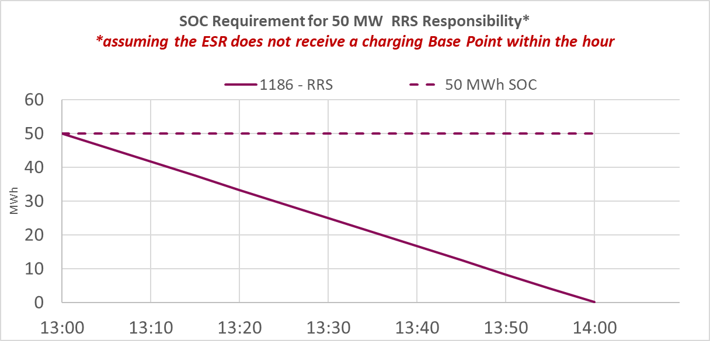
For each hour, the amount of minimum SOC for these services would start over at the maximum possible deployment level and decline to zero. A mirror-image requirement would apply to the headroom that must be maintained to provide “down” Ancillary Services.
Two Ancillary Service products require the calculation of a minimum SOC over a period of longer than one hour. Specifically, ECRS and Non-Spin require that the Resources designated by their QSEs to provide these services must be capable of responding at the MW level carried by the Resource for two hours and four hours, respectively. Consequently, the minimum SOC that an ESR must maintain for these services under NPRR1186 would need to be sufficient to cover a two-hour continuous response for ECRS and a four-hour continuous response for Non-Spin. The ESR would therefore need to begin each two-hour (or four-hour) period with sufficient SOC to fully deploy for that service over a two-hour (or four-hour) period. However, because Ancillary Services are not procured in multi-hour blocks, but are instead procured on an hourly basis, any consecutive hours of ECRS or Non-Spin commitment would require that the minimum SOC requirement be reset to the full level of SOC charge at the beginning of the next hour, given the possibility that the Resource could be deployed for that Service for a two-hour or four-hour period that begins in that next hour. An example of the minimum SOC requirement that would apply to an ESR that is carrying ECRS for three consecutive hours is as follows:

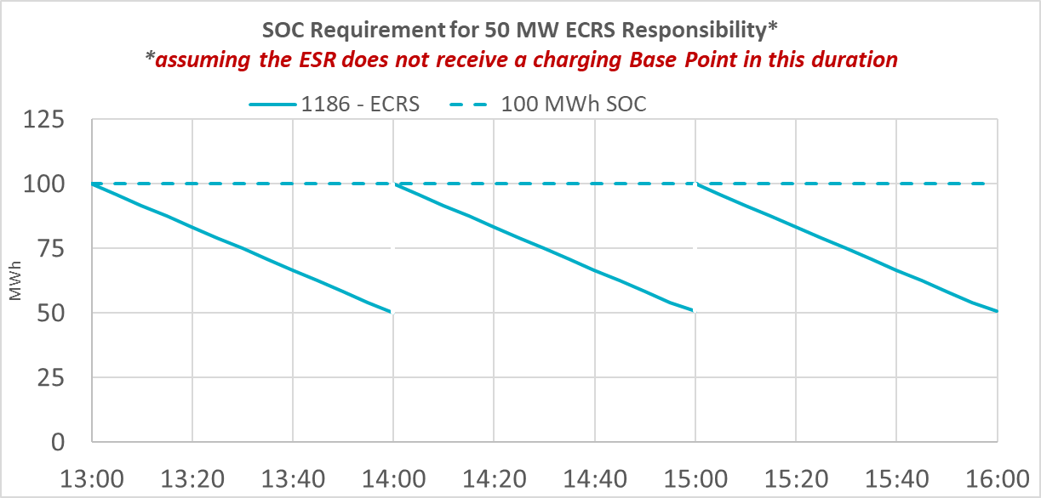
Because Resources, including ESRs, can carry multiple Ancillary Service Resource Responsibilities simultaneously, the above SOC requirements are cumulative for each Ancillary Service carried. Thus, a 50 MW ESR that is carrying 25 MW of RRS and 25 MW of Reg-Up for a given hour would need to have 50 MWh of stored energy at the beginning of that hour to meet its cumulative SOC requirement.
Given ERCOT’s existing systems and what is feasible to change prior to the implementation of the RTC+B project (without delaying the project), the proposal in NPRR 1186 represents the least-restrictive means of ensuring ERCOT continues to obtain the full value of Ancillary Services being provided by ESRs while allowing for maximum flexibility outside of the responsibility being carried by that ESR. If a QSE has designated an ESR to carry an Ancillary Service Resource Responsibility, and the ESR has stored more energy than the minimum required SOC, the QSE is free to offer that ESR’s energy to SCED and accept a deployment that would deplete the ESR’s energy down to the minimum SOC level. But allowing the ESR to deploy below that minimum SOC level for Ancillary Services would, by definition, introduce a risk of SOC insufficiency.
ERCOT notes that NPRR1186 also introduces important changes that will ensure its Reliability Unit Commitment (RUC) process can account for SOC in evaluating the need for RUC during any given hour. Today, ERCOT’s RUC systems do not have visibility of SOC in determining the need for RUC commitments. This lack of visibility can result in ERCOT committing too little capacity to meet future system needs. NPRR1186 will give ERCOT this critical visibility. This feature of the NPRR has not been a source of controversy in the stakeholder process.
Response to Eolian’s TAC Recommendation Opposition
Based on ERCOT’s dialogue with stakeholders, including battery developers, ERCOT has adopted several revisions to NPRR1186 that have addressed many of the concerns raised without materially contributing to reliability risk. Nevertheless, Eolian argues that TAC’s recommendation to approve NPRR1186 should still be rejected for several reasons.
Urgency
Eolian first complains that NPRR1186 does not satisfy the conditions for urgency in the Protocols. However, as ERCOT noted in its July 12, 2023 comments, this NPRR clearly meets the conditions for urgency stated in the Protocols. Under Section 21.5, Urgent and Board Priority Nodal Protocol Revision Requests and System Change Requests, an NPRR may be considered “urgent” when the submitter can reasonably show that “an existing . . . condition is impairing or could imminently impair ERCOT System reliability or wholesale or retail market operations. . . .” As discussed above, and as ERCOT has repeatedly demonstrated during the stakeholder process, failing to maintain sufficient SOC poses a risk to reliability. Although maintaining sufficient SOC is already effectively required by PUCT rules, this NPRR is urgently needed because it would allow ERCOT to modify certain SCED inputs to ensure that an ESR can be dispatched in a way that ensures sufficient SOC is retained during any hour in which the ESR carries an Ancillary Service award.
This NPRR is properly considered urgent for the additional reason that it provides important improvements in ERCOT’s visibility of ESR SOC when evaluating the need for RUC commitments in future hours, as noted above. This lack of visibility in the face of exponential growth in battery development constitutes an imminent risk to reliability, as it could cause ERCOT to undercommit the amount of generation needed to serve Load in future hours. If the amount of generation is not sufficient to meet ERCOT’s Load and reserve requirements, ERCOT could be required to lean on Ancillary Services to fill in the gap and, in cases where Ancillary Services may not be sufficient, ERCOT could be required to direct firm Load-shedding.
Additionally, the changes to ERCOT systems needed to address these reliability risks must also be undertaken promptly and completed before the end of this year before ERCOT resources must be shifted to developing the code to implement the Real-Time Co-optimization and Single Model ESR (RTC+B) project, which is planned to begin in January 2024. Therefore, if these reliability improvements are to be effective at all, they must be approved soon. The changes in NPRR1186 have been proposed with the aim of improving ERCOT’s SOC accounting in its existing tools and studies with minimal system changes so that the complete suite of RUC and SCED improvements needed to fully model ESRs and account for their SOC can be designed and implemented with the RTC+B project.
Reliability Impacts
Eolian asserts that, rather than improving reliability, NPRR1186 will actually hurt reliability in two key ways. First, Eolian complains that NPRR1186 will require ESRs to “arbitrarily withhold energy in future [hours] irrespective of whether an ESR has actually been awarded in future [hours].” This is simply incorrect. The minimum SOC requirement in this NPRR will apply only to each hour for which an ESR is providing an Ancillary Service Resource Responsibility. If an ESR has no Ancillary Service Resource Responsibility in a given hour, it will not be required to meet a minimum SOC requirement at any part of that hour.
Second, Eolian complains that, under NPRR1186, ESRs “will be forced to charge” during ECRS and Non-Spin deployments in order to meet the minimum SOC obligation at the top of any following hour in which the ESR has an ECRS or Non-Spin responsibility. While it is true that an ESR that has been designated by its QSE to carry an Ancillary Service Resource Responsibility will need to charge before the end of the hour if it lacks sufficient SOC heading into an hour in which it is carrying that responsibility, this argument misplaces the burden. No Resource operator is under any obligation to offer its capacity to provide any Ancillary Service product. If a QSE believes that an ESR will not be able to comply with a minimum SOC requirement, it should refrain from assigning that Ancillary Service Resource Responsibility to an ESR that it knows it may not be able to provide that service, given the requirements of P.U.C. Subst. R. 25.503, Oversight of Wholesale Market Participants. The difficulty that some ESRs may face in meeting SOC obligations in successive hours is entirely a consequence of the QSE’s decision to offer that ESR to provide an Ancillary Service in successive hours of obligation when that QSE is aware that the ESR’s inherently limited supply of energy could prevent the ESR from complying with those obligations. No Resource owner or operator has a right to provide a critical grid reliability service that it knows it may not be capable of providing.
While ERCOT recognizes that a requirement to have 100% of the potentially required SOC at the top of each obligated hour may seem undesirable to a QSE that has routinely offered all of its ESRs’ capacity to provide Ancillary Services, QSEs representing ESRs do have options for complying with such a requirement, including the following:
- Reducing the amount of an ESR’s capacity that is offered to provide Ancillary Services to a level that would be feasible under any deployment circumstance;
- Moving the Ancillary Service Resource Responsibility to another Resource, as permitted by ERCOT Protocols, in the event an ESR is subject to a sustained deployment and is not otherwise expected to be able to reach the minimum SOC required at the beginning of the next hour; or
- Avoiding offering to provide Ancillary Services from that ESR in consecutive hours.
ERCOT acknowledges that each of the above options would obviously have commercial impacts on some ESRs. Nevertheless, it is critical to ensure that Ancillary Services can be counted on to provide the reliability benefits for which they are procured, and NPRR1186 achieves this important purpose while preserving the commercial flexibility for ESRs to the greatest extent possible.
Proposal to Allow Limited Exception from Minimum SOC Requirement
While ERCOT generally disagrees with Eolian’s position on the substance of NPRR1186, ERCOT believes that Eolian raises one point that deserves additional consideration by ERCOT and the stakeholder community. Eolian suggests that NPRR1186 will “prevent SCED from deploying ESRs with excess energy even in emergencies.” ERCOT agrees that, under certain circumstances, the application of the minimum SOC requirement in successive hours of ECRS or Non-Spin obligation could result in energy being held back in an ESR at a time when ERCOT may well prefer that the ESR continue to discharge pursuant to an extended deployment instruction. Because maintaining sufficient SOC is important to reliability in its own right, those circumstances would naturally be limited to unusual situations involving scarcity of energy in which ERCOT has identified an actual or potential threat to maintaining a sufficient level of operating reserves. In those limited circumstances, ERCOT may prefer that an ESR carrying ECRS or Non-Spin continue to deploy to maximize the energy contribution of the ESR.
Accordingly, ERCOT proposes that the ERCOT Board consider a limited remand of this NPRR to TAC to allow discussion of possible revisions to the NPRR to address this one limited issue ahead of the ERCOT Board’s next meeting in October. If the remand is limited to this narrow scope, the imposition on the development of the RTC+B Revision Requests (RRs) should not be significant, and an ERCOT Board approval of this NPRR in October would be sufficient. If the scope of such a remand is not specified, or if it is broadened to include other issues, ERCOT has strong concerns that this would jeopardize the timing of the RTC+B development effort.
Discrimination
Eolian also alleges that the minimum SOC requirement would discriminate against ESRs because the requirement is crafted as an hourly requirement instead of a monthly requirement like many other existing performance measures such as Generation Resource Energy Deployment Performance (GREDP) and Controllable Load Resource Energy Deployment Performance (CLREDP). This argument lacks any merit. The fact that a compliance metric may differ in form from other compliance metrics does not make it discriminatory. As discussed above, ESRs present a unique problem—SOC insufficiency—that other Resources do not present. This unique problem requires a regulatory solution that is specific to this problem. In developing the solution to that problem, nothing requires ERCOT to adopt a metric that would be calculated as an average over a month, as opposed to a metric that would be calculated for each hour, as is proposed in NPRR1186.
ESRs, other Resources, and their QSEs are subject to hundreds of requirements that do not involve a calculation of compliance based on a monthly average—in fact, only a very small set of requirements use such a metric. For example, Section 6.4.6, Resource Status, requires a QSE to “provide ERCOT with accurate telemetry of the current capability of each Resource including the Resource Status, Ramp Rates, HSL, and LSL.” Section 6.5.7.7, Voltage Support Service, obligates each Generation Resource that is required to provide Voltage Support Service to “follow its Voltage Set Point as directed by ERCOT, the interconnecting TSP, or the TSP’s agent, within the operating Reactive Power capability of the Generation Resource.” Neither of these requirements has any monthly compliance metric, and the same is true for the vast majority of requirements in the ERCOT Protocols and Other Binding Documents.
Moreover, as one of several concessions ERCOT agreed to during the stakeholder discussion of this NPRR over the past two months, NPRR1186 already includes a performance metric reporting threshold that tolerates a small amount of non-compliance in any given hour. While it is conceivable that ERCOT could have developed a more permissive monthly SOC requirement that would have tolerated more failures of the SOC requirement than the metric that was adopted, nothing in the law requires ERCOT to have adopted such a metric.
Conclusion
ERCOT appreciates the ERCOT Board’s consideration of these comments and recommends that the Board remand the NPRR to TAC for the sole purpose of considering a limited revision that would enable ERCOT to allow an ESR to continue discharging at the beginning of a second or later hour in which an ESR is carrying an ECRS or Non-Spin responsibility during certain conditions of generation scarcity. If the Board chooses not to accept that recommendation for any reason, ERCOT would recommend that the Board recommend approval of NPRR1186 as recommended by TAC in the 8/22/23 TAC Report.

Revised Cover Page Language
None
Revised Proposed Protocol Language
None

“Up” Ancillary Services are those services that would require an increase in power injection; these include Regulation Up Service, RRS, NSRS, and ECRS.
These amounts reflect the proposed nameplate capacity of active projects for which a Full Interconnection Study has been requested. Based on historical observation, it is likely that most of this capacity will not materialize, although ERCOT has no reason to expect that the proportion of battery capacity to total capacity that eventually interconnects will materially differ from the proportion that is currently in the interconnection process.
See Protocols Section 2.1, Definitions (defining ECRS as an Ancillary Service “that is intended to . . . be sustained at a specified level for two consecutive hours,” and Non-Spin as an Ancillary Service provided by Resources that, among other things, “can operate . . . at a specified output level for at least four consecutive hours.”).
Eolian TAC Recommendation Opposition at 4.
Eolian TAC Recommendation Opposition at 4.
Section 8.1(4) requires ERCOT to report an ESR for failing to maintain its SOC only when the “integrated shortfall in comparison to the minimum required SOC over the course of an Operating Hour exceeds the greater of 2 MWhh or the lower of 8 MWhh or 20% of the integrated SOC requirement for the hour or the integrated excess in comparison to the maximum required SOC exceeds the greater of 2 MWhh or the lower of 8 MWhh or 20% of the integrated SOC requirement for the hour.”

