  - LP&L 2023 Distribution Loss Factor Calculations and Methodology

Assumptions:
- Inputs are measured from substation high side breakers and feeder breakers
- Outputs are measured from customers’ meters
- Component Losses are represented by the following equation:
$$Losses=AX^{2}+B$$
$$Where X=Power into Component$$
$$A=Power Loss Coeffiecient$$
$$B=No Load Loss Coeffiecient$$

Approximate Simplified Circuit Model
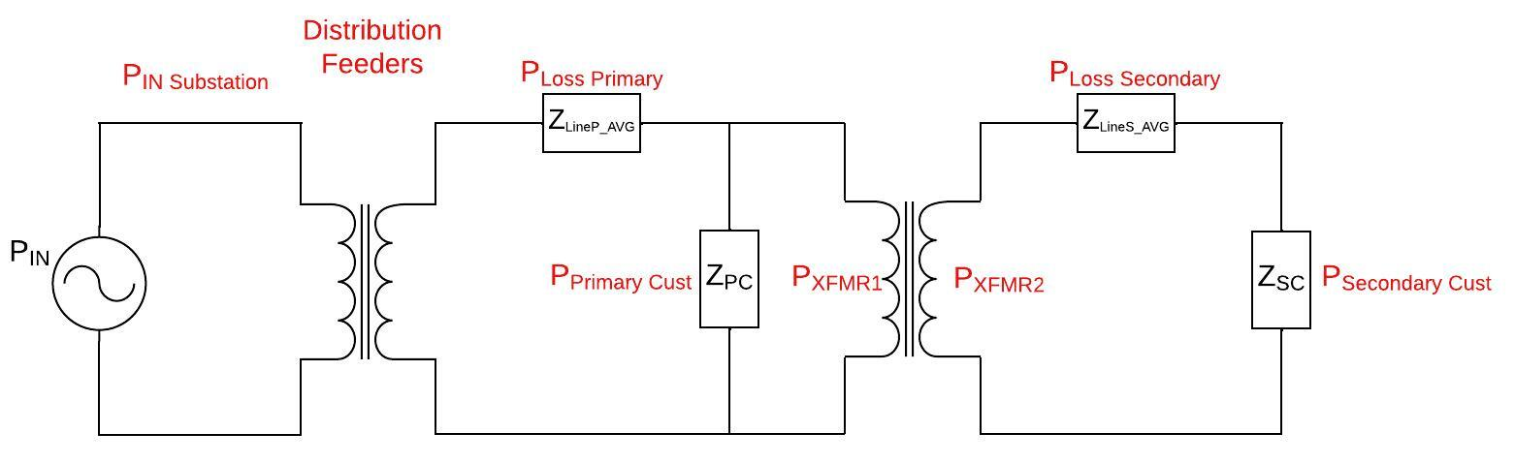
Figure 1: Approximate and Simplified Distribution System Circuit Model

Primary Conductor Loop
Figure 1 above shows the simplified model of LP&L’s distribution system. The power source represents the high side of a representative substation. The metered data LP&L has is the real and reactive power from the substation, the power factor, and the 3 main phase currents. Based on this information, we know the total power being delivered to the distribution system as well as the injection currents at various points in the system. Using substation data from the high side breakers and the feeder breakers, the substation transformer losses can be found with the following equation:
$$Substation Losses=A_{Sub}X_{Sub}^{2}+B_{Sub}$$
Losses can also be represented by the difference in input and output powers of a component.
$$\left(1\right) X_{Sub}-Y_{Sub}=A_{Sub}X_{Sub}^{2}+B_{Sub}$$
$$Where X_{Sub}=Substation Power Input,$$
$$Y_{Sub}=Substation Power Output$$

Primary Conductor and Secondary Loop Equations
Losses in the distribution system were found by creating a mathematical model of the distribution system and fitting the available feeder and customer consumption data to it. The losses of the primary conductor can be represented by the following equation:
$${\left(2\right) X}_{P}-X_{T}-Y_{P}=A_{P}X_{P}^{2}+B_{P}$$
$Where X_{P}=Primary Conductor Input$,
$X_{T}=Distribution Transformer Input$,
$$Y_{P}=Primary Customer Consumption$$
The secondary conductor losses are tied in with the transformer losses as one loss calculation. The secondary losses of the system are calculated by first determining the injection power into the transformer (using equation 2) and then subtracting the customer output data. These losses are represented by the following equation:
$$\left(3\right) X_{T}-Y_{S}={A_{T}X}_{T}^{2}+B_{T}$$
$$Where Y_{S}=Secondary Customer Consumption$$
Combining equations 2 and 3 will give an overall mathematical model of the distribution system from the feeder breaker to the customer meters. This will represent secondary customer consumption as a function of primary conductor input and primary customer consumption as seen below:
$$Y_{S}=X_{P}-A_{P}X_{P}^{2}-B_{P}-Y_{P}-A_{T}{\left(X_{p}-A_{P}X_{P}^{2}-B_{P}-Y_{P}\right)}^{2}-B_{T}$$
Customer and substation meter data can then be regressed to this model to provide the A and B coefficients for each loss equation. These loss equations can then be used to calculate the percent loss across the system.

DLF Calculation
The A and B coefficients are used to determine the loss percentages at varying loads into the LP&L distribution system. These loss percentages are then used to find the Settlement Interval Distribution Loss Factor (SILF_{i}) for each class of customer. These loss factors are then fit to the following equation to find F1, F2, and F3:
$$SILF_{i}=F1⋅\left(\frac{SIEL_{i}}{AAL}\right)+F2+\frac{F3}{\left(\frac{SIEL_{i}}{AAL}\right)}$$
Figures 2 through 7 show the DLF calculation and graphs for the 15 kV and 23 kV customers. Coefficients for each are below:
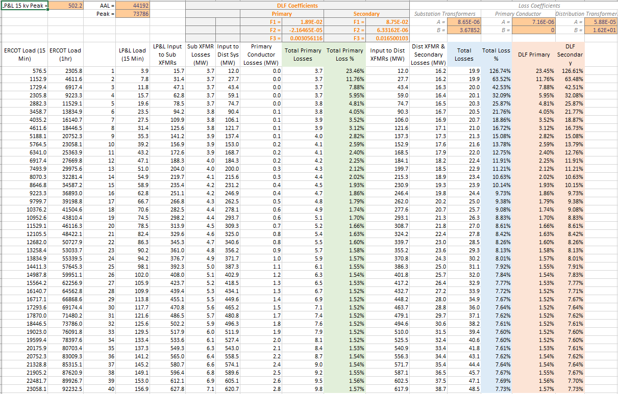
Figure 2: 15 kV DLF Calculation Table

Figure 3: 15 kV Secondary DLF Calculated vs Actual

Figure 4: 15 kV Primary DLF Calculated vs Actual
D-15 kV Primary |  | B-15 kV Secondary
F1 = | 1.89E-02 | F1 = | 8.75E-02
F2 = | -2.16465E-05 | F2 = | 6.33162E-06
F3 = | 0.003056116 | F3 = | 0.016500103

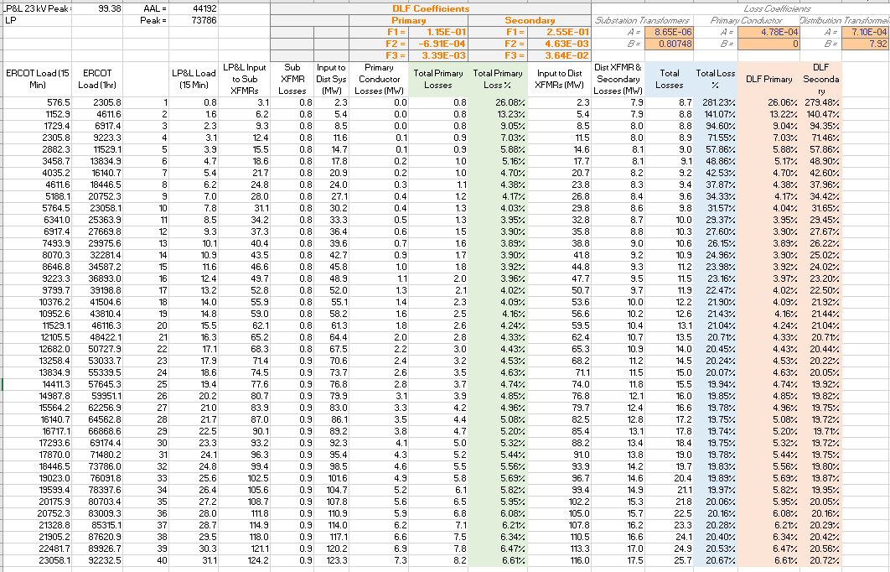
Figure 5: 23 kV DLF Calculation Table

Figure 6: 23 kV Secondary DLF Calculated vs Actual

Figure 7: 23 kV Primary DLF Calculated vs Actual
E-23 kV Primary |  | C-23 kV Secondary
F1 = | 1.15E-01 | F1 = | 2.55E-01
F2 = | -6.91E-04 | F2 = | 4.63E-03
F3 = | 3.39E-03 | F3 = | 3.64E-02

