June 2023 ERCOT Monthly Operations Report
Reliability and Operations Subcommittee Meeting
August 3, 2023

Table of Contents
1. Report Highlights 2
2. Frequency Control 3
2.1. Frequency Events 3
2.2. ERCOT Contingency Reserve Events 4
2.3. Load Resource Events 4
3. Reliability Unit Commitment 4
4. IRR, Wind, and Solar Generation as a Percent of Load 6
5. Largest Net-Load Ramps 7
6. Congestion Analysis 8
6.1. Notable Constraints 8
6.2. Generic Transmission Constraint Congestion 14
6.3. Manual Overrides 14
6.4. Congestion Costs for Calendar Year 2023 14
7. System Events 16
7.1. ERCOT Peak Load 16
7.2. Load Shed Events 16
7.3. Stability Events 16
7.4. Notable PMU Events 16
7.5. DC Tie Curtailment 17
7.6. TRE/DOE Reportable Events 17
7.7. New/Updated Constraint Management Plans 17
7.8. New/Modified/Removed RAS 17
7.9. New Procedures/Forms/Operating Bulletins 17
8. Emergency Conditions 18
8.1. OCNs 18
8.2. Advisories 18
8.3. Watches 19
8.4. Emergency Notices 19
9. Application Performance 19
9.1. TSAT/VSAT Performance Issues 19
9.2. Communication Issues 19
9.3. Market System Issues 19
10. Model Updates 19
Appendix A: Real-Time Constraints 22

Report Highlights
- The unofficial ERCOT peak demand was 80,787 MW for the month of June on 6/27/2023 HE 18:00; this was 4,069 MW more than the previous record of 76,718 MW set on 6/23/2022 HE 17:00.
- A PVGR Generation Record of 13,086 MW was set on 06/25/2023 at 12:48.
- There were 5 frequency events.
- There were 4 instances where ERCOT Contingency Reserve Service was deployed.
- 2 OCN’s for the extreme hot weather with forecasted temperatures in the North Central and South Central weather zones. 1 AAN’s issued for possible future emergency condition.
- 1 Watch for a projected reserve capacity shortage with no market solution.
- 3 DC Tie Curtailment Notices due to a planned or unplanned outage, including 1 Notice for DC_R and 2 Notices for DC_L.
- There were 46 HRUC commitments.
- There was 1 day of congestion on the Bearkat GTC, 28 days on the North Edinburg to Lobo GTC, 26 days on the Nelson Sharpe to Rio Hondo GTC, 11 days on the West Texas Export GTC, 14 days on the Valley Export GTC, and 9 days on the North to Houston GTC. There was no activity on the remaining GTCs during the month

Frequency Control

Frequency Events

The ERCOT Interconnection experienced 3 frequency events, which resulted from units tripping. The shortest event duration was 01:54 and the longest was 17:55.

A summary of the frequency events is provided below. The reported frequency events meet one of the following criteria: Delta Frequency is 60 mHz or greater; the MW loss is 350 MW or greater; resource trip event triggered ECRS deployment. Frequency events that have been identified as Frequency Measurable Events (FME) for purposes of BAL-001-TRE-2 analysis are highlighted in blue. When analyzing frequency events, ERCOT evaluates PMU data according to industry standards. Events with an oscillating frequency of less than 1 Hz are inter-area, while higher frequencies indicate local events. Industry standards specify that damping ratio for inter-area oscillations should be 3.0% or greater. For the frequency events listed below, the ERCOT system met these standards and transitioned well after each disturbance. In the case of negative delta frequency, the MW Loss column could refer to load loss.

Date and Time | Delta Frequency | Max/Min Frequency | Duration of Event | PMU Data |  | MW Loss | Load | IRR | Inertia
 | (Hz) | (Hz) |  | Oscillation Mode (Hz) | Damping Ratio |  | (MW) | % | (GW-s)
6/3/2023 0:27:05 | 0.083 | 59.934 | 00:01:54 | 0.7 | 12% | 477 | 48,414 | 16% | 276,475
6/10/2023 17:12:44 | 0.072 | 59.934 | 00:08:39 | 0.53 | 10% | 989 | 70,739 | 28% | 326,506
6/16/2023 18:31:51 | 0.081 | 59.880 | 00:03:37 | 0.65 | 14% | 1236 | 73,977 | 20% | 362,708
6/20/2023 18:57:06 | 0.073 | 59.921 | 00:17:55 | 0.63 | 14% | 619 | 76,838 | 17% | 378,999
6/25/2023 16:08:22 | 0.061 | 59.946 | 00:04:19 | 0.95 | 8% | 410 | 78,283 | 25% | 358,374

(Note: All data on this graph encompasses frequency event analysis based on BAL-001-TRE-2.)

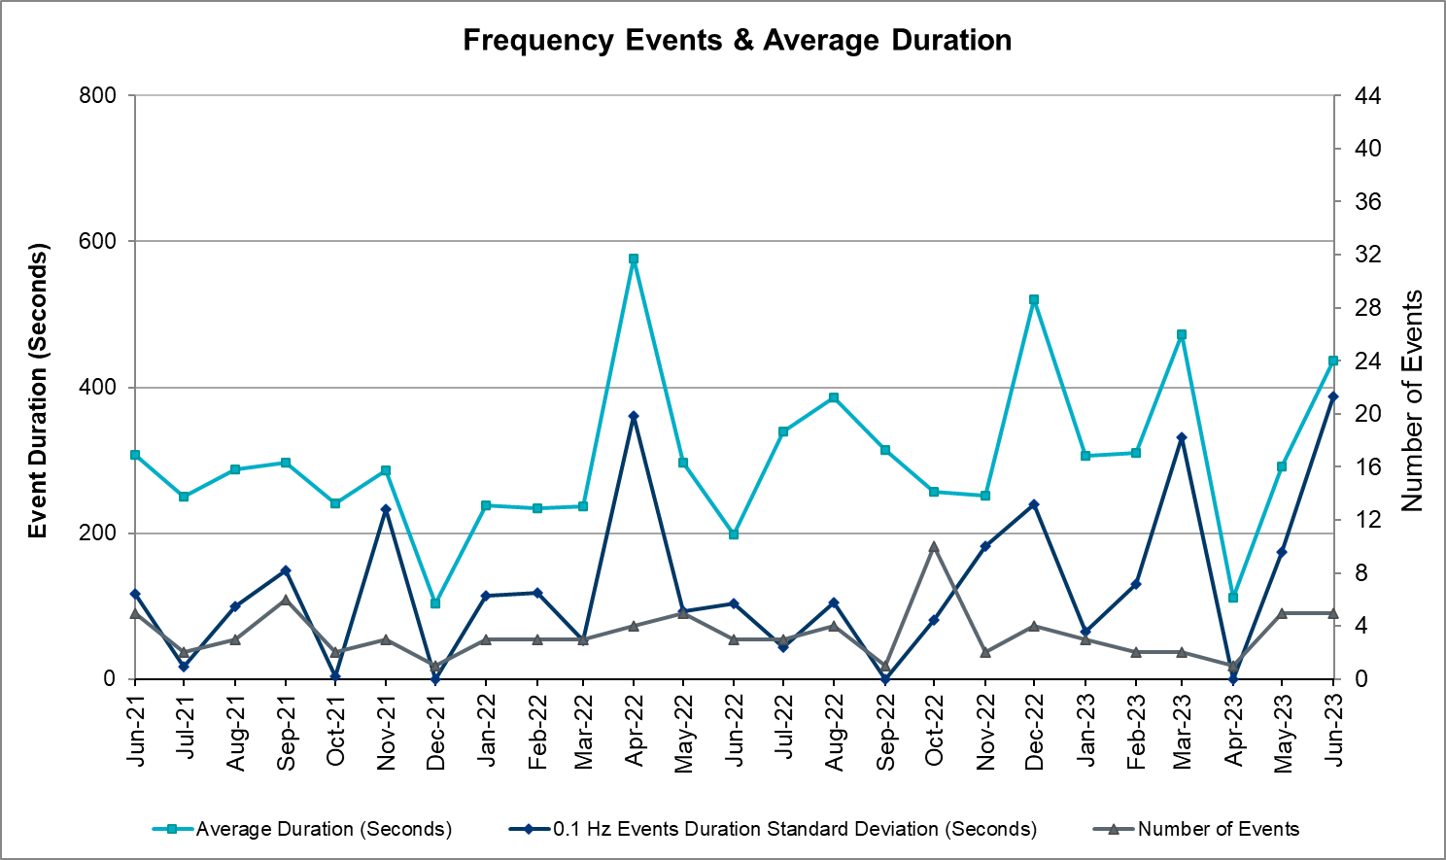

ERCOT Contingency Reserve Events

There were 4 events where ERCOT Contingency Reserve MWs were released to SCED. The events highlighted in blue were related to frequency events reported in Section 2.1 above.

Date and Time Released to SCED | Date and Time Recalled | Duration of Event | Maximum MWs Released | Comments
06/14/2023 19:20:46 | 06/14/2023 19:33:14 | 00:12:28 | 600 | Insufficient capability for forecasted 10min Ahead Net Load
06/16/2023 18:31:58 | 06/16/2023 18:36:38 | 00:04:40 | 430 | Unit Trip
06/18/2023 19:20:41 | 06/18/2023 19:46:06 | 00:25:25 | 200 | Insufficient capability for forecasted 10min Ahead Net Load
06/20/2023 16:21:40 | 06/20/2023 21:01:43 | 04:40:03 | 1900 | Unit Trip and Insufficient capability for forecasted 10min Ahead Net Load

Load Resource Events
None.

Reliability Unit Commitment
ERCOT reports on Reliability Unit Commitments (RUC) monthly. Commitments are reported grouped by operating day and weather zone. The total number of hours committed is the sum of the hours for all the units in the specified region. Additional information on RUC commitments can be found on the MIS secure site at Grid Generation Reliability Unit Commitment.

There were no DRUC commitments.

There were 46 HRUC commitments.
Resource Location | # of Resources | Operating Day | Total # of Hours Committed | Total MWhs | Reason for Commitment
EAST, NORTH_CENTRAL | 4 | 06/01/2023 | 12 | 4,169.0 | System Capacity
COAST, SOUTH_CENTRAL | 3 | 06/06/2023 | 18 | 4,158.0 | System Capacity
COAST, NORTH_CENTRAL | 3 | 06/07/2023 | 19 | 5,504.0 | System Capacity
COAST, NORTH_CENTRAL | 4 | 06/09/2023 | 25 | 3,208.0 | System Capacity
EAST, NORTH_CENTRAL, SOUTH_CENTRAL, SOUTHERN | 9 | 06/11/2023 | 57 | 6,490.0 | System Capacity
NORTH_CENTRAL | 2 | 06/12/2023 | 48 | 7,272.0 | Minimum Run Time
COAST, EAST, NORTH_CENTRAL, SOUTHERN | 6 | 06/13/2023 | 68.8 | 13,317.4 | SSTILOM8, System Capacity,  Minimum Run Time
COAST, NORTH_CENTRAL, SOUTHERN | 7 | 06/14/2023 | 68 | 11,289.0 | SSTILOM8, System Capacity
NORTH_CENTRAL | 5 | 06/17/2023 | 30 | 1,948.0 | System Capacity
FAR_WEST | 1 | 06/20/2023 | 2 | 270.0 | System Capacity
NORTH_CENTRAL | 1 | 06/22/2023 | 4 | 86.0 | System Capacity
COAST | 1 | 06/23/2023 | 4 | 644.0 | System Capacity

IRR, Wind, and Solar Generation as a Percent of Load
The graph below shows the maximum, minimum and average aggregate solar, wind and IRR output as a percentage of total ERCOT load when evaluated as 10-minute averaged intervals, over the past 13 months. Current wind and solar generation and penetration records are listed in the footnote below. Maximum IRR penetration for the month was 49.6% on 06/30/2023 interval ending 09:20 and minimum IRR penetration for the month was 1.3% on 06/06/2023 interval ending 06:30.

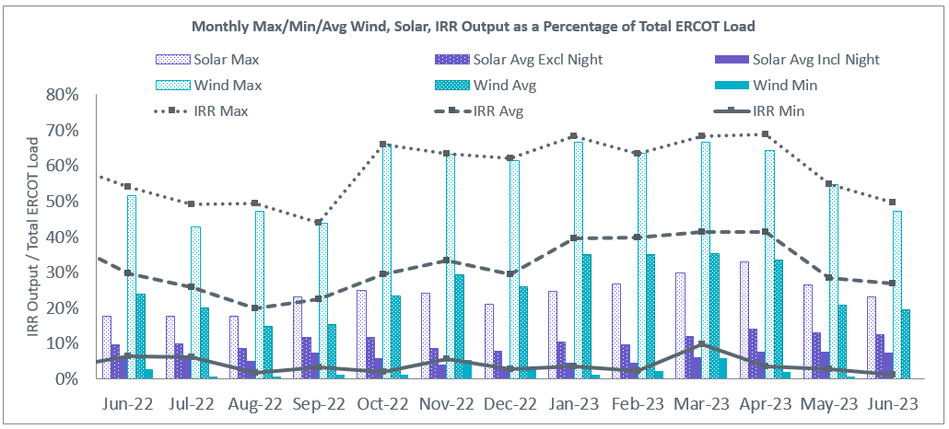

During the hour of peak load for the month, hourly integrated wind generation was 18,632 MW and solar generation was 9,839 MW. The graph below shows the wind and solar penetration percentage during the hour of the peak load in the last 13 months.

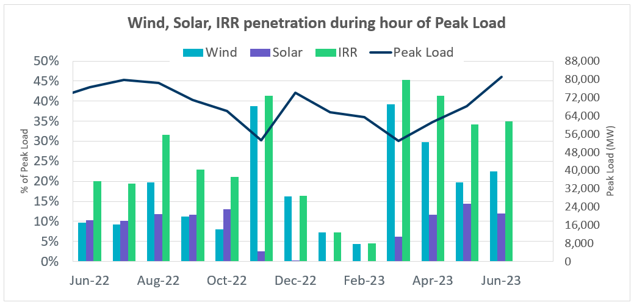

Lastly, the graph below shows the minimum wind, solar and IRR output during the peak load hour as a percentage of the daily peak load for every day in the month.

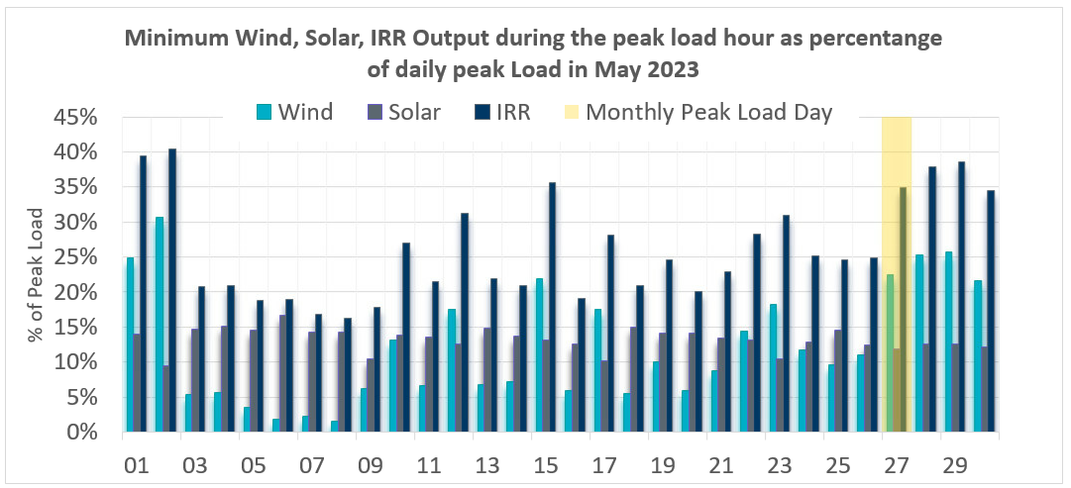

Largest Net-Load Ramps
The net-load ramp is defined as the change in net-load (load minus wind and PVGR generation) during the defined time horizon. Such a variation in net-load needs to be accommodated in grid operations to ensure that the reliability of the grid is satisfactorily maintained. The largest net-load ramp during 5-min,
10-min, 15-min, 30-min and 60-min in June 2023 was 1,044 MW, 1,672 MW, 2,316 MW, 4,075 MW, and 7,845 MW, respectively. The comparison with respect to the historical values is given in the table below.

Month and Year | 5 min | 10 min | 15 min | 30 min | 60 min
June 2014 | 919 MW | 1,329 MW | 1,873 MW | 3,516 MW | 5,724 MW
June 2015 | 1,038 MW | 1,771 MW | 2,489 MW | 3,119 MW | 5,360 MW
June 2016 | 1,183 MW | 1,716 MW | 2,148 MW | 3,131 MW | 5,975 MW
June 2017 | 751 MW | 1,287 MW | 1,772 MW | 3,106 MW | 5,573 MW
June 2018 | 1,029 MW | 1,413 MW | 2,035 MW | 3,590 MW | 6,320 MW
June 2019 | 824 MW | 1,284 MW | 1,706 MW | 2,985 MW | 5,684 MW
June 2020 | 902 MW | 1,615 MW | 2,340 MW | 3,726 MW | 7,015 MW
June 2021 | 1,442 MW | 2,157 MW | 2,646 MW | 3,468 MW | 5,963 MW
June 2022 | 1,064 MW | 1,588 MW | 2,166 MW | 4,035 MW | 7,866 MW
June 2023 | 1044 MW  06/16/2023  (IE 13:09) | 1,672 MW  06/16/2023  (IE 13:11) | 2,316 MW  06/25/2023  (IE 12:14) | 4,075 MW  06/25/2023  (IE 12:10) | 7,845 MW  06/25/2023  (IE 12:06)
All Months in 2014-2023 | 1,647 MW  05/25/2022  (IE 17:06) | 2,506 MW  1/12/2023  (IE 17:16) | 3,583 MW  04/29/2023  (IE 19:19) | 6,640 MW  04/29/2023  (IE 19:34) | 12,352 MW  04/29/2023  (IE 19:50)

Congestion Analysis

Notable Constraints

Nodal protocol section 3.20 specifies that ERCOT shall identify transmission constraints that are binding in Real-Time three or more Operating Days within a calendar month. As part of this process, ERCOT reports congestion that meets this criterion to ROS. In addition, ERCOT also highlights notable constraints that have an estimated congestion rent exceeding $1,000 for a calendar month. These constraints are detailed in the table below, including approved transmission upgrades from TPIT that may provide some congestion relief based on ERCOT’s engineering judgement. Rows highlighted in blue indicate the congestion was affected by one or more outages. For a list of all constraints activated in SCED, please see Appendix A at the end of this report.

Contingency Name | Overloaded Element | # of Days Constraint Binding | Congestion Rent | Transmission Project
Elmcreek-Sanmigl 345kV | Pawnee Switching Station - Calaveras 345kV | 14 | $17,693,810.90
Austro-Daffin&Dunlap-Decker 138kV | Mcneil - Mcneil Aen 138kV | 12 | $16,784,057.61
Loss of NEDIN train | Burns Sub - Rio Hondo 138kV | 11 | $12,374,391.42 | STEC_71930_RioHondo_Burns_Upgrade (71930)
DIMMIT to BEVO LIN 1 | Hamilton Road - Maverick 138kV | 12 | $9,924,099.51 | AEP_TCC_Ganso - Hamilton Road 138 kV Line Rebuild(22RPG044, MOD 55626)
SALSW - HUTTO 345KV | Bell County - Salado Switch 138kV | 6 | $7,889,283.85
COLETO - GRISSOM (345) & VICTORIA - FANNINS (69) | Pawnee Switching Station - Tango 345kV | 1 | $7,333,865.43
Basecase | NE_LOB GTC | 22 | $6,493,975.25 | The Lower Rio Grande Valley (LRGV) System Enhancement Project (21RPG017) will improve the NorthEd_LoboGTC to support up to 80% of total wind and solar generation capacity in the LRGV area.
Koch Upriver - Tortuga & Lon Hill - Nueces Bay 138KV | Champlin - Weil Tract 138kV | 9 | $6,437,373.25 | ETT_TCC_Champlin-WeilTractRebuild (57912)
Basecase | WESTEX GTC | 8 | $5,476,949.65
Manual dbl ckt for NEDIN-BONILLA 345kV & RIOH-PRIM138kV | Burns Sub - Rio Hondo 138kV | 15 | $5,018,787.05 | STEC_71930_RioHondo_Burns_Upgrade (71930)
McCala-Hunter &Hillto 138kV | Rattler - Mccarty Lane 138kV | 3 | $4,210,217.73 | LCRATSC_McCartyLane_Rattler_TL_Upgrade (70204)
Austro-Daffin&Dunlap-Decker 138kV | Sim Gideon - Bastrop City 138kV | 3 | $3,716,435.62
Basecase | NELRIO GTC | 22 | $3,553,617.70 | The Lower Rio Grande Valley (LRGV) System Enhancement Project (21RPG017) will cause there to be no stability constraint for NelsonSharpe_RioHondoGTC under normal conditions.
LON_HILL - BUNSEN & WEIL_TRC 138 KV | Champlin - Weil Tract 138kV | 2 | $3,257,784.37 | ETT_TCC_Champlin-WeilTractRebuild (57912)
AUSTROP to DAFFIN GIN LIN 1 | Decker Power Plant - Aen Dunlap 138kV | 1 | $3,088,311.92 | AEN_24TPIT67091_PMCR_CKT1034_DUNLAP_DECKER_138 KV (67091)
MGSES TO CCRSW 345 AND BTRCK TO MGSES 345 DBLCKT | Tonkawa Switch - Morgan Creek Ses 345kV | 14 | $3,046,026.30
KENDALL to COMFORT LIN 1 | Kerrville Stadium - Kendall 138kV | 4 | $2,976,123.66
DMTSW TO SCOSW 345 DBLCKT | Knapp - Scurry Chevron 138kV | 8 | $2,921,918.63
TWR(345) WAP-WLF64 & WAP-WLY72 | South Texas Project - Wa Parish 345kV | 7 | $2,871,371.15 | CNP_23TPIT57412_Remove_Genral_Substation (57412), CNP_22TPIT57549_Garden_69kV_Load_Conversion (57549)
McCullough Substation to Co-op Substation LIN 1 | Erskine Substation - Mackenzie Substation 69kV | 5 | $2,815,335.50 | LPL_Fix Split Buses(65766)
McCala-Hunter &Hillto 138kV | Rattler - Redwood 138kV | 1 | $2,707,118.56 | LCRATSC_Rattler_Redwood_TL_Upgrade (70351)
Fowlerton to LOBO 345 LIN1 | Laredo Vft North - Las Cruces 138kV | 16 | $2,316,113.24 | AEP_TCC_Laredo VFT North - North Laredo SS 138 kV Line Rebuild (58008)
Zenith to TH WHARTON LIN A | Th Wharton - Zenith 345kV | 3 | $2,314,456.92
MULDOON to MULDOON LIN 1 | Magruder - Victoria 138kV | 5 | $2,052,243.31
MAN_DBL_'CONSW-MGSES_and_CONSW-LNGSW_345kV_DBLCKT | Polecat Creek Switch - Dewey Lake Tap 138kV | 8 | $2,029,006.97
STILLMAN to LOMA ALTA SUBSTATION LIN 1 | Titan Substation - South Carbide 138kV | 3 | $1,991,593.72
Rattlesnake Rd Switch to LAKE CREEK SES LIN _A | St Johns Switch - Jewett 345kV | 6 | $1,972,663.40
WESTSIDE - MCKENZIE (138) & LON_HILL - NUECES_B (138) | Champlin - Weil Tract 138kV | 1 | $1,871,406.19 | ETT_TCC_Champlin-WeilTractRebuild (57912)
MAN_DBL_'CONSW-MGSES_and_CONSW-LNGSW_345kV_DBLCKT | Morgan Creek Ses - Navigation Sub 138kV | 8 | $1,753,185.83
Bighil-Kendal 345kV | Yellow Jacket - Treadwell 138kV | 12 | $1,748,075.15
Lon_Hill - Nueces & Equistar 138 kV | Champlin - Weil Tract 138kV | 1 | $1,645,913.65 | ETT_TCC_Champlin-WeilTractRebuild (57912)
ROANOKE SWITCH to HICKS SWITCH LIN _A | Hicks Switch - Alliance 345kV | 4 | $1,635,040.59
COLETO CREEK to Euler LIN 1 | Coleto Creek - Rosata Tap 138kV | 4 | $1,508,638.56 | AEP_TCC_Add_Rosata Station (6749)
TRIDGE-ASHWDSnHWRDLN 138 KV | Gilleland Creek - Mcneil 138kV | 1 | $1,439,694.39
LON HILL to NELSON SHARPE LIN 1 | Nelson Sharpe 345kV | 15 | $1,245,804.53
Lon_Hill-Coleto 345kV&Warburtn 138kV | Pawnee Switching Station - Tango 345kV | 1 | $1,191,944.12
Bonilla to NORTH EDINBURG LIN 1 | Burns Sub - Rio Hondo 138kV | 3 | $1,023,210.76 | STEC_71930_RioHondo_Burns_Upgrade (71930)
White Point to Angstrom & Lon Hill 345KV DOUBLE | Pawnee Switching Station - Tango 345kV | 8 | $1,010,420.25
wett_long_draw to VEALMOOR - Sharyland Utilities LIN 1 | Willow Valley Switch - Gail Sub 138kV | 7 | $681,298.82
BAKERSFIELD SWITCHYARD to Big HiLL LIN 1 | Palouse - Wolfcamp 138kV | 3 | $564,680.16
Fowlerton to LOBO 345 LIN1 | Catarina - Piloncillo 138kV | 10 | $550,323.64 | AEP_TCC_AshertontoPiloncillo138kVLine_rebuild (73100)
BALLINGER TRX FMR1 138/69 | San Angelo Concho - Veribest 69kV | 4 | $513,672.00
OASIS to MEADOW LIN A | Monsan Cogen - Petson 138kV | 8 | $493,194.38 | CNP_22TPIT64941_Ckt04_Petson_Monsan_Upgrades (64941)
MESA VIEW SWITCH to FORT LANCASTER LIN 1 | North Mccamey - Crossover 138kV | 3 | $447,368.07
KING RANCH GAS PLANT to FALFURRIAS LIN 1 | Falfurrias - Premont 69kV | 8 | $447,312.81
Grissom to COLETO CREEK LIN 1 | Pawnee Switching Station - Tango 345kV | 8 | $423,577.19
COLETO CREEK to VICTORIA LIN 1 | Coleto Creek - Victoria 138kV | 13 | $416,539.81
ZORN - HAYSEN 345KV | Bergheim 138kV | 7 | $415,574.90
BLACKWATER DRAW SWITCH to DOUBLE MOUNTAIN SWITCH LIN 1 | Mackenzie Substation - Northeast Substation 115kV | 3 | $412,296.21 | LPL_Fix Split Buses(65766)
FORT LANCASTER to ILLINOIS #4 LIN 1 | Hamilton Road - Maxwell 138kV | 7 | $405,921.84
DYANN to CANEY LIN A | Damon - West Columbia 138kV | 3 | $364,415.56
NATURAL DAM to BEALS CREEK SUB LIN _A | Big Spring West - Stanton East 138kV | 3 | $339,645.27 | Oncor_FW_71989_Big Spring West - Stanton East 138 kV Line (71989)
MAN_DBL_'CONSW-MGSES_and_CONSW-LNGSW_345kV_DBLCKT | Lamesa - Jim Payne Poi 138kV | 5 | $312,350.64 | Oncor_FW_66635_Lamesa 69 kV Substation Conversion to 138 kV (66635)
JEWET TO SNG 345 DBLCKT | Singleton - Gibbons Creek 345kV | 4 | $287,162.74
PALODURO SUB to PEARSALL SWITCHING STATION LIN 1 | Pearsall Switching Station 138kV | 5 | $273,946.78 | STEC_71319_upgradePearsallStation (71319)
MAN_DBL_'CONSW-MGSES_and_CONSW-LNGSW_345kV_DBLCKT | Rocky Road - Stiles 138kV | 3 | $256,504.70 | Oncor_FW_45693_Rocky Road - Stiles 138 kV Line (45693)
Carver to FRIEND RANCH LIN 1 | Atlantic Sonora - Sonora 69kV | 5 | $249,251.48
MAN_DBL_'CONSW-MGSES_and_CONSW-LNGSW_345kV_DBLCKT | East Stiles - Blissard Sub 138kV | 3 | $239,268.18 | Oncor_FW_61516_Blissard - East Stiles 138 kV Line Section (61516)
Bighil-Kendal 345kV | Maddux - Treadwell 138kV | 8 | $236,292.37
SAN ANGELO RED CREEK to Weiss LIN 1 | San Angelo Concho - Veribest 69kV | 3 | $229,948.03
BBSES TO RCHBR 345 DBLCKT | Pin Oak Switch - Fairfield Bepc 138kV | 5 | $224,391.22 | Oncor_SE_62327_Fairfield West - Big Brown Tap 138 kV Line (62327)
AJO to NELSON SHARPE LIN 1 | Las Pulgas - Raymondville 2 138kV | 17 | $206,565.15
CARTERVILLE to EINSTEIN LIN 1 | Rocky Road - Stiles 138kV | 7 | $177,763.44 | Oncor_FW_45693_Rocky Road - Stiles 138 kV Line (45693)
LAS PULGAS to RAYMONDVILLE 2 LIN 1 | Haine Drive - La Palma 138kV | 3 | $134,874.22
DILLEY SWITCH AEP to DILLEY SWITCH AEP LIN 1 | Dilley Switch Aep 138kV | 4 | $129,126.58
GRAHAM SES to RICE SWITCH LIN _A | Anarene - Navy Kickapoo Switch 69kV | 5 | $126,309.82
FT LANCASTER - FRIEND RANCH 138 & FT LANCASTER - ILLINOIS 138 | Hamilton Road - Maxwell 138kV | 6 | $118,079.85
LAQUINTA to LOBO LIN 1 | Falfurrias - Premont 69kV | 10 | $117,756.55
LAQUINTA to LOBO LIN 1 | Bruni Sub 138kV | 14 | $117,077.90
FIREROCK TO BRNWD 138 AND FIREROCK TO BANGS 69 DBLCKT | Cottonwood Road Switch - Olney Pod 69kV | 4 | $116,659.35
Fowlerton to LOBO 345 LIN1 | Falfurrias - Premont 69kV | 5 | $107,976.91
GRSES TO PKRSW 345 DBLCKT | Barton Chapel Wind Farm - Oran Sub 138kV | 5 | $107,267.11
AJO to NELSON SHARPE LIN 1 | Falfurrias - Premont 69kV | 5 | $106,379.84
Basecase | VALEXP GTC | 13 | $100,932.87 | The Lower Rio Grande Valley (LRGV) System Enhancement Project (21RPG017) will improve but not eliminate the need for this GTC.
MOLINA - LOBO 138 & LOBO - CENIZO 345 | Pawnee Switching Station - Tango 345kV | 4 | $72,195.58
HAYS ENERGY to ZORN LIN 1 | Zorn - Hays Energy 345kV | 5 | $71,510.73
Bighil-Kendal 345kV | Hamilton Road - Maxwell 138kV | 6 | $62,357.22
MADDUX to SAN ANGELO POWER STATION LIN 1 | Maddux - San Angelo Power Station 138kV | 9 | $60,964.83
Fowlerton to LOBO 345 LIN1 | Asherton - Catarina 138kV | 3 | $48,320.46 | AEP_TCC_AshertontoPiloncillo138kVLine_rebuild (73100)
KLEBERG AEP to LOYOLA SUB LIN 1 | Loyola Sub 138kV | 6 | $46,607.57
SWESW TO MULBERRY AND SWESW TO LNCRK 345 DBLCKT | Bluff Creek - Abilene Mulberry Creek 345kV | 3 | $35,946.38 | AEP_TNC_MulberryCreek (48816)
ODLAW SWITCHYARD to ASPHALT MINES LIN 1 | Hamilton Road - Maverick 138kV | 5 | $31,133.75 | AEP_TCC_Ganso - Hamilton Road 138 kV Line Rebuild(22RPG044, MOD 55626)
SALSW - HUTTO 345KV | Temple Switch - Knob Creek Switch 345kV | 3 | $26,409.29
Manual for I_DUPS - RESNIK & MCCAMPBE 2 138KV | Whitepoint - Rincon 138kV | 5 | $13,523.94
PANCAKE to PANCAKE LIN 1 | Gustine - Hasse 69kV | 4 | $9,178.56 | BEPC_TPIT1205_HASSE_GUSTINE (1205)
ASPERMONT AEP to SPUR LIN 1 | Girard Tap - Spur 69kV | 3 | $5,830.54
Basecase | Rambler Solar - Twin Buttes 345kV | 5 | $2,065.08
SAM RAYBURN SWITCHING STATION to VANDERBILT SWITCHING STATION LIN 1 | Sam Rayburn Switchyd 138kV | 3 | $1,378.49

Generic Transmission Constraint Congestion
There was 1 day of congestion on the Bearkat GTC, 28 days on the North Edinburg to Lobo GTC, 26 days on the Nelson Sharpe to Rio Hondo GTC, 11 days on the West Texas Export GTC, 14 days on the Valley Export GTC, and 9 days on the North to Houston GTC. There was no activity on the remaining GTCs during the month.

Note: This is how many times a constraint has been activated to avoid exceeding a GTC limit, it does not imply an exceedance of the GTC occurred or that the GTC was binding.

Manual Overrides
None

Congestion Costs for Calendar Year 2023
The following table represents the top twenty active constraints for the calendar year based on the estimated congestion rent attributed to the congestion. ERCOT updates this list on a monthly basis.

Contingency | Overloaded Element | # of 5-min SCED | Estimated Congestion Rent (2023)
MAN_DBL_MDSSW-ODEHB_and_CONSW-QALSW_345kV_DBLCKT | Midessa South Sw 138kV | 11605 | $79,014,288.16
Basecase | WESTEX GTC | 13718 | $46,731,784.43
SKYWEST to SPRABERRY SWITCH LIN 1 | Consavvy Switch - Cottonfield Sub 138kV | 2909 | $45,341,291.63
SKYWEST to SPRABERRY SWITCH LIN 1 | South Midland - Consavvy Switch 138kV | 10282 | $41,928,489.30
Basecase | NE_LOB GTC | 21969 | $35,032,106.60
Manual_SGL_CONSW-MDSSW_345kV_SglCkt | Quail Switch - Odessa Ehv Switch 345kV | 3594 | $26,545,479.50
BLACKWATER DRAW SWITCH to DOUBLE MOUNTAIN SWITCH LIN 1 | Mackenzie Substation - Northeast Substation 115kV | 7788 | $25,999,322.35
Basecase | PNHNDL GTC | 7932 | $24,476,704.55
Elmcreek-Sanmigl 345kV | Pawnee Switching Station - Calaveras 345kV | 5226 | $24,456,322.53
MAN_DBL_CONSW-MDSSW_and_CONSW-QALSW_345kV_DBLCKT | Morgan Creek Ses - Forest Creek And Sand Bluff Wind Farms 138kV | 2616 | $21,174,926.89
McCullough Substation to Co-op Substation LIN 1 | Erskine Substation - Mackenzie Substation 69kV | 3817 | $18,467,803.12
CRLNW TO LWSSW 345 DBLCKT | Ti Tnp - South Tnp 138kV | 2519 | $17,238,444.46
Manual dbl ckt for NEDIN-BONILLA 345kV & RIOH-PRIM138kV | Burns Sub - Rio Hondo 138kV | 7593 | $17,010,149.19
Basecase | BEARKT GTC | 17532 | $16,857,909.26
Austro-Daffin&Dunlap-Decker 138kV | Mcneil - Mcneil Aen 138kV | 1518 | $16,784,057.61
SALSW TO KLNSW 345 DBLCKT | Harker Heights South - Killeen Switch 138kV | 7358 | $16,377,407.19
NATURAL DAM to BEALS CREEK SUB LIN _A | Big Spring West - Stanton East 138kV | 15716 | $16,282,649.10
MAN_DBL_MGSES-LNGSW_and_MGSES-CONSW_345_DBLCKT | Morgan Creek Ses - Forest Creek And Sand Bluff Wind Farms 138kV | 1208 | $13,017,838.24
Fowlerton to LOBO 345 LIN1 | Catarina - Piloncillo 138kV | 8159 | $13,013,318.56
Bighil-Kendal 345kV | Hamilton Road - Maverick 138kV | 9151 | $12,598,454.10

System Events

ERCOT Peak Load
The unofficial ERCOT peak load for the month was 80,787 MW and occurred on 06/27/2023, during hour ending 18:00.

Load Shed Events
None.

Stability Events
None.

Notable PMU Events
ERCOT analyzes PMU data for any significant system disturbances that do not fall into the Frequency Events category reported in section 2.1. The results are summarized in this section once the analysis has been completed.

ERCOT has identified multiple oscillations from real time PMUs in the Rio Hondo area for multiple events between 6/22/223 and 6/27/2023. MW swings up to 10 MW have also been observed during this time. The frequency mode of the oscillations consistently remains around 5.5 Hz.

A request for information has been sent for the following times:

- 6/26 from 16:35 – 20:00 (all times CPT)
- 6/25 from 15:30 – 18:20
- 6/25 from 8:55 – 10:10
- 6/24 from 14:50 – 19:20
- 6/23 from 17:35 – 21:30
- 6/22 from 18:10 – 21:15

DC Tie Curtailment
Date | DC Tie | Curtailing Period | # of Tags Curtailed | Initiating Event | Curtailment Reason,
06/09/2023 | DC_R | HE 01 – HE24 | 5 | Forced Outage | Planned or Unplanned Outage
06/13/2023 | DC_L | HE 01 – HE24 | 2 | Forced Outage | Planned or Unplanned Outage
06/16/2023 | DC_L | HE 21 – HE24 | 3 | Forced Outage | Planned or Unplanned Outage

TRE/DOE Reportable Events
- Centerpoint Submitted a DOE-417 For 06/04/2023 Normal Report: Loss of 50,000 customers.
- Oncor Submitted an EOP-004-4 For 06/08/2023 Physical Threat of its Facility.
- Oncor Submitted a DOE-417 For 06/08/2023 System Report: Physical Threat of its Facility.
- Centerpoint Submitted a DOE-417 For 06/09/2023 Normal Report: Loss of 50,000 customers.
- LCRA Submitted a DOE-417 For 06/09/2023 System Report: Unexpected Transmission Loss within its area, Contrary to design, of three or more Bulk electric system.
- Centerpoint Submitted a DOE-417 For 06/10/2023 Normal Report: Loss of 50,000 customers.
- AEP Submitted a DOE-417 For 06/11/2023 Final System Report: Damage or destruction of a Facility
- RWE Submitted an EOP-004-4 For 06/14/2023 System Report: Damage or destruction of a Facility
- LST Submitted a DOE-417 For 06/15/2023 System Report: Unplanned Evacuation of Control Center.
- ERCOT Submitted a DOE-417 For 06/20/2023 Emergency Alert: Public Appeal
- Centerpoint Submitted a DOE-417 For 06/21/2023 Normal Report: Loss of 50,000 customers.
- LCRA Submitted a DOE-417 For 06/22/2023 System Report: Unexpected Transmission Loss within its area, Contrary to design, of three or more Bulk electric system.

New/Updated Constraint Management Plans
There was 1 new CMP: MP_2023_10

There were 2 modified CMPs: MP_2011_08 and MP_21_02

New/Modified/Removed RAS
None.

New Procedures/Forms/Operating Bulletins

Date | Subject | Bulletin No.
6/5/2023 | Shift Supervisor Desk V1 Rev 88 | 1088
6/5/2023 | Scripts V1 Rev 48 | 1087
6/5/2023 | Resource Desk V1 Rev 74 | 1086
6/5/2023 | Reliability Unit Commitment V1 Rev 73 | 1085
6/5/2023 | Real Time Desk V1 Rev 86 | 1084
6/6/2023 | Transmission and Security Desk V1 Rev 101 | 1089
6/7/2023 | Transmission and Security Desk V1 Rev 99 | 1090
6/29/2023 | Scripts V1 Rev 49 | 1094
6/29/2023 | Resource Desk V1 Rev 75 | 1093
6/29/2023 | Shift Supervisor Desk V1 Rev 89 | 1092
6/29/2023 | Real Time Desk V1 Rev 87 | 1091

Emergency Conditions

OCNs
Date and Time | Message
Jun 05, 2023 14:00  CPT | ERCOT issued an AAN due to a possible future Emergency Condition of reserve capacity deficiency beginning June 7, 2023 through June 9, 2023 HE 1700 - HE 2000 Daily. ERCOT may Delay/Withdraw Approved or Accepted Resource Outages. ERCOT may seek 586 MW from an OAE and then make the OSA. On June 6, 2023 at 14:00 ERCOT will execute an OAE if deemed necessary. Please notify ERCOT by email aan@ercot.com if a specific resource cannot be considered in the OAE.
Jun 06, 2023 14:00  CPT | ERCOT updated the Advance Action Notice (AAN) due to a possible future Emergency Condition of reserve capacity deficiency beginning Wednesday June 7, 2023 through Friday June 9, 2023 (HE 17-20) based on changed conditions. At this time, we still show 674 MW deficient although no additional capacity is available, and we will not be issuing an OSA.. ERCOT has posted an updated AAN Planning Assessment for reference..
Jun 07, 2023 14:00  CPT | ERCOT updated the AAN for a possible future Emergency Condition of reserve capacity deficiency beginning Wednesday June 7, 2023 through Friday June 9, 2023 HE 17 - HE 20 (Daily). At this time, based on changed conditions the capacity deficiency has cleared and ERCOT does not seek additional capacity. ERCOT has posted an updated AAN Planning Assessment for reference.
Jun 18, 2023 14:00  CPT | ERCOT is issuing an OCN for the extreme hot weather with forecasted temperatures to be above 103°F in the North Central and South Central weather zones, from Monday, June 19, 2023 until Wednesday, June 21, 2023.
Jun 23, 2023 13:00  CPT | ERCOT is issuing an OCN for the extreme hot weather with forecasted temperatures to be above 103°F in the North Central and South Central weather zones, from Sunday, June 25, 2023 until Friday, June 30, 2023.

Advisories
Date and Time | Message
N/A | N/A

Watches
Date and Time | Message
Jun 20, 2023 10:30  CPT | ERCOT issued a Watch for a projected reserve capacity shortage with no market solution available for Tuesday, June 20, 2023 HE 15:00 – 21:00, which causes a risk for an EEA event.

Emergency Notices
None.

Application Performance

TSAT/VSAT Performance Issues
None

Communication Issues
None.

Market System Issues
None.

Model Updates
The Downstream Production Change (DPC) process allows ERCOT to make changes in the on-line Network Operations Model without loading a completely new model. The purpose of this process is to allow for reliable grid operations as system conditions change between designated Network Operations Model database loads. The DPC process is limited in scope to just those items listed below, with equipment ratings updates being the most common. ERCOT has seen a rise in the use of the DPC process to make on-line updates to the Network Operations Model in recent years, instead of through the standard Network Operations Model Change Request process.

- Static Line ratings (Interim Update)
- Dynamic Line ratings (non-Interim Update)
- Autotransformer ratings (non-Interim Update)
- Breaker and Switch Normal status (Interim Update)
- Contingency Definitions (Interim Update)
- RAP and RAS changes or additions (Interim Update)
- Net Dependable and Reactive Capability (NDCRC) values (Interim Update)
- Impedance Updates (non-Interim)

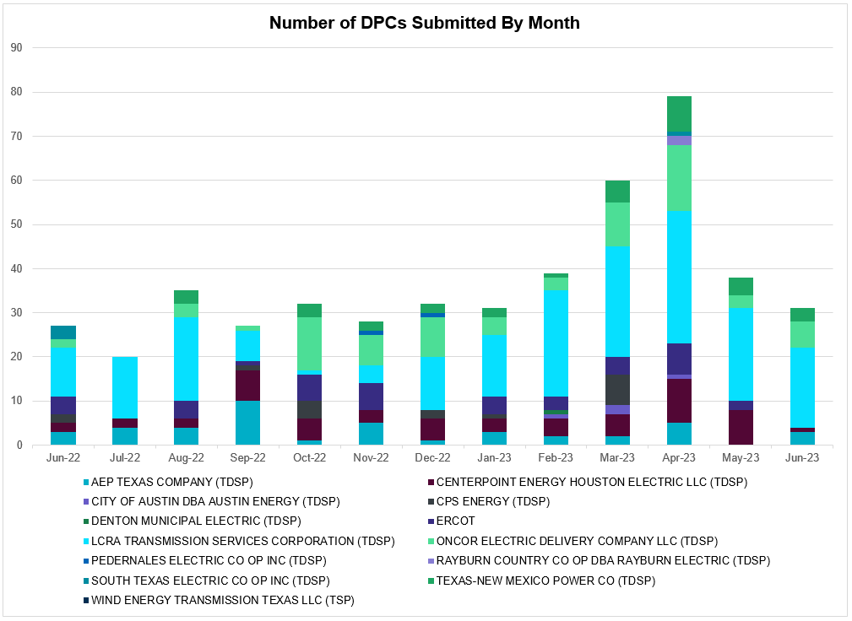

Transmission Operator | Number of DPCs
AEP TEXAS COMPANY (TDSP) | 1
BRAZOS ELECTRIC POWER CO OP INC (TDSP) | 0
BROWNSVILLE PUBLIC UTILITIES BOARD (TDSP) | 0
BRYAN TEXAS UTILITIES (TDSP) | 0
CENTERPOINT ENERGY HOUSTON ELECTRIC LLC (TDSP) | 1
CITY OF AUSTIN DBA AUSTIN ENERGY (TDSP) | 0
CITY OF COLLEGE STATION (TDSP) | 0
CITY OF GARLAND (TDSP) | 0
CPS ENERGY (TDSP) | 0
DENTON MUNICIPAL ELECTRIC (TDSP) | 0
ELECTRIC TRANSMISSION TEXAS LLC (TDSP) | 1
ERCOT | 1
LCRA TRANSMISSION SERVICES CORPORATION (TDSP) | 13
LONE STAR TRANSMISSION LLC (TSP) | 0
ONCOR ELECTRIC DELIVERY COMPANY LLC (TDSP) | 5
PEDERNALES ELECTRIC CO OP INC (TDSP) | 0
RAYBURN COUNTRY CO OP DBA RAYBURN ELECTRIC (TDSP) | 0
SHARYLAND UTILITIES LP (TDSP) | 0
SOUTH TEXAS ELECTRIC CO OP INC (TDSP) | 0
TEXAS MUNICIPAL POWER AGENCY (TDSP) | 0
TEXAS-NEW MEXICO POWER CO (TDSP) | 0
WIND ENERGY TRANSMISSION TEXAS LLC (TSP) | 0

Appendix A: Real-Time Constraints
The following is a complete list of constraints activated in SCED. Full contingency descriptions can be found in the Standard Contingencies List located on the MIS secure site at Grid Generation Reliability Unit Commitment.
Year | Month of the Year | Contingency Name | Overloaded Element | From Station | To Station | Count of Days
2023 | 6 | BASE CASE | NE_LOB | n/a | n/a | 27
2023 | 6 | BASE CASE | NELRIO | n/a | n/a | 25
2023 | 6 | DMGSBTR5 | 6036__A | TKWSW | MGSES | 18
2023 | 6 | DELMSAN5 | PAWNEE_SPRUCE_1 | PAWNEE | CALAVERS | 18
2023 | 6 | SLOBSA25 | LARDVN_LASCRU1_1 | LARDVNTH | LASCRUCE | 18
2023 | 6 | SLAQLOB8 | BRUNI_69_1 | BRUNI | BRUNI | 17
2023 | 6 | SN_SAJO5 | LASPUL_RAYMND1_1 | LASPULGA | RAYMND2 | 17
2023 | 6 | SVICCO28 | COLETO_VICTOR2_1 | COLETO | VICTORIA | 17
2023 | 6 | MHARNED5 | BURNS_RIOHONDO_1 | RIOHONDO | MV_BURNS | 16
2023 | 6 | DMGSBIT5 | 6036__A | TKWSW | MGSES | 15
2023 | 6 | DWHILON5 | PAWNEE_TANGO1_1 | TANGO | PAWNEE | 15
2023 | 6 | SN_SLON5 | N_SHARPE_XF1 | N_SHARPE | N_SHARPE | 15
2023 | 6 | SVEAW_L5 | 6217__A | WLVSW | GAILS | 15
2023 | 6 | MCONLNG5 | 6471__C | MGSES | NAVIG | 14
2023 | 6 | SDIMBEV8 | HAMILT_MAVERI1_1 | HAMILTON | MAVERICK | 14
2023 | 6 | SGRICOL5 | PAWNEE_TANGO1_1 | TANGO | PAWNEE | 13
2023 | 6 | BASE CASE | VALEXP | n/a | n/a | 13
2023 | 6 | SLAQLOB8 | FALFUR_PREMON1_1 | FALFUR | PREMONT | 13
2023 | 6 | SGARBAT8 | RKYROAD_STILES_1 | RCKYROAD | STILES | 13
2023 | 6 | DAUSDUN8 | MCN_MCN_1 | MCNEIL_ | MCNEIL | 12
2023 | 6 | MCONLNG5 | 14040__A | PCTSW | DEWTP | 12
2023 | 6 | DBIGKEN5 | TREADW_YELWJC1_1 | TREADWEL | YELWJCKT | 12
2023 | 6 | SLOBSA25 | CATARI_PILONC1_1 | CATARINA | PILONCIL | 12
2023 | 6 | SLOBSA25 | CATARI_PILONC1_1 | PILONCIL | CATARINA | 12
2023 | 6 | DCC3_NED | BURNS_RIOHONDO_1 | RIOHONDO | MV_BURNS | 11
2023 | 6 | SBATPEA8 | PEARSALL_69_4 | PEARSALL | PEARSALL | 11
2023 | 6 | DKOCNUE8 | CHAMPL_WEIL_T1_1 | WEIL_TRC | CHAMPLIN | 10
2023 | 6 | BASE CASE | WESTEX | n/a | n/a | 10
2023 | 6 | SKINFAL8 | FALFUR_PREMON1_1 | FALFUR | PREMONT | 10
2023 | 6 | SMDOOAS5 | MSNPET04_A | PET | MSN | 10
2023 | 6 | MCONLNG5 | 6095__D | LMESA | JPPOI | 9
2023 | 6 | SBENS_M8 | BENTS_FRTER_1C_1 | S_MISSIN | RAILROAD | 9
2023 | 6 | DMTSCOS5 | 6437__F | SCRCV | KNAPP | 9
2023 | 6 | SMADSAP8 | MADDUX_SAPOWE2_1 | MADDUX | SAPOWER | 9
2023 | 6 | MCONLNG5 | RKYROAD_STILES_1 | RCKYROAD | STILES | 9
2023 | 6 | SRRDLCS5 | 235__A | SJNSW | JEWET | 9
2023 | 6 | MMGSCON5 | 6471__C | MGSES | NAVIG | 9
2023 | 6 | SCO2EUL8 | COLETO_ROSATA1_1 | COLETO | ROSATA | 9
2023 | 6 | MRESMCM8 | RINCON_WHITE_2_1 | WHITE_PT | RINCON | 9
2023 | 6 | DWPWFWP5 | STPWAP39_1 | STP | WAP | 9
2023 | 6 | DSWECCR5 | 6036__A | TKWSW | MGSES | 8
2023 | 6 | DZORHAY5 | BERGHE_AT1L | BERGHE | BERGHE | 8
2023 | 6 | SKLELOY8 | LOYOLA_69_1 | LOYOLA | LOYOLA | 8
2023 | 6 | DMOLLO58 | PAWNEE_TANGO1_1 | TANGO | PAWNEE | 8
2023 | 6 | BASE CASE | N_TO_H | n/a | n/a | 8
2023 | 6 | SILLFTL8 | HAMILT_MAXWEL1_1 | MAXWELL | HAMILTON | 8
2023 | 6 | DBIGKEN5 | MADDUX_TREADW1_1 | MADDUX | TREADWEL | 8
2023 | 6 | SHAYZO25 | 6T227_1 | HAYSEN | ZORN | 7
2023 | 6 | SLOBSA25 | ASHERT_CATARI1_1 | ASHERTON | CATARINA | 7
2023 | 6 | DSALHUT5 | 1710__C | BELCNTY | SALSW | 7
2023 | 6 | DBIGKEN5 | HAMILT_MAXWEL1_1 | MAXWELL | HAMILTON | 7
2023 | 6 | SLP3LPL9 | LPLER_LPLMK_1 | LPLMK | LPLER | 7
2023 | 6 | SGARBAT8 | 15010__B | BLISS | ESTILES | 7
2023 | 6 | SLOBSA25 | ASHERT_CATARI1_1 | CATARINA | ASHERTON | 7
2023 | 6 | DWPWFCK5 | STPWAP39_1 | STP | WAP | 7
2023 | 6 | DGRSPKR5 | 6377__A | BRTSW | ORANS | 6
2023 | 6 | SBRAUVA8 | HAMILT_MAVERI1_1 | HAMILTON | MAVERICK | 6
2023 | 6 | DFRIILL8 | HAMILT_MAXWEL1_1 | MAXWELL | HAMILTON | 6
2023 | 6 | SFTLMES8 | PALOUS_WOLFCA1_1 | PALOUSE | WOLFCAMP | 6
2023 | 6 | DSALHUT5 | 270__A | KNBSW | TMPSW | 6
2023 | 6 | BASE CASE | RAMBLER_GENTIE_1 | RAMBLER | TWINBU | 6
2023 | 6 | DMCCHIL8 | 725T725_1 | MCCALA | RATTLE | 6
2023 | 6 | SN_SAJO5 | FALFUR_PREMON1_1 | FALFUR | PREMONT | 6
2023 | 6 | SBWDDBM5 | LPLMK_LPLNE_1 | LPLMK | LPLNE | 6
2023 | 6 | MCONLNG5 | 15010__B | BLISS | ESTILES | 6
2023 | 6 | SLOBSA25 | FALFUR_PREMON1_1 | FALFUR | PREMONT | 6
2023 | 6 | SNATBEA8 | 6144__A | BSPRW | STASW | 6
2023 | 6 | DBBSRCH5 | 1240__J | POKSW | FFD | 5
2023 | 6 | SVICCOL8 | COLETO_VICTOR1_1 | COLETO | VICTORIA | 5
2023 | 6 | XOKL58 | SANDRO_VERS1_1 | VERS | SANDROAD | 5
2023 | 6 | SRICGRS8 | 6840__B | NVKSW | ANARN | 5
2023 | 6 | SCARFRI8 | ATSO_SONR1_1 | SONR | ATSO | 5
2023 | 6 | SWRDYN8 | DA_WC_89_A | WC | DA | 5
2023 | 6 | SCOMKEN8 | 115T123_1 | KENDAL | KERRST | 5
2023 | 6 | DGRMGRS8 | 6830__B | CRDSW | OLNEY | 5
2023 | 6 | SHCKRNK5 | 106__A | HCKSW | ALLNC | 5
2023 | 6 | SDI2DIL9 | DILLEYSW_69A1 | DILLEYSW | DILLEYSW | 5
2023 | 6 | DAUSDUN8 | 608T608_1 | GIDEON | BASTCI | 5
2023 | 6 | SPLUMUL8 | MAGRUD_VICTOR2_1 | VICTORIA | MAGRUDER | 5
2023 | 6 | DSWELNC5 | BLUF_C_MULBER1_1 | BLUF_CRK | MULBERRY | 4
2023 | 6 | SBLSJAC8 | MYRA_VAL_1 | MYRA | VALYVIEW | 4
2023 | 6 | XBAL89 | CONCHO_VRBS1_1 | CONCHO | VRBS | 4
2023 | 6 | SPOTPAN9 | GUS_HAS_1 | GUSTINE | HAS | 4
2023 | 6 | SCRTEIL8 | RKYROAD_STILES_1 | RCKYROAD | STILES | 4
2023 | 6 | DGIBZEN5 | SNGXGC75_1 | GIBCRK | SNG | 4
2023 | 6 | SVANRAY8 | RAYBURN_69_2 | RAYBURN | RAYBURN | 4
2023 | 6 | SRAYRI38 | HAINE__LA_PAL1_1 | LA_PALMA | HAINE_DR | 4
2023 | 6 | SCOLBAL8 | SANA_FMR1 | SANA | SANA | 4
2023 | 6 | DSALKLN5 | 630__B | KLNSW | HHSTH | 4
2023 | 6 | DCENREV5 | PAWNEE_TANGO1_1 | TANGO | PAWNEE | 4
2023 | 6 | SBONNED5 | BURNS_RIOHONDO_1 | RIOHONDO | MV_BURNS | 4
2023 | 6 | SBIGSCH5 | PALOUS_WOLFCA1_1 | PALOUSE | WOLFCAMP | 4
2023 | 6 | DCENRI35 | PAWNEE_TANGO1_1 | TANGO | PAWNEE | 4
2023 | 6 | DJEWSNG5 | SNGXGC75_1 | GIBCRK | SNG | 4
2023 | 6 | SW_GODE5 | 15060__B | VEALMOOR | KOCHTAP | 4
2023 | 6 | SKOCBUZ8 | 6217__A | WLVSW | GAILS | 4
2023 | 6 | SBAKCED5 | CONCHO_SANW0_1 | CONCHO | SANW | 4
2023 | 6 | SSTILOM8 | SCARBI_TITAN_1_1 | SCARBIDE | TITAN_SU | 3
2023 | 6 | DABPAB98 | SOUTHA_VINSON1_1 | SOUTHABI | VINSON | 3
2023 | 6 | SALLHCK5 | 107__A | HCKSW | RNKSW | 3
2023 | 6 | DKENNO89 | COLETO_ROSATA1_1 | COLETO | ROSATA | 3
2023 | 6 | SEBHUG8 | DA_WC_89_A | WC | DA | 3
2023 | 6 | DBWN_AM5 | ORNT_REDCRE1_1 | REDCREEK | ORNT | 3
2023 | 6 | STANPAW5 | CALLIC_LON_HI1_1 | LON_HILL | CALLICOA | 3
2023 | 6 | DWESNUE8 | CHAMPL_WEIL_T1_1 | WEIL_TRC | CHAMPLIN | 3
2023 | 6 | SFORYEL8 | HEXT_YELWJC1_1 | YELWJCKT | HEXT | 3
2023 | 6 | DWISALV8 | MYRA_VAL_1 | MYRA | VALYVIEW | 3
2023 | 6 | DBRNCMN8 | ORNT_REDCRE1_1 | REDCREEK | ORNT | 3
2023 | 6 | SFTLMES8 | CROSSO_NORTMC1_1 | NORTMC | CROSSOVE | 3
2023 | 6 | DSTPANS5 | PAWNEE_TANGO1_1 | TANGO | PAWNEE | 3
2023 | 6 | SHAYZOR5 | 388T388_1 | HAYSEN | ZORN | 3
2023 | 6 | SBENRAI8 | BENTS_FRTER_1C_1 | S_MISSIN | RAILROAD | 3
2023 | 6 | DVICVI89 | COLETO_VICTOR2_1 | COLETO | VICTORIA | 3
2023 | 6 | SBGLTWI8 | CONCHO_SANW0_1 | CONCHO | SANW | 3
2023 | 6 | SSPUASP8 | GIRA_T_SPUR1_1 | SPUR | GIRA_TAP | 3
2023 | 6 | SBTPBNT8 | MYRA_VAL_1 | MYRA | VALYVIEW | 3
2023 | 6 | DCOLFA59 | PAWNEE_TANGO1_1 | TANGO | PAWNEE | 3
2023 | 6 | SCRMSAR8 | CONCHO_VRBS1_1 | CONCHO | VRBS | 3
2023 | 6 | SZENTH35 | THWZEN71_A | ZEN | THW | 3
2023 | 6 | DTHSLCS5 | 282__A | LHLSW | LCSES | 2
2023 | 6 | DLEGOUT5 | 506__A | SAMSW | FBRSW | 2
2023 | 6 | SWALWLN8 | 568__A | RYSSW | NEVADA | 2
2023 | 6 | DODEMOS5 | 6512__B | ODEHV | TROTP | 2
2023 | 6 | DMTSCOS5 | 6437__A | KNAPP | BCKSW | 2
2023 | 6 | DMCCHIL8 | 103T262_1 | RATTLE | REDWOO | 2
2023 | 6 | MMGSCON5 | 15010__B | BLISS | ESTILES | 2
2023 | 6 | MCONLNG5 | 6046__A | MGSES | FLCNS | 2
2023 | 6 | SCMNCPS5 | 651__B | CMNSW | CMNTP | 2
2023 | 6 | XCAG158 | CAGNON_MR4H | CAGNON | CAGNON | 2
2023 | 6 | SWEILON8 | CHAMPL_WEIL_T1_1 | WEIL_TRC | CHAMPLIN | 2
2023 | 6 | SCOLBAL8 | CONAN_SANA1_1 | SANA_TAP | CONAN | 2
2023 | 6 | DWHILON5 | NCARBI_SEADRF1_1 | SEADRFTC | NCARBIDE | 2
2023 | 6 | DRNS_TB5 | THWZEN71_A | ZEN | THW | 2
2023 | 6 | SSTLEIN8 | CRTVLE_EINSTEN_1 | EINSTEIN | CRTRVLLE | 2
2023 | 6 | SFORGIL8 | FRPHIL_MASN1_1 | FRPHILLT | MASN | 2
2023 | 6 | SFORGIL8 | FRPHIL_MASN1_1 | MASN | FRPHILLT | 2
2023 | 6 | SWHILON5 | GILA_MAYO1_1 | GILA | MAYO | 2
2023 | 6 | DWHILON5 | MELONC_SEADRF1_1 | MELONCRE | SEADRFTC | 2
2023 | 6 | DBIGKEN5 | ORNT_REDCRE1_1 | REDCREEK | ORNT | 2
2023 | 6 | DBWN_AM5 | ORNT_TENNYS1_1 | ORNT | TENNYSON | 2
2023 | 6 | DNOECED5 | HARGRO_TWINBU1_1 | TWINBU | HARGROVE | 2
2023 | 6 | SBAKCED5 | HARGRO_TWINBU1_1 | TWINBU | HARGROVE | 2
2023 | 6 | SOBWAP5 | OB_WAP98_A | WAP | OB | 2
2023 | 6 | DCENFAL5 | PAWNEE_TANGO1_1 | TANGO | PAWNEE | 2
2023 | 6 | MMGSCON5 | RKYROAD_STILES_1 | RCKYROAD | STILES | 2
2023 | 6 | DCAGCO58 | 656T656_1 | KENDAL | BERGHE | 2
2023 | 6 | SCARFRI8 | ATSO_OZNC1_1 | ATSO | OZNC | 2
2023 | 6 | SBIGSCH5 | CROSSO_NORTMC1_1 | NORTMC | CROSSOVE | 2
2023 | 6 | SALIKIN8 | FALFUR_PREMON1_1 | FALFUR | PREMONT | 2
2023 | 6 | SMDOOAS5 | HUDMSN04_A | MSN | HUD | 2
2023 | 6 | SABNABN8 | ORNT_REDCRE1_1 | REDCREEK | ORNT | 2
2023 | 6 | DBIGKEN5 | ORNT_TENNYS1_1 | ORNT | TENNYSON | 2
2023 | 6 | DLONWAR5 | PAWNEE_TANGO1_1 | TANGO | PAWNEE | 2
2023 | 6 | SCENLOB5 | PAWNEE_TANGO1_1 | TANGO | PAWNEE | 2
2023 | 6 | SCOMCYP8 | 122T122_1 | COMFOR | RAYBAR | 2
2023 | 6 | DMCOPHA8 | AZTECA_HEC1_1 | HEC | AZTECA | 2
2023 | 6 | DLONWEI8 | CHAMPL_WEIL_T1_1 | WEIL_TRC | CHAMPLIN | 2
2023 | 6 | SDAFAUS8 | CKT_1027_1 | DUNLAP | DECKER | 2
2023 | 6 | BASE CASE | ELSAUZTL_1 | CEBOLLA | ELSAUZ | 2
2023 | 6 | BASE CASE | ELSAUZTL_1 | ELSAUZ | CEBOLLA | 2
2023 | 6 | DAMOBOW5 | ORNT_REDCRE1_1 | REDCREEK | ORNT | 2
2023 | 6 | SMV_PAR8 | RIOHND_ERIOHND_1 | MV_RIOHO | RIOHONDO | 2
2023 | 6 | SFTLMES8 | SANTAR_WOLFCA1_1 | WOLFCAMP | SANTARIT | 2
2023 | 6 | DLEGOUT5 | 1240__J | POKSW | FFD | 2
2023 | 6 | SCRTEIL8 | 15010__B | BLISS | ESTILES | 2
2023 | 6 | SRICGRS8 | 6840__A | ANARN | CRDSW | 2
2023 | 6 | DCC1DUKE | BURNS_RIOHONDO_1 | RIOHONDO | MV_BURNS | 2
2023 | 6 | SSIEMOL8 | LARDVN_LASCRU1_1 | LARDVNTH | LASCRUCE | 2
2023 | 6 | DELMSAN5 | MAGRUD_VICTOR2_1 | VICTORIA | MAGRUDER | 2
2023 | 6 | SGRILON5 | PAWNEE_TANGO1_1 | TANGO | PAWNEE | 2
2023 | 6 | SBIGSCH5 | SANTAR_WOLFCA1_1 | WOLFCAMP | SANTARIT | 2
2023 | 6 | DGRMGRS8 | 6840__B | NVKSW | ANARN | 1
2023 | 6 | SAJ2CEB5 | CELANE_N_SHAR1_1 | N_SHARPE | CELANEBI | 1
2023 | 6 | DELMSAN5 | COLETO_ROSATA1_1 | COLETO | ROSATA | 1
2023 | 6 | SRAYRI28 | HAINE__LA_PAL1_1 | LA_PALMA | HAINE_DR | 1
2023 | 6 | SNORKEN8 | MAGRUD_VICTOR2_1 | VICTORIA | MAGRUDER | 1
2023 | 6 | XOLS89 | WNTSP_FMR2 | WNTSP | WNTSP | 1
2023 | 6 | DSCOFAR5 | 6216__B | WLVSW | SHRNE | 1
2023 | 6 | SW_BW_25 | 6470__E | PCTSW | FRSTP | 1
2023 | 6 | SSANFOW5 | ASHERT_CATARI1_1 | ASHERTON | CATARINA | 1
2023 | 6 | SAJ2CEB5 | CELANE_KLEBER1_1 | CELANEBI | KLEBERG | 1
2023 | 6 | MCEBRIO5 | CELANE_N_SHAR1_1 | N_SHARPE | CELANEBI | 1
2023 | 6 | DLONEQU8 | CHAMPL_WEIL_T1_1 | WEIL_TRC | CHAMPLIN | 1
2023 | 6 | DBIGSCH5 | CROSSO_NORTMC1_1 | NORTMC | CROSSOVE | 1
2023 | 6 | SMIDLO28 | FALFUR_PREMON1_1 | FALFUR | PREMONT | 1
2023 | 6 | SFORGIL8 | FRPHIL_GILLES1_1 | FRPHILLT | GILLES | 1
2023 | 6 | SGRILON5 | KATOEN_LON_HI1_1 | LON_HILL | KATOEN | 1
2023 | 6 | MHARNED5 | LASPUL_RAYMND1_1 | LASPULGA | RAYMND2 | 1
2023 | 6 | SBEAOR8 | PT_TWM25_A | PT | TWM | 1
2023 | 6 | DBIGSCH5 | SANTAR_WOLFCA1_1 | WOLFCAMP | SANTARIT | 1
2023 | 6 | SCENMCC8 | SHIL_MCC_1 | MCCREE | SHILOH | 1
2023 | 6 | SOLNRIC8 | 6840__B | NVKSW | ANARN | 1
2023 | 6 | DAJOSTE5 | ASHERT_CATARI1_1 | ASHERTON | CATARINA | 1
2023 | 6 | BASE CASE | BEARKT | n/a | n/a | 1
2023 | 6 | MCEBRIO5 | CATARI_PILONC1_1 | CATARINA | PILONCIL | 1
2023 | 6 | MCEBRIO5 | CELANE_KLEBER1_1 | CELANEBI | KLEBERG | 1
2023 | 6 | SN_SLON5 | CHAMPL_WEIL_T1_1 | WEIL_TRC | CHAMPLIN | 1
2023 | 6 | STULKEN8 | COLETO_ROSATA1_1 | COLETO | ROSATA | 1
2023 | 6 | DBWN_AM5 | CONCHO_VRBS1_1 | CONCHO | VRBS | 1
2023 | 6 | DWHICOT5 | FARMLAND_LONGD_1 | FARMLAND | W_LD_345 | 1
2023 | 6 | SBIGV_D8 | GREENL_WEAVER1_1 | WEAVERRD | GREENLK | 1
2023 | 6 | SCOMHA38 | HAMILT_MAXWEL1_1 | MAXWELL | HAMILTON | 1
2023 | 6 | SN_SLON5 | LASPUL_RAYMND1_1 | LASPULGA | RAYMND2 | 1
2023 | 6 | SCOLPAW5 | MAGRUD_VICTOR2_1 | VICTORIA | MAGRUDER | 1
2023 | 6 | SFORRAY8 | RAYBURN_69_2 | RAYBURN | RAYBURN | 1
2023 | 6 | DBBSRCH5 | 1240__E | FFD | FRFWS | 1
2023 | 6 | DCENRO58 | 904T485_1 | FRONTERA | GOODWIN | 1
2023 | 6 | XWO58 | ADKCB_09_A | ADK | CB | 1
2023 | 6 | SSANONI8 | CKT_1099_1 | SANDHSYD | HORNSB | 1
2023 | 6 | SBAKCED5 | CROSSO_PALOUS1_1 | PALOUSE | CROSSOVE | 1
2023 | 6 | SW_SBRN5 | CRTVLE_EINSTEN_1 | EINSTEIN | CRTRVLLE | 1
2023 | 6 | SFORGIL8 | FRPHIL_GILLES1_1 | GILLES | FRPHILLT | 1
2023 | 6 | STANPAW5 | LON_HI_ORNGRO1_1 | LON_HILL | ORNGROV | 1
2023 | 6 | DBBSJEW5 | 1240__J | POKSW | FFD | 1
2023 | 6 | SGRMGRS8 | 6830__B | CRDSW | OLNEY | 1
2023 | 6 | MCEBRIO5 | ASHERT_CATARI1_1 | ASHERTON | CATARINA | 1
2023 | 6 | SCOMHA38 | CARVER_TINSLE1_1 | CARVER | TINSLEY | 1
2023 | 6 | SALAN_28 | CELANE_KLEBER1_1 | CELANEBI | KLEBERG | 1
2023 | 6 | SBIGSCH5 | CROSSO_PALOUS1_1 | CROSSOVE | PALOUSE | 1
2023 | 6 | SBRAUVA8 | ESCOND_GANSO1_1 | GANSO | ESCONDID | 1
2023 | 6 | DLONWAR5 | KATOEN_LON_HI1_1 | LON_HILL | KATOEN | 1
2023 | 6 | BASE CASE | MYRA_VAL_1 | MYRA | VALYVIEW | 1
2023 | 6 | SGRMGRS8 | OLN_FMR2 | OLN | OLN | 1
2023 | 6 | DAMOBOW5 | ORNT_TENNYS1_1 | ORNT | TENNYSON | 1
2023 | 6 | DFRIILL8 | SANTAR_WOLFCA1_1 | WOLFCAMP | SANTARIT | 1
2023 | 6 | XRYS89 | 2020__I | SCATR | NYLDV | 1
2023 | 6 | DCAGCI58 | 255T279_1 | PIPECR | MEDILA | 1
2023 | 6 | DGRSPKR5 | 6376__A | GRMSW | BRTSW | 1
2023 | 6 | DCAGCI58 | 656T656_1 | KENDAL | BERGHE | 1
2023 | 6 | DNLSCRL8 | 715__A | CRLNW | CRLJL | 1
2023 | 6 | DCC3_NED | BURNS_HEIDLBRG_1 | MV_BURNS | MV_HBRG4 | 1
2023 | 6 | SSPUASP8 | DKEC_GIRA_T1_1 | GIRA_TAP | DKEC | 1
2023 | 6 | SCARFRI8 | FDR_OZNC_1 | OZNC | FRIEND_R | 1
2023 | 6 | DCENREV5 | KATOEN_LON_HI1_1 | LON_HILL | KATOEN | 1
2023 | 6 | SMULFLA8 | MAGRUD_VICTOR2_1 | VICTORIA | MAGRUDER | 1
2023 | 6 | SPAWCAL5 | MAGRUD_VICTOR2_1 | VICTORIA | MAGRUDER | 1
2023 | 6 | SFT_BAL8 | STMBOA_WINT1_1 | STMBOAT | WINT | 1
2023 | 6 | DLEGOUT5 | 1240__E | FFD | FRFWS | 1
2023 | 6 | DTRIASH8 | 211T147_1 | GILLCR | MCNEIL_ | 1
2023 | 6 | SOWLBIG8 | BISON_STRS1_1 | BISON | STRS | 1
2023 | 6 | SLOBSA25 | BRUNI_69_1 | BRUNI | BRUNI | 1
2023 | 6 | SILLFTL8 | CARVER_TINSLE1_1 | CARVER | TINSLEY | 1
2023 | 6 | SLOLFOR8 | FORMOS_JOSLIN1_1 | FORMOSA | JOSLIN | 1
2023 | 6 | DKG_NB_5 | JFSSC_06_A | JFS | SC | 1
2023 | 6 | DMOLLO58 | KATOEN_LON_HI1_1 | LON_HILL | KATOEN | 1
2023 | 6 | SLOBSA25 | LASCRU_MILO1_1 | LASCRUCE | MILO | 1
2023 | 6 | SLOBSA25 | NLARSW_PILONC1_1 | NLARSW | PILONCIL | 1
2023 | 6 | SOBWA2P5 | OB_WAP99_A | WAP | OB | 1
2023 | 6 | DBWNAMO5 | SAPOWE_SAST1_1 | SAPOWER | SAST | 1
2023 | 6 | DGRSLNC5 | SOUTHA_VINSON1_1 | SOUTHABI | VINSON | 1
2023 | 6 | SBONRIO5 | STEWAR_VERTRE1_1 | STEWART | VERTREES | 1
2023 | 6 | DNAVOUT5 | 1240__J | POKSW | FFD | 1
2023 | 6 | DSNDBCE5 | 1710__C | BELCNTY | SALSW | 1
2023 | 6 | XRYS89 | 2020__B | NYLDV | CDMIL | 1
2023 | 6 | SGILTRI8 | 211T147_1 | GILLCR | MCNEIL_ | 1
2023 | 6 | DLEGOUT5 | 505__B | FBRSW | THSES | 1
2023 | 6 | SOLNRIC8 | 6840__A | ANARN | CRDSW | 1
2023 | 6 | XWO58 | ADKCB_21_A | ADK | CB | 1
2023 | 6 | DAJOSTE5 | CATARI_PILONC1_1 | CATARINA | PILONCIL | 1
2023 | 6 | SEULTUL8 | COLETO_ROSATA1_1 | COLETO | ROSATA | 1
2023 | 6 | SNOECED5 | CROSSO_PALOUS1_1 | PALOUSE | CROSSOVE | 1
2023 | 6 | SW_SDIV5 | CRTVLE_EINSTEN_1 | EINSTEIN | CRTRVLLE | 1
2023 | 6 | SLGEI_D8 | I_DUPS_LGE1_1 | LGE | I_DUPSW | 1
2023 | 6 | SWISJAC8 | MYRA_VAL_1 | MYRA | VALYVIEW | 1
2023 | 6 | DGRMGRS8 | OLN_FMR2 | OLN | OLN | 1
2023 | 6 | XCMN58 | ORNT_REDCRE1_1 | REDCREEK | ORNT | 1
2023 | 6 | XCMN58 | ORNT_TENNYS1_1 | ORNT | TENNYSON | 1
2023 | 6 | MPEAMOO8 | UVALDE_W_BATE1_1 | W_BATESV | UVALDE | 1
2023 | 6 | DCMNCMN8 | 660__B | MGPSW | ZEPHYR | 1

Current Wind Generation Record: 27,044 MW on 05/29/2022 at 22:36 | Current Wind Penetration Record: 69.15% on 04/10/2022 at 01:43 Current Solar Generation Record: 13,086 MW on 06/25/2023 at 12:48 | Current Solar Penetration Record: 32.93% on 04/30/2023 at 09:24
This is the hourly integrated peak demand as published in the ERCOT D&E report.
All DC Tie Curtailments are posted publicly on the ERCOT Market Information System. See that posting for additional details for the event(s) in question.
See DC Tie Operating Procedure (http://www.ercot.com/mktrules/guides/procedures) for more details.

