May 2023 ERCOT Monthly Operations Report
Reliability and Operations Subcommittee Meeting
July 6, 2023

Table of Contents
1. Report Highlights 2
2. Frequency Control 3
2.1. Frequency Events 3
2.2. Responsive Reserve Events 4
2.3. Load Resource Events 4
3. Reliability Unit Commitment 4
4. IRR, Wind, and Solar Generation as a Percent of Load 6
5. Largest Net-Load Ramps 8
6. Congestion Analysis 9
6.1. Notable Constraints 9
6.2. Generic Transmission Constraint Congestion 22
6.3. Manual Overrides 23
6.4. Congestion Costs for Calendar Year 2023 23
7. System Events 24
7.1. ERCOT Peak Load 24
7.2. Load Shed Events 24
7.3. Stability Events 24
7.4. Notable PMU Events 24
7.5. DC Tie Curtailment 24
7.6. TRE/DOE Reportable Events 25
7.7. New/Updated Constraint Management Plans 25
7.8. New/Modified/Removed RAS 25
7.9. New Procedures/Forms/Operating Bulletins 25
8. Emergency Conditions 25
8.1. OCNs 25
8.2. Advisories 25
8.3. Watches 26
8.4. Emergency Notices 26
9. Application Performance 26
9.1. TSAT/VSAT Performance Issues 26
9.2. Communication Issues 26
9.3. Market System Issues 27
10. Model Updates 27
Appendix A: Real-Time Constraints 29

Report Highlights
- The unofficial ERCOT peak demand was 68,121 MW for the month of May on 5/5/2023 HE 18:00; this was 3,524 MW less than the previous record of 71,645 MW set on 5/31/2022 HE 17:00.
- There were 5 frequency events.
- There were 3 instances where Responsive Reserve Service was deployed.
- 2 OCN’s due to taking manual action on the WESTEX IROL. 4 AAN’s issued for possible future emergency condition.
- 1 Advisory due to postponed the deadline for the posting of the DAM solution.
- 1 Advisory due to VSAT is unavailable.
- There were 72 HRUC commitments.
- There was 1 day of congestion on the Bearkat GTC, 26 days on the North Edinburg to Lobo GTC, 12 days on the Nelson Sharpe to Rio Hondo GTC, 12 days on the West Texas Export GTC, 4 days on the Raymondville to RioHondo GTC, 5 days on the McCamey GTC, 22 days on the Valley Export GTC, 1 day on the Valley Import GTC, 6 days on the North to Houston GTC. There was no activity on the remaining GTCs during the month.

Frequency Control

Frequency Events

The ERCOT Interconnection experienced 5 frequency events, which resulted from units tripping. The shortest event duration was 01:25 and the longest was 07:34.

A summary of the frequency events is provided below. The reported frequency events meet one of the following criteria: Delta Frequency is 60 mHz or greater; the MW loss is 350 MW or greater; resource trip event triggered RRS deployment. Frequency events that have been identified as Frequency Measurable Events (FME) for purposes of BAL-001-TRE-2 analysis are highlighted in blue. When analyzing frequency events, ERCOT evaluates PMU data according to industry standards. Events with an oscillating frequency of less than 1 Hz are inter-area, while higher frequencies indicate local events. Industry standards specify that damping ratio for inter-area oscillations should be 3.0% or greater. For the frequency events listed below, the ERCOT system met these standards and transitioned well after each disturbance. In the case of negative delta frequency, the MW Loss column could refer to load loss.

Date and Time | Delta Frequency | Max/Min Frequency | Duration of Event | PMU Data |  | MW Loss | Load | IRR | Inertia
 | (Hz) | (Hz) |  | Oscillation Mode (Hz) | Damping Ratio |  | (MW) | % | (GW-s)
5/1/2023 13:32:02 | 0.168 | 59.847 | 00:03:37 | 0.73 | 14% | 851 | 47,892 | 39% | 220,211
5/3/2023 18:03:37 | 0.085 | 59.931 | 00:07:34 | 0.68 | 16% | 475 | 55,926 | 26% | 260,922
5/12/2023 1:40:28 | 0.096 | 59.920 | 00:08:10 | 0.7 | 16% | 471 | 45,985 | 38% | 228,052
5/23/2023 11:21:12 | 0.082 | 59.898 | 00:03:30 | 0.64 | 12% | 651 | 52,869 | 32% | 271,409
5/24/2023 20:38:59 | 0.082 | 59.892 | 00:01:25 | 0.54 | 8% | 606 | 56,899 | 19% | 293,684

(Note: All data on this graph encompasses frequency event analysis based on BAL-001-TRE-2.)

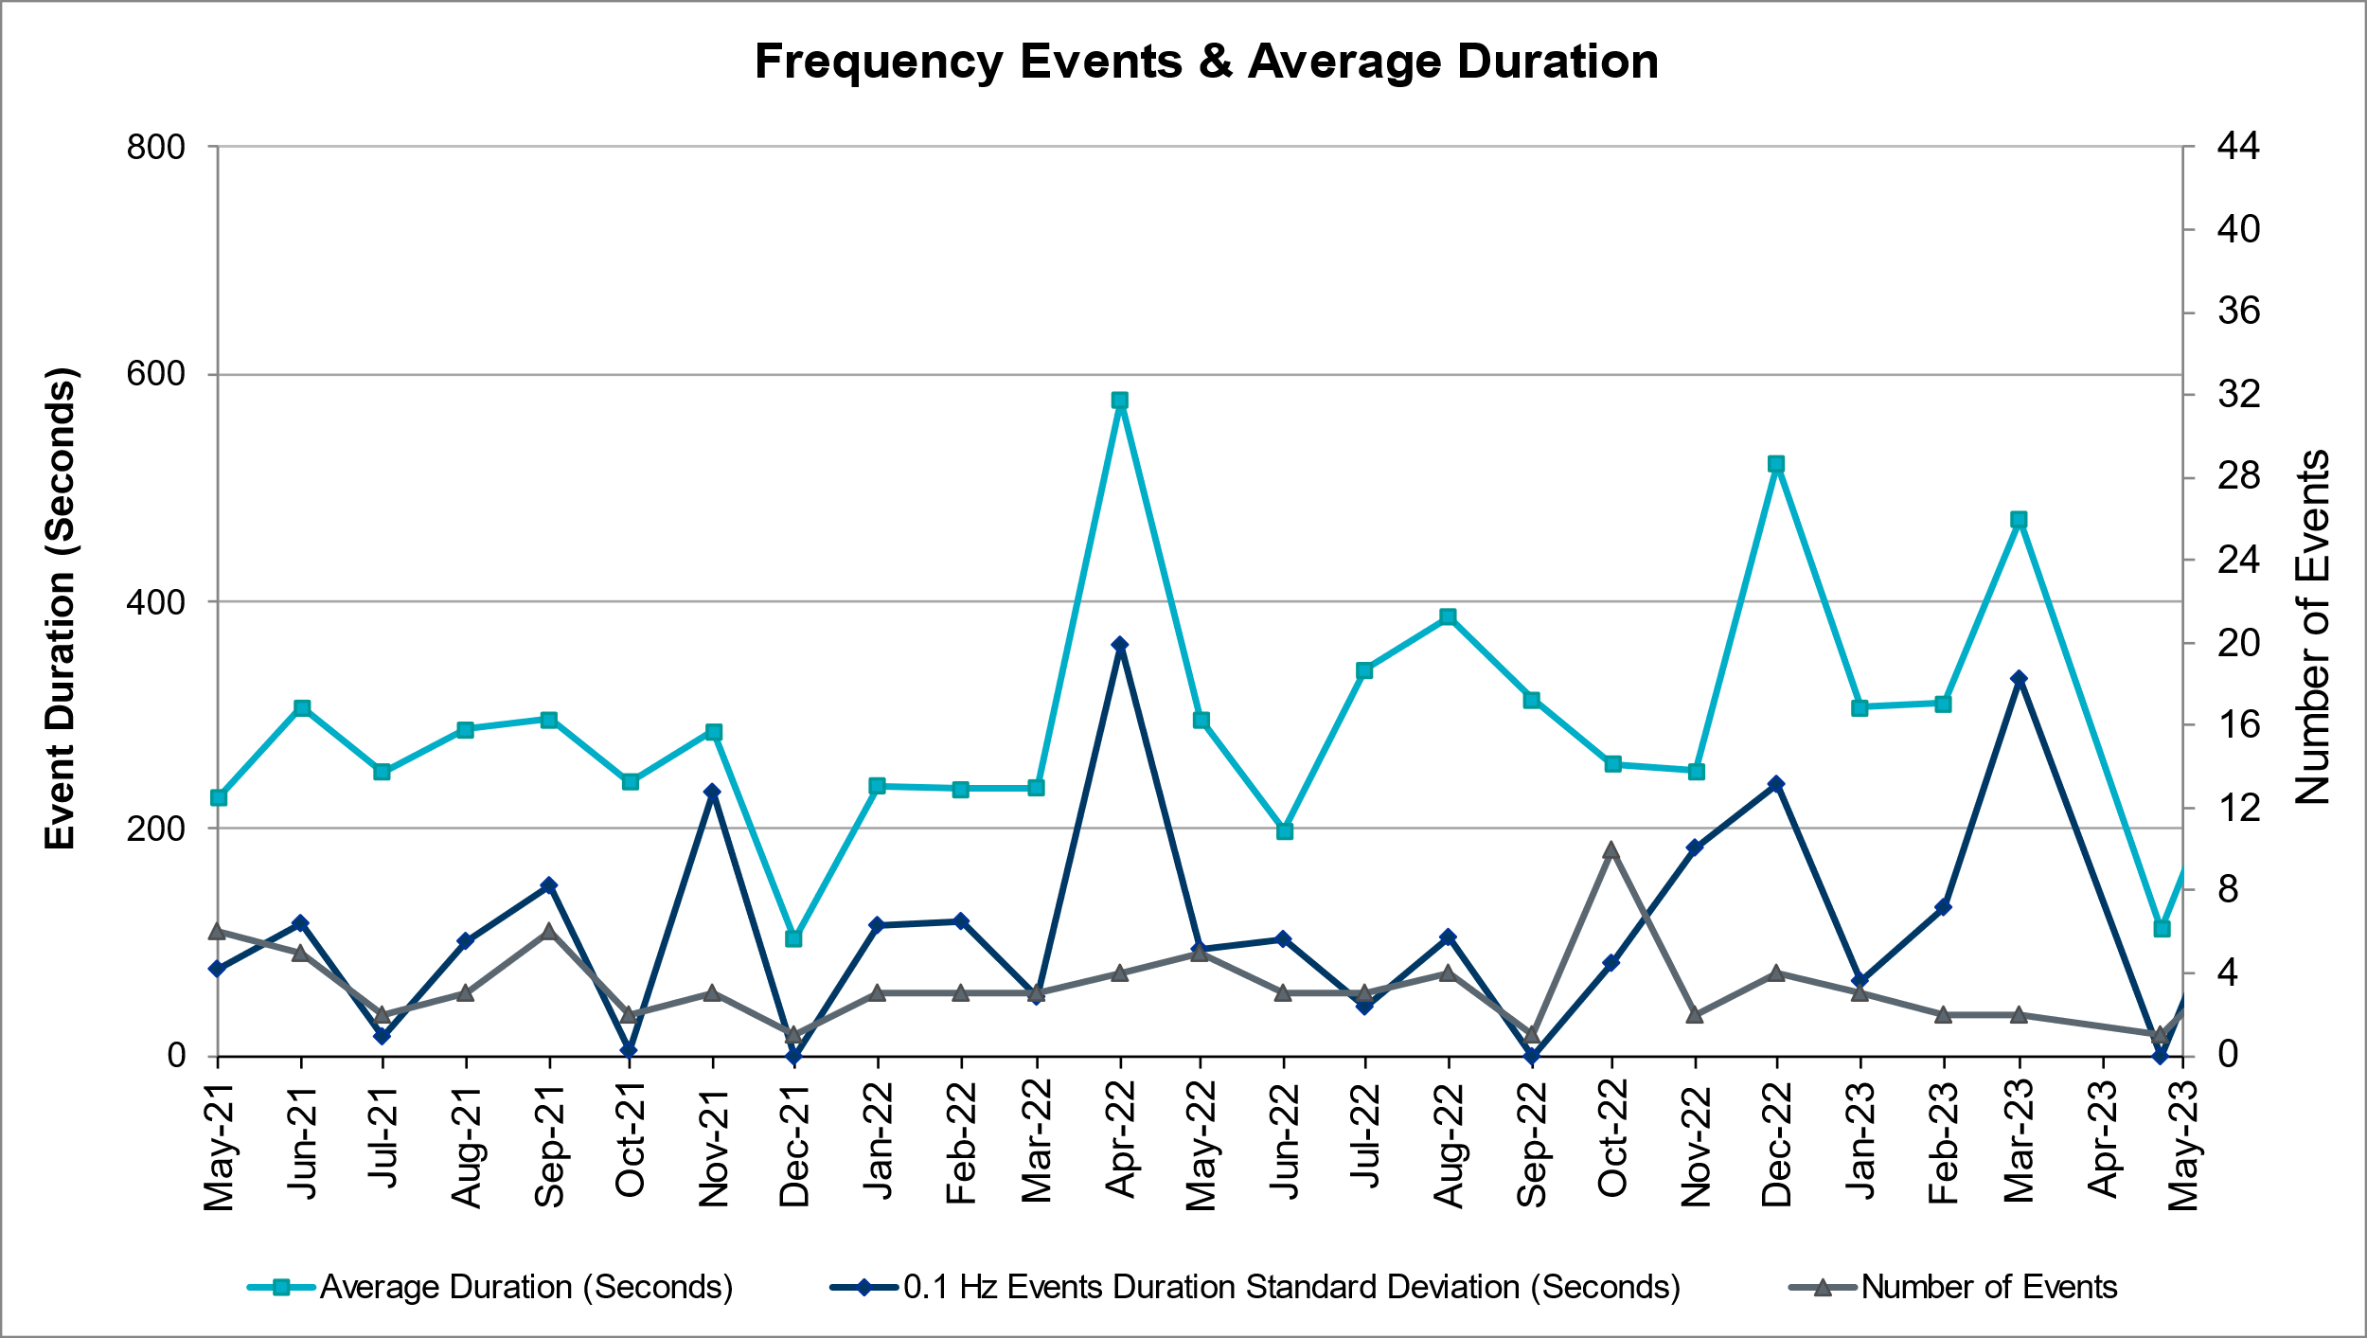

Responsive Reserve Events

There were 3 events where Responsive Reserve MWs were released to SCED. The events highlighted in blue were related to frequency events reported in Section 2.1 above.

Date and Time Released to SCED | Date and Time Recalled | Duration of Event | Maximum MWs Released | Comments
05/01/2023 13:32:12 | 05/01/2023 13:35:08 | 00:02:56 | 664 | Unit Trip
05/23/2023 11:21:24 | 05/23/2023 11:24:44 | 00:03:20 | 263 | Unit Trip
05/24/2023 20:39:12 | 05/24/2023 20:42:44 | 00:03:32 | 455 | Unit Trip

Load Resource Events
None.

Reliability Unit Commitment

ERCOT reports on Reliability Unit Commitments (RUC) monthly. Commitments are reported grouped by operating day and weather zone. The total number of hours committed is the sum of the hours for all the units in the specified region. Additional information on RUC commitments can be found on the MIS secure site at Grid Generation Reliability Unit Commitment.

There were no DRUC commitments.

There were 72 HRUC commitments.
Resource Location | # of Resources | Operating Day | Total # of Hours Committed | Total MWhs | Reason for Commitment
COAST, EAST, NORTH_CENTRAL, SOUTH_CENTRAL | 6 | 05/01/2023 | 25 | 6,723.0 | System Capacity
NORTH_CENTRAL | 1 | 05/02/2023 | 2 | - | System Capacity
EAST, NORTH_CENTRAL | 2 | 05/04/2023 | 3 | 1,243.0 | System Capacity
SOUTH_CENTRAL | 1 | 05/06/2023 |  |  | OSA
SOUTH_CENTRAL | 1 | 05/07/2023 |  |  | OSA
EAST, NORTH_CENTRAL, SOUTH_CENTRAL | 5 | 05/08/2023 |  |  | System Capacity,  OSA
NORTH_CENTRAL, SOUTHERN | 3 | 05/09/2023 |  |  | SSTILOM8,Minimum Run Time, ,  OSA
NORTH_CENTRAL, SOUTH_CENTRAL | 2 | 05/10/2023 |  |  | Minimum Run Time,  OSA
COAST, NORTH_CENTRAL, SOUTHERN | 7 | 05/11/2023 | 56 | 6,683.0 | System Capacity
NORTH_CENTRAL, SOUTH_CENTRAL | 2 | 05/12/2023 | 17 | 3,046.0 | System Capacity
COAST, EAST, NORTH_CENTRAL | 4 | 05/13/2023 | 10 | 2,270.0 | System Capacity
EAST | 1 | 05/16/2023 | 7 | 1,190.0 | System Capacity
COAST, EAST, NORTH_CENTRAL, SOUTH_CENTRAL | 6 | 05/18/2023 | 30 | 8,593.0 | System Capacity
NORTH_CENTRAL, SOUTH_CENTRAL | 6 | 05/20/2023 | 40 | 4,415.0 | System Capacity,
EAST, NORTH_CENTRAL, SOUTH_CENTRAL | 10 | 05/23/2023 |  |  | System Capacity
EAST, NORTH_CENTRAL | 4 | 05/24/2023 |  |  | System Capacity, Minimum Run Time
EAST, NORTH_CENTRAL, SOUTH_CENTRAL | 5 | 05/25/2023 |  |  | System Capacity, Minimum Run Time
COAST, NORTH_CENTRAL, SOUTH_CENTRAL | 5 | 05/26/2023 |  |  | System Capacity, Minimum Run Time

IRR, Wind, and Solar Generation as a Percent of Load
The graph below shows the maximum, minimum and average aggregate solar, wind and IRR output as a percentage of total ERCOT load when evaluated as 10-minute averaged intervals, over the past 13 months. Current wind and solar generation and penetration records are listed in the footnote below. Maximum IRR penetration for the month was 54.7% on 05/05/2023 interval ending 03:10 and minimum IRR penetration for the month was 2.9% on 05/16/2023 interval ending 06:30.

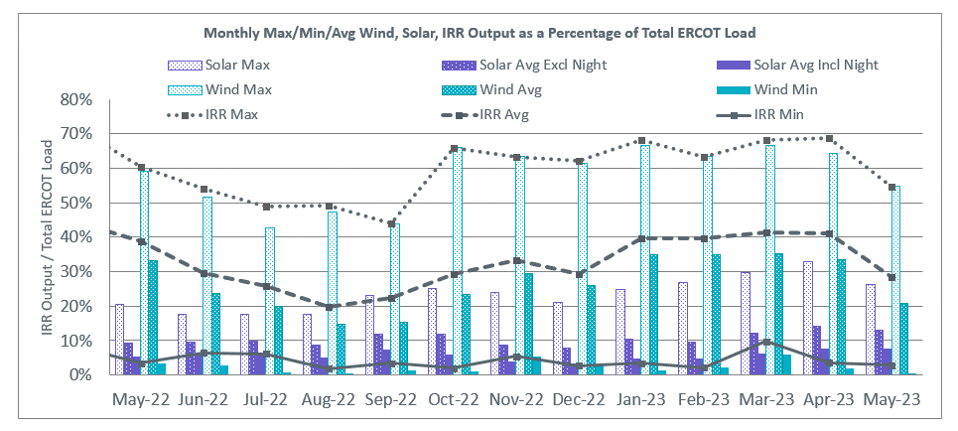

During the hour of peak load for the month, hourly integrated wind generation was 13,507 MW and solar generation was 9,869 MW. The graph below shows the wind and solar penetration percentage during the hour of the peak load in the last 13 months.

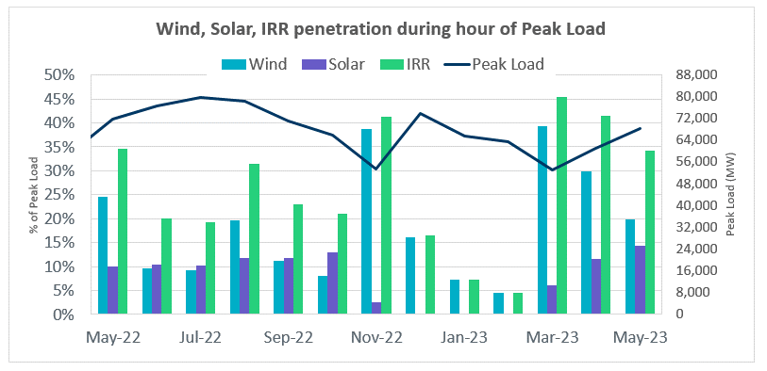

Lastly, the graph below shows the minimum wind, solar and IRR output during the peak load hour as a percentage of the daily peak load for every day in the month.

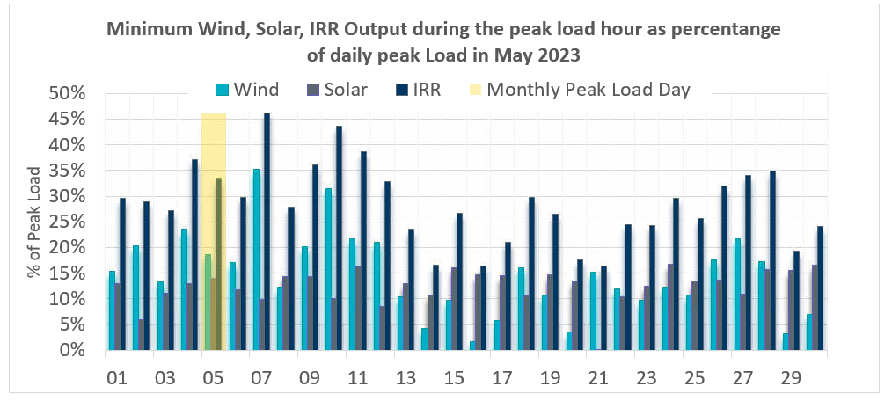

Largest Net-Load Ramps
The net-load ramp is defined as the change in net-load (load minus wind and PVGR generation) during the defined time horizon. Such a variation in net-load needs to be accommodated in grid operations to ensure that the reliability of the grid is satisfactorily maintained. The largest net-load ramp during 5-min, 10-min, 15-min, 30-min and 60-min in May 2023 was 986 MW, 1,590 MW, 2,191 MW, 3,670 MW, and 5,981 MW, respectively. The comparison with respect to the historical values is given in the table below.

Month and Year | 5 min | 10 min | 15 min | 30 min | 60 min
May 2014 | 914 MW | 1468 MW | 2264 MW | 3123 MW | 4331 MW
May 2015 | 1156 MW | 1770 MW | 2088 MW | 3242 MW | 5318 MW
May 2016 | 871 MW | 1324 MW | 1804 MW | 2945 MW | 4897 MW
May 2017 | 1109 MW | 1422 MW | 1883 MW | 3149 MW | 5348 MW
May 2018 | 1173 MW | 1330 MW | 1845 MW | 3382 MW | 6508 MW
May 2019 | 1066 MW | 1767 MW | 2483 MW | 4227 MW | 5146 MW
May 2020 | 988 MW | 1529 MW | 1852 MW | 3104 MW | 5757 MW
May 2021 | 1414 MW | 1664 MW | 1967 MW | 2874 MW | 4860 MW
May 2022 | 1,647 MW | 1,663 MW | 2,154 MW | 4,140 MW | 7,012 MW
May 2023 | 986 MW  05/29/2023  (IE 19:13) | 1,590 MW  05/29/2023  (IE 19:14) | 2,191 MW  05/29/2023  (IE 19:19) | 3,670 MW  05/29/2023  (IE 19:34) | 5,981 MW  05/29/2023  (IE 19:50)
All Months in 2014-2023 | 1,647 MW  05/25/2022  (IE 17:06) | 2,506 MW  1/12/2023  (IE 17:16) | 3,583 MW  04/29/2023  (IE 19:19) | 6,640 MW  04/29/2023  (IE 19:34) | 12,352 MW  04/29/2023  (IE 19:50)

Congestion Analysis

Notable Constraints

Nodal protocol section 3.20 specifies that ERCOT shall identify transmission constraints that are binding in Real-Time three or more Operating Days within a calendar month. As part of this process, ERCOT reports congestion that meets this criterion to ROS. In addition, ERCOT also highlights notable constraints that have an estimated congestion rent exceeding $1,000 for a calendar month. These constraints are detailed in the table below, including approved transmission upgrades from TPIT that may provide some congestion relief based on ERCOT’s engineering judgement. Rows highlighted in blue indicate the congestion was affected by one or more outages. For a list of all constraints activated in SCED, please see Appendix A at the end of this report.
Contingency Name | Overloaded Element | # of Days Constraint Binding | Congestion Rent | Transmission Project
McCullough Substation to Co-op Substation LIN 1 | Erskine Substation - Mackenzie Substation 69kV | 14 | $11,995,423.79
Manual_SGL_CONSW-MDSSW_345kV_SglCkt | Quail Switch - Odessa Ehv Switch 345kV | 8 | $6,951,610.97
Basecase | NE_LOB GTC | 20 | $6,770,709.54 | The Lower Rio Grande Valley (LRGV) System Enhancement Project (21RPG017) will improve the NorthEd_LoboGTC.
Toksw-Gibcrk & Jk_Ck 345kV | Jewett - Singleton 345kV | 9 | $6,339,096.14
BLACKWATER DRAW SWITCH to DOUBLE MOUNTAIN SWITCH LIN 1 | Mackenzie Substation - Northeast Substation 115kV | 14 | $5,992,941.69
MAN_DBL_MDSSW-ODEHB_and_CONSW-QALSW_345kV_DBLCKT | Midessa South Sw 138kV | 11 | $4,857,584.01
BOWMAN SWITCH TRX BOMSW_3_2 345/138 | Bowman Switch 345kV | 4 | $2,658,036.32
PH ROBINSON to MEADOW LIN A | Magnolia Tnp - Seminole Tnp 138kV | 10 | $2,477,341.36 | TNMP_4010_MAG_SEM_G138_10B_REBUILD (4010)
wett_long_draw to VEALMOOR - Sharyland Utilities LIN 1 | Willow Valley Switch - Gail Sub 138kV | 4 | $2,452,106.43
TWR(345) WAP-WLF64 & WAP-WLY72 | South Texas Project - Wa Parish 345kV | 6 | $2,404,108.21 | CNP_23TPIT57412_Remove_Genral_Substation (57412), CNP_22TPIT57549_Garden_69kV_Load_Conversion (57549)
NORTH ALVIN TNP to HASTINGS TNP LIN 1 | League City Tnp - Hidden Lakes Tnp 138kV | 1 | $2,114,697.81 | TNMP_66208_LeagueCity-HiddenLakes_Rebuild (66208), TNMP_60522_HiddenLakes-LeagueCity_Rebuild (60522)
STILLMAN to LOMA ALTA SUBSTATION LIN 1 | La Palma - Villa Cavazos 138kV | 3 | $2,048,786.53
ODESSA EHV SWITCH to QUAIL SWITCH LIN _A | Midessa South Sw - Consavvy Switch 345kV | 1 | $1,806,455.61
ROANOKE SWITCH to HICKS SWITCH LIN _A | Hicks Switch - Alliance 345kV | 1 | $1,628,335.56
CARTERVILLE to EINSTEIN LIN 1 | East Stiles - Blissard Sub 138kV | 14 | $1,544,883.87 | Oncor_FW_61516_Blissard - East Stiles 138 kV Line Section (61516)
NATURAL DAM to BEALS CREEK SUB LIN _A | Big Spring West - Stanton East 138kV | 13 | $1,531,600.83 | Oncor_FW_71989_Big Spring West - Stanton East 138 kV Line (71989)
BALLINGER TRX FMR1 138/69 | San Angelo Concho - Veribest 69kV | 9 | $1,273,784.44
STILLMAN to LOMA ALTA SUBSTATION LIN 1 | Titan Substation - South Carbide 138kV | 1 | $1,238,067.54
Basecase | NELRIO GTC | 12 | $1,220,346.68 | The Lower Rio Grande Valley (LRGV) System Enhancement Project (21RPG017) will improveNelsonSharpe_RioHondo GTC.
SKYWEST to SPRABERRY SWITCH LIN 1 | East Stiles - Blissard Sub 138kV | 8 | $1,142,351.94 | Oncor_FW_61516_Blissard - East Stiles 138 kV Line Section (61516)
Fowlerton to LOBO 345 LIN1 | Catarina - Piloncillo 138kV | 6 | $881,064.04 | AEP_TCC_AshertontoPiloncillo138kVLine_rebuild (73100)
MAN_DBL_'CONSW-MGSES_and_CONSW-LNGSW_345kV_DBLCKT | Lamesa - Jim Payne Poi 138kV | 4 | $827,212.38
DIMMIT to BEVO LIN 1 | Hamilton Road - Maverick 138kV | 4 | $767,513.11 | AEP_TCC_Ganso - Hamilton Road 138 kV Line Rebuild(22RPG044, MOD 55626)
MGSES TO CCRSW 345 AND BTRCK TO MGSES 345 DBLCKT | Tonkawa Switch - Morgan Creek Ses 345kV | 7 | $722,309.82
Fowlerton to LOBO 345 LIN1 | Laredo Vft North - Las Cruces 138kV | 4 | $660,701.20 | AEP_TCC_Laredo VFT North - North Laredo SS 138 kV Line Rebuild (58008)
LON HILL to NELSON SHARPE LIN 1 | Haine Drive - La Palma 138kV | 5 | $646,806.66
Manual dbl ckt for NEDIN-BONILLA 345kV & RIOH-PRIM138kV | Burns Sub - Rio Hondo 138kV | 5 | $623,514.98 | STEC_71930_RioHondo_Burns_Upgrade (71930)
LON HILL to NELSON SHARPE LIN 1 | Raymondville 2 - Yturria Sub 138kV | 9 | $594,711.81
MAN_DBL_MDSSW-ODEHB_and_CONSW-QALSW_345kV_DBLCKT | Midessa South Sw 345kV | 3 | $525,195.29
TWINBU-DVIDE 345KV | Anson - Radium 69kV | 3 | $314,952.69 | AEP_TNC_AnsontoRadium69kVRebuild (70671)
ABILENE MULBERRY CREEK TRX ABMB_3_2 345/138 | Anson - Radium 69kV | 3 | $268,650.19 | AEP_TNC_AnsontoRadium69kVRebuild (70671)
Carver to FRIEND RANCH LIN 1 | Atlantic Sonora - Sonora 69kV | 9 | $240,944.71
MESA VIEW SWITCH to FORT LANCASTER LIN 1 | Palouse - Wolfcamp 138kV | 3 | $213,298.50
Owls to BIG LAKE LIN 1 | Bison - Strauss Rea 69kV | 5 | $212,870.69
Basecase | WESTEX GTC | 4 | $212,865.13
Bighil-Kendal 345kV | Hamilton Road - Maverick 138kV | 6 | $198,923.95
SAN ANGELO RED CREEK to Weiss LIN 1 | San Angelo Concho - Veribest 69kV | 7 | $184,345.50
Basecase | RV_RH GTC | 4 | $165,243.71
Manual dbl ckt for NEDIN-BONILLA 345kV & RIOH-PRIM138kV | Haine Drive - La Palma 138kV | 4 | $129,082.94
LON HILL to NELSON SHARPE LIN 1 | Las Pulgas - Raymondville 2 138kV | 7 | $115,345.12
LOBO TRX A1 345/138 | Pawnee Switching Station - Tango 345kV | 3 | $110,332.82
DUPONT SWITCH - INGLESIDE to INGLESIDE COGEN SWITCH LIN 1 | Dupont Pp1 - Ingleside - Dupont Switch - Ingleside 138kV | 5 | $108,903.12
Fowlerton to LOBO 345 LIN1 | Asherton - Catarina 138kV | 4 | $95,338.21 | AEP_TCC_AshertontoPiloncillo138kVLine_rebuild (73100)
MESA VIEW SWITCH to FORT LANCASTER LIN 1 | North Mccamey - Crossover 138kV | 3 | $89,579.23
MADDUX to SAN ANGELO POWER STATION LIN 1 | Maddux - San Angelo Power Station 138kV | 13 | $85,592.70
Basecase | VALEXP GTC | 15 | $77,294.39 | The Lower Rio Grande Valley (LRGV) System Enhancement Project (21RPG017) will improve this GTC.
BARNEY DAVIS to ALAZAN LIN 1 | Celanese Bishop - Kleberg Aep 138kV | 4 | $37,966.93
RAILROAD to DC_ROAD LIN 1 | #N/A | 4 | $25,232.09
Basecase | MCCAMY GTC | 3 | $6,259.45

Generic Transmission Constraint Congestion
There was 1 day of congestion on the Bearkat GTC, 26 days on the North Edinburg to Lobo GTC, 12 days on the Nelson Sharpe to Rio Hondo GTC, 12 days on the West Texas Export GTC, 4 days on the Raymondville to RioHondo GTC, 5 days on the McCamey GTC, 22 days on the Valley Export GTC, 1 day on the Valley Import GTC, 6 days on the North to Houston GTC. There was no activity on the remaining GTCs during the month.

Note: This is how many times a constraint has been activated to avoid exceeding a GTC limit, it does not imply an exceedance of the GTC occurred or that the GTC was binding.

Manual Overrides
None

Congestion Costs for Calendar Year 2023
The following table represents the top twenty active constraints for the calendar year based on the estimated congestion rent attributed to the congestion. ERCOT updates this list on a monthly basis.

Contingency | Overloaded Element | # of 5-min SCED | Estimated Congestion Rent (2023) | Estimated Congestion Rent (2022)
MAN_DBL_MDSSW-ODEHB_and_CONSW-QALSW_345kV_DBLCKT | Midessa South Sw 138kV | 11,592 | $77,729,198.80 | Not in top 20 for 2022
SKYWEST to SPRABERRY SWITCH LIN 1 | Consavvy Switch - Cottonfield Sub 138kV | 13,631 | $44,628,271.30 | Not in top 20 for 2022
Basecase | WESTEX GTC | 6,080 | $40,520,722.60 | $178,444,281.00
SKYWEST to SPRABERRY SWITCH LIN 1 | South Midland - Consavvy Switch 138kV | 17,519 | $37,143,839.50 | Not in top 20 for 2022
Basecase | NE_LOB GTC | 6,119 | $27,476,035.20 | $64,531,351.00
Manual_SGL_CONSW-MDSSW_345kV_SglCkt | Quail Switch - Odessa Ehv Switch 345kV | 5,517 | $26,481,522.50 | Not in top 20 for 2022
BLACKWATER DRAW SWITCH to DOUBLE MOUNTAIN SWITCH LIN 1 | Mackenzie Substation - Northeast Substation 115kV | 2,401 | $24,187,204.50 | Not in top 20 for 2022
Basecase | PNHNDL GTC | 4,508 | $23,408,919.90 | $37,597,795.60
MAN_DBL_CONSW-MDSSW_and_CONSW-QALSW_345kV_DBLCKT | Morgan Creek Ses - Forest Creek And Sand Bluff Wind Farms 138kV | 1,777 | $20,527,018.50 | Not in top 20 for 2022
CRLNW TO LWSSW 345 DBLCKT | Ti Tnp - South Tnp 138kV | 13,871 | $16,958,746.70 | Not in top 20 for 2022
Basecase | BEARKT GTC | 10,546 | $16,704,839.60 | Not in top 20 for 2022
SALSW TO KLNSW 345 DBLCKT | Harker Heights South - Killeen Switch 138kV | 6,983 | $16,337,228.10 | Not in top 20 for 2022
McCullough Substation to Co-op Substation LIN 1 | Erskine Substation - Mackenzie Substation 69kV | 2,909 | $15,652,467.60 | Not in top 20 for 2022
NATURAL DAM to BEALS CREEK SUB LIN _A | Big Spring West - Stanton East 138kV | 10,282 | $15,579,486.60 | Not in top 20 for 2022
MAN_DBL_MGSES-LNGSW_and_MGSES-CONSW_345_DBLCKT | Morgan Creek Ses - Forest Creek And Sand Bluff Wind Farms 138kV | 7,932 | $12,831,967.20 | Not in top 20 for 2022
Fowlerton to LOBO 345 LIN1 | Catarina - Piloncillo 138kV | 2,616 | $12,190,969.10 | Not in top 20 for 2022
Bighil-Kendal 345kV | Hamilton Road - Maverick 138kV | 6,179 | $12,152,745.80 | Not in top 20 for 2022
TVWSW TO CPSES 345 AND CPSES TO JONSW 345 DBLCKT | Comanche Peak Ses - Mitchell Bend Switch 345kV | 2,490 | $12,109,054.40 | Not in top 20 for 2022
West Denton to FORT WORTH SUBSATION LIN 1 | West Denton - Rd Wells Interchange 138kV | 2,519 | $11,696,578.10 | Not in top 20 for 2022
Manual dbl ckt for NEDIN-BONILLA 345kV & RIOH-PRIM138kV | Burns Sub - Rio Hondo 138kV | 7,010 | $11,520,270.20 | $32,690,651.60

System Events

ERCOT Peak Load
The unofficial ERCOT peak load for the month was 68,121 MW and occurred on 05/05/2023, during hour ending 18:00.

Load Shed Events
None.

Stability Events
None.

Notable PMU Events
ERCOT analyzes PMU data for any significant system disturbances that do not fall into the Frequency Events category reported in section 2.1. The results are summarized in this section once the analysis has been completed.

There were no PMU events outside of those reported in section 2.1.

DC Tie Curtailment
There were no DC tie curtailments.

TRE/DOE Reportable Events
- Oncor Submitted an EOP-004 for 05/02/2023. Reportable Event Type: Damage or destruction of its Facility.
- Oncor Submitted a DOE-417 For 05/02/2023. Reportable Event Type: Damage or destruction of its Facility.
- Oncor Submitted an EOP-004 for 05/11/2023. Reportable Event Type: Damage or destruction of its Facility.
- Oncor Submitted a DOE-417 For 05/11/2023. Reportable Event Type: Damage or destruction of its Facility.
- AEN Submitted a DOE-417 For 05/18/2023. Reportable Event Type: Damage or destruction of its Facility.

New/Updated Constraint Management Plans
There were 6 new CMPs, MP_2023_02, MP_2023_03, MP_2023_04, MP_2023_05, MP_2023_06, MP_2023_07.

There were 16 modified CMPs, MP_2011_08, MP_2012_07, MP_2022_08, MP_2013_27, MP_2016_12, MP_2020_01, MP_2021_02, MP_2021_03, MP_2021_09, MP_2022_01, MP_2022_02, MP_2022_03, MP_2022_05, MP_2022_17, MP_2022_20, MP_2023_01

There was one new PCAP, PCAP_2023_01

New/Modified/Removed RAS
None.

New Procedures/Forms/Operating Bulletins
Date | Subject | Bulletin No.
05/03/2023 | Shift Supervisor Desk V1 Rev 85 | 1083

Emergency Conditions

OCNs
Date and Time | Message
5/3/2023  10:00 | ERCOT issued an AAN due to a possible future Emergency Condition of reserve capacity deficiency beginning May 5, 2023 HE 1500 - HE 2100.
5/4/2023 06:59  CPT | ERCOT is issuing an OCN for taking manual action on the WESTEX IROL due to a topology change.
5/4/2023 10:00  CPT | ERCOT has updated the AAN for a possible future Emergency Condition of reserve capacity deficiency beginning May 5, 2023 HE 1500 - HE 2100 based on changed conditions.
5/4/2023 12:00  CPT | ERCOT issued an AAN due to a possible future Emergency Condition of reserve capacity deficiency beginning May 8, 2023 through May 10, 2023 HE 1600 - HE 2100 Daily.
5/5/2023 07:04  CPT | ERCOT is issuing an OCN for taking manual action on the WESTEX IROL due to a topology change.
5/5/2023 12:00  CPT | ERCOT is updating an AAN due to conditions changing and a possible future Emergency Condition of reserve capacity deficiency beginning May 8, 2023 through May 10, 2023 HE 1600 - HE 2100 (Daily). ERCOT may Delay/Withdraw Approved or Accepted Resource Outages. ERCOT may seek 1,130 MW from an OAE and then make the OSA.
5/6/2023 14:45  CPT | ERCOT has executed the OSA process due to a possible future Emergency Condition of reserve capacity deficiency on May 5, 2023, at 1200.
5/11/2023 12:00  CPT | ERCOT issued an AAN due to a possible future Emergency Condition of reserve capacity deficiency beginning May 15, 2023 HE 1500 - HE 2200 thru May 17, 2023 HE 1500 – HE 2200 daily.
5/12/2023 12:00  CPT | ERCOT has updated the AAN for a possible future Emergency Condition of reserve capacity deficiency beginning May 15, 2023 through May 17, 2023 HE 1500 - HE 2200 (Daily) based on changed conditions.
5/16/2023 14:00  CPT | ERCOT issued an AAN due to a possible future Emergency Condition of reserve capacity deficiency beginning May 19, 2023 HE 1600 - HE 1900.
5/17/2023 14:00  CPT | ERCOT has updated the AAN for a possible future Emergency Condition of reserve capacity deficiency beginning Friday May 19, 2023 HE 16:00 - HE 19:00 based on changed conditions.

Advisories
Date and Time | Message
5/4/2023 13:30  CPT | ERCOT has postponed the deadline for the posting of the DAM solution for Operating Day 05/05/2023 due to long running solution.
5/15/2023 19:47  CPT | Advisory issued due to ERCOTs Voltage Security Assessment Tool is currently unavailable.

Watches
Date and Time | Message
N/A | N/A

Emergency Notices
None.

Application Performance

TSAT/VSAT Performance Issues
1 Advisory due to VSAT is unavailable.

Communication Issues
None.

Market System Issues
1 Advisory due to postponed the deadline for the posting of the DAM solution.

Model Updates
The Downstream Production Change (DPC) process allows ERCOT to make changes in the on-line Network Operations Model without loading a completely new model. The purpose of this process is to allow for reliable grid operations as system conditions change between designated Network Operations Model database loads. The DPC process is limited in scope to just those items listed below, with equipment ratings updates being the most common. ERCOT has seen a rise in the use of the DPC process to make on-line updates to the Network Operations Model in recent years, instead of through the standard Network Operations Model Change Request process.

- Static Line ratings (Interim Update)
- Dynamic Line ratings (non-Interim Update)
- Autotransformer ratings (non-Interim Update)
- Breaker and Switch Normal status (Interim Update)
- Contingency Definitions (Interim Update)
- RAP and RAS changes or additions (Interim Update)
- Net Dependable and Reactive Capability (NDCRC) values (Interim Update)
- Impedance Updates (non-Interim)

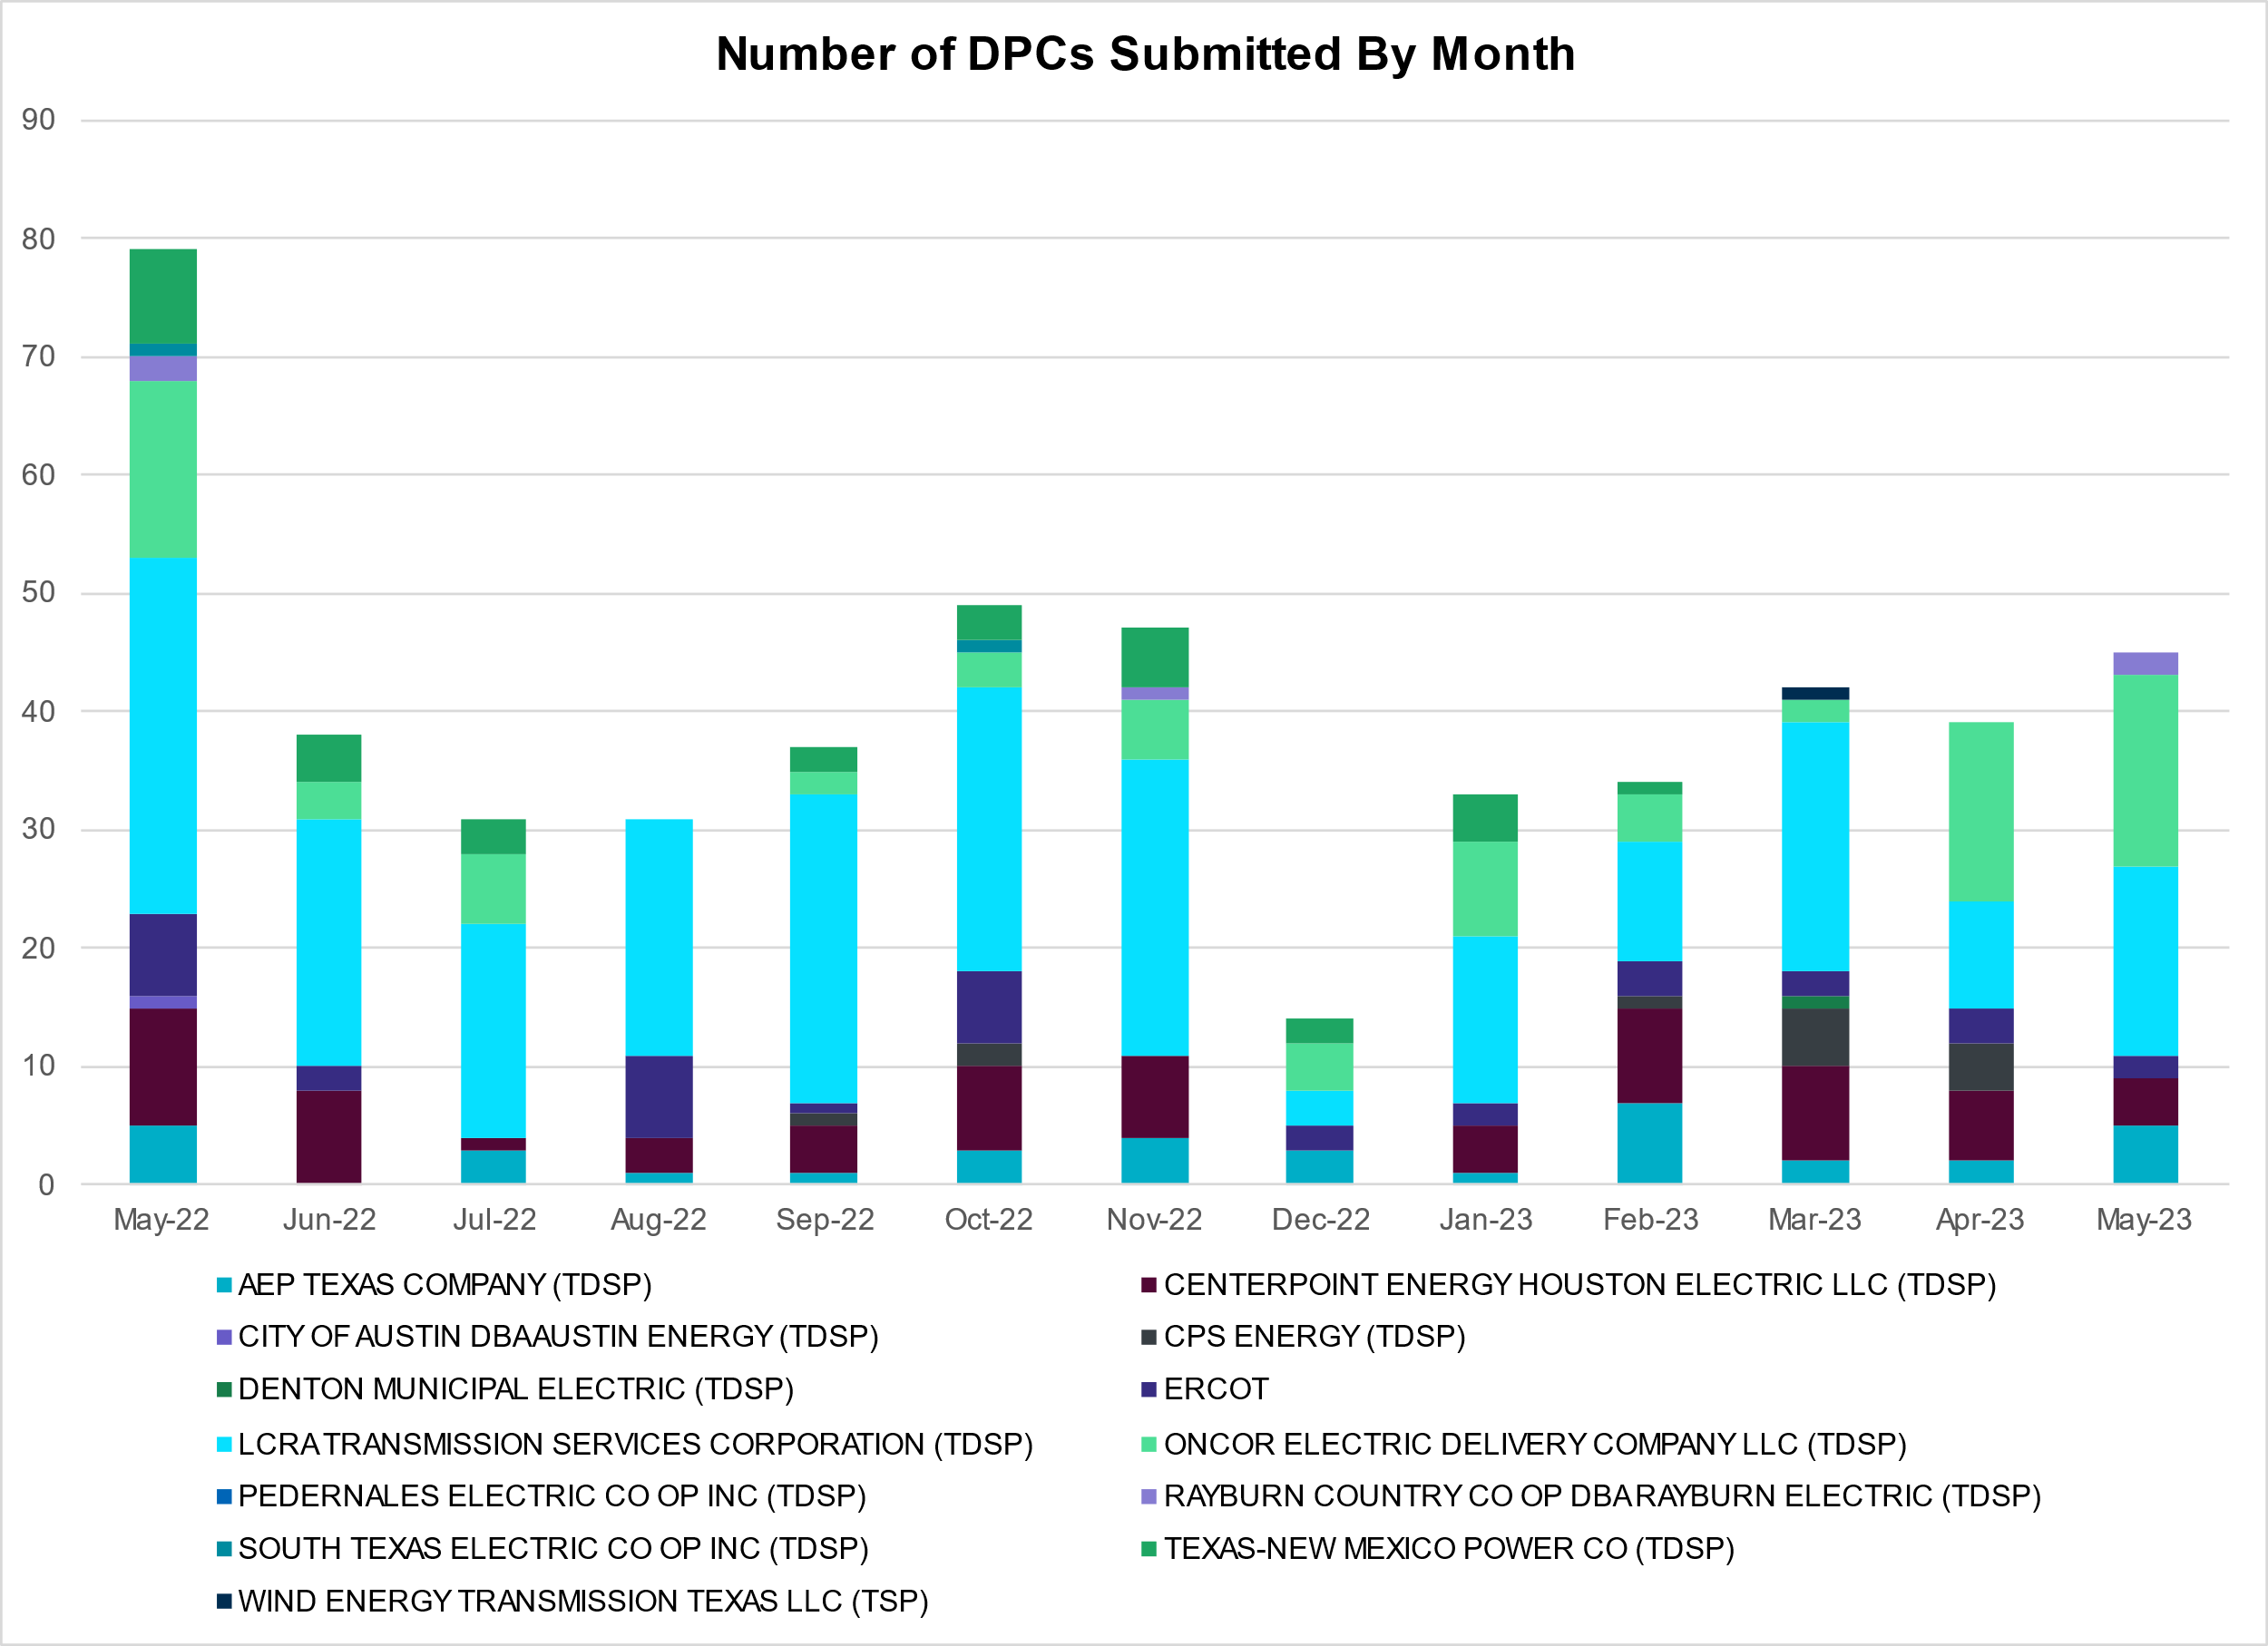

Transmission Operator | Number of DPCs
AEP TEXAS COMPANY (TDSP) | 5
BRAZOS ELECTRIC POWER CO OP INC (TDSP) | 0
BROWNSVILLE PUBLIC UTILITIES BOARD (TDSP) | 0
BRYAN TEXAS UTILITIES (TDSP) | 0
CENTERPOINT ENERGY HOUSTON ELECTRIC LLC (TDSP) | 4
CITY OF AUSTIN DBA AUSTIN ENERGY (TDSP) | 0
CITY OF COLLEGE STATION (TDSP) | 0
CITY OF GARLAND (TDSP) | 0
CPS ENERGY (TDSP) | 0
DENTON MUNICIPAL ELECTRIC (TDSP) | 0
ELECTRIC TRANSMISSION TEXAS LLC (TDSP) | 0
ERCOT | 2
LCRA TRANSMISSION SERVICES CORPORATION (TDSP) | 16
LONE STAR TRANSMISSION LLC (TSP) | 0
ONCOR ELECTRIC DELIVERY COMPANY LLC (TDSP) | 16
PEDERNALES ELECTRIC CO OP INC (TDSP) | 0
RAYBURN COUNTRY CO OP DBA RAYBURN ELECTRIC (TDSP) | 2
SHARYLAND UTILITIES LP (TDSP) | 0
SOUTH TEXAS ELECTRIC CO OP INC (TDSP) | 0
TEXAS MUNICIPAL POWER AGENCY (TDSP) | 0
TEXAS-NEW MEXICO POWER CO (TDSP) | 0
WIND ENERGY TRANSMISSION TEXAS LLC (TSP) | 0

Appendix A: Real-Time Constraints
The following is a complete list of constraints activated in SCED. Full contingency descriptions can be found in the Standard Contingencies List located on the MIS secure site at Grid Generation Reliability Unit Commitment.
Year | Month of the Year | Contingency Name | Overloaded Element | From Station | To Station | Count of Days
2023 | 5 | BASE CASE | NE_LOB | n/a | n/a | 25
2023 | 5 | SSKYSB28 | 15010__B | BLISS | ESTILES | 22
2023 | 5 | SGARBAT8 | 15010__B | BLISS | ESTILES | 21
2023 | 5 | SNATBEA8 | 6144__A | STASW | BSPRW | 20
2023 | 5 | SNATBEA8 | 6144__A | BSPRW | STASW | 20
2023 | 5 | SLP3LPL9 | LPLER_LPLMK_1 | LPLMK | LPLER | 18
2023 | 5 | SBWDDBM5 | LPLMK_LPLNE_1 | LPLMK | LPLNE | 17
2023 | 5 | BASE CASE | VALEXP | n/a | n/a | 15
2023 | 5 | SMADSAP8 | MADDUX_SAPOWE2_1 | SAPOWER | MADDUX | 14
2023 | 5 | SMADSAP8 | MADDUX_SAPOWE2_1 | MADDUX | SAPOWER | 14
2023 | 5 | MMDSQAL5 | MDSSW_MR1L | MDSSW | MDSSW | 14
2023 | 5 | DTOKJK_5 | 260_A_1 | JEWET | SNG | 12
2023 | 5 | MCONMDS5 | 6051__A | ODEHV | QALSW | 12
2023 | 5 | BASE CASE | NELRIO | n/a | n/a | 12
2023 | 5 | MCONMDS5 | 6051__A | QALSW | ODEHV | 12
2023 | 5 | BASE CASE | WESTEX | n/a | n/a | 11
2023 | 5 | SMDOPHR5 | G138_10B_1 | SEMINOLE | MAGNO_TN | 10
2023 | 5 | SN_SLON5 | MV_YUT_RAYMND1_1 | RAYMND2 | MV_YUTT | 10
2023 | 5 | DMGSBTR5 | 6036__A | TKWSW | MGSES | 9
2023 | 5 | SCARFRI8 | ATSO_SONR1_1 | ATSO | SONR | 9
2023 | 5 | SLOBSA25 | CATARI_PILONC1_1 | PILONCIL | CATARINA | 9
2023 | 5 | XBAL89 | CONCHO_VRBS1_1 | CONCHO | VRBS | 9
2023 | 5 | SCARFRI8 | ATSO_SONR1_1 | SONR | ATSO | 9
2023 | 5 | SLOBSA25 | CATARI_PILONC1_1 | CATARINA | PILONCIL | 9
2023 | 5 | SOWLBIG8 | BISON_STRS1_1 | BISON | STRS | 8
2023 | 5 | DBIGKEN5 | HAMILT_MAVERI1_1 | HAMILTON | MAVERICK | 8
2023 | 5 | SLOBSA25 | LARDVN_LASCRU1_1 | LARDVNTH | LASCRUCE | 8
2023 | 5 | SCRTEIL8 | 15010__B | BLISS | ESTILES | 8
2023 | 5 | SN_SLON5 | LASPUL_RAYMND1_1 | LASPULGA | RAYMND2 | 8
2023 | 5 | MCONQAL5 | 6471__C | MGSES | NAVIG | 8
2023 | 5 | DWPWFWP5 | STPWAP39_1 | STP | WAP | 7
2023 | 5 | SDC_RAI8 | VALEXP | n/a | n/a | 7
2023 | 5 | MCONLNG5 | 6095__D | LMESA | JPPOI | 7
2023 | 5 | SLOBSA25 | ASHERT_CATARI1_1 | CATARINA | ASHERTON | 7
2023 | 5 | MHARNED5 | BURNS_RIOHONDO_1 | RIOHONDO | MV_BURNS | 7
2023 | 5 | DMGSBIT5 | 6036__A | TKWSW | MGSES | 7
2023 | 5 | SLOBSA25 | ASHERT_CATARI1_1 | ASHERTON | CATARINA | 7
2023 | 5 | SVEAW_L5 | 6217__A | WLVSW | GAILS | 7
2023 | 5 | SCRMSAR8 | CONCHO_VRBS1_1 | CONCHO | VRBS | 7
2023 | 5 | SBAKCED5 | 15010__B | BLISS | ESTILES | 6
2023 | 5 | SEILPCT8 | 15010__B | BLISS | ESTILES | 6
2023 | 5 | SN_SAJO5 | MV_YUT_RAYMND1_1 | RAYMND2 | MV_YUTT | 6
2023 | 5 | SQALODE5 | 6059__B | CONSW | MDSSW | 6
2023 | 5 | MHARNED5 | HAINE__LA_PAL1_1 | LA_PALMA | HAINE_DR | 6
2023 | 5 | SI_DI_38 | I_DUPP_I_DUPS1_1 | I_DUPP1 | I_DUPSW | 6
2023 | 5 | DWPWFCK5 | STPWAP39_1 | STP | WAP | 6
2023 | 5 | SPOTPAN9 | GUS_HAS_1 | HAS | GUSTINE | 6
2023 | 5 | SPOTPAN9 | GUS_HAS_1 | GUSTINE | HAS | 6
2023 | 5 | XBOM358 | BOMSW_MR1H | BOMSW | BOMSW | 6
2023 | 5 | XBGL88 | BISON_STRS1_1 | BISON | STRS | 5
2023 | 5 | SN_SLON5 | HAINE__LA_PAL1_1 | LA_PALMA | HAINE_DR | 5
2023 | 5 | SW_GODE5 | 15060__B | VEALMOOR | KOCHTAP | 5
2023 | 5 | SDIMBEV8 | HAMILT_MAVERI1_1 | HAMILTON | MAVERICK | 5
2023 | 5 | BASE CASE | MCCAMY | n/a | n/a | 5
2023 | 5 | BASE CASE | N_TO_H | n/a | n/a | 5
2023 | 5 | SFTLMES8 | CROSSO_NORTMC1_1 | NORTMC | CROSSOVE | 4
2023 | 5 | BASE CASE | RV_RH | n/a | n/a | 4
2023 | 5 | SKOCBUZ8 | 6217__A | WLVSW | GAILS | 4
2023 | 5 | SVICCO28 | COLETO_VICTOR2_1 | COLETO | VICTORIA | 4
2023 | 5 | BASE CASE | RAMBLER_GENTIE_1 | RAMBLER | TWINBU | 4
2023 | 5 | XLOB258 | PAWNEE_TANGO1_1 | TANGO | PAWNEE | 4
2023 | 5 | DELMSAN5 | PAWNEE_SPRUCE_1 | PAWNEE | CALAVERS | 4
2023 | 5 | SOXYING8 | I_DUPP_I_DUPS2_1 | I_DUPP1 | I_DUPSW | 4
2023 | 5 | XABM58 | ANSN_RADIUM1_1 | RADIUM | ANSN | 4
2023 | 5 | SALAN_28 | CELANE_KLEBER1_1 | CELANEBI | KLEBERG | 4
2023 | 5 | SFTLMES8 | PALOUS_WOLFCA1_1 | PALOUSE | WOLFCAMP | 4
2023 | 5 | SN_SLON5 | ARMSTR_MV_YUT1_1 | MV_YUTT | ARMSTRON | 3
2023 | 5 | MRESMCM8 | RINCON_WHITE_2_1 | RINCON | WHITE_PT | 3
2023 | 5 | DBBSRCH5 | 1240__J | POKSW | FFD | 3
2023 | 5 | DKG_NB_5 | JFSSC_06_A | JFS | SC | 3
2023 | 5 | MCONLNG5 | 15010__B | BLISS | ESTILES | 3
2023 | 5 | SBGLTWI8 | CONCHO_SANW0_1 | CONCHO | SANW | 3
2023 | 5 | SBRAUVA8 | HAMILT_MAVERI1_1 | HAMILTON | MAVERICK | 3
2023 | 5 | SBIGSCH5 | PALOUS_WOLFCA1_1 | PALOUSE | WOLFCAMP | 3
2023 | 5 | MRESMCM8 | RINCON_WHITE_2_1 | WHITE_PT | RINCON | 3
2023 | 5 | SHCKRNK5 | 106__A | HCKSW | ALLNC | 3
2023 | 5 | DTWIDIV5 | ANSN_RADIUM1_1 | RADIUM | ANSN | 3
2023 | 5 | DCC3_NED | BURNS_RIOHONDO_1 | RIOHONDO | MV_BURNS | 3
2023 | 5 | SBCVPSA8 | JFSSC_06_A | JFS | SC | 3
2023 | 5 | SSTILOM8 | LA_PAL_VCAVAZ1_1 | LA_PALMA | VCAVAZOS | 3
2023 | 5 | SALIBNT8 | MYRA_VAL_1 | MYRA | VALYVIEW | 3
2023 | 5 | DRNS_TB5 | THWZEN71_A | ZEN | THW | 3
2023 | 5 | MMGSCON5 | 6095__D | LMESA | JPPOI | 3
2023 | 5 | DCC3_NED | ASHERT_CATARI1_1 | ASHERTON | CATARINA | 3
2023 | 5 | SW_SDIV5 | 15010__B | BLISS | ESTILES | 3
2023 | 5 | DSWECCR5 | 6036__A | TKWSW | MGSES | 3
2023 | 5 | SRICGRS8 | 6840__B | NVKSW | ANARN | 3
2023 | 5 | SNEDSTE5 | BURNS_RIOHONDO_1 | RIOHONDO | MV_BURNS | 3
2023 | 5 | MMDSQAL5 | MDSSW_MR1H | MDSSW | MDSSW | 3
2023 | 5 | DLEGOUT5 | 40__A | BBSES | JEWET | 2
2023 | 5 | MMGSCON5 | 6471__C | MGSES | NAVIG | 2
2023 | 5 | MMDSQAL5 | 6512__B | ODEHV | TROTP | 2
2023 | 5 | DREFSTP5 | CKT_3124_1 | STP | HLJ | 2
2023 | 5 | SPSAPSA8 | JFSSC_06_A | JFS | SC | 2
2023 | 5 | DWISALV8 | MYRA_VAL_1 | MYRA | VALYVIEW | 2
2023 | 5 | SSKYSB28 | PECNGRV_TALLCY_1 | TALLCITY | PECN_GRV | 2
2023 | 5 | SSTILOM8 | SCARBI_TITAN_1_1 | SCARBIDE | TITAN_SU | 2
2023 | 5 | SHAYZO25 | 6T227_1 | HAYSEN | ZORN | 2
2023 | 5 | DNUEGIL8 | CHAMPL_WEIL_T1_1 | WEIL_TRC | CHAMPLIN | 2
2023 | 5 | SKINFAL8 | FALFUR_PREMON1_1 | FALFUR | PREMONT | 2
2023 | 5 | SLOBSA25 | FREER_LOBO1_1 | LOBO | FREER | 2
2023 | 5 | SCT2CAR8 | HAMILT_MAVERI1_1 | HAMILTON | MAVERICK | 2
2023 | 5 | DBIGKEN5 | TREADW_YELWJC1_1 | TREADWEL | YELWJCKT | 2
2023 | 5 | DSCOTKW5 | 15060__B | VEALMOOR | KOCHTAP | 2
2023 | 5 | SKEYWLV8 | 15060__B | VEALMOOR | KOCHTAP | 2
2023 | 5 | BASE CASE | HHGTOM_1 | HHGT | OMEGA | 2
2023 | 5 | SCABWES8 | HOLLY4_WESTSI1_1 | HOLLY4 | WESTSIDE | 2
2023 | 5 | SIOLKEI8 | RPR_GIBC_1 | RPR | GIBCRK | 2
2023 | 5 | SKINODE5 | 421T441_1 | LCRANE | MOTORM | 2
2023 | 5 | DSCOFAR5 | 6216__B | WLVSW | SHRNE | 2
2023 | 5 | DWAP_JN5 | BI_SMR98_A | SMITHERS | BI | 2
2023 | 5 | SBENS_M8 | BENTS_FRTER_1C_1 | S_MISSIN | RAILROAD | 2
2023 | 5 | DCENFAL5 | CATARI_PILONC1_1 | PILONCIL | CATARINA | 2
2023 | 5 | SBE2ASH8 | HAMILT_MAVERI1_1 | HAMILTON | MAVERICK | 2
2023 | 5 | SBIGTWI5 | HAMILT_MAVERI1_1 | HAMILTON | MAVERICK | 2
2023 | 5 | SSPJFS8 | JFSSC_06_A | JFS | SC | 2
2023 | 5 | DJACALV8 | MYRA_VAL_1 | MYRA | VALYVIEW | 2
2023 | 5 | SBTPBNT8 | MYRA_VAL_1 | MYRA | VALYVIEW | 2
2023 | 5 | SGRICOL5 | PAWNEE_TANGO1_1 | TANGO | PAWNEE | 2
2023 | 5 | SKEYWLV8 | 15060__A | KOCHTAP | BUZSW | 2
2023 | 5 | DODEMOS5 | 6095__D | LMESA | JPPOI | 2
2023 | 5 | SKINODE5 | HARGRO_TWINBU1_1 | HARGROVE | TWINBU | 2
2023 | 5 | SBEAOR8 | PT_TWM25_A | PT | TWM | 2
2023 | 5 | DSTPRED5 | CKT_3124_1 | STP | HLJ | 2
2023 | 5 | DCHBJO25 | EAGMB_52_A | MB | EAG | 2
2023 | 5 | SKINODE5 | HARGRO_TWINBU1_1 | TWINBU | HARGROVE | 2
2023 | 5 | SFORYEL8 | HEXT_MASONS1_1 | MASONSW | HEXT | 2
2023 | 5 | SSKYSB28 | PECNGRV_SMIDLA_1 | PECN_GRV | SMIDLAND | 2
2023 | 5 | XEIN58 | 6471__C | MGSES | NAVIG | 2
2023 | 5 | SN_SAJO5 | ARMSTR_MV_YUT1_1 | MV_YUTT | ARMSTRON | 2
2023 | 5 | SLAQLOB8 | FALFUR_PREMON1_1 | FALFUR | PREMONT | 2
2023 | 5 | SPOMNED5 | ASHERT_CATARI1_1 | CATARINA | ASHERTON | 1
2023 | 5 | DSWELNC5 | BLUF_C_MULBER1_1 | BLUF_CRK | MULBERRY | 1
2023 | 5 | SNICORN8 | CONCHO_VRBS1_1 | CONCHO | VRBS | 1
2023 | 5 | SCARFRI8 | FDR_OZNC_1 | OZNC | FRIEND_R | 1
2023 | 5 | SN_SLON5 | FREER_LOBO1_1 | LOBO | FREER | 1
2023 | 5 | DNUEGIL8 | GILA_MAYO1_1 | GILA | MAYO | 1
2023 | 5 | SBATPEA8 | PEARSALL_69_4 | PEARSALL | PEARSALL | 1
2023 | 5 | XBGL88 | PHBL_T_STRS1_1 | STRS | PHBL_TAP | 1
2023 | 5 | SFTLMES8 | SANTAR_WOLFCA1_1 | WOLFCAMP | SANTARIT | 1
2023 | 5 | SKINODE5 | SANTAR_WOLFCA1_1 | WOLFCAMP | SANTARIT | 1
2023 | 5 | DWLV89N8 | 3410__A | ELVSW | REGST | 1
2023 | 5 | SCLCGRS8 | 6635__G | ESTLD | MRVLY | 1
2023 | 5 | SCLCGRS8 | 6635__G | MRVLY | ESTLD | 1
2023 | 5 | SCABWES8 | ARCADI_SOUTH_1_1 | ARCADIA | SOUTH_SI | 1
2023 | 5 | SOAKNIC8 | CONCHO_VRBS1_1 | CONCHO | VRBS | 1
2023 | 5 | DWPWFWP5 | DA_WC_89_A | WC | DA | 1
2023 | 5 | SCABWES8 | HOLLY4_SOUTH_1_1 | HOLLY4 | SOUTH_SI | 1
2023 | 5 | SBE2ASH8 | TURTLECK_WCRYS_1 | TURTLCRK | WCRYSTS | 1
2023 | 5 | SBRACAL8 | V2_Z5_1 | Z5 | V2 | 1
2023 | 5 | DWLDSCO5 | 15060__B | VEALMOOR | KOCHTAP | 1
2023 | 5 | DNAVOUT5 | 40__A | BBSES | JEWET | 1
2023 | 5 | DSCOTKW5 | 6095__D | LMESA | JPPOI | 1
2023 | 5 | DSCOTKW5 | 6215__A | BCKSW | CGRSW | 1
2023 | 5 | SLAQLOB8 | BRUNI_69_1 | BRUNI | BRUNI | 1
2023 | 5 | SPOMDEL5 | CATARI_PILONC1_1 | PILONCIL | CATARINA | 1
2023 | 5 | SSTLEIN8 | CRTVLE_EINSTEN_1 | EINSTEIN | CRTRVLLE | 1
2023 | 5 | SBIGTWI5 | ESCOND_GANSO1_1 | GANSO | ESCONDID | 1
2023 | 5 | SWHILON5 | GILA_MAYO1_1 | GILA | MAYO | 1
2023 | 5 | SN_SAJO5 | HAINE__LA_PAL1_1 | LA_PALMA | HAINE_DR | 1
2023 | 5 | SI_DWH38 | I_DUPS_RESNIK2_2 | I_DUPSW | RESNIK | 1
2023 | 5 | DCENREV5 | PAWNEE_TANGO1_1 | TANGO | PAWNEE | 1
2023 | 5 | MMGSCON5 | 15010__B | BLISS | ESTILES | 1
2023 | 5 | SPOMDEL5 | ASHERT_CATARI1_1 | CATARINA | ASHERTON | 1
2023 | 5 | XBGL88 | BIGLAK_PHBL_T1_1 | PHBL_TAP | BIGLAKE | 1
2023 | 5 | SPOMNED5 | CATARI_PILONC1_1 | PILONCIL | CATARINA | 1
2023 | 5 | SWRDYN8 | DA_WC_89_A | WC | DA | 1
2023 | 5 | SHASTNN8 | G138_8B_1 | HDNLAKES | LEAGCITY | 1
2023 | 5 | DNUEGIL8 | GILA_MAYO1_1 | MAYO | GILA | 1
2023 | 5 | XB2I58 | HT_TAP24_1 | HT | HT | 1
2023 | 5 | DYELHE89 | KATEMC_MASN1_1 | MASN | KATEMCY | 1
2023 | 5 | SKLELOY8 | LOYOLA_69_1 | LOYOLA | LOYOLA | 1
2023 | 5 | DBIGKEN5 | MADDUX_TREADW1_1 | MADDUX | TREADWEL | 1
2023 | 5 | DBIGSCH5 | PALOUS_WOLFCA1_1 | PALOUSE | WOLFCAMP | 1
2023 | 5 | SBE2ASH8 | TURTLECK_WCRYS_1 | WCRYSTS | TURTLCRK | 1
2023 | 5 | DELMWWE8 | 1020__A | ELMOT | MCTYE | 1
2023 | 5 | SRRDLCS5 | 235__A | SJNSW | JEWET | 1
2023 | 5 | DBUZLME8 | 6095__D | LMESA | JPPOI | 1
2023 | 5 | SSCLWF18 | 6840__A | ANARN | CRDSW | 1
2023 | 5 | SSCLWF18 | 6840__B | NVKSW | ANARN | 1
2023 | 5 | DCENFAL5 | ASHERT_CATARI1_1 | CATARINA | ASHERTON | 1
2023 | 5 | BASE CASE | BEARKT | n/a | n/a | 1
2023 | 5 | DSWECBF5 | BLUF_C_MULBER1_1 | MULBERRY | BLUF_CRK | 1
2023 | 5 | SW_SDIV5 | CRTVLE_EINSTEN_1 | EINSTEIN | CRTRVLLE | 1
2023 | 5 | XNOR358 | HARGRO_TWINBU1_1 | TWINBU | HARGROVE | 1
2023 | 5 | SN_SAJO5 | LASPUL_RAYMND1_1 | LASPULGA | RAYMND2 | 1
2023 | 5 | DWHILON5 | PAWNEE_TANGO1_1 | TANGO | PAWNEE | 1
2023 | 5 | SN_SLON5 | ARMSTR_LOYOLA1_1 | ARMSTRON | LOYOLA | 1
2023 | 5 | SN_SLON5 | BURNS_RIOHONDO_1 | RIOHONDO | MV_BURNS | 1
2023 | 5 | DDELGA58 | CATARI_PILONC1_1 | PILONCIL | CATARINA | 1
2023 | 5 | DBRNCMN8 | CONCHO_VRBS1_1 | CONCHO | VRBS | 1
2023 | 5 | SKINODE5 | CROSSO_NORTMC1_1 | NORTMC | CROSSOVE | 1
2023 | 5 | SEBHUG8 | DA_WC_89_A | WC | DA | 1
2023 | 5 | SBRAUVA8 | ESCOND_GANSO1_1 | GANSO | ESCONDID | 1
2023 | 5 | DPHRAL58 | G138_10B_1 | SEMINOLE | MAGNO_TN | 1
2023 | 5 | DKOCNUE8 | GILA_MAYO1_1 | GILA | MAYO | 1
2023 | 5 | SILLFTL8 | HAMILT_MAXWEL1_1 | MAXWELL | HAMILTON | 1
2023 | 5 | SPLUPIN8 | MAGRUD_VICTOR2_1 | VICTORIA | MAGRUDER | 1
2023 | 5 | SW_BW_25 | RKYROAD_STILES_1 | RCKYROAD | STILES | 1
2023 | 5 | SBIGSCH5 | SANTAR_WOLFCA1_1 | WOLFCAMP | SANTARIT | 1
2023 | 5 | DGRSPKR5 | 6377__A | BRTSW | ORANS | 1
2023 | 5 | DMTSCOS5 | 6437__F | SCRCV | KNAPP | 1
2023 | 5 | SW_BW_25 | 6471__C | MGSES | NAVIG | 1
2023 | 5 | DGRMGRS8 | 6635__G | MRVLY | ESTLD | 1
2023 | 5 | SN_SAJO5 | ARMSTR_LOYOLA1_1 | ARMSTRON | LOYOLA | 1
2023 | 5 | DDELGA58 | ASHERT_CATARI1_1 | CATARINA | ASHERTON | 1
2023 | 5 | DCC3_NED | CATARI_PILONC1_1 | CATARINA | PILONCIL | 1
2023 | 5 | DCENFAL5 | FREER_LOBO1_1 | LOBO | FREER | 1
2023 | 5 | SCOMHA38 | MAXWEL_WHITIN1_1 | MAXWELL | WHITING | 1
2023 | 5 | SOWLBIG8 | PHBL_T_STRS1_1 | STRS | PHBL_TAP | 1
2023 | 5 | BASE CASE | RIOHND_ERIOHND_1 | MV_RIOHO | RIOHONDO | 1
2023 | 5 | SW_SBRN5 | 15010__B | BLISS | ESTILES | 1
2023 | 5 | DSALHUT5 | 630__B | KLNSW | HHSTH | 1
2023 | 5 | SCLCGRS8 | 6635__E | MRVLY | WAYLAND | 1
2023 | 5 | SOWLBIG8 | BIGLAK_PHBL_T1_1 | PHBL_TAP | BIGLAKE | 1
2023 | 5 | DBIGKEN5 | BONDRO_SONR1_1 | SONR | BONDROAD | 1
2023 | 5 | SFORYEL8 | FRPHIL_GILLES1_1 | GILLES | FRPHILLT | 1
2023 | 5 | SFORYEL8 | FRPHIL_MASN1_1 | FRPHILLT | MASN | 1
2023 | 5 | MCONLNG5 | HARGRO_TWINBU1_1 | TWINBU | HARGROVE | 1
2023 | 5 | BASE CASE | NEDIN_SERDEV5_1 | NEDIN | NEDIN | 1
2023 | 5 | DCOLFA59 | PAWNEE_TANGO1_1 | TANGO | PAWNEE | 1
2023 | 5 | DCC3_NED | VALIMP | n/a | n/a | 1
2023 | 5 | SLCRCRA8 | 15010__B | BLISS | ESTILES | 1
2023 | 5 | MWSHNAV5 | 6377__A | BRTSW | ORANS | 1
2023 | 5 | SCLCGRS8 | 6635__E | WAYLAND | MRVLY | 1
2023 | 5 | DGRMGRS8 | 6635__G | ESTLD | MRVLY | 1

Current Wind Generation Record: 27,044 MW on 05/29/2022 at 22:36 | Current Wind Penetration Record: 69.15% on 04/10/2022 at 01:43 Current Solar Generation Record: 12,757 MW on 04/30/2023 at 12:03 | Current Solar Penetration Record: 32.93% on 04/30/2023 at 09:24
This is the hourly integrated peak demand as published in the ERCOT D&E report.

