TDTMS
May 16th, 2023
WebEx only
Attendee | Company | Attendee | Company | Attendee | Company
Diana Rehfeldt | TNMP | Dave Michelson | ERCOT | Kyle Patrick | NRG
Sam Pak | Oncor | Dee Lowerre | NRG | Monica Jones | CNP
Jordan Troublefield | ERCOT | Mick Hanna | ERCOT | Eric Lotter | GridMonitor
Sheri Wiegand | Vistra | Amy Sue Stirland | Lubbock | Kathy Scott | CNP
Lori Lee Barfield | Just Energy | Cindy Duong | Just Energy | Carolyn Reed | CNP
 |  |  |  | Edward Aranda | ?

Sheri opened the meeting with the Antitrust Admonition.
Minutes from the April 20th meeting were approved.

ERCOT System Instances & MarkeTrak Monthly Performance Review
- Mick presented April performance reports and reviewed the April outages experienced –SLA targets for April were not met, however, YTD SLAs are good.
    - 4/3 NAESB outage 10:30 – 10:43 am – external patching cycle exercise – as noted earlier, with heightened cybersecurity activity, patching will occur on a more regular basis. Since 4/3 have had two patching exercises with no issues
    - 4/13 NAESB outage 3:56 – 4:22 pm – outage impacted entire ERCOT network DNS (phone book with URL addresses) was down and system essentially did not know where to send information.
- MarkeTrak response times continue to be good
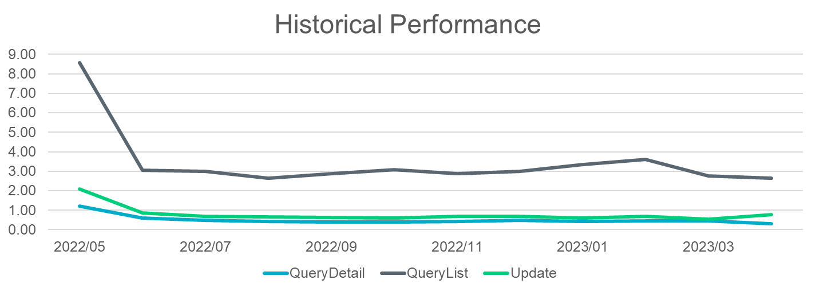

- Listserv activity – 4/3 NAESB outage also impacted listserv
    - Weather Moratorium listserv – two deletes noted
- TDTMS EDM Implementation Guide update – Mick proposed an administrative revision to the existing guide thus removing ERCOT support of FTP transports. ERCOT no longer supports and guide should align. Mick commented on the idea of a portal for developers (aka message board) to discuss/comment on EWS/NAESB issues. Jordan explained the revision would be an OBDRR and follow the TAC-RMS-Board-PUCT path. ERCOT will draft and TDTMS will support.
- MIS API project update – no significant update; planned for the early December release, testing will be available for the 4-5 API users the week prior to test applications (DDLs) – noted architecture will be the same as EWS (ERCOT Web Services) that is used in other applications noting transactions will not be able to be sent via API – this is read only.
- ERCOT Digital Certificates – Mick and Dave reported ERCOT has seen a growth of ~30% since 2021 (20580 certs in 2021, 33600 certs in 2023 to date). Goal is a cost savings measure to reduce number of unused certs. ERCOT is seeking insight on why # is increasing and proposed action to reduce # of unused certs.
    - Initial thought is cert application is part of onboarding procedure for market participants whether cert is needed or not. Another thought is that the # of subLSEs and subQSEs all require individual certs and this number is increasing
    - Ideas are to provide list of unused certs to market participants(mp) (90 days unused) for mp action to delete. Lists could be provided quarterly and assist with annual audit process. ERCOT is estimating a 2024 implementation. This item will be kept on agenda for additional ideas.
- October extended retail release – Kathy questioned if ERCOT will still be using the extended release originally scheduled for Lubbock integration in October 2023. Dave indicated ERCOT has not re-evaluated and plans to leave as scheduled.
- December extended retail release – Dave announced extended additional hours are not expected to be needed for planned release. This will alleviate the need for safety net provisions for that weekend.

SCR 817 MarkeTrak Validations –
Dave reported development is on track and they are currently performing testing for the Inadvertent workflow which is testing successfully per requirements.

IAG Discussion
The working group discussed the need for revisions to the recently effective RMGRR 170 modifying the Inadvertent Gain process which included provisions for IAGs used for identity theft and codifying the Current Occupant process. It was reported by some REPs that other REPs are unexcuting requests to regain an ESI based on identity theft. One suggestion was to clarify the RMG to indicate the following:

7.3.2.1.3 Service Connected As A Result of Identity Theft
(1) The IAG process shall not be used by the Gaining REP to resolve an issue where the service is connected as result of identity theft.

As opposed to an additional RMGRR, the working group suggested this issue be reviewed in training, both instructor-led and on-line modules.

MarkeTrak Deep Dive Analysis
Dave provided the “data dump” and Sam was able to sort the data to review initial volumes of various subtypes and provide insight into REPs submitting and the TDSPs receiving the data. Additional analysis will be provided on timing for completion of MTs. See embedded matrix for results. This data, along with other data, will be used for Client Services template to REPs to bring awareness to REP performance.

NEXT MEETING scheduled – June 22nd Thursday @ 9:30 AM WebEx only
- ERCOT Updates
  - System Instances & MT Performance
  - Listserv
  - EDM OBDRR, if necessary
  - MIS API review
  - Digital Certificate Application Reduction
  - October retail release scheduled
- SCR817 Business Requirements discussion, if needed
- MarkeTrak Subtype Analysis – timing
- Inadvertent Gain Data Analysis, if data is available

