April 2023 ERCOT Monthly Operations Report
Reliability and Operations Subcommittee Meeting
June 8, 2023

Table of Contents
1. Report Highlights 2
2. Frequency Control 3
2.1. Frequency Events 3
2.2. Responsive Reserve Events 4
2.3. Load Resource Events 4
3. Reliability Unit Commitment 4
4. IRR, Wind, and Solar Generation as a Percent of Load 6
5. Largest Net-Load Ramps 8
6. Congestion Analysis 9
6.1. Notable Constraints 9
6.2. Generic Transmission Constraint Congestion 22
6.3. Manual Overrides 23
6.4. Congestion Costs for Calendar Year 2023 23
7. System Events 24
7.1. ERCOT Peak Load 24
7.2. Load Shed Events 24
7.3. Stability Events 24
7.4. Notable PMU Events 24
7.5. DC Tie Curtailment 24
7.6. TRE/DOE Reportable Events 25
7.7. New/Updated Constraint Management Plans 25
7.8. New/Modified/Removed RAS 25
7.9. New Procedures/Forms/Operating Bulletins 25
8. Emergency Conditions 25
8.1. OCNs 25
8.2. Advisories 25
8.3. Watches 26
8.4. Emergency Notices 26
9. Application Performance 26
9.1. TSAT/VSAT Performance Issues 26
9.2. Communication Issues 26
9.3. Market System Issues 27
10. Model Updates 27
Appendix A: Real-Time Constraints 29

Report Highlights
- ERCOT’s maximum peak demand for the month of April was 60,922 MW on 04/03/2023 HE 18:00; and 2,503 MW more than the April 2022 hourly demand, and previous April demand record, which were both 58,419 MW on 04/05/2022 HE 18:00.
- There was 1 frequency event.
- There was 1 instance where Responsive Reserves was deployed.
- 1 DC Tie Curtailment Notice for the DC_R due to an unplanned outage.
- 3 OCN’s issued. 1 for a severe weather warning, large hail, damaging winds and isolated tornados. 2 AAN’s issued for possible future emergency condition.
- 1 Advisory issued pertaining to a geomagnetic disturbance of k-7 and k-8 levels.
- 1 Watch due to SCED Failure, 1 Watch due to HRUC failure.
- There were 67 HRUC commitments.
- There were 18 days of congestion on the Bearkat GTC, 25 days on the North Edinburg to Lobo GTC, 4 days on the Panhandle GTC, 13 days on the Nelson Sharpe to Rio Hondo GTC, 18 days on the West Texas Export GTC, 13 days on the McCamey GTC, 20 days on the Valley Export GTC, 21 days on the North to Houston GTC. There was no activity on the remaining GTCs during the month.
- A PVGR Generation Record of 12,757 MW was set on 04/30/2023 at 12:03.
- A PVGR Penetration Record of 32.93% was set on 04/30/2023 at 09:24.

Frequency Control

Frequency Events
The ERCOT Interconnection experienced 1 frequency event, which resulted from a unit trip. The event duration was 00:01:52.

A summary of the frequency events is provided below. The reported frequency events meet one of the following criteria: Delta Frequency is 60 mHz or greater; the MW loss is 350 MW or greater; resource trip event triggered RRS deployment. Frequency events that have been identified as Frequency Measurable Events (FME) for purposes of BAL-001-TRE-2 analysis are highlighted in blue. When analyzing frequency events, ERCOT evaluates PMU data according to industry standards. Events with an oscillating frequency of less than 1 Hz are inter-area, while higher frequencies indicate local events. Industry standards specify that damping ratio for inter-area oscillations should be 3.0% or greater. For the frequency events listed below, the ERCOT system met these standards and transitioned well after each disturbance. In the case of negative delta frequency, the MW Loss column could refer to load loss.

Date and Time | Delta Frequency | Max/Min Frequency | Duration of Event | PMU Data |  | MW Loss | Load | IRR | Inertia
 | (Hz) | (Hz) |  | Oscillation Mode (Hz) | Damping Ratio |  | (MW) | % | (GW-s)
4/12/2023 20:46:25 | 0.071 | 59.901 | 00:01:52 | 0.73 | 6% | 525 | 47,772 | 37% | 208,846

(Note: All data on this graph encompasses frequency event analysis based on BAL-001-TRE-2.)

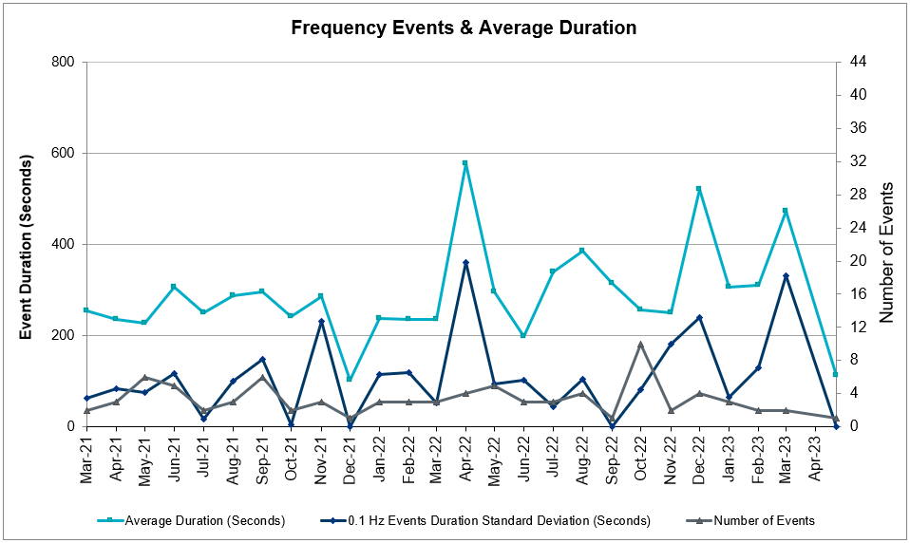

Responsive Reserve Events
There was 1 event where Responsive Reserve MWs were released to SCED. The events highlighted in blue were related to frequency events reported in Section 2.1 above.

Date and Time Released to SCED | Date and Time Recalled | Duration of Event | Maximum MWs Released | Comments
04/12/2023 20:46:36 | 04/12/2023 20:49:04 | 00:02:38 | 382 | Unit Trip

Load Resource Events
None.

Reliability Unit Commitment
ERCOT reports on Reliability Unit Commitments (RUC) monthly. Commitments are reported grouped by operating day and weather zone. The total number of hours committed is the sum of the hours for all the units in the specified region. Additional information on RUC commitments can be found on the MIS secure site at Grid Generation Reliability Unit Commitment.

There were no DRUC commitments.

There were 67 HRUC commitments.
Resource Location | # of Resources | Operating Day | Total # of Hours Committed | Total MWhs | Reason for Commitment
EAST | 1 | 04/08/2023 | 2 | 472.0 | System Capacity
COAST, EAST, NORTH_CENTRAL | 8 | 04/10/2023 | 59 | 14,672.0 | System Capacity
NORTH_CENTRAL | 1 | 04/11/2023 | 6 | 2,250.0 | Minimum Run Time
COAST, NORTH_CENTRAL, SOUTH_CENTRAL | 10 | 04/15/2023 | 63 | 8,306.0 | DCRLLSW5, System Capacity
COAST, EAST, NORTH_CENTRAL | 6 | 04/16/2023 | 28 | 4,840.0 | System Capacity,
NORTH_CENTRAL, SOUTHERN | 4 | 04/20/2023 | 33 | 5,738.0 | System Capacity
COAST, NORTH_CENTRAL | 5 | 04/21/2023 | 56 | 7,368.0 | System Capacity
NORTH_CENTRAL | 2 | 04/22/2023 | 27 | 3,207.0 | Minimum Run Time
EAST, NORTH_CENTRAL | 2 | 04/24/2023 | 18 | 7,004.0 | Minimum Run Time, System Capacity, VALEXP
NORTH_CENTRAL, SOUTH_CENTRAL | 3 | 04/27/2023 | 14 | 2,806.0 | Minimum Run Time System Capacity
EAST, NORTH_CENTRAL, SOUTH_CENTRAL, SOUTHERN | 6 | 04/28/2023 | 36 | 8,650.1 | Minimum Run Time, System Capacity
EAST, NORTH_CENTRAL | 4 | 04/29/2023 | 10 | 3,499.0 | System Capacity,

IRR, Wind, and Solar Generation as a Percent of Load
The graph below shows the maximum, minimum and average aggregate solar, wind and IRR output as a percentage of total ERCOT load when evaluated as 10-minute averaged intervals, over the past 13 months. Current wind and solar generation and penetration records are listed in the footnote below. Maximum IRR penetration for the month was 68.7% on 04/29/2023 interval ending 11:20 and minimum IRR penetration for the month was 3.6% on 04/29/2023 interval ending 21:40.

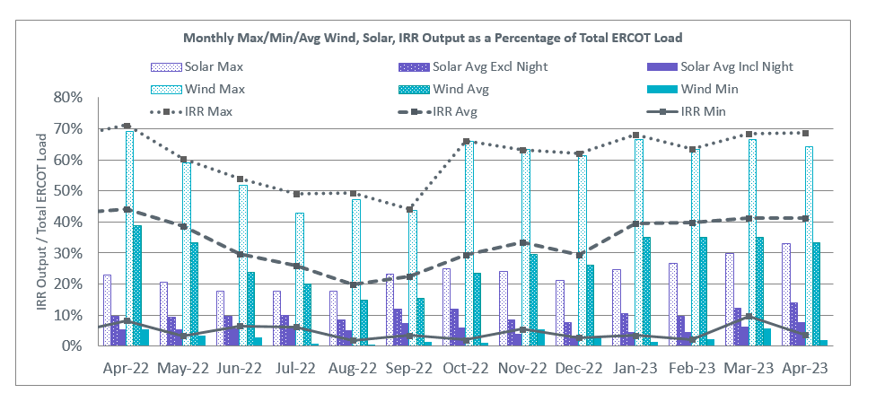

During the hour of peak load for the month, hourly integrated wind generation was 18,229 MW and solar generation was 7,114 MW. The graph below shows the wind and solar penetration percentage during the hour of the peak load in the last 13 months.

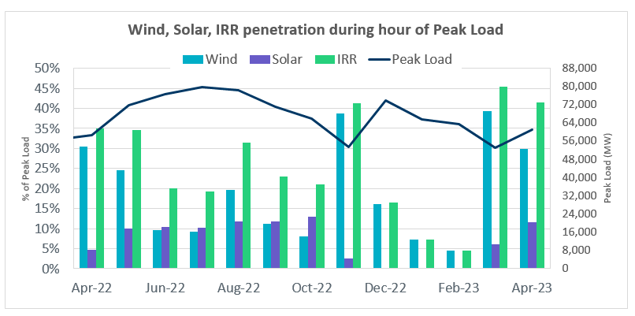

Lastly, the graph below shows the minimum wind, solar and IRR output during the peak load hour as a percentage of the daily peak load for every day in the month.
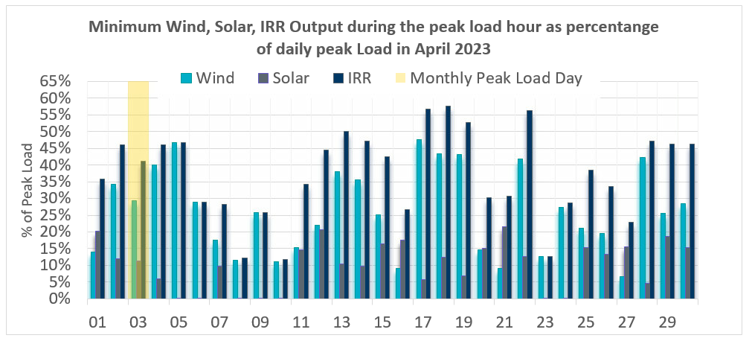

Largest Net-Load Ramps
The net-load ramp is defined as the change in net-load (load minus wind and PVGR generation) during the defined time horizon. Such a variation in net-load needs to be accommodated in grid operations to ensure that the reliability of the grid is satisfactorily maintained. The largest net-load ramp during 5-min, 10-min, 15-min, 30-min and 60-min in April 2023 was 1,282 MW, 2,452 MW, 3,583 MW, 6,640 MW, and 12,352 MW, respectively. The comparison with respect to the historical values is given in the table below.

Month and Year | 5 min | 10 min | 15 min | 30 min | 60 min
Apr 2014 | 796 MW | 1,358 MW | 1,868 MW | 3,445 MW | 6,274 MW
Apr 2015 | 835 MW | 1,482 MW | 1,985 MW | 3,216 MW | 5,330 MW
Apr 2016 | 1,183 MW | 1,666 MW | 2,394 MW | 3,804 MW | 5,101 MW
Apr 2017 | 914 MW | 1,492 MW | 2,315 MW | 3,779 MW | 6,385 MW
Apr 2018 | 947 MW | 1,366 MW | 1,710 MW | 3,303 MW | 5,030 MW
Apr 2019 | 1,147 MW | 1,778 MW | 1,866 MW | 2,866 MW | 4,856 MW
Apr 2020 | 1,189 MW | 1,655 MW | 1,578 MW | 2,773 MW | 4,948 MW
Apr 2021 | 1,414 MW | 1,664 MW | 1,967 MW | 2,874 MW | 4,860 MW
Apr 2022 | 1,218 MW | 1,594 MW | 2,179 MW | 4,191 MW | 7,851 MW
April 2023 | 1,282 MW  04/29/2023  (IE 19:13) | 2,452 MW  04/29/2023  (IE 19:14) | 3,583 MW  04/29/2023  (IE 19:19) | 6,640 MW  04/29/2023  (IE 19:34) | 12,352 MW  04/29/2023  (IE 19:50)
All Months in 2014-2023 | 1,647 MW  05/25/22  (IE 17:06) | 2,506 MW  1/12/2023  (IE 17:16) | 3,583 MW  04/29/2023  (IE 19:19) | 6,640 MW  04/29/2023  (IE 19:34) | 12,352 MW  04/29/2023  (IE 19:50)

Congestion Analysis

Notable Constraints
Nodal protocol section 3.20 specifies that ERCOT shall identify transmission constraints that are binding in Real-Time three or more Operating Days within a calendar month. As part of this process, ERCOT reports congestion that meets this criterion to ROS. In addition, ERCOT also highlights notable constraints that have an estimated congestion rent exceeding $1,000 for a calendar month. These constraints are detailed in the table below, including approved transmission upgrades from TPIT that may provide some congestion relief based on ERCOT’s engineering judgement. Rows highlighted in blue indicate the congestion was affected by one or more outages. For a list of all constraints activated in SCED, please see Appendix A at the end of this report.

Contingency Name | Overloaded Element | # of Days Constraint Binding | Congestion Rent | Transmission Project
MAN_DBL_CONSW-MDSSW_and_CONSW-QALSW_345kV_DBLCKT | Morgan Creek Ses – Forest Creek And Sand Bluff Wind Farms 138kV | 10 | $19,721,398.38
CRLNW TO LWSSW 345 DBLCKT | Ti Tnp – South Tnp 138kV | 12 | $16,958,746.66
SKYWEST to SPRABERRY SWITCH LIN 1 | South Midland – Consavvy Switch 138kV | 12 | $14,709,066.94
MAN_DBL_MGSES-LNGSW_and_MGSES-CONSW_345_DBLCKT | Morgan Creek Ses – Forest Creek And Sand Bluff Wind Farms 138kV | 6 | $12,831,967.16
MAN_DBL_’CONSW-MGSES_and_CONSW-LNGSW_345kV_DBLCKT | Morgan Creek Ses – Forest Creek And Sand Bluff Wind Farms 138kV | 2 | $10,136,498.61
West Denton to FORT WORTH SUBSATION LIN 1 | West Denton – Rd Wells Interchange 138kV | 3 | $9,446,821.38
MAN_DBL_MDSSW-ODEHB_and_CONSW-QALSW_345kV_DBLCKT | Midessa South Sw 138kV | 20 | $7,029,607.39
Bighil-Kendal 345kV | Hamilton Road – Maverick 138kV | 27 | $6,312,634.64
POCKRUS SUBSTATION to TEASLEY SUBSTATION LIN 1 | West Denton – Rd Wells Interchange 138kV | 1 | $5,297,218.59
Manual for I_DUPS – RESNIK & MCCAMPBE 2 138KV | Whitepoint – Rincon 138kV | 8 | $4,695,767.11
Basecase | PNHNDL GTC | 4 | $3,745,530.04
McCullough Substation to Co-op Substation LIN 1 | Erskine Substation – Mackenzie Substation 69kV | 6 | $3,657,043.83
Wett_long_draw to VEALMOOR – Sharyland Utilities LIN 1 | Willow Valley Switch – Gail Sub 138kV | 8 | $3,644,813.08
Basecase | NE_LOB GTC | 21 | $3,440,749.83 | The Lower Rio Grande Valley (LRGV) System Enhancement Project (21RPG017) will improve the NorthEd_LoboGTC to support up to 80% of total wind and solar generation capacity in the LRGV area.
Basecase | WESTEX GTC | 10 | $3,308,618.38
BLACKWATER DRAW SWITCH to DOUBLE MOUNTAIN SWITCH LIN 1 | Mackenzie Substation – Northeast Substation 115kV | 14 | $3,083,410.62
MGSES TO CCRSW 345 AND BTRCK TO MGSES 345 DBLCKT | Tonkawa Switch – Morgan Creek Ses 345kV | 2 | $3,080,298.17
Bighil-Kendal 345kV | Escondido – Ganso 138kV | 21 | $2,854,215.60
PH ROBINSON to MEADOW LIN A | Magnolia Tnp – Seminole Tnp 138kV | 16 | $2,779,260.41
Fowlerton to LOBO 345 LIN1 | Laredo Vft North – Las Cruces 138kV | 8 | $2,674,115.93
NATURAL DAM to BEALS CREEK SUB LIN _A | Big Spring West – Stanton East 138kV | 21 | $2,643,428.96 | Oncor_FW_71989_Big Spring West – Stanton East 138 kV Line (71989)
Basecase | BEARKT GTC | 18 | $2,539,386.70
Willow Valley Switch to Gail Sub LIN _B | Koch Tap – Vealmoor 138kV | 4 | $2,056,368.18
CRANE LCRA to CRANE EAST (LCRA) LIN 1 | Spraberry Switch – Skywest 138kV | 2 | $1,824,366.73
Basecase | Omega – Horse Hollow Generation Tie 345kV | 10 | $1,730,897.34
MOLINA to WORMSER ROAD LIN 1 | Laredo Vft North – Las Cruces 138kV | 2 | $1,500,402.90 | AEP_TCC_Laredo VFT North – North Laredo SS 138 kV Line Rebuild (58008)
Fowlerton to LOBO 345 LIN1 | Catarina – Piloncillo 138kV | 12 | $1,438,720.34 | AEP_TCC_AshertontoPiloncillo138kVLine_rebuild (73100)
SALSW TO KLNSW 345 DBLCKT | Harker Heights South – Killeen Switch 138kV | 6 | $1,210,786.48
Manual_SGL_CONSW-MDSSW_345kV_SglCkt | Quail Switch – Odessa Ehv Switch 345kV | 8 | $1,178,613.49
NORTH ALVIN TNP to HASTINGS TNP LIN 1 | League City Tnp – Hidden Lakes Tnp 138kV | 1 | $1,021,696.77 | TNMP_66208_LeagueCity-HiddenLakes_Rebuild (66208)
Manual dbl ckt for NEDIN-BONILLA 345kV & RIOH-PRIM138kV | Burns Sub – Rio Hondo 138kV | 12 | $735,186.54 | STEC_71930_RioHondo_Burns_Upgrade (71930)
SAN ANGELO RED CREEK to Weiss LIN 1 | San Angelo Concho – Veribest 69kV | 9 | $704,961.98 | AEP_TNC_Ballinger-ConchoRebuild(20RPG004, MOD 55421)
Cagnon-Kendal 345 &Cico-Mengcr 138 | Medina Lake – Pipe Creek 138kV | 5 | $645,202.79
TWR(345) JOR-KG97 & JOR-NB99 | Bigvue – Lyondell 138kV | 5 | $543,645.65
LON HILL to NELSON SHARPE LIN 1 | Raymondville 2 – Yturria Sub 138kV | 7 | $530,533.92
MAN_DBL_’CONSW-MGSES_and_CONSW-LNGSW_345kV_DBLCKT | Lamesa – Jim Payne Poi 138kV | 5 | $515,434.13
MAN_DBL_MDSSW-ODEHB_and_CONSW-QALSW_345kV_DBLCKT | Midessa South Sw 345kV | 8 | $480,841.70
COMANCHE SWITCH (Oncor) to COMANCHE PEAK SES LIN _A | Comanche Tap – Comanche Switch (Oncor) 138kV | 8 | $456,282.55
Basecase | N_TO_H GTC | 10 | $439,285.62
Twinbu-Sarc&Amoscr 345kV | Schkad – San Angelo Power Station 138kV | 3 | $420,769.11
MANUALS BOG – DER 85 & EAB – BOG 88 | Conial – Philip 138kV | 3 | $313,259.32
Basecase | NELRIO GTC | 12 | $288,425.18 | The Lower Rio Grande Valley (LRGV) System Enhancement Project (21RPG017) will improve the stability constraint for NelsonSharpe_RioHondoGTC under normal conditions.
BEVO to ASHERTON LIN 1 | Turtle Creek Switching Station – West Crystal City Sub 69kV | 5 | $243,731.71
BIG LAKE TRX PS_1 138/138 | Bison – Strauss Rea 69kV | 5 | $228,420.61
Carver to FRIEND RANCH LIN 1 | Atlantic Sonora – Sonora 69kV | 4 | $205,780.84
BARNEY DAVIS to ALAZAN LIN 1 | Celanese Bishop – Kleberg Aep 138kV | 14 | $199,536.23
CARTERVILLE to EINSTEIN LIN 1 | East Stiles – Blissard Sub 138kV | 12 | $192,141.24
SALSW – HUTTO 345KV | Temple Switch – Knob Creek Switch 345kV | 4 | $189,265.47
MANUAL DOUBLE NVARO-LEG & OUTSW-LEG 345 KV | Big Brown Ses – Jewett 345kV | 8 | $181,915.43
LOBO TRX A1 345/138 | Pawnee Switching Station – Tango 345kV | 4 | $141,700.88
Basecase | VALEXP GTC | 12 | $130,495.13 | The Lower Rio Grande Valley (LRGV) System Enhancement Project (21RPG017) will improve the stability constraint for this GTC.
KLEBERG AEP to LOYOLA SUB LIN 1 | Loyola Sub 138kV | 8 | $107,708.93
Basecase | MCCAMY GTC | 9 | $99,076.33
VICTORIA DUPONT SWITCH TO VICTORIA DOUBLE CKT 138KV | North Carbide – Port Lavaca Tap 69kV | 4 | $97,780.26
CAUTHORN to Carver LIN 1 | Hamilton Road – Maverick 138kV | 12 | $92,347.12
Fowlerton to LOBO 345 LIN1 | Asherton – Catarina 138kV | 3 | $90,299.40 | AEP_TCC_AshertontoPiloncillo138kVLine_rebuild (73100)
WEST COLUMBIA to San Bernard LIN A | Lane City – Pavlov 138kV | 4 | $64,254.49
Braunig-Streich&Calaveras 138kV | Eagleck – Elmendrf 138kV | 6 | $56,169.16
MANUAL DOUBLE RGPSW – KLNSW 345 KV & BUCSW – KLNSW 345 KV | Comanche Tap – Comanche Switch (Oncor) 138kV | 3 | $54,201.13
LON HILL to NELSON SHARPE LIN 1 | Las Pulgas – Raymondville 2 138kV | 9 | $53,472.87
Wett_grelton to ODESSA EHV SWITCH LIN 1 | Koch Tap – Vealmoor 138kV | 3 | $46,094.26
RAILROAD to DC_ROAD LIN 1 | #N/A | 4 | $45,553.82
Bighil-Kendal 345kV | Yellow Jacket – Treadwell 138kV | 5 | $39,211.97
MADDUX to SAN ANGELO POWER STATION LIN 1 | Maddux – San Angelo Power Station 138kV | 10 | $35,090.27
CALAVERAS to BRAUNIG LIN 1 | Eagleck – Elmendrf 138kV | 3 | $18,926.08
Fowlerton to LOBO 345 LIN1 | Asherton – Catarina 138kV | 3 | $15,972.24 | AEP_TCC_AshertontoPiloncillo138kVLine_rebuild (73100)
PH ROBINSON to ATTWATER TNP LIN 1 | Attwater Tnp – Ph Robinson 138kV | 3 | $13,100.74
Elmcreek-Sanmigl 345kV | Big Foot – Pleasanton 138kV | 3 | $12,812.30
CAUTHORN to Carver LIN 1 | Escondido – Ganso 138kV | 4 | $8,785.92

Generic Transmission Constraint Congestion
There were 18 days of congestion on the Bearkat GTC, 25 days on the North Edinburg to Lobo GTC, 4 days on the Panhandle GTC, 13 days on the Nelson Sharpe to Rio Hondo GTC, 18 days on the West Texas Export GTC, 13 days on the McCamey GTC, 20 days on the Valley Export GTC, 21 days on the North to Houston GTC. There was no activity on the remaining GTCs during the month.

Note: This is how many times a constraint has been activated to avoid exceeding a GTC limit, it does not imply an exceedance of the GTC occurred or that the GTC was binding.

Manual Overrides
None

Congestion Costs for Calendar Year 2023
The following table represents the top twenty active constraints for the calendar year based on the estimated congestion rent attributed to the congestion. ERCOT updates this list monthly.

Contingency | Overloaded Element | # of 5-min SCED | Estimated Congestion Rent
MAN_DBL_MDSSW-ODEHB_and_CONSW-QALSW_345kV_DBLCKT | Midessa South Sw 138kV | 10,640 | 74,156,704.15
SKYWEST to SPRABERRY SWITCH LIN 1 | Consavvy Switch - Cottonfield Sub 138kV | 2,909 | 45,341,291.63
Basecase | WESTEX GTC | 11,675 | 41,928,489.30
SKYWEST to SPRABERRY SWITCH LIN 1 | South Midland - Consavvy Switch 138kV | 10,284 | 41,082,644.18
Basecase | PNHNDL GTC | 7,933 | 24,476,704.55
Basecase | NE_LOB GTC | 13,680 | 21,204,677.11
MAN_DBL_CONSW-MDSSW_and_CONSW-QALSW_345kV_DBLCKT | Morgan Creek Ses - Forest Creek And Sand Bluff Wind Farms 138kV | 2,616 | 21,174,926.89
Manual_SGL_CONSW-MDSSW_345kV_SglCkt | Quail Switch - Odessa Ehv Switch 345kV | 2,491 | 19,594,084.45
BLACKWATER DRAW SWITCH to DOUBLE MOUNTAIN SWITCH LIN 1 | Mackenzie Substation - Northeast Substation 115kV | 6,181 | 19,593,868.53
CRLNW TO LWSSW 345 DBLCKT | Ti Tnp - South Tnp 138kV | 2,519 | 17,238,444.46
Basecase | BEARKT GTC | 17,520 | 16,853,894.20
SALSW TO KLNSW 345 DBLCKT | Harker Heights South - Killeen Switch 138kV | 7,010 | 16,338,804.04
NATURAL DAM to BEALS CREEK SUB LIN _A | Big Spring West - Stanton East 138kV | 13,999 | 14,411,391.85
MAN_DBL_MGSES-LNGSW_and_MGSES-CONSW_345_DBLCKT | Morgan Creek Ses - Forest Creek And Sand Bluff Wind Farms 138kV | 1,208 | 13,017,838.24
TVWSW TO CPSES 345 AND CPSES TO JONSW 345 DBLCKT | Comanche Peak Ses - Mitchell Bend Switch 345kV | 392 | 12,420,734.77
Bighil-Kendal 345kV | Hamilton Road - Maverick 138kV | 8,821 | 12,109,054.41
West Denton to FORT WORTH SUBSATION LIN 1 | West Denton - Rd Wells Interchange 138kV | 1,089 | 11,699,722.37
Fowlerton to LOBO 345 LIN1 | Catarina - Piloncillo 138kV | 7,264 | 11,581,345.11
Manual dbl ckt for NEDIN-BONILLA 345kV & RIOH-PRIM138kV | Burns Sub - Rio Hondo 138kV | 5,922 | 11,367,847.16
Basecase | Omega - Horse Hollow Generation Tie 345kV | 6,080 | 11,002,483.99

System Events

ERCOT Peak Load
The unofficial ERCOT peak load for the month was 60,922 MW and occurred on 04/03/2023, during hour ending 18:00.

Load Shed Events
None.

Stability Events
None.

Notable PMU Events
ERCOT analyzes PMU data for any significant system disturbances that do not fall into the Frequency Events category reported in section 2.1. The results are summarized in this section once the analysis has been completed.

There were no PMU events outside of those reported in section 2.1.

DC Tie Curtailment
There was one DC tie curtailment.

Date | DC Tie | Curtailing Period | # of Tags Curtailed | Initiating Event | Curtailment Reason
4/29/2023 | DC_R | HE 01 – HE 04 | 1 | Forced Outage | Planned or Unplanned Outage

TRE/DOE Reportable Events
- BPUB Submitted a DOE-417 For 04/08/2023. Reportable Event Type: Damage or destruction of its Facility.
- AEP Submitted a DOE-417 For 04/20/2023. Reportable Event Type: Electrical Separation (Islanding).
- AEN Submitted a DOE-417 For 04/20/2023. Reportable Event Type: Damage or destruction of its Facility.
- PEC Submitted a DOE-417 For 04/28/2023. Reportable Event Type: Suspicious activity to its Facility.
- AEP Submitted a DOE-417 For 04/20/2023. Reportable Event Type: Loss of electrical service to more than 50,000 customers.

New/Updated Constraint Management Plans
None.

New/Modified/Removed RAS
None.

New Procedures/Forms/Operating Bulletins
Date | Subject | Bulletin No.
4/27/2023 | Resource Desk V1 Rev 75 | 1081
4/27/2023 | Scripts V1 Rev 47 | 1082

Emergency Conditions

OCNs
Date and Time | Message
April 18, 2023 09:30 CPT | AAN issued due to possible future Emergency Condition of reserve capacity deficiency beginning April 20, 2023 – HE 1800 – 2200.
April 19, 2023 10:00 | AAN issued due to possible future Emergency Condition of reserve capacity deficiency beginning April 21, 2023 – HE 2000 - 2100.
April 28, 2023 11:30 CPT | OCN issued due to forecasted large hail, damaging winds and isolated tornados for the I-35 corridor/surrounding areas for this afternoon and evening April, 28, 2023

Advisories
Date and Time | Message
April 23, 2023 16:37 CPT | Advisory issued for a geomagnetic disturbance of GMD Alert of K-7 until 04/24/2023 at 01:00

Watches
Date and Time | Message
April 13, 2023 16:58 CPT | At 1650, ERCOT is issuing a Watch due to HRUC not completing for HE1800 due to HRUC failure.
April 13, 2023 16:47 CPT | ERCOT has declared a Watch due to the failure of the SCED process, starting at 16:19

Emergency Notices
None.

Application Performance

TSAT/VSAT Performance Issues
None.

Communication Issues
None.

Market System Issues
None.

Model Updates
The Downstream Production Change (DPC) process allows ERCOT to make changes in the on-line Network Operations Model without loading a completely new model. The purpose of this process is to allow for reliable grid operations as system conditions change between designated Network Operations Model database loads. The DPC process is limited in scope to just those items listed below, with equipment ratings updates being the most common. ERCOT has seen a rise in the use of the DPC process to make on-line updates to the Network Operations Model in recent years, instead of through the standard Network Operations Model Change Request process.

- Static Line ratings (Interim Update)
- Dynamic Line ratings (non-Interim Update)
- Autotransformer ratings (non-Interim Update)
- Breaker and Switch Normal status (Interim Update)
- Contingency Definitions (Interim Update)
- RAP and RAS changes or additions (Interim Update)
- Net Dependable and Reactive Capability (NDCRC) values (Interim Update)
- Impedance Updates (non-Interim)

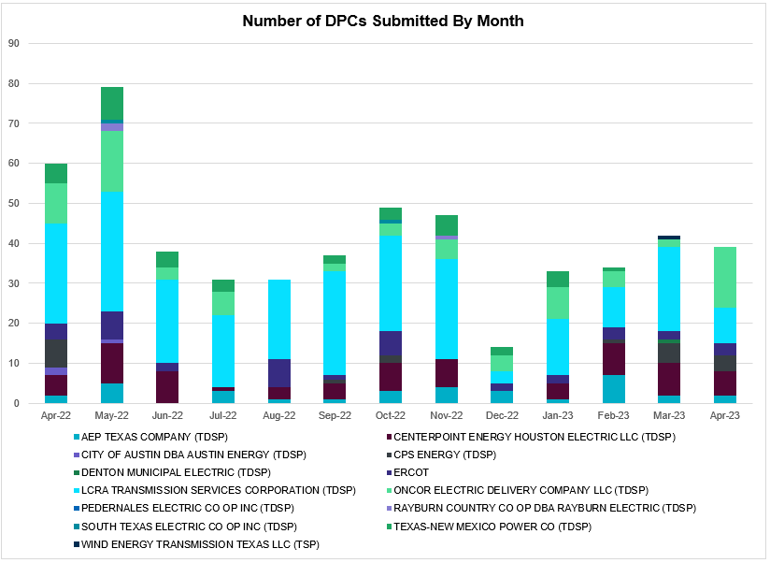

Transmission Operator | Number of DPCs
AEP TEXAS COMPANY (TDSP) | 2
BRAZOS ELECTRIC POWER CO OP INC (TDSP) | 0
BROWNSVILLE PUBLIC UTILITIES BOARD (TDSP) | 1
BRYAN TEXAS UTILITIES (TDSP) | 0
CENTERPOINT ENERGY HOUSTON ELECTRIC LLC (TDSP) | 6
CITY OF AUSTIN DBA AUSTIN ENERGY (TDSP) | 0
CITY OF COLLEGE STATION (TDSP) | 0
CITY OF GARLAND (TDSP) | 0
CPS ENERGY (TDSP) | 4
DENTON MUNICIPAL ELECTRIC (TDSP) | 0
ELECTRIC TRANSMISSION TEXAS LLC (TDSP) | 0
ERCOT | 3
LCRA TRANSMISSION SERVICES CORPORATION (TDSP) | 9
LONE STAR TRANSMISSION LLC (TSP) | 0
ONCOR ELECTRIC DELIVERY COMPANY LLC (TDSP) | 15
PEDERNALES ELECTRIC CO OP INC (TDSP) | 0
RAYBURN COUNTRY CO OP DBA RAYBURN ELECTRIC (TDSP) | 0
SHARYLAND UTILITIES LP (TDSP) | 0
SOUTH TEXAS ELECTRIC CO OP INC (TDSP) | 0
TEXAS MUNICIPAL POWER AGENCY (TDSP) | 0
TEXAS-NEW MEXICO POWER CO (TDSP) | 0
WIND ENERGY TRANSMISSION TEXAS LLC (TSP) | 0

Appendix A: Real-Time Constraints
The following is a complete list of constraints activated in SCED. Full contingency descriptions can be found in the Standard Contingencies List located on the MIS secure site at Grid Generation Reliability Unit Commitment.

Year | Month of the Year | Contingency Name | Overloaded Element | From Station | To Station | Count of Days
2023 | 4 | SNATBEA8 | 6144__A | BSPRW | STASW | 28
2023 | 4 | SNATBEA8 | 6144__A | STASW | BSPRW | 28
2023 | 4 | DBIGKEN5 | HAMILT_MAVERI1_1 | MAVERICK | HAMILTON | 28
2023 | 4 | DBIGKEN5 | HAMILT_MAVERI1_1 | HAMILTON | MAVERICK | 28
2023 | 4 | BASE CASE | NE_LOB | n/a | n/a | 24
2023 | 4 | DBIGKEN5 | ESCOND_GANSO1_1 | ESCONDID | GANSO | 23
2023 | 4 | DBIGKEN5 | ESCOND_GANSO1_1 | GANSO | ESCONDID | 23
2023 | 4 | MMDSQAL5 | MDSSW_MR1L | MDSSW | MDSSW | 22
2023 | 4 | BASE CASE | N_TO_H | n/a | n/a | 20
2023 | 4 | SBWDDBM5 | LPLMK_LPLNE_1 | LPLMK | LPLNE | 19
2023 | 4 | SMDOPHR5 | G138_10B_1 | SEMINOLE | MAGNO_TN | 19
2023 | 4 | SVEAW_L5 | 6217__A | WLVSW | GAILS | 18
2023 | 4 | BASE CASE | BEARKT | n/a | n/a | 18
2023 | 4 | SSKYSB28 | 15081__Z | SMIDLAND | CONSW | 17
2023 | 4 | BASE CASE | WESTEX | n/a | n/a | 17
2023 | 4 | MCONMDS5 | 6051__A | QALSW | ODEHV | 17
2023 | 4 | SLOBSA25 | CATARI_PILONC1_1 | CATARINA | PILONCIL | 16
2023 | 4 | SALAN_28 | CELANE_KLEBER1_1 | CELANEBI | KLEBERG | 16
2023 | 4 | SLOBSA25 | CATARI_PILONC1_1 | PILONCIL | CATARINA | 16
2023 | 4 | SGARBAT8 | 15010__B | BLISS | ESTILES | 15
2023 | 4 | MCONQAL5 | 6471__A | MGSES | MCDLD | 15
2023 | 4 | SCT2CAR8 | HAMILT_MAVERI1_1 | HAMILTON | MAVERICK | 15
2023 | 4 | SCT2CAR8 | HAMILT_MAVERI1_1 | MAVERICK | HAMILTON | 15
2023 | 4 | BASE CASE | VALEXP | n/a | n/a | 14
2023 | 4 | BASE CASE | MCCAMY | n/a | n/a | 13
2023 | 4 | BASE CASE | NELRIO | n/a | n/a | 13
2023 | 4 | MMDSQAL5 | MDSSW_MR1H | MDSSW | MDSSW | 13
2023 | 4 | MCONLNG5 | 6095__D | LMESA | JPPOI | 13
2023 | 4 | DCRLLSW5 | 589_E_1 | LWVTI | LWSVS | 13
2023 | 4 | MHARNED5 | BURNS_RIOHONDO_1 | RIOHONDO | MV_BURNS | 12
2023 | 4 | SN_SLON5 | LASPUL_RAYMND1_1 | LASPULGA | RAYMND2 | 12
2023 | 4 | SCRMSAR8 | CONCHO_VRBS1_1 | CONCHO | VRBS | 11
2023 | 4 | SMADSAP8 | MADDUX_SAPOWE2_1 | MADDUX | SAPOWER | 11
2023 | 4 | DLEGOUT5 | 50__A | BBSES | JEWET | 10
2023 | 4 | BASE CASE | HHGTOM_1 | HHGT | OMEGA | 10
2023 | 4 | SN_SLON5 | MV_YUT_RAYMND1_1 | RAYMND2 | MV_YUTT | 10
2023 | 4 | SBIGTWI5 | HAMILT_MAVERI1_1 | HAMILTON | MAVERICK | 10
2023 | 4 | SLOBSA25 | LARDVN_LASCRU1_1 | LARDVNTH | LASCRUCE | 10
2023 | 4 | SLOBSA25 | ASHERT_CATARI1_1 | CATARINA | ASHERTON | 10
2023 | 4 | SLOBSA25 | ASHERT_CATARI1_1 | ASHERTON | CATARINA | 10
2023 | 4 | SCARFRI8 | ATSO_SONR1_1 | SONR | ATSO | 9
2023 | 4 | MRESMCM8 | RINCON_WHITE_2_1 | WHITE_PT | RINCON | 9
2023 | 4 | MMGSCON5 | 6471__A | MGSES | MCDLD | 9
2023 | 4 | SKEYWLV8 | 15060__B | VEALMOOR | KOCHTAP | 9
2023 | 4 | SCMNCPS5 | 651__B | CMNSW | CMNTP | 9
2023 | 4 | SCT2CAR8 | ESCOND_GANSO1_1 | GANSO | ESCONDID | 8
2023 | 4 | DBIGKEN5 | TREADW_YELWJC1_1 | TREADWEL | YELWJCKT | 8
2023 | 4 | SLP3LPL9 | LPLER_LPLMK_1 | LPLMK | LPLER | 8
2023 | 4 | DKG_NB_5 | BCVLY_03_A | BCV | LY | 8
2023 | 4 | SKLELOY8 | LOYOLA_69_1 | LOYOLA | LOYOLA | 8
2023 | 4 | DSALKLN5 | 630__B | KLNSW | HHSTH | 7
2023 | 4 | MDKLRGP5 | 651__B | CMNSW | CMNTP | 7
2023 | 4 | DCAGCI58 | 255T279_1 | PIPECR | MEDILA | 7
2023 | 4 | XLOB258 | PAWNEE_TANGO1_1 | TANGO | PAWNEE | 7
2023 | 4 | SBIGTWI5 | TREADW_YELWJC1_1 | TREADWEL | YELWJCKT | 7
2023 | 4 | DVICDUP8 | NCARBI_PV_TAP1_1 | NCARBIDE | PV_TAP | 6
2023 | 4 | DSALHUT5 | 270__A | KNBSW | TMPSW | 6
2023 | 4 | SKOCBUZ8 | 6217__A | WLVSW | GAILS | 6
2023 | 4 | SQALODE5 | 6059__B | CONSW | MDSSW | 6
2023 | 4 | DMGSBTR5 | 6036__A | TKWSW | MGSES | 6
2023 | 4 | DVICDUP8 | NCARBI_PV_TAP1_1 | PV_TAP | NCARBIDE | 6
2023 | 4 | DBRNSTR8 | D3_G3_1 | D3 | G3 | 6
2023 | 4 | DPHRAL58 | G138_10B_1 | SEMINOLE | MAGNO_TN | 6
2023 | 4 | XBGL88 | BISON_STRS1_1 | BISON | STRS | 5
2023 | 4 | SDC_RAI8 | VALEXP | n/a | n/a | 5
2023 | 4 | SFORYEL8 | HEXT_MASONS1_1 | HEXT | MASONSW | 5
2023 | 4 | SBE2ASH8 | TURTLECK_WCRYS_1 | WCRYSTS | TURTLCRK | 5
2023 | 4 | DCPSST58 | 651__B | CMNSW | CMNTP | 5
2023 | 4 | SBE2ASH8 | TURTLECK_WCRYS_1 | TURTLCRK | WCRYSTS | 5
2023 | 4 | SW_GODE5 | 15060__B | VEALMOOR | KOCHTAP | 5
2023 | 4 | SFTWW_D8 | WD_RDWELLS_1 | W_DENT | RDWELLS | 5
2023 | 4 | SN_SAJO5 | MV_YUT_RAYMND1_1 | RAYMND2 | MV_YUTT | 5
2023 | 4 | SSKYSB28 | 15010__B | BLISS | ESTILES | 5
2023 | 4 | DBWNAMO5 | 134T429_1 | SAPOWER | SCHKAD | 4
2023 | 4 | SBIGTWI5 | ESCOND_GANSO1_1 | GANSO | ESCONDID | 4
2023 | 4 | DELMSAN5 | PAWNEE_SPRUCE_1 | PAWNEE | CALAVERS | 4
2023 | 4 | MCONLNG5 | 15010__B | BLISS | ESTILES | 4
2023 | 4 | SCRTEIL8 | 15010__B | BLISS | ESTILES | 4
2023 | 4 | DWLDSCO5 | 15060__B | VEALMOOR | KOCHTAP | 4
2023 | 4 | MEABBOG8 | CO_PL_84_A | PL | CO | 4
2023 | 4 | MHARNED5 | HAINE__LA_PAL1_1 | LA_PALMA | HAINE_DR | 4
2023 | 4 | SWCSAN8 | LAN_CT_PAVLOV1_1 | LAN_CTY | PAVLOV | 4
2023 | 4 | DAUSSND5 | SNDSW_MR1H | SNDSW | SNDSW | 4
2023 | 4 | DNAVOUT5 | 50__A | BBSES | JEWET | 4
2023 | 4 | SGRICOL5 | PAWNEE_TANGO1_1 | TANGO | PAWNEE | 4
2023 | 4 | SSTLEIN8 | CRTVLE_EINSTEN_1 | EINSTEIN | CRTRVLLE | 4
2023 | 4 | SGARBAT8 | RKYROAD_STILES_1 | RCKYROAD | STILES | 4
2023 | 4 | SEILPCT8 | 15010__B | BLISS | ESTILES | 4
2023 | 4 | DMGSBIT5 | 6036__A | TKWSW | MGSES | 4
2023 | 4 | DELMSAN5 | PAWNEE_SPRUCE_1 | CALAVERS | PAWNEE | 4
2023 | 4 | SOWLBIG8 | PHBL_T_STRS1_1 | STRS | PHBL_TAP | 4
2023 | 4 | BASE CASE | PNHNDL | n/a | n/a | 4
2023 | 4 | DRNS_TB5 | THWZEN71_A | ZEN | THW | 4
2023 | 4 | DCAGCO58 | 583T583_1 | BANDER | MASOCR | 3
2023 | 4 | SPH2ATT8 | G138_5_1 | ATTWATER | PHR | 3
2023 | 4 | SOWLBIG8 | BISON_STRS1_1 | BISON | STRS | 3
2023 | 4 | DSCOTKW5 | 15060__B | VEALMOOR | KOCHTAP | 3
2023 | 4 | SLARLA58 | LARDVN_LASCRU1_1 | LARDVNTH | LASCRUCE | 3
2023 | 4 | SFTLMES8 | PALOUS_WOLFCA1_1 | PALOUSE | WOLFCAMP | 3
2023 | 4 | DSALHUT5 | 1710__C | BELCNTY | SALSW | 3
2023 | 4 | DCPSST58 | 651__C | CMNTP | SHILO | 3
2023 | 4 | SN_SLON5 | ARMSTR_LOYOLA1_1 | ARMSTRON | LOYOLA | 3
2023 | 4 | XLOB58 | ASHERT_CATARI1_1 | ASHERTON | CATARINA | 3
2023 | 4 | SN_SLON5 | BURNS_RIOHONDO_1 | RIOHONDO | MV_BURNS | 3
2023 | 4 | MBOGTID8 | CO_PL_84_A | PL | CO | 3
2023 | 4 | DKG_NB_5 | JFSSC_06_A | JFS | SC | 3
2023 | 4 | DWHILON5 | PAWNEE_TANGO1_1 | TANGO | PAWNEE | 3
2023 | 4 | SGRICOL5 | CALLIC_LON_HI1_1 | LON_HILL | CALLICOA | 3
2023 | 4 | SBRACAL8 | D3_G3_1 | D3 | G3 | 3
2023 | 4 | MCONLNG5 | HARGRO_TWINBU1_1 | TWINBU | HARGROVE | 3
2023 | 4 | SSIEMOL8 | LARDVN_LASCRU1_1 | LARDVNTH | LASCRUCE | 3
2023 | 4 | DBWNAMO5 | PALOUS_WOLFCA1_1 | PALOUSE | WOLFCAMP | 3
2023 | 4 | SW_GODE5 | 6095__D | LMESA | JPPOI | 3
2023 | 4 | SALAN_28 | CELANE_N_SHAR1_1 | N_SHARPE | CELANEBI | 3
2023 | 4 | DSALGA58 | GABRIE_AT1 | GABRIE | GABRIE | 3
2023 | 4 | DCENRI25 | PAWNEE_TANGO1_1 | TANGO | PAWNEE | 3
2023 | 4 | DMTSCOS5 | 6437__F | SCRCV | KNAPP | 3
2023 | 4 | DELMSAN5 | BIG_FO_PLEASA1_1 | BIG_FOOT | PLEASANT | 3
2023 | 4 | XLOB58 | ASHERT_CATARI1_1 | CATARINA | ASHERTON | 3
2023 | 4 | MMGSCON5 | HARGRO_TWINBU1_1 | TWINBU | HARGROVE | 3
2023 | 4 | DCAGCO58 | 656T656_1 | KENDAL | BERGHE | 3
2023 | 4 | XBOM358 | BOMSW_MR1H | BOMSW | BOMSW | 3
2023 | 4 | SECRDMT8 | 6215__A | BCKSW | CGRSW | 3
2023 | 4 | DBWNAMO5 | 15010__B | BLISS | ESTILES | 2
2023 | 4 | SPOMNED5 | FREER_LOBO1_1 | LOBO | FREER | 2
2023 | 4 | SBIGMO38 | DILLEY_DILLY1_1 | DILLEYSW | DILLY | 2
2023 | 4 | DVICDUP8 | GREENL_WEAVER1_1 | GREENLK | WEAVERRD | 2
2023 | 4 | DBCETMP5 | MCN_MCN_1 | MCNEIL_ | MCNEIL | 2
2023 | 4 | DJACALV8 | MYRA_VAL_1 | MYRA | VALYVIEW | 2
2023 | 4 | DLWSRNK5 | 587__A | ARGYL | LWSVH | 2
2023 | 4 | DVICEDN8 | BLESSI_PALACI1_1 | BLESSING | PALACIOS | 2
2023 | 4 | SBGLTWI8 | CONCHO_SANW0_1 | CONCHO | SANW | 2
2023 | 4 | DCOLFA59 | PAWNEE_TANGO1_1 | TANGO | PAWNEE | 2
2023 | 4 | SLCRCRA8 | 1327T440_1 | SBYSW | SKYWES | 2
2023 | 4 | SBE2ASH8 | CARIZOSPG_BEVO_1 | CARIZOS | BEVO | 2
2023 | 4 | DCENREV5 | PAWNEE_TANGO1_1 | TANGO | PAWNEE | 2
2023 | 4 | DLWSRNK5 | WD_RDWELLS_1 | W_DENT | RDWELLS | 2
2023 | 4 | SPOCTE28 | WD_RDWELLS_1 | W_DENT | RDWELLS | 2
2023 | 4 | DBIGKEN5 | YELWJCKT_PS_1 | YELWJCKT | YELWJCKT | 2
2023 | 4 | STANPAW5 | CALLIC_LON_HI1_1 | LON_HILL | CALLICOA | 2
2023 | 4 | DCALBEC8 | E1_R2_1 | R2 | E1 | 2
2023 | 4 | DBRNSTR8 | F1_O9_1 | F1 | SUTHRLND | 2
2023 | 4 | DSTPANS5 | PAWNEE_TANGO1_1 | TANGO | PAWNEE | 2
2023 | 4 | SWHILON5 | PAWNEE_TANGO1_1 | TANGO | PAWNEE | 2
2023 | 4 | DBWNAMO5 | REDCREEK_T2L | REDCREEK | REDCREEK | 2
2023 | 4 | SKINODE5 | 421T441_1 | LCRANE | MOTORM | 2
2023 | 4 | DCC3_NED | ASHERT_CATARI1_1 | ASHERTON | CATARINA | 2
2023 | 4 | SREVDIL8 | ASHERT_CATARI1_1 | ASHERTON | CATARINA | 2
2023 | 4 | DKG_NB_5 | BCVPSA03_A | PSA | BCV | 2
2023 | 4 | DDEESTR8 | F2_11_1 | F2 | KENEDSW | 2
2023 | 4 | DLONWEI8 | KOCH_H_LON_HI1_1 | KOCH_HF | LON_HILL | 2
2023 | 4 | DBWNAMO5 | SAPOWE_SAST1_1 | SAST | SAPOWER | 2
2023 | 4 | SW_GW_L5 | 15060__B | VEALMOOR | KOCHTAP | 2
2023 | 4 | MMGSCON5 | 6095__D | LMESA | JPPOI | 2
2023 | 4 | SBAKCED5 | 6095__D | LMESA | JPPOI | 2
2023 | 4 | DBSPSGM8 | 6471__A | MGSES | MCDLD | 2
2023 | 4 | MMDLFLC5 | 6471__A | MGSES | MCDLD | 2
2023 | 4 | DDILCOT8 | ASHERT_CATARI1_1 | ASHERTON | CATARINA | 2
2023 | 4 | DDILCOT8 | ASHERT_CATARI1_1 | CATARINA | ASHERTON | 2
2023 | 4 | SESCGAN8 | CATARI_PILONC1_1 | PILONCIL | CATARINA | 2
2023 | 4 | DBWNAMO5 | COKEST_REDCRE1_1 | REDCREEK | COKESTRE | 2
2023 | 4 | MCONLNG5 | CONCHO_SANW0_1 | CONCHO | SANW | 2
2023 | 4 | DDEESTR8 | D3_G3_1 | G3 | D3 | 2
2023 | 4 | DBIGKEN5 | GANSO_MAVERI1_1 | MAVERICK | GANSO | 2
2023 | 4 | DCAGTA58 | H3_K0_1 | K0 | H3 | 2
2023 | 4 | SHOLWES8 | HOLLY4_SOUTH_1_1 | HOLLY4 | SOUTH_SI | 2
2023 | 4 | MCONLNG5 | JERRY_PUMPJA1_1 | PUMPJACK | JERRY | 2
2023 | 4 | DWHILON5 | LASPUL_RAYMND1_1 | LASPULGA | RAYMND2 | 2
2023 | 4 | DSNG_TB5 | THWZEN71_A | ZEN | THW | 2
2023 | 4 | XFL2C58 | 6471__A | MGSES | MCDLD | 2
2023 | 4 | SCMNCPS5 | 651__C | CMNTP | SHILO | 2
2023 | 4 | MCONLNG5 | HARGRO_PUMPJA1_1 | HARGROVE | PUMPJACK | 2
2023 | 4 | SMCEESK8 | MKLT_TRNT1_1 | TRNT | MKLT | 2
2023 | 4 | SBCESND5 | 421__A | BCESW | SNDSW | 2
2023 | 4 | SVEAW_L5 | 6217__B | GAILS | KEYSB | 2
2023 | 4 | MCONLNG5 | 6471__A | MGSES | MCDLD | 2
2023 | 4 | SBE2ASH8 | ASHERT_LIPTON1_1 | ASHERTON | LIPTON | 2
2023 | 4 | DBWNAMO5 | BIGLAK_RUSSEK1_1 | BIGLAKE | RUSSEKST | 2
2023 | 4 | DDEESTR8 | D3_G3_1 | D3 | G3 | 2
2023 | 4 | XMCL85 | ESCOND_GANSO1_1 | GANSO | ESCONDID | 2
2023 | 4 | SREVDIL8 | ASHERT_CATARI1_1 | CATARINA | ASHERTON | 2
2023 | 4 | DWHILON5 | CATARI_PILONC1_1 | PILONCIL | CATARINA | 1
2023 | 4 | DGRSLNC5 | ESTES_PECAN_1_1 | PECAN_BY | ESTES | 1
2023 | 4 | SDIMBEV8 | HAMILT_MAVERI1_1 | HAMILTON | MAVERICK | 1
2023 | 4 | XHH2G58 | HHGT_T1H | HHGT | HHGT | 1
2023 | 4 | SBRACAL8 | P2_U2_1 | BRAUNIG | P2 | 1
2023 | 4 | MMGSCON5 | PALOUS_WOLFCA1_1 | PALOUSE | WOLFCAMP | 1
2023 | 4 | SLONLON8 | PAWNEE_TANGO1_1 | TANGO | PAWNEE | 1
2023 | 4 | DWPWFCK5 | STPWAP39_1 | STP | WAP | 1
2023 | 4 | DAJOSTE5 | VERTRE_WESLAU1_1 | VERTREES | WESLAU | 1
2023 | 4 | DSCOFAR5 | 6216__B | WLVSW | SHRNE | 1
2023 | 4 | XBRK89 | 6830__B | CRDSW | OLNEY | 1
2023 | 4 | SW_2ASH8 | ASHERT_CATARI1_1 | ASHERTON | CATARINA | 1
2023 | 4 | SBENS_M8 | BENTS_FRTER_1C_1 | S_MISSIN | RAILROAD | 1
2023 | 4 | DVICDUP8 | BLESSI_PALACI1_1 | BLESSING | PALACIOS | 1
2023 | 4 | XLOB58 | CATARI_PILONC1_1 | CATARINA | PILONCIL | 1
2023 | 4 | SSCHTWI8 | CONCHO_SANW0_1 | CONCHO | SANW | 1
2023 | 4 | SWOLPAL8 | CONCHO_SANW0_1 | CONCHO | SANW | 1
2023 | 4 | XNED358 | FREER_LOBO1_1 | LOBO | FREER | 1
2023 | 4 | SFTWTEA8 | WD_RDWELLS_1 | W_DENT | RDWELLS | 1
2023 | 4 | SW_BBAT8 | 2585_1 | DOWNIES | MOORE | 1
2023 | 4 | DSWECCR5 | 6036__A | TKWSW | MGSES | 1
2023 | 4 | XFL2C58 | 6095__D | LMESA | JPPOI | 1
2023 | 4 | DGRSPKR5 | 6377__A | BRTSW | ORANS | 1
2023 | 4 | MCONQAL5 | 6471__C | MGSES | NAVIG | 1
2023 | 4 | MDBWRGP5 | 651__B | CMNSW | CMNTP | 1
2023 | 4 | SSWDMGS8 | 669T669_1 | ESKSW | MCELMU | 1
2023 | 4 | SN_SLON5 | ARMSTR_MV_YUT1_1 | MV_YUTT | ARMSTRON | 1
2023 | 4 | DSWECBF5 | BLUF_C_MULBER1_1 | MULBERRY | BLUF_CRK | 1
2023 | 4 | DFORKIR8 | C4_L2_1 | C4 | L2 | 1
2023 | 4 | SRUSBIG8 | CONCHO_SANW0_1 | CONCHO | SANW | 1
2023 | 4 | XBAL89 | CONCHO_VRBS1_1 | CONCHO | VRBS | 1
2023 | 4 | DBRNSTR8 | F2_11_1 | F2 | KENEDSW | 1
2023 | 4 | SHASTNN8 | G138_8B_1 | HDNLAKES | LEAGCITY | 1
2023 | 4 | SWHILON5 | LASPUL_RAYMND1_1 | LASPULGA | RAYMND2 | 1
2023 | 4 | XLO2N58 | LON_HI_SERDEV1_1 | LON_HILL | LON_HILL | 1
2023 | 4 | DBIGKEN5 | MADDUX_TREADW1_1 | MADDUX | TREADWEL | 1
2023 | 4 | SGODKAT5 | NORMAN_PETTUS1_1 | PETTUS | NORMANNA | 1
2023 | 4 | DBRNSTR8 | P2_U2_1 | BRAUNIG | P2 | 1
2023 | 4 | SCRTEIL8 | RKYROAD_STILES_1 | RCKYROAD | STILES | 1
2023 | 4 | SBATPEA8 | 2585_1 | DOWNIES | MOORE | 1
2023 | 4 | DCAGCO58 | 392T392_1 | MASOCR | PIPECR | 1
2023 | 4 | MDKLRGP5 | 651__C | CMNTP | SHILO | 1
2023 | 4 | SBISMI5 | BI_WAP50_A | WAP | BI | 1
2023 | 4 | SWHILON5 | CALLIC_LON_HI1_1 | LON_HILL | CALLICOA | 1
2023 | 4 | SW_2ASH8 | CATARI_PILONC1_1 | CATARINA | PILONCIL | 1
2023 | 4 | SKINODE5 | CROSSO_NORTMC1_1 | NORTMC | CROSSOVE | 1
2023 | 4 | DDEESTR8 | D3_U2_1 | BRAUNIG | D3 | 1
2023 | 4 | DNUEGIL8 | GILA_MAYO1_1 | GILA | MAYO | 1
2023 | 4 | DNUEGIL8 | GILA_MAYO1_1 | MAYO | GILA | 1
2023 | 4 | MCEBRIO5 | STEWAR_VERTRE1_1 | STEWART | VERTREES | 1
2023 | 4 | XLOB258 | STEWAR_VERTRE1_1 | STEWART | VERTREES | 1
2023 | 4 | DKENCA58 | 255T279_1 | PIPECR | MEDILA | 1
2023 | 4 | DSCOTKW5 | 6215__A | BCKSW | CGRSW | 1
2023 | 4 | DCC3_NED | BURNS_RIOHONDO_1 | RIOHONDO | MV_BURNS | 1
2023 | 4 | SBRACAL8 | C3_F1_1 | C3 | F1 | 1
2023 | 4 | DDILCOT8 | CATARI_PILONC1_1 | PILONCIL | CATARINA | 1
2023 | 4 | SMCEESK8 | ESKSW_TRNT1_1 | ESKSW | TRNT | 1
2023 | 4 | SBRACAL8 | F2_11_1 | F2 | KENEDSW | 1
2023 | 4 | MSTILA_8 | LA_PAL_VCAVAZ1_1 | LA_PALMA | VCAVAZOS | 1
2023 | 4 | SMCEESK8 | MERK_MKLT1_1 | MKLT | MERK | 1
2023 | 4 | SWHILON5 | MV_YUT_RAYMND1_1 | RAYMND2 | MV_YUTT | 1
2023 | 4 | DELMSAN5 | NORMAN_PETTUS1_1 | PETTUS | NORMANNA | 1
2023 | 4 | DTWIDIV5 | PALOUS_WOLFCA1_1 | PALOUSE | WOLFCAMP | 1
2023 | 4 | SMV_PAR8 | RIOHND_ERIOHND_1 | MV_RIOHO | RIOHONDO | 1
2023 | 4 | DTWIDIV5 | STMBOA_WINT1_1 | STMBOAT | WINT | 1
2023 | 4 | DWPWFWP5 | STPWAP39_1 | STP | WAP | 1
2023 | 4 | SDOWMOO8 | UVALDE_W_BATE1_1 | UVALDE | W_BATESV | 1
2023 | 4 | SWHILON5 | WHITE_PT_XFH1 | WHITE_PT | WHITE_PT | 1
2023 | 4 | SSKYSB28 | 15080__Z | CONSW | CTFLD | 1
2023 | 4 | SMCDBSP8 | 6471__A | MGSES | MCDLD | 1
2023 | 4 | SRICGRS8 | 6840__B | NVKSW | ANARN | 1
2023 | 4 | MASHDIL8 | ASHERT_CATARI1_1 | CATARINA | ASHERTON | 1
2023 | 4 | BASE CASE | CATARI_PILONC1_1 | PILONCIL | CATARINA | 1
2023 | 4 | DDILCOT8 | CATARI_PILONC1_1 | CATARINA | PILONCIL | 1
2023 | 4 | SVICCO28 | COLETO_VICTOR2_1 | COLETO | VICTORIA | 1
2023 | 4 | DTWIBGL8 | CONCHO_SANW0_1 | CONCHO | SANW | 1
2023 | 4 | DCENFAL5 | FREER_LOBO1_1 | LOBO | FREER | 1
2023 | 4 | DSALTM58 | GABRIE_AT1 | GABRIE | GABRIE | 1
2023 | 4 | SN_SLON5 | HAINE__LA_PAL1_1 | LA_PALMA | HAINE_DR | 1
2023 | 4 | DWHILON5 | MV_YUT_RAYMND1_1 | RAYMND2 | MV_YUTT | 1
2023 | 4 | DCENRI35 | PAWNEE_TANGO1_1 | TANGO | PAWNEE | 1
2023 | 4 | MCONQAL5 | SAMATH_SANW1_1 | SANW | SAMATHIS | 1
2023 | 4 | MCEBRIO5 | VERTRE_WESLAU1_1 | VERTREES | WESLAU | 1
2023 | 4 | DTWIDIV5 | 134T429_1 | SAPOWER | SCHKAD | 1
2023 | 4 | SW_GODE5 | 15060__A | KOCHTAP | BUZSW | 1
2023 | 4 | SSKYSB28 | 421T441_1 | LCRANE | MOTORM | 1
2023 | 4 | DCAGCI58 | 460T460_1 | MEDILA | W1 | 1
2023 | 4 | MDKLRGP5 | 506__A | SAMSW | FBRSW | 1
2023 | 4 | SLYTBIG9 | BIG_FO_PLEASA1_1 | BIG_FOOT | PLEASANT | 1
2023 | 4 | SREVDIL8 | CATARI_PILONC1_1 | CATARINA | PILONCIL | 1
2023 | 4 | DBIGKEN5 | CONCHO_VRBS1_1 | CONCHO | VRBS | 1
2023 | 4 | SBAKCED5 | CROSSO_PALOUS1_1 | PALOUSE | CROSSOVE | 1
2023 | 4 | SFTLMES8 | DINNY_IRAAN1_1 | DINNY | IRAAN | 1
2023 | 4 | BASE CASE | MIDGT_90_A | GT | MID | 1
2023 | 4 | SVANRAY8 | RAYBURN_69_2 | RAYBURN | RAYBURN | 1
2023 | 4 | MDKLRGP5 | 505__B | FBRSW | THSES | 1
2023 | 4 | DMBDRKC5 | 651__B | CMNSW | CMNTP | 1
2023 | 4 | MDBCRGP5 | 651__C | CMNTP | SHILO | 1
2023 | 4 | DCAGCI58 | 656T656_1 | KENDAL | BERGHE | 1
2023 | 4 | MASHDIL8 | ASHERT_CATARI1_1 | ASHERTON | CATARINA | 1
2023 | 4 | DSALTM58 | BELCNTY_XFMR | BELCNTY | BELCNTY | 1
2023 | 4 | SREVDIL8 | CATARI_PILONC1_1 | PILONCIL | CATARINA | 1
2023 | 4 | DAMOBOW5 | CONCHO_VRBS1_1 | CONCHO | VRBS | 1
2023 | 4 | SBRACAL8 | F1_O9_1 | F1 | SUTHRLND | 1
2023 | 4 | SLOBSA25 | FREER_LOBO1_1 | LOBO | FREER | 1
2023 | 4 | SFORYEL8 | HEXT_YELWJC1_1 | YELWJCKT | HEXT | 1
2023 | 4 | SLOBSA25 | NLARSW_PILONC1_1 | NLARSW | PILONCIL | 1
2023 | 4 | SKINODE5 | PALOUS_WOLFCA1_1 | PALOUSE | WOLFCAMP | 1
2023 | 4 | DKENCA58 | V3_W1_1 | W1 | V3 | 1
2023 | 4 | SBAKCED5 | 15010__B | BLISS | ESTILES | 1
2023 | 4 | DSALHUT5 | 1710__E | SALSW | SALDS | 1
2023 | 4 | SBATPAL8 | 2585_1 | DOWNIES | MOORE | 1
2023 | 4 | DSWETKW5 | 6036__A | TKWSW | MGSES | 1
2023 | 4 | XBGL88 | BIGLAK_PHBL_T1_1 | PHBL_TAP | BIGLAKE | 1
2023 | 4 | DWHILON5 | CALLIC_LON_HI1_1 | LON_HILL | CALLICOA | 1

Current Wind Generation Record: 27,044 MW on 05/29/2022 at 22:36 | Current Wind Penetration Record: 69.15% on 04/10/2022 at 01:43 Current Solar Generation Record: 12,757 MW on 04/30/2023 at 12:03 | Current Solar Penetration Record: 32.93% on 04/30/2023 at 09:24
This is the hourly integrated peak demand as published in the ERCOT D&E report.
All DC Tie Curtailments are posted publicly on the ERCOT Market Information System. See that posting for additional details for the event(s) in question.
See DC Tie Operating Procedure (http://www.ercot.com/mktrules/guides/procedures) for more details.

