

System Planning

**Monthly Status Report**

Report Highlights

* ERCOT is currently reviewing proposed transmission improvements with a total estimated cost of $527.00 million as of April 30, 2023.
* Transmission Projects endorsed in 2023 total $555.15 million as of April 30, 2023.
* All projects (in engineering, routing, licensing, and construction) total approximately $11.643 billion[1] as of February 1, 2023.
* Transmission Projects energized in 2023 total approximately $149 million[2] (as of February 1, 2023).

Regional Planning Group Reviews

RPG Projects under Review:

* Oncor has submitted the Peck to Driver 138 kV Line Project (RPG Project ID: 22RPG047). This is a Tier 2 project that is estimated to cost $36.20 million. This project is currently under ERCOT’s independent review.
* CPS has submitted the San Antonio South Reliability Project (RPG Project ID: 22RPG048). This is a Tier 1 project that is estimated to cost $281.00 million. This project is currently under ERCOT’s independent review.
* AEPSC has submitted the Asherton to Uvalde 138-kV Conversion Project (RPG Project ID: 23RPG007). This is a Tier 3 project that is estimated to cost $56.00 million. This project is currently in the RPG comment period.
* AEPSC has submitted the Fort Stockton Plant to Lynx 138-kV Line Rebuild Project (RPG Project ID: 23RPG008). This is a Tier 3 project that is estimated to cost $44.90 million. This project is currently in the RPG comment period.
* Oncor has submitted the Spraberry to Polecat 138-kV Line Rebuild Project (RPG Project ID: 23RPG009). This is a Tier 3 project that is estimated to cost $56.90 million. This project is currently in the RPG comment period.
* Oncor has submitted the Big Spring West to Stanton East 138-kV Line Rebuild Project (RPG Project ID: 23RPG010). This is a Tier 3 project that is estimated to cost $52.00 million. This project is currently in the RPG comment period.

RPG Project Reviews Completed in 2023:

|  |  |  |  |  |  |
| --- | --- | --- | --- | --- | --- |
| RPG Project ID | RPG Project Name | Submitted Entity | Tier | Estimated Cost  ($ Millions) | Review Completion Month |
| 22RPG043 | Haskell to Munday 69 kV Line Rebuild Project | AEPSC | Reclassified from Tier 3 to Tier 4 per Protocol | 31.00 | January |
| 22RPG044 | Escondido to Hamilton Road 138 kV Line Rebuild Project | AEPSC | Reclassified from Tier 3 to Tier 4 per Protocol | 73.50 | January |
| 22RPG045 | Yucca to Moss 138 kV Line Project | Oncor | Reclassified from Tier 3 to Tier 4 per Protocol | 60.70 | January |
| 22RPG046 | Peppervine to Temple 69 kV Line Conversion Project | Oncor | Reclassified from Tier 3 to Tier 4 per Protocol | 36.00 | January |
| 22RPG026 | Wimberley Loop Project | PEC | Tier 2 | 61.93 | February |
| 23RPG001 | Bessel to Falfurrias 138 kV Line Rebuild Project | AEPSC | Reclassified from Tier 3 to Tier 4 per Protocol | 84.76 | February |
| 23RPG002 | Hamlin to Roby 69 kV Line Rebuild Project | AEPSC | Reclassified from Tier 3 to Tier 4 per Protocol | 33.00 | February |
| 23RPG003 | Eagle Ford Large Load Interconnection Project | GVEC | Tier 3 | 35.15 | March |
| 23RPG004 | Lockhart to Luling 69-kV Transmission Line Overhaul Project | LCRA TSC | Reclassified from Tier 3 to Tier 4 per Protocol | 33.50 | March |
| 23RPG005 | La Palma to Stewart Road Rebuild and Conversion to 138-kV Project | AEPSC | Reclassified from Tier 3 to Tier 4 per Protocol | 71.50 | March |
| 23RPG006 | North Lake 138 kV Switch Rebuild | Oncor | Reclassified from Tier 3 to Tier 4 per Protocol | 34.11 | March |

More information on current and past RPG projects can be found on the ERCOT MIS Secure (digital certificate required): https://mis.ercot.com/secure/data-products/grid/regional-planning

Past email communication on RPG projects can be found on the ERCOT listserv by signing up for the REGPLANGROUP list: <http://lists.ercot.com/scripts/wa-ERCOT.exe?A0=REGPLANGROUP>

Planning Model Activities

The short-term calendar of major planning model events is as follows:

* By May 30, 2023 23SSWG cases and TPIT will be posted
* By June 16, 2023 23SSWG Contingency definitions & Planning Data Dictionary will be posted

The following table shows interconnection projects that met Planning Guide section 6.9(1) and 6.9(2) and were modeled in the SSWG cases as a full model or as a simple model in accordance with Planning Guide section 6.9.



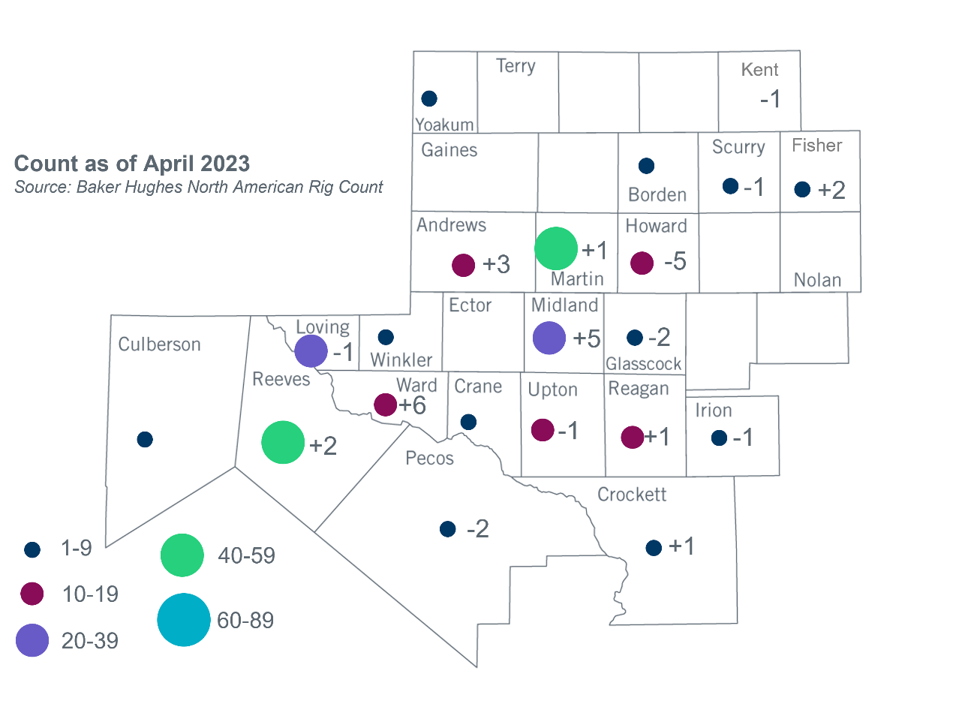Permian Basin Oil Rig Count[3]

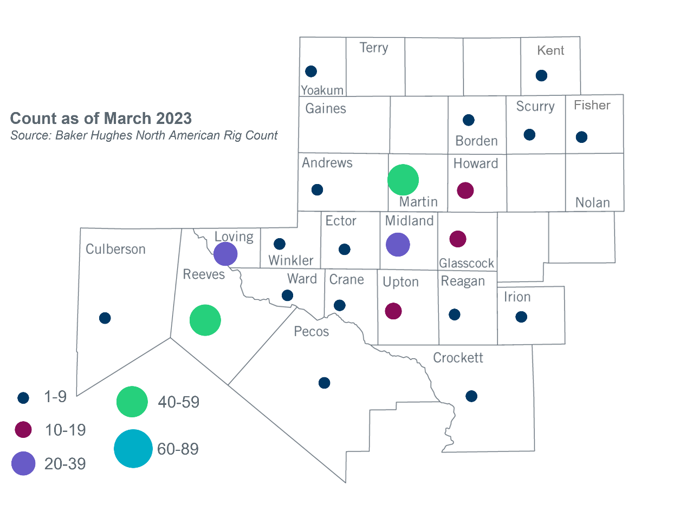

Other Notable Activities

* ERCOT presented the 2023 Regional Transmission Plan (RTP) assumptions update at the April RPG meeting.

1. Based on the Total Project Estimated Cost for all future projects listed in the Transmission Project Information and Tracking (TPIT) report. TPIT is updated three times each year based on information TSPs provide in Model on Demand (MOD) as specified in the ERCOT Steady State Working Group Procedure Manual. The latest TPIT is available at https://www.ercot.com/gridinfo/planning.
2. Based on the Total Project Estimated Cost for all completed projects with Projected In-Service Dates in 2023 listed in the TPIT.
3. +/- symbol indicates the increase or decrease from the previous month in oil rigs present in each county. There are 253 rigs, including an increase of 7 oil rigs, in the Permian Basin from March to April 2023.