PWG Meeting Notes – March 9th, 2023
Via WebEx 1:30 PM
Attendees:
Sam Pak - Oncor | Jordan Troublefield – ERCOT | Diana Rehfeldt - TNMP | Amar Khalifeh – ERCOT
Sheri Wiegand - TXUE | Angela Ghormley – Calpine | Randy Roberts - ERCOT
Kathy Scott - CNP | Eric Lotter – Grid Monitor | Sam Cannon - ERCOT
Steve Pliler - TXUE | Calvin Opheim - ERCOT | Bill Snyder - AEP

- Meeting notes for January 17th were reviewed and approved with no revisions.

- 2023 Annual Validation Kickoff
- Sam Cannon provided context on the kickoff of the 2023 ERCOT Annual Validation. Lists of applicable ESIs were provided to the TDUs via MarkeTrak on 2/23/23. ERCOT will soon be distributing the validations. Sam Pak requested that the next ERCOT update include refreshed data in the Validation Status Matrix.

- Potential LPGRR to Revise Annual Validation Schedule
  - In the 1/17/23 PWG meeting it was decided to suspend 2024 residential and business validations due to competing priorities. Sam advised that the decision should be codified in the market. There was discussion of an “on behalf” approach through RMS in which PWG would draft the verbiage.
  - Kathy Scott referenced Section 18.4.3.1 of the ERCOT Nodal Protocols. Kathy suggested that a recommendation could be sent from RMS to TAC to temporarily suspend the validations.
  - Randy Roberts suggested including the recommendation in LPGRR 070 Sam will present the recommendation to RMS by referencing 18.4.3.1 and explaining the validation suspension reasoning. RMS can then consider presenting the recommendation to TAC. Jordan will confirm if the approach is correct and ask ERCOT Legal to review the revision to LPGRR 070 verbiage.

- IDR/AMS BUSLRG Updates from TDSPs
- Oncor – The count of 252 held steady from the previous update. Most of the remaining meters are EPS.
- AEP – Bill Snyder advised that the AEP count is unchanged and that most of the remaining meters are EPS. He also advised that 50-60 meters may not transition to BUSLRG and will remain BUSIDRRQ.
- CenterPoint – There was no change to the CenterPoint count. Kathy described a timeline that included development in May and testing in June. The worst-case scenario completion timeframe would be the end of July. Kathy confirmed that the changes will be on cycle.
- TNMP – There was no change to the TNMP count. Diana Rehfeldt advised that many of the remaining ESIs have premise access issues and that some ESIs will not be transitioning.

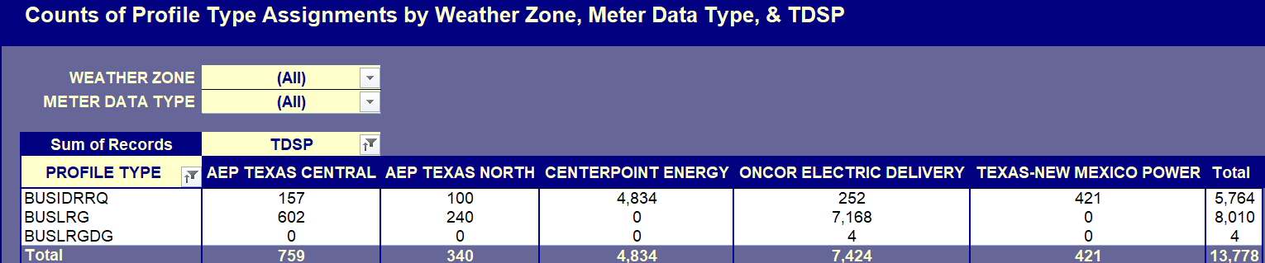

- LPGRR 070 – Discontinuation of IDR Meter Weather Sensitivity Process
  - LPGRR 070 aim is to discontinue the annual Weather Sensitivity (WS) process per market consensus especially given the vast majority of BUSIDRRQ ESIs have or will soon be converted to AMS daily settlement profiles (ie BUSLRG). Along with language to eliminate the WS processing, there was revised language to default BUSLRG profiles with the Non Weather Sensitivity (NWS) designation. However, currently, the Load Profiling Guide (LPG) does not recognize the combination of BUSLRG & NWS as a valid existing profile combination. New profiles would need to be created to accommodate the BUSLRG & NWS combination.
  - The justification of defaulting BUSLRG to NWS was based on historical data Randy Roberts provided which showed approx 85% of BUSIDRRQ profiles were identified as NWS for estimation purposes. Since essentially all BUSLRG were formerly BUSIDRRQ profiled, it is logical NWS should be the appropriate assignment.

    - 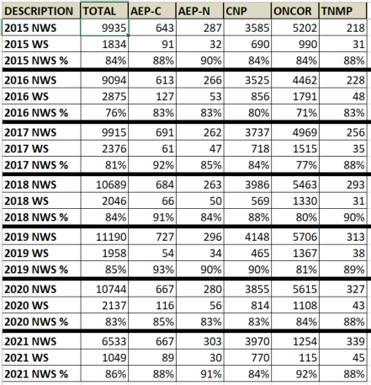
  - Randy provided context on the process that predated Weather Sensitivity (WS), advising that the Profile Decision Tree mandated the change to WS. Randy advised that for profiles in which WS will cease, the best estimation process would be to use the current WS classification.
  - In lieu of creating new profiles, Kathy stated that with language changes to Section 11 of the Protocols, BUSLRG and BUSLRGDG can be treated with the NWS estimation methodology with ERCOT’s backend process even though WS is assigned.
  - Sheri observed that WS is another level of estimation that comes into play only when there is no estimation data. The question was asked if WS should simply be eliminated. Randy said that elimination of WS would necessitate new profiles and a lot of work. Approximately 85% of ERCOT BUSIDRRQ profiles are NWS (see chart above)
  - The discontinuation proposal would not need WMS consideration due to minimal impact on wholesale volumes.
  - Sam expressed support for Kathy’s proposal. Randy recommended that ERCOT file the comments regarding the profile defaults to NWS. Randy offered to draft the verbiage and circulate among PWG leadership.

- Other Business
  - Additional context was provided regarding Protocols 18.4.3.1, as Kathy spoke about PUCT Order 36150 (Issues Related to the Disaster Resulting From Hurricane Ike). Kathy stated during Hurricane Ike, Centerpoint invoked Protocol 18.4.3.1 language to temporarily suspend AV processing thus laying precedence for suspending 2024 AV processing.

    - ERCOT Nodal Protocols: 18.4.3.1 (3) Validation Process:
      - “Any Market Participant may request temporary changes to the process for validating Load Profile IDs to address unusual circumstances. Such change requests shall be recommended by the appropriate TAC subcommittee and approved by TAC. Change requests as a result of an extreme event such as a hurricane or ice storm may be approved directly by TAC. Such requests, if approved by the TAC, shall be in effect only for the requested year.”

- Future Meeting Dates:
- Cancelled April 12^{th.}

- DRAFT Agenda for May 10th meeting:
  - 2023 Annual Validation
  - IDR/AMS BUSLRG Updates from TDSPs
  - Annual Validation Suspension via LPGRR 070
  - LPGRR Verbiage Review
  - Conversion of the Profile Decision Tree from Excel to Word format (LPGRR)

