# Q and A

1. 2021-832:  What situation(s) would the MVO reject code be used?  Is it only for IA or CR’s?

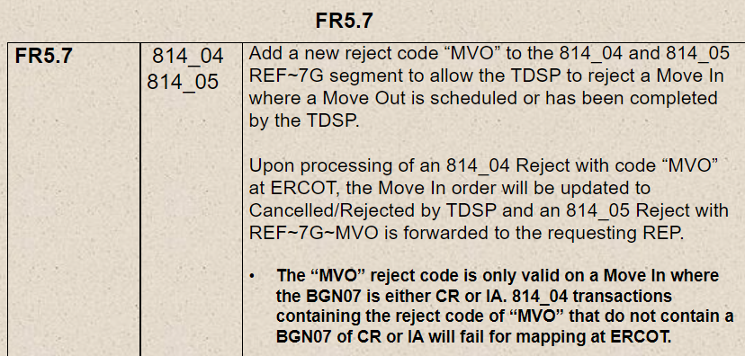

Answer – Yes, it would have to have the IA or CR code.

This reject would occur when a MVO has been submitted and scheduled prior to the Inadvertent.

1. 2021-830:
   1. FR6.5 and 6.13 – What is the difference between DCI and DIP?  Wouldn’t DCI only apply if it was a DIP?  Can we eliminate DCI and just use DIP as a reject code in both FR’s?

Answer – question no longer needed

* 1. FR6.12 – What situation would the TDPS use SOP as the reject code?    Transaction already worked?  TDSP already cancelled?  Other?

Answer –

SOP – unable to cancel due to order already cancelled or completed

Update SOP to – Subsequent Order Processed

Update Gray box for SOP – Rejected Due to Competing Transaction Already Pending, Scheduled or Completed

Question: what to use if the order that received the cancel is already cancelled?

Answer: A78

* 1. FR6.23 – How do TDSP’s treat a MVO to CSA when a new transaction is a MVI?  Do we reject MVO to CSA or the MVI?  Does one trump the other?

Answer – MVI trumps MVO

Example: 2 MVIs came in requesting the same day and both 814_03s were sent to the TDSP. TDSP schedules first MVI and rejects the second for NFI.

* 1. FR6.25 – What’s an example of reject code SCP (Schedule Conflict Pending)?

Answer – this is just removing MIMO and ERCOT/TDSP rules

1. Is 180 days still the furthest we can go back on tampering back billing?

Answer – It’s 150 days in the tariff.

1. TXSETCC 2021-836 – Punctuation marks in name fields (various transactions)
2. TXSETCC 2022-837 – NFI (Not First In) rejection code in the 814_25
3. TXSETCC 2021-830 – use case for rejection codes on
   1. 814_04
   2. 814_09
   3. 814_13
   4. 814_21
   5. 814_25
   6. 814_29