

System Planning

**Monthly Status Report**

Report Highlights

* ERCOT is currently reviewing proposed transmission improvements with a total estimated cost of $385.85 million as of February 28, 2023.
* Transmission Projects endorsed in 2023 total $380.89 million as of February 28, 2023.
* All projects (in engineering, routing, licensing, and construction) total approximately $11.643 billion[1] as of February 1, 2023.
* Transmission Projects energized in 2023 total approximately $149 million[2] (as of February 1, 2023).

Regional Planning Group Reviews

RPG Projects under Review:

* PEC has submitted the Wimberley Loop Project (RPG Project ID: 22RPG026). This is a Tier 2 project that is estimated to cost $77.32 million. ERCOT completed the independent review on February 3, and the recommended project is estimated to cost $61.93 million. ERCOT will not issue an ERCOT endorsement letter for this project, as it is needed to solely meet PEC Planning Criteria.
* Oncor has submitted the Peck to Driver 138 kV Line Project (RPG Project ID: 22RPG047). This is a Tier 2 project that is estimated to cost $36.20 million. This project is currently under ERCOT’s independent review.
* CPS has submitted the San Antonio South Reliability Project (RPG Project ID: 22RPG048). This is a Tier 1 project that is estimated to cost $281.00 million. This project is currently under ERCOT’s independent review.
* AEPSC has submitted the Bessel to Falfurrias 138 kV Line Rebuild Project (RPG Project ID: 23RPG001). This is a Tier 3 project that is estimated to cost $84.76 million. The RPG review of this project was completed on February 21. Pursuant to the Protocol Section 3.11.4.3.1 (d), this project has been reclassified as a Tier 4 neutral project.
* AEPSC has submitted the Hamlin to Roby 69 kV Line Rebuild Project (RPG Project ID: 23RPG002). This is a Tier 3 project that is estimated to cost $33.00 million. The RPG review of this project was completed on February 28. Pursuant to the Protocol Section 3.11.4.3.1 (d), this project has been reclassified as a Tier 4 neutral project.
* GVEC has submitted the Eagle Ford Large Load Interconnection Project (RPG Project ID: 23RPG003). This is a Tier 3 project that is estimated to cost $35.15 million. This project is currently in the RPG comment period.
* LCRA TSC has submitted the Lockhart to Luling 69-kV Transmission Line Overhaul Project (RPG Project ID: 23RPG004). This is a Tier 3 project that is estimated to cost $33.50 million. This project is currently in the RPG comment period.

RPG Project Reviews Completed in 2023:

|  |  |  |  |  |  |
| --- | --- | --- | --- | --- | --- |
| RPG Project ID | RPG Project Name | Submitted Entity | Tier | Estimated Cost  ($ Millions) | Review Completion Month |
| 22RPG043 | Haskell to Munday 69 kV Line Rebuild Project | AEPSC | Reclassified from Tier 3 to Tier 4 per Protocol | 31.00 | January |
| 22RPG044 | Escondido to Hamilton Road 138 kV Line Rebuild Project | AEPSC | Reclassified from Tier 3 to Tier 4 per Protocol | 73.50 | January |
| 22RPG045 | Yucca to Moss 138 kV Line Project | Oncor | Reclassified from Tier 3 to Tier 4 per Protocol | 60.70 | January |
| 22RPG046 | Peppervine to Temple 69 kV Line Conversion Project | Oncor | Reclassified from Tier 3 to Tier 4 per Protocol | 36.00 | January |
| 22RPG026 | Wimberley Loop Project | PEC | Tier 2 | 61.93 | February |
| 23RPG001 | Bessel to Falfurrias 138 kV Line Rebuild Project | AEPSC | Reclassified from Tier 3 to Tier 4 per Protocol | 84.76 | February |
| 23RPG002 | Hamlin to Roby 69 kV Line Rebuild Project | AEPSC | Reclassified from Tier 3 to Tier 4 per Protocol | 33.00 | February |

More information on current and past RPG projects can be found on the ERCOT MIS Secure (digital certificate required): https://mis.ercot.com/secure/data-products/grid/regional-planning

Past email communication on RPG projects can be found on the ERCOT listserv by signing up for the REGPLANGROUP list: <http://lists.ercot.com/scripts/wa-ERCOT.exe?A0=REGPLANGROUP>

Planning Model Activities

The short-term calendar of major planning model events is as follows:

* By May 30, 2023 23SSWG cases and TPIT will be posted
* By June 16, 2023 23SSWG Contingency definitions & Planning Data Dictionary will be posted

The following table shows interconnection projects that met Planning Guide section 6.9(1) and 6.9(2) and were modeled in the SSWG cases as a full model or as a simple model in accordance with Planning Guide section 6.9.



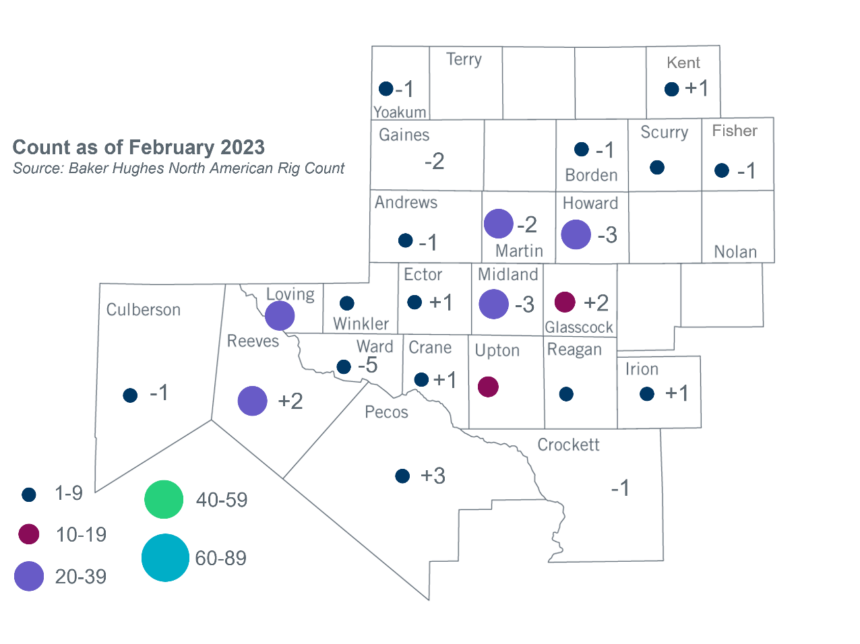Permian Basin Oil Rig Count[3]

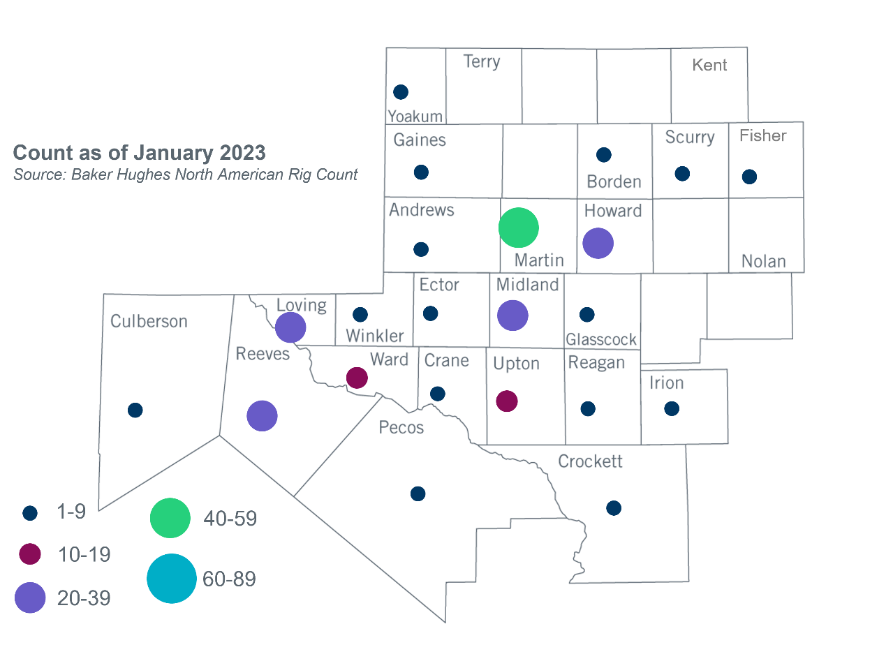

Other Notable Activities

* ERCOT presented the financial assumptions update for economic transmission planning at the February RPG meeting.

1. Based on the Total Project Estimated Cost for all future projects listed in the Transmission Project Information and Tracking (TPIT) report. TPIT is updated three times each year based on information TSPs provide in Model on Demand (MOD) as specified in the ERCOT Steady State Working Group Procedure Manual. The latest TPIT is available at https://www.ercot.com/gridinfo/planning.
2. Based on the Total Project Estimated Cost for all completed projects with Projected In-Service Dates in 2023 listed in the TPIT.
3. +/- symbol indicates the increase or decrease from the previous month in oil rigs present in each county. There are 243 rigs, including a decrease of 10 oil rigs, in the Permian Basin from January to February 2023.