# Rejections Deep Dive

1. 2021-832:  What situation(s) would the MVO reject code be used?  Is it only for IA or CR’s?

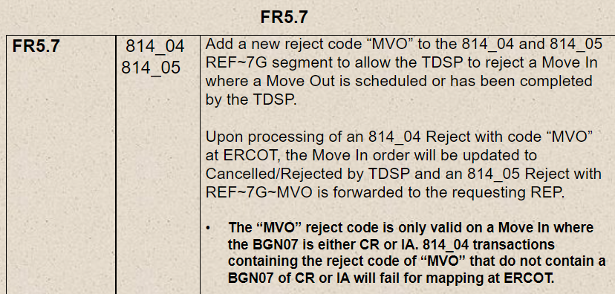

1. 2021-830:
   1. FR6.5 and 6.13 – What is the difference between DCI and DIP?  Wouldn’t DCI only apply if it was a DIP?  Can we eliminate DCI and just use DIP as a reject code in both FR’s?
   2. FR6.12 – What situation would the TDPS use SOP as the reject code?    Transaction already worked?  TDSP already cancelled?  Other?
   3. FR6.23 – How do TDSP’s treat a MVO to CSA when a new transaction is a MVI?  Do we reject MVO to CSA or the MVI?  Does one trump the other?
   4. FR6.25 – What’s an example of reject code SCP (Schedule Conflict Pending)?
2. Is 180 days still the furthest we can go back on tampering back billing?
3. TXSETCC 2021-836 – Punctuation marks in name fields (various transactions)
4. TXSETCC 2022-837 – NFI (Not First In) rejection code in the 814_25
5. TXSETCC 2021-830 – use case for rejection codes on
   1. 814_04
   2. 814_09
   3. 814_13
   4. 814_21
   5. 814_25
   6. 814_29